Invitation to Quote for Stand Build
Cereals 11-12 June 2024

Contact Name: Will be given to award bidder Email: Will be given to award bidder
Company Name: AHDB Website: www.ahdb.org.uk
Address: Middlemarch Business Park
Siskin Parkway Estate, Coventry, CV3 4PE, United Kingdom
Show Name: Cereals 2024
Show Dates: 11-12 June 2024
Stand Size: 20m x 12.5m open space containing a marquee
Budget: £40,000 GBP Stand No. 526
Show Venue: Bygravewoods, Newham Farm, Herts
Deadlines: Tender submissions to be received by Friday 16th February 2024

- Introduction
This document is an invitation to tender for the provision of stand build services for Agriculture and Horticulture Development Board (AHDB) to attend Cereals event.

AHDB is a statutory levy board, funded by farmers, growers and others in the food supply chain. It exists to make the British agriculture industry more competitive and sustainable through factual, evidence-based advice, information and activity. We want to create a world-class food and farming industry, inspired by and competing with the best.
For further information, please visit – www.ahdb.org.uk
- Event Objectives

AHDB are looking for a supplier to provide the design, production, build and dismantling of stand with marquee including raised flooring, interactive graphic installs providing an open and inviting space to draw people in. Quote to include all equipment hire and associated services other than those listed in section 3.
Deadlines and submission instructions are contained in Section 7 & 8
Cereals is the UK’s technical event for the arable industry. Over 18,000 farmers, agronomists, and industry experts visit Cereals each year to discover the latest arable innovations, hear from key opinion leaders, and find the best arable products and services to help grow their businesses.
For background of what can be expected at the event, visit: www.cerealsevent.co.uk/
The supplier must have the ability to build and dismantle on uneven farm land, and foresee any problematic issues that may occur with this being an outdoor build.
What our stand will offer to visitors:
- Meet AHDB Cereal and Oilseeds staff.
- Discuss the key messages
- Keep abreast of research and development work being undertaken by AHDB Cereals and Oilseeds and their stakeholders.
- Network with new and existing customers and colleagues.
- Browse our publications and explore our tools.
- Displays that are eye catching and encourage visitors to stop
- Discover more about the activity that AHDB funds to help its sectors grow to become more competitive and sustainable.
- AV that can be seen and heard all around our stand.

- Service Build Requirements

The successful supplier will be responsible for the design, construction and dismantling of marquee, interactive installs, including graphics, within the timescales set out by the event organisers.
The successful supplier will be responsible for managing subcontractors and paying for their services and will be responsible for organising any specific arrangements e.g. electrics. The supplier shall send AHDB one single invoice for services rendered by subcontractors.
All installations and systems shall be built in compliance with Health & Safety and fire prevention regulations, along with all other rules safe guarding the personal and material safety of exhibitors and third parties.
Structures and furniture must be sturdy and be able to withstand strong winds.
Transportation, maintenance and disposal of installs are not the responsibility of AHDB. Shipping and delivery, including costs, of the stand and associated products are the contactor’s responsibility.
The Project Manager/equivalent of the successful suppliers’ team shall be available during the construction and dismantling of the stand and for the duration of the exhibition and must be capable of dealing with any eventuality. A nominated deputy shall be available during any absence of the Project Manager.
All construction and dismantling of the installs must be within the time frames indicated by the event organisers.
During the event the marquee will need to be opened up each morning and secured each evening by the successful supplier.
- Structure of the stand space
A non-standardise marquee with branding allowing for something visually appealing to help AHDB stand out from the crowd with small outside area. High level signage needed.
- Elements of the stand
The responsibility of applying for the provision of electricity, water, waste and any rigging requirements will lay with the successful supplier who will need to coordinate with the exhibition organisers. All related costs shall be borne by the successful supplier.
Event security will be provided by the main organisers but it will be expected the successful supplier will put provisions in place to ensure all stand areas are secure from when the stand build is complete until when the stand dismantling commences for the hours of which the event is closed to visitors.

- Branding and logos
AHDB will co-ordinate the artwork of all stand graphics and the successful supplier will be responsible for the printing and production of the supplied installs.
- Areas of the stand
The concept of the stand will include the following key areas:
- AHDB branded marquee
- 3 interactive display pods
- Outdoor seating area
- Outdoor Perimeter (graphics & flags)
  - Requirements for Inside Marquee
This is the central hub for AHDB to show relevant key messages and to engage with visitors, and build elements that we are seeking are as following:
- Welcome Reception/Information Hub – design and production of a large welcoming and branded reception desk with storage underneath, and an electric supply for tea & coffee making facilities, and also to charge handheld tablets. This is to be a central point within the marquee offering an inviting and open feel to the stand.
- Store room – a lockable area to store bags, coats and literature.
- Publication Bins – design and production of 5x branded publication bins/racks that are freestanding, moveable and re-useable.
- Graphic wall – design and production of a panel across the back wall.
- 3 x interactive display pods to display relevant messages (open to stand builders interpretation).

  - Requirements for Outdoor Perimeter of Marquee
AHDB’s stand is situated in the centre of the event with the perimeter of our stand alongside a main walkway this gives a great opportunity to display messages to visitors walking around the site, so we are looking for the supply of outside seating benches/tables with waterproof parasols.
The stand build construction and breakdown dates and times will be advised to the winning supplier nearer the time of the event, although we can advise that there is usually a 5 day build up once the marquees are installed, and as advised above, the successful supplier will be expected to work closely with the contractors erecting the marquees.
Please note: All measurements are approximate, and the stand build requirements are subject to change.

4. Venue plan
Please note the stand backs onto a service road.
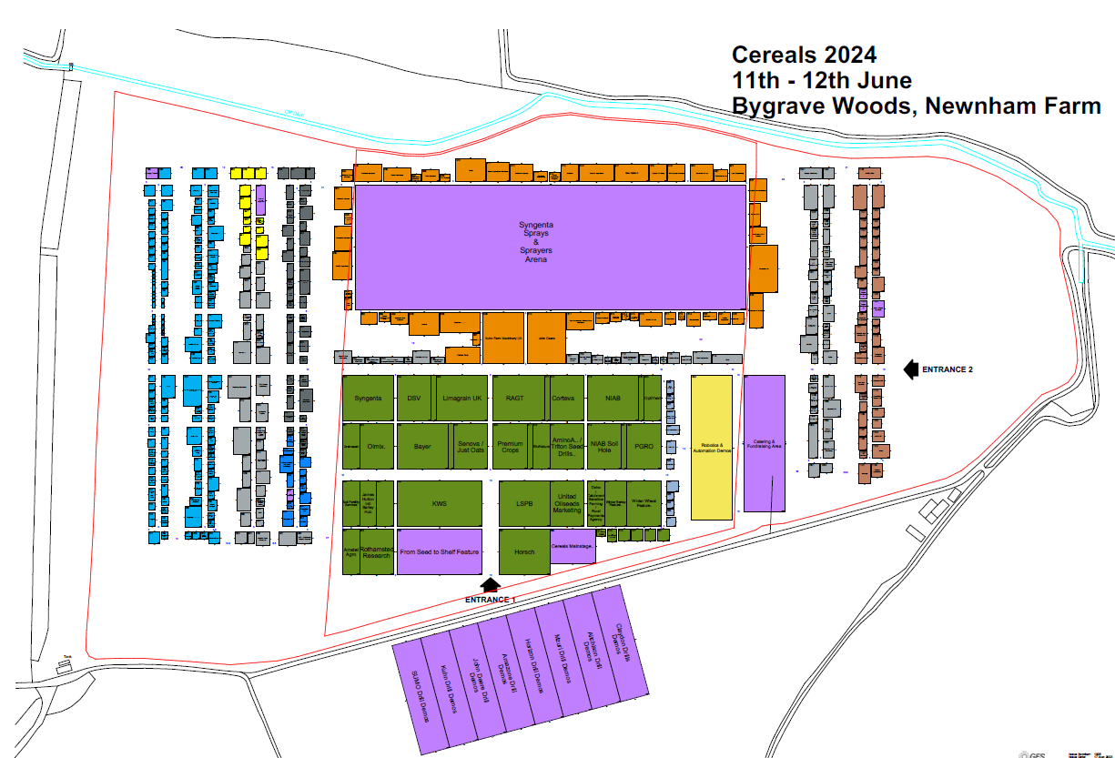

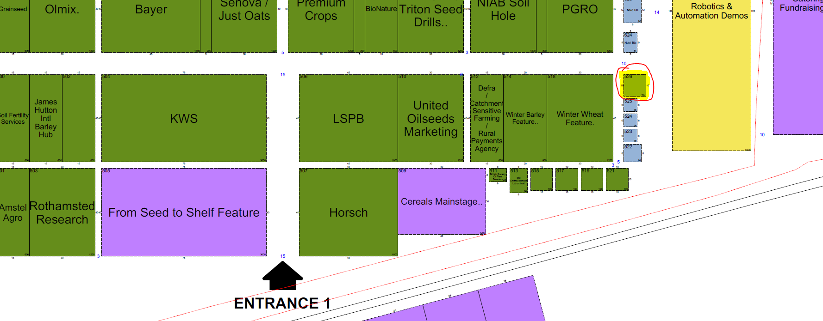
- Stand layout and design
The aim of our presence at this show is to engage with our customers, the stand needs to draw visitors into our area, the design needs to be creative visually and inviting with facilities to engage with as many levy payers as possible. Below is a suggested layout of the stand.
- Budget
Our budget for the stand build which is to include graphic production and marquee hire is £40,000 GBP
7. Tender Process
The contractor shall deliver the whole of the services, complete in all parts and furnished with every necessary detail, notwithstanding any omission or inconsistency in the specification.
The quote should include ‘to scale’ visuals of your design and be clearly itemised for all services and provision; where possible split by area (pods, storeroom, outside/inside areas etc.) stating if any sub-contractors will be used; graphic dimensions and artwork deadline.
Except as otherwise stipulated in the specific conditions of service required, the contract shall remain at the fixed price and rates shall not be revised.
AHDB’s Event Manager can order reasonable additions to or reduce from the service specified. These amendments shall be requested in writing and agreed by both parties.
Your brief should include:
- Full proposal based on brief
- To scale designs / drawings
- Proposed timetable – of how the supplier will achieve the build
- Information on how you will deliver this project within the stated budget
- Methodology for liaising with AHDB staff, other suppliers and event’s organisers
- Proposals and solutions to any unforeseen challenges in relation the venue and any extreme weather conditions that may arise
- Generic project plans/checklists to ensure full delivery of service
- Risk assessments/Method statements in relation to this project
- Health & Safety policy and details of any key issues for this project
- Your measures in place against current and potential changing Covid-19 requirements
- Itemised breakdown of costs within the budget. Any additional costs are to be clearly itemised outside of the budget.

8. Evaluation of Tenders
Our award criteria are:
Understanding of the brief 20%
Innovation / Creativity 40%
Ability to deliver the brief cost effectively 25%
Delivering tender on time 15%

Please email your design proposals to procurement@ahdb.org.uk by NOON on Friday 16th February 2024.
Following the successful awarding of a supplier, an initial meeting will be put in place to meet the team and discuss initial changes to the preferred designs.
9. Payment Terms
Please note that all invoices submitted to AHDB require a purchase order number to enter onto our payment system. Our payment terms are 30 days from receipt of the invoice.

