Whole Site Risk Assessment Record – Cavenham Heath NNR

|  |  |  |  |
| --- | --- | --- | --- |
| NNRs covered | Cavenham Heath | |  |
| Assessment of: | Whole site risk assessment | |  |
| Training Required? | N/A | NE High Risk Category |  |
| Date completed | 13/5/2022 | Review Date | 13/5/2023 |
| Notes: |  | |  |
| Signed off by (SRM name) | Chris Hainsworth | |  |

|  |  |  |  |
| --- | --- | --- | --- |
| What are the Hazards? | Who might be harmed and how? | What precautions are you already taking? | Further Action |
| Rough terrain | Staff, Volunteers &  Visitors    Trips, slips and falls Sprains. | Highlight to all visitors the need for care when walking.    Issue staff with good footwear and encourage all visitors to wear stout footwear. |  |
| Wet and Boggy ground | Staff, Volunteers &  Visitors  Trips, slips and falls sprains. | Highlight that especially in winter areas of the NNR can become waterlogged and hazardous. |  |
| Uneven rough terrain and boggy areas. Rabbit holes and anti glider ditches | Staff, Volunteers &  Visitors    Off road vehicles can become stuck or come to a sudden stop causing injury to occupants | Highlight to all who have permission to drive off the main tracks that the NNR has challenging terrain. Keep to existing tracks as much as possible Drive at slow speeds.  Do not try to cross anti glider ditches except at crossing points. All NE staff to have 4x4 off road driver training or be closely supervised by trained colleague. |  |
| River Lark, ponds /ditches and fen areas (particularly in winter or when very wet) | Staff, Volunteers &  Visitors    Falling into river /ponds. Becoming  stuck/lost/drowning. | River Lark is most dangerous near the weir. The weir area has good fencing and is kept well maintained by the Environment Agency. A life belt and warning signs are maintained by the Environment Agency. Safety features are checked by NE staff.  Swimming upstream of the weir is potential dangerous.  All water features have muddy unstable banks and should be approached with caution.  If undertaking tasks near water features no lone working is allowed. |  |
| Working on, in or adjacent to water of unknown depth, temperature, current, visibility, obstruction and pollutants | Staff, Volunteers &  Visitors    Accidental immersion drowning | No work to be carried out adjacent to the River Lark until a task risk assessment has been signed off by the Senior Reserve Manager.    If undertaking tasks near water features no lone working is allowed. |  |
| Working in Reedbeds/ tall fen  Wet holes/dykes obscured by vegetation | Staff, Volunteers &  Visitors    Trips, slips and falls due to soft ground, Sprains, drowning | Features are relatively small and obvious. If visit is focused on wetland features then a task risk assessment must be signed off by the Senior Reserve Manager before work commences.    If undertaking tasks near water features no lone working is allowed. |  |
| Biting Insects/ticks | Staff, Volunteers &  Visitors    Tick bites causing  Lymes disease | Insect repellent is recommended for use and provide for staff and official visitors.  Ticks can be numerous on the heath – staff/volunteers/official visitors to be made aware of the risk/symptoms of Lymes disease and advised to wear suitable clothing (stout boots/trousers tucked into socks). Also to check themselves thoroughly after visit.  Any ticks found should be removed in approved manner – bite should be monitored and medical advice sought promptly if necessary. | All tick bites to be recorded as accidents on NE form. |
| Adders | Staff, Volunteers &  Visitors    Venomous bite – extreme allergic reaction. | Guidance issued to all staff and official visitors to highlight need for care, particularly when reaching into thick vegetation (eg picking up brash, surveying vegetation) especially in Spring. Gloves to be issued and worn when undertaking tasks where there is a significant risk of an encounter.  Snake bites are rare and about 100 adder bites are reported in the UK each year. Most bites occur between June and August, with the number of bites peaking during in July (NHS website 2016). Adders can suffer persecution and so we will maintain a low key and proportionate level of publicity to the hazard. |  |
| Weils Disease    Tetanus | Staff, Volunteers &  Visitors    ill health/ death | Awareness of rats, particularly along river and other open water, and risk of Weils disease.  Request all staff keep tetanus program up to date.  Protect and cover wounds. Encourage handwashing before food and whenever return to base/home. In field provide handwash gel. |  |
| Grazing animals - Unpredictable- horns, sharp hooves.  Inquisitive nature | Staff, Volunteers &  Visitors    Can butt, kick, stamp cause falls & trips, | Inexperienced visitors should not enter field with cattle present. All visitors should be vigilant of livestock and pay attention to their movements and demeanour.    All staff handling/checking livestock are mentored by an experienced colleague.    If bull is present with cows extra caution to be exercised.  Bull to be removed from site during Open Access period. | . |
| Grazing animals  Exposure to dung and  Zoonoses | Staff, Volunteers &  Visitors    May pick up scab, E.coli infections etc | Ensure hand wash/ anti bacterial gel is available for use after handling sheep/ before refreshments.    Brief staff on risks. | Monitor incidence of illness following handling events. Request staff get up to date ‘tetanus’ and record date of injection. |
| Utility Company Assets  Overhead electrical cable | Staff / contractors  Volunteers    Electrocution / serious injury burns/ death | Care should be taken when working in the vicinity of power lines. No tree felling should be undertaken if there is any chance that the tree may contact the power lines without prior consultation with National Grid and agreement on a safe system of work. |  |
| Utility Company Assets  Foul water pipe | Staff, Volunteers &  Visitors    Exposure to foul water and potential illness / serious leak and pollution incident | The foul water pipe runs along the main track. No excavation should be undertaken in this area until the pipe is located by the water company. Fence replacement along or very close to existing lines is acceptable. |  |
| Site infrastructure –  Fences, gates, Styles. | Staff, Volunteers &  Visitors  Electric fences can give shocks causing heart issues in some.  Barbed Wire fences can cause cuts and entanglement.  Styles can be a trip  hazard | All infrastructure is checked quarterly.  Warn people of electric fences – consider turning off if public can be close to them / for events.  Always use gates to enter/exit fields. If not using gates encourage folks to roll under fences rather that climb over. | Maintain  infrastructure check |
| Trees- falling trees or limbs. | Staff, Volunteers &  Visitors    Trees or branches falling and crushing or hitting people  Serious injury/ death. | Undertake annual tree safety audit seek professional advice on complex issues and every 5 years.    Cancel work/events in high wind. | Act upon findings of Tree safety audit in timely manner. Maintain constant vigilance and deal with any concerns immediately. |
| Dealing with the Public- Anti social behaviour | Staff, Volunteers &  Visitors    Physical / verbal abuse /  Assault | Interactions with individuals or groups who are misusing the site should be handled carefully especially if lone working or at evenings/ early mornings. Retreating and calling the police is first response.  All staff to comply with NE lone working protocol |  |
| Working near or finding Unexploded ordinance | Staff, Volunteers &  Visitors    Serious injury /death | NNR is part of an old WW2 airfield so there is a possibility of finding unexploded ordinance. The site has been checked by official agencies but there is always a possibility.  Assume any suspicious looking objects are a hazard. Call police on 999 if objects are found.  Retreat to safety and attempt to prevent others from accessing area until further instruction from authorities. |  |
| Wildfire | Staff, Volunteers &  Visitors    Serious injury /death  Serious damage to wildlife feature of site | No fires or BBQ on site without express permission from NE.  Especially no fires in summer months or during prolonged periods of dry hot weather. |  |

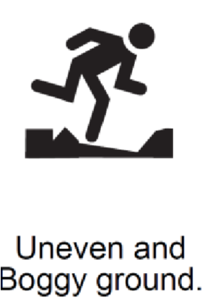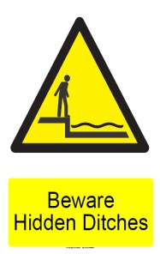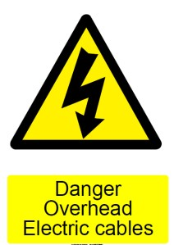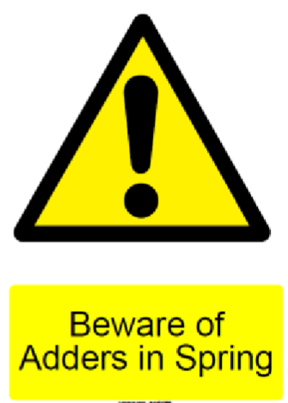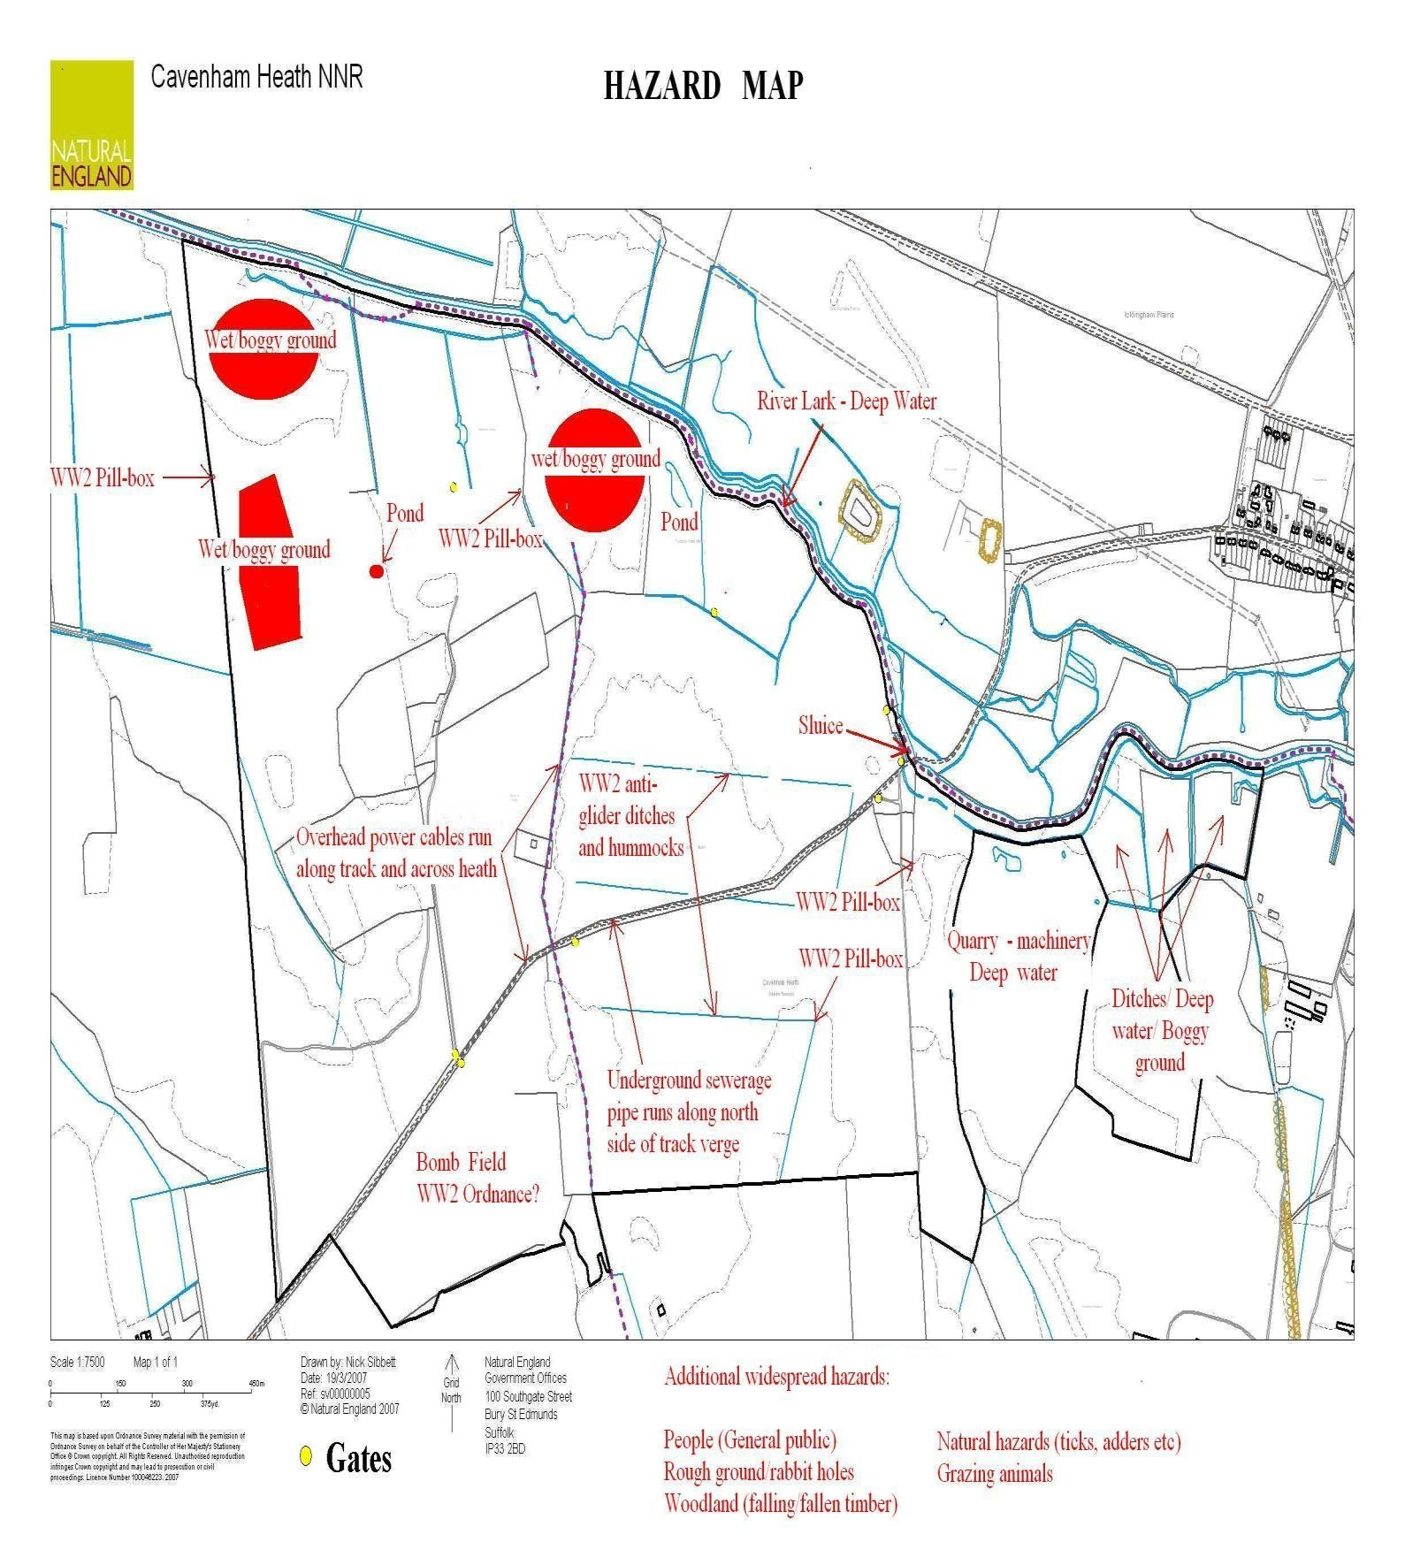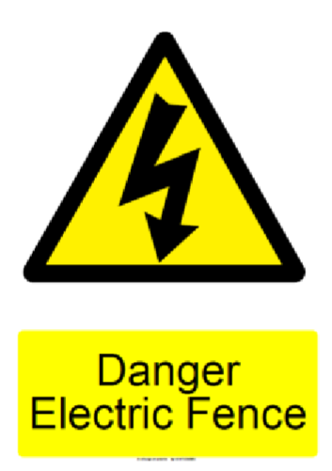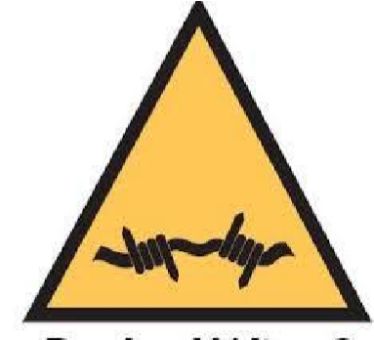

Barbed Wire

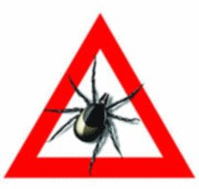

Beware of Ticks

