

**Tender**

Replacement Lighting Control Equipment for the Dance Theatre Space

The University of Chichester

**Latest date for Return – 12:00 on 23 June 2022**

Copyright © 2022 by The University of Chichester. All rights reserved. This document is supplied purely for the purpose of assisting suppliers to respond to this procurement, no part of this document may be reproduced or transmitted in any form, by any means (electronic, photocopying, recording or otherwise) for any other purpose

|  |  |  |
| --- | --- | --- |
| University of Chichester  College Lane  Chichester  West Sussex  PO19 6PE | Telephone:  Date:  Revision:  Email | 01243 816000  23 May 2022  0.1 Draft  [Tenders@chi.ac.uk](mailto:Tenders@chi.ac.uk) |

**Contents**

0 Introduction and general background 1

0.1 Purpose of this tender document 1

0.2 Background to this tender 1

0.3 High level requirements 1

0.4 The bidding process 1

0.5 Seeking clarification 1

0.6 Procurement timetable 2

0.7 Submission details 2

0.8 The assessment process 2

0.9 Confidentiality and Freedom of Information 2

0.10 The template below 2

0.11 The techncial requirements 4

Appendix 1: Social Value Model: Model Award Criteria 5

Appendix 2: Additional Technical Diagrams and Images 8

1. Introduction and general background
   1. Purpose of this tender document

The purpose of this tender is to enable suppliers to demonstrate expertise and compliance with the University’s requirements, and to enable the University to assess the most economically advantageous solutions to its requirements, using the prescribed tendering methodology for requirements of this size and nature.

* 1. Background to this tender

The University of Chichester is seeking a supplier to supply, install and commission theatrical lighting control equipment in the Dance Theatre Space, a 90-seater performance venue. The current equipment is now 20 years old and risks becoming unreliable for production work.

Appendix 2 contains plans and images of the current setup within the space. In Section 0.10, please outline your proposed solution, with schematics for how this will integrate within the space. It is important that within this section that you identify any contingency or requirements you have for the space, for access and what support you will need from our University team.

In Section 0.10.5 please set out the financial structure of your services, including the costs of the supply, and installation works, and please identify any optional or add-value services.

* 1. High level requirements

We are seeking a supplier to supply, install and commission the following equipment:

* 72 ways of Flex Dimmer Racks capable of supplying dimmable or switchable power. This must be capable of being changed, rapidly and at short notice without needing hardware changes. Examples of suitable solution include ETC Coloursource Thru-power system, but we are willing to consider other options that deliver to at least the same specification and performance.
* 3x 15-metre-long Internally Wired Bars with 12x evenly spaced 16-amp sockets and a DMX connection to one end of the bar. These replace the currently installed, ceiling mounted bars Front of House and to the two sides.
* 6x 6-metre-long Internally Wired Bars with 16-amp sockets placed every 1 metre and a DMX connection to one end of the bar. To be ceiling mounted above the space.
* 6x 3-metre-long Internally Wired Bars with 4x 16-amp sockets with tails and a DMX connection to one end of the bar. To be floor mounted as side booms with the DMX connection at the floor end of the bar.
* A computerized lighting desk capable of running a minimum of 2048 output control channels compatible with the solution and supporting ETC EOS operating system and full bi-directional RDM. This desk must contain a user configurable fader wing.
* Associated power and data links between the Internally Wired Bars and the control room.
* Installation to be tested and certified for use as appropriate.
  1. The bidding process

Whether through our tendering advertisements, or where we have contacted you directly to ask for a quotation, we ask that you contact us only through the email account [tenders@chi.ac.uk](mailto:tenders@chi.ac.uk). This includes for your submission, and any questions you may have. We are obliged by the Public Contacts Act (2015) and by our own financial regulations to undertake a competitive process. In this case the perceived value of the tender, requires us to use an open tender process. To help us assess quotations we have added a questionnaire, and ask that you complete this to help us understand the value your company can achieve.

To assist with preparing your quote will be inviting candidates on site to view the building and facilities. We expect that this will be undertaken in the week commencing 6 June 2022. Please register your interest by emailing [tenders@chi.ac.uk](mailto:tenders@chi.ac.uk), and by supplying a brief overview of you company and examples of similar work.

* 1. Seeking clarification

For all queries please contact us by email [tenders@chi.ac.uk](mailto:tenders@chi.ac.uk). Please note that during the tender period you should not contact University staff directly, as this might be considered canvassing, and in which case the University might need to exclude your organisation from the tender process.

Please note that dependent upon the nature of the enquiry, and in so much as it does not identify your organisation, the answers to any questions you raise may be circulated to all suppliers who have expressed interest in this tender.

* 1. Procurement timetable

The procurement project is working to the following timescale:

|  |  |
| --- | --- |
| Stage | Key Dates |
| Publication of Tender Notice | 23/05/2022 |
| Clarifications | 23/05/2022 – 22/06/2022 |
| Invitation to visit site | W/C 06/06/2022 |
| Closing Date for submission | 12:00 on 23/06/2022 |
| Award | 30/06/2022 |

* 1. Submission details

You are welcome to notify the University with your ‘Expression of Interest’ but please do send your completed submission (including a completed version of this document) to the University by the closing date (12:00 on 23 June 2022), to [tenders@chi.ac.uk](mailto:tenders@chi.ac.uk).

* 1. The assessment process

The University awards contracts on the basis of most economically advantageous tender, (quote) assuming that there is nothing that excludes the tenderer. All documents submitted are assessed by a panel to ensure fairness and understanding. The panel reviews the quotation for;

|  |  |
| --- | --- |
| Criteria | Weighting |
| Coherence and clarity to the University’s requirement ~ | 35% |
| Organisational experience and capability | 15% |
| Costs | 30% |
| Compliance with the Social Value Model | 10% |
| Added value | 10% |
| Exclusion grounds *see ([link](https://assets.publishing.service.gov.uk/government/uploads/system/uploads/attachment_data/file/558520/PPN_8_16_StandardSQ_Template_v3.pdf)) | Pass / Fail |

~ inclusive of quality and longevity of the equipment provided.

* 1. Confidentiality and Freedom of Information

All tendering documentation and correspondence are treated as strictly confidential. However, the University is subject to UK Data Protection Legislation, and the Freedom of Information Act 2000. This means that the University can be asked to disclose procurement and contracting information. Please indicate any areas of your submission that you consider should be exempted from any disclosure requests and identify why they should not be disclosed.

* 1. The template for your bid/quote

We have set out a template below, and ask that you use this to help us understand your bid, in a way that allows us to compare its benefits against others. This anticipates question we / you may have.

You are welcome to submit other information, but please do help us by identifying what you can do, in relation to our requirements, and do please answer the questions below where it is possible to do so.

We have deliberately avoided overloading the quotations process with the rigors of (for example) the Crown Commercial Service’s ‘reason for exclusion’, but please note there are a number of requirements we have to ensure before finalising any subsequent contracts. These range from the ownership of the companies we work with, to environmental sustainability and key questions such as your policies and approach to Modern Slavery and equal opportunity.

There is no limit to the word count for any of the questions here, but please bear in mind the need for clarity etc

|  |  |
| --- | --- |
| 1 | Please see the high-level requirements in Section 0.3, and the schematics etc in Appendix 2. This free-text section is intended to describe the solutions you propose, and how this will achieve the objectives, with best value, and least disruption.  Please note that whilst you may wish to include general company information to cross-reference various points, but please be very specific in your proposal, to this (our) requirements. |
|  | |

|  |  |
| --- | --- |
| 2 | Please describe your typical services |
|  | |

|  |  |
| --- | --- |
| 3 | Please describe the installation itself – with options  It will be helpful if you can supply photographs of similar installations you have been involved in. |
|  | |

|  |  |
| --- | --- |
| 4 | Please describe annual maintenance and licensing costs, ideally with warranty and call-out arrangements should an error occur |
|  | |

|  |  |
| --- | --- |
| 5 | Please set out your cost proposal with explanatory notes. Please identify clearly what is included in the core of your proposal, and what are any additions you wish us to consider. |
| |  |  |  | | --- | --- | --- | | Costs to the University | Included | Cost £ GBP Ex VAT (included explanatory notes) | | Cost of goods | Yes  No |  | | Delivery | Yes  No |  | | Any additional cost, expenses or disbursements | Yes  No |  | | Discretionary items (please identify the, role benefits / value of such items) | Yes  No |  | | Cost of any support arrangements | Yes ☐ No ☐ |  | |  |  |  | | |

|  |  |
| --- | --- |
| 6 | Please note any additional facility  It would be helpful if you could advise on future proofing the system and ability to update features. |
|  | |

|  |  |
| --- | --- |
| 7 | Please provide estimates of your timescales for installing the lighting system, such as availability to commence work, time required on site, etc. |
|  | |

|  |  |
| --- | --- |
| 8 | Please tell us something about you and your organisation, for example in relation to the social value model |
|  | |

* 1. The techncial requirements

To comply with the Public Contracts Act 2015 and our own financial regulations, before it makes any final decisions, the University is required to ensure that any supplier meets a number of key characteristics. As well as ensuring suitability and value these include areas, such as how you comply and support the Modern Slavery Act and the various aspects of the Social Value Model.

Please note that during the contacting phase of this procurement, we will ask questions about;

* The status and formation of your company
* The ownership of your company, and any exclusion grounds (for example convictions)
* Any sub-contractors that you might use
* Economic and financial standing
* Technical and professional ability (potentially to access references of relevant existing customers)
* Compliance with statutory obligations (Modern Slavery Act)
* Liabilities Insurance

How your company supports the Social Value Model (including recovering from Covid 19, tackling inequality, fighting climate change, equal opportunity and wellbeing). Principles of the SVM are described in **Appendix 1**

Appendix 1: Social Value Model: Model Award Criteria

|  |  |  |
| --- | --- | --- |
| SVM Theme | SVM Policy Outcome | SVM Model Award Criteria |
| COVID-19 Recovery | Help local communities to manage and recover from the impact of COVID-19 | Effective measures to deliver any/all of the following benefits through the contract:   * Creation of employment, re-training and other return to work opportunities for those left unemployed by COVID-19, particularly new opportunities in high growth sectors. * Support for people and communities to manage and recover from the impacts of COVID-19, including those worst affected or who are shielding. * Support for organisations and businesses to manage and recover from the impacts of COVID-19, including where new ways of working are needed to deliver services. * Support for the physical and mental health of people affected by COVID-19, including reducing the demand on health and care services. * Improvements to workplace conditions that support the COVID-19 recovery effort including effective social distancing, remote working, and sustainable travel solutions. |
| Tackling economic inequality | Create new businesses, new jobs and new skills[1] | Effective measures to deliver any/all of the following benefits through the contract:   * Create opportunities for entrepreneurship and help new organisations to grow, supporting economic growth and business creation. * Create employment and training opportunities particularly for those who face barriers to employment and/or who are located in deprived areas, and for people in industries with known skills shortages or in high growth sectors. * Support educational attainment relevant to the contract, including training schemes that address skills gaps and result in recognised qualifications. |
| Increase supply chain resilience and capacity | Effective measures to deliver any/all of the following benefits through the contract:   * Create a diverse supply chain to deliver the contract including new businesses and entrepreneurs, start-ups, SMEs, VCSEs and mutuals. * Support innovation and disruptive technologies throughout the supply chain to deliver lower cost and/or higher quality goods and services. * Support the development of scalable and future-proofed new methods to modernise delivery and increase productivity. * Demonstrate collaboration throughout the supply chain, and a fair and responsible approach to working with supply chain partners in delivery of the contract. * Demonstrate action to identify and manage cyber security risks in the delivery of the contract including in the supply chain |
| Fighting Climate Change | Effective stewardship of the environment | Effective measures to deliver any/all of the following benefits through the contract:   * Deliver additional environmental benefits in the performance of the contract including working towards net zero greenhouse gas emissions. * Influence staff, suppliers, customers and communities through the delivery of the contract to support environmental protection and improvement. |
| Equal opportunity | Reduce the disability employment gap | Effective measures to deliver any/all of the following benefits through the contract:   * Demonstrate action to increase the representation of disabled people in the contract workforce. * Support disabled people in developing new skills relevant to the contract, including through training schemes that result in recognised qualifications. |
| Tackle workforce inequality | Effective measures to deliver any/all of the following benefits through the contract:   * Demonstrate action to identify and tackle inequality in employment, skills and pay in the contract workforce. * Support in-work progression to help people, including those from disadvantaged or minority groups, to move into higher paid work by developing new skills relevant to the contract. * Demonstrate action to identify and manage the risks of modern slavery in the delivery of the contract, including in the supply chain. |
| Wellbeing | Improve health and wellbeing | Effective measures to deliver any/all of the following benefits through the contract:   * Demonstrate action to support health and wellbeing, including physical and mental health, in the contract workforce. * Influence staff, suppliers, customers and communities through the delivery of the contract to support health and wellbeing, including physical and mental health. |
| Improve community integration | Effective measures to deliver any/all of the following benefits through the contract:   * Demonstrate collaboration with users and communities in the co-design and delivery of the contract to support strong integrated communities. * Influence staff, suppliers, customers and communities through the delivery of the contract to support strong, integrated communities. |

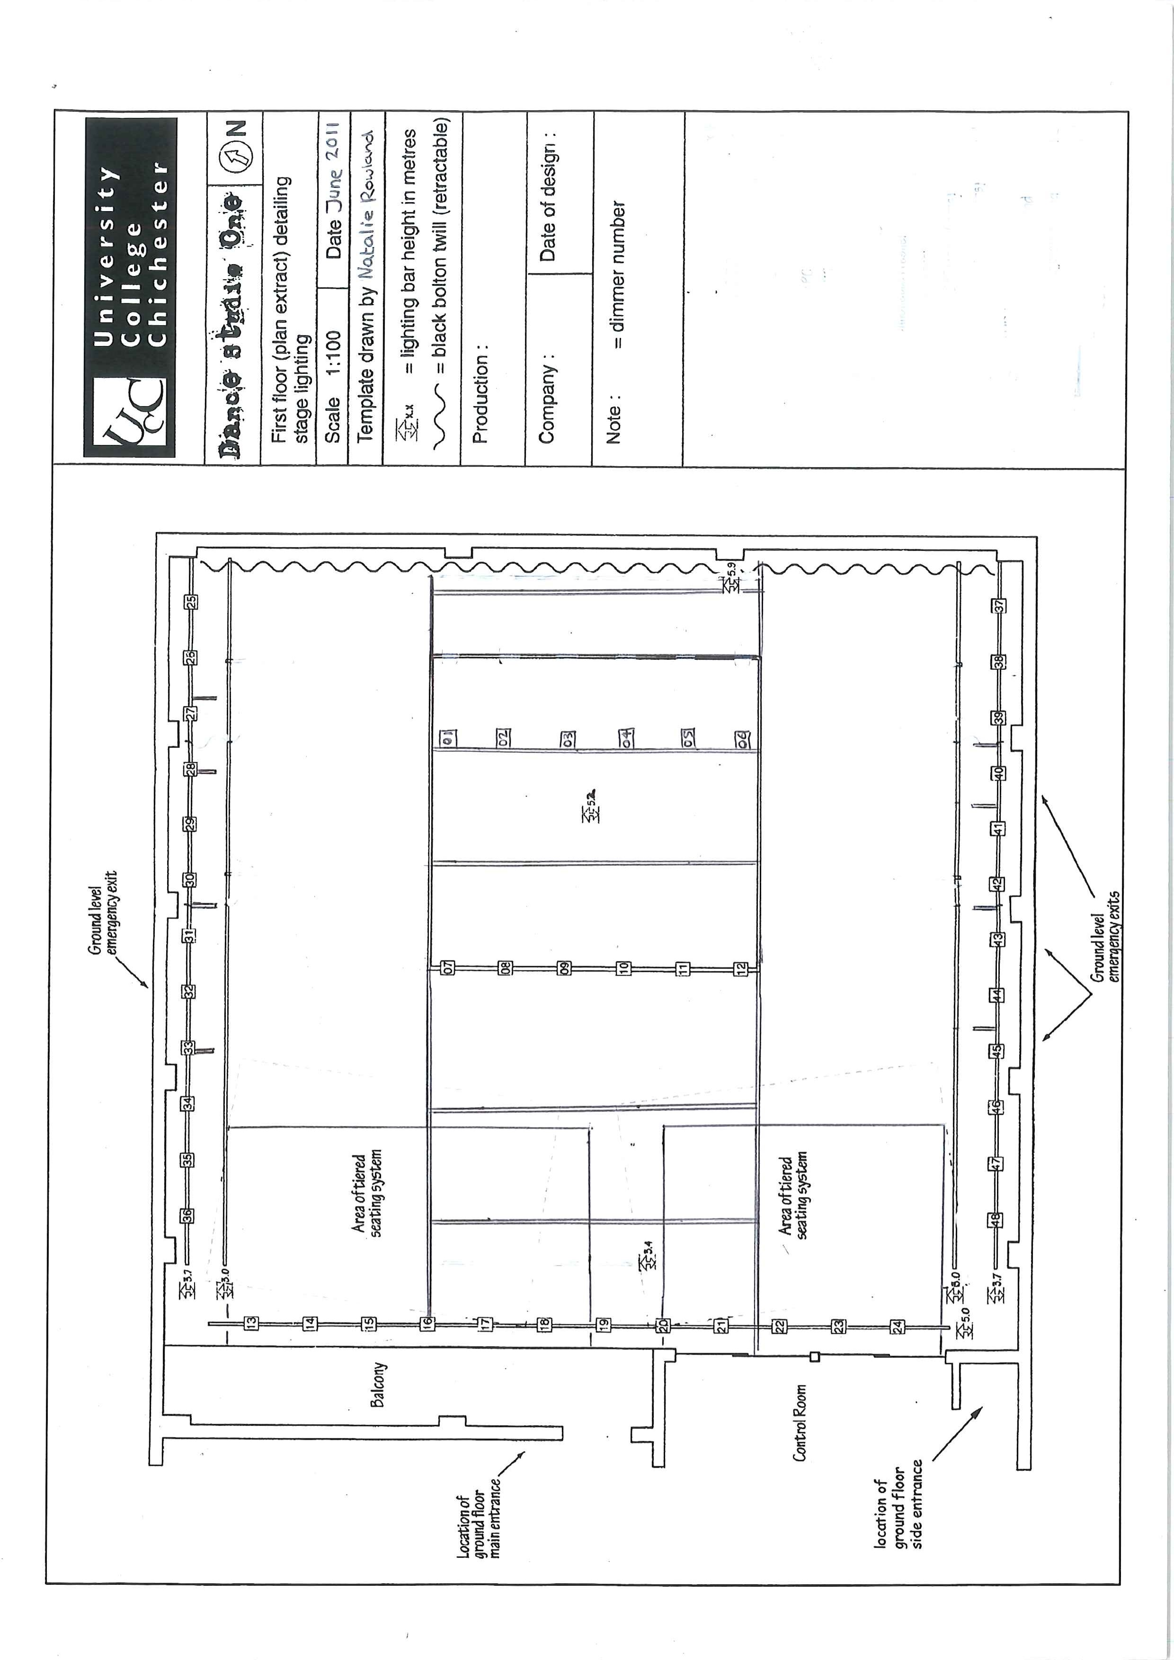Appendix 2: Additional Technical Diagrams and Images

Current Lighting Plan (Not to Scale)

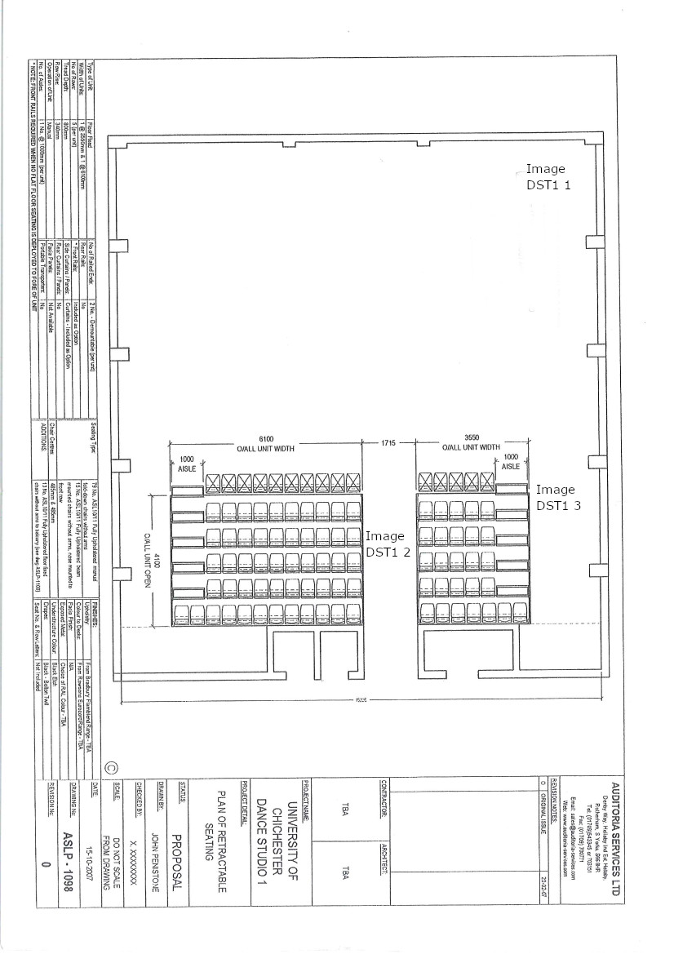Current Floor Plan Showing Image Locations

DST1 1

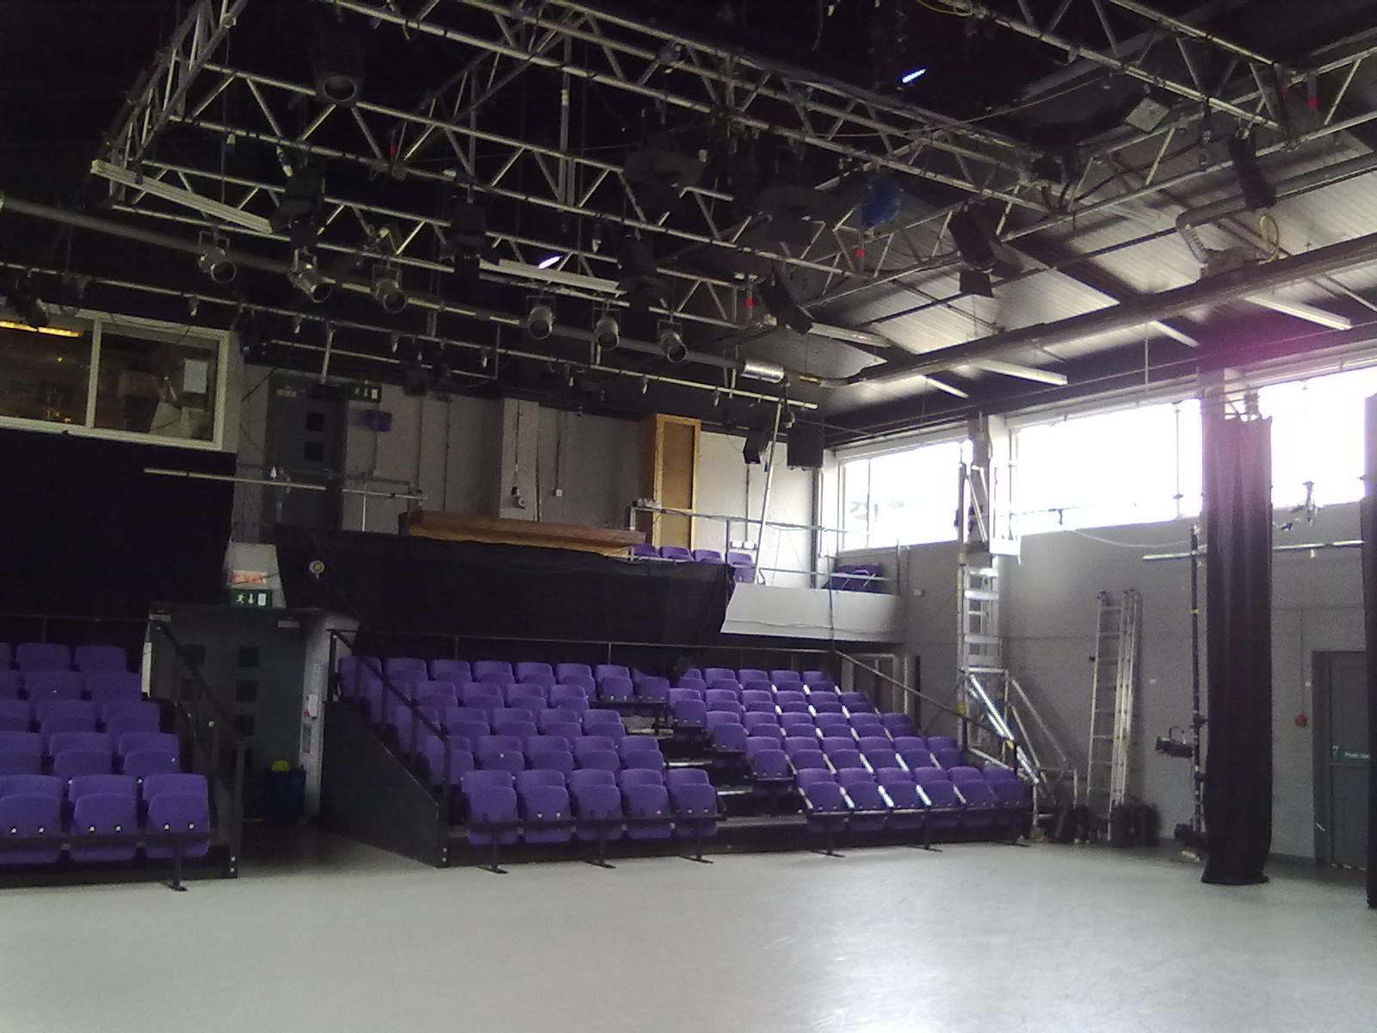

DST1 2

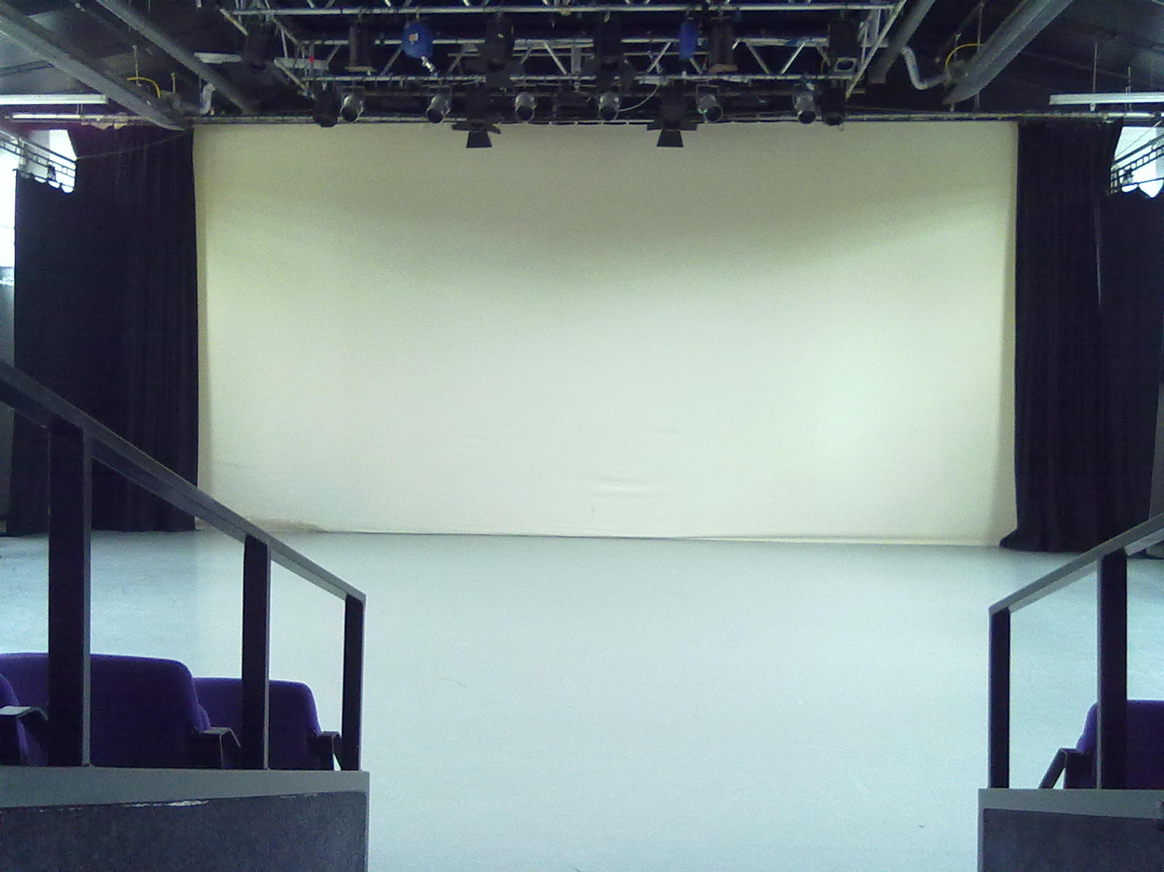

DST1 3

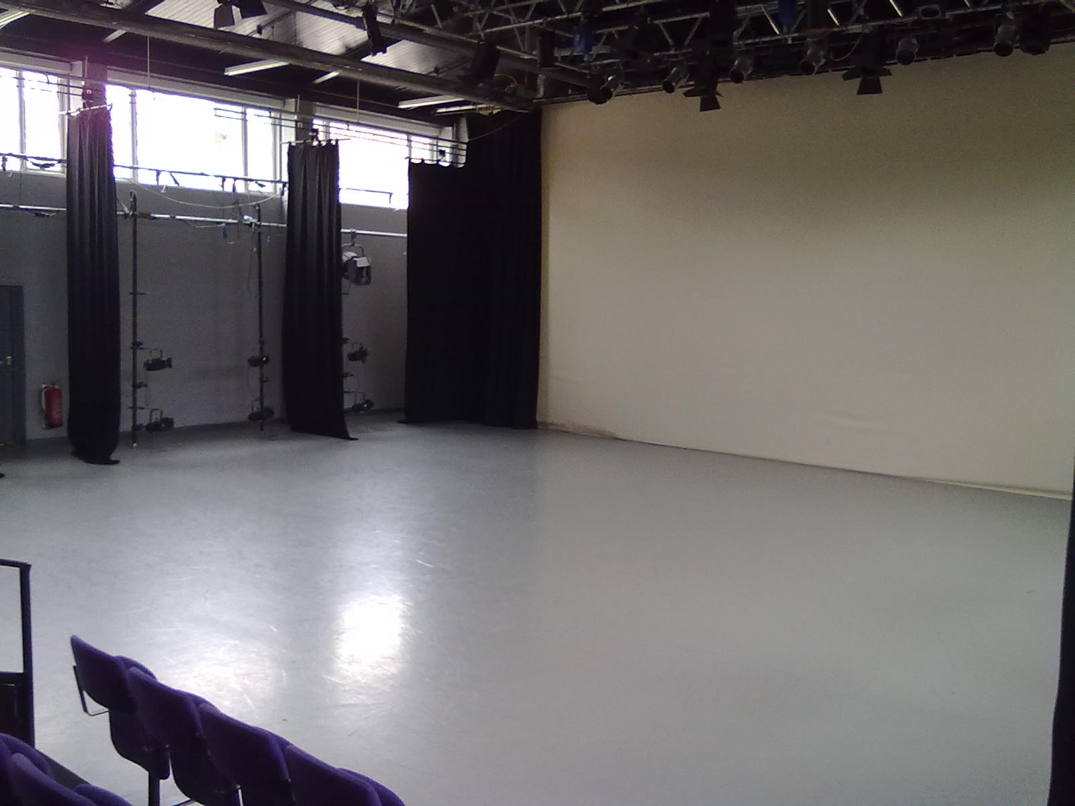

1. The University will welcome the opportunity to develop degree apprenticeships, internships and placements, Continuous Professional Development, as well as collaborative programmes and career pathways with suppliers.