**Energy Audit Report**

Chard Town Council Guildhall and Cemetery

# Foreword

**The UK Government has legislated for net zero carbon emissions by 2050. In order to achieve this target, we all need to make changes to the way we live and work.**

As an Energy Efficiency Consultancy, our primary focus is to reduce our Clients’ energy costs, by advising and implementing methods to reduce energy consumption.

UK Energy Watch Group takes a holistic approach to energy efficiency, encompassing all aspects within a site in order to maximise efficiencies and minimise CO2 emissions.

*Ashley Bullock*

Managing Director

UK Energy Watch Group

# About Us

UK Energy Watch Group are Education Energy Saving Specialists. We have a combined 20 years’ experience working in the energy sector, conducting surveys and coordinating efficiency technology projects within schools.

Schools and academies commission us to support them in incorporating energy efficiency projects. Our services are aimed to help buildings comply with regulations, reduce their energy consumption, carbon footprint and improve their overall sustainability.

In 2019 alone, we:

* Supported 184 school managers
* Delivered 139 energy audits
* Coordinated installs of 14,500 light fittings
* Generated over £250k efficiency savings
* Helped secure Salix funding for school

**Our mission is to help the education sector significantly reduce energy costs and lead the way in the fight against climate change.**

Contents

Foreword 1

About Us 1

Executive Summary 3

Summary of Opportunities 3

Introduction 4

Site Details 5

Energy Review 6

Energy Savings Opportunities 9

Further Savings Opportunities 12

Conclusions 14

# Executive Summary

The overall energy efficiency at Chard Town Guildhall and Cemetery is not very good. The boilers are relatively old, most areas do not have LED lighting and building envelope performance can be improved. The building is very early on in its stages of becoming decarbonised. By implementing the technologies recommended in this report the building will greatly increase energy efficiency, making cost savings that be re-directed to core education budgets.

With the addition of the recommendations stated in this audit report, as well as further technology implementations like solar PV, energy efficient hand dryers and battery storage, the building would be well on their way to achieving a net zero goal and making a contribution to the fight against climate change.

Further growth can be achieved with the assessment of the building’s overall CO2e baseline, including the staff vehicle emissions, vehicles emissions by parents when dropping off and picking up children, as well as the import and export supply chain.

# Summary of Opportunities

Four key opportunities have been identified and initially evaluated. Some will require further investigation; however, most can now be developed with the assistance of equipment suppliers.

The opportunities are outlined as below.

|  |  |  |  |  |  |  |
| --- | --- | --- | --- | --- | --- | --- |
| **No.** | **Opportunity** | **Energy Savings (kWh)** | **Cost Savings (£)** | **Carbon Savings (tCO2e)** | **Estimated Cost (£)** | **Payback (years)** |
| 1 | LED Lighting Upgrade | 21,176 | 2,908 | 1.5 | - | - |
| 2 | Voltage Optimisation | 7,968 | 1,094 | 0.6 | 4,495 | 4.1 |
| 3 | BEMS Upgrade | 9,913 | 1,361 | 0.7 | 3,600 | 2.6 |
| 4 | Heat Pumps | 149,120 | -2,430 | 32.6 | - | - |

# Introduction

The UK’s energy system is changing rapidly. Our reliance on fossil fuels is diminishing and the focus on renewable energy is increasing. As more commercial, industrial, and domestic consumers look to cleaner electricity generation, steering away from the increasingly taxed fossil fuels, there is an increased demand on the electricity infrastructure.

It is therefore vital that consumers from all sectors look to decrease energy wastage in all forms to reduce this demand and help the electricity grid to continue increasing the renewable electricity usage percentage. This decrease in wastage can only be achieved through increasing efficiency in all areas.

This report presents the findings of an energy audit, conducted for Chard Town Council Guildhall and Cemetery. The audit objectives are the identification and prioritisation of opportunities to improve energy performance, reduce energy waste and obtain related environmental and decarbonisation benefits.

This report is based upon a walk-through audit of the building and analysis of relevant data provided. Energy consumption data has been based upon utility invoices and engineering estimates of likely energy consumption.

# Site Details

The Guildhall, as a whole, is a combination of 3 structures, the entrance and front section of the building is a 2 storey structure, which also contains the more ceremonial and reception offices on the first floor was constructed around 1836, while the rear main public hall structure which contains the auditorium, stage and changing rooms was constructed around 1890. The central section which links the 2 buildings, and contains the modern council employee offices on the upper floors, and the external rooms and peripheral roof areas was added in 2006. The guildhall has a floor area estimated at ~4,000 m2. It is grade 2 listed building.

The cemetery has 2 small chapels on either side of central footpath, these chapels are linked with a covered arch structure which passes over the footpath. The structures are over 100 years old and are of a stone construction with arched timber roof with slate finish.

## Site Map

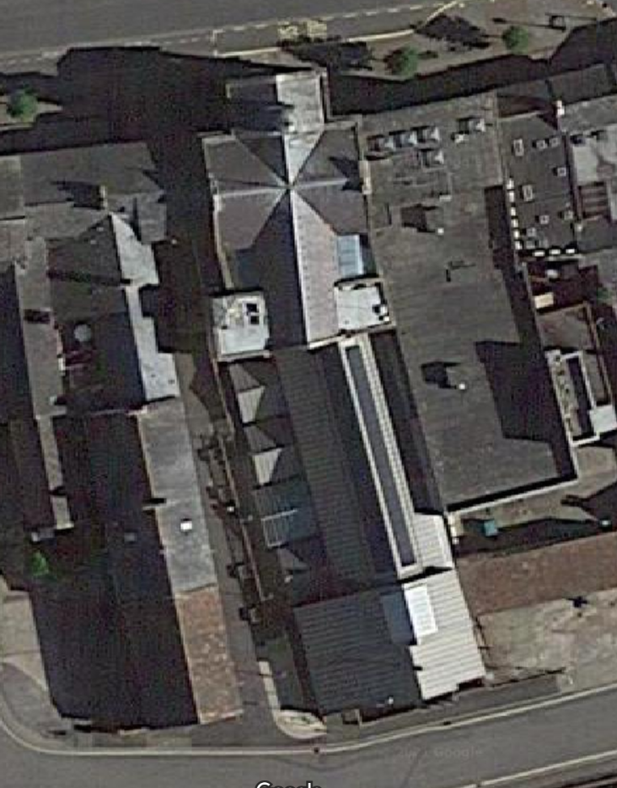

# Energy Review

## Data Collection Information

Data has been based on the 12-month period 1st April 2019 to 31st March 2020. More recent invoices have been collected but the data will be skewed due to the impact of COVID-19, so these invoices have not been included in the analysis.

The site has one metered electricity supply, along with a non-daily metered gas supply.

## Current Energy Use

The table below shows the energy consumption, costs and average unit rates for the period 1st April 2019 to 31st March 2020. The average price is calculated by dividing the total cost (excluding VAT) by the kWh consumption for the year.

|  |  |  |  |  |  |
| --- | --- | --- | --- | --- | --- |
| **Fuel Used** | **Energy Use (kWh)** | **%** | **Annual Cost (£)** | **%** | **Average Unit Rate (p/kWh)** |
| Electricity | 99,126 | 34% | £13,610 | 78% | 13.73 |
| Natural Gas | 194,719 | 66% | £3,830 | 22% | 1.97 |
| **Total** | 293,845 | 100% | £17,440 | 100% |  |

Electricity is much more expensive per kWh than Natural Gas. For this reason, even though the consumption of Natural Gas kWh’s is more than 2 times electricity – the cost electricity is the larger portion of total energy costs.

Looking forward 12-months from now; if prices were to rise by an average of 5%; assuming the same consumption, costs will rise by approximately £850. If these revised prices are factored in, then savings from the recommendations within this report will also rise.

## Electricity Profile Analysis

To understand how electricity is being consumed at the building, the monthly consumption profile has been assessed.

The monthly electricity consumption profile for the building is shown below:

It can be seen that although the absolute consumption fluctuates from month to month the building electricity use appears relatively consistent with the season and term time.

There is an increase in energy use during the winter months, which is likely to be attributed to the increased lighting requirement as a result of lower daylight hours. Electrical heaters may also play a role in the increase which peaks in January but are expected to only comprise a small minority of the electricity requirement.

During the summer months, electricity use begins to increase again to peak in May and June. This is to be expected with the increased requirement of air conditioning in warmer weather. The large drop in consumption during August is notable and consistent with the out of term-time.

As part of the next stage of the project, it will be necessary to request half hourly data from the supplier to allow us to complete more in-depth energy analysis.

## Natural Gas Profile Analysis

To understand how natural gas is being consumed at the building, the monthly consumption profile was assessed as is shown below:

The graph shows the highest gas consumption took place in January 2020, with the lowest consumption occurring during August. This is as expected as the majority of gas used will be for space heating which will correlate with monthly changes in ambient temperature.

Were the site able to more closely monitor gas consumption on a half-hourly basis, a reasonable benchmarking exercise would be to compare the consumption profile with the buildings operating hours to verify that the boiler is not operating outside of these times.

# Energy Savings Opportunities

The following opportunities provide a summary of the potential savings in energy consumption and costs, along with the initial outlay costs, and a simple payback calculation.

Please note that the implementation of some of the energy saving measures will impact on the savings that can be achieved by other opportunities. This means that there might be a degree of duplication of savings if all the measures are implemented.

## LED Lighting Upgrade

|  |  |  |  |  |
| --- | --- | --- | --- | --- |
| **Energy Savings (kWh)** | **Cost Savings (£)** | **Carbon Savings (tCO2e)** | **Estimated Cost (£)** | **Payback (years)** |
| 21,176 | £2,908 | 1.5 | - | - |

### Overview:

Lighting manufacturers are constantly releasing improved light output fittings with reduced energy input to meet the growing demands to reduce energy consumption related to artificial lighting. LED fittings have now become the standard for artificial lighting in buildings. Savings have been estimated based on reducing the estimated lighting consumption by ~70%. Costs are based on a reduction in known power rating by switching to LED equivalents.

### Opportunity Identified:

A lighting audit was undertaken at the building to assess the opportunity to upgrade existing fluorescent fittings to LED. The survey detailed that the lighting within the building is a mixture of traditional fluorescent strip light fittings, and recessed modular lights in grid ceilings.

The lighting upgrade presents a great opportunity to reduce energy use and annual energy costs. We estimate that an upgrade to LED throughout the building would yield a saving of ~21,176 kWh’s leading to cost savings of over £2.9k per year.,

Further analysis should be done to calculate the costs of lighting replacement.

### Implementation Steps:

1. Obtain firm proposals from LED lighting providers.
2. Confirm the cost saving potential of the proposals.
3. Assess user acceptance and product build quality.
4. Implement measure in full.
5. Review the actual savings achieved.

## Voltage Optimisation

|  |  |  |  |  |
| --- | --- | --- | --- | --- |
| **Energy Savings (kWh)** | **Cost Savings (£)** | **Carbon Savings (tCO2e)** | **Estimated Cost (£)** | **Payback (years)** |
| 7,968 | £1,094 | 0.6 | £4,495 | 4.1 |

### Overview:

Voltage Optimisation is a passive form of energy management. This technology optimises the incoming voltage from the electricity grid, thereby reducing the total kWh’s used. This is a highly effective form of energy reduction that helps to prevent surge damage as well as reduce reactive power charges.

### Opportunity Identified:

It has been identified that Chard Town Guildhall could save ~7,968 kWh per year which translates to a cost savings of £1k. Please not, however, that these figures are for this technology on its own and the savings may vary depending on what energy efficiency projects are undertaken at the building. For example, installing efficient LED’s will reduce the total consumption available for voltage optimisation and thereby, the savings of this technology.

However, it should also be considered that electricity use at the building may increase in the future. For example, to fully decarbonise, the building may need to install an electrical heat pump to replace gas boilers. In addition, Electric Vehicle charge points may be introduced on the building grounds to allow staff to charge their cars. Both of this changes would result in a significant increase in annual electricity consumption, enhancing the case for a voltage optimisation project.

### Implementation Steps:

1. Obtain firm proposals from Voltage Optimisation providers.
2. Confirm the cost saving potential of the proposals.
3. Assess user acceptance and product build quality.
4. Implement measure in full.
5. Review the actual savings achieved.

## Building Energy Management Systems (BEMS)

|  |  |  |  |  |
| --- | --- | --- | --- | --- |
| **Energy Savings (kWh)** | **Cost Savings (£)** | **Carbon Savings (tCO2e)** | **Estimated Cost (£)** | **Payback (years)** |
| 9,913 | £1,361 | 0.7 | £3,600 | 2.6 |

### Overview:

Unnecessary energy use (waste) can be identified using energy monitoring, assessment and analytics. Energy metering can be used to gain deeper insights into energy use and highlight opportunities for further energy efficiency projects.

### Opportunity Identified:

We estimate that the installation of smart metering with access to exception reporting and targeting should reduce electricity consumption by a conservative 10%.

Ongoing support from the BEMS bureau service will also provide valuable monitoring services to assist in energy efficiency efforts into the future, and provide results from the implementation of the technologies in our project, for the next 3 years.

We estimate that taking this more active approach to energy management could lead to savings of ~£1.3k per annum.

### Implementation Steps:

1. Obtain firm proposals from BEM’s system providers.
2. Confirm the cost saving potential of the proposals.
3. Assess user acceptance and product build quality.
4. Implement measure in full.
5. Review the actual savings achieved.

## Heat Pumps

|  |  |  |  |  |
| --- | --- | --- | --- | --- |
| **Energy Savings (kWh)** | **Cost Savings (£)** | **Carbon Savings (tCO2e)** | **Estimated Cost (£)** | **Payback (years)** |
| 149,120 | -£2,430 | 32.6 | - | - |

### Overview:

Heating is the United Kingdom's biggest source of carbon emissions – burning fossil fuel contributes to climate change. In same time, the majority of electrical power generation started to come from low carbon sources in the recent years. Therefore, switching from gas heating to low carbon electrical heating plays an important part in decarbonisation. Heat pumps use a small amount of electricity to transfer a large amount of heat from ambient air into buildings. If they use green electricity then no CO2 will be released at all.

### Opportunity Identified:

The building is served by gas boilers that are 18 years old. It is suggested to replace the system with electrical heat pumps. The heat pump has an efficiency of 3.16 where the existing boiler is expected to have an efficiency less than 75%. Switching to heat pumps would be an important part of the decarbonization project.

### The results show that the gas consumption would save 3 tonnes of CO2-e emissions.

# Further Savings Opportunities

The following section will consider further recommendations that could not be included in the main opportunities due to a lack of granular data.

It is recommended that the building investigate the feasibility of the further opportunities outlined below through the logging of relevant equipment. This will determine accurate consumption figures and allow potential savings and payback periods to be calculated.

The installation of a comprehensive BMS system (as described in Opportunity 3) would allow for the identification of consumption of individual equipment. This data could then be utilised for the scoping of future energy efficiency opportunities.

## Rooftop Solar PV

### Solar PV is a renewable technology that is quickly becoming one of the cheapest forms of electricity available. Installations of Solar PV are growing rapidly in the residential, commercial and utility sectors.

Buildings are well suited to Solar PV due to the nature of the electricity generation. Solar power generation is highest during daytime hours which matches the time that buildings use electricity during the typical building day.

### Building Fabric Insulation

The thermal performance of the walls plays an important role to reduce heat loss in a building. As the buildings are now ~180 years old, it’s likely improvements could be made to the internal or external wall insulation.

The building was originally constructed in the late 1830`s, and has been subject to several upgrades since it was originally built. Cavity wall insulation is existing possibly on south and west side but not on north and east sides. There is no external wall insulation. The roof attic is insulated with fibre glass.

Further site visits and inspection are needed to assess this opportunity.

### Windows Upgrade

The thermal performance of the windows plays an important role in reducing the overall energy consumption. There are some windows in the building that have poor thermal performance and replacement would greatly increase the energy efficiency.

The building has undergone several re-fits of the windows. The building has double glazing at south and west side but north side has only single glazed windows. It is foreseen that window replacement would greatly reduce the heating energy consumption.

Further site visits and inspection are needed to assess this opportunity.

### Electric Vehicle (EV) Charge Points

Ownership of full electric and hybrid electric vehicles in the UK is growing and expected to see huge growth over the coming decades. Installing EV chargepoint’s will allow the building to reduce its indirect carbon emissions.

Teachers and staff will have the option to charge their cars on building grounds which could incentivise them to switch from petrol and diesel cars to EV’s.

The installation of EV chargepoints will increase the electricity usage at the building and may require an increase in grid capacity allowed.

### Battery Storage

Battery Storage is a relatively new technology to be implemented in the residential and commercial environment. When combined with installed Solar PV, battery storage gives the opportunity to reduce reliance on the grid allowing a building to be the main producer of its energy.

The benefits of installing battery storage include being able to better match renewable production with electricity use. This allows to better optimise energy costs. In addition, many commercial battery storage units can be used by National Grid to balance the grid. This could provide a new revenue stream for a building to enhance the business case.

# Conclusions

Four opportunities have been identified and initially evaluated, shown in the table below:

|  |  |  |  |  |  |  |
| --- | --- | --- | --- | --- | --- | --- |
| **No.** | **Opportunity** | **Energy Savings (kWh)** | **Cost Savings (£)** | **Carbon Savings (tCO2e)** | **Estimated Cost (£)** | **Payback (years)** |
| 1 | LED Lighting Upgrade | 21,176 | 2,908 | 1.5 | - | - |
| 2 | Voltage Optimisation | 7,968 | 1,094 | 0.6 | 4,495 | 4.1 |
| 3 | BEMS Upgrade | 9,913 | 1,361 | 0.7 | 3,600 | 2.6 |
| 4 | Heat Pumps | 149,120 | -2,430 | 32.6 | - | - |

Some will require further investigation; however, most can now be developed with the assistance of equipment suppliers. UK Energy Watch would be pleased to apply for grant assistance for these projects and recommend suitable suppliers.

Whenever possible, the focus has been on identifying opportunities that make significant savings, with the potential to be self-funding. Through the implementation of the identified actions reductions in carbon emissions equate to approximately 34 tCO2e per year.