**PRIOR INFORMATION NOTICE (PIN) – PRE MARKET ENGAGEMENT**

**THERMAL TREATMENT OF MIXED BETA/GAMMA SOLID WASTES (MBGW)**

**INTRODUCTION**

The Sellafield Site have moved from a focus on nuclear fuel reprocessing to a focus on prioritising waste retrievals and decommissioning.

The Sellafield Ltd Enterprise Strategy is available online for further information.

Sellafield Ltd. (SL) have identified the potential for significant strategic and economic benefits associated with the thermal treatment of mixed beta/gamma solid wastes in comparison to the current baseline. The key perceived benefits from thermal treatment relate to the potential volume reduction and passivation of wastes, resulting in more optimised and fewer waste packages and by extension, reducing the future storage and disposal requirements. Consequently, SL would like to explore the capability and compatibility of thermal treatment technologies for mixed beta/gamma solid wastes.

This Prior Information Notice (PIN) has been developed to aid in identifying thermal treatment technologies that are compatible with mixed beta/gamma solid wastes and to understand the capability of the supply chain to support these technologies.

Through this PIN SL seek an understanding of;

* Identification of thermal treatment technologies that could be utilised in the treatment of mixed beta/gamma solid waste.
* Determine the current level of technical maturity associated with the thermal treatment technology.
* Understand the tolerance of thermal treatment technologies to various components of mixed beta/gamma solid wastes.
* Understand the technical feasibility of the application of thermal treatment technologies against mixed beta/gamma solid wastes, based upon Learning from Experience (LFE) and technical limitations.

The information gathered shall be used to inform the development of the future stages of the thermal treatment of mixed beta/gamma solid wastes project. Timescales of which are undetermined currently.

SL have undertaken a thorough exercise to identify the information requirements needed to support the implementation of thermal treatment technologies for the treatment of mixed beta/gamma solid wastes. However, SL also recognises that different technologies can be at different levels of technological maturity. As such, while a response to all questions would be preferred, should it not be possible to provide an answer to a specific question, this is acceptable. Where answered, all responses should be clear, of sufficient detail and without marketing information.

The information may be shared with third parties who are developing, on Sellafield Ltd’s behalf, a Strategic Case for the Treatment of mixed beta/gamma solid wastes project Thermally. A list of these can be made available on request.

Sellafield Ltd may wish to enter technical dialogue with some or all respondents.

To emphasise, this isn’t to down select to a single technology from a single provider and as previously noted above; is only to gather information to aid in identifying thermal treatment technologies that are compatible with mixed beta/gamma solid wastes and to understand the capability of the supply chain to support these technologies.

For any potential future competition, Sellafield Ltd would engage the market on a technology agnostic basis for a type of thermal treatment technology.

Should any suppliers choose not to respond to the PIN, this pre-market engagement will have no impact on or reflect in any manner on a potential future procurement, all be it, there are no activites of this kind scheduled at this time.

As part of any future potential competition, Sellafield Ltd will publish information gathered as part of pre-market engagement activity to ensure it can operate a fair, open and transparent competition.

Any clarifications and response should be through ATAMIS. Responses should be on ATAMIS Reference C13758 no later than 12 noon on 9th June 2023.

For further details, please refer to;

SECTION 1 Background Information page 3  
SECTION 2 Lines of Enquiry page 7

**SECTION 1 BACKGROUND INFORMATION**

**GLOSSARY**

|  |  |
| --- | --- |
| AGR | Advanced Gas-cooled Reactor |
| CHILW | Contact Handleable ILW |
| HAW | Higher Activity Waste |
| IEX | Ion Exchange Resin |
| ILW | Intermediate Level Waste |
| LFE | Learning from Experience |
| LLW | Low Level Waste |
| PCM | Plutonium Contaminated Material |
| RHILW | Remote Handleable ILW |

This section provides the following background information:

* Challenges of operating in a nuclear environment.
* General characteristics of mixed beta/gamma solid wastes.
* A description of the mixed beta/gamma solid wastes.
* Examples of mixed beta/gamma solid wastes which are part of these waste groups

**Challenges of Operating in a Nuclear Environment**

This PIN is intended for all possible thermal technologies that could apply to mixed beta/gamma solid wastes. As such, SL recognises that there may be some suppliers who have no knowledge of operating and/or applying their respective technology in a nuclear environment. Therefore, the following is a brief summary of two of the main technical considerations when operating in a nuclear environment.

|  |  |
| --- | --- |
| Shielding | Due to the radionuclides found in mixed beta/gamma solid wastes, there is a significant potential for high dose rates and by extension harm to people. In order to protect technology operators, other employees and members of the public shielding will likely be required.  Shielding changes dependent on activity and type of activity, radionuclides and proximity to the waste. Examples of shielding that may be utilised are:   * Concrete barriers * Water blocks * Lead shielding * Other high density materials   Shielding may need to be deployed directly next to a technology, or more generally around an area. |
| Containment | There is the potential with mixed beta/gamma solid wastes to have releasable radionuclides. These need to be prevented from reaching technology operators, other employees and members of the public.  Typically, this would be via the use of containment systems. Containment can be very localised, e.g. on a specific piece of equipment, or more generalised to cover an entire process/building. |

**General Characteristics of Mixed Beta/ Gamma Solid Waste**

Mixed beta/gamma solid waste is waste with predominately beta/gamma emitting radionuclides, though some mixed beta/gamma solid wastes can contain significant quantities of alpha emitting radionuclides. The mixed beta/gamma waste being considered for this PIN falls into the Higher Activity Waste (HAW) classification. This classification, in this context, refers to Intermediate Level Waste (ILW) and Low Level Waste (LLW) that is unsuitable for disposal in the Low Level Waste Repository. **Table 1** defines the radiological classification that may be found in mixed beta/gamma wastes. **Table 2** provides additional information on the potential waste groups that fall within the classifications in **Table 1**.

**Table 1: Radiological Classification**

|  |  |  |
| --- | --- | --- |
| **Classification** | **Definition** | **Comments** |
| Remote Handleable ILW (RHILW) | >4 GBq/Te (Alpha) and/or >12 GBq/Te (Beta/Gamma) | Handling of these wastes require heavy shielding |
| Contact Handleable ILW (CHILW) | >4 GBq/Te (Alpha) and/or >12 GBq/Te (Beta/Gamma) | Handling of these wastes do not require heavy shielding.  A typical dose rate limit of 300 μSv/hr is in place for contact. |
| Low Level Waste | ≤4 GBq/Te (Alpha) and/or ≤12 GBq/Te (Beta/Gamma) |  |

**Table 2: Waste Groups within Mixed Beta/Gamma Waste**

|  |  |  |
| --- | --- | --- |
| **Group** | **Sub-Group** | **Description** |
| Activated Metal |  | Generally metallic items irradiated in reactors. Bulk metals, typically reactor operational or decommissioning wastes. The fissile content of these wastes would be expected to be low. |
| Activated Non-Metals |  | Structural concrete, thermocouples etc., typically reactor operational or decommissioning wastes.  The fissile content of these wastes would be expected to be low |
| ILW Graphite |  | Graphite (principally large blocks) arising during reactor decommissioning. |
| Contaminated Materials | High Fissile | Wastes generated from decommissioning of facilities. This could be stainless steel, aluminium, mild steel, HEPA filters, concrete. The fissile content of these wastes would be expected to be high, in the gram quantities per m3. |
| Low Fissile | Wastes generated from decommissioning of facilities. This could be stainless steel, aluminium, mild steel, HEPA filters, concrete. The fissile content of these wastes would be expected to be low. |

**A Description of the Mixed Beta/Gamma Solid Wastes**

SL have identified eight “waste families” suppliers should consider when completing a response. These “waste families” are captured in **Table 3**, along with a high-level description of the waste family and approximate volumes associated with each family. Table 4 provides a more detailed description and breakdown of the waste families.

**Table 3: Down Selected Waste Families**

| **Waste Family** | **Approximate Volume (m3)** | **High Level Description** |
| --- | --- | --- |
| **Metallic** | 29,450 | Those wastestreams with high concentrations (>75wt%) of metallics, including large items and reactive metals. |
| **Mixed** | 9950 | Those wastestreams with low concentrations of metallics, inorganics and combustible wastes. Additionally, those wastestreams where segregation of the waste is unlikely to be feasible, e.g. waste stored loose in silos, vaults, etc. |
| **Solid Inorganic** | 480 | Those wastestreams with high concentrations (>75wt%) of inorganic waste (contaminated soil, gravel, concrete, etc.). |
| **Solid Combustible** | 1,400 | Those wastestreams with high concentrations (>75wt%) of combustible wastes, typically in fibreboard or steel drums. |
| **Problematics** | 465 | The proportion of wastestreams consisting of; Powders and Particulates, Redundant Sources, Uranic Waste and Filters. Typically identified from the NDA problematic waste inventory and assumed to be segregable. |
| **Large Containerised Waste** | 22,800 | Large waste containers, typically cemented boxes/ drums and crates filled with mixed waste. |
| **Graphite** | 11,800 | Those wastestreams with high concentrations (>75wt%) of graphite. |
| **Wet Wastes[1]** | 990 | Liquids, including decontamination liquid (acids) and pond sludge not considered to be pumpable. |

Due to the highly variable composition of the mixed beta/gamma solid waste, there is not one singular container for the storage of mixed beta/gamma wastes. Due to this, part of the desired outcome of the Lines of Enquiry will be to understand how waste can be imported into a technology.

**Table 4: Waste Types with Examples**

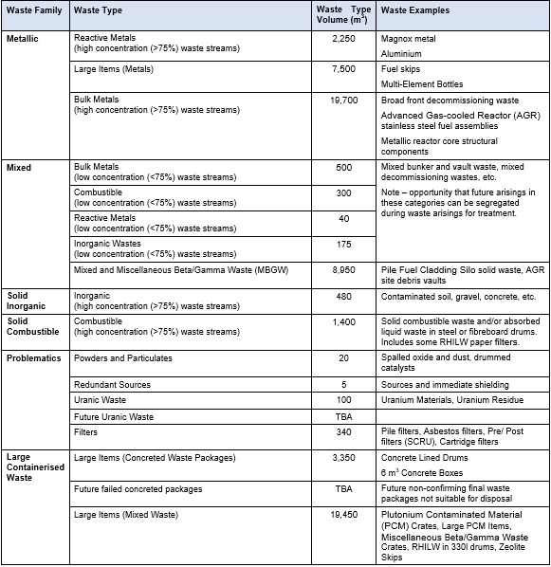

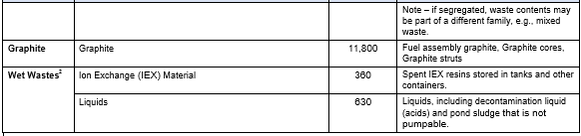



**SECTION 2 LINES OF ENQUIRY**

This section presents the Lines of Enquiry to be answered by the supplier as part of this PIN.The Supply Chain are asked to provide answers to all the Lines of Enquiry as they will support SL in understanding the current maturity of thermal technologies. However, if the Supply Chain prefer not to respond to any question please make this clear in the response.

|  |  |
| --- | --- |
|  | **Lines of Enquiry** |
| 1 | Please explain the technical maturity of your technology |
| 2 | Please share any information of any existing industrial scale processes using your technology. |
| 3 | Please comment on the scalability of your technology in the treatment of mixed beta/gamma solid wastes. |
| 4 | Please share what you have previously done in regards to the handling materials with similar physical and chemical characteristics to the wastes described. |
| 5 | Please provide any information on the processing of radioactive materials/wastes using your technology |
| 6 | Please provide a description of the extent of volume reduction of the waste that is achievable. |
| 7 | Please explain your capability to research and develop your technology towards different applications. |
| 8 | Please provide a general description of your process detailing the principle of operation (e.g. batch or continuous etc) and highlighting the key unit operational stages involved, including how the hot zone is heated. |
| 9 | Please provide information on the applicability of your process to the wastes described. |
| 10 | Please define any contraband items or materials incompatible in your thermal process (e.g. sealed containers) which cannot be fed into your thermal process or need to be added in a controlled manner. |
| 11 | Can the waste, as described, be fed directly into your thermal process or is there a requirement for a pre-treatment step such as size reduction or drying. |
| 12 | Is there a requirement for the feed to be prepared in a particular form, such as, in a container or in a blended or shredded form? |
| 13 | Please explain how your thermal process manages emissions to ensure they are maintained within regulatory limits. |
| 14 | What is the tolerance of your thermal process to compositional changes in the feeds, such as high metal content and high organics content? |
| 15 | Please describe the characteristics of the primary output (waste form) from your thermal process. |
| 16 | Please describe how your thermal process is initiated and are there any preparatory requirements (e.g. pre-heating) prior to starting up the thermal process). |
| 17 | Please describe the operating temperature range of your thermal process. |
| 18 | Please describe the process additives, if any, that are used in your thermal process towards creation of the primary output (waste form) and their tolerance to variations in waste composition. |
| 19 | Please describe how your thermal process is monitored and controlled. |
| 20 | Please describe how the primary output (waste form) is exported from the thermal step of your thermal process. |
| 21 | What are the maintenance requirements of your thermal process? |

1. While not solid, these wastes may have value in being thermally treated and are covered under this scope.