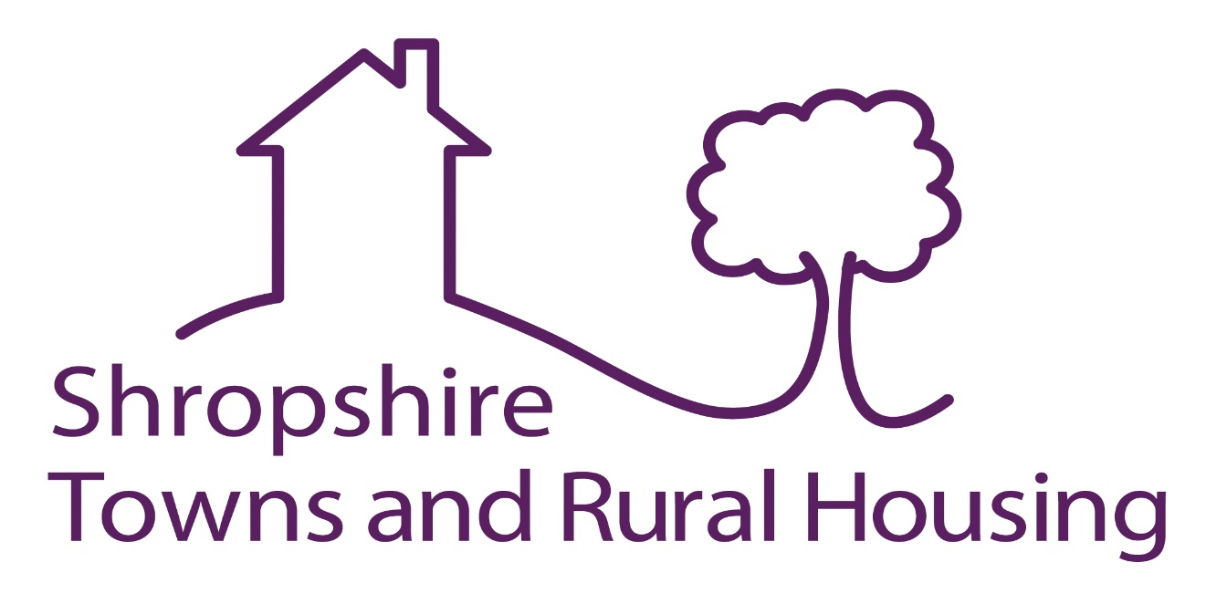

EXPRESSION OF INTEREST

SG.PM2019D – Drainage works to Domestic Council Homes in Shropshire.

Applicants are invited to apply for carrying out drainage works to council homes belonging to Shropshire Council. The contract will be for a period of up to 5 years covering approx 4200 properties and associated buildings commencing 1st April 2020.

The contract will primarily include external drainage works to our council homes in the Bridgnorth and Oswestry areas. Works may involve new installations and repairs to properties and also rodding, clearing / unblocking of services as required. There will also be a requirement to provide a 24 hours / 365 days service, jetting facilities and provision of CCTV surveys.

Applicants wishing to be considered for inclusion in the tender process should firstly request a tender pack which will include a pre-qualification questionnaire and a Schedule of Rates. Both of these documents should be completed and returned by the closing date of 12 noon on Thursday 12th December 2019.
Successful applicants will be notified in early January 2020.

If you wish to receive a Tender pack, please email or write as soon as possible to Steve Gray, Procurement and Contracts Officer, Shropshire Towns and Rural Housing Ltd, steve.gray@starhousing.org.uk quoting reference SG.PM2019D

Please Note that he deadline for the return of completed documentation is 12 noon 12th December 2019. Applications received after this deadline cannot be considered.

