PROVISION OF DIGITAL READINESS EXPERIMENT & MVP CONCEPT DEVELOPMENT IN SUPPORT OF EX RHINO CHARGE
STATEMENT OF REQUIREMENT

PURPOSE

Exercise activity scheduled to take place during the period Jun – Dec 21 presents an opportunity for the Fd Army, through HQ 1 (UK) Division (1XX) to accelerate its understanding of digital Force Preparation timelines and processes, and to develop viable digital tools (software, algorithms and data) for experimentation on Ex RHINO CHARGE and beyond.

The lessons learnt, including from a possible failure to turn concepts into fielded production capabilities, will inform how we develop and deploy data and software-driven solutions at all levels across the Army and Defence.

Background
Set against the outcomes of the Integrated Review, Headquarters 1st (United Kingdom) Division (HQ 1XX) is preparing to deliver a sequence of exercises in the period Jun 21 – Dec 21 to test the HQ’s structures, preparedness and CONEMP, culminating in Ex RHINO CHARGE. Exercising against realistic readiness timelines, this will allow us to test assumptions, processes and procedures that are often taken for granted. In addition to routine preparation and planning, we wish to test our ability to apply innovative thinking and solutions, consistent with the future role of 1XX. The Ex period commences with the receipt of orders and CAST on Ex RHINO STAFF in Jun 21, leading to the deployment of 1XX TAC and the GOC in Nov/Dec 21.
This is an opportunity to accelerate our understanding of digital Force Preparation timelines and processes, and to develop viable digital tools (based on software and algorithms) for experimentation/deployment on Ex RHINO CHARGE. The lessons we learn, including from failure, will inform how we develop and deploy data, alogorithm and software-driven solutions at all levels across the Army and Defence. Project ARIEL is a key partner in identifying lessons learnt.

In order to rapidly conceive and develop algorithmic and software concepts to prototype state for testing on Ex RHINO CHARGE, in line with a synthetic readiness timeline, 1XX wishes to conduct the DRE in partnership with industry partner(s) including the conduct of a competitive innovation workshop event or “Hackathon” to identify concepts for development and experimentation.

OBJECTIVES

HQ 1XX seeks to undertake a Digital Readiness Experiment (DRE) to achieve two principle objectives:

  - Process
Test creation and integration of novel software-driven capabilities, specifically in the area of Artificial Intelligence (AI), within readiness timelines to inform Army understanding of formation digital readiness and connect formation staff with those who hold relevant authorities.
  - Product
Prototype concepts and deploy available commerial digital (software/algorithmic) tools for experimentation on RHINO CHARGE, demonstrating to Defence and external audiences’ digital capabilities of the Fd Army.

DRE will seek to create a digital experimentation environment to enable innovative solutions and ideas to be generated and developed by industry participants and their applicability/effectiveness evaluated for possible future acquisition.

The principal outcome of DRE is to test, within readiness timelines set against Ex RHINO CHARGE, the ability of existing structures to identify, innovate and implement (to prototype) novel mission/task specific software/algorithmic products. To achieve this test, up to 5 software, algorithmic or data specifc prototypes will be identified and selected through the initial Hackathon event, and then further developed and refined for potential deployment and experimentation on Ex RHINO CHARGE.

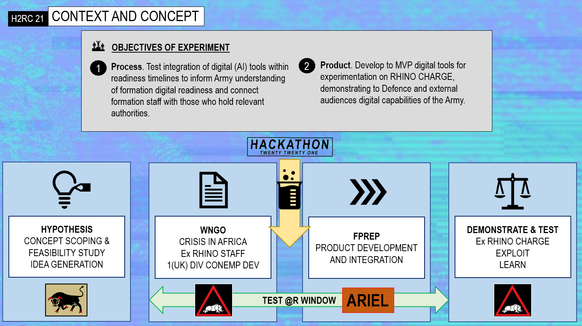

Fig 1. Digital Readiness Experiment: Context & Concept.

Scope

This requirement is for the provision and delivery of DRE, to partner with HQ 1XX and nominated units, to create novel software/algorithmic concept solutions to a curated problem set (selected by 1XX) in a competitive exploratory workshop or “Hackathon”; further to develop the selected/winning products to MVP state to be deployed for experimentation on Ex RHINO CHARGE 21 to complete the DRE.

Further development or acquisition of digital capabilities and products identified during the DRE will be subject to a separate, subsequent commercial process.

DELIVERABLES

Suppliers are asked to deliver the following products:
Quantity | Description
1 | Support to the Authority in planning, conducting and enabling a Digital Readiness Experiment to test understanding of existing formation readiness, including its policies and procedures, existing and future digital infrastructure capabilities, on-strength digital skills and relevent operating concepts.
1 | Delivery of a competitive exploratory workshop event or “Hackathon” to design software, algorithmic or data led prototypes and explore the use of existing software capabiltiies. Activities will include:  - Event planning, management & coordination;  - Liaison with HQ 1XX and relevant parties;  - Provision of suitable cloud, development and MLOps environments, AI platforms and dev tools to enable rapid product development, testing, and deployment, and to support teams in managing and leveraging data sets;  - Provision of suitable multi-disciplinary SQEP specialists to support workshop teams;  - Outcome aligned use case design services, and;  - Advice on concept development and implementation for experimentation.
5 | Development of concepts (selected at DRE event) to prototypes for deployment on Ex RHINO CHARGE for experimentation
1 | Participation in a full lessons and recommendations process participation to inform and improve future DRE iterations.

No enduring support is required. Any digital capabilities and products deemed suitable for acquisition will be subject to a separate competitive tender process.

Training and support is to be provided as part of the purchase price; to include the effective hand over and user guidance for operators (identified by HQ 1XX) use on Ex RHINO CHARGE.

key milestones

The Potential Provider should note the following project milestones that the Authority will measure the delivery against:
Milestone | Description | Timeframe
1 | Delivery of Hackathon-style event | To take place NLT w/c 13 Sept 21 across a 72 hour period
2 | Delivery of Products (prototypes, recommendations, data, software tools and any enabling infrastructure or tools required for the operation of the Products) to the user. The items shall support the users’ development of recommendations. This will include between 1 to 3 user training and familiarisation workshops. | Within 8 weeks of event
3 | Completion of post experiment lessons and recommendations process. | Within 24 weeks of event

ACCEPTANCE

Acceptance of the Products will be phased through the DRE:

Completion and delivery of the Hackathon event.

Adarga and 1XX selection of up to 5 concepts for development at Hackathon event.

Adarga and 1XX recommendation of up to 5 concepts for development into prototypes, and productionised features.

Further development of the Products, subject to separate commercial agreement with the supplier/developer of that Product.

Completion of post experimentation review and recommendations process.

GOVERNANCE
REDACTED

government furnished assets

Access to appropriate Authority data sets and systems will be facilitated (subject to appropriate approvals and permissions) to enable algorithmic model and software development, installation; integration; testing and demonstration.

DATA CLASSIFICATION

The information and data that shall be used by industry particpants during the DRE shall be up to a security grading of OFFICIAL.

Security

DRE concepts should be designed to meet Defence’s accreditation requirements. A risk assessment has been completed and the Cyber Risk Profile is assessed as LOW. Tenderer will be required to complete a Supplier Assurance Questionnaire.

quality
The concepts are will be developed will be to the standard of a prototype, meaning that they are early samples, models, or releases of a product built to test a concept or process.

STAFF AND CUSTOMER SERVICE

The Authority requires the Potential Provider to provide a sufficient level of resource throughout the duration of this Agreement / Contract in-order to consistently deliver a quality service to all Parties.

Potential Provider’s employees, and any 3rd party sub-contractors or affiliates, assigned to this Agreement / Contract shall have the relevant qualifications and experience to deliver the Contract.

The Potential Provider shall ensure that staff understand the Authority’s vision and objectives and will provide excellent customer service to the Authority throughout the duration of the Contract.

intellectual property rights (ipr)

There will be no transfer of any IPR which is already owned by the Potential Provider to the Authority under the potential contract or as part of the DRE.

To the extent that any IPR is created or developed by a Party (or its employees, contractors or other representatives) during the performance of the DRE, any such IPR shall vest in the Party that created or developed it.

payment

The DRE is priced at £550,000(excluding VAT). The development of any concepts following the DRE is subject to further commercial agreement.

Payment will be made via CP&F. The supplier must have signed up to the terms within DEFFORM 30 (Electronic Transactions Agreement) and be fully set-up on EXOSTAR.

Payment shall be made prior to the commencement of the activities detailed in this SoR. can only be made following satisfactory delivery of pre-agreed certified products and deliverables.

Before payment can be considered, each invoice must include a detailed elemental breakdown of work completed and the associated costs.

Location

Unless otherwise specified and/or agreed by the Authority (including the Potential Providers office premises and virtual attendance by DRE participants), the principal locations for this project will be:
REDACTED

END OF CONTRACT

No enduring support is required. Any technologies deemed suitable for acquisition will be subject to a separate tender process

POINTS OF CONTACT

Project Team:
REDACTED

Army Commercial:

REDACTED

