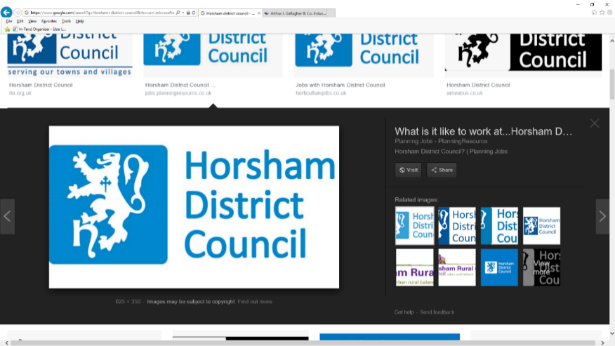

**HDC Arboricultural Services**

Pre-Market Engagement Questionnaire

Thank you for registering your interest in our Supplier Engagement Event taking place in person on 17th July 2024. The Council will provide full details upon receipt of a completed questionnaire.

To help make the session as informative as possible we would like you to respond to the questions provided overleaf. We are not looking for a detailed response and we would expect that the questions take no longer than 30 minutes to complete.

**Please send your answers to these questions to** [**procurement@horsham.gov.uk**](mailto:procurement@horsham.gov.uk) **by 12:00 Wednesday 10th July 2024.**

The responses to this questionnaire will provide the Council with useful market insight and is not part of any competitive tender, nor does this indicate that the Council will undertake any contract award relating to this requirement in the future. Any information provided will be treated in confidence and only used to inform the Council about current market conditions and supplier preferences.

Neither failing to respond to this questionnaire will mean exclusion from any potential tendering opportunity going forward nor can the Council guarantee any inclusion in any potential tendering opportunity if you do respond to this Questionnaire.

**Background to the Contract**

The Council are seeking to appoint an arboricultural contractor(s) to undertake tree works on their behalf. We would be looking for the contract(s) to start in the spring of 2025. We currently do not have a main contractor but are using a number of different local suppliers.

**Project Scope**

Inspection, maintenance and specialist works on all the trees and woodland on Council land across the District. The maintenance element will include a requirement for a 24hr, 365 day emergency call-out service.

**Project Budget**

In the financial year 2023-24 the cost of tree inspection and maintenance was £210k, with a further £151k on ash-dieback removal. We expect the value of the latter to reduce over the term of the contract.

**Market Engagement Questions**

|  |  |
| --- | --- |
| **Supplier Name:** |  |
| **Previously we tendered for one contract which encompassed all tree works, including inspections. Would a tender being split into different lots make bidding for part of the work more attractive to your organisation?**  **The likely lots would be tree inspections, maintenance and specialist tree working**  **(such as forestry work).** | |
|  | |
| **If the Council was to restrict the number of lots a supplier could tender for, would this be preferable / present a challenge to your organisation? Please explain.** | |
|  | |
| **What would be the best contract length – 7+7, 5+5 or 5+3? or your own suggestion. Please briefly explain the reason for your answer.** | |
|  | |
| **What do you feel is the best way to present a schedule of rates as part of this process? Previously we have based it on a combination of tree size and the types of works required, but is there another form of pricing you might prefer?** | |
|  | |
| **Occasionally there are works that fall outside the breakdown of scheduled size and pricing i.e. works to large trees. What would be the best way to price for these works e.g. day rates, bespoke?** | |
|  | |
| **What timescales would your organisation require between contract award and the contract start date for mobilisation? Please provide as much detail as possible.** | |
|  | |
| **Please provide any questions you would like to ask us below.** | |
|  | |

Please email your completed questionnaire to [Procurement@horsham.gov.uk](mailto:Procurement@horsham.gov.uk) by 12:00 Wednesday 10th July 2024.