Unity in Community – 372 Greenwood Avenue Refurbishment and Building
Invitation to Tender Part 1



Tender Closing Date and Time: Friday 20th December at 12.00hrs GMT

1 The invitation to tender

The Contracting Agency for the purpose of this Invitation to Tender is Northern Hull Community Development Ltd (Unity in Community).

Northern Hull Community Development Ltd’s registered office is 501 Endike Lane, Hull, HU6 8AQ.

You are being invited to submit a tender to Northern Hull Community Development Ltd (the ‘Agency’) to carry out:

- Refurbishment and building works at 372 Greenwood Avenue (former council works depot).

  - Northern Hull Community Development Ltd

Northern Hull Community Development Ltd is a charity dedicated to the development of the HU6 area of Hull.

The objectives of Northern Hull Community Development Ltd are:
- To support activities to aid the development of North Hull
- To provide accommodation & support services to community groups, individuals and projects
- To attract investment to build on the skills and energies of the community
- To communicate with local residents to establish the needs of the community
- To find new and innovative ways to meet those needs

The Agency reserves the right to novate this Contract to any successor organisation at any point during the contract term.

The Agency reserves the right to terminate this agreement at any point by giving you one month’s written notice.

- Background

Northern Hull Community Development Ltd has been awarded European Regional Development Fund funding for the refurbishment of 372 Greenwood Avenue (‘the site’). Northern Hull Community Development Ltd has a long term lease of the site and has held this since 2015.
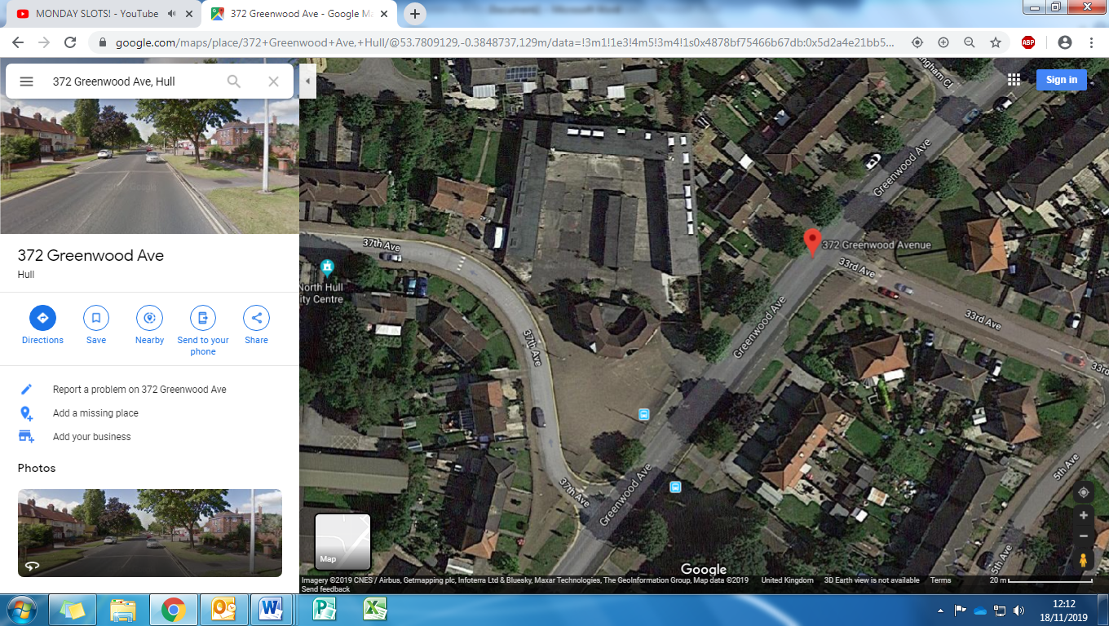
The site consists of a two storey office building facing out to Greenwood Avenue, adjacent to 37th Avenue with a large depot to the rear consisting of a number of units and a large two storey work space. The site has been vacant for approx. 9 years and is in needs of repair and refurbishment.

- Specification

  - Detailed requirements

Northern Hull Community Development Limited is looking to appoint a contractor to undertake all of the refurbishment and building works at the site. The contractor will be able to display an accurate breakdown of costs and timescales for the works to be undertaken.

The agency has an indicative budget of £120,000 and applicants are asked to show economies of scale and also cost efficiencies.

The scope of the works required within the project includes, but is not expressly limited to the following:

- Confirm any notable conflicts of interest in writing

- Provide the agency with all relevant evidence that health and safety requirements have been met and Construction Design and Management Regulations 2015 has been complied with

- Ensure that all work(s) carried out fall in line with the necessary legislation and regulations

- Arrange with the agency to attend a site visit at your convenience. Dates for site visits are: Monday 2nd December @ 2pm, Wednesday 4th December @ 10am, Friday 6th December @ 9am, Tuesday 10th December @ 12pm.

- Provide an accurate breakdown of all costs

- Work to the project timetable. Delays may incur penalties.

- Work to strict deadlines, inform the agency in advance of any potential delays where reasonably practicable.

- Erect a site perimeter, ensuring that disruption to those working within the grounds is kept to a minimum as reasonably practicable

- Manage and oversee all waste management and disposal on site

- All information held by the contractor is GDPR compliant.

- Manage and oversee all sub-contractors on site, ensuring they adhere to health and safety requirements.

- All relevant certification of any build will be provided to the agency upon completion (i.e. FENSA or equivalent for windows)

- All manufacturers guarantees activated, adhered to and provided to the agency.

- Provide sufficient public liability employers liability and professional liability insurance (minimum of £5m is required).

- Work to only be undertaken between the hours of 8am-5pm Monday to Friday. Weekend work can be undertaken with prior permission from the agency.

- Outputs required

- Evidence of health and safety compliance
- Evidence of Construction Design and Management Regulations compliance
- Arrange and attend a site visit
- Accurate breakdown of costs
- GDPR policy and procedure
- Evidence of HU6 labour being contracted/employed
- Work signed off as competent from time served/competent worker
- Records kept of all sub-contractors, and health and safety documentation
- Evidence of certification of build
- Manufacturers guarantees kept
- Evidence of public liability and indemnity insurance

- Project Team
Bidders should provide the names of key members of the proposed team for delivering the requirements
6 Contract Management and Contract Requirements
The successful bidder will be required to:
- Deliver the requirements outlined in Sections 3 and 4 above;

- Maintain full records including financial and accounting records for the contract;

- Be proactive rather than reactive;

- Provide weekly contract progress updates to the Agency.

- Host regular site visits and walk arounds for the agency staff and trustees
6.1 Contract Price
The anticipated ceiling budget for this contract is no more than £120,000 exclusive of VAT and inclusive of expenses.
Bidders should indicate prices for a range of services (as outlined in Section 3) which must be in line with the rates tendered. Costs should be clearly broken down to reflect the different elements of the methodology you propose, including any additional data collection as suggested.
6.2 Contract term
It is anticipated that the contract will commence on 13 January 2020 and will run to 6 April 2020. The successful bidder will be required to attend an inception meeting at Northern Hull Community Development Limited on 13th January 2020. Bidders are asked to keep this date free in anticipation. The Agency reserves the right to novate this Contract to any successor organisation at any point during the contract term.
7 Quality Assurance
Bidders should describe their procedures for quality assuring their work.
8 Payment Arrangements

Northern Hull Community Development Limited is committed to Prompt Payment and shall pay the Contractor within 30 days of the receipt of a valid invoice, provided that:
- A Purchase Order has been raised by the Agency and the PO number has been provided to You, the Contractor
- That all invoices submitted to the Agency quote the PO number
- The Agency is satisfied that the Services for which the invoice relates have been performed fully in accordance with the Contract.
- All invoices are submitted prior to the 28th day of the month.
- All invoices addressed to:
Unity in Community
501 Endike Lane,
Hull,
HU6 8AQ

9 Tender Submissions

Bidders should provide details within their tender proposals of:

- Their proposed model for delivery of the service, which will meet the required specification requirements in section 3 and will achieve the required outputs in section 4.

- Consortium or partnership bids are welcome to apply with lead partner identified

- The programming of the commission from start to the completion of the contract

- How their model for delivery will meet the outcomes and demonstrate added value by stage to the outcome of the contract

- A full cost breakdown of their proposal in line with the rates included within the original tender. This should include details of the numbers and status of staff involved, their time and associated costs. VAT and expenses should be identified separately.
- No organisations tendering will be able to claim costs in relation to producing their tender.

Tenders will be evaluated against the award criteria as set out in clause 11 and bidders should demonstrate

- Cost effectiveness
- Technical ability to meet the contract requirements
- Strong service delivery
- Quality
- Commitment to the environment

10 Award Criteria

The award for this tender will be weighed against the following:

 | Overall Weighting | Category | Category Weighting | Element | Element Weighting
Price | 30% | Commercial | 30% | Cost/Competitiveness | Cost Matrix/Spreadsheet
Quality | 70% | Technical | 20% | Capability | 10%
 |  |  |  | Resources | 10%
Quality | 70% | Service Delivery | 15% | Flexibility & Responsiveness | 5%
 |  |  |  | Communication | 5%
 |  |  |  | Reaction to problems | 3%
 |  |  |  | Innovation & added value | 2%
Quality | 70% | Quality | 15% | Customer Care | 7%
 |  |  |  | Quality of service | 5%
 |  |  |  | Continuous improvement | 3%
Quality | 70% | Environment | 10% | Commitment | 8%
 |  |  |  | Environmental targets | 2%
Quality | 70% | Social Value | 10% | Opportunities for local people | 7%
 |  |  |  | Supporting local initiatives | 3%
 | 100% |  | 100%
The successful bidder will be required to attend a meeting on Monday 13th January 2020. Bidders as asked to keep this date free in anticipation.

Unsuccessful bidders will be notified by letter and electronically before or on Wednesday 8th January 2020.

11 Tender Scoring and evaluation

Any contract awarded following this procurement process will be on the basis of the tender that is most economically advantageous to Northern Hull Community Development Limited. The award criteria are:
- 70% Quality
- 30% Price
Scores are arrived at following the application of the Evaluation Criteria as set out below. Tenderers are required to submit their tender in accordance with the requirements set out to in this invitation to ensure that the agency has full and correct information to undertake this evaluation. Evasive or unclear or hedged tenders may be rejected and therefore disqualified from the process.

Each response given to the Quality and Price will be given a score on the scale of 0-5 in accordance with the table below.

QUALITY ASSESSMENT SCALE
Tenderers should be aware that when scoring evaluators will be considering the following:
- The extent to which the Tenderer’s response meets the Agency’s requirements
- The extent to which the Tenderer’s response demonstrates an understanding of requirements
- Whether the Tenderer’s response is supported by a sufficient level of evidence
Assessor Score |  | Rating
5 | Significant assurance of an ability to deliver the requirements as evidenced by a robust, comprehensive response. The response contains no apparent errors or omissions. | excellent
4 | Whilst not as fully comprehensive as an “excellent” response, evidences overall assurance of ability to deliver the requirements with no significant cause for concern. | good
3 | Demonstrates an understanding of the requirements and ability to deliver but fails to provide full assurance. | satisfactory
2 | Demonstrates an ability to deliver most of the requirements but contains a number of errors or omissions which raise questions over technical ability in some areas. | fair
1 | Fails to demonstrate quality or technical ability to deliver the Works to the required level. | poor
0 | Failure to respond to the question or response contains serious errors or omissions which indicate an inability to deliver the requirements. | very poor

The evaluation criteria and maximum score attributed to them are set out below:

Category | Weighting | Assessor Score | Actual Score
Commercial | Assessor Score x 6 | 5 | 30
Commercial | Assessor Score x 6 | 4 | 24
Commercial | Assessor Score x 6 | 3 | 18
Commercial | Assessor Score x 6 | 2 | 12
Commercial | Assessor Score x 6 | 1 | 6
Technical | Assessor Score x 4 | 5 | 20
Technical | Assessor Score x 4 | 4 | 16
Technical | Assessor Score x 4 | 3 | 12
Technical | Assessor Score x 4 | 2 | 8
Technical | Assessor Score x 4 | 1 | 4
Service Delivery | Assessor Score x 3 | 5 | 15
Service Delivery | Assessor Score x 3 | 4 | 12
Service Delivery | Assessor Score x 3 | 3 | 9
Service Delivery | Assessor Score x 3 | 2 | 6
Service Delivery | Assessor Score x 3 | 1 | 3
Quality | Assessor Score x 3 | 5 | 15
Quality | Assessor Score x 3 | 4 | 12
Quality | Assessor Score x 3 | 3 | 9
Quality | Assessor Score x 3 | 2 | 6
Quality | Assessor Score x 3 | 1 | 3
Environment | Assessor Score x 2 | 5 | 10
Environment | Assessor Score x 2 | 4 | 8
Environment | Assessor Score x 2 | 3 | 6
Environment | Assessor Score x 2 | 2 | 4
Environment | Assessor Score x 2 | 1 | 2
Social Value | Assessor Score x 2 | 5 | 10
Social Value | Assessor Score x 2 | 4 | 8
Social Value | Assessor Score x 2 | 3 | 6
Social Value | Assessor Score x 2 | 2 | 4
Social Value | Assessor Score x 2 | 1 | 2

12 Queries

All queries made to Unity in Community in relation to this tender must be done so in writing and will receive a written response. Any written responses that would give a bidder an advantage will immediately be published on the FAQ section of the Unity in Community website.
All queries in relation to this tender must be submitted in writing to Dennis Woods, General Manager of Unity in Community. Dennis can be contacted via the following methods:

E-mail Dennis@unityincommunity.org.uk
Post Dennis Woods
501 Endike Lane,
HU6 8AQ
FAQ’s can be found on our website at www.unityincommunity.org.uk/tenderfaq

13 Tender Return

The completed Tender and associated documents must be submitted via to e-mail to tenderapplications@unityincommunity.org.uk by no later than 12:00 noon on Friday 20th December 2019. Any tenders that are submitted incomplete will not be considered.
14 Timetable
TASK | DEADLINE
Publication ITT | 29/11/2019
Clarification Window Opens | 29/11/2019
Site Visits begin (by appointment) | 02/12/2019, 04/12/2019 , 06/12/2019
Site visits end | 10/12/2019
End date for clarification messages | 13/12/2019
Response to all Clarifications Published | 14/12/2019
ITT closes | 20/12/2019
Notification of Award decisions issued | 08/01/2019
Contract Entered Into | 13/01/2020
Delivery Commences | 13/01/2020
Delivery Ends | 06/04/2020

15 Confidentiality
Any organisation or individuals wanting to submit a tender must do so in the strictest confidence. They must not tell any external organisations or individuals what their tender price is or will be. They must not attempt to obtain information about anyone else’s tender or proposed tender or make any arrangements with another organisation about whether or not they should tender, or about their or another’s tender price. Consortia or partnership bids are welcome.
16 Freedom of Information Act
The Agency is committed to meeting their responsibilities under the Freedom of Information Act 2000 (FOIA). This means, all information submitted to the Agency may need to be disclosed in response to a FOIA request. If you consider that any of the information included in your tender is commercially sensitive, please identify it and explain what harm may result from disclosure if a request is received, and include the time period applicable to that sensitivity. You should be aware that, even where you have indicated that information is commercially sensitive, we may still be required to disclose it under the Act if a request is received. Please also note that the receipt of any material marked ‘confidential’ or equivalent by the Agency should not be taken to mean that we accept any duty of confidence by virtue of that marking. If a request is received, we may also be required to disclose details of unsuccessful tenders.

The Works
Internal
Stair Hall
- Remove and replace radiator
- Remove/replace communication cables
- If required repair/skim walls
- New front door
- Removal of lights on underside of staircase (to be removed)
- Wall knocked through at top of stairs to the right hand side to create entrance
- Build on the left hand side floor to ceiling wall
Reception area
- Remove radiator
- Remove all trunking and wiring
- Repair walls/ skim walls
- Knock through to door height left corner into office
- Remove internal wall through to meeting room/IT room
- Remove lights ( 2 white, 1 blue, 1 orange)
- Remove Toshiba grey air con unit
- Install new air conditioning unit
- Install 5 doors (entrance to office, entrance to corridor leading to toilets, stairwell door, one to one door and meeting room door)
Lift/one to one
- Remove trunking
- Remove air con white
- Build a storage cupboard and 1 to 1 meeting room
- Install door to storage
- Install radiator
Meeting room
- Removal of old safe
- Removal of wiring
- Wall installed between pillars to the right
- Glass partition installed to the left
- CCTV Camera to be removed x2
- Air con to be removed and replaced
- Letterbox to be removed
- New fire door to replace existing door (ramp door)
- 3 radiators to be replaced
- Existing walls to be repaired/skimmed

Downstairs office
- Wall to be built
- Replace radiator
- Wiring / trunking to be removed
- Air con to be removed and replaced
- Expelair fan to be removed and covered
- Carpet removed
- Network cabinet installed (moved from IT suite)
- Sink installed in corner as per drawing
Kitchen area
- Remove full kitchen
- Boiler to be retained
- Wall removed
- x2 disabled access toilets and 2 sinks installed
- Radiators replaced
- Walls repaired/skimmed
- Lockable Cupboard built around boiler
- Electrics removed
Computer suite
- Wooden frame to be removed
- Wiring to be removed
- Ceiling to be repaired
- Demolition of breeze block wall
- 4 radiators to be replaced
- Ventilation repaired to left of room
- Network cabinet to be removed and installed in office
- Glass partition installed x4
- Replacement of sky light glass, repaired and cleaned
- Yard facing window bars retained throughout
- Carpet throughout
6 person office
- Replace door
- Replace 3 radiators
- Remove telephone box / unnecessary wires
- Removal carpets
- Repair/skim walls
- Install 1 air con in most suitable location
- Install push bar fire exit onto door leading to terrace

Terrace
- Replace guard rail
- Clean and replace cage on sky light
- Remove or replace air con units as necessary
Upstairs main corridor
- Remove boxes on wall next to electric cupboard if possible
- Replace radiators x2
- Replace windows if required or Perspex over if possible
L Shaped office
- Remove door and wall (for lift)
- Install new door
- Build a wall for store
- Install new radiator
- Check wiring electrical
3 Person office
- Replace radiator
- Repair/skim walls
- New wall to form part of stair well
- Install new door
Staff area
- Install sink/Small kitchen
- Replace radiator
- Repair/skim walls
Cleaning cupboard
- Create a cupboard at end of corridor near toilets
- Cleaning sink to be installed
Toilet area
- Create a new corridor leading to male and female toilets
Male toilet
- Install 1 urinal / 1 sink and replace toilet & stall
- Replace hand drier
Female Toilet
- Replace 2 toilets and stalls
- Remove both sinks and install 1 sink
- Replace hand drier
Windows
- 2 Frosted windows toilets (downstairs to left)
- 7 windows at rear of property (5 large, 2 small)
- 3 frosted windows (1 bottom and 2 top facing out toward 37th Avenue)
- 15 windows to be replaced
- 6 shutters
External
- Repair/replace roof where necessary
- Replace drain pipes
- Minor brickwork at front needs repairing
- Check and repair any drainage
Relating to the drawings on pages 16 & 17
Construction Notes
EXTERNAL WALL
(Min U value 0.24W/m²K)
To be built off existing slab to be confirmed by structural engineer further to slab edge exposure and inspection.
Render system (colour TBC) on block outer leaf (medium density) on Hi load DPC
100mm cavity with partial fill insulation, 50mm Kingspan Kooltherm K108 cavity board
100mm block inner leaf (medium density)
12.5mm plasterboard on adhesive dabs with skim finish.
DPC
DPC to be 'rubberoid' reinforced PVC to both inner and outer leaves lapped to prevent water penetration and dressed up into openings.
CAVITY TRAY
To be provided over all openings with min. 2 No. weepholes per opening.
CAVITY CLOSERS
All windows / door reveals to include Thermabite cavity closers.
LINTELS
IG L1/S 100 lintels (factory filled insulation) over window openings IG lintels elsewhere.
All fitted to mfrs. guidance
Min. 150mm end bearing.
WALL TIES & LATERAL RESTRAINT
Stainless steel wall ties at 450mm vertical and 750mm horizontal cts.
Vertical ties to reveals at 225mm (every block course)
Lateral restraint to first floor and / or roof to be via 30 x 1000 x 5mm straps @ max. 2000 ctrs and as Building Regs. Approved Document part A1/2.
STUD PARTITION WALLS
12.5mm Gypsum based plasterboard to each side
100x50mm studs. Inc. 60mm min. mineral wools batts or quilt (density
10-60kg/m3 between studs).
All to give min 30mins fire resistance.
Ensure quilt or batts fit tight between studs without sagging and covering entire surface area of lining.
All edges to be taped or caulk sealed.
DOORS
Internal ground floor door 800mm clear opening to all doors.
926mm door leaf - 40mm max. Thick 38mm door lining inc. 13mm stop
Max. 3mm clearance between door & frame to each side
WC doors may be 826mm except Accessible WC MUST be 926mm
Provide high and low level vision panels to all internal doors with the exception of WC's to satisfy Part M Building Regulations.
To be 30mins fire resistant glazing to fire door view panels.
EXTERNAL DOORS
Main Entrance Door
To achieve 1000mm clear opening width to meet part M.
All external doors/screens in toughened safety glass with manifestations to satisfy
Build Regs Part N
WINDOWS
Windows in white Upvc (to achieve 1.6 w/m2k)
The windows are to be glazed with 24mm (4:16:4) sealed double glazed
(Low E emissivity of 0.15) units with a minimum U-Value of 1.6 W/m sq
K.
All glass shall be in accordance with BS 6262:1978.
All openable windows to receive restrictors with max opening of 100mm
Critical low level glazing to be laminated
All windows and doors are to be weather stripped.
Rapid ventilation to habitable rooms to be equal to 1/20th of floor area.
Trickle ventilation to habitable rooms to be 8000 sq mm. All other rooms to be
4000 sq mm. Continuous trickle vent to full length of external screens and door within screens
SAFETY GLAZING
All glazing below 800mm to be toughened to meet building regulations approved
Doc. Part N, as is all glazing below 1500mm to doors and areas within 300mm of any door leaf.
DRAINS
All drains in 100mm dia flexible jointed supersleeve equal, laid to min.
1:80 falls or sufficient to achieve a self-cleaning velocity.
All drains to be surrounded in pea gravel.
Drains passing through wall to use rocker pipes, with hole mortar sealed to prevent ingress of vermin. Concrete lintels to brickwork over openings.
If proposed foundation comes within 1m of existing drain, bottom of excavation to be level with bottom of drain (or as instructed by Building Inspector).
ELECTRICAL
The electrical installation is to be designed, installed, inspected and tested in accordance with Chapter 13 of BS7671:2001, and sufficient information will be provided so that persons wishing to operate, maintain or alter the electrical installation can do so with reasonable safety.
All electrical installations to be undertaken under the auspice of an electrical self-certification scheme authorised by the Secretary of State were the person or organisation carrying out the electrical work is a competent person under such a scheme.
ALL SWITCHES, SOCKETS, ETC. TO BE WITHIN 450 -1200MM
OF FINISHED FLOOR LEVEL
FIRE
Mains wired interlinked smoke detection, wired to a dedicated circuit, should be provided to the stair enclosure at ground & first floor landings. To meet Building Regs.
Approved Doc. B, Section 1 & BS5839

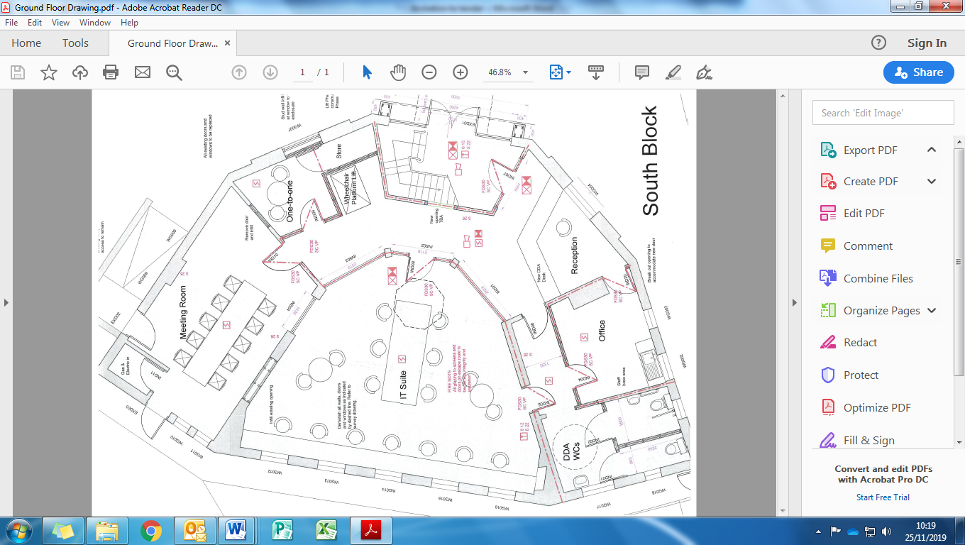
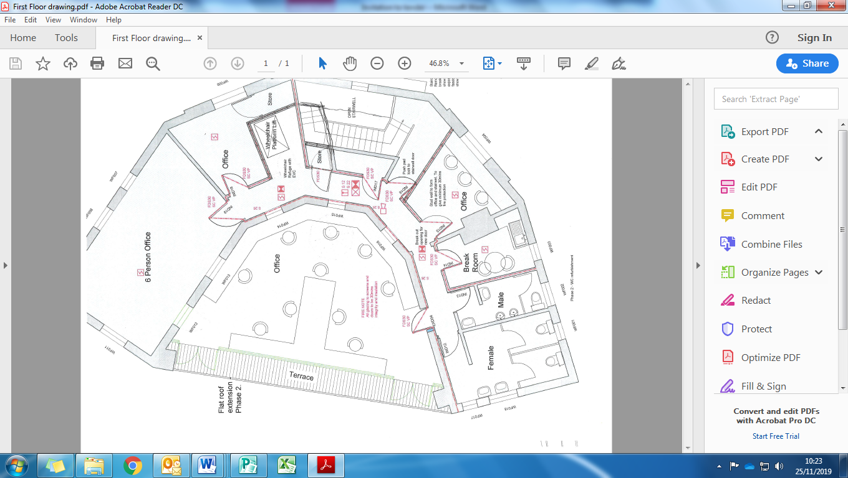
Proposed Schedule of Works

THIS AGREEMENT is made on 2020

BETWEEN:

- [Northern Hull Community Development Limited of the 501 Endike Lane, Hull, HU6 8AQ](herein referred to as the "Agency")

- [THE CONTRACTOR] of [ ] (Company No. [ ]) whose registered office is at [ ] (the "Contractor").

WHEREAS:

- The Agency and the Contractor have entered into a (title of agreement) on (date) (the 'Agreement').

NOW IT IS AGREED as follows:

GUARANTEE
In consideration of the Agency agreeing to enter into the Agreement with the Contractor:
irrevocably and unconditionally guarantees for the benefit of the Agency the payment by the Contractor of all monies to be paid by the Contractor under the Agreement at the times and the manner provided in the Agreement and the observance and performance to the Agency of the provisions contained or implied in the Agreement and on the part of the Contractor to be observed and performed; and
as a separate and severable covenant agrees to indemnify the Agency and keep it indemnified from and against all losses, costs, charges and expenses (including legal expenses) whatsoever that the Agency may suffer or incur by reason of the failure or default of the Contractor to pay all monies to be paid by it pursuant to the Agreement at the times and manner provided in the Agreement or to observe and perform the provisions and covenants contained or implied in the Agreement and on the part of the Contractor to be observed and performed.
The Agency may not recover any more under this deed in respect of any matter than the Agency would be entitled to recover from the Contractor in respect of that matter, net of any set off..
LAW AND JURISDICTION
The validity, construction and performance of this Agreement shall be governed by English law and shall be subject to the exclusive jurisdiction of the English courts to which the Parties submit.
THIS DOCUMENT is executed as a deed and delivered on the date stated at the beginning of this Agreement.

THE AFFIXING HERETO of the )
CORPORATE COMMON SEAL of )
Northern Hull Community Development Limited )
is authenticated by: )

Authorised Signatory
EXECUTED as a Deed by )
[ ] LIMITED )
acting by its directors )

Director

