Invitation to Quote
Lepe D-Day Digital Project
(NFNPA – 0046)

SUMMARY

The New Forest National Park Authority (NFNPA) and partners are leading a Landscape Partnership Scheme funded by the National Lottery Heritage Fund: Our Past, Our Future (OPOF). This 5 year partnership project will deliver some 21 projects under three main themes (see Section 2 below).

As part of this partnership work the NFNPA has acquired a number of digital datasets and are now seeking a developer or contractor to help us make the best use of this data through production of a number of dissemination and interpretation projects.
Further information about the project and detailed specifications are included the Sections below.

OUR PAST, OUR FUTURE OVERVIEW

The OPOF’s vision is to ensure the New Forest’s distinctive landscape survives through future change and modern-day pressures. A range of projects to restore habitats, discover forest heritage and develop forest skills alongside volunteering and measures to connect people to the landscape, will aim to provide a step-change towards this goal.

This will be achieved through the delivery of 21 projects under the following themes.

Restoring Lost Landscapes
This theme focuses on practical work and management of the lands surrounding the Open Forest in order to improve and protect the natural environment. The projects are aimed at restoring habitats and decreasing fragmentation, increasing responsible access, sustaining historic land management practices and discovering and restoring archaeology and built heritage.

Developing Forest Skills
This theme focuses on the people and communities living and working in the New Forest. The projects will aim to retain, develop and share knowledge and skills required for sustainable management of the New Forest habitats and built heritage.

Discovering Forest Heritage & Inspiring a New Generation
This theme focuses on encouraging, enthusing and inspiring a new generation of people to be more involved in learning about, championing and caring for the New Forest. The projects will promote an understanding of the New Forest’s unique heritage and its common story amongst residents, communities and visitors through a range of interpretation projects, educational campaigns, and engagement of volunteers.

PROJECT OVERVIEW

The Heritage on my Doorstep project aims to get people involved with, and inspired by, all aspects of their local heritage. Communities will also be supported in their own research, with funding available to support the sharing of their research around the New Forest.

One of our target locations is Lepe Country Park, where we are working with staff and volunteers to promote the WWII heritage that survives there.

3.1 Lepe D Day Remains
Recent partnership work with the Channel Coastal Observatory (CCO), New Forest District Council (NFDC) and the Environment Agency (EA) has led to the capture of high quality laser scan data of the surviving D Day remains at Lepe Country Park.
- Background on site: https://nfknowledge.org/contributions/d-day-at-lepe-beach
- Laser Scanning Work: https://nfknowledge.org/contributions/lepe-laser-scanning/
- Drone Capture by Citizan & MOLA: https://www.dronelab.io/map/public/view/4843c9d5f38a474eb0f368500e4b69eb
- Citizan Report: Forthcoming
- Volunteer Modelling: https://sketchfab.com/3d-models/phoenix-caisson-launches-at-stone-point-lepe-b971f0b34f1e4e2eb4942857f835eba5
The point cloud at Lepe has been acquired over a number of days and will be made available by the Channel Coastal Observatory in certain exports depending on requests.

3.2 Point Cloud Format and Size
Point cloud capture from Lepe has currently been exported for demonstration and testing in the following forms.
Intensity: To date the following has been exported: One point cloud at around 30mm, the other at 50mm resolution. The 30mm comes out at around 540MB while the 50mm is around 200MB. When you add the RGB values to the file the lower res comes out at 262MB.
Colour: there is a colour version though some of the colouration looks a bit washed out when processed as one dataset due to the fact that data was collected on different days with different light levels, with the camera in the scanner not being all that good.
Imagery was also captured so it is possible to drape imagery over the point cloud which could improve the result for display purposes.
Images of these can be found in APPENDIX 1 at the end of this document.

3.3 Interpretation and Dissemination
The WWII remains are accessible from Lepe Country Park by walking but aren’t well known and the access can be tricky and challenging. The intention is to use the recent data capture to produce a suite of digital and tactile interpretation that can be used to disseminate this important site more widely to different audiences from schools to old people’s homes.

3.4 Events
2019 sees the 75th anniversary of D-Day which is an additional factor in our seeking to undertake the interpretation and dissemination work on the Lepe WWII sites. Lepe Country Park will be hosting a ‘Lepe into History’ public event on Saturday 1 and Sunday 2 June 2019 which the NFNPA will be attending and it would be hoped that we would have some deliverables to show during the event or even be in the situation that at least 1 of the projects below would be finished and released at the event.

TENDER SPECIFICATION

4.1 Project 1: As Is/Today
The point cloud is a point in time capture which will be essential for monitoring the condition of the site that lies in a challenging environment over the coming years.

Digital Model – Today
Produce an interactive engaging model that can be manipulated by the user which will also allow embedding in the New Forest Knowledge website.
This could be done as a static 3D model, but we would be looking to see a model in a digital environment that can be walked through and explored easily by a user on a computer or potentially as a virtual 3D environment with suitable equipment.

3D printed model – Today
Production of a 3D printed version of the digital model to produce a tactile version for the Lepe and NFNPA education initiatives. Scale and materials are at the discretion of the tenderer, but discussed and agreed with the NFNPA.

4.2 Project 2: As was WWII
The surviving sites at Lepe are not only victims of their challenging environment, but as a result of their top-secret nature. This can make explaining them to visitors more difficult. Since their construction the site has suffered from both coastal erosion and deliberate destruction. People can visit the site and easily see what survives today, but we would like to try and build a link between the present and the past. This element of the project will be delivered through close working with the NFNPA team and local specialists to provide the most accurate interpretation and modelling of the site possible. As no contemporary photos of the site are currently known to exist, help with some of the modelling beyond the base point cloud will be done through matching photos from other south coast D-Day and Mulberry construction sites, oral histories, post WWII historical surveys and current research.

Digital Model – As was
Making use of the base data supplied to create an ‘As Was’ model for 1944. This will allow users to explore the differences and consider the post use history of the site and issues of coastal processes.

Such a model would need to consider:
- Caisson construction platforms 4, 5 & 6 that were demolished sometime after 1997
- Modelling the camp associated with the construction platforms
- Modelling the Embarkation Hard
- Adding the removed/destroyed Dolphins

We would be looking to see a model in a digital environment that can be walked through and explored easily by a user on a computer or potentially as a virtual 3D environment with suitable equipment.

A selection of the types of supporting data for project 2 can be found in APPENDIX 2 at the end of this document.

3D Printed Model – As Was
As with the ‘Today’ model we would like to acquire a 3D printed model of the site ‘as was’ after it has been created. Scale and materials are at the discretion of the tenderer.

- HOW TO TENDER

Contractors should provide:
- an itemised breakdown of costs for this service. In this case we are requesting a clear breakdown of costs for delivering Project 1, Project 1 & 2, and Project 2 as a standalone
- evidence of experience of providing these services in the past
- a clear timeline for delivering Project 1, Project 1 & 2, and Project 2 as a standalone
- any additional information or deliverables you would suggest or recommend as part of this project to add value along with their associated costs.

- SELECTION CRITERIA

The evaluation will be undertaken on the basis of the most economically advantageous supplier to the Authority, taking into account both the indicative prices provided as well as the quality aspects of each respective bid.

- TIMESCALE FOR TENDER

The outline timescale is:

Stage | Date
ITQ submission deadline | Noon Friday 22 March 2019
Contract award | Wednesday 27 March 2019
Contract commencement | Monday 1 April 2019
Key Deadline Date for some elements – this project milestone will be discussed with the successful contractor | Friday 31 May 2019
Key Deadline Date for some elements – this project milestone will be discussed with the successful contractor | Thursday 6 June 2019

A copy of our Standard Conditions of Contract for Services can be found below:

The Authority reserves the right to withdraw this contract opportunity without notice and will not be liable for any costs incurred by suppliers during any stage of the process.
Any queries must be made via the In-tend portal and any subsequent clarifications will be notified likewise (you will receive email notification from the In-tend system should this be the case).
All submissions must be made via our e-Procurement portal In-tend and must be submitted by 12noon Friday 22 March 2019.

- CONTACT DETAILS

Any queries relating to this brief should be addressed to:
James Brown
Community Archaeologist
New Forest National Park Authority
james.brown@newforestnpa.gov.uk
Direct Line: 01590 646695

For queries relating to the procurement process or any issues with our e-Procurement portal, In-tend, please contact:
Chris Pathmadeva
Finance and Procurement Officer
New Forest National Park Authority
chris.pathmadeva@newforestnpa.gov.uk
Direct Line: 01590 646678

As intimated above, any clarifications to substantive questions will be posted on our In-tend portal and therefore made available to all prospective suppliers to view.
APPENDIX 1

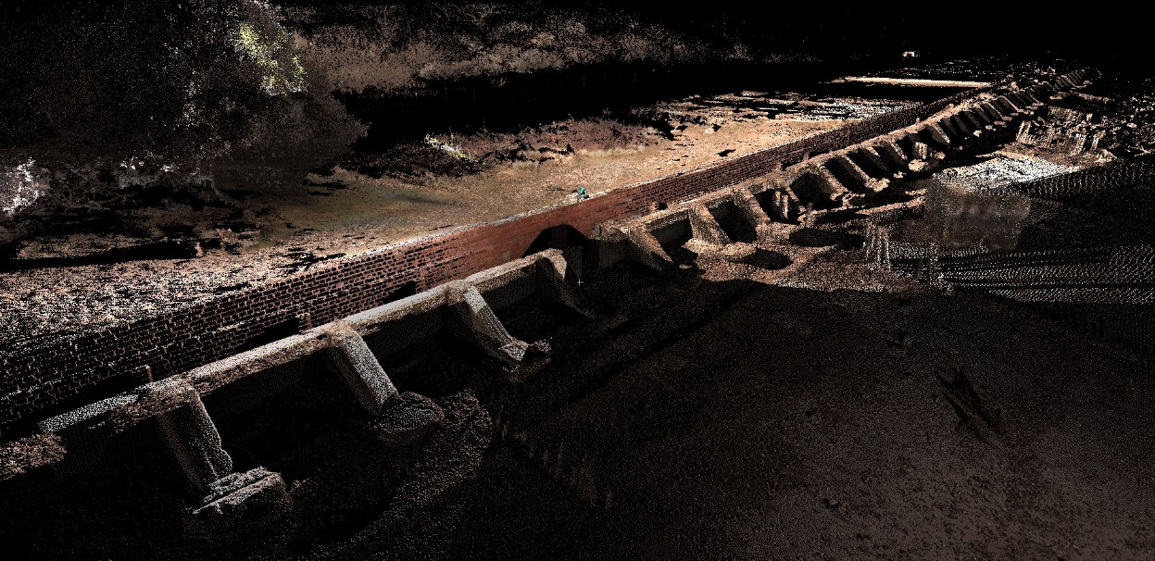
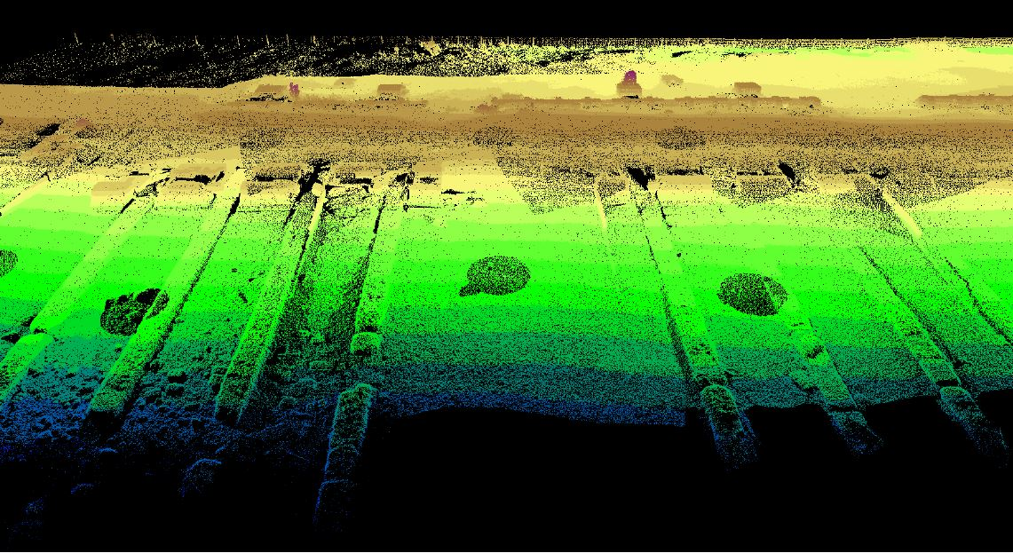
Screen grabs of existing point cloud dataset
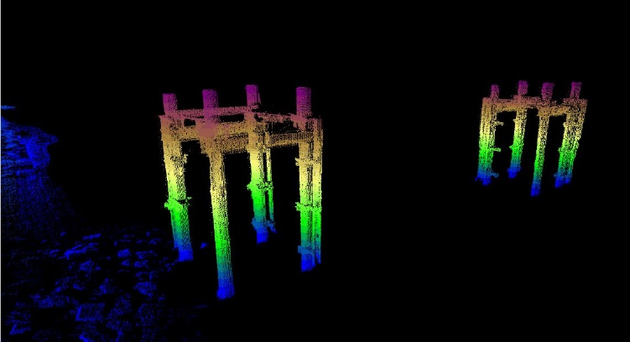
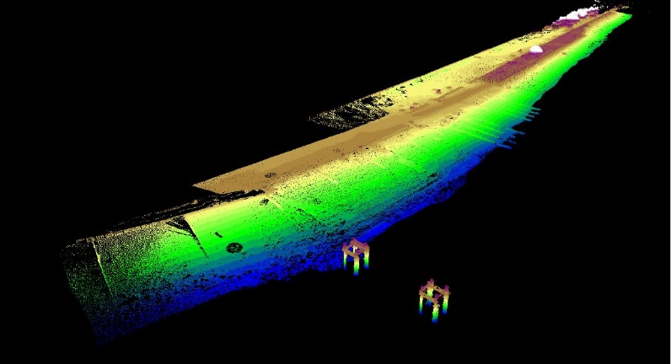
APPENDIX 2
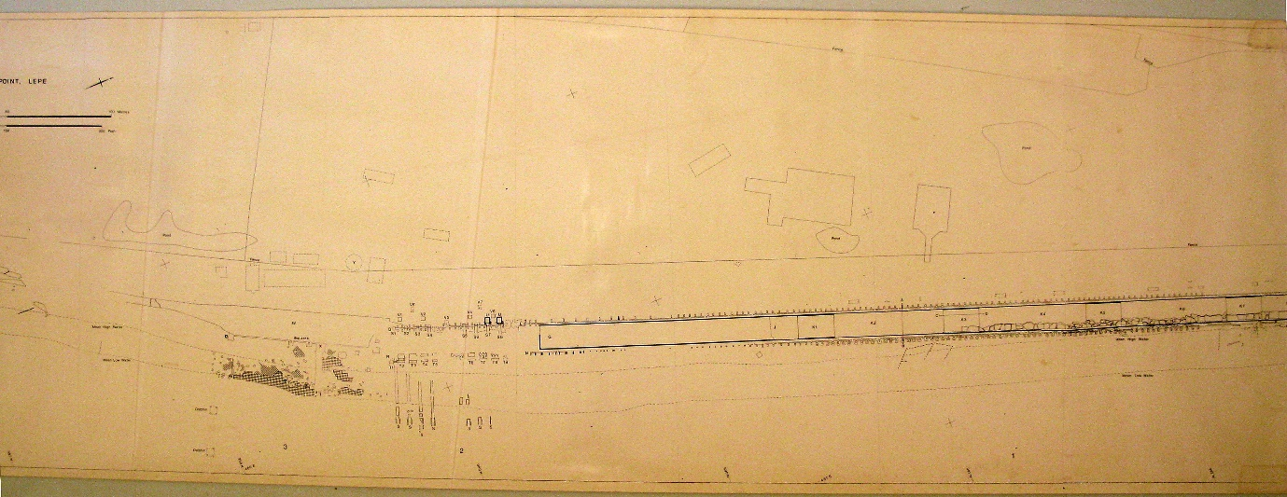
Figure 1: Plan dating to around 1990 has been made available by the D-Day Story
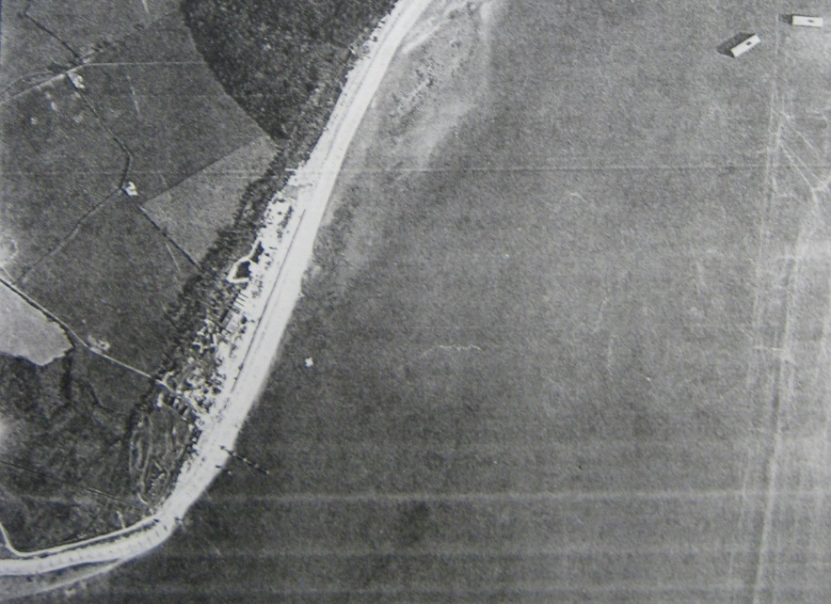
Figure 2: 1946 RAF Aerial detail of Lepe Area
