LONDON STADIUM
Installation of Security Fencing
Project LS1246
Document Issue Date: 14 May 2021
The following clarifications are issued to potential bidders.
Location | Clarification
All | Updated Fence tender slides issued
All | Site visits are available 20 May 2021 at 3pm. You must email the LS1246 email address to book. Please be aware that there are Covid19 restrictions in place so we will need to have visitors registered and a pre visit Covid questionnaire will need to be completed
Bridge 5 Gate (Project 7 on plan) | The drawings show both a red gate and overhang under the bridge and an extensive set of yellow coloured fence panels in surrounding locations.  Prices are only required for the gate and overhang panel under Bridge 5.
Options and Alternative Solutions | To ensure consistency during evaluation tenders must include a price and methodology to deliver the solutions set out in the tender documents. These will be evaluated.  Bidders can identify alternatives / innovation / adjustments to reflect concerns over the solutions identified in the Specification in their methodology section. These can be priced, but not as part of the core bid.  Bidders who state valid alternatives / issues may secure higher technical evaluation marks, as they will have demonstrated engagement with the specification and a collaborative approach to delivering effective solutions
Closing Date | Closing date moved from 25 May to 5pm Monday 7 June 2021
Height of Bridge 5 Gate | The plans show a gate 2m if height. Tenders to include a price for 3.6m height gate to provide improved security.  Overhang gate to remain at 2m.  See 17800-KSS-ZZ-ZZ-DR-A-FL-004-S0-P03 May 24 Update  17800-KSS-ZZ-ZZ-DR-A-FL-002-S0-P04 May 24 Update
Extra Panel on Car Park 1 / A1 (Project 6) | Image on the Fence slide pack omits a fence panel to link the new gate over the landscaping area. Drawing in pack shows this fence panel and should be the basis of the tender.  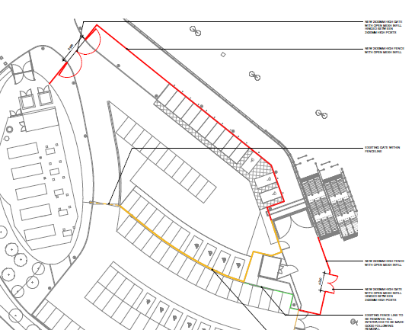
Fence Slides and Drawings | The intention of the fence slides are to give an overview of the projects. Where there is any discrepancy between the fence tender slides pack and the drawings, the drawings should be used as the basis for the tender proposals.
Timing | The intention is to proceed with all projects between June 2021 and September 2021.  Tenderers are asked to provide a programme showing their approach.  The dated below set out key milestones where the client would like the fences to be installed. However, tenderers will not be penalised for not meeting the dates set out below if there is a strong rationale explained (e.g. supply chain, price etc):  - Area surrounding the Statue (project 1) before 5 August 2021 to coincide with start of the football season  - Areas on the towpath (projects 2, 3,5,7) before 5 August 2021 to coincide with start of the football season  - Living Wall Fence (Project 4) before end September 2021  - Car Park 1/1A before end September 2021  The final details of the area surrounding the workforce entrance in car park 1/1A are subject to planning and final design. Tenderers should assume the fence and gates shown on the plans will be installed in September 2021 for the purposes of their bid.
Marathon Ramp fence panel (Project 3) | The gate on the marathon ramp should be connected to the Living Wall of the stadium. Drawing below issued to reflect expected design  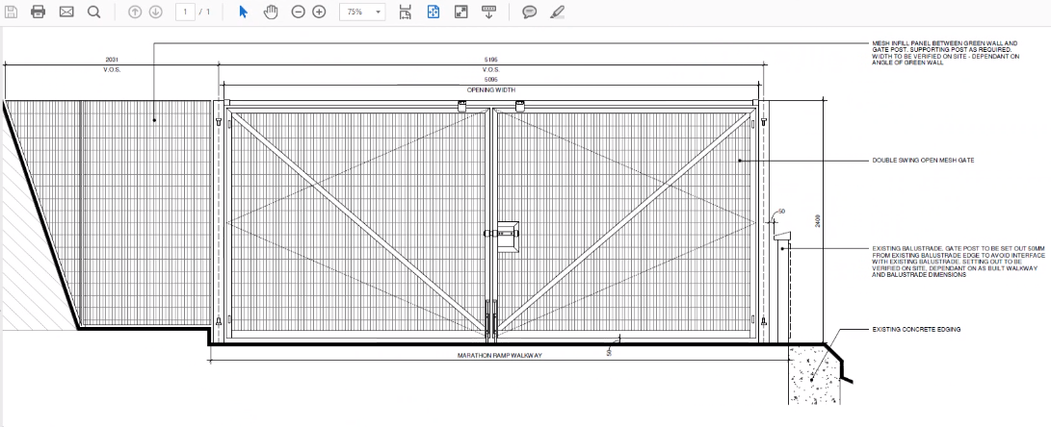
Gate on Statue Area | The preference is for the gate adjacent to the statue plinth to swing away from the statue to improve the aesthetics of the statue area. See drawing uploaded to Contracts Finder - 17800-KSS-ZZ-ZZ-DR-A-FL-005-S0-P02 May 24 Update  