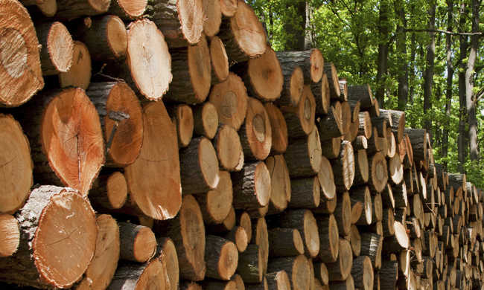

**Invitation to Tender**

***Verification of species and origin of Timber and Timber based products through Anatomic and Genetic analysis for the purpose of assessment of conformance with the European Union Timber Regulation:***

**(EU) No 995/2010 (laying down the obligations of operators who place timber and timber products on the market)**

**Michael Jones**

**24/04/2015**



**Enforcement Authority**

# Introduction

The National Measurement & Regulation Office (NMRO) Enforcement Authority is the competent authority responsible for enforcing the EU Timber Regulation within the United Kingdom. This Regulation makes it an offence to place illegal timber or timber products on the EU market.

For more information, visit the NMRO website:

<https://www.gov.uk/government/collections/national-measurement-office-enforcement-authority>

The NMRO will carry out six product verification projects simultaneously to establish the species and/or origin of up to 200 samples of timber/timber based products including fibre analysis of paper products.

Tenders are invited for testing according to the requirements detailed below.

# Requirements

The following six projects will be conducted, with testing to commence on June 1st 2015 and to be completed by July 24th 2015:

1. Marine decking and carpentry
2. Ipe decking/Brazil
3. South American timbers
4. Paper
5. African timbers
6. Certification (FSC /PEFC)

**Note, each project will be evaluated separately and awarded as an individual contract.**

Suppliers are welcome to bid for any number of contracts up to the total of six. Generic information need not be repeated when bidding for more than one project but the specific requirements of each project must be addressed separately and clearly.

Please note that all projects will run concurrently with the same start and completion dates. Suppliers must state the maximum capacity in terms of number of samples and type of analysis that can be guaranteed to be analysed and reported by the completion date. As the completion date is not negotiable, no supplier will be awarded more contracts than its capacity allows for. The winning supplier will be awarded all relevant contracts up to the maximum stated capacity, with the remaining contracts being awarded to the next best proposal.

Below are details (type of product, type of timber, number of samples and type of analysis) for each project followed by some generic information and requirements.

Specific details concerning samples are provided in [3.Sample Details].

Project 1 – Marine decking and carpentry

* Various sawn timbers, used in the construction of boats, predominate species Teak
* 20 samples
  + Anatomic – microscopic analysis (10 samples)
  + Genetic – DNA analysis (10 samples)

Project 2 – Ipe decking/Brazil

* Decking
* Ipe
* 30 samples
  + Anatomic – microscopic analysis (30 samples)

Project 3 – South American timbers

* Various sawn timbers Joatoba, Cumaru, Massarandruba
* 30 samples
  + Anatomic – microscopic analysis (30 samples)

Project 4 – Paper

* Various products
* Various timbers
* 30 samples
  + Anatomic – fibre analysis (30 samples)

Project 5 – African timbers

* Various sawn timbers, likely to include but not limited to Bubinga, Joatoba Afromosia
* 30 samples
  + Anatomic – microscopic analysis (30 samples)

Project 6 – Certification (FSC /PEFC)

* Various products, predominantly furniture products
* Various timbers predominantly used in the manufacture of furniture
* 60 samples
  + Anatomic – microscopic analysis (30 samples)
  + Genetic – DNA analysis (30 samples)

**Declarations**

NMRO will provide declarations of species and origin with each sample submitted for analysis.

**DNA analysis**

Genetic testing using DNA analysis will be to verify species and origin of the timber samples – where this is possible.

At the tendering stage, and given the project details above, suppliers should state if they have capability to deliver any more detail on species and/or origin (possible or probable) through DNA analysis than would be possible through anatomic (microscopic) analysis. If this is not possible then DNA analysis should not be offered as a service.

At the analysis stage Once the actual samples are available and presented to the supplier, and based on the declaration and an initial anatomical analysis (macroscopic or microscopic) the supplier should confirm that DNA analysis is still likely to yield more detailed results.

(I.e. it is believed that the analysis will provide useable results and that the laboratory has relevant reference material etc.).

If this is not possible no DNA analysis should be attempted. The supplier should then report the results of the anatomical analysis and NMRO should only be invoiced for the cost of the anatomical analysis.

NMRO does of course accept that even if a DNA analysis is carried out, this may not always yield a definitive result (due to e.g. poor sample quality, no matching reference data etc.). In this case the supplier should still provide a complete report of the findings

**Test Reports**

A single test report should be supplied for each project and should be in a form and format agreed with NMRO that is suitable for use in a UK court.

Each report should contain a separate summary page with the following basic information for all samples:

**Sample number | Declared species | Declared origin | Analysis result (species) |Analysis result (origin)**

Where there is no result the reason should be stated (e.g. not applicable/not possible to determine/not analysed etc.).

# Sample Details

For each project NMRO will dispatch the samples to the supplier at the times stated in [7.Time Scales] below.

The samples will always be clearly identified and sealed in evidence bags along with the declarations. If for any reason the declarations are not available at time of dispatch these will be e-mailed to the supplier at the first possible opportunity, clearly identifying the sample in question. Once received the supplier should maintain complete control over the samples to ensure correct identification and reporting of results.

The supplier should clearly state in the proposal any specific requirements on the sample size.

All samples supplied will, wherever possible be of a single piece of timber, but it is not always possible until the timber is cut for sampling to know if it is a composite. NMRO may therefore choose to send composite samples for testing. In this case each different timber will be identified, marked and specified as a separate sample and the supplier should analyse as separate samples. If the supplier, on receipt of a composite sample believes this to comprise of more sub-samples than identified by NMRO, this should be discussed with NMRO and consensus agreed before any testing is performed.

summarises the samples for each project (=contract).

Table - Sample details

| **Project/product** | **No. of samples** | **Analysis** | **Sample description** |
| --- | --- | --- | --- |
| 1. Marine decking and carpentry | 10 | Anatomic - microscopic | Unless specifically defined by the supplier, all samples will be a block of timber sized approx. [8 x 5 x 2] cm.  For paper samples, the supplier should define minimum requirements. |
| 10 | Genetic - DNA |
| 2. Ipe decking/Brazil | 30 | Anatomic - microscopic |
| 3. South American timbers | 30 | Anatomic - microscopic |
| 4. Paper | 30 | Anatomic - fibre |
| 5. African timbers | 30 | Anatomic - microscopic |
| 6. Certification (FSC /PEFC) | 30 | Anatomic - microscopic |
| 30 | Genetic - DNA |
| Total | 200 |  |  |

# Laboratory Competency

Accredited test labs would be preferred, but other labs with equivalent quality management systems would be accepted.

The laboratory should have access to data from a sufficient reference bank of certified samples to ensure the accuracy of results.

Please describe the test methods in the response.

Testing may be used as part of a criminal investigation. Therefore the supplier must confirm that they can fulfil the evidential requirements for supplying evidence that may be used as part of a prosecution.

# Timescales

The procurement timescales are given in the Invitation to Tender document.

NMRO will dispatch the samples as follows:

* 50% of the samples to arrive first week of project (week starting 1st June)
* the remaining 50% of the samples to arrive midway through the project (week starting 29th June).

# 