Completed forms and any queries should be directed to fst-consultancy@cabinetoffice.gov.uk

COVID 19 Response – Project Engagement Letter
Engagement ref # | 089C
CCS Salesforce ref# | 588323
Extension? | Yes | Ref | 032C
Department / Area | Department for International Trade (DIT) – GSSEP support
Supplier | EY LLP
Title | To identify the key production processes for each PPE sub- category product including the key component materials, with photos and equipment types where possible.  This short report will build in the previous work delivered by EY
Engagement start / end date | Proposed start date 15/06/2020 |  | Proposed end date 10/07/2020
Funding source | Department
Expected costs 19/20 | £n/a
Expected costs 20/21 | £15.95k
Dept. PO reference | TBC (Supplier to charge direct to customer)
Lot # | Lot 1 / 2
Version # | 0.1
By signing and returning this cover note, DIT accepts the contents of this Engagement Letter as being the services required and agreed for EY LLP to provide the services in accordance with the Statement of Requirements under the overarching contract (Lot 1 / 2 - Ref CCCC18A29) with the Cabinet Office and confirms the availability of funding to support recharge for the services

Signatures
Supplier | Department | Cabinet Office / EUEICU
By:  Signature | By:  Signature | By:  Signature
For and on behalf of EY LLP | For and on behalf of Department for International Trade | Cabinet Office / EUEICU
14/07/20 | 20 July 2020 | 09:38 BST

Supplier engages with Department to complete. Once agreed, Supplier signs front page and sends to Department | Department signs front page and sends to EUEICU | On approval, EUEICU signs and returns copy to Department and Supplier

Supplier contact:
Department contact:

General instructions
The Engagement Letter describes the services required and provided. When completing the Engagement Letter establish the context, explain why external support is required and distinguish between the objectives, outcomes, scope and deliverables. The rationale behind the costs should be made evident in the Fees section.

The departmental considerations are guidance notes for the customer to support their evaluation of the Engagement Letter.

Background
Briefly outline why support is required:
- As HMG plans for the next phase of the UK’s response to the COVID-19 pandemic, a critical element is to maintain and increase the availability of PPE
- The use of PPE is critical to the NHS and the social services to manage the spread of CV19 and the carers at the front line
- There is a global shortage of key products and raw materials which needs to be further understood and in developing solutions to match supply with demand
- There is an immediate requirement to extend the external support to identify the key production processes for each PPE sub-category product including the key component materials, with photos and equipment types where possible.

- Statement of services

Objectives and outcomes to be achieved
State and describe the aims of the engagement:
This short term extension work will focus on the key objective of identifying the key process for the manufacture of the 6 categories and MPP. The aims will be to provide the category definitions and define the scope of research, including any limitations. This will be provide in a summary of findings with the proposed next steps and further considerations.
The core part of the engagement will be to provide a manufacturing overview of the following;
- Raw materials: Nitrile production
- Manufacturing: Nitrile gloves
- Raw materials: Meltblown polypropylene (MPP) production
- Manufacturing: FFP3 respirators
- Manufacturing: Type IIR face masks
- Manufacturing: Disposable gowns
- Manufacturing: Eye protection (visors and safety glasses)

Scope
Define the works (SMART):
The work will support the development strategic sourcing and UK Make decisions for the manufacturing of PPE and to improve the resilience of the future category supply chains. The scope will be 6 key categories of Nitrile Gloves, Gowns, Eye protection, IIR Masks, Disposable Aprons, Respirators (FFP3). This work will include the manufacturing process for MPP.
The work will be limited to the information possible to find based upon desktop and primary research.

Assumptions and dependencies
The following assumptions and dependencies will be made:
- Key DHSC and DIT team members will be available for key meetings with EY
- Any specifications for the products will be made available
- The information gathered will be limited to desktop and primary research sources
- In the absence of this information, and due to the tight timelines, EY will make assumptions which will be validated with HMG when the report is provided (not during production)
- Working at Official Sensitive level will be approved, and this will include the approval of working on EY laptops
- No security clearance is required

Deliverables
Describe what the supplier will produce:
By Friday 10th July 2020
A PowerPoint report to include:
- Category definitions
- Scope of research
- Limitations of research statement
- Summary of findings
- Next steps
- Further considerations
- Manufacturing overview:
  - Raw materials: Nitrile production
  - Manufacturing: Nitrile gloves
  - Raw materials: Meltblown polypropylene (MPP) production
  - Manufacturing: FFP3 respirators
  - Manufacturing: Type IIR face masks
  - Manufacturing: Disposable gowns
  - Manufacturing: Eye protection (visors and safety glasses)
- Appendix:
  - Category definitions - detailed
  - Raw materials producers

Deliverable | Milestone / Date | Owner (who in the delivery team?)
Stage A
PowerPoint report on the PPE Strategy Manufacturing Research | 10th July 2020

Limitations on scope and change control

Unless instructions to the Supplier are later amended in writing, the work undertaken will be restricted to that set out above. In providing the services detailed above, the Supplier will be acting in reliance on information provided by the Department.

The Engagement Letter is the agreed contract of work between the Cabinet Office, Department and Supplier and can be varied under the change control process. Any changes to timescales, scope and costs will require approval by EUEICU.

Delivery team

The team will be led by and supported by and . This core leadership team brings a depth of skills in developing manufacturing and procurement strategies. They will be supported by a small team with manufacturing and analysis capability.

The project will be delivered for an estimated fee of £15,950 a summary of the names and grades is below

Grade | Daily rate | # of days |  | Estimated Cost
Total |  |  |  | £15,950
Total resource  Total days* Engagement Length**  *Total days worked across all resources  **Total working days in engagement |  |  | 14.5 days

EY fees will be invoiced on the basis of the Cabinet Office / CCS approved discounted Covid-19 rate card shown below:

Supplier | Partner / Managing Director | Managing Consultant / Associate Director / Director | Principal Consultant | Senior Consultant / Manager | Consultant | Junior Consultant
EY

Out of pocket expenses which we expect to incur will be agreed with you in advance and charged in line with the contracting.

Department’s team
– Operational oversight, progress and performance review, project direction.

– Day to day operational management and interaction with consultants, progress and performance review.
– Commercial oversight on Change control and any contractual issues.

Fees

The Department will reimburse the Supplier for approved work done according to the table below.

Stage | Cost | Due (link to milestone dates)
A |  | DD/MM/YY
Deliverables 1 | £ 15,950 | 10/07/2020
B (additional stages can be added)
Expenses
Grand total | £15,950

Expenses statement

The Cabinet Office overarching contract rates include expenses for any travel to/from any UK location defined by the Department as the base office for the work. Only expenses for travel at departmental request from this base can be charged. If appropriate, define permissible expenses to be charged.

Payment

The Supplier should invoice fees monthly in arrears. VAT will be added to fees at the prevailing rate. The Department will reimburse fees monthly on confirmation of approval of work. The Supplier will keep an accurate record of time spent by staff in providing the services and provide this information and supporting narrative, if requested.

Governance and reporting
As part of the Call-Off Contract, the Supplier and Department agree to provide reporting on the following:

  - will be the SRO who EY will take guidance from on the scope of the work to be delivered, and agreement and sign off the work products

Feedback and satisfaction

The Cabinet Office reserves the right to hold review meetings during the assignment, discussing what went well, opportunities for improvement on future assignments and similar. This will incorporate any ‘Show and Tell’ documentation or transferable products that have been produced.

A number of interim feedback meetings will take place throughout the engagement to check that everything is progressing as expected. We envisage that these will start weekly from the date of this letter

A post-engagement quality review of the engagement will be arranged where client departments rate the services provided.

Non-disclosure agreements

Not applicable

Notice period

The nature of these engagements require that the Department / Cabinet Office have the ability to terminate an engagement with notice. The Department or the Cabinet Office’s termination rights for this engagement are marked below.

The minimum notice period for termination is 5 working days regardless of engagement duration.

Where the Department or the Cabinet Office terminate an engagement, agreed costs incurred to the end of the notice period will be reimbursed.

- Department identifies a potential need for delivery support, initiates a conversation with EUEICU, confirms which approvals are required for an engagement to occur
- Request Form completed by department and submitted to EUEICU at: fst-consultancy@cabinetoffice.gov.uk
- The form is reviewed by the EUEICU team re which resource route is most appropriate (e.g. Clearing Hub, Lots 1/2/3), and may request additional information/edits from department if required
- Lot / Supplier is selected and briefed on the request by EUEICU, then introduced to the requesting department for further discussion and confirmation of work to be delivered
- An Engagement Letter is completed by the supplier and agreed with department, including evidence of all required approvals either being in place or being progressed (e.g. PO) and forwarded to the EUEICU for review by Approvals Board. Approval states are:
 | Approval state | Definition | Permissions
 | Full approval | - PEL agreed  - PEL signed: Supplier, Dept and CO  - Purchase Order number | - Work can start  - Supplier can invoice for work
 | Approval in principle | - Confident PEL is on track or PEL agreed  - Reliable confirmation from Dept that internal approvals / funding in place as no PO number | - CO gives supplier permission to work at risk if they choose  - Dept required to complete Full approval ASAP  - Supplier can’t invoice until Full approval

COVID-19 Consultancy Request Process

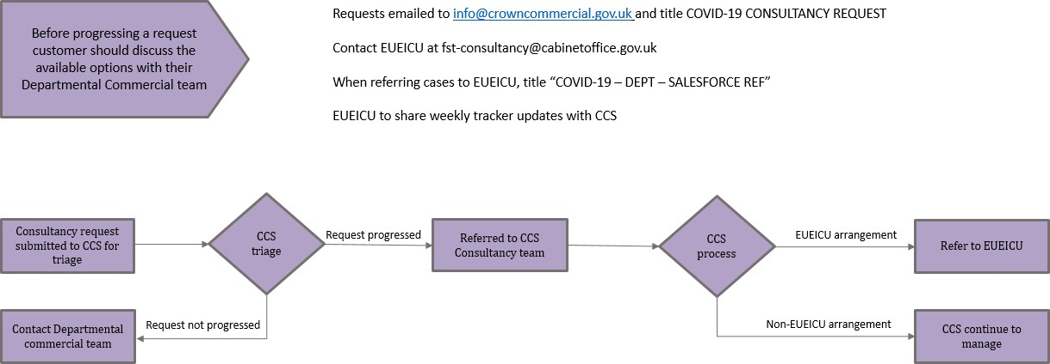

EUEICU Commissioning Process
