PUMP OVERHAUL x 2

ENQUIRY REFERENCE: STSC-JN-0008
Enquiry Date: 11th August 2017
Return Date: 29th August

South Tees Site Company Limited
Procurement Department
Teesside Management Offices
Redcar
TS10 5QW

Enclosed are the following sections:
Section 1 Introduction/Indicative timetable
Section 2 Job background
Section 3 Scope/drawings & specifications/standards
Section 4 Site PPE / visit information
Section 5 Price questions/requirements
Section 6 Evaluation/Quality questions
Section 7 General procurement information

Section 1: Introduction

On 2 October 2015 the SSI steel works in Redcar was placed into compulsory liquidation and an official receiver (OR) was appointed as liquidator. On 12 October, following no buyer for the steel works being found, the decision was taken by the official receiver to set about the hard closure of the site. Since that time the official receiver undertook a protracted liquidation of SSI and, in the absence of an owner, he has been overseeing the safe and secure hard closure of the site. Government, through the Department for Business, Energy and Industrial Strategy, provided an indemnity to the OR so that he could carry out his duties as liquidator of the company and ensure its ongoing safety and security.
On the 1st December 2016 The Department established a Government company, known as the South Tees Site Company Ltd, in order to take forward the safety and security of the site from the OR. STSC have a management team as well as a board of directors, accountable to the BEIS Secretary of State. In order to allow the board of directors and management team to carry out their duties, as well as funding the operation of the Company, BEIS has agreed to indemnify them against all claims, proceedings, costs—including the cost of defending proceedings—and expenses.
Indicative Timetable
The anticipated timetable for this tender exercise is as follows. The OGA reserves the right to vary this timetable. Any variations will be published on contracts finder or circulated to all organisations who have registered an interest in notifications.
Tender Timeline | Date
Advert and full invitation to tender issued (STSC Ltd) | 11.08.17
Confirmation of attendance of site visit  (Bidder) | 15.08.17
Mandatory site visit  (Bidder) | 18.08.17
Deadline for questions relating to the tender  (Bidder) | 23.08.17
Responses to questions published  (STSC Ltd) | 25.08.17
Deadline for receipt of tender  (Bidder) | 29.08.17
Invite suppliers for bid clarification (if needed)  (STSC Ltd) | 05.09.17
All suppliers alerted of outcome  (STSC Ltd) | 12.09.17
Contract start date | 18.09.17
Section 2: Job Background

Warman vertical sump pump that pumps rain water from deep drains on numerous plants across site. They are designed to pump Best efficiency point @ 1400rpm, flow and head 40M head (131.20ft) @ 300M³/hr (1100GPM)

An independent report has been commissioned in order to provide the scope of work.

Section 3: Scope/drawings & specifications/standards
Drawings & Specifications
RBF 24471 Drawing.

REF: 98590 – Pump 1

Deep Drain Sump Pump Warman Size 100

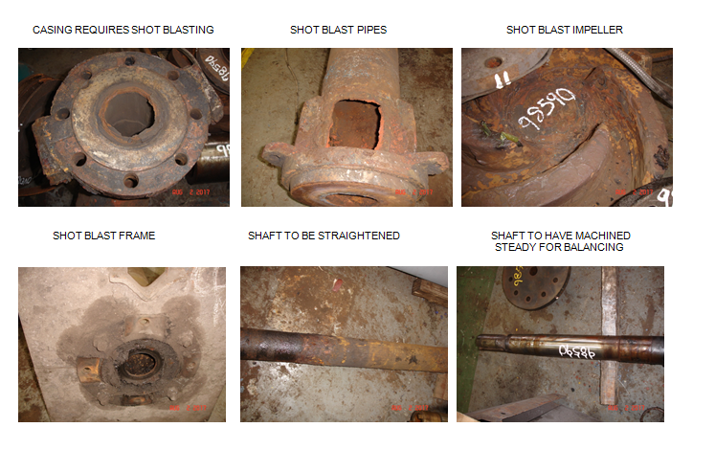
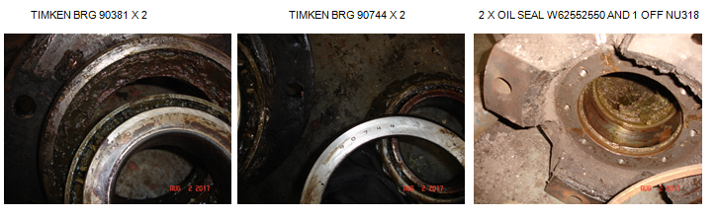

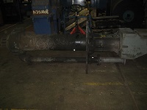

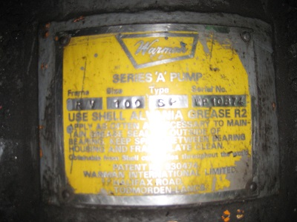

Work-scope
Shot blast full pump parts - mask off machined faces after hand cleaning
Make new top inlet filters
Check shaft in lathe for straightness – straighten shaft – machine shaft area near impeller for balancing
Balance impeller to G2.5 on shaft
Assemble pump
Fit Base motor couplings and belts
Full load and performance test curve & Certification to best efficiency point @ 1400rpm, flow and head 40M head (131.20ft) @ 300M³/hr (1100GPM)

Make new guards
Paint and make ready for despatch

New parts

2 off 90381 Timken Bearings
1 off 90744 Timken Bearings
2 off W62552550 oil seals
1 off NU 318 Bearing
1 off Set nuts and bolts
1 off Set V belts

REF: 98591 – Pump 2

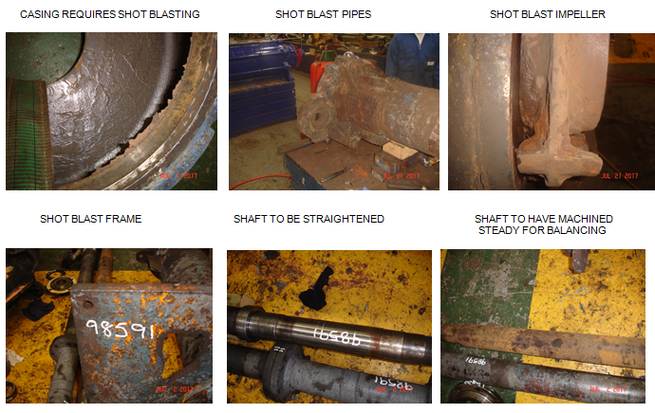
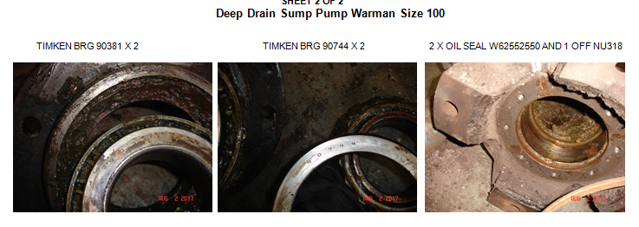
Work-scope
Shot blast full pump parts - mask off machined faces after hand cleaning
Make new top inlet filters
Check shaft in lathe for straightness – straighten shaft – machine shaft area near impeller for balancing
Balance impeller to G2.5 on shaft
Assemble pump
Fit Base motor couplings and belts
Full load and performance test & Certification Best efficiency point @ 1400rpm, flow and head 40M head (131.20ft) @ 300M³/hr (1100GPM).

Requires new motor.
Make new guards
Paint and make ready for despatch.

Standards

Please advise of any industry standards if applicable that you will be working to, along with any Company accreditations – for example ISO 90001 etc.

Section 4: Site visit information

Site visit is mandatory-
This will be held on 18.08.17, Visitors pass will be issued and you will be met at the security gate and escorted to the repair area(s) by the relevant STSC Ltd manager.

Section 5: Price questions/requirements
Price – Question 1

Please provide a fixed lump sum price for this scope of work broken down into the elements below as required (but not exclusive to the tender).

Pump 1
Item | Description | Total
1 | Site Supervision | £
2 | Site Labour
3 | 2 x 90381 Timken bearings | £
4 | 1 x 90744 Timken bearings | £
5 | 2 z W62552550 oil seals | £
6 | NU 318 Bearings | £  £
7 | 1 x Set nuts and bolts | £
8 | 1 x Set V belts | £
9 | Transport | £
10 | Other(s) | £
If the work involves a labour element on site please supply a rate breakdown of each trade included in the quotation.
Pump 2
Item | Description | Total
1 | Site Supervision | £
2 | Site Labour
3 | 2 x 90381 Timken bearings | £
4 | 1 x 90744 Timken bearings | £
5 | 2 z W62552550 oil seals | £
6 | NU 318 Bearings | £  £
7 | 1 x Set nuts and bolts | £
8 | 1 x Set V belts | £
9 | 1 x New motor | £
10 | Transport | £
11 | Other(s) | £
If the work involves a labour element on site please supply a rate breakdown of each trade included in the quotation.

Programme / Contract Duration

- Contractor to supply a program of works showing activities and duration.

KPI’s

- The site supervisor is required to feedback progress/delays to the STSC contact – Steve Coaker Office: +44 (0) 1642 408539/405565, Mobile: +44 (0) 7591260182
- Adherence to the programme/contract duration submitted in the tender (as agreed with STSC Ltd).

PPE requirements

It is the contractor’s responsibility to provide appropriate PPE, including, but not limited to:

- Eye protection
- Ear protection
- Safety boots
- Helmets
- Hi Visibility garments

South Tees Site Company Ltd is a top tier COMAH site and as such, is heavily regulated. All contractors are required to complete the VA01 contractor approval form (attached for information, will only be completed by the successful contractor) and return with required documentary evidence (including relevant insurances, ISO and training certificates as are appropriate), in order to be added to the approved contractor register (if awarded contract). All work is to be covered by our permit to work.

Section 6: Evaluation/Quality questions

- In consideration of this particular requirement STSC Ltd has decided to evaluate Potential Providers by adopting the weightings/scoring mechanism detailed within this ITQ. STSC Ltd considers these weightings to be in line with existing best practice for a requirement of this type:
- The tender process will be conducted to ensure that bids are evaluated fairly and transparently, in accordance with agreed assessment criteria. Further details are provided below.

Questionnaire |  | Q No. | Question subject | Maximum Marks
Price |  | 1 | Price | 60%
Quality |  | 2 | Methodology | 10%
Quality |  | 3 | Resource | 10%
Quality |  | 4 | Knowledge | 10%
Quality  Quality scoring: |  | 5 | Contingency | 10%
0 | The Question is not answered or the response is completely unacceptable.
10 | Extremely poor response – they have completely missed the point of the question.
20 | Very poor response and not wholly acceptable. Requires major revision to the response to make it acceptable. Only partially answers the requirement, with major deficiencies and little relevant detail proposed.
40 | Poor response only partially satisfying the selection question requirements with deficiencies apparent. Some useful evidence provided but response falls well short of expectations. Low probability of being a capable supplier.
60 | Response is acceptable but remains basic and could have been expanded upon. Response is sufficient but does not inspire.
80 | Good response which describes their capabilities in detail which provides high levels of assurance consistent with a quality provider. The response includes a full description of techniques and measurements currently employed.
100 | Response is exceptional and clearly demonstrates they are capable of meeting the requirement. No significant weaknesses noted. The response is compelling in its description of techniques and measurements currently employed, providing full assurance consistent with a quality provider.

Price Scoring:

Where an evaluation criterion is worth 10% then the 0-100 score achieved will be multiplied by 10.

Example if a Bidder scores 60 from the available 100 points this will equate to 6% by using the following calculation: Score/Total Points available multiplied by 10 (60/100 x 10 = 6)

Quality questions:

Methodology – Question 2

Please provide a comprehensive methodology of how you will meet the requirements set out in the specification
Bidder guidance - The bidder should detail clearly how their bid will meet the requirements including (but not limited to) details of the approach to be taken, the stages of development and the key considerations.
Maximum word count: 1,000 words.
Bid responses over 1,000 words will only be scored based on the words within the prescribed limit.
Please ensure your response, if provided as an attachment, is in Word format so that the word count can be verified.
Scoring criteria - 0 – 100 Scoring Methodology.
Maximum Score = 10% of overall bid.

Resource – Question 3

Please detail your proposed team for this project. Please ensure you detail your management structure, clearly detailing lines of responsibility and escalation.
Bidder guidance - The bidder should clearly demonstrate the appropriate resource and skill set to meet the requirements of the specification. The bidder should clearly stating the lines of reporting’s/management and escalations methods.
Maximum word count: 1,000 words.
Bid responses over 1,000 words will only be scored based on the words within the prescribed limit.
Please ensure your response, if provided as an attachment, is in Word format so that the word count can be verified.
Scoring criteria - 0 – 100 Scoring Methodology.
Maximum Score = 10% of overall bid.
Knowledge – Question 4

Please detail your knowledge of working and managing similar Contracts on Heavy Industrial Sites
Bidder guidance - The Bidder is required to provide a detailed description on their knowledge of working within Heavy Industrial Site and how they would manage such an environment.
Maximum word count: 1,000 words.
Bid responses over 1,000 words will only be scored based on the words within the prescribed limit.
Please ensure your response, if provided as an attachment, is in Word format so that the word count can be verified.
Scoring criteria - 0 – 100 Scoring Methodology.
Maximum Score = 10% of overall bid.
Contingency – Question 5

Please detail how you would manage resources to ensure agreed timescales are met.
Bidder guidance - The Bidder is required to detail their ability to ensure the required resources are available in order to meet agreed timescales.
Maximum word count: 500 words.
Bid responses over 500 words will only be scored based on the words within the prescribed limit.
Please ensure your response, if provided as an attachment, is in Word format so that the word count can be verified.
Scoring criteria - 0 – 100 Scoring Methodology.
Maximum Score = 10% of overall bid.
Please confirm that you understand that by submitting your completed bid response, should you be awarded this contract, the pricing and installation timetable submitted will be non-negotiable.
There will be no allowance for lack of information or understanding of requirement.
Should you be awarded this Contract without having visited site and then find that there will be additional costs that you have not allowed for, these will have to be covered by your company.
For this reason we strongly advise that you have visited site and submitted any clarification questions to gain complete clarity of these Works

Section 7: General Procurement information

Your contact for the South Tees Site Company Procurement person whom you may contact to:
- Confirm the Tenderer intends to submit a tender.
- Raise any questions during the tender period.
- Return the completed tender.
Email: procurement@stscltd.co.uk

The Terms and Conditions published with this invitation to tender (below) on Contracts Finder will apply to this contract.

