**DRAFT INTEGRATED DERMATOLOGY SERVICE SPECIFICATION**

# SCHEDULE 2 – THE SERVICES

1. **Service Specification for Croydon Integrated Dermatology Service**

|  |
| --- |
| **1. CONTEXT** |

# National Context

Dermatology is the branch of medicine concerned with the diagnosis and treatment of skin disorders1. Unlike most other medical specialties, which usually cite around 50 diseases, Dermatology recognises more than 1000 conditions affecting skin, hair and/or nails.

With high disease prevalence and low mortality rates, there are large numbers of people seeking specialist advice about skin disease2. Some skin disease can be life threatening, for example malignant melanoma. Expert advice is often required to distinguish melanoma from other far more common pigmented skin lesions.

In recent years, there has been a national increase in referrals to dermatology services. This is due to the increased frequency of some of the commonest skin diseases such as skin cancer, leg ulcers and atopic eczema.

The burden of skin disorders is outlined in the statistics where:

* 24% of the population consults their General Practitioner (GP) each year because of a skin complaint3.
* GPs refer approximately 6.1 % of the dermatological cases they see to secondary care2
* In 2010/11, 873,000 such referrals were made in England, with 2.79m total outpatient appointments for skin diseases4
* Of referrals 50% are cancer-related (skin lesions for diagnosis and/or skin cancer for management)5
* Approximately one-third of the dermatological workload in secondary care is surgical6

Approximately 4,000 people die in the UK annually due to skin disease, with 1,800 due to malignant melanoma2. Skin cancer is the commonest form of cancer in the UK and the second most common cancer causing death in young adults. Basal cell carcinoma (BCC) numbers equal all other malignancies combined, and increased by 133% between 1980 and 20007. Reported melanoma incidences increased by 50% over 13 years8. Although mortality rates from skin conditions are comparatively low, skin cancer rates are rising as the population ages; just under half of specialist activity now relates to the diagnosis and management of skin lesions2. It should also be noted that only first tumours are recorded on cancer registries, so the full extent of skin cancer may not be adequately captured2.

The ageing population is expected to put further pressure on the specialty, as some common conditions, particularly skin cancer, occur much more frequently in the elderly, and are often more difficult to treat in the presence of co-morbidities (which are associated with age)9. It is also likely that demand for dermatology services will increase in line with people’s rising expectations about skin, hair, and nail appearance10.

Chronic skin diseases have a substantial impact on work, social interaction and healthy living: skin disease is one of the commonest reasons for injury and disablement benefit and spells of certified incapacity to work in the UK. Accurate diagnosis and direct access to care is fundamental to successful management of skin disease11.

Improved treatments and changing attitudes to skin conditions have also contributed to increased demand. Though the majority of skin diseases are not life threatening the high prevalence and morbidity associated with them results in a large burden of disease.

1.1.2 Dermatology provision

The King’s fund recommend that dermatology care should be delivered by individuals with the right skills, in the right setting, the first time. The way in which services are provided to people depends on factors including local needs, the demography of the area, facilities available and the availability of staff with the required knowledge and skills12.

1.1.3 Definition of levels of care provided

British Association of Dermatology (B.A.D) recommends that people with skin conditions should have their care managed at a level appropriate to the severity and complexity of their condition, acknowledging that this may vary over time. The principles of care are therefore described in relation to the level of care required:

* Self-care (Level 1)
* Generalist care (Level 2)
* Specialist care (Level 3)
* Supra-specialist care (Level 4)13

BAD recommends that people with skin conditions who manage their conditions themselves (Level 1 care) should be supported with high-quality patient information and input from suitably trained nurses, patient support groups and community pharmacists. People with skin conditions needing generalist (Level 2) care are managed initially through self-referral to their GP. Level 2 care should also include access to input from suitably trained nurses. Any patient whose skin condition cannot be managed by a generalist will need to be referred for specialist care (Level 3) and/or supra-specialist services (Level 4)13

# Local Context

The borough is home to 380,700 people and this is expected to reach 465,600 in 2041.The higher birth rate means that there is an increase in the number of younger children requiring services in the borough. Croydon has the largest population of young people in London. The proportion of older adults, aged 65 and over, in Croydon is relatively low (and is lower than the national average of 13 percent).Croydon has a diverse population. As with other London boroughs Croydon has a higher proportion of residents from black and minority ethnic (BME) backgrounds than the national average. This fact needs to be taken into account in the delivery of the new model of care.

Over the course of the summer of 2017 there has been a review of Dermatology involving all key stakeholders within the current provision. This has involved representatives from Croydon CCG, Croydon Health Services, the Intermediate Service (Communitas), Primary Care, Croydon GP Collaborative and Patients. The outcome of this work has been to develop a revised model of care in Dermatology as part of the CCG Planned Care Transformation Programme.

Acute Dermatology is principally provided by Croydon Health Services with some services provided at Kings College Hospital, St George’s University Hospital and other Trusts. The intermediate services generally operate between Acute and Primary Care levels of provision. The intention of the Intermediate provision is to treat less serious skin conditions that do not need to be referred to secondary care.

It became apparent in 2016-17 that there was a % increases in outpatient activity. In response a comprehensive piece of work was undertaken over quarter three to address this. Visits to GP was undertaken by the Variation Support Managers and Clinical Lead GPs to promoted the use of peer review processes, self-care, shared decision making and maximising the use of in house expertise prior to referral to secondary care which resulted in a decrease in activity for Dermatology.

Collectively these activities resulted in an 8% reduction in GP FOPA on 2016-17 figures at M6 2017-18, including a 4% reduction in dermatology. However it was also concluded that in order to further ensure a financially and clinically sustainable dermatology service a whole system service model redesign is required.

The following are challenges with the existing service:

1. There is no incentive within the system generally to manage demand effectively.
2. There is inconsistent practice within primary care.
3. Education and training within primary care is limited and not effectively coordinated.
4. The services are not as integrated as possible.
5. High proportion of referrals made via two week wait (2WW) pathways for suspected cancer are not diagnosed as cancer.
6. Limited scope of self-care management
7. Limited use of modern technology eg video consultations and use of digital photography for remote diagnosis.

|  |
| --- |
| **2. OBJECTIVES** |

# 2.1 NHS Outcomes Framework Domains & Indicators

|  |  |  |
| --- | --- | --- |
| **Domain No.** | **Domain Description** | **Applicable** |
| Domain 1 | Preventing people from dying prematurely | x |
| Domain 2 | Enhancing quality of life for people with long-term conditions | x |
| Domain 3 | Helping people to recover from episodes of ill-health or following injury | x |
| Domain 4 | Ensuring people have a positive experience of care | x |
| Domain 5 | Treating and caring for people in safe environment and protecting them from avoidable harm | x |

# 2.2 Local Defined Outcomes

Croydon CCG is implementing a Planned Care & Long-Term Conditions Transformation Programme and is seeking to commission new models of care for planned care specialities, which reflect best practice, to achieve the following overarching outcomes:

* enable people to take responsibility for managing their own health and wellbeing in the most appropriate setting for them;
* deliver a Model of Care that ensures people are at the centre of their care, enabling them to achieve the outcomes that are important to them and promotes a shift in focus from dependency and ill health to independence and wellbeing;
* a holistic non-medical approach to care and incentivising effective partnerships, providing care and support in and through the community;
* develop a robust GP learning and development framework embracing individual, practice, network and Croydon-wide need
* engage, empower and grow community networks and assets so they are responsive, timely and flexible to individual needs;
* reduce health inequalities and improve health and well-being outcomes across the borough;
* deliver transformation across the system in order to achieve optimum value for money and economies of scale and efficiency by leveraging resources and capabilities across the system.

To support the achievement of these overarching outcomes we have developed a set of dermatology focussed outcomes that we wish to see delivered on behalf of the people of Croydon. We welcome provider input into the further refinement of these outcomes. A market engagement event will be held shortly after the end of Market Testing which will enable us to review these outcomes in consultation with those who have expressed an interest in delivering the service. This event will help to shape the performance measures which will demonstrate impact in the outcome areas. It will also support development of the thresholds which will be used to trigger incentive payments.

|  |  |  |
| --- | --- | --- |
| **Theme** | **"Outcome "  (to be refined through market engagement)** | **Indicator  (examples)** |
| Self-management | Patients have increased confidence and ability in relation to managing their own dermatology care | Use of Social Prescribing, patient Activation and Self-management (e.g.self-help tools - Health Help Now) for the management of dermatological conditions |
| % of practice attendances with Dermatology conditions in Secondary Care |
| % of patients managed fully in Primary Care |
| % of patients discharged to self-care who feel confident in the management of their care |
| % patient satisfaction in relation to dermatology care and support available within Croydon |
| Access | Patients have access to timely care | % of patients seen by a GPwER - Enhanced primary care |
| % of patients seen in Specialised secondary care |
| % of patients managed fully in Primary Care |
| Self-management | Patients are in control of their care and support | % of patients offered Choice |
| % not meeting Choosing Wisely policy is referred back. |
| Number of meetings with the Patient and Public Involvement Group |
| Quality | Patients receive care that is appropriate to their needs delivered in the appropriate location | % of patients discharged to Group Consultation and Health coaching |
| % of patients suitable for Group Consultation who went to Secondary Care |
| % of patients who went to Group Consultation and also went to secondary care within 6 months |
| Quality | GPs, GPwERs can access the advice, guidance and training that they need | All GPs have been offered suitable technical solutions and the required training to enable them to access advice and guidance related to dermatological conditions within three months of contract commencement and ongoing support is available. |
| All GP Networks have access to GP Education & Training with standardised materials to enable them to understand dermatological conditions and treatment options |
| All GP Networks have access to GP Education & Training with standardised materials to enable them to understand dermatological conditions and treatment options |
| Quality | GPs and GPwERs have increased confidence when managing dermatology cases and there is no unacceptable variation in the care and support offer received by patients | Number of inappropriate referrals into Secondary care and 2WW |
| % of patients requiring minor ops referred to GPwERs |
| % of GPs and GPwER satisfied with the dermatology education & training plus the support available to them |
| Quality | Communication between primary and secondary care in relation to dermatology cases supports effective patient care and support | No. of consultants who request images to be attached to referrals. |
| Number of requests for Advice & Guidance by GPs |
| Innovation | Innovative use of technology to access clinical advice to improve diagnosis and treatment of skin conditions. | % of consultations done remotely (or % of consultants offering remote diagnosis of % of practices using tech for remote diagnosis |
| Sustainability | Effective demand management across the system leading to an overall financially sustainable model | Service not making a loss and quality targets met. |

|  |
| --- |
| **3. Scope** |

# Scope of service:

* Provision of Integrated Dermatology Service with a holistic approach, which provides a range of services across primary care / community and secondary care settings to meet the range of needs of Croydon population. The service will cover an end to end pathway with emphasis on managing demand primarily in primary care/community with a focus on self-management, GP learning and development and innovative use of technology. The provider will deliver care using a model that facilitates shift of care from secondary care settings to community / primary care settings.
* Scope of service includes
  1. Promotion and delivery of skin health promotion and self-management
  2. Use of digital connectivity to provide guidance to GPs and delivery of care
  3. Primary care learning and development
  4. A full range of dermatology assessments, diagnosis and treatments in primary care / community and secondary care settings
  5. All eligible patients irrespective of age, culture, belief, disability, gender, and accessibility.
  6. Skin procedures that can be safely delivered in a community / secondary care setting on an out-patient basis (but excluding activity that is undertaken through the Direct Enhanced Service for minor surgery and cosmetic procedures)
  7. Assessment and management of all suspected cancers / 2WW in accordance to pan-London 2 week wait pathway
* Scope does not include provision of any In-patient dermatology service The Provider(s) are responsible for ensuring that the service objectives are met working in conjunction with, Croydon CCG, Primary Care, One Croydon Alliance and any sub-contracted resource

|  |
| --- |
| **4. Service Model** |

The new dermatology model will be delivered through an integrated pathway delivered by the provider in setting that is most appropriate for patients (primary care, community and secondary care) with a particular focus on improving self-care and GP learning and development. The model will involve taking forward an innovative approach to care, promoting social prescribing, Increasing activation & self-care and use of technology such as Tele-dermatology. This model will ensure that there is greater proactivity at the beginning of the pathway rather than being reactive and should identify the most effective interventions for managing demand across the system.

We anticipate that the Integrated Dermatology Service model will include the following interlinked elements, but we are seeking innovative solutions to the delivery of the required outcomes which may require modifications to this approach:

**Diagram 1: Proposed future Integrated Dermatology service – key elements**

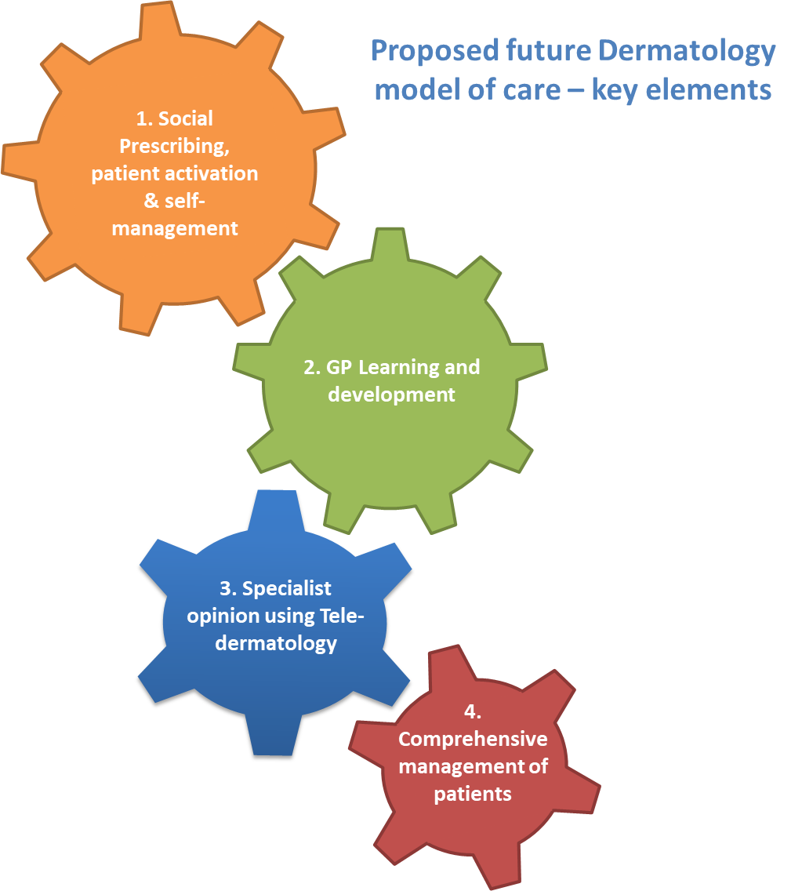

1. **Social Prescribing, patient activation & self-care/management:** The provider is expected to deliver a system that promotes self-care and self-management, employs innovative ways of social prescribing and galvanising community resources around the individual.
2. **GP learning and development in primary care:** Focus on training and development within General Practice with the objective to support GPs in managing patients appropriately, closer to home and reduce reliance on specialist service. Learning and Development to be imbedded in every part of the integrated pathway to support GPs and provide sustainability to the new model of care.
3. **Specialist advice using Tele-dermatology:** Provision of specialist advice to GPs using information and images transferred online
4. **Comprehensive management of patients:** 
   1. Enhanced primary care: Management of patients proactively in primary care / community that would support learning and development in GPs and other primary care clinicians
   2. Specialised secondary care: Manage complex patients that cannot be managed in Primary Care. Provision will be via face-to-face / virtual consultations, one to one or group consultations, single or multiple professional consultations.

This does not include inpatient (elective or non-elective) care

|  |
| --- |
| **5. Service Description** |

The following pathway provides an illustration of potential patient journey in the new system. It should be noted that the diagram does not show the model of care in its entirety and shows overview of key elements only. The key expectation from the provider is to ensure that patient journey is seamless as he/she traverses through the various elements of the Integrated Dermatology Service.

**Diagram 2: Illustration proposed future dermatology patient journey**

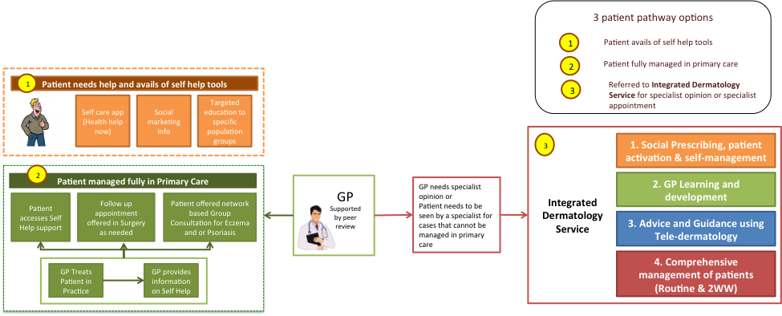

The various service elements have been described in more detail below:

# 1. Social Prescribing, patient activation & self-care/management

People have a key role in protecting their own health, choosing appropriate treatments and managing long-term conditions. ‘Patient activation’ describes the knowledge, skills and confidence a person has in managing their own health and care. Evidence shows that when people are supported to become more activated, they benefit from better health outcomes, improved experiences of care and fewer admissions.

Self-care / Self-management

The provider will embed promotion of self-management and improvement of activation across all aspects of its service provision. The provider will use innovative ways of reaching out to people in improving their ability to self-manage.

The provider will ensure all patients are provided with information and support on how to access web-based tools and apps such as Health Help now app to improve self-care and management and take better more control of their health condition. This will be achieved by ensuring engagement with GPs, healthcare professionals and patients and to provide training, educational support and materials to under-pin continued professional development across the healthcare system. For instance, working with health visitors and schools in encouraging self-management of eczema in children.

Social Prescribing

The provider will also ensure that there is significantly greater emphasis at the beginning of the pathway on raising patient awareness to access social prescribing opportunities. Social prescribing schemes view a person not as a ‘condition’ or disability, but quite simply as a person. This will ensure that patients have alternatives to visiting their GP thereby reducing the level of activity in primary care. The provider will work with local communities and voluntary sector to refer patients to various community-based initiatives that could be available on social prescription. Some of these activities may not have a direct relation to the ailment but are likely to impact on motivation and mental well-being, thereby improving overall clinical outcomes and experience.

Improving patient activation

In Croydon, Group Consultations have had favourable outcome when these have been used in particular in Diabetes. Group consultations are medical appointments delivered by a clinician to a group of patients with similar health issues in a group setting; supporting group learning and motivation. Group Consultations could be offered for chronic conditions such as psoriasis and eczema and could be delivered at network level.

The Provider will use new ways of working such as group consultations to deliver better experience and outcomes to patients. It will work with primary care in delivering group consultations by provision of specialists and help in identifying patients who might benefit from attending group consultations.

Patients will always have the option (patient choice) of a sole consultation and therefore Group Consultation is optional. It is envisaged that the introduction of Group Consultations will not just improve patient activation but also release capacity in primary care in order to spend more time with patients with greater need. In addition there may also be some impact / reduction in follow-up requirements in dermatology clinics as patients work with others with a similar condition to better manage their condition.

In summary

Provider is expected to use other innovative and evidence based interventions such as health coaching, expert patient champions or health guides to support chronic and complex patients in managing their condition on a day-to-day basis and improve their quality of life and overall outcomes. This is an area where the Third Sector can play a valuable contribution.

The provider will support and encourage uptake of Social Prescribing and use of activation & self-management tools and applications. It is expected that the provider will employ a number of ways to support upstream and proactive management of conditions. Provider will also offer support and guidance to clinicians on how best to promote these enablers and in cases, identify practices that may be facing challenges in their ability deliver on these initiatives and to provide targeted support.

# 2. Learning and Development (L&D)

Within the new model there will be a significant focus on training and development within General Practice during their protected learning time. The objective is to support General Practice in managing patients appropriately, closer to home and reduce reliance on specialist services.

The provider will inject learning and development in every part of the integrated pathway and support primary care with constructive feedback and training and development opportunities. Provider(s) will collate information and intelligence on demand from primary care to construct a learning and development framework providing continued professional development to GPs leading to a more efficient and effective service for patients. Support could be targeted at practices or specific conditions depending upon the nature of demand.

Learning and development framework could include:

* Identification of learning and development needs at Practice / Network level.
* Constructive feedback on referrals that can be managed in primary care
* Provision of guidance materials for professionals in conjunction with CCG clinical leads
* Continued professional development of GPs through rotation within dermatology educational clinics (acute / community) for interested GPs. The purpose of these sessions is to work directly with GPs in a consultation setting to support the CPD of individual GPs and create a wider skilled pool over time. The intention is that this will help support peer review at GP Practice level resulting in more patients being managed confidently in primary care.
* Croydon Network or borough wide L&D sessions: Incorporation of L&D into individual practice meetings and network or borough wide L&D sessions (such as PLT Sessions). Educational opportunities such as case conferences or Lunch & Learn sessions could be used to provide opportunities for GP and other members of the Primary Care Team for learning and development. These sessions should also be CPD (Continuous Professional Development) accredited to encourage attendance and participation. These sessions will be planned where possible within Protected Learning Time (PLT).
* Training of Key Individuals in the Community:Specific training of key individuals is also proposed to reduce attendances within primary care for common dermatological conditions. This includes information / face-to-face training for Antenatal Nurses to support mothers in how to manage nappy rash. In addition similar training support could be provided for District and Primary Care Nurses in management of common skin conditions in the Community. Also training and education could be provided for School Nurses in the management of common childhood skin conditions within schools.

# 3. Specialist opinion using Tele-dermatology as appropriate

Specialist opinion using Tele-dermatology (as appropriate) is a key element of Integrated Dermatology Service. This provides GPs swift access to specialist advice on how to treat and manage patients in primary care. The intention is to increase GP confidence in diagnosis and management of common skin conditions, plus reducing waiting time for patients to receive treatment and avoid unnecessary outpatient visits.

This element of the service will enable the referring GP to send a message and images (as appropriate and required) to the Provider and receive a timely diagnosis and management plan for patients with a skin lesion with diagnostic and/or management uncertainty. Using digital technology (eg: camera, smartphone or App) providing GPs with rapid access to dermatology assessment of skin lesions by dermatology specialists as an alternative to routine referrals to secondary care. It will also provide a learning & development opportunity for GPs as they receive feedback on the diagnoses of lesions they have seen.

This will allow the Provider to work with primary care to deliver a pathway that is safe, expedient and is acceptable to primary care.

Service requirements (include but not limited to):

* Service will be consultant-led and delivered either by the consultant or by another appropriate clinician where the consultant retains responsibility for the service and the advice provided
* That 100% of all responses are being turned around within 48 hours of receipt, and that any other locally-agreed quality standards will be met
* Consultant will make a judgement to either respond with an advice or further clarification, book patient directly into Enhanced Primary Care Clinics or book a secondary care outpatient appointment. In either circumstances, information on outcome will be sent to the referring GP
* When booking a secondary care appointment, it should be done using eRS ensuring that patient’s choice of secondary care has been considered
* The Provider will supply, install and upgrade appropriate equipment, software and applications used by the service, including any upgrades or future innovations connected with the service. This will be in accordance with all relevant NHS Guidance, including e-health guidelines.
* Provider will provide training to all GPs and other referring clinicians in use of Tele-dermatology and Advice and guidance. The training will include, but not limited to:
  + Correct use of equipment for good quality images
  + Correct use of the application and system, including obtaining and recording, patient consent, sending the details and uploading of photos
  + Appropriate selection of patients
  + Interpretation of reports and acting on feedback
* Information transfer must be by means of secure encrypted pathways
* Reports will contain the original images, additional information provided by the referring clinician, the diagnosis and differential diagnosis. The reports shall be in a format that can be uploaded into clinical systems. The reporting clinician will be suitably qualified with training and accreditation in assessment of dermatology images and treatment of suspected cancerous lesions of the skin.
* The Provider shall complete regular, but no less than bi-annual, audits to assess the clinical effectiveness, diagnostic accuracy and quality of reporting. Audits shall result in action plans and evidence of learning and completed one-month post audit. The reports shall be available to the Commissioner on request.
* The Provider shall meet all necessary information and clinical governance standards, in particular NICE guidelines, NHS standards and the British Association of Dermatologists.
* Provision of specialist opinion virtually will be used as an opportunity to support learning and development within primary care

# 4. Comprehensive Management of patients

The provider will provide comprehensive care to patients who require specialist interventions. It is expected that care will be provided in community / primary care as much as possible using a skill-mix team consisting of consultants, specialist registrars, GPwER (GPs with extended roles) and specialist nurses.

The provider will review all referrals and allocate patients to the most appropriate element within the integrated pathway ie specialist opinion using Tele-dermatology and virtual or face-to-face consultation. It is envisaged that the patient will be referred to the Provider by the GP via e-RS where the Provider is expected to review the cases referred and allocate them to the most appropriate intervention. All suspected cancer referrals will be seen by a by the service in line with the Pan-London 2WW pathway.

The service should be delivered in such a way that ensures patients are seen and treated in an environment most appropriate to their needs.

As part of comprehensive management of patients, Provider will:

* Improve patient choice and convenience, with patients having the option to be treated for dermatology conditions within the local community, closer to home as clinically appropriate
* Educate patients with long-term skin conditions so that they understand the causes, trigger factors and lifestyle choices available to them and have a management plan that is fully understood and owned by them
* Empower patients to manage their condition independently, knowing when to seek further help, improving activation and reducing their reliance for specialist care
* Ensure joined up, clinically effective patient care and pathways across the whole health and care community. This includes working in partnership with the local voluntary organisations and community groups
* Provide care in settings as appropriate to the needs of the patients ensuring access is optimised throughout the pathway. The future dermatology model will be delivered through an integrated approach using Primary Care / community based provision as much as possible
* Deliver care by appropriately qualified clinicians; for eg; Consultants / GPwERs / specialist registrars / nurses
* Have a significant focus on training and development in primary care
* A smaller proportion of patients with complex needs who cannot be managed in community setting will be seen in Specialised Secondary Care setting
* Provide care face-to-face or virtually, single or group consulting and single professional or multiple professional setting
* Will ensure compliance with Key Performance Indicators and patient outcomes measures (eg: Waiting Times; DNAs; First to follow-up Ratios; Clinical Outcome measures and Patient Reported Outcome Measures (PROMs))
* Provide outpatient procedures as clinically appropriate and would do so in a manner that supports shared decision-making. It should not include procedures performed as part of DES and cosmetic procedures
* Provide rapid access to chronic patients with relapse
* Investigate and treat allergies as an essential part of this service
* Ensure mechanisms are in place for continuity of care into Primary Care; ensuring comprehensive discharge information
* Ensure shared care protocols are in place with Primary Care where required

|  |
| --- |
| **7. Applicable Service Standards** |

**7.1 Applicable National Standards (e.g. NICE**

1. NICE Cancer Standards.
2. National Standards for Referral.

**7.2 Applicable local standards**

|  |
| --- |
| **8. Applicable quality requirements and CQUIN goals** |

**8.1 Applicable Quality Requirements**

**Appendix A**

**8.2 Applicable CQUIN goals (See Schedule 4E)**

Not applicable.

|  |
| --- |
| **9. Location of Provider Premises** |

**9.0 The Provider’s Premises are located at:**

The Provider is expected to delivery services in each GP Networks. (Locality areas)

|  |
| --- |
| **10. Individual Service User Placement** |

Not applicable

**REFERENCES:**

1. https://www.dermnetnz.org/topics/what-is-a-dermatologist-what-is-dermatology/

2. Schofield J, Grindlay D and Williams H, 2009, Skin Conditions in the UK: a Health Care Needs Assessment. Centre of Evidence Based Dermatology, University of Nottingham

3. Royal College of General Practitioners Birmingham Research Unit, 2006, Weekly Returns Service annual report 2006(b) [online]. Birmingham: Royal College of General Practitioners Birmingham Research Unit

4. Hospital Episode Statistics Online. http://www.hscic.gov.uk/hes

5. West Herts NHS Trust, 2004, unpublished scoping work for Action on Plastic Surgery project (see NHS Modernisation Agency 2005)

6. Williams HC, 1997, ‘Dermatology’ in Stevens A and Raftery J (eds) Health Care Needs Assessment Series 2. Oxford: Radcliffe Medical Press

7. Royal College of Physicians, 2011, Consultant Physicians Working with Patients 5th edition

8. Levell NJ et al, 2009, Melanoma epidemic: a midsummer night’s dream? Br J Dermatol, 161(3):630–4

9. Schofield J K et al, 2011, ‘Skin conditions are the commonest new reason people present to general practitioners in England and Wales’. British Journal of Dermatology, 165(5): 1044- 50. Available at: www.ncbi.nlm.nih.gov/pubmed/21692764 (accessed 21 May 2013)

10. Hospenthal T (2013). ‘Lessons for the NHS: commissioning a dermatology services - Based on case studies from England’. British Association of Dermatologists

11. Williams HC, 1997, ‘Dermatology’ in Stevens A and Raftery J (eds) Health Care Needs Assessment Series 2. Oxford: Radcliffe Medical Press

12. King’ s Fund, 2014, How can dermatology services meet current and future patient needs while ensuring that quality of care is not compromised and that access is equitable across the UK? Source report 7

13. British Association of Dermatologists, Quality standards for dermatology providing the right care for people with skin conditions.