 | 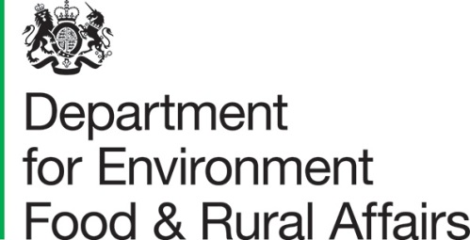 | DEFRA Group Commercial  Lateral House  8 City Walk  Leeds  LS11 9AT | T: 03459 335577  helpline@defra.gov.uk  www.gov.uk/defra
All Suppliers |  |  | Our ref: project_35432  Date: February 2022

Dear ,

Provision of an evidence review and PESTLE analysis of the illegal wildlife trade in specific countries
The Department for Environment, Food & Rural Affairs (DEFRA) is carrying out market engagement in anticipation of an upcoming procurement opportunity for evidence and analysis relating to international illegal wildlife trade.

DEFRA will require a Supplier to undertake this evidence review and analysis. The draft Terms of Reference (ToR) enclosed provides an overview of our requirements.

DEFRA plans to approach the market in the coming months to procure a Supplier. Ahead of our approach to the market we are undertaking a piece of market engagement activity, principally testing our proposed ToR for this work.

We have enclosed a working draft of our ToR, including details on objectives, scope and potential role and responsibilities of any Supplier to this letter and invite your review. Annexed to this letter you will find a market engagement questionnaire with more specific questions that we would value your feedback on.

This market engagement piece will inform our approach to the market. In the interest of momentum, we are seeking responses no later than Friday 4th March 2022.

Yours sincerely

Tom Redfearn
Senior Category Officer

Enc. Draft Terms of Reference

Annex : Market engagement questionnaire

Question | Response
What is an indicative cost benchmark or range of costs for this contract?

What is an indicative timeline for delivery and completion of this contract?

We propose giving the Supplier 2 weeks to start work following contracts, is that timing sufficient?

Are there any challenges you would envisage in conducting this work? How should challenges identified be mitigated?

Are the requirements on the Supplier clear and realistic? If not, in what ways could they be adapted to ensure clarity, and that objectives are met and value for money maintained?

How might the Supplier propose approaching the Workstreams and countries in terms of delivering (i) value for money, (ii) in timely manner. For example – would work begin in all countries in parallel, or sequenced?

How could barriers as a result of Covid 19, including travel and in country engagement be mitigated? Do Suppliers have access to country expertise on the ground that could carry out aspects of this work?

Please provide any other observations, comments or feedback here.

