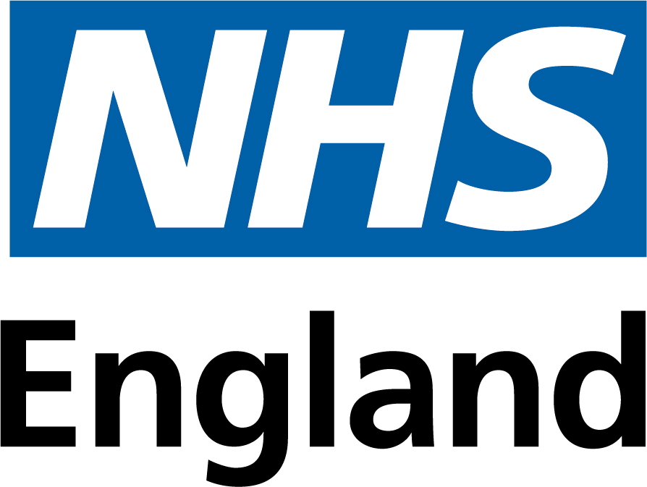

Commercial Medicines Unit

NHS England

2nd Floor

Rutland House

Runcorn

Cheshire

WA7 2ES

**All messages regarding the  
Offer documentation should**

**be sent via the Atamis Website:**

health.atamis.co.uk

**Friday 27th October 2023**

**Invitation to Offer - NHS Framework Agreement for Aseptically Prepared Cytotoxic Medicines and Monoclonal Antibodies for the Treatment of Cancer (Lots 1, 2, 3, 4 and 5)**

**Tender Reference: CM/PHR/22/5686/01**

**Period of framework agreement: 1 April 2024 to 31 March 2028 (covering regions East of England, London, North of England and South East).**

NHS England (‘Authority’) invites offers for the above-mentioned goods and/or services as defined in Document No. 03 Framework Agreement and Terms and Conditions. Offers shall be made subject to the terms of:

Document No.01 This covering letter

Document No.02 Terms of Offer

Document No.03 Framework Agreement and Terms and Conditions

Document No.04a Conformance Specification

Document No.04b Performance Specification

Document No.04c Management Information – Template

Document No.04d KPI Reporting Tool - Template

Document No.04e Management of Supply Issues

Document No.04f Labelling and Packaging of Unlicensed Medicines (Specials) - Best Practice Guidance for the NHS - December 2021

Document No.04g Standard Protocol for Deriving and Assessment of Stability Part 1 Aseptic Preparations (Small Molecules)

Document No.04h Standard Protocol for Deriving and Assessment of Stability Part 2 Biopharmaceuticals

Document No.04i Protocols for the Integrity Testing of Syringes

Document No.05 Offer Schedule

Document No.06 Form of Offer

Document No.06a Call-Off Award Procedure

Document No.06b Call-Off Order Form

Document No.07a Aseptically Prepared Specials and Manufacturing Assessments

Document No.07b Basket of Goods

Document No. 08 Confidential Information Schedule

Document No. 09 Participating Authorities

all of which constitute this Invitation to offer.

If any of the documents constituting the Invitation to offer are missing, please contact the undersigned immediately via the Atamis messaging portal.

The Authority does not bind itself to accept the lowest offer or any offer at all and reserves the right to accept an offer either in whole or in part, each item being for this purpose treated as offered separately. The Authority reserves the right to conclude a framework agreement for the supply of the goods and/or services with more than one Offeror.

I would like to draw your attention to the following important points when completing and submitting your offer:

1. All offers must be written in English.

2. All offers must be submitted subject to and in accordance with the documentation comprising the Invitation to offer. Save where the Offerors are instructed to provide information, the documentation comprising the Invitation to offer must not be amended in any way.

3. All offers must be loaded onto the Commercial Medicines Unit’s eTendering portal health.atamis.co.uk

4. Offers must be open for 90 days.

5. Offers must be fully completed and available on the designated website no later than **13:00** on **1st December 2023.**

I must also draw your attention to the enclosed Form of offer where all the requirements for completing and submitting an offer can be found. Failure to comply with these instructions may result in your offer being rejected.

I hope that the above instructions are clear but please contact the undersigned via the Atamis messaging portal if there is anything you wish to clarify.

Yours faithfully

Collette Patrick Sourcing Specialist

Branded and Biosimilars, IV Fluids and Dose Banded Chemotherapy