RSSB Digital Rule Book 2016

Project Reference/Number: RSSB2051

Functional Specification

Version 2.15

Last updated: April 2016

# Contents

1) Revision History 3

2) How to read this document 3

3) Background 4

4) Project vision 8

5) Project success criteria 8

6) Envisaged rule book content management and distribution pipeline 10

7) Challenges and risks 13

8) Project management approach and development 14

9) Project management approach and envisaged project phases 14

10) Requirements 19

11) Terms and definitions 38

12) Budget and Timescale 39

Appendix A – PDF handbook layout example (A6) 40

Appendix B – PDF module layout example (A5) 47

# Revision History

|  |  |  |  |
| --- | --- | --- | --- |
| Version | Date | By | Comment |
| Draft 2.4 | 30/03/16 | Rob Agutter, Philip Chow | Updated Testing and Hosting requirements |
| Draft 2.5 | 08/04/2016 | Alan Cropley | General updates to content to improve readability and clarity for non-technical reviewers, and updates to user, business, and stakeholder requirements. Robert to extract the user, business, and stakeholder requirements for review with TOM SC. |
| Draft 2.6 | 12/04/2016 | Alan Cropley | Continuation of updates to the document. |
| Draft 2.6 | 13/04/2016 | Rob Agutter / Philip Chow / Alan Cropley | Review of document and amendments to success criteria |
| Draft 2.7 | 14/04/2016 | Alan Cropley |  |
| Draft 2.8 | 18/04/2016 | Rob Agutter | Requirement review and amendments |
| Draft 2.9 | 19/04/2016 | Alan Cropley | Content corrections |
| Draft 2.10 | 20/04/2016 | Philip Chow | Updates to requirements |
| Draft 2.11 | 20/04/2016 | Alan Cropley | General updates to content, and additional information regarding Plain English Campaign and formatting rules. |
| Draft 2.11 | 20/04/2016 | Rob Agutter | Final review |
| Draft 2.12 | 20/04/2016 | Rob Agutter | Sent out for Sponsor and Senior Supplier review |
| Draft 2.13 | 25/04/2016 | Rob Agutter / Alan Cropley | Consultation comments |
| Draft 2.14 | 25/04/2016 | Alan Cropley | Updates based on review with steering group 25/04/2016 |
| 2.15 | 25/04/2016 | Rob Agutter | Final amendments |

# How to read this document

This document sets out the business and technical requirements for the digital rule book project. Where possible, clear requirements have been provided, which include expected outcomes and potential means of delivery.

Definitions for specific technology and industry specific terms is provided within the terms and definitions section of this document on page 42.

# Background

## Overview of RSSB

The Rail Safety and Standards Board Limited ([RSSB](http://www.rssb.co.uk/about-rssb)) was established in April 2003. The Company’s primary objective is to facilitate the railway industry’s work to achieve continuous improvement in the health and safety performance of the railways in Great Britain, and thus to facilitate the reduction of risk to passengers, employees and the affected public.  
We are an expert body with a wide range of knowledge, skills and experience. We are funded by the rail industry but are non-profit-making and independent of any commercial interests. We span the whole system, our members include - infrastructure companies, train and freight operators, rolling stock owners and industry suppliers.   
  
Key elements of the company’s remit are to:

* Manage Railway Group Standards on behalf of the industry.
* Lead the development of long-term safety strategy for the industry, including the publication of annual Railway Strategic Safety Plans.
* Propose change through facilitation of the research and development programme, education and awareness.
* Measure, report and inform on health and safety performance, safety intelligence, trends, data and risk.
* Support cross-industry groups in national programmes which address major areas of safety concern.
* Facilitate the effective representation of the UK rail industry in the development of European legislation and standards that impact on the rail system.

## Rule Book

The Rule Book (GERT8000) and other National Operations Publications are documents that contain direct instructions for railway staff.

The Rule Book is held in printed copy by over 100,000 people from companies across the rail industry, and as such is probably the best known and most widely distributed in the entire RSSB catalogue. Even greater numbers of people are known to use it as a reference and information document both from the Great Britain (GB) and abroad through using the online version. The Rule Book is a vital safety document. It comprises a set of modules and handbooks which contain direct instructions for railway staff, which currently totals 1790 pages of text and images. It sets out the operational rules for application on the GB mainline railway, which are necessary to enable the safe and timely delivery of people and goods to their destination and to provide the framework to enable safe engineering operations.​​​​

### Current PDF Rule Book

A series of five PDF Rule Book Manuals, which are designed to be viewed on either a personal computer or mobile device, are now available from the RSSB website. The Manuals provide frontline staff with access to content that is relevant to their competence within a single digital document and brings together a defined set of Rule Book modules and Handbooks.

The Manuals, which are available for downloading from the [Rule Book section](http://goo.gl/iGXXGB) of the Standards Catalogue (click on the 'Rule Book' tab on the centre of the Standards Catalogue page) are as follows:

* Master Module.
* Signaller and Signalling Technician.
* Track Workers.
* Train Driver.
* Train Operations Staff.

This means that rail staff are able to refer to a single Rule Book document for content relevant to their own role, using a PDF reader on a smartphone, tablet or pc with either the iOS, Android or Windows platform.

Having content in a single document means that users are able to navigate to the required content using the predefined bookmarks, links on the contents pages or search the entire Manual for key words or phrases e.g. Single Line Working. Designing the Manuals to be viewed on a compatible electronic device has meant that users only need to download the Manual that relates to their role.

## RMDB

The requirements management database (RMDB) has recently been implemented to manage the storage and production of RSSB’s Railway Group Standards (RGSs). Prior to the implementation of the RMDB, RSSB previously used Microsoft Word to create the RGSs, which resulted in labour intensive extraction of individual requirements to manage traceability of updates and cross referencing.

The RMDB is built on a component content management system (CCMS) called easyDITA, which provides an authoring, storage and publishing solution for RSSB. A CCMS differs from a traditional document management system by managing small chunks of content (requirements, tasks, glossaries, etc) for assembly and utilisation within one or more publications.

Authors have access to create content using prebuilt templates, which help guide the author to use the correct elements (ordered lists, unordered lists, figures, etc) for different content types. All content created within the RMDB complies with the DITA open standard, which ensures that it can be shared and migrated to other DITA compliant authoring, storage, and processing systems.

The RMDB project has developed some preliminary authoring templates and publishing styles to support the Rule Book content for the PDF style printed output, which has been postponed to explore options for digital delivery to mobile devices beyond the current PDF style.

The RMDB project has also provided training to help authors move towards writing discrete and reusable content. The RMDB went live in November 2015, and RSSB is starting to use the new processes and technology for the production of RGSs.

## RMDB configuration

As mentioned within the previous section, the RMDB is built on the easyDITA CCMS. easyDITA is provided as a Software as a Service (SaaS), which encompasses hosting and support services for RSSB.

The RMDB is accessible via a Firefox internet browser, and doesn’t require any additional locally installed software on the PC or mobile device.

Within the above diagram, the Antenna House software is also noted as part of server configuration for the RMDB, to provide additional formatting functionality above the default Apache Formatting Objects Processor (FOP).

The Design Sciences software is also installed on the server to provide additional functionality for the author when having to create complex equations (similar to inserting complex equations within MS Word). The functionality is made available to the author as an internet browser plugin.

Release management functionality is utilised to create a static archive of selected content within the RMDB, and is primarily used for traceability between the final published document (PDF) and the source content within the RMDB at a specific date and time.

# Project vision

There is a need to provide the Rule Book content in a form which is more suited to use on mobile devices, with the ability to also maintain the current printed format experienced within the PDF output. The mobile format will also utilise the technological benefits by optimising the layout of the content based on the end user’s device, whilst maintaining the readability, integrity and currency of the source content. The source content must also service both delivery formats, to ensure continuity and integrity for both publication options, with options for optimized content (videos, interactive diagrams) for mobile use where available and appropriate.

# Project success criteria

Below is a brief summary of the project stakeholder’s success criteria.

1. The ability to update and publish information via RMDB to mobile devices such as tablets, smart phones and supported on any windows, mac and android devices with standard browsers.
2. A “single source of the truth” – both the PDF print and mobile outputs must be derived from one source.
3. Analytics available to view user behaviour.
4. Ability for frontline staff to access relevant content offline (when no internet connection is available).
5. Notification to frontline staff of updates and amendments to content and a mechanism that ensures each change is acknowledged by the user.
6. The ability to easily navigate through the documents and cross reference between topics.
7. The functionality to allow frontline staff to highlight key words or phrases within a document and allow these to be saved for future reference and notes to be made next to relevant content.
8. The ability to incorporate additional content in various formats to suit a range of different learning styles e.g. video/audio files.
9. The ability to support future developments e.g. eLearning, through videos and audio.
10. Flexible for us to amend content and end solution styles and format in house.

# Envisaged rule book content management and distribution pipeline

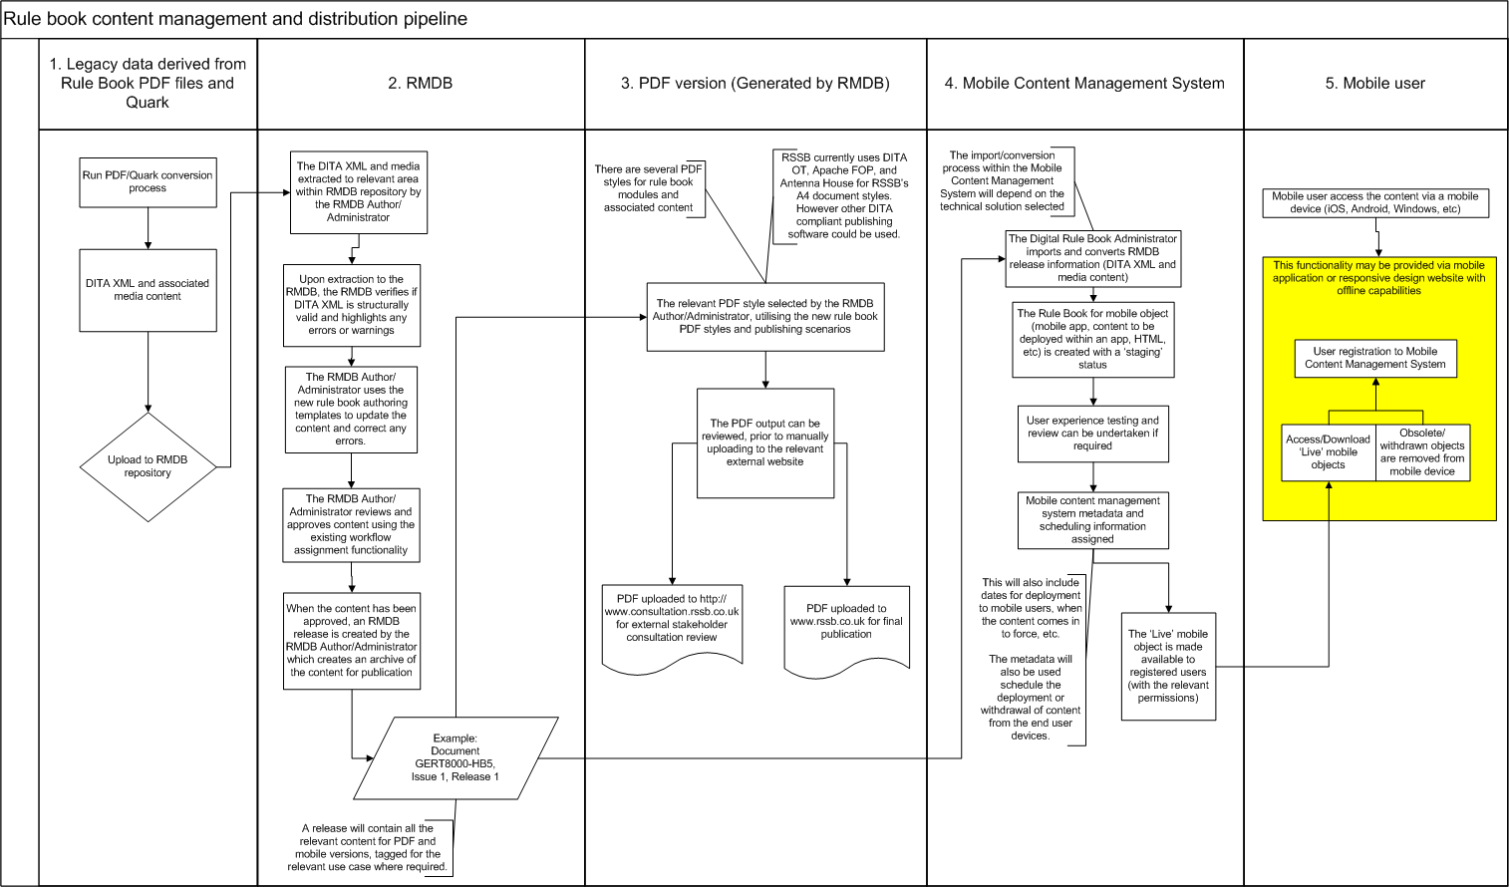The following diagram provides a simple graphical representation of the envisaged content management and distribution pipeline for Rule Book content. The details regarding the mobile content management system and mobile user interaction will depend upon on the technical solution, and therefore described at a high level.

## Diagram process notes

## Legacy data derived from Rule Book PDF files and Quark

The conversion process for the legacy data will produce DITA XML files (topics, maps, etc) and associated image files based on an agreed structure defined through an information model process facilitated by the supplier. This stage depicts the final conversion content to be used for the production environment, however it is recognised that the conversion process may have to run numerous times during the development phase of the project to valid the content and make adjustments to the conversion rules.

## RMDB

The converted content will be uploaded to the RMDB by a RMDB Author/Administrator using the RMDB upload interface. The RMDB can receive individual files or collections within a ZIP archive, which are extracted to a target location (a folder within the repository). Upon extraction to a target location within the RMDB, the individual XML files and images can be reorganised and/or moved in to other areas of the repository for organisation and management purposes. If links have been defined between files and images, the RMDB will ensure they are automatically resolved if files are moved within the system. The RMDB will also confirm if the imported content is structurally correct based on the DITA XML standard and any DITA constraints which have been implemented, for example a list item must only exist within an ordered list or unordered list or an image must be nested within a figure element.

The RMDB Author/Administrator will also make use of new authoring templates to update imported content or create new content. The RMDB templates guide the author to select the correct elements for a specific topic or bookmap (a bookmap is used to assemble multiple topics for publication). The templates will follow the structure and rules which have been identified as part of the data analysis and mapping to support the conversion process, and may include additional content placeholders for supplementary information that may be required which isn’t available within the legacy content, for example the historic rationale for a rule book rule (which isn’t captured within the PDF or Quark files).

The imported/updated/new content will utilise the RMDB workflow assignment system which is currently being used for reviewing and approving RGSs and associated topics created within the RMDB. The workflow system allows users within the system to route and approve individual topics or collections of topics, and also utilises document level statuses to control access, for example topics with an “approved” status can’t be edited.

When the content (topics, bookmap, images, etc) has been approved, a release is created which is a static archive of the content, including all globally referenced information such as copyright topics. A release is an important step because it creates a time/date stamped archive that can be directly traced to a published document which is derived from it.

## PDF version (generated by RMDB)

When a release has been created within the RMDB, the RMDB Author/Administration can select a suitable pre-built publishing scenario to produce a PDF output for manual upload to either the consultation stakeholder register for consultation or the [www.rssb.co.uk](http://www.rssb.co.uk) website for final publication. The RMDB currently has publishing scenarios built for RGSs and supporting documents, and partially developed publishing scenarios for the rule book content to produce a PDF document. The PDF styles are currently built off-line as XSL Format Object stylesheets and deployed to the RMDB as publishing scenarios, which utilise the DITA Open toolkit, Apache Format Objects Processor, and Antenna House Formatter on the RMDB server. However deployment of alternative publishing software to provide rule book content as PDF would be acceptable if it was able to process DITA XML and integrate with the easyDITA software.

## Mobile Content Management System

The Mobile Content Management System (MCMS) provides the hosting, content conversion from an RMDB release, mobile user subscription services and content deployment to subscribed users. The Digital Rule Book Administrator imports the release generate by the RMDB and runs a conversion/transformation process to create a rule book mobile object (mobile application, content to be deployed within a mobile application, responsive design HTML for mobile). The rule book mobile object will be set to a “staging” status to provide an opportunity to conduct user experience testing and assignment of descriptive metadata and control metadata, such as in-force date, scheduled deployment date, status, and permissions. When the rule book mobile object is ready for deployment, the status will be set to “live” and deployed to the mobile user with the appropriate permissions. If a rule book mobile object status is set to “withdrawn” within MCMS, any instances where this object has been deployed to a registered user will be made inaccessible and removed ( immediately or scheduled). The Digital Rule Book Administrator can also provide individual and group notifications to registered users to inform them of new content, potential outages, and other relevant information via the MCMS.

## Mobile user

The mobile user accesses the rule book mobile content via their mobile device (tablet, phone, etc). The method for deployment to the end user will depend on the technical solution proposed (mobile application, responsive design web pages), but in all scenarios the user will need to register to use the service, which may be achieved via RSSB’s single sign-on system currently utilised for RSSB’s websites. The proposed solution will also function to sufficient level when no WIFI or internet connectivity is available.

# Challenges and risks

## Culture

Mobile devices are ubiquitous and used on a daily basis by the majority of people for personal and domestic user, however the approach for delivering regulatory and operational information to front-line staff within the GB rail industry will be unfamiliar. The current printed format has a long legacy within the industry, and adoption of new approaches requires careful communication with RSSB’s members and the users.

Delivery of content to mobile and printed format from a single source of information requires focused discussion and agreement to ensure that everyone understands the paradigm shift from format driven content to structured content. This was a significant challenge for the RMDB project, and will be significantly more challenging for the Rule Book when considering a structure for both publication channels. For example, the current approach for authoring rule book content with Quark allows for individual application of formatting, which needs to be captured as formatting rules programmatically defined.

The current rule book also undergoes an independent content review by the Plain English Campaign to ensure readability and usability follows best practice for the target audience, identified by the crystal mark.

Lessons and case studies for comparable projects within other regulated industries may be useful to help support the project and identify potential user adoption and operational issues.

## Technology

RSSB currently provides no dedicated mobile information services beyond the current RSSB website, email, and social media channels. It is envisaged that RSSB will need to be upskilled in order to develop the mobile content delivery pipeline beyond the initial implementation for the digital rule book project. RSSB is starting to build the knowledge base to support the RMDB, in particular working with DITA XML and associated processing for templates and stylesheets. Additional skills may also be required in order to support continued development for delivery of content to mobile devices.

The technology also needs to be scalable and flexible enough to allow RSSB to utilise the technology for publishing other content beyond the digital rule book project. Upon completion of the digital rule book project, all RGSs and rule book content will be stored as structured DITA XML within the RMDB. However, opportunities may arise to also develop and publish other RSSB content via this process in the future, for example research reports.

## Reputation and RSSB brand

RSSB has a strong brand recognition and trusted reputation within the GB rail industry, which must be preserved during and after the project. The digital rule book project will impact a significant portion of RSSB’s members and staff, and whilst they recognise the benefits of the project, the project team (including the suppliers) must take into consideration the long term and day-to-day impact on them.

# Project management approach and development

The RSSB project team has recognised that early project stakeholder buy-in will be very important to deliver a successful project, and also ensure that potential benefits can be demonstrated at the earliest opportunity.

The project plan and project management approach must be organised to provide early demonstration of functionality through iterative development, often referred to as AGILE development within software engineering. The project timescales are also challenging, which favours and AGILE approach for grouping development and testing activities based on packaged deployments of functionality.

The project management approach and development must also take in to consideration the principles defined within ISO/IEC/IEEE 26531:2015 – Systems and software engineering – System life cycle processes, which also incorporates approaches for information modelling and design to support single source content development.

# Project management approach and envisaged project phases

## Discovery and planning

The first phases of the project is expected to encompass discovery and planning, to provide an opportunity to further review RSSB technology and project materials, clarify the project plan, secure resources, and an review objectives. Typical milestones and deliverables may include:

1. Project roadmap and schedule.
2. Outline roles and responsibilities of the RSSB team and supplier(s).
3. Communication planning.
4. Change management process and approach.
5. Review existing RSSB Rule Book content and current DITA XML development and implementation.
6. Draft information model for Rule Book content as DITA XML and review against existing RSSB information model.
7. Draft output styles for print (PDF) and mobile.
8. Draft infrastructure requirements, including user acceptance testing environments, and production environments.
9. Quality assurance process, which may include content conversion, content curation, training, technical delivery, on-boarding, and service delivery.
10. Test plans for iterative developments and full regression testing.
11. Draft analytics requirements and process.
12. Identify changes to relevant RSSB business policies, for example current website terms and conditions and capture of analytics.

## Iterative development and testing cycles for XML structure, print (PDF) style, and mobile styles

On completion of the discovery and planning phase, the iterative development phases can begin. The RSSB project team are familiar with the development concept of AGILE sprints, which are managed through via a requirements backlog, with an agreed set of functionality/deliverables to be available for testing and deployment

This phase will focus on the conversion of existing content, XML data structures, and stylesheet testing.

1. Iterative development sprints for this phase may include:
   1. Conversion of PDF samples for each rule book type to DITA XML topics and maps.
   2. Preliminary stylesheets for PDF based on converted content.
      1. Verification against current rule book layouts for print and draft styles defined within the discovery and planning phase.
      2. Verify any metadata requirements for administrative purposes within the RMDB.
   3. Preliminary stylesheet/layout for mobile delivery.
      1. Verification of layouts for mobile styles defined within the discovery and planning phase.
      2. Verify any metadata requirements for administrative purposes within the RMDB and the mobile delivery pipeline.
   4. User review of outputs for PDF and mobile.
      1. The review of mobile outputs will require more extensive user testing to guarantee the content is contextually correct across different mobile devices. RSSB human factors team to test content with end user to ensure the functionality is intuitive and is appropriate for use
   5. Refine conversion process based on review and analysis.
   6. Update information model.
2. Finalise and capture within relevant project documentation.

## Iterative development of XML templates to support authors amending and creating content within the RMDB

This phase will focus on amending and creating templates to support authors who need to amend converted rule book content or create new rule book content within the RMDB. A RMDB testing environment will be required to avoid any conflicts with the RMDB production environment, which is currently being used for creation and publication of RGSs.

1. Iterative development sprints for this phase may include:
2. Develop new / update existing XML templates.
3. Design and test with RSSB with authors within the RMDB test environment.
4. Testing with sample conversion content.
5. Test metadata assignment.
6. Test easyDITA user interface features against converted content and new content created by users.
7. Test bookmap assembly process and workflow for Rule Book content (including release management).
8. Test constraints and rules for document types and elements.
9. Update information model.
10. Update relevant project documentation.

## Deploy and test PDF styles against RMDB publishing process

It is envisaged that the PDF publishing process will follow a similar process currently used for publishing RGSs within the RMDB. The PDF publishing scenarios for the rule book will be deployed to the RMDB test environment, to be tested against sample conversion content and content created by content authors. This is not expected to be an iterative phase based on the testing and development carried out within a previous phase, however some minor changes may be expected.

1. Deploy PDF publishing plugins to RMDB test environment.
2. Identify and select suitable test content for testing against each publishing scenario.
3. Run each publishing scenario against relevant content.
4. Update information model.
5. Update relevant project documentation.

## 5. Iterative build, configuration, and testing of infrastructure for deployment to mobile devices

The build and test process for the mobile infrastructure will depend upon the technical solution selected for the mobile delivery. It is envisaged that the content developed within the RMDB will be passed to the mobile solution (Mobile Content Management System) for conversion to a mobile format, distribution management, and user management. This phase is expected to be iterative based on changes that may arise through testing the delivery solution to mobile users, and the aspects of user and content management. RSSB’s Human Factors team and the supplier’s user experience specialists are expected to be heavily involved during the testing at this phase to ensure the mobile content and delivery solution is meeting the end user expectations.

Test steps may include:

1. Upload rule book content (legacy converted and user created) from the RMDB, submitted via a release archive.
2. Test and verify the uploaded content against the source content from RMDB when conversion is complete.
3. Test and verify the publication management and user management functionality.
4. Test user registration for mobile content services.
5. Test deployment of rule book module to mobile user(s).
6. Test deployment of one or more updates against content to mobile user(s).
7. Validation of current and superseded content on mobile device, including user notification.
8. Test removal of access on mobile devices to withdrawn content.
9. Test offline working functionality, including reconnection scenarios and unexpected termination of connectivity.
10. Test high and low bandwidth scenarios.
11. Test mobile device storage and processing time.
12. Test analytics capture and reporting.
13. Penetration testing and security testing and server and device level.
14. Test user feedback and support processes.
15. Volume and flood testing of software and infrastructure.
    1. The current user based for the existing rule books is approximately 120,000 staff within RSSB’s member organisations.

## 6. Configuration of mobile delivery infrastructure for production

The configuration and commissioning of the production system will be based on the completion of the planned build and testing identified within the project plan, and agreed acceptance criteria.

# Requirements

Requirements have been organised in to relevant categories and cross reference where applicable. Additional guidance has also been provided regarding options for potential compliance and supplemental information. If a requirement requires dialogue between RSSB and the supplier in order to define the scope, this has also been noted within the guidance.

MOSCOW:   
**M**ust have; **S**hould have; **C**ould have; **W**on’t have

|  |  |  |  |
| --- | --- | --- | --- |
| **BUSINESS REQUIREMENTS** | | | |
| Req. ID | Description / User Story | Guidance and potential options for meeting the requirement | MOSCOW |
| B1 | The following content needs to be available and displayed within a mobile device, and accommodates different device manufacturers, operating systems, viewable area, and WIFI / internet coverage.  [Rule books content](http://www.rssb.co.uk/rgs#Default=%7B%22k%22%3A%22%22%2C%22r%22%3A%5B%7B%22n%22%3A%22rgsolDocumentContentType%22%2C%22t%22%3A%5B%22%5C%22%C7%82%C7%8252756c6520426f6f6b73%5C%22%22%5D%2C%22o%22%3A%22and%22%2C%22k%22%3Afalse%2C%22m%22%3Anull%7D%5D%7D). | RSSB has no control over the end user devices, operating systems, and viewable areas. To date, two technical solutions appear to be available:   * Mobile applications for each device / operating system, with content downloaded to the device for offline viewing * Responsive design website with offline capabilities via application caching   See Appendix D for in scope documents. See requirement O1 for out of scope documents. | M |
| B2 | Rule Book content (text, images, audio and video) to be updated once in the RMDB by RSSB authors and published in a format viewable on mobile devices. | When the PDF Rule Book content has been converted to DITA XML and associated images, the RMDB will be the single sourcing repository by which existing content will be updated and new content created.  Upon review and approval within the RMDB:   * a PDF for print will be created from the source content (manually uploaded to the RSSB website) * The source content (or derivative of the source content if additional mobile specific content is available) will be utilised within the mobile delivery (requirement B1) | M |
| B3 | The current numbering of content as displayed in the PDF copies is required. | The numbering nomenclature provides a useable reference point between the current PDF print style document, and the potential mobile delivery. In some cases numbers are used as part of quoted regulations or industry folksonomy.  Numbering and cross-referencing use of numbering must be consistent between the PDF and mobile output. | M |
| B4 | Ability to notify users of updates to content and provide a summary of the updates, similar to the below:  <http://www.rssb.co.uk/rgs/rulebooks/GERT8000-RBBL%20Iss%2027.pdf> | The current approach for the PDF documents is not expected to change, whereby the updated PDF and the briefing material for updates will be available in the RSSB website.  The approach users of the mobile content my differ, for example:   * A notification email when they have subscribed for the mobile content service * A notification within the mobile content, or functionality specific to a mobile application * Proposed changes to content and invite them to participate in the consultation process through the sending of a related link. | M |
| B5 | Ability to classify content that is released for version control. | When new content is release to the mobile user, this needs to be tagged to signify the applicable version and release in order to:   * Provide traceability to the source content stored within the RMDB (i.e. RMDB release information plus document issue/version information) * Organise and categorise release and version information when reviewing download and usage analytics. | S |
| B6 | RSSB staff can notify users of a pending update, either to content or general maintenance. Additionally, to warn of potential system outage. | See guidance for B4. | M |
| B7 | Communications can be sent from RSSB to either:   1. Company level users 2. End users | See guidance for B4.   * A company level user could be a primary contact within a member organisation or company * An end user will be a registered user for the mobile content | 1. C 2. C |
| B8 | Ability to highlight (in some way) what content has changed. | If specific content has changed between the previous and current version, this information should be highlighted to the user without detracting from the usability of the content. Within the current PDF style, revision bars are used to signify a change. | M |
| B9 | Existing diagrams and text to be easily viewable by the user. | The quality of images and diagrams must be consistent across devices with small and large viewable areas. This may require conversion of existing image content to vector graphics and low loss raster graphics, to prevent pixilation and loss of fidelity. | M |
| B10 | RSSB staff to edit content within the RMDB and edit the end solution styles and format. | The tools and skills must be available to RSSB IT in order to update the content rules, structure and style. It is envisaged that training would be required, based on the possible variation of approach within requirement B1. | M |
| B11 | RSSB staff to add in new rule book content into the RMDB which will feed through into the digital solution. | See guidance for B2. | M |
| B12 | RSSB staff to log into the digital solution to view data mining of user viewed content based on analytics information captured:   1. By individual 2. By company 3. By job role 4. Selected content to download 5. Last content update downloaded on device 6. Viewed content, including how long 7. Frequency of viewed content 8. Last view content 9. Common searches | See guidance for B5 and L1.  The approach for capturing and access to analytics will potentially vary based on the technical solution, as an outcome of requirement B1. The analytics capture process should also be able to cache analytics information locally if the end user is working offline, to be sent back to the server when an internet connection has been established. | M |
| B13 | The system shall ensure that any analytic reports, data extracts or generated in Excel shall be for version 2003 upwards until the latest version. | See guidance for B12. | S |
| B14 | This is safety critical information, so it will need to be protected against cyber-attacks. | The mechanism for providing the mobile content must be secure, and the end user device as secure as possible (the end user device is outside the control of RSSB). | M |
| B15 | This is safety critical information, so it is also integral for strong server resilience to ensure content is viewable for users at all times. | A minimum level of service needs to be established for availability. This may need to be categorised based on responsiveness of specific services and downtime. For example, user authentication may require 99% uptime if the user has to authenticate for each time the mobile application is opened.  Updates to rule book content is usually planned several months in advance, and therefore maintenance and upgrades must be planned around planned updates to content. | M |
| B16 | All dates shall be stored in UTC with time zone offset.  Times/dates/currencies and measurements shall be displayed alongside their time zone offset, currency type and measurement unit. | Dates, times, measurements and currencies must reflect the content as written, with the correct time zone offset, currency type and measurement unit. RSSB currently uses MathML to represent complex equations within DITA XML, and doesn’t implement any localisation processing for publications. | S |
| B17 | The system shall be able to communicate with individual or grouped recipients via a system generated email. | See guidance for B7, B4. | M |
| B18 | The solution shall be battery efficient and shall cause a reasonable drain on the power of a mobile device.  An organisation’s mobile device has got to last as long as possible without utilising all of the resources. Therefore, the design of the mobile application has got to take this into account. | No guidance. | M |
| B19 | The user interface shall be clean, uncluttered and make the interaction between the system and the user as simple and intuitive as possible. | The level of responsiveness to the device and possible style will depend on the technology, and a possibly compromise to cater for as many devices and sizes as possible. RSSB will need to work with the supplier and stakeholders to define the baseline style and layout, also taking in to consideration the timescales and resource limitations. | M |
| B20 | Automated error reporting to the supplier for early life of go live. | The ability for users to communicate errors and bugs to the supplier / RSSB. The reporting transition to RSSB would be expected after the go live warranty period. | M |
| B21 | When updates are available, users have to download the latest version of the content before they can view the existing document. | No guidance. | M |
| B22 | Integrate digital Rule Book with our SSO system. | The LoginRadius SSO system (<http://www.loginradius.com>) is currently under consideration to replace the existing SSO system, which currently services RSSB’s external websites.  RSSB administrator will be able to configure specific email addresses for automatic addition to a particular role upon registration.  Approved domains – an RSSB administrator will be able to configure specific email address domains for automatic addition to a particular role, upon registration. Although registration is likely to be managed through an external identity management tool (such as login radius), a list of approved email addresses will need to be retained and editable by an RSSB administrator. | M |
| B23 | Ensure the conversion to a different digital format isn't hindered to ensure product longevity. | The converted content from the PDF/Quark files to the RMDB XML format will ensure that the source content is technology agnostic, and allows for different publishing solutions in the future. | M |
| B24 | RSSB shall have the ability to direct users to other web based content/sites for example: OpsWeb (http://opsweb.co.uk). | The digital rule book is also a communications channel that provides potential opportunities to share information relevant to the target audience. This may take the form of a reference document which is delivered to the mobile device or part of the general functionality to provide useful links to external content. | M |
| B25 | The supplier will need to agree/demonstrate a suitable ESCROW arrangement which allows RSSB to continue service provision. | An ESCROW agreement provides RSSB with a suitable level of protection to continue services if a supplier is unable to continue provision of services if the supplier ceases trading. | M |
| B26 | The supplier must provide an independent security test | Links to requirement T2  The supplier must arrange an independent security test prior to hand-over and sign-off to RSSB if hosting and support is provided, for example SaaS (software as a service) provision. If SaaS is provided, the supplier will also need to provide an annual independent security test as part of the SaaS agreement.  The provision of security testing must also include robust procedures for continuous monitoring of cyber-attacks and malware threats, and failover provision for continuation of service to an acceptable level. If RSSB chooses to host the solution, the supplier and RSSB will need to develop a testing security agreement which facilitates effective testing of the hosting infrastructure, failover provision and continuous monitoring of cyber-attacks and malware threats. | M |
| **RSSB STAFF TRAINING** | | | |
| Req. ID | Description / User Story | Guidance and potential options for meeting the requirement | MOSCOW |
| TR1 | Training for internal staff to help them configure and develop style sheets and XML templates – future proof the end solution to enable hosting and support of the system. | RSSB IT and administration staff will require training to enable to:   * Develop and deploy new output styles for PDF and mobile content * Update and re-deploy existing output styles * Update and configure the MCMS (Mobile Content Management System) * Develop and deploy new authoring templates within the RMDB * Update and re-deploy existing authoring templates within the RMDB | M |
| TR2 | RSSB developers to view the digital solution database and structure in a repository during the development. | RSSB IT are members of the project but will also need to work closely with the suppliers to understand and critique the development. This will also be essential to ensure the single sign-on process is implemented without disruption to RSSB’s existing single sign-on registered users. | M |
| TR3 | Unlimited access for RSSB staff to the source code repository and document repository. | The supplier will need to provide access to code repositories and other document repositories during the project. This may take the form of a source safe (i.e. Team Foundation Server) for RSSB IT developers to interact with supplier developers, and a document repository for project documentation. | M |
| **USER REQUIREMENTS** | | | |
| Req. ID | Description / User Story | Guidance and potential options for meeting the requirement | MOSCOW |
| U1 | Able to identify the content library, then download and access required content, all content or a selection is possible for download. | No guidance. | M |
| U2 | Able to register to view Rule Book content, stating the below:   * Company – drop down * Role – drop down * Contact details * Email address   Password (mixture of numbers and characters, requires CAPTCHA). | See related requirement B22 for single sign-on. | M |
| U3 | Automated reset password functionality for users. | If a user forgets their password, they have an options to request a new password using their registered email. | M |
| U4 | Users can update details and preferences available once logged in. | See related requirements U2 and B22. | M |
| U5 | Change password functionality for users. | See related requirements U2 and B22. | M |
| U6 | Content to be viewable on mobile and tablet devices. | See related requirement B1. | M |
| U7 | Content is responsive to the size of the device. | See related requirement B1. | M |
| U8 | Users can view all required text and diagrams and users can vary their size. | See related requirement B9. | M |
| U9 | Usability is intuitive so instruction / training is not required. | It is possible that some end users have limited experience with mobile devices. | M |
| U10 | Content can be downloaded onto a device. | See related requirement B1.  Content may be used offline, but still within the control of the MCMS to facilitate removal of withdrawn and obsolete content. | M |
| U11 | Content can be viewed without access to the internet. | See related requirements U10 and B1. | M |
| U12 | Users can view a summary of content that is either new or updated.  This is currently achieved through a summary document that is issued. | See related requirement B4.  For the PDF content this is currently achieved via a briefing leaflet, which highlights specific changes and summarises larger wholesale changes within a document or documents. | M |
| U13 | Users can identify specific content that has been added as new or updated.  This is currently achieved through the placement of a bold vertical black bar alongside content. | See related requirement B8. | M |
| U14 | Users confirm they have received and read new content. | This will require some additional discussion because the current process for downloading the PDF version from website doesn’t ask for this step, and therefore, could provide ambiguous results.  If the user is offline when accessing new content, users will still be asked to confirm they have read new content and their confirmation will be recorded when they are back online. | M |
| U15 | Users can search for content across all documents. | Users can search across and within content on downloaded to their device when offline and online. The basic search functionality must include:   * Searching based on the content * Searching by metadata (where used), for example documents which contain a specific role ie Driver or Signaller * Boolean and wildcard searching against content text and metadata * Navigation from a search result to a document or relevant point within a document * Configurable search dictionary for common misspelt words, stemming and synonyms * Narrowing search to only display content that has been changed or updated | M |
| U16 | Intelligent search functionality, including predictive search | It is expected that basic search functionality will be sufficient for the end user because the information be provided will be derived from structured content (XML). However, as more content is added (including potentially less structure content from outside RSSB), a more advanced search capability may be required.  Advanced search functionality to include:  • Predictive search term/autocomplete when populating the search criteria  • Administrator configuration of search result weighting bias  • Customisable taxonomies (admin controlled) and folksonomies (user controlled)  • Federated search to include results from other relevant sources | C |
| U17 | Ability to download video to view offline alongside the related content. | RSSB currently has no video content available for the Rule Book, but has an aspiration to provide video content in the future as part of the mobile delivery. There may have to be a strict limit regarding size of video files in order to support offline viewing, there is also storage and bandwidth consideration if RSSB don’t use a third party streaming provider, for example Vimeo or YouTube.  It may be a sufficient alternative to provide a video when online via a streaming service, and replace with a suitable image with equivalent information when offline. | C |
| U18 | Can highlight specific text and save the highlighting. | The highlighted text could also be included as part of the analytics information to identify useful content. | C |
| U19 | Can make notes on content and can bookmark content. | The notes and bookmarks as part of the analytics information to identify useful content. | M |
| U20 | Cross referencing between content has live links for both online and offline content. | Links within document and across documents behave the same when offline and online. | M |
| U21 | Quick navigation and intuitive navigation. | The approach may differ based on each supplier and technical approach. The effectiveness may also differ across each device. The navigation is also dependent on how well the content is structured for granular navigation. | M |
| U22 | Each rule has a responsibility indicator which states to who the rule applies (i.e. track worker or driver etc.) needs to be displayed. | The responsibility indicators are currently displayed within the page margins for the PDF documents, and very left and right page orientation due to ring binding. The orientation of the responsibility indicators within the mobile format may have to change based on the viewable area to ensure the context is maintained with the associated rule. | M |
| U23 | The size of files are small enough to be downloaded on devices. | RSSB doesn’t have any control over the end user devices, so a baseline would need to be established based on anticipated users, devices, and technical solutions. | M |
| U24 | Users to submit comments to the enquiry desk to provide feedback – a live link to be shown on the end solution. | This could be an enquiry form included as part of the solution derived from B1, which submits the information to a specific recipient within the supplier, or RSSB post implementation warranty period. | M |
| U25 | The solution shall be battery efficient and shall cause a reasonable drain on the power of a mobile device.  An organisation’s mobile device has got to last as long as possible without utilising all of the resources. Therefore the design of the mobile application has got to take this into account. | No guidance, same requirement as B18. | M |
| U26 | The system shall support the user in obtaining access to other related information, for example: links to OpsWeb. | See related business requirement B24.  Providing the user with notification / access to related information considered to be useful, but would need to be strictly controlled by RSSB. | M |
| U27 | The system shall notify the user of current consultations relating rule book content that is applicable to their functional role. | See related business requirement B4.  User will be made aware of the opportunity to participate in the consultation and actively engaged in change. | M |
| U28 | Users require the ability to capture rationale and explanation of change at a granular level and high level against the converted content and new content. | Within a rule book module, a rule may contain several paragraphs, bullet lists, and images which may require a rationale and explanation of change for each element or a rationale for the collection of elements. Rationales and explanation of change are not currently captured or displayed within the PDF rule books, and therefore a placeholder needs to be identified and available within the converted content and authoring templates for amending and creating new content.  It would be beneficial if the rationale can be captured as part of the conversion process, rather manual than copy/paste when the content has been migrated to the RMDB. Explanation of change will be captured as content is amended. | M |
| **RSSB MEMBER ORGANISATION REQUIREMENTS** | | | |
| Req. ID | Description / User Story |  | MOSCOW |
| S1 | Stakeholders are able to register their company’s use of the digital Rule Book for their staff which will activate domain names for users to register against. | See requirement B22. | S |
| S2 | Company level users are able to register individual users for company viewing rights of user analytics.  RSSB staff will need to approve these users. | See related requirement B12. | S |
| S3 | Company level users can log into the digital solution to view data mining of user viewed content based on analytics information captured:   1. By individual 2. By company 3. By job role 4. Selected content to download 5. Last content update downloaded on device 6. Viewed content, including how long 7. Frequency of viewed content 8. Last view content 9. Common searches | See related requirement B12. | S |
| S4 | Solution can be viewed on devices provided to their staff (Samsung, Hudl, iPad to name a few). | See related requirement B1. | M |
| S5 | Supported on any windows, mac and android devices with standard browsers. Pages and components will be responsive, meaning they automatically render differently depending upon the user device size. | See related requirement B1. | M |
| S6 | The following browsers will be fully supported   * IE (from 9 to latest) * Firefox (latest) * Chrome (latest) * Safari (latest)   E.g. the system will need to work on the current versions of IE (9, 10, and 11). Once the next release of IE/Edge comes out version 9 will become an unsupported browser. | This will be dependent upon the solution born out of B1, for example the solution may be mobile application based rather than responsive design HTML and application cache. | M |
| S7 | The solution shall be battery efficient and shall cause a reasonable drain on the power of a mobile device.  An organisation’s mobile device has got to last as long as possible without utilising all of the resources. Therefore the design of the mobile application has got to take this into account. | No guidance, same requirement as B18. | M |
| PUBLISHING | | | |
| Req. ID | Description / User Story | Guidance and potential options for meeting the requirement | MOSCOW |
| P1 | RSSB to publish and update information to mobile devices on tablet, smart phones, laptop etc. as needed post project, this will be managed in-house. Updates to the source content will be managed within the RMDB, with the mobile content uploaded to the mobile delivery service. | The approach for delivery to the end user will depend on the technical solution proposed, but the PDF and mobile content must be derived from content developed and made available from the RMDB. | M |
| P2 | RSSB want to have as much control as possible over UI changes. Where possible, we would like the features to be created so they can be modified, maintained and reused by an RSSB Administrator. | This will apply to the mechanism by which users register for access to the mobile, and style and functionality of the mobile content when provided to the end user.  It is acknowledged that the scope to make changes may be limited by the technical solution proposed, for example mobile application or responsive design HTML a browser. | M |
| P3 | The digital output style must retain the contextual relevance against the current PDF print style to prevent misinterpretation of the content. | The style of the mobile content will need to be developed and agreed with RSSB (in addition to the supporting functionality). The look and feel may be responsive based on the end user device, however the contextual relevance must be identical to the printed version when read side-by-side. | M |
| P4 | The current approach for creating rule book content within Quark allows for individual application of formatting, based on a set of style guidelines. The style guidelines will require careful review and testing to ensure that all potential scenarios for PDF and mobile are captured to eliminate post publication formatting corrections. | For example the following high level style guidelines apply for rule book content:   * New sections (but not sub‑sections) must always start on a new page. * Any bulleted list should be kept on one page whenever possible. * Hyphens should not break * Responsibility indicators (The green ‘job‑title’ in the margins) are positioned adjacent to the paragraph to which they apply.  They are reiterated following each sub‑section heading, even if there is no change from the previous sub‑section.  Note that there may be changes of responsibility indicator during a sub‑section.  Where more than one role (job title) is listed, then these are given in alphabetical order.  The full bulleted list of responsibility indicators which are used in the individual module is also iterated at the front of the module following the text ‘*You will need this module if you carry out the duties of a*:’ * Because of printing requirements, the number of pages in all modules and handbooks should be a multiple of four. * Diagrams should be kept with the text which refers to them.  Where a diagram fills a page, then the text should appear on an adjacent page. * Every effort is made to avoid large empty spaces in the document. * Some modules (eg TW5 which has numerous sections relating to different on‑train equipment) are arranged in alphabetical order. * Prevent “widows and orphans” paragraphs and content for rule book rules   Layout examples are also included within Appendices A and B. PDF outputs are also produced as multiples of 4 pages to support the printing process with RSSB’s external printing supplier. |  |
| **STANDARDS AND BEST PRACTICE** | | | |
| Req. ID | Description / User Story | Guidance and potential options for meeting the requirement | MOSCOW |
| BP1 | Knowledge of techniques and practices defined within ISO/IEC/IEEE 26531:2015 – Systems and software engineering – System life cycle processes. | Many of the principles set out within ISO/IEC/IEEE 26531:2015 were adopted when implementing the RMDB project. The supplier(s) must demonstrate how their approach support the approaches outlined within the standard. | M |
| BP2 | Plain English Campaign (Crystal Mark) | The rule book content is independently reviewed by the Plain English Campaign in order for RSSB to obtain a crystal mark for each rule book document published. This standard needs to be maintained for PDF and mobile delivered content. The rule book content delivered via the mobile solution will also be subject to review by the Plain English Campaign in order to obtain the Internet Crystal Mark, which also encompasses functionality and usability. More information is available at <http://www.plainenglish.co.uk>. | M |
| **TESTING** | | | |
| Req. ID | Description / User Story | Guidance and potential options for meeting the requirement | MOSCOW |
| T1 | The RSSB Human Factors team will be responsible for testing the prototype and end-to-end solution with users to ensure usability is intuitive, and suitable across a variety of mobile devices. | The RSSB Human Factors team have worked on a wide variety of projects within the UK Rail Industry, ranging from website testing to train driver simulators. The RSSB Human Factors team will be responsible for testing the mobile solution with users, but would also benefit from user experience testing evidence which is comparable for RSSB’s project requirements. | M |
| T2 | Penetration and security testing of mobile deployment service and mobile devices. | Linked to requirement B26.  The penetration and security scope is limited to the mobile solution, and doesn’t include the RMDB.  RSSB has previously used an external supplier for security and penetration testing, and would be willing to use this arrangement again as part of project acceptance, or accept a nominated external security and penetration testing company that would be contracted as to RSSB as a project deliverable within the project proposal.  The security testing must also take in to consideration any specific social engineering scenarios in addition to brute force technical based testing of the software.  Training must also include development of policies and training materials for continuous monitoring of the mobile solution to mitigate the risks and impact associated with cyber-attacks, including malware and potential user vulnerability when working with other mobile application services. | M |
| T3 | To provide evidence that each individual requirement has been met. | The supplier needs to provide an approach for quality, change management, and acceptance that ensures that deliverables can be traced back to requirements. | M |
| T4 | To provide evidence that no functional regression has been introduced. | This can be demonstrated by the approach for specific unit testing, and full regression testing as part of the delivery for the entire solution. | M |
| T5 | To provide evidence that the changes are suitable for deploying into the production environment. | The supplier will need to provide access to a test environment for testing and acceptance prior to deployment to a production environment. This arrangement also need to be observed post project delivery and acceptance if any future develop is planned.  An RMDB test environment will also be required, to be arranged by RSSB with easyDITA. | M |
| T6 | To provide input to the test strategy and test planning phase. | No guidance available. | M |
| T7 | Unit Testing (UT). | Unit Testing (UT) is the initial testing of new configurations or customisations made. It validates the changes meets the requirement.  The supplier will be expected to carry out UT in the development environment. Evidence will have to be provided to RSSB before sign-off can be achieved and the changes moved to the hosted environment. The acceptance criteria must be agreed between RSSB and supplier as part of sign-off. | M |
| T8 | System and Integration Testing (SIT). | System and Integration Testing (SIT) verifies the overall system in light of the changes made. Where relevant, all modules will need to be involved in the testing. The testing will be performed on hardware, software and infrastructure components in a production-like environment.  Both RSSB (support team) and the supplier will be performing the SIT. Testing will be done against jointly agreed acceptance criteria. Only once the testing results have met the acceptance criteria can the testing process continue. | M |
| T9 | User acceptance testing (UAT). | User acceptance testing (UAT) verifies that the system meets the requirements from an end user perspective. It simulates the user environment that is available and will demonstrate that the system performs as expected to the end-user expectations, so that they may accept the system.  UAT is performed by the user running pre-agreed test scenarios and scripts. For major enhancements or future phase releases, users may be required to perform regression testing.  RSSB and other nominated users will carry out tests as required. The supplier will be required to support the testing activities and be involved in the test review. RSSB will be responsible for signing off the UAT test results. | M |
| T10 | A final Pre-release test is carried out once the UAT has been successfully passed. RSSB will carry out a pre-release test and the supplier will, again, be required to support this process. The process will be established with the suppler during further discussions of the agreement. | No guidance available. | M |
| **LEGAL** | | | |
| Req. ID | Description / User Story | Guidance and potential options for meeting the requirement | MOSCOW |
| L1 | Advice and review of terms of service and DPA for capturing user behaviour for mobile device usage. | The scope of the current SSO registration process and conditions doesn’t include the user having to acknowledge that they have read or acknowledged changes to any content. The granularity of analytics and anonymity of users will also need to be reflected within the registration and usage terms if RSSB intends to share analytics information with RSSB’s members pertaining to document usage and behaviours. | M |
| L2 | The solution shall not require excessive bandwidth when accessing and downloading content. | Related requirements U1 and B9. RSSB has no control over the end user device or mobile network provisions in place for end users. A suitable approach for potentially addressing this requirement is a policy regarding file formats and acceptable sizes, which forms part of the information model and business processes. | M |
| **HOSTING** | | | |
| Req. ID | Description / User Story | Guidance and potential options for meeting the requirement | MOSCOW |
| H1 | The supplier shall be required to suggest the number of environments and instances that will be able to meet the requirements that are described. | A test environment will be required for the RMDB activities, to be arranged by RSSB.  The requirements are to carry out the following activities:  • Build and test solution, including initial and future phases  • Test solution from a system integration and user perspective  • Host solution as a live system  • Support post go live  • Carry out further development, testing, evaluations | M |
| **WARRANTY** | | | |
| Req. ID | Description / User Story | Guidance and potential options for meeting the requirement | MOSCOW |
| W1 | A warranty of 3 months is required on the product to resolve all bugs and issues raised. | The warranty period is required to ensure the supplier’s project teams are still accessible to identify and resolved issues relating to the project delivery, prior to moving in to a formal support and maintenance arrangement.   * All bugs and issues raised in UAT are resolved or closed, i.e. there are no pending issues. * The technical coding highlights no major issues and any issues highlighted are resolved before going live. | M |
| **FUTURE REQUIREMENTS**  **Not to be quoted against, however, the digital solution should be able to deliver these requirements** | | | |
| Req. ID | Description / User Story | Guidance and potential options for meeting the requirement | MOSCOW |
| F1 | RSSB able to deliver e-learning to end users through the digital solution | RSSB have the ability to create e-learning content and then prompt users to participate. Users can view content, answer questions and receive a mark against their answers. Member organisations are able to view responses for their staff and RSSB users are able to view this content across all users. | C |
| F2 | Each Member Organisation is able to upload documents (PDFs) for their staff to see onto the digital solution. | Member organisation user can log into the digital solution and upload PDF documents for their staff to view. | C |
| F3 | Products are distributed to members free of charge. Opportunity to create income stream for access to non- members. | RSSB members have free access to all RSSB content, and non-members also benefit from free access to all content at the moment. However, RSSB may wish to move to a controlled distribution process in future where RSSB members have free access and non-members may be charged for some content. | C |
| **OUT OF SCOPE** | | | |
| Req. ID | Description / User Story | | |
| O1 | The following Rule Book documents are out of scope: <http://www.rssb.co.uk/rgs/rulebooks/GERT8000-Issue%20Iss%2024.pdf> and <http://www.rssb.co.uk/rgs/rulebooks/GERT8000-Issue%20HB%20Iss%206.pdf> | | |
| O2 | We currently author content in Quark and going forward will be authoring the RMDB to publish content in digital format and it is out of scope for the selected supplier to author and publish on our behalf after go live. Quark licenses will be kept as a contingency for a period during and after project completion. | | |
| O3 | Each duty holder (rail company) has a legal obligation to demonstrate H&S competency and the users understanding of the content, it is out of scope of this digital solution to ensure competency. | | |
| **MIGRATION REQUIREMENTS** | | | |
| Req. ID | Description / User Story | Guidance and potential options for meeting the requirement | MOSCOW |
| M1 | Content to be migrated into RMDB, 1790 pages.  XML DITA files can be stored and edited Other file types can be stored. | Converted content will be migrated to the RMDB, where RMDB Authors/Administrators will have access to amend the migrated content and create new content using templates. Converted image related information should be converted to a format which will suit both PDF and mobile delivery. If a suitable size/format can’t be defined for both delivery channels, a suitable derivative should be crated with a relationship to the parent media used for the PDF version. | M |
| M2 | Convert our existing rule book documents (PDF) into structured DITA XML and migrate into RMDB. Currently we have 58 documents (please refer to the [rule book module matrix](http://www.rssb.co.uk/Library/standards-and-the-rail-industry/2015-01-rule-book-module-matrix-10.pdf)). There are 33 modules and 25 hand books (please refer to [modules and handbooks](http://www.rssb.co.uk/railway-group-standards#Default=%7B%22k%22%3A%22%22%2C%22r%22%3A%5B%7B%22n%22%3A%22rgsolDocumentContentType%22%2C%22t%22%3A%5B%22%5C%22%C7%82%C7%8252756c6520426f6f6b73%5C%22%22%5D%2C%22o%22%3A%22and%22%2C%22k%22%3Afalse%2C%22m%22%3Anull%7D%5D%7D) from the RSSB Standards catalogue). There are a number of tasks and rules in a module. | The original Quark files are also available for use within the conversion process, which may provide a higher quality source for image conversion when compared against the PDF output.  The conversion structure will depend upon the agreed information model for the content within the rule book. RSSB has undertaking some initial modelling of the rule book content for the RMDB project, which could be utilised to support the digital rule book project. | M |
| M3 | Converted content must be DITA 1.2 compliant. | The converted content must be DITA 1.2 compliant, unless there is a specific case communicated within supplier response which warrants implementing changes incorporated within DITA 1.3. Implementing changes relating to DITA 1.3 may incur additional configuration costs within easyDITA that will require review and approval.  Example DITA structures have been provided within Appendix C based on the preliminary designs constructed within the RMDB. | M |
| M4 | In scope for Migration requirements <http://www.rssb.co.uk/rgs/rulebooks/GERT8000-RBBL%20Iss%2027.pdf> | See appendix D |  |
| M5 | Ensure the granularity of data extraction of existing content (from QUARK/PDFs) is at an appropriate level to allow the repurposing of content. | This will be based on the structured agreed for the information model. The initial review of the rule book for the RMDB project identified the use of the Task information type as suitable for each requirement identified within a rule book module, with the Concept information type for general content. | M |
| **TEMPLATES AND STYLESHEETS FOR PDF REQUIREMENTS** | | | |
| Req. ID | Description / User Story |  | MOSCOW |
| TS1 | Publish and update information to mobile devices on tablet, smart phones, laptop etc. The publishing will be part of the functionality for this project. Updates to the source content will be managed within the RMDB, with PDFs being manually uploaded to [rssb.co.uk](http://www.rssb.co.uk) | It is envisaged that the PDF stylesheet development process will follow the current arrangement for the RMDB A4 standards, whereby stylesheets are developed using XSL:FO and deployed to RMDB as a publishing plugin, utilising the DITA Open Toolkit and Antenna House (if required). However, other options will be considered for producing the PDF content from the DITA XML content within the RMDB if they can integrate with the easyDITA software, and provide other benefits over the current process.  The mobile publishing technology and delivery approach will depend upon the supplier proposal, but must utilise the source DITA XML from the RMDB. | M |
| TS2 | Development training for internal staff to help them configure and develop style sheets and XML templates – future proof the end solution. | Related to training requirements TR1 and TR2. | M |
| TS3 | In scope <http://www.rssb.co.uk/rgs/rulebooks/GERT8000-RBBL%20Iss%2027.pdf> | See appendix D |  |

# Terms and definitions

| **Term** | **Definition** |
| --- | --- |
| CCMS | Component Content Management System  Supports the entire document or information development life cycle from authoring through review and publishing, including the reuse of modular content.  Derived from BS ISO/IEC/IEEE 26531:2015 |
| Digital Rule Book Administrator | RSSB employee who has access to manage and administer the Digital Rule Book deployment software. Activities may include:   * Upload of new and revised content for use within the digital rule book deployment software (the process will differ depending on the technical solution, for example import of XML and associated content to a mobile application for deployment to iStore or Google Playstore; or publication to a HTML based website which is also available offline. * Manage user accounts and access to analytics * Issue notifications to uses regarding downtime and service announcements |
| RMDB Content Author & Administrator | A user within the RMDB with access to update, create, and approves content to be used for the PDF Rule Book and Digital Rule Book. The user can also create a release of the content for deployment by the Digital Rule Book Administrator. |
| DITA | Darwin Information Typing Architecture |
| DITA Bookmap | A mechanism for organising a collection of topics or maps in to hierarchy for publishing |
| DITA Map | A mechanism for organising a collection of topics in to a hierarchy |
| DITA Topic | An XML document conforming to the DITA standard |
| DPA | Data Protection Act, and association legislation regarding the capture and retention of data |
| Human Factors | RSSB has access to an internal team of Human Factors experts who will provide support for usability assessment for mobile content |
| Information Model | A document which defines how XML has been implemented to support an organisation’s information and publication requirements |
| Mobile Content Management System | The Mobile Content Management System provides the hosting, content conversion from an RMDB release, mobile user subscription services and content deployment to subscribed users |
| Mobile content / version / object | Mobile content / version is the published alternative to the PDF Rule Book, specifically stylised for delivery to mobile devices |
| Release Management | A process within the RMDB where a bookmap and dependencies are copied to an archive which reflects the current point in time state for the bookmap and each associated document. The release management process can also be applied to a single topic. The RMDB also has branching and merging functionality available, but is not currently utilised for RSSB’s business processes |
| Responsibility Indicator | A responsibility indicator highlights which role(s) are responsible for performing a task, for example Driver, Signaller, Guard. In some situations multiples of a role may be displayed, for example Signaller box A notifies Signaller box B of train failure |
| RMDB | Requirements Management Database based easyDITA CCMS which provides authoring, storage, and publishing functionality for RSSB’s A4 standards and guidance notes |
| RSSB | Rail Safety and Standards Board. Organisation whose purpose is to support their members and industry to improve the level of safety in the rail industry, reduce unnecessary costs and improve business performance |
| SaaS | Software as a service; an externally hosted application which requires no thick client software installation for localised processing |
| UAT | User acceptance testing |
| UI | User interface |
| User | Person using the site, who may be a signed-in member or browsing anonymously |
| RSSB member organisation | An organisation with membership to RSSB - <http://www.rssb.co.uk/about-rssb/join-as-a-member/join-rssb-next-steps> |
| XML | Extensible Mark-up Language |

For more information regarding railway specific terms, please visit the RSSB jargon buster at [www.rssb.co.uk](http://www.rssb.co.uk) .

# Budget and Timescale

Full solution ready by March 2017

Final testing to start in February 2016, with sign-off implementation in March 2017

**This tender has an agreed budget of £200,000, this is the maximum available at this time.**

**There is a potential unsecured budget of an additional £50,000 (do not consider this as part of your price submission).**

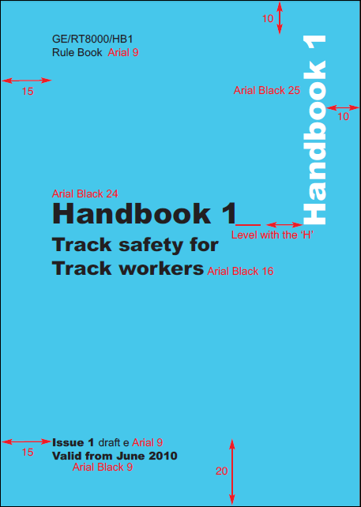Appendix A – PDF handbook layout example (A6)

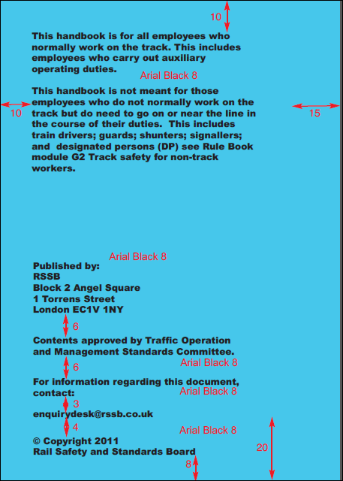

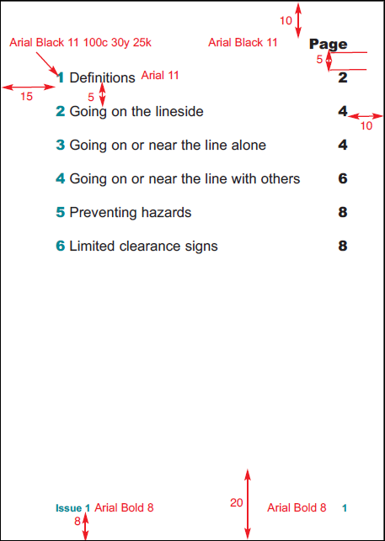

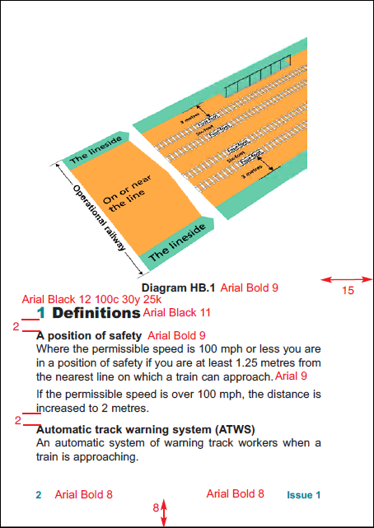

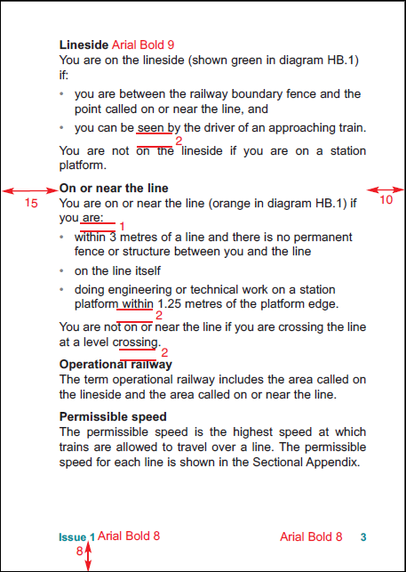

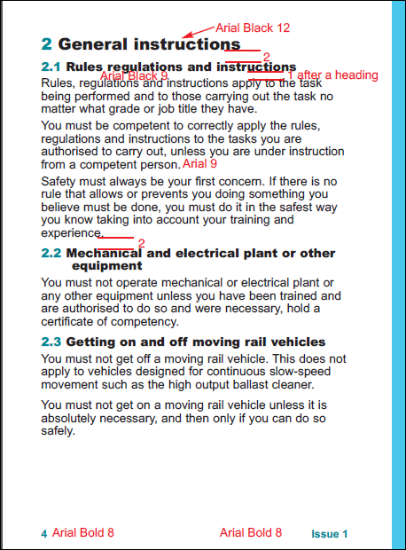



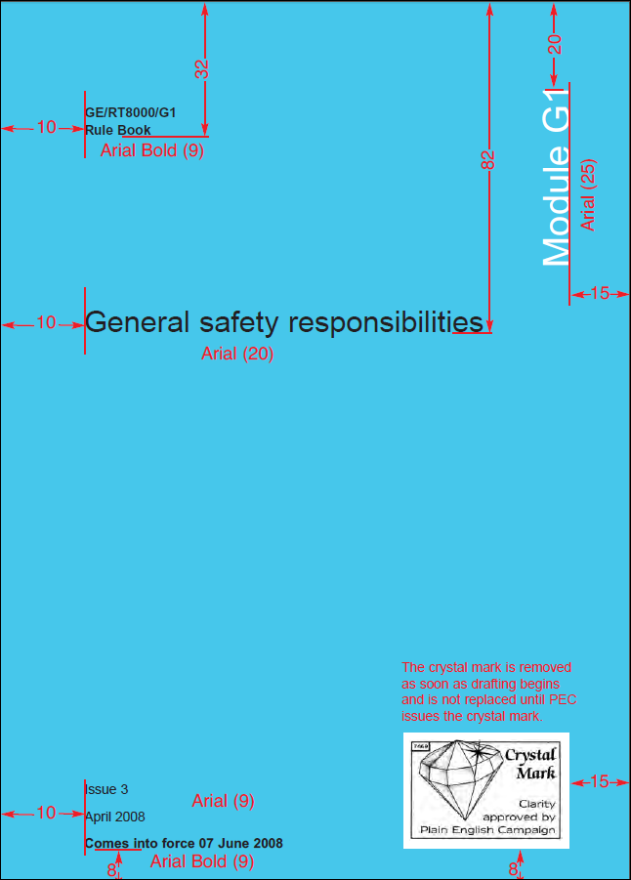Appendix B – PDF module layout example (A5)

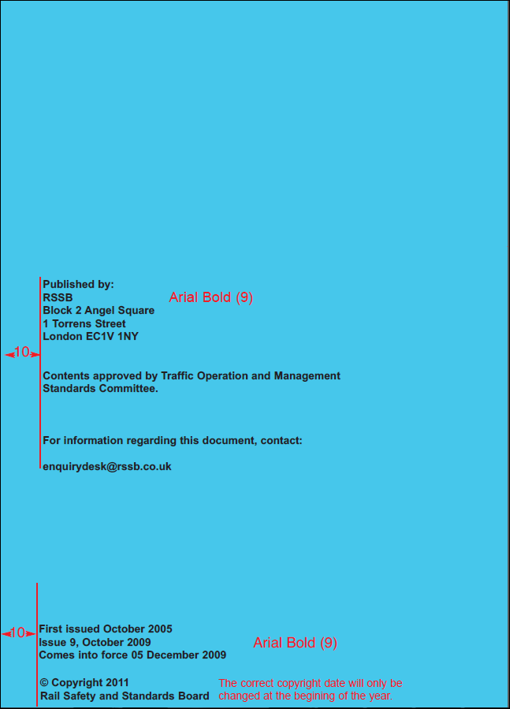

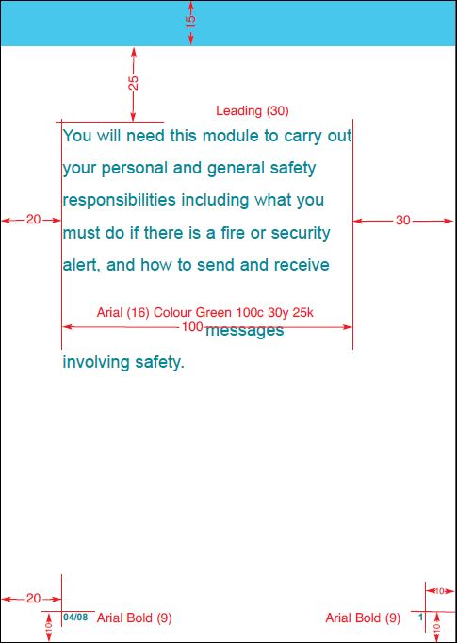

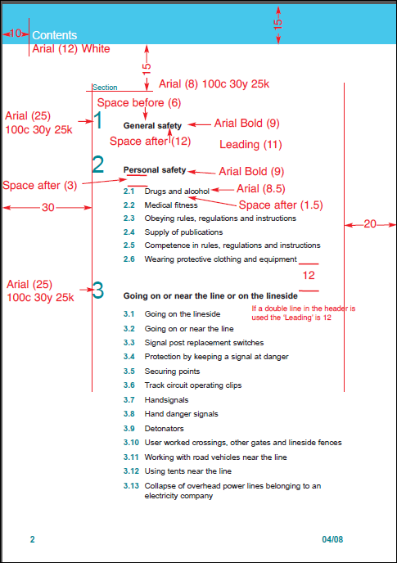

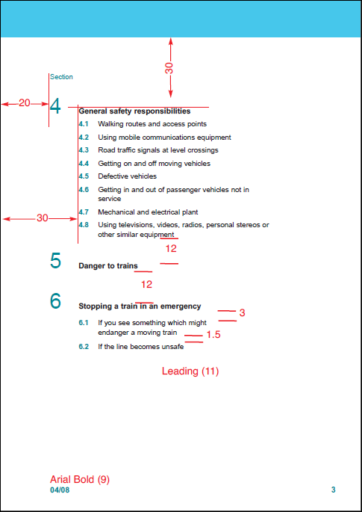

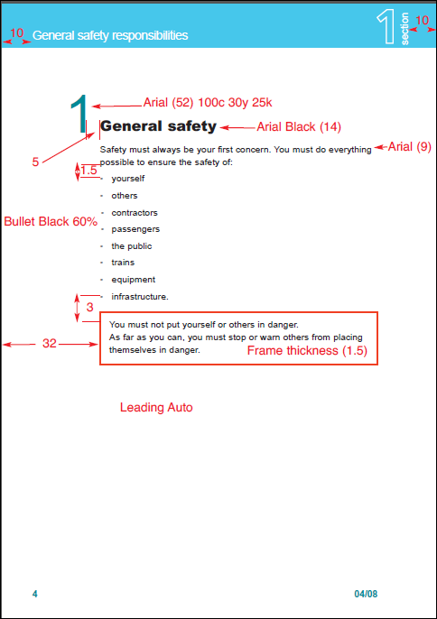

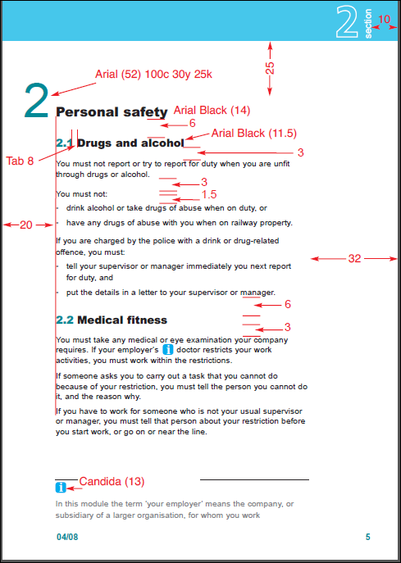

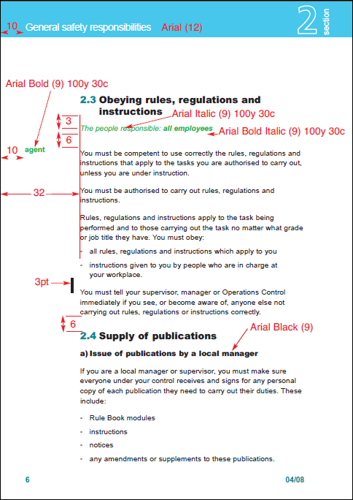

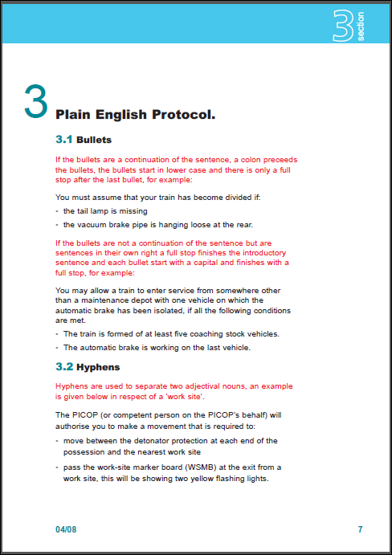







Appendix C –DITA XML examples for rulebook module DITA bookmap and DITA task

### Example bookmap taken from the initial RMDB development

<bookmap id="rulebook_bookmap_1042">

<booktitle>

<booklibrary>Rule Book Module

<!--TIP: Provide the type of Rule Book document--></booklibrary>

<mainbooktitle>General safety responsibilities and personal track safety for non-track

workers

<!--TIP: Provide a descriptive name for the document--></mainbooktitle>

</booktitle>

<bookmeta>

<author>Traffic Operation and Management Standards Committee

<!--TIP: In this element, enter the approving standards committee for the document. This information will be included on the cover of the document.--></author>

<authorinformation>

<organizationinfo>

<namedetails>

<organizationnamedetails>

<organizationname>RSSB</organizationname>

</organizationnamedetails>

</namedetails>

<addressdetails>

<thoroughfare>Block 2 Angel Square</thoroughfare>

<thoroughfare>1 Torrens Street</thoroughfare>

<locality>

<localityname>London</localityname>

<postalcode>EC1V 1NY</postalcode>

</locality>

<country>United Kingdom</country>

</addressdetails>

<contactnumbers>

<contactnumber type="telephone">020 3142 5400</contactnumber>

</contactnumbers>

<emailaddresses>

<emailaddress>enquirydesk@rssb.co.uk</emailaddress>

</emailaddresses>

<urls>

<url>http://www.rssb.co.uk</url>

</urls>

</organizationinfo>

</authorinformation>

<publisherinformation>

<organization>RSSB</organization>

<published>

<revisionid>March 2014</revisionid>

<!--TIP: In this section, enter the publication date for the document. This information will be included on the cover of the document.-->

<completed>

<!--TIP: Use the international date formats for day, month, and year. yyyy for year; mm for month; dd for day -->

<day>01</day>

<month>03</month>

<year>2014</year>

</completed>

</published>

</publisherinformation>

<critdates>

<revised modified="November 2014"/>

</critdates>

<bookid>

<bookpartno>

<!--TIP: Provide the specific document ID of the publication (e.g. TW8 for the Level crossings - drivers’ instructions, Rule Book Module) --></bookpartno>

<edition rev="5">Five

<!--TIP: Enter the Issue number of the document. Do not use a number, but instead spell it out with an initial capital letter. If this is not draft 2 of this issue, change the @rev attribute on this element to the appropriate draft number.--></edition>

<booknumber>GE/RT8000/GT1

<!--TIP: Provide the document number of the publication.--></booknumber>

</bookid>

<bookchangehistory>

<approved>

<!--TIP: In this section, add the name of the person who approved the document, along with the date on which he/she approved it. Use the <organization> element to indicate the organization or standards committee the person represents and the <summary> element to provide his/her title.-->

<person/>

<organization/>

<completed>

<day/>

<month/>

<year/>

</completed>

<summary/>

</approved>

<bookevent type="firstpublished">

<revisionid/>

<completed>

<month>June</month>

<day/>

<year>2003</year>

</completed>

<summary/>

</bookevent>

<bookevent>

<!--TIP: In this section, indicate when the document was submitted for approval and by whom. Include the person's title in the <summary> element.-->

<bookeventtype name="submitted"/>

<person/>

<completed>

<day/>

<month/>

<year/>

</completed>

<summary/>

</bookevent>

<bookevent>

<!--TIP: In this section, indicate the earliest date for compliance to this document.-->

<bookeventtype name="in-force"/>

<completed>

<month>June</month>

<day>07</day>

<year>2014</year>

</completed>

</bookevent>

<bookevent>

<!--TIP: In this section, indicate the latest date for compliance to this document.-->

<bookeventtype name="compliance"/>

<completed>

<month>June</month>

<day>07</day>

<year>2014</year>

</completed>

</bookevent>

<bookevent>

<!--TIP: If this document supersedes another, include the specific document it is replacing in the <summary> element and the date on which the change takes affect. If the document does not supersede another, you can delete this <bookevent>-->

<bookeventtype name="supersedes"/>

<completed>

<day/>

<month/>

<year/>

</completed>

<summary/>

</bookevent>

<bookevent>

<!--TIP: When this document will be superseded by another, include the specific document that will replace it in the <summary> element and the date on which the change takes affect. -->

<bookeventtype name="superseded"/>

<completed>

<day/>

<month/>

<year/>

</completed>

<summary/>

</bookevent>

<bookevent>

<!--TIP: If this document is withdrawn, indicate the date on which should no longer be considered.-->

<bookeventtype name="withdrawn"/>

<completed>

<day/>

<month/>

<year/>

</completed>

</bookevent>

</bookchangehistory>

<bookrights>

<copyrlast>

<year>2015

<!--TIP: Enter the copyright year if different than the one shown.--></year>

</copyrlast>

<bookowner>

<!--TIP: This element indicates who owns the copyright. Do not change this information.-->

<organization>Rail Safety and Standards Board Limited</organization>

</bookowner>

</bookrights>

<!-- The code block to control insertion of the front and back cover images for plain english campaign has been removed from the example due to not currently wroking within the formatter-->

<data name="Corporate Memory">

<foreign>

<!--TIP: Use the table to capture a history of the changes to this document as a whole. Keep in mind that each individual topic captures the changes made within the topic. Use this table only to capture changes related to the structure or topics included in this map.-->

<simpletable frame="all" relcolwidth="1.0* 4.71*">

<sthead>

<stentry>Date</stentry>

<stentry>Description</stentry>

</sthead>

<strow>

<!--TIP: Add a new row to capture a distinct change made to the document.-->

<stentry>

<!--TIP: Enter the date on which the change was made. Use the date picker to enter the

appropriate date.--></stentry>

<stentry>

<!--TIP: Describe the changes made on this date.--></stentry>

</strow>

</simpletable>

</foreign>

</data>

</bookmeta>

<frontmatter>

<!--TIP: A partially completed, conventions topic will be created for you and referenced in the following <notices> element when you choose to create a new Rule Book document. Open the topic by clicking on the reference below and add the appropriate list of duties.-->

<notices href="Conventions.dita" toc="no"/>

<!--TIP: A blank synopsis topic will be created for you and referenced in the following <bookabstract> element when you choose to create a new RGS/RIS document. Open the topic by clicking on the reference below and add the appropriate synopsis statement.-->

<bookabstract href="Synopsis.dita" toc="no"/>

<booklists>

<toc/>

<!--TIP: A blank glossary topic will be created for you and referenced in the following <topicref> element when you choose to create a new RGS/RIS document. Open the topic by clicking on the reference below and conref all appropriate terms that should be defined this document from the master glossary.-->

<glossarylist toc="yes" href="Glossary.dita">

<topicmeta>

<navtitle>Definitions</navtitle>

</topicmeta>

</glossarylist>

</booklists>

</frontmatter>

<!--TIP: The audience attribute values are separated by commas and will appear in the output just beneath the Part title. -->

<part audience="expert, novice, linesman">

<topicmeta>

<navtitle>

<!--TIP: Enter the title of the Part here.--></navtitle>

</topicmeta>

<!--TIP: Add as many <topicref> elements as required to complete the part. For each topic, be sure to include its title in the <navtitle> element as shown below.-->

<topicref>

<topicmeta>

<navtitle>

<!--TIP: Enter the title of the topic here.--></navtitle>

</topicmeta>

</topicref>

<topicref/>

</part>

<!--TIP: Group related rules together into individual parts. For each part, provide the title of the part in the <navtitle> element below. You can add as many <part> elements as required by the document.-->

<part audience="expert, novice, linesman">

<topicmeta>

<navtitle>

<!--TIP: Enter the title of the Part here.--></navtitle>

</topicmeta>

<!--TIP: Use the <mapref> element to point to a map of DITA topics. You must include the @href attribute to point to the path and file name for the DITA map you want to include.-->

<mapref format="ditamap"/>

</part>

</bookmap>

### Example rule book task taken from the initial RMDB development

<task id="task_335" jcm-link-man:uuid="580fe220-06fc-11e6-a958-bc764e091878" xmlns:jcm-link-man="http://jorsek.com/content-management/modules/linkmanagement" domains="(topic task) (topic hi-d basicHighlight-c) (topic hazard-d) (topic abbrev-d) (topic pr-d) (topic ui-d) (taskbody requireSteps-c) (topic math-d) " ditaarch:DITAArchVersion="1.2" xmlns:ditaarch="http://dita.oasis-open.org/architecture/2005/">

<title>Test_Task2

<!--TIP:Use this template for any task from a rulebook. A task consists of specific actions that the user must take to achieve a specific outcome. If the rulebook section consists only of rules that shold be followed, without a specific tangible result, use a concept topic.--></title>

<prolog>

<!--TIP:(optional) If applicable, include all standards committees responsible for this content, each in its own element. Conref to the accepted values from the master StdComm.dita file. If more than one committee, list the primary committee in the LeadStdComm element next.-->

<author/>

<!--TIP:(optional) If applicable, include the lead standards committee responsible for this content. Conref to the accepted values from the master StdComm.dita file. If more than one committee, list the others in the StdComm element earlier.-->

<publisher/>

<metadata>

<!--TIP:(optional) In the @job attribute, select the high level roles associated with the reference if applicable. Enter as many audience elements as needed. Where individual paragraphs and sections need to be tagged for specific roles or steps ie "Signal Box 1", "Signal Box 2", the audience metadata must be used. -->

<audience job=""/>

<!--TIP:(optional) List all generic hazards that might apply to this content. Conref to the master list of hazards, including one hazard per element.-->

<category/>

<!--TIP:Add keywords from the List of Active Keywords that apply to this document. Use a new keyword tag for each keyword you include. Conref terms from the master Keywords.dita file.-->

<keywords>

<keyword/>

</keywords>

<prodinfo>

<!--TIP:Select the rule type in relation to the TSI context.-->

<prodname/>

<vrmlist>

<!--TIP:In the version attribute, select the appropriate version of the TSI Decision/Regulation Number. Enter the actual number in the Program Number (TSI Decision/Regulation Number) element later in this metadata section.-->

<vrm version=""/>

</vrmlist>

<!--TIP:Enter the title of the NOTIF IT parameter; for example, 12.1 Onboard Radio System-->

<brand/>

<!--TIP:Enter the id number of the NOTIF IT parameter; for example, 12.1.-->

<featnum/>

<!--TIP:Indicate the TSI subsystem. Conref to the master list of TSI subsystems.-->

<component/>

<!--TIP:Indicate the TSI title. Conref to the master list of TSI Title Short Forms-->

<series/>

<!--TIP:Enter the applicable TSI Decision or Regulation number. For example, 2008/217/EC. Enter the version of this TSI in the VRM element earlier in this metadata section.-->

<prognum/>

</prodinfo>

<!--TIP:In the content attribute, select the reason that this rule is required.-->

<othermeta name="reason" content=""/>

</metadata>

</prolog>

<taskbody>

<section audience="internal" id="section_corp_mem">

<title outputclass="label">Corporate

Memory

<!--TIP:This section, which is tagged as Internal only, should concisely record what changes were made in this topic, why, and which party initiated the change. Include the following information as relevant:

•A summary of the anticipated effect

•A reference to the meeting date, minutes, and committee that approved the change.

•A brief history of the requirement

•Any significant consultation comments

•Reasons for delaying/speeding up of implementation--></title>

<simpletable frame="all" relcolwidth="1.0* 4.71*">

<sthead>

<stentry outputclass="label">Date

<!--TIP:Enter the date on which the change was made. Use the date picker to enter the

appropriate date.--></stentry>

<stentry outputclass="label">Description

<!--TIP:Describe the changes made on this date.--></stentry>

</sthead>

<strow>

<stentry/>

<stentry>

<p/>

</stentry>

</strow>

</simpletable>

</section>

<context>

<!--TIP:Provide information regarding the purpose of the task, who should complete the task, when, and why. If necessary, also provide related background information, if it is shorter than two or three paragraphs. Otherwise, refer users to a related concept topic.-->

<p/>

</context>

<steps>

<!--TIP:Describe each step in the process, using imperative commands. -->

<step>

<cmd/>

</step>

</steps>

<!--TIP:Describe what should happen or what something should look like when the entire task has been completed correctly if it is not apparent what will happen from the title of the topic.-->

<result/>

<!--TIP:If necessary present specific scenarios and show how the task would be completed in those scenarios. Users can greatly benefit from examples that illustrate the task they are trying to complete or that help them relate a concept to their own situation.-->

<example/>

<!--TIP:List anything the user needs to know or do after completing the task. This information may include actions that need to be completed before the user can see the expected results, such as information that the user needs to read or cross-reference to verify the completion of the task.-->

<postreq/>

</taskbody>

</task>

Appendix D – list of in scope documents

|  |  |
| --- | --- |
| **Number** | **Title** |
| GERT8000-RBBL Iss 28 | Rule Book Briefing Leaflet |
| GERT8000-HB13 Iss 2 | Duties of the person in charge of the siding possession (PICOS) |
| GERT8000-Issue HB Iss 7 | Rule Book Handbook Issue History |
| GERT8000-HB7 Iss 5 | General duties of a controller of site safety (COSS) |
| GERT8000-HB17 Iss 3 | DC electrified lines |
| GERT8000-HB11 Iss 5 | Duties of the person in charge of the possession (PICOP) |
| GERT8000-HB1 Iss 4 | General duties and track safety for track workers |
| GERT8000-HB16 Iss 3 | AC electrified lines |
| GERT8000-HB9 Iss 5 | IWA or COSS setting up safe systems of work within possessions |
| GERT8000-HB15 Iss 4 | Duties of the machine controller (MC) and on-track plant operator |
| GERT8000-HB8 Iss 5 | IWA, COSS, or PC blocking a line |
| GERT8000-HB19 Iss 3 | Work on signalling equipment - duties of the signalling technician |
| GERT8000-HB3 Iss 3 | Duties of the lookout and site warden |
| GERT8000-HB4 Iss 2 | Duties of a points operator and route-setting agent - moving and securing points by hand |
| GERT8000-HB5 Iss 2 | Handsignalling duties |
| GERT8000-HB6 Iss 5 | General duties of an individual working alone (IWA) |
| GERT8000-HB12 Iss 5 | Duties of the engineering supervisor (ES) or safe work leader (SWL) in a possession |
| GERT8000-HB2 Iss 2 | Instructions for track workers who use emergency protection equipment |
| GERT8000-HB10 Iss 4 | Duties of the COSS or SWL and person in charge when using a hand trolley |
| GERT8000-HB20 Iss 2 | General duties of a safe work leader (SWL) working outside a possession |
| GERT8000-HB14 Iss 2 | Duties of the person in charge of loading and unloading rail vehicles during engineering work |
| GERT8000-HB21 Iss 2 | Safe work leader (SWL) blocking a line |
| GERT8000-HB18 Iss 4 | Duties of a level crossing attendant |
| GORT3053-PPBL Iss 3 | Pink Pages Briefing Leaflet |
| GORT3053-2 Iss 6 | Working Manual for Rail Staff Handling and Carriage of Dangerous Goods - Appendix 2 - Bulk Traffic Dangerous Goods, Wagon and Container Separation Distance Requirements / Prohibitions |
| GORT3053-1 Iss 7 | Working Manual for Rail Staff Handling and Carriage of Dangerous Goods - Appendix 1 - List of Dangerous Goods with their United Nations Number, Dangerous Goods Class and TOPS Commodity Code |
| GORT3053 Iss 5 | Working Manual for Rail Staff Handling and Carriage of Dangerous Goods |
| Form RT3180 Iss 12-15 | Signaller's Line Blockage Form |
| GERT8000-AC Iss 4 | AC electrified lines |
| GERT8000-DC Iss 4 | DC electrified lines |
| GERT8000-TS10 ERTMS Iss 3 | ERTMS level 2 train signalling regulations |
| GERT8000-HB12 ERTMS Iss 2 | Duties of the engineering supervisor (ES) or safe work leader (SWL) in a possession on ERTMS lines where lineside signals are not provided |
| GERT8000-HB15 ERTMS Iss 2 | Duties of the machine controller (MC) and on-track plant operator on ERTMS lines where lineside signals are not provided |
| GERT8000-HB11 ERTMS Iss 2 | Duties of the person in charge of the possession (PICOP) on ERTMS lines where lineside signals are not provided |
| GERT8000-HB9 ERTMS Iss 2 | IWA or COSS setting up safe systems of work within possessions on ERTMS lines where lineside signals are not provided |
| GERT8000-G1 Iss 6 | General safety responsibilities and personal track safety for non-track workers |
| GERT8000-Gloss Iss 2 | Glossary of Railway Terminology |
| GERT8000-Issue Iss 25 | Rule Book Module Issue History |
| GERT8000-M2 Iss 4 | Train stopped by train failure |
| GERT8000-M1 Iss 3 | Dealing with a train accident or train evacuation |
| GERT8000-M3 Iss 2 | Managing incidents, floods and snow |
| GERT8000-OTM Iss 7 | Working of on-track machines (OTM) |
| GERT8000-P2 Iss 4 | Working single and bi-directional lines by pilotman |
| GERT8000-P1 Iss 6 | Single line working |
| GERT8000-PoSA Iss 3 | Proceed-on-Sight Authority (PoSA) |
| GERT8000-S7 Iss 2 | Observing and obeying fixed signals: Train warning systems: Reporting signalling failures and irregularities |
| GERT8000-S4 Iss 5 | Trains or shunting movements detained on running lines |
| GERT8000-S5 Iss 6 | Passing a signal at danger or an end of authority (EoA) without a movement authority (MA) |
| GERT8000-SP Iss 5 | Speeds |
| GERT8000-SS1 Iss 4 | Station duties and train dispatch |
| GERT8000-SS2 Iss 5 | Shunting |
| GERT8000-T3 ERTMS Iss 3 | Possession of an ERTMS running line for engineering work where lineside signals are not provided |
| GERT8000-T3 Iss 6 | Possession of a running line for engineering work |
| GERT8000-T10 Iss 4 | Duties of a designated person (DP) and people working on rail vehicles |
| GERT8000-TS11 Iss 2 | Failure of, or work on, signalling equipment - signallers' regulations |
| GERT8000-TS1 Iss 10 | General signalling regulations |
| GERT8000-TS3 Iss 6 | Absolute block regulations |
| GERT8000-TS9 Iss 4 | Level crossings - signallers' regulations |
| GERT8000-TS2 Iss 4 | Track circuit block regulations |
| GERT8000-TS4 Iss 4 | Electric token block regulations |
| GERT8000-TS5 Iss 4 | Tokenless block regulations |
| GERT8000-TS7 Iss 5 | No-signaller token regulations |
| GERT8000-TS8 Iss 4 | One-train working regulations |
| GERT8000-TW5 Iss 6 | Preparation and movement of trains. Defective or isolated vehicles and on-train equipment |
| GERT8000-TW1 Iss 10 | Preparation and movement of trains |
| GERT8000-TW8 Iss 7 | Level - crossings - drivers' instructions |
| GERT8000-TW7 Iss 6 | Wrong-direction movements |
| GORT3056-WPBL Iss 1 | White Pages Briefing Leaflet |
| GORT3056 Iss 4 | Working Manual for Rail Staff - Freight Train Operations |