VOLY stakeholder workshop – Monday 25 September

HSE is holding a workshop to discuss a project to explore new research to establish a monetary estimate of the social value of a life year (and QALY) for use in UK Government economic appraisal. The workshop will take place at the Department of Health [directions in Annex I below]. For invitees unable to attend in person we plan to provide Skype audioconferencing and BlueJeans video conferencing links . The agenda is still being confirmed, however we aim to begin at 11:00, with a view to finish around 16:00 (please note this may change depending on attendance). A final agenda for the workshop with be circulated prior to the event.

The objective of the workshop is to bring together UK government officials, academics and other experts to facilitate an open and frank discussion about the challenges of estimating monetary values for life and health impacts in economic appraisal. The outcomes of the workshop will inform the final research specification for a scoping study that the Government is hoping to commission to further examine these issues. Further background to this work is presented below.

To this end, the workshop will include a session where the funding Departments and Agencies discuss how they apply these valuations in appraisals (and some of the challenges they encounter in doing so). This will be followed by a presentation of plans for the research specification for the scoping study, with an opportunity to ask questions of the Departments.

The afternoon will include a session in which experts can showcase relevant research.

There are still a number of spaces available in this session and so if you would like to give a short presentation on some research that you have been involved in in this area (and that you would be happy to share), please respond with a brief summary of the work. Please note that presenting (or not presenting) at the event does not preclude you from bidding on the research.

Spaces are limited, and so I would be grateful if you could reply by COP Friday 8 September
via email to tenders@hse.gov.uk to confirm your attendance (please highlight if you would like to attend in person, or connect via teleconferencing or videoconferencing).

Background to the project

So that the costs of policies designed to reduce health risks (compliance costs) can be compared with the benefits (in terms of avoided injury/ill health) in the same metric, UK government cost-benefit analysis (CBA) typically seeks to monetise life and health impacts of policy interventions. The value afforded to these impacts is therefore critical in ensuring that economic appraisals of government interventions reliably and credibly provide a sound basis for policy decisions. A number of approaches are applied across government, and proposals that were put forward by the Interdepartmental Group on the Valuation of Life and Health (IDGVLH) to HM Treasury aim to achieve greater consistency. The proposals, likely to be reflected in the new Green Book expected towards the end of this year, place greater emphasis than current guidance on the monetary valuation of statistical life years lost or gained (VOLY), while recommending the use of measures of health-related quality of life for changes in morbidity, such as quality- or disability-adjusted life years (QALYs or DALYs), chained to a VOLY.

Research that underpins the Department for Transport’s ‘Value of a Prevented Fatality’ (VPF), forms the basis for estimates of the public’s monetary valuation of risks to life and health across UK government (including the current VOLY), however there are a range of methodological and conceptual issues inherent in arriving at a VOLY. Accordingly, a consortium of government bodies (comprising, in alphabetical order, the Department for Environment, Food and Rural Affairs, Department for Transport, Department of Health, Food Standards Agency, the Health and Safety Executive and Home Office) is interested in exploring new research to establish a monetary estimate of the social value of / willingness to pay for a life year (and QALY) for use in appraisal. In line with recommendations from a review of the VPF (commissioned in 2011), the project will begin with a scoping study to explore some of these challenges and inform any subsequent specification for new primary valuation work. (If intending participants are not familiar with this report² we can send a copy.)

Annex I – Directions to Department of Health, Richmond House

Richmond House is located at 79 Whitehall, London, SW1A 2NS. See below for a map indicating its exact location.

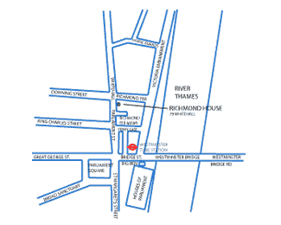
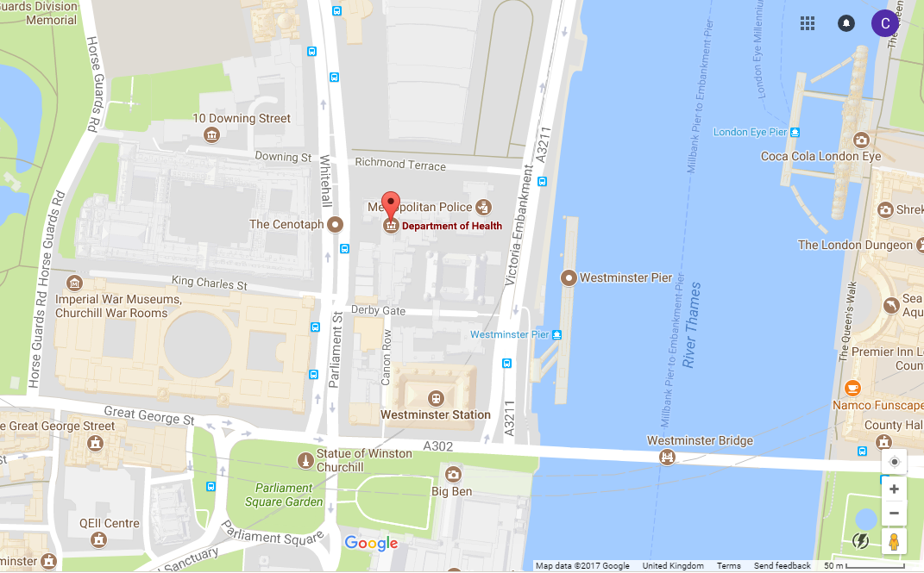

Richmond House, the home of the Department of Health, is in the heart of Westminster, within walking distance of the Houses of Parliament and various other Government departments.

If you are travelling by Tube, the nearest Underground station is Westminster. From Westminster station, exit right onto Bridge Street, turn right again onto Parliament Street and walk for a few minutes until the road becomes Whitehall.

Richmond House is on your right, before you reach the Cenotaph.

NB the number of feasible separate VC links has yet to be established
NERA Economic Consulting, London. (2011). Updating the VPF and VPIs: Phase 1: Final Report, Department for Transport.

