Tender for Gaydon Meadow Natural Play Area

Gaydon Parish Council March 2020

Invitation to Tender: Provision to design and install play equipment in a newly designated open space in Gaydon

Contents
1. General Requirements/Background.....................................................................................................
2. Prices.....................................................................................................................................................
3. Contract Conditions..............................................................................................................................
4. Project Specification ............................................................................................................................
5. Materials...............................................................................................................................................
6. Surfacing...............................................................................................................................................
7. Waste....................................................................................................................................................
8. Post Installation Inspection ..................................................................................................................
9. Project timetable .................................................................................................................................
10. Collusive Tendering............................................................................................................................
11. Evaluation...........................................................................................................................................
12. Scoring of Tenders .............................................................................................................................
13. Format for Response...........................................................................................................................
14. Non-Consideration of a Tender Response .........................................................................................
15. Contract Administrator.......................................................................................................................
16. Appendix A: Tender return.................................................................................................................

1. General Requirements
Gaydon Parish Council (GPC) have secured funding to develop a newly designated public open space and is seeking an experienced company to design, project manage and build a new natural play area with the emphasis on PLAY VALUE. We are looking to install a bespoke, natural, robust and durable play area which is unobtrusive and blends into the rural environment. Play value is of upmost importance and companies which can demonstrate that the Play England ten design principles are being observed will score more highly. https://www.playengland.org.uk/media/70684/design-for-play.pdf
The overall project will deliver a range of social possibilities for the whole community to enjoy - imagine a play space that children will seek out, enjoy and return to – remembering their time for years to come. We wish to promote a healthy community, encouraging inclusion and adult participation, acknowledging that this will also be an important social space for parents and carers.
Our concept is to create a space sympathetically managed for people and wildlife. This needs to be at the heart of any design. A successful design would be an integrated space so that all ages and abilities play together. It could include a toddler ‘zone’ for tinies and tots and an older children’s area with a variety of play experiences including non-prescriptive play equipment and features, which put play in the control of children and encourage imagination and creativity.
The supplier will need to have proven and demonstrated experience in similar projects (preferably in National Trust/Wildlife Trust settings) and a wide ranging skill base to achieve the various elements of the contract, working closely with GPC and user groups in the construction and installation of a community playground, health & safety management and defect diagnosis and rectification. The supplier must be able to demonstrate an excellent Health and Safety record, accordingly suppliers that cannot demonstrate an excellent record, free from enforcement action, will not be considered.
The supplier must also demonstrate that all practicable steps are being taken to allow equal access and equal treatment in employment and service delivery, as appropriate to the nature of the project as well as Sustainability – the environment should always be front of mind as we are working toward creating an area sympathetically managed for both people and wildlife.
Please note a maximum of £59,000 exclusive of VAT is available for the build of the playground. The playground must have the surrounding natural environment at the heart of the design as it is a special, semi improved, species rich meadow.

Background:
We have planning permission for the far end of the meadow with some conditions which you will find attached, but in short, structures may not exceed 4m in height and equipment must only be installed on the indicated area.
The area with planning permission is a semi-improved hay meadow with a variety of grasses and wildflowers and visible earthworks on the village side which hint at the remains of a medieval settlement.
A public footpath crosses the field on our side where the divide is shown, this is used by local dog walkers. The hatched area shown is reasonably level. There is a wet area at the very rear boundary which should be considered – equipment should be placed away from this area.
Figure 1 & 2. (Aerial image of the field, the area shown in figure 2 indicates the area with planning permission for a play area, this measures approx. 40m x 40m, ideally the play area equipment will not exceed 1000sqm and does not need to conform to the square layout).
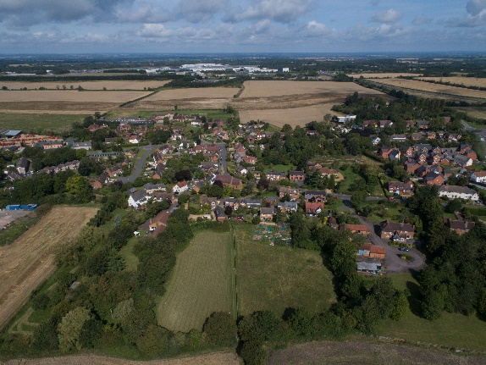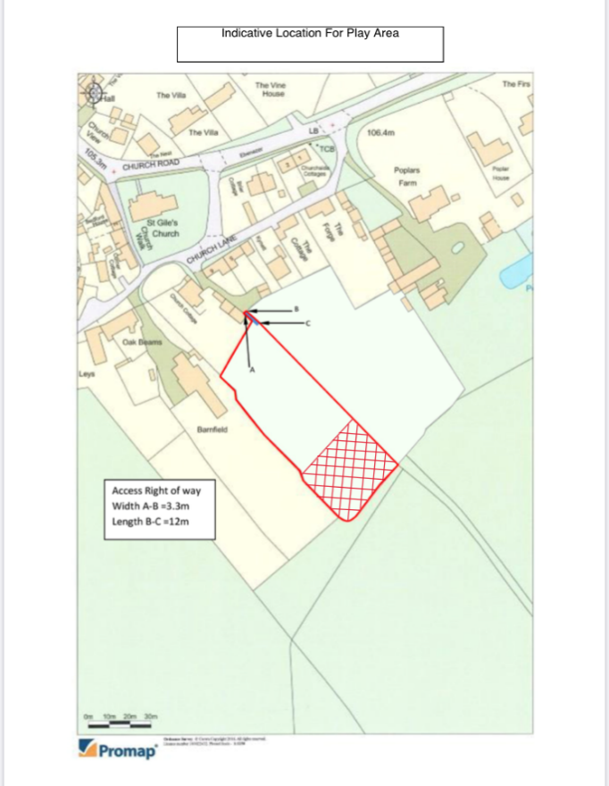
WET AREA

2. Prices
All pricing should be exclusive of VAT and valid for 12 Months from the due date of the response. Prices will be fixed and firm for the duration of the contract.
3. Contract Conditions
The successful supplier will enter into a contract by way of a Purchase Order with Gaydon Parish Council. The works will include
• the design and build of a playground according to the design brief,
• supply of appropriate drawings to show proposed layout
• supply and installation of all equipment, surfacing and furniture
Equipment must conform to BS EN 1176. Where equipment is unable to meet a standard, an explanation of acceptability or third party testing by a recognised body or a risk assessment by RoSPA must be provided. Compliance may be judged by a BS Kitemark, TuV mark or by such testing as may be carried out on site without dismantling or destruction, by RoSPA. The successful supplier must provide written confirmation of Standard compliance where relevant and evidence of Public Liability Insurance of no less than £5 Million, Employers Liability Insurance of no less than £5 Million and Professional Indemnity insurance of no less than £5 million to the council within the tender response.
The supplier is assumed to have visited the site to assess the nature of the work, access, topography etc. and carried out relevant services checks. Confirmation of work hours, storage of materials, access, location of skips and a final Programme of Works and Risk Assessment Methods Statements (RAMS) will need to be finalised and agreed with the Parish Council before work begins. During installation, the supplier should provide a secure work compound for the build, this compound should ensure that the public cannot gain access to the work site, we suggest the supplier erect suitable HERAS fencing and safety notices around the construction site. The supplier must take all reasonable action to ensure that newly installed apparatus is not used until practical completion is confirmed. Any machinery left on site overnight must, where possible, be immobilised. The supplier will be held responsible for a) any damage caused to machinery/materials left on site by the supplier; b) any damage caused by machinery/materials left on site by the supplier; c) any vandalism caused to machinery/materials left on site by the supplier. The supplier will be held responsible for and must make good any damage caused to existing buildings, roads, paths, grassed areas, car parks, fences, drains, sewers, service mains, landscaping etc. and for completion of the project, any area that has been damaged during the installation must be made good and returned to new or as a minimum returned to the original condition at the supplier’s expense.
4. Project Specification
The supplier will provide turnkey (end to end) service. It is expected all labour, materials, fuel, water, carriage, plant, tools and machinery of all descriptions in order to execute the works.
5. Materials
GPC is looking for longevity, durability and above all ‘natural’ Equipment. Equipment should be mainly timber – British, FSC hardwood timber is preferred, from both an eco-friendly and sustainability stand point, such as Robinia, Sweet Chestnut and Oak, with steel fittings and consideration taken to ongoing maintenance. All materials will be of the best of their respective kinds and shall conform to appropriate British and if appropriate European Standards. All timber in the ground should be wrapped and protected with a robust water and air proof layer, with a strimmer border surround in polyurethane bound rubber and a PVC strimmer guard.
6. Surfacing
GPC has a preference for grass matting to blend into the natural environment and to focus on the actual play equipment. For areas of attenuation rubber mats may also be considered. Protection around posts to minimise maintenance and potential for strimmer damage is also required. Surfacing will have been tested in accordance with BS7188 and EN1177. Protected surfacing shall be laid in areas recommended by EN1176 as being appropriate.
7. Waste
The supplier must ensure that all waste materials produced during these works that cannot be reused onsite, are transported from site using waste carriers with a current Waste Carriers License appropriate for the type of waste being transported. A copy of the Waste Carriers License for all carriers being used during the course of these works must be provided to GPC if requested. Wherever possible, waste materials will be taken to appropriate waste recycling centres. Where waste cannot be recycled, it shall be taken to an approved tip. GPC may require evidence of which tipping sites are being used, and where required, appropriate copies of Waste Site Licenses for the tipping site must be provided.
8. Post Installation Inspection
Following completion, a ROSPA inspection will need to be undertaken and any noted defects or medium to high risk reports will need to be attended to and resolved in accordance with the project timetable. After completion of the construction and before handover GPC may also arrange an independent inspection by ROSPA or equivalent authority and require resolution of defects and risks before handover and final payment.
9. Project timetable
Suppliers will need to provide within the tender response confirmation (or Programme of Works) that these dates for starting and finishing the project can be met.
Action Date Due By
Tender Response Due  Contract Award Date  Project Start Date  Project Completion  Post Installation Report completed and snagging issues rectified while contractor still on site | 03/04/20  06/05/20  25/05/20  30/06/20  01/07/20

10. Collusive Tendering
Any tenderer who:-
• fixes or adjusts the amount of his Tender by or under in accordance with any agreement or arrangement with any persons; or
• communicates to any person other than GPC the amount or approximate amount of the proposed Tender except where the disclosure is made in confidence in order to obtain quotations for insurance necessary for the preparation of the Tender; or
• enters into any agreement with any person that he shall refrain from tendering or as to the amount of any Tender to be submitted; or
• offers or agrees to pay or give any sum of money, inducement or valuable consideration directly or indirectly to any person for doing or causing to be done any act or omission in relation to the supply of goods and services specified or proposed in this Tender: or
• directly canvasses any member of the council concerning the tender (other than “appropriate” communication with the named contacts within this document for the purposes of clarifying the requirements, or raising any questions pertaining to the tender); or
• commits an offence or inappropriate action, including an offence under the Prevention of Corruption Act; shall (without prejudice to any other civil remedies and/or criminal liability) be disqualified.

11. Evaluation
The evaluation will be in accordance with the following criteria, a fail under the Health and Safety criteria will automatically result in exclusion from the tender list. An aggregate of 3 or more fails will automatically result in exclusion from the tender list.
Item Score
Proven experience in the supply and installation of play equipment. | Pass/Fail
Proven experience in supply and installation of safety surfacing. | Pass/Fail
Resources and availability to meet timetable. | Pass/Fail
Financial capability. | Pass/Fail
Evidence of an excellent Health and Safety Record (no enforcement action under current legislation). | Pass/Fail
Evidence that all practicable steps are being taken to allow equal access and equal treatment in employment and service delivery, as appropriate to the nature of the contract. | Pass/Fail
Evidence of Public Liability Insurance of no less than £5 Million; Employers Liability Insurance of no less than £5 Million; Professional. Indemnity insurance £5 Million. | Pass/Fail

12. Scoring of Tenders
Scoring will be assessed in accordance with the following criteria. The design would ideally incorporate zones for tinies and tots and older children and should include challenging climbing experiences, swings for all ages (including a basket swing), Roundabout, Zip Wire and Slides. Play Equipment to consider the local environment and rural setting in its design. Please note that the maximum budget does not have to be met.
45% Concept, Play Value, Play England 10 Design Principles | Overall design reflects concept. Variety of play activities for all ages and abilities.
20% Longevity, Quality, Sustainable Materials and Durability | Maintenance, expected longevity of equipment and surfacing
10% Price | Competitiveness, Good value
10% Warranties | What is covered in the warranty, length of warranty for each type of material. We require at least 2 years warranty.
10% Presentation | Overall presentation of submission and visuals.
5% GPC is not bound to accept any tender and does not commit to accepting the lowest priced tender. The amount of the successful Tender and the name of the Contractor may be published on the Contracts Finder portal. If in special circumstances a Tenderer does not wish detail of his successful Tender to be released, he should notify his objections and reasons at the time of tendering.

13. Format for Response
Please provide to the The Clerk, Gaydon Parish Council, at the address shown below:
A project plan.
1 x A1 hard copy of any visuals / designs.
1 x A4 hard copy of any supporting material such as the quotation.
A detailed breakdown of the tendered amount showing, as a minimum
- The cost of each piece of equipment
- The cost of the safety matting etc for each piece of equipment
- The cost of installing each piece of equipment
- Details of any proposed sub-contractors, if any.
- Details of annual maintenance costs and parts
Information sheet that includes:
• Company name, address, and registration number.
• Company bankers name, sort code, account name and account number.
• Contact name, position, email address and phone number.
• Last set of audited accounts.
• Details of any enforcement action under Health & Safety Legislation.
• Brief details of two recent (within last 36 months) similar projects undertaken by the company (Maximum 1000 words).
- Confirmation that the company should they be successful, will be able to meet the timetable set out.
- Insurance details confirming that the Contract requirements are met. Additionally, you should include a USB memory stick containing electronic copies of the above. The items should be clearly marked in the top left corner “Tender response – to be opened only by tender panel”. Alternatively, an address label is included at Appendix A. To maintain the sealed tender process, electronic documents should not be submitted directly to the Parish Council.

14. Non-Consideration of a Tender Response

GPC has the right to refuse any or all submissions without tenderers being able to claim any compensation. All costs associated with the tender process and response is the responsibility of the suppliers that participate in this tender process.

GPC may refuse a tender response if there has been any attempt to vary or alter the details within the document, or the supplier is not able to provide all the information required by the council to make a full evaluation. Any offence or inappropriate actions by the supplier, including an offence under the Prevention of Corruption Act or the supplier directly canvasses any member of the council concerning the tender other than “appropriate” contact with the individuals named within this document for the purposes of clarifying the requirements or raising any questions pertaining to the tender.

15. Contract Administrator

Any questions relating to the tender should be directed in writing/email to: The Clerk: gaydonpc@gmail.com

