Public First Limited Government Communication Service
REDACTED TEXT REDACTED TEXT

5th June 2020

Dear Public First Limited,

Direct Award of Contract – CCZZ20A24 Research in to Government Communications

I am writing to inform you that Cabinet Office (the “Customer”) proposes to make an award of a contract to you to provide extremely urgent deliverables as part of the response to unforeseeable consequences of the COVID-19 pandemic on the terms set out in this letter (the “Contract”).

Due to unforeseeable consequences of the current COVID-19 pandemic, Cabinet Office reasonably anticipates that the Public Contracts Regulations 2015 will apply to this Contract and the Parties shall ensure that there is a lawful basis for awarding the Contract under the Public Contracts Regulations 2015 and/or any applicable procurement rules. Due to unforeseeable consequences of the current COVID-19 pandemic, this may include in particular justifications under Regulation 32 of the Public Contracts Regulations 2015 or such other applicable or equivalent provision.

The Contract

In the light of the extreme urgency of the current situation and as you are already a supplier on Research Marketplace Dynamic Purchasing System RM6018 (the “DPS Contract”), the Contract shall be based on the DPS Contract’s Contract Terms as follows:

- The Supplier shall supply the Services and the Deliverables to complete the Project as specified in Annex A to this letter as if Annex A to this letter was each of a Letter of Appointment and a Statement of Work for the Project comprising of each of a Customer Project Specification and a Supplier Proposal.

- The Contract Charges relating to the Project are specified in Annex A to this letter.

- The Special Terms set out in the Statement of Works at Annex A to this letter apply to the Contract. The Special Terms set out in Annex A to this letter are terms of this letter.

- The Effective Date of the Contract will be 3rd March 2020.

- The Customer and the Supplier acknowledge and agree that:

  - each of the Effective Date and the Project Commencement Date occurred before the date on which the Parties documented the terms of the Contract;

  - the terms of the Contract documented in this letter are all of the terms upon which the Parties agreed to contract on and from the Effective Date; and

  - no other written or oral agreements, representations or understandings exist between them in respect of the subject-matter of this Contract.

- The Expiry Date of the Contract will be 2nd September 2020.

- This Contract is not conditional upon the receipt of a Guarantee.

- The documents from the DPS Contract specified in Annex B to this letter are incorporated into the Contract (the “Incorporated Documents”). If any of the Incorporated Documents conflict with any of the terms of this letter, the terms of this letter prevail.

- References in the Contract Terms to “Agreement” shall be read as references to this Contract.

- References in the Incorporated Documents to “Letter of Appointment” shall be read as references to this letter.

- “Force Majeure”, as defined in paragraph 1.6 of Schedule 1 of the Contract Terms, shall exclude any acts, events, omissions, happenings or non-happenings arising out of or in connection to either or both coronavirus (the severe acute respiratory syndrome coronavirus 2 (SARS-CoV-2)) and/or COVID-19 (the official designation of the disease which can be caused by coronavirus).

- For the avoidance of doubt, the DPS Contract and any provision of any Incorporated Document which relates only to the DPS Contract (other than clauses Clause 6 of the DPS Contract, DPS Schedule 5 (Management Charge and Information) and the corresponding definitions contained in DPS Schedule 1 (Definitions and Interpretation) which are incorporated into the Contract by paragraph 14 below) are not incorporated into the Contract.

- In spite of paragraph 13 above, the Customer and the Supplier agree that:

  - clause 6 of the DPS Contract;

  - DPS Schedule 5 (Management Charge and Information); and

  - all definitions for terms defined in DPS Schedule 1 of the DPS Contract which are capitalised and used in clause 6 of the DPS Contract and DPS Schedule 5 (Management Charge and Information),

are incorporated into this Contract so that:

  - the Supplier shall on receipt of an invoice from the Crown Commercial Service (“CCS”) for the Management Levy, pay the Management Levy and provide Management Information using the process in clause 6 of the DPS Contract; and

  - the Customer and the Supplier agree that clause 28 of the Contract Terms (Third Party Rights) apply to this paragraph 15 to the extent necessary to ensure that CCS will have the right to enforce any obligation owed to it by the Supplier under this paragraph 15 in its own right under section 1(1) of the Contract (Rights of Third Parties) Act 1999.

- References to “Contract” in the clauses and schedules of the DPS Contract which are incorporated into this Contract by paragraph 14 above shall be read as references to this Contract.

- If the Customer and the Supplier enter into the Contract, the Customer and the Supplier will, each at their own expense, do all acts and things necessary or desirable to give effect to the Contract.

Accepting the offer of the Contract

In the circumstances, Cabinet Office proposes to confirm that the Parties entered into the Contract on 3rd March 2020 exceptionally by an exchange of correspondence.

Please confirm that you accepted the Contract terms on that date by email REDACTED TEXT, using the heading CCZZ20A24 Research in to Government Communications.

To assist us in managing the process, please respond by 17:00 on 9th June 2020.

Please provide the following information with your email confirmation of acceptance:

- Authorised Supplier Approver (name, role, email address and address)
- Commercially Sensitive Information (not applicable or insert your Commercially Sensitive Information)
- Key Individuals (name, role, email address and address)
- Supplier Address (registered address if registered)
- Registration number (registration number if registered)
- DUNS number (if known)
- SID4GOV ID (if known)

If you have any queries, please contact the team on rebecca.williams@crowncommercial.gov.uk.

Yours faithfully,

REDACTED TEXT

5th June 2020

Annex A
Project, Services and Deliverables, Contract Charges and Special Terms

Project: | CCZZ20A24 Research in to Government Communications
Project Commencement Date: | 3rd March 2020
Project Completion Date: | 2nd September 2020
Project Term: | 6 months
Project Notice Period: | The period of notice for cancellation of a Project is to be set out in the Statement of Work
Services & Deliverables: | The following is within scope of this requirement:  - Recruitment and delivery of focus groups and/or mini groups to an agreed specification, covering the general public and key sub-groups defined by demographic, lifestage or other agreed criteria. Same-day topline reporting and next-day fuller reporting of focus group findings.  - On-site resource to support Number 10 Communications.  Please see Annex A – Statement of Requirements for details of the Services and Deliverables to be provided as part of this Contract.
Inclusion of Additional Schedules | Not Applicable
Project Plan: | 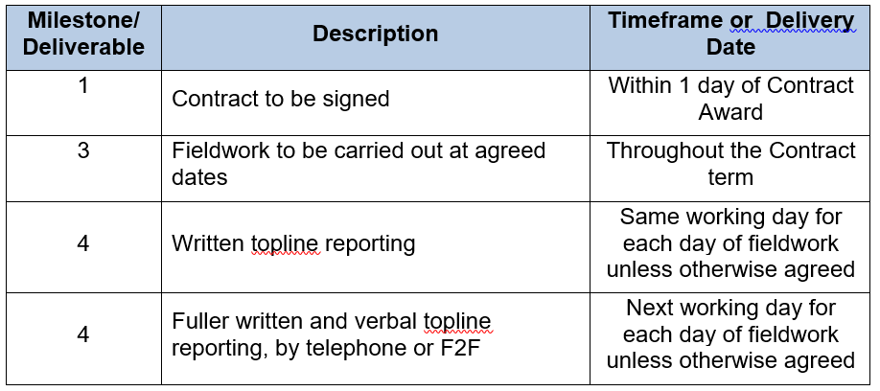

Contract Charges: | See Schedule 6 – Contract Charges of ‘CCZZ20A24 Terms and Conditions’.
Customer Materials: | Not Applicable
International locations | Not Applicable
Customer Affiliates: | Not Applicable
Special Terms: | Not Applicable
Authorised Customer Approver: | REDACTED TEXT

Annex B
Incorporated Documents

The documents specified in this Annex B are incorporated into the Contract from the DPS Contract.

Where numbers are missing, those schedules are not included. If the Incorporated Documents conflict with each other, the following order of precedence applies:

- The Contract Terms from RM6018
- The following Schedules to the Contract Terms in equal order of precedence:
- The Schedules from the Contract Terms for RM6018
- Schedule 1 – Definitions And Interpretations
- Schedule 2 – Statement Of Work
- Schedule 3 – Staff Transfer
- Schedule 4 – Dispute Resolution Procedure
- Schedule 5 – Variation Form
- Schedule 6 – Contract Charges
- Schedule 7 – Processing, Personal Data And Data

No other Supplier terms are part of the Contract. That includes any terms written in the email accepting the offer of the Contract or presented at the time of delivery.

The Incorporated Documents can be found at https://www.crowncommercial.gov.uk/agreements/RM6018

Annex C
Contract Management Information

CUSTOMER CONFIDENTIAL INFORMATION
The Supplier shall acknowledge and protect all sensitive and confidential information its employees have access to. The Supplier shall also ensure their IT security systems are sufficiently robust to prevent confidential and sensitive material being made available to the public.

CUSTOMER’S INVOICE ADDRESS:
REDACTED TEXT

CUSTOMER’S SECURITY POLICY
The Supplier shall acknowledge and protect all sensitive and confidential information its employees have access to. The Supplier shall also ensure their IT security systems are sufficiently robust to prevent confidential and sensitive material being made available to the public.

INSURANCE REQUIREMENTS
Public liability insurance to cover all risks in the performance of the Contract, with a minimum limit of £1,000,000.00 million for each individual claim
Employers' liability insurance with a minimum limit of £5,000,000.00 indemnity
Professional indemnity insurance adequate to cover all risks in the performance of the Contract with a minimum limit of indemnity of £1,000,000.00 for each individual claim

MAXIMUM LIABILITY
Supplier limitation of liability as per clause 18.2 of the Contract Terms of RM6018 Contract Terms and Conditions.

PURCHASE ORDER NUMBER
REDACTED TEXT

STANDARDS
Supplier will adhere to the Market Research Society guidelines for conducting qualitative research.

