Engineering and Construction Short Contract

Contract Data Forms
June 2017
(with amendments January 2023)

Template version history

V1 (as per bidder pack) | Go live template (this document)

NEC4 Engineering and Construction Short Contract
Asset Operation, Maintenance and Response Framework
Lot 1 Civil Engineering (Maintain and Construct)
2024/25 LNA Capital Reconditioning
A contract between | The Environment Agency  Horizon House  Deanery Road  Bristol  BS1 5AH
And | AMCO.GIIFEN  Whaley Rd,  Barnsley  S75 1HT
For | SP25-22C Steeping imm u/s Wainfleett
Contract Forms
- Contract Data
- The Contractor’s Offer and Client’s Acceptance
- Price List
- Scope
- Site Information

Contract Data

The Client’s Contract Data

 | The Client is
Name | Environment Agency
Address for communications | The Environment Agency, Horizon House, Deanery Road, Bristol, BS1 5AH
Address for electronic communications
The works are | LNA 24/25 Capital Reconditioning
The site is | SP25-22C Steeping imm u/s Wainfleet
The starting date is | 15 December 2024
The completion date is | 31 March 2025
The delay damages are | Nil | Per day
The period for reply is | 2 | weeks
The defects date is | 52 | weeks after Completion
The defects correction period is | 4 | weeks
The assessment day is | the last working day | of each month
The retention is | nil | %
The United Kingdom Housing Grants, Construction and Regeneration Act (1996) does apply
The Adjudicator is :
In the event that a first dispute is referred to adjudication, the referring Party at the same time applies to the Institution of Civil Engineers to appoint an Adjudicator. The application to the Institution includes a copy of this definition of the Adjudicator. The referring Party pays the administrative charge made by the Institution. The person appointed is also Adjudicator for later disputes.

Contract Data

The Client’s Contract Data

The interest rate on late payment is |  | 2 (two) |  | % per complete week of delay.
For any one event, the liability of the Contractor to the Client for loss of or damage to the Client’s property is limited to |  | £100,000
The Client provides this insurance |  | None
Insurance Table
Event |  |  | Cover |  | Cover provided until
Loss of or damage to the works |  |  | Replacement Cost |  | The Client’s certificate of Completion has been issued
Loss of or damage to Equipment, Plant and Materials |  |  | Replacement Cost |  | The defects Certificate has been issued
The Contractor’s liability for loss of or damage to property (except the works, Plant and Materials and Equipment) and for bodily injury to or death of a person (not an employee of the Contractor) arising from or in connection with the Contractor’s Providing the Works |  |  | Minimum £5,000,000 in respect of every claim without limit to the number of claims |  | The defects Certificate has been issued
Liability for death of or bodily injury to employees of the Contractor arising out of and in the course of their employment in connection with this contract |  |  | The amount required by the applicable law |  | The defects Certificate has been issued
Failure of the Contractor to use the skill and care normally used by professionals providing works similar to the works |  |  | Minimum Contract Price in respect of every claim without limit to the number of claims |  | 6 years following Completion of the whole of the works or earlier termination
The Adjudicator nominating body is |  | The Institution of Civil Engineers
The tribunal is |  | litigation in the courts
The conditions of contract are the NEC4 Engineering and Construction Short Contract June 2017 (including 2023 amendments) and the following additional conditions
Z1.0 | Sub-contracting
Z1.1 | The Contractor submits the name of each proposed subcontractor to the Client for acceptance. A reason for not accepting the subcontractor is that their appointment will not allow the Contractor to Provide the Works. The Contractor does not appoint a proposed subcontractor until the Client has accepted them.
Z1.2 | Payment to subcontractors and suppliers will be no more than 30 days from receipt of correct invoice.
Z2.0 | Environment Agency as a regulatory authority
Z2.1 | The Environment Agency’s position as a regulatory authority and as Client under the contract is separate and distinct. Actions taken in one capacity are deemed not to be taken in the other.
Z2.2 | Where statutory consents must be obtained from the Environment Agency in its capacity as a regulatory authority, the Contractor is responsible for obtaining these and paying fees (unless stated otherwise in the Scope). The Client’s acceptance of a tender and the Client’s instruction or variation of the works does not constitute statutory approval or consent.
Z2.3 | An action by the Environment Agency as regulatory authority is not in its capacity as Client and is not a compensation event.
Z3.0 | Confidentiality & Publicity
Z3.1 | The Contractor may publicise the works only with the Client’s written agreement.
Z4.0 | Correctness of Site Information
Z4.1 | Site Information about the ground, subsoil, ducts, cables, pipes and structures is provided in good faith by the Client but is not warranted correct. The Contractor checks the correctness of any such Site Information they rely on for the purpose of Providing the Works.
Z5.0 | The Contracts (Rights of Third Parties) Act 1999
Z5.1 | For the purposes of the Contracts (Rights of Third Parties) Act 1999, nothing in this contract confers or purports to confer on a third party any benefit or any right to enforce a term of this contract.
Z6.0 | Design
Z6.1 | Where design is undertaken, it is the obligation of the Contractor to ensure the use of skill and care normally used by professionals providing similar design services.
Z6.2 | The Contractor designs the parts of the works which the Scope states they are to design.
Z6.3 | The Contractor submits the particulars of their design as the Scope requires to the Client for acceptance. A reason for not accepting the Contractor’s design is that it does not comply with either the Scope or the applicable law.  The Contractor does not proceed with the relevant work until the Client has accepted this design.
Z6.4 | The Contractor may submit their design for acceptance in parts if the design of each part can be assessed fully.
Z7.0 | Change to Compensation Events
Z7.1 | Delete the text of Clause 60.1(11) and replace by:  The works are affected by any one of the following events  • War, civil war, rebellion revolution, insurrection, military or usurped power  • Strikes, riots and civil commotion not confined to the employees of the Contractor and subcontractor  • Ionising radiation or radioactive contamination from nuclear fuel or nuclear waste resulting from the combustion of nuclear fuel  • Radioactive, toxic, explosive or other hazardous properties of an explosive nuclear device  • Natural disaster  • Fire and explosion  • Impact by aircraft or other device or thing dropped from them
Z8.0 | Framework Agreement
Z8.1 | The Contractor shall ensure at all times during this contract it complies with all the obligations and conditions of the Framework Agreement made with the Client.
Z9.0 | Termination
Z9.1 | Delete the text of Clause 92.3 and replace with:  If the Contractor terminates for Reason 1 or 6, the amount due on termination also includes 5% of any excess of a forecast of the amount due at Completion had there been no termination over the amount due on termination assessed as for normal payments.
Z10.0 | Data Protection
Z10.1 | The requirements of the Data Protection Schedule shall be incorporated into this contract
Z11.0 | Liabilities and Insurance
Z11.1 | Civil data protection claims and regulatory fines for breaches of Data Protection Legislation are excluded from any limit of liability stated.
Z12.0 | Packaging
Z12.1 | For contracts containing packages of projects the Client’s Contract Data, Scope and Site Information particular to an individual project is contained within its Site Specific Pack
Z110 | Inflation  At the Contract Date the total of the Prices does not include a sum to cover inflation.  The total of the Prices [at the Contract Date] shall be adjusted by a fixed number of Price Adjustments.  The number of Price Adjustments shall be equal to:  The number of months between the Completion Date included at the starting date and the Contract Date.  The proportion of Price Adjustment shall be equal to:  The total of the Prices at the Contract Date / The number of Price Adjustments  Each time the amount due is assessed, the Price Adjustment shall be:  The proportion of Price Adjustment x [80% x Construction Output Price Indices (OPIs) New work output prices: Infrastructure Index 1 – month rate]  The Construction Output Price Indices (OPIs) New work output prices: Infrastructure Index 1 – month rate shall be the value determined by the Office of National Statistics for the applicable month of the amount due assessment  Provided always that the fixed number of Price Adjustments has NOT been exceeded.  The Price Adjustment adjusts the total of the Prices.  If a compensation event under this contract omits original Scope covered by the total of the Prices at the Contract Date the Price Adjustments made under this clause shall be corrected accordingly.

Contract Data

The Contractor’s Contract Data

 | The Contractor is
Name
Address for communications | Whaley road, Barugh, Barnsley South Yorkshire S75 1HT
Address for electronic communications
The fee percentage is | 12 | %
The people rates are
category of person | unit | rate
The published list of Equipment is
The percentage for adjustment for Equipment is

Contract Data

The Contractor’s Offer and Client’s Acceptance

The Contractor offers to Provide the Works in accordance with these conditions of contract for an amount to be determined in accordance with these conditions of contract.
The offered total of the Prices is | £123,394.13
 | Enter the total of the Prices from the Price List.
Signed on behalf of the Contractor
Name
Position | Contract Manager
Signature

Date | 10/02/2025
The Client accepts the Contractor’s Offer to Provide the Works
Signed on behalf of the Client
Name
Position | Project Executive
Signature

Date | 27/02/2025

Price List

This Price List is a summary using the subtotals from the detailed price breakdown, which is in turn derived from the Contractor’s rates in the Lot 1 Pricing Workbook. The detailed price breakdown reference is EM0448
Item Number | Description | Unit | Quantity | Rate | Price
1 | Design / Suitability Check | 1 | Sum | 10,000 | £10,000
2 | Traffic Management | 1 | Sum | 7,584.00 | £7,584.00
3 | Project Management (Week 1) | 1 | Sum | 5,708.80 | £5,708.80
4 | Project Management (Week 2) | 1 | Sum | 5,708.80 | £5,708.80
5 | Project Management (Week 3) | 1 | Sum | 5,708.80 | £5,708.80
6 | Site set up /Welfare /mobilisation | 1 | Sum | 696.89 | £696.89
7 | Procurement of Concrete Boards / materials | 1 | Sum | 24,000 | £24,000.00
8 | Security | 1 | Sum | 6,290.59 | £6,290.59
9 | Physical works |  | Sum | 56,999.36 | £56,999.36
10 | Site Set up /Welfare demobilise | 1 | Sum | 696.89 | £696.89
The total of the Prices |  |  |  | £123,394.13

The method and rules used to compile the Price List are

Civil Engineering Standard Method of Measurement 4th edition (CESMM4) as per the Framework Price Workbook.

Scope

1. Description of the works
1.1 Project background
1.1.1 The Clients owned/maintained assets (115175, 504192 & 1151760) have been identified as being below required condition (BRC). Bringing these assets back to the Client’s minimum acceptable standard is of primary importance.
In the Lincolnshire and Northampton (LNA) catchment area the Client has identified a BRC scheme along the river Steeping Bank. These assets require improvement to bring each asset back to a minimum acceptable standard that existed prior to the asset damage. The works shall be undertaken considering all required environmental, programme and cost considerations whilst also complying with all relevant Client good practice and guidance.
1.1.2 The overall objective is to make the necessary improvements to the Client’s assets such that they are:
- Return assets to at least minimum acceptable standard which shall not be less than the asset condition prior to the winter storm events
- Legally compliant in respect of flood risk and public safety
- Safe and efficient to operate and maintain
- Reduce whole-life financial and carbon cost
1.1.3 The specific objective within this contract is to ensure all remedial works are carried out as per the Description of the Works contained in Section 1.2, the Client provided Scope Information Document (SID) and the other documents contained in Sections 2 and 3.
1.2 Description of the works
1.2.1 The Contractor is to undertake the design and construction for all assets where repair works are identified by the contractor and agreed upon with the client. All construction work, including that of peripheral assets but not limited to fencing and telemetry, must be compliant with all current Client Standards and industry best practice. Where compliance is not possible, reasonable justification must be provided by the Contractor for the Client’s consideration and to inform the engineering decision process.
The works are as described in the SID document and other documents which can be found in section 3.
1.2.2 Purpose of the Works/ Outcome required
An assessment of the need for works to be carried shall be as described in the SID and PCI. The production of SID and PCI will be carried out by Others. The purpose and outcome of the Works will be the return of BRC assets to the asset condition in order that the assets meet the Client’s minimum acceptable standards required to ensure compliance with the Client’s flood risk and safety works are met.
The Contractor shall maximise positive environmental outcomes and demonstrate mitigation has been considered.
1.2.3 Steeping imm u/s Wainfleet (Asset Reference 115175, 504192 & 115176)
There are three below required condition assets on the right bank of the river Steeping over an approximately 1.1km stretch running in parallel to Vicarage Lane and Wainfleet road. The earth embankment is not to the required flood defence level and additional planking was installed some time ago to raise the defence level. The planks are similar in design to gravel boards from a typical concrete post and timber fence. Over time the planks have been damaged, possibly by maintenance equipment such as flails or by anglers seeking easier access the riverbank.
The project seeks to reinstate the level of defence where it is damaged with due regard to the fact that the original planking was not watertight and would seep. Any solution would have to be comparable in seepage to the existing undamaged planks. The Contractor is to give consideration in the solution to minimising future maintenance damage
The Works can be summarised as follows and the Contractor is to pay due cognisance of the Client’s completed SID and other available information.
- Obtain all required permits, licenses as listed in section 1.10 to allow works to commence. The Client will provide detail of requirement and where exemption(s) may be permitted.
- The Client holds ground investigation data for several of their assets. Where data does not exist or is incomplete, the Contractor is to assume a worst-case scenario in preparing their design. The Contractor is to undertake utility searches to further inform the Contractor’s design solution(s).
- Evaluate concrete pile and plank floodwall to determine extent of replacement/repair work required to restore asset tothe required condition between GPS coordinates 53.104522, 0.224575 - 53.109532, 0.211811.
- Develop design solution and submit to the Client for acceptance.
- Prepare and submit all necessary documentation to ensure compliance with CDM Regulations and any Client specific health and safety requirements.
- Undertake pre and post condition surveys including photographs/video.
- Mobilise and demobilise People and Equipment to the site.
- Undertake vegetation clearance and dispose of the arisings off-site.
- Remove topsoil and set aside for re-use.
- Undertake works to replace/repair damaged wall.
- Dispose of all defunct sections of the floodwall.
- Topsoil and seed embankment.
- Reinstatement of the site on completion of site activities
The Contractor is to produce all required handover documents and H&S Pack including operation and maintenance manuals, ground investigation reports, as-built drawings, recommended maintenance regimes to be followed and the like. All documentation is to be submitted to the Client and accepted by the Client. Acceptance by the Client shall determine completion of the Work.
1.3 Contractor’s design
The Contractor is to develop a design solution for the flood wall (Plank & Pile) repairs and present to the Client for acceptance with such acceptance not being unreasonably withheld.
Where design is undertaken, it is the obligation of the Contractor to ensure the use of skill and care normally used by professionals providing similar design services.
The Contractor submits the particulars of their design as the Scope requires to the Client for acceptance. A reason for not accepting the Contractor’s design is that it does not comply with either the Scope or applicable law.
The Contractor does not proceed with the relevant work until the Client has accepted this design.
Should the Contractor seek to deviate from any relevant design code or standard for efficiency, then the Contractor shall seek derogation from the Client in writing which shall include detailed technical reasoning and proposal(s) for the derogation. The Client, in consideration of the Contractor’s request may require further and better technical particulars prior to a final decision being made on the derogation request.
For the avoidance of doubt, the Client’s acceptance of the Contractor’s design solution or any design derogation does not relieve the Contractor of liability for their design under the contract.
1.4 Accommodation
1.4.1 The Contractor shall provide accommodation, services, and facilities as is necessary to complete the works, as quantified and priced in the Framework Pricing Workbook.
1.5 Access to the Site
1.5.1 Prior to first entry to the site to undertake physical works, the Contractor shall record the condition of the site and accesses to the site through photographs and videos. These are submitted to the Client for record keeping. The Contractor shall leave the site and accesses to the site in as good a condition as prior to first entry.
1.6 Sharing the Site with the Client and Others
1.6.1 In the context of this contract, others is defined as all stakeholders relevant to the Scope of the contract.
1.6.2 The Contractor shall co-operate with others in obtaining and providing information which they need in connection with the works.
1.6.3 The Contractor shall maintain access at all times to properties located within the work area and road closure see section 6 for location of the properties.
1.6.4 The Contractor shall inform via a letter drop of the planned work to the properties in and in close proximity to the work area.
1.7 Management of the Works
1.7.1 The Client and Contractor administer the contract using the Client’s contract management tools. This is currently Fast Draft but may be transferred to similar systems from time to time.
1.7.2 The Client and Contractor attend the following meetings:
- Project start meeting
- Fortnightly progress meetings from the starting date to the end of the project. The Client confirms the date and venue of these meetings. The Contractor chairs and records these meetings.
- Monthly commercial meetings from the starting date to end of the project. The Client confirms the date and venue of these meetings. The Client chairs and records these meetings as required.
- Site walkovers as requested by the Client.
- Early Warning meetings as instructed by either Party.
1.7.3 The Contractor shall produce a progress report and submit this with their updated programme a minimum of 2 working days ahead of the monthly progress meeting. This report:
- highlights the progress achieved since the last programme submission.
- explains any deviation from the previous programme in terms of progress and/or changes to the planned activities,
- explains what actions are being implemented to mitigate any delay,
- state the expected date when the Contractor forecast to complete the works compared to the contract Completion Date,
- details any lost days due to weather,
- summarises the latest commercial position with detail of the original Prices, the value of implemented Compensation Events, the forecast of unimplemented Compensation Events, the forecast of the Prices,
- includes site photos of progress achieved since the previous progress report.
1.8 Weather Measurements
1.8.1 The place where weather is to be recorded is: Wainfleet No 2 Location: 53.088, 0.273
1.8.2 The weather measurements are to be supplied by the MET Office.
1.9 Quality Management
1.9.1 The Contractor shall carry out tests and inspections in accordance with the Client’s Minimum Technical Requirements Standard (LIT 13258) version 13 and the Client’s Safety, Health, Environment and Wellbeing (SHEW) Code of Practice (LIT 16559).
1.10 Consents, Permits and Licenses
1.10.1 The Client shall obtain the following consents, permits, licenses and/or agreements from third parties for the permanent works.
Notice of Entry – Contractor to provide 14 days’ notice to the Client to ensure Notice is in place and valid prior to works commencement.
All other necessary consents (including those required from the relevant IDB), permits (including Permit to Work), licences and and/or agreements from third parties for the permanent works are to be obtained by the Contractor prior to the works commencing.
1.10.2 The Contractor shall obtain the necessary consents, permits, licenses and/or agreements from third parties for the temporary works, including but not limited to:
Contractor’s H&S Plan
Contractor’s Environmental Action Plan
Contractor’s Road Closure Plan
Contractor’s Flood Risk Assessment Permit exemption submission
Contractor’s risk assessments and method statements (RAMS)
Contractor’s construction Plan
Contractor’s temporary works designs
1.10.3 All the above are to be submitted to the Client’s construction Principle Designer for review and acceptance.
1.11 Health, Safety & Environment
1.11.1 The Client’s SHEW CoP is applicable to the Contractor in providing the works.
1.11.2 The Considerate Constructors Scheme is applicable as per the Client’s SHEW CoP. The Contractor is responsible for registering the project unless otherwise instructed by the Client.
1.11.3 The Construction, Design & Management (CDM) Regulations are applicable to the works. The Contractor acts as Principal Contractor / Contractor under the Regulations.
1.11.4 The Contractor shall produce project specific risk assessments and method statements (RAMS) detailing how they will provide the works and submits these to the Client for acceptance. The Contractor does not commence activities until the relevant RAMS have been accepted by the Client. The Client has the period of reply to respond to the RAMS.
1.11.5 The Contractor undertakes the actions within the Environmental Action Plan (EAP).
1.12 Procurement of subcontractors
1.12.1 In accordance with Framework , the Contractor shall use sustainability, quality and price criteria when selecting subcontractors, evidence of how this was undertaken to be retained and made available to the Client if required.
1.11.2 In accordance with Framework the Contractor shall ensure that supply chain opportunities are inclusive and accessible to Small and medium-sized Enterprises; Voluntary, Community and Social Enterprise organisations and under-represented groups of suppliers.
1.11.3 In accordance with Framework , the Contractor shall use the Contracts Finder website to advertise any subcontracting opportunities to encourage a diverse and inclusive supply base. Within ninety (90) calendar days of awarding a sub-contract to a subcontractor, the Delivery Partner updates the notice on Contracts Finder with details of the successful subcontractor.
1.13 Title
1.13.1 The Client does not wish to salvage any material arising from excavation, demolition or removal works. The Contractor shall be responsible for disposing of all excavation arisings and disposal of the defunct flood wall. A standard waste test (WAC) is required to be carried out prior to disposal of arisings which are to be disposed of through a licenced waste carrier at a licenced waste disposal facility. The Contractor is to provide all relevant waste disposal documentation such as carrier details and waste transfer notes.
1.14 Completion
1.14.1 Prior to Completion the Contractor shall arrange a joint site inspection with the Client. The initial inspection shall take place a minimum of one week in advance of the Contractor’s Completion date. Completion is achieved and certified only when the works have reached a stage of completion where the site is judged to be acceptable for handover and the required Contractor handover documentation has been provided as described in Section 1.2 of this contract. The Client is responsible for making their initial judgement following the joint inspection.
1.14.2 The following criteria must be met for the works to be certified as complete
                - all hard landscape construction work must be fully complete, and all construction plant, and machinery must have been removed from site.
                - all construction, excavation, earthworks, and topsoiling work must be fully complete, and all construction plant, and machinery must be removed from site.
                - all site perimeter fencing, temporary works, materials storage, and waste must be removed from site.
                - all public open spaces must be safe for use by the public with no remaining hazards associated with construction operations.
1.14.3 The following are absolute requirements for Completion to be certified, without these items the Client is unable to accept the works:
- Provision of all information required by the Principal Designer for the Health & Safety File including but not limited to:
- As-built drawings if there have been any changes to design
- Operation & Maintenance Manuals
- Maintenance plans
- Testing certificates
- Public Safety Risk Assessment
1.15 ACCOUNTS AND RECORDS
1.15.1 The Contractor’s application for payment shall be submitted on Fast Draft and supported by a breakdown of the works per site for which payment is due in the format provided in the Price List, including any implemented compensation events.
1.15.2 Following Completion and during the establishment maintenance period, the Contractor shall submit applications for payment at quarterly intervals (or half-yearly if agreed with the Client).
1.15.3 The Contractor shall issue invoices to the following two (2) email addresses and shall quote "Asset OMR, the relevant Framework Hub / Area, and PO number" in the email subject line.
- apinvoices-env-u@gov.sscl.com and
- ea_invoices-pa@environment-agency.gov.uk

1.16 SITE PROGRESS MEETINGS
1.16.1 Frequency: Fortnightly
1.16.2 Location: To be determined by the Client
1.16.3 Chairperson (who will also take and distribute minutes): The Contractor
2. Drawings

Title
N/A
3. Specifications

List the specifications which apply to the contract.
Title |  |  | Date or Revision |  | Tick if publicly available
Asset OMR Framework Deed of Agreement and Schedules |  |  | 04/03/2024
Minimum Technical Requirements – Standard (LIT 13258) |  |  | V 13
AOMR Lot 1 Specification Supplementary Clauses Document Reference 249_18_SD11 |  |  | V.01
Exchange Information Requirements (LIT 17641) |  |  | V 3.0
Safety, Health, Environment and Wellbeing (SHEW) Code of Practice (LIT 16559) |  |  | V 6.0
SHEW CoP |  |  | V 6
Flood and Coastal Risk, Asset Management Environmental Maintenance Standards (LIT 12144) |  |  | V2.0
Control of Substances Hazardous to Health (COSHH) Regulations
Construction Design Regulations (CDM) 2015
Lot 1 & Lot 3 – Supply Chain Passport Template
Exchange Information Requirements (BIM) |  |  | V3
Safety, Health, Environment and Wellbeing (SHEW) Code of Practice (CoP) |  |  | V5
Exchange Information Requirements (EIR) |  |  | V3
4. Constraints on how the Contractor Provides the Works

4.1 In accordance with Clause 14.5 of the contract, all the Client’s actions under the contract are delegated to James Browne. The Contractor shall only act upon instructions received from the Client’s delegate.
4.2 All communications from the Contractor to the Client shall be sent to Sij Dhanju and James Browne.
4.3 The Contractor shall prepare, for the Client’s acceptance, the Construction Phase Plan (CPP) and the Environmental Action Plan (EAP) prior to starting the works. Delete this guidance before issue.
4.4 The Contractor shall not commence any work on the site until the Client, or their representative, has accepted the method statements and risk assessments related to this contract.
4.5 Protection against Damage
4.5.1 The Contractor shall ensure that flood embankments, access tracks, fences, hedges, structures etc. found on site are not damaged by their activities. Such features are fully reinstated to the satisfaction of the Client and the landowner/occupier within the timescales detailed in the Specification.
4.5.2 Particular attention is required when working in proximity to Armaflex and Enkamat systems, which may have exposed elements above the surface. Significant damage would be caused to assets should these elements get entangled in Contractor’s Equipment.
4.5.3 The Contractor shall not commence any works on site until the Client, or their representative, has accepted the construction phase plan, including method statements and risk assessments ahead of each project in this contract. Acceptance will be by way of a written communication from the Client confirming the Contractor may take possession of the site from the agreed starting date.
4.5.4 The Contractor must allow a minimum of 2 weeks to allow the Principal Designer to review construction phase plans.
4.5.5 In order to assess the extent of work, the Contractor shall visit each site when pricing the work. The Contractor shall inform the Client of the time and date of each site visit before going to site.
4.5.6 The Client has the contractual right to access the working area as shown on the drawings. The Contractor shall be required to determine the suitability of the access and agree any alternative routes with the landowner should the identified routes be unsuitable.
4.5.7 Details of the routes must be included within the method statements. Access conditions may deteriorate following wet weather and the Contractor should assume the worst conditions when preparing his quotation.
4.5.8 Compensation will be agreed and paid by the Client (via its appointed land agents) to affected landowners based on the Contractor’s programme, proposed access routes and method statements. Compensation claims incurred due to the Contractor’s failure to comply with its programme, access routes and/or method statements will be passed on to the Contractor.4.5.9 Where necessary the Contractor shall include for the removal and replacement of any gates, fences or hedges or any other measures necessary such as installing temporary tracks or crossings to facilitate access. The Contractor shall be responsible for reinstating access tracks/routes to the same conditions as encountered on arrival to the site.
4.5.10 The Contractor shall take all reasonable steps to avoid damage and disruption to the surrounding land, to the designated sites and associated access routes. Such land may be privately owned, commercially managed for industrial, agricultural use, or part of the local social amenities etc. Any problems with access should be reported directly to the Client.
4.5.11 A key, which must be returned on Completion of the works, will be provided as necessary to allow access through the Client’s gates.
4.5.12 If access to a site has deteriorated (e.g., due to heavy rainfall) making it difficult or impossible for the Contractor to access, the Contractor shall immediately contact the Client. The Contractor shall inform the Client of their intention to continue work at this site or submit a request to the Client that they may either postpone work or be permitted to start work at another site. If the Contractor decides to continue at the original site, this will be at his own risk.
4.5.13 Fourteen (14) working days’ notice of commencement of works shall be given to the Client.
4.5.14 Seven (7) working days’ notice must be given to the Client in advance of any inspection or test and Completion of the works.
4.5.15 All accidents, near misses, dangerous occurrences and environmental incidents shall be notified to the Client, or their representative.
4.5.16 The Contractor shall be responsible for obtaining and/or registering for any necessary waste exemptions.
4.5.17 The Client requires twenty-four (24) hour / seven (7) days per week emergency contacts from the Contractor including the provision of out of hour’s response if required due to theft, fire, flood, and vandalism. It is expected that any emergency procedures are conducted by a competent employee of the Contractor.
4.5.18 No mud or other debris to be deposited on any tarmac areas outside the site access gate, any such material to be removed immediately.
4.5.19 The Contractor shall ensure that any service diversions and protection measures required during the works have been arranged and agreed with the relevant Statutory Authority.
4.5.20 Un-scoped or additional projects may be added to the package upon acceptance of the relevant compensation events (CE’s) and revised programmes depending on Contractor performance.
4.5.21 No fires may be lit on site unless expressly authorised by the Client.
4.5.22 The Contractor shall undertake an inspection and obtain pre and post work condition photos of any access routes that are expected to be used. This shall be made available to the Client upon request.
4.6 Choice of Equipment
4.6.1 The Contractor shall choose the most appropriate equipment to complete the works.
4.6.2 The Contractor ensures that all equipment is maintained.
4.6.3 Equipment with hydraulic systems shall use biodegradable hydraulic oil.
4.6.4 Equipment traversing under overhead cables shall be fitted with a Prolec or other height limiting device.
4.7 Permits
4.7.1 The Works may require the Contractor to obtain a Flood Risk Activity Permit from the Environment Agency.
4.7.2 The Contractor shall be responsible for obtaining the necessary Environmental Permits for Flood Risk Activities (if applicable). The Contractor shall ensure the permits are received a minimum of two (2) weeks prior to commencement of works. The Contractor shall be responsible for all costs associated with permit applications. The Contractor shall be aware the permitting process can take eight (8) weeks from receipt of payment. The requirement for permits shall be discussed with the Client prior to applying for permits.
4.8 Working times
4.8.1 The Contractor will be permitted to work between 7.30am and 6.00pm on weekdays (Monday to Friday). In some instances, it may be deemed necessary for the Contractor to undertake weekend working, if required this will be limited to Saturday mornings and subject to advanced agreement with the Client.
4.8 Site Restrictions
4.8.1 Vicarage Lane and Wainfleet Road run parallel to the flood wall and will need to be closed
5. Requirements for the programme

The Contractor submits his programme with the Contractor’s Offer for acceptance. The Contractor shows on each programme which they submits for acceptance (in form of Gantt chart showing the critical path, proposed order and timing to undertake the works and proposed plant and labour resources) the following:
The Contractor shall submit the programme in Adobe PDF and Microsoft Project formats.
The Contractor shall show on each programme submitted for acceptance:
- the starting date and Completion Date
- the critical path
- Period required for mobilisation/ planning & post contract award
- Each of the activities listed within the Price List
- Any key third party interfaces: lead in periods for materials and sub-Contractors; time required to obtain consents/waste permits; stated constraints; Contractor’s risks.
- the dates when the Contractor forecasts to need first access to each part of the site to undertake physical works
- the order and timing of the operations which the Contractor plans to do in order to provide the works
- lead in periods for materials and sub-Contractors,
- the order and timing of the work of the Client and others required for the Contractor to provide the works,
- provisions for float, time risk allowance and procedures set out in the contract,
The Contractor shall submit a revised programme to the Client for acceptance:
- Within the period for reply after the Client has instructed the Contractor to
- When the Contractor chooses to and, in any case,
- At no longer interval than stated below from the starting date until Completion of the whole of the works
From | To | Interval
Starting date | Start of establishment period | 1 month
Start of establishment period | End of establishment period | 3 months
Start of maintenance | Completion | Annual

6. Services and other things provided by the Client

Item |  |  |  | Date by which it will be provided
Site Information |  |  |  | 15/12/2024
Fastdraft Access |  |  |  | 31/01/2025
PCI |  |  |  | 15/12/2024
SID |  |  |  | 15/12/2024
Site Information

The Site
Steeping imm u/s Wainfleet (Asset Reference 115175, 504192 & 115176)
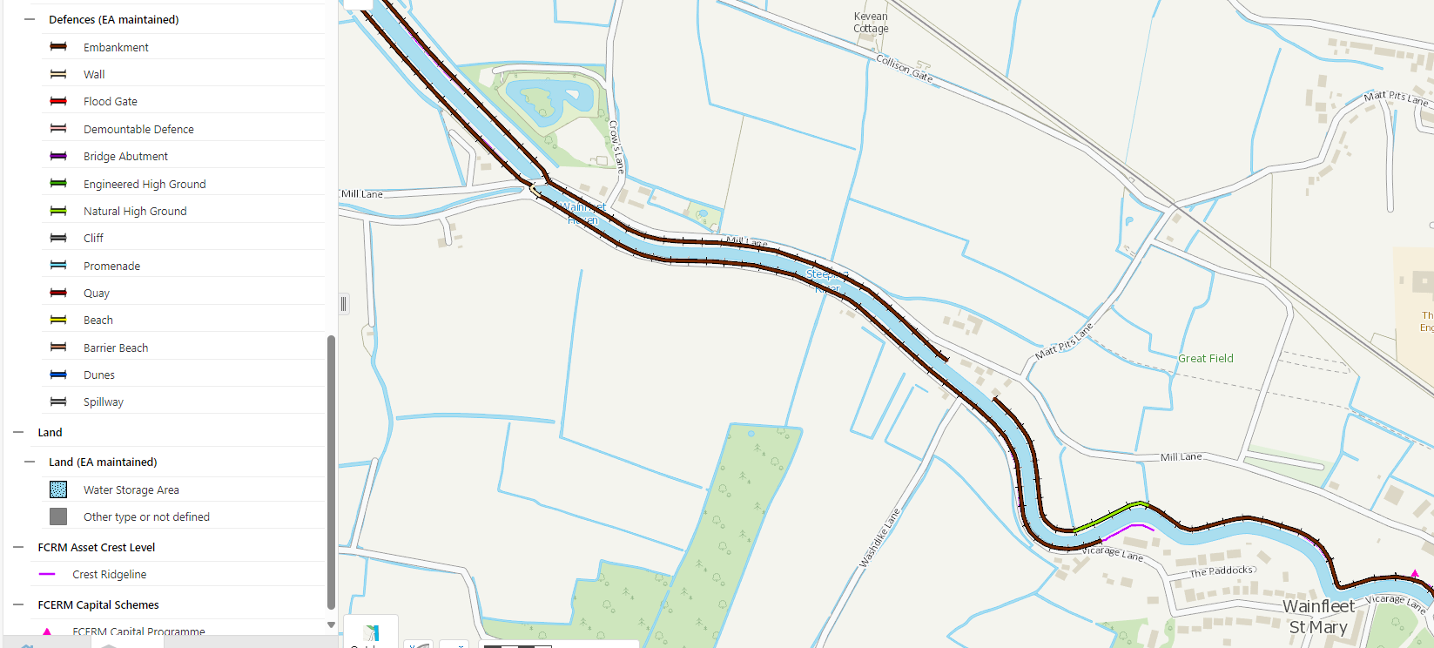
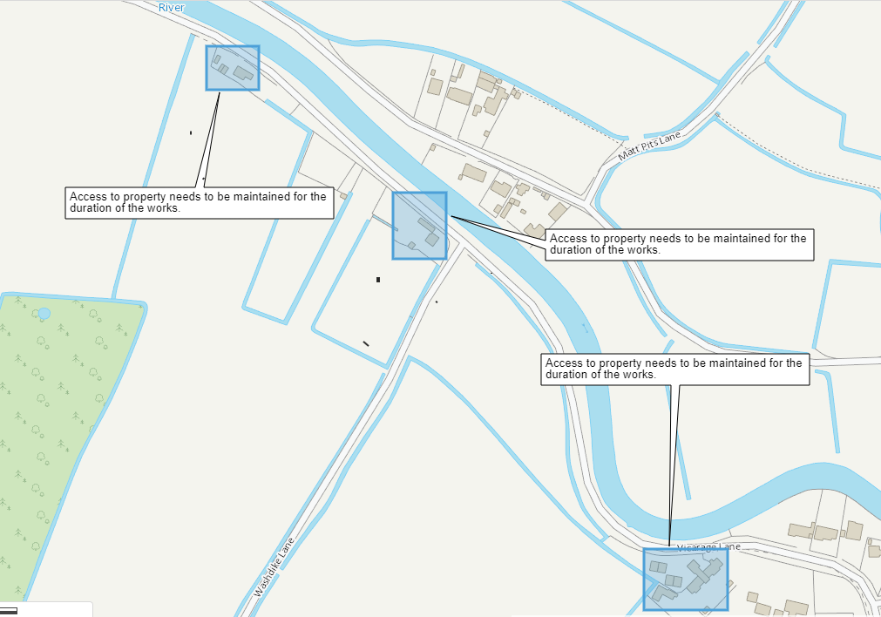
Existing utilities and services
Some preliminary service checks have been carried out and the results can be found in the PCI pack, however, the Contractor is to undertake a full services search as part of the Works.

Site investigation
Contractor is to liaise with the Client for available site investigation data which the Client holds on a central database.
Site location plans
Please refer to section “The Site” above and the relevant Scope Information Document.
Health and safety file
N/A
Access to site
Description: Please refer to section 7.
Limitations: Limitations may come in the form of site compound area as only the road space is available.
Access for inspections: The Contractor is to provide adequate and safe access to the Client and others to inspect the works as they progress.
Use of the site
General: The sites will not be used for anything other than the execution of the works.
Limitations: N/A
Surrounding land / building uses
General: Adjacent and nearby uses are as follows: Only land which has been agreed prior to the works commencing can be used for the works.
Health and safety hazards
General: The nature and condition of the site cannot be fully and certainly ascertained before it is opened up. However, the following hazards are or may be present:
- Working near water
- Road conditions such as dirt roads
Information: The accuracy and sufficiency of this information is not guaranteed. Ascertain if any additional information is required to ensure the safety of all persons and the works.
Site staff: Draw to the attention of all personnel working on the site the nature of any possible contamination and the need to take appropriate precautionary measures.

Proposed sub-contractors.

 | Name and address of proposed subcontractor | Nature and extent of work
1 | Form of Contract:
2 | Form of Contract:
3 | Form of Contract:
4 | Form of Contract:

