Boston Tidal Barrier – Operation and Maintenance – 2026 to 2030

Market Engagement – Questionnaire

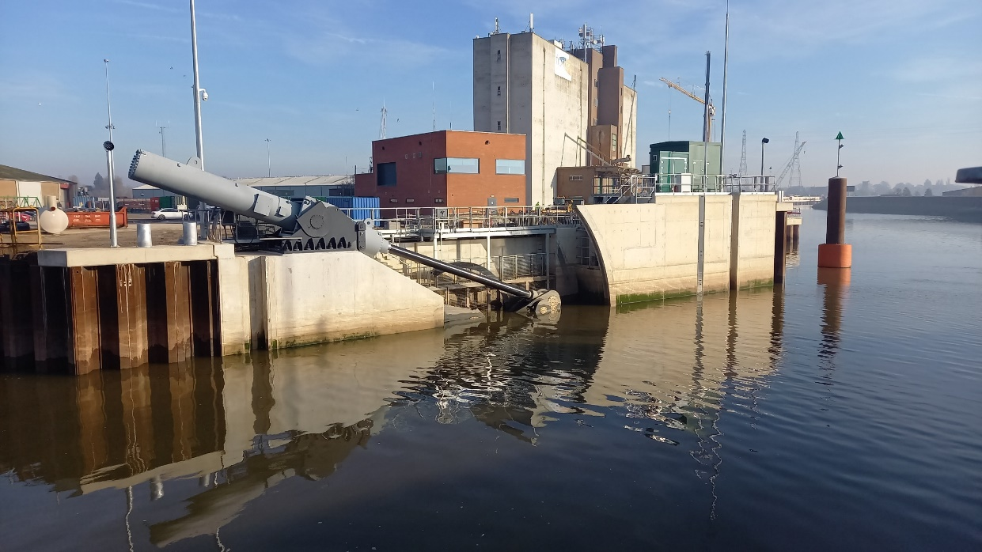
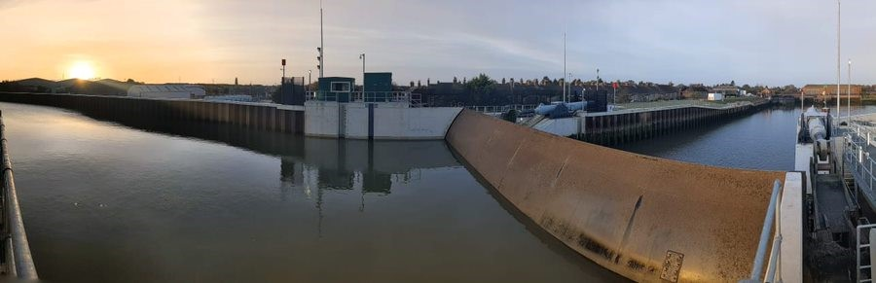
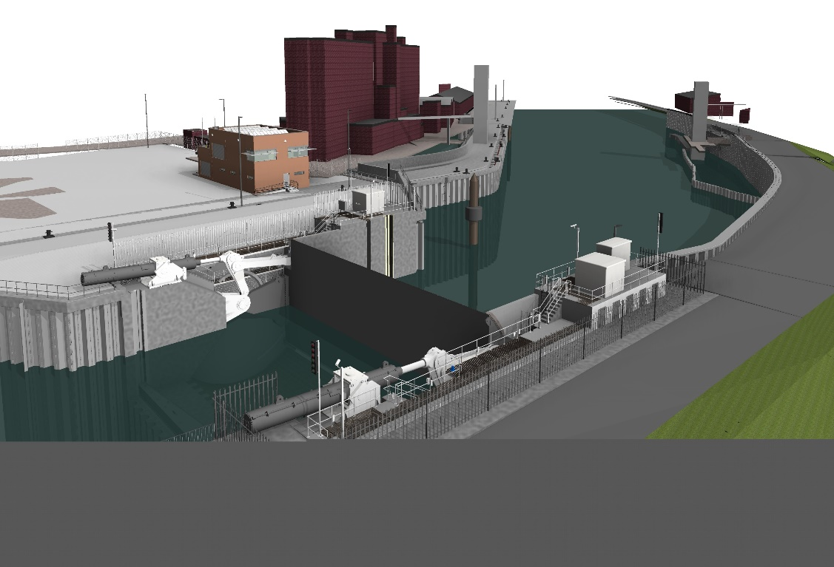
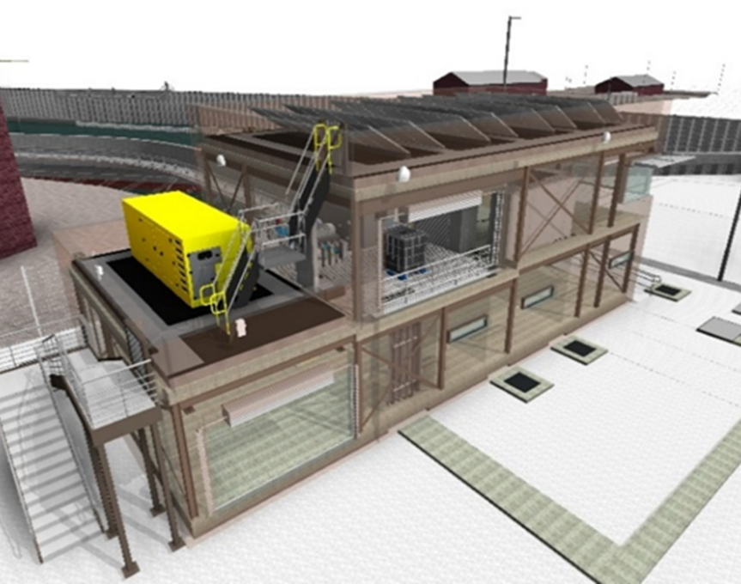
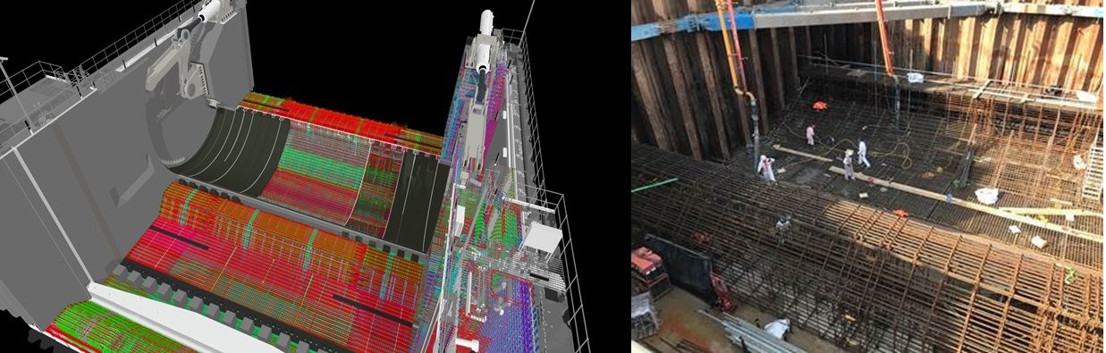
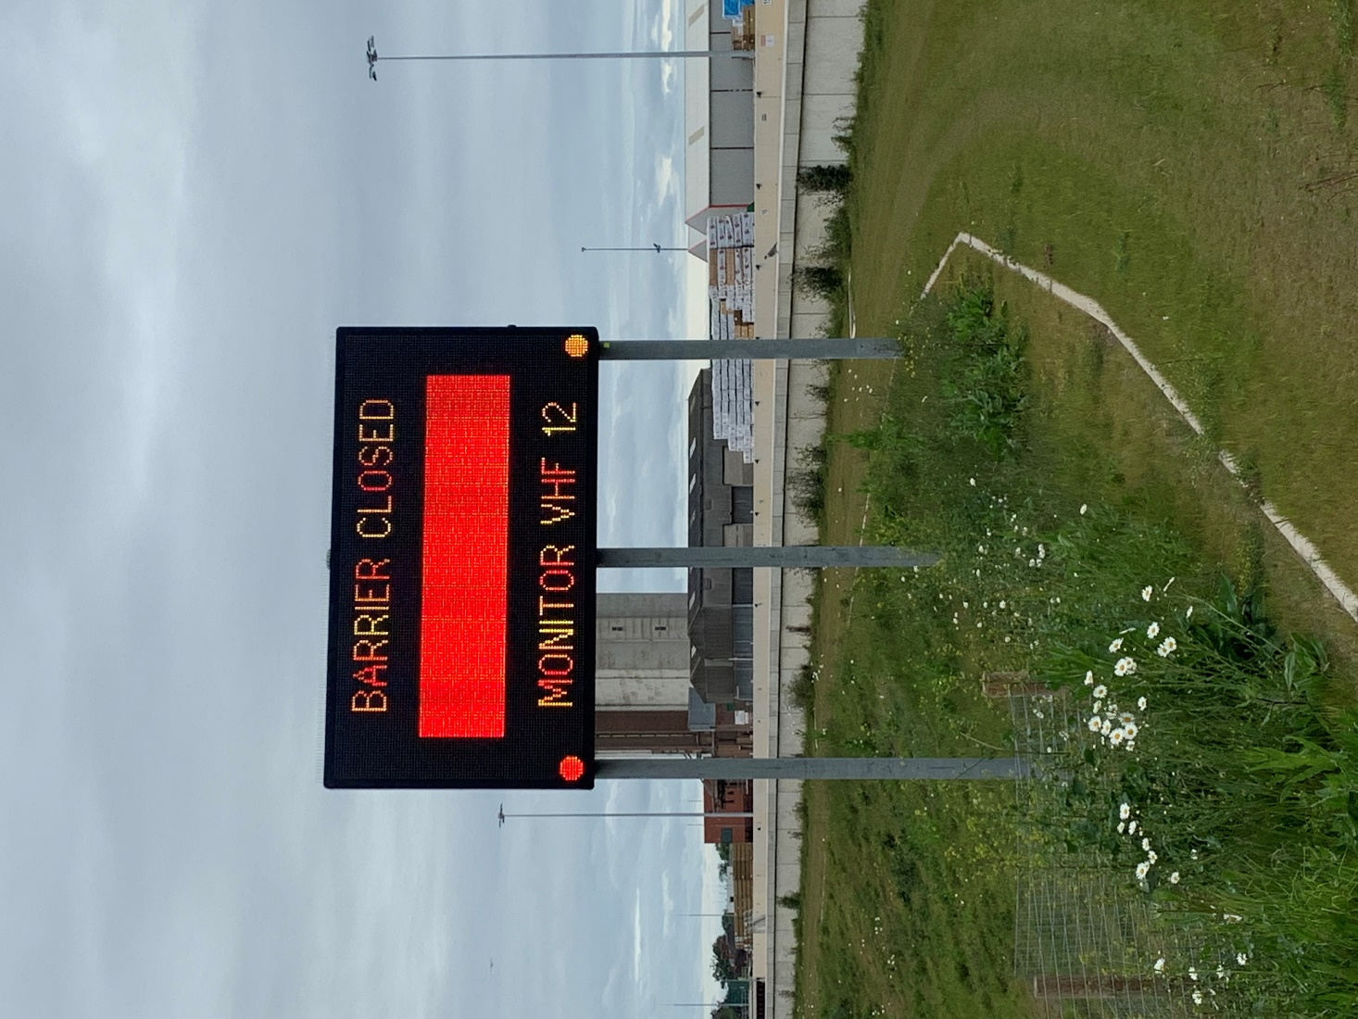

Introduction
The Environment Agency (EA) is seeking expressions of interest and pre-market engagement from suppliers for a proposed 5-year term service contract for the operation and maintenance of the Boston Tidal Barrier and associated MEICA and building services assets
The contract will deliver both technical consultancy services and operation and maintenance works that support the EA’s asset management, maintenance, repair and refurbishment programmes of work.
The purpose of this questionnaire is to gather additional feedback from the market which will help to develop the procurement strategy for this requirement.
Please note: This is not a call for competition.
The procurement remains subject to approval. The EA does not intend to be bound by any information at this stage and makes no commitment to incorporate any recommendations or suggestions within the final procurement documents.

Background
The Boston Barrier scheme has been created by way of a £120m investment, started in 2017 and scheduled to be completed in 2027.
The barrier is classified as a National Critical Infrastructure Project and a Strategically Important Asset. Both classifications require the assets to have enhanced standards of service, reliability and resiliency to component failure.
The scheme comprises a group of over 100 individual assets which, between them, protect more than 14,000 residential properties and 800 commercial and community buildings.
The centrepiece of the scheme is a 700-tonne, 30m wide radial gate flood barrier which was put into active service in 2020 and to date has been raised for flood protection purposes on seven occasions.
Since being active the barrier and associated assets have been operated and maintained by an Environment Agency Framework Contractor under a NEC Term Service Contract. This contract comes to an end in December 2025.
To ensure the continuing readiness of the gate and associated assets a new service contract for their long-term operation and maintenance is required.
A new 5-year Term Service Contract is envisaged, that will allow the Agency to engage with its delivery partners to bring in-house the necessary knowledge, skills and experience for the management of the Boston Barrier Assets.

Scope
The contract will deliver both technical consultancy services and operation and maintenance works that support the EA’s asset management, maintenance, repair and refurbishment programmes of work.
The Service is envisaged to comprise:
- The routine and intermittent operation, maintenance, monitoring, inspection and testing of the Boston Tidal Barrier and associated MEICA and building services assets
- Reporting the outcomes of the above activities
- Implementing remedial measures (repairing) where outcomes are outside of Acceptability Criteria
- Management of spare parts and consumables
- Incident Response – operating the barrier during surge tide events
- Operational Readiness Exercises

Questions
- Please complete the company details table below:

No. | Question | Response
1 | Full name of the potential supplier submitting the information
2 | Trading status:  - public limited company  - limited company  - limited liability partnership  - other partnership  - sole trader  - third sector  - other (please specify your trading status)
3 | Company registration number (if applicable)
4 | Charity registration number (if applicable)
5 | Registered VAT number
6 | Which of the following best describes your organisation?  - Consultancy supplier  - Construction supplier  - Supplier of both consultancy and construction services  - Subconsultant  - Subcontractor
7 | If applicable, is your organisation registered with the appropriate professional or trade register(s) in the member state where it is established?  If so please detail. | Yes/No
8 | Relevant classifications (state whether you fall within one of these, and if so which one)  - Voluntary Community Social Enterprise (VCSE)  - Sheltered Workshop  - Public service mutual
9 | Are you a Small, Medium or Micro Enterprise (SME)1?
10 | Details of immediate parent company:  - Full name of the immediate parent company  - Registered office address (if applicable)  (Please enter N/A if not applicable)
11 | Please provide contact details which you would be happy for the Boston Barrier project to share with other organisations that may be looking to sub-contract or form collaborative relationships?

- Do you have any specific comments on the outline scope or maintenance schedule? Please elaborate.

- The site location is Boston, Lincolnshire. During an emergency flood event, a quick response time is imperative to ensure protection of the area. Please comment on how the required service could be provided sustainably and economically.

- Please can you highlight any specific market opportunities which you could provide and that the Environment Agency may wish to consider when developing the contract strategy?
For example:
  - Engagement with the supply chain – best approach?
  - Sustainability Initiatives: promoting reuse of material; recycling; waste reduction; resource efficiency; etc
  - Encouraging EA area teams’ involvement; working together; engagement and collaboration

- Please can you highlight any specific market threats which the Environment Agency may need to consider when developing the contract strategy?

- How can the Environment Agency make the contract more attractive to the market?

- Is there anything that would prevent or discourage your organisation from submitting a tender?

- The Agency envisages appointing a single contractor who will engage specialist sub-contractors, where necessary, to complete some maintenance activities. Would this be an attractive arrangement to you and if not is there an alternative that would be preferable?

- Please provide ideas for the implementation of a performance evaluation system to assess suppliers' performance?
For example:
- Types of KPI
- Risk Management

- Please provide any additional information you feel is relevant to this procurement exercise.

