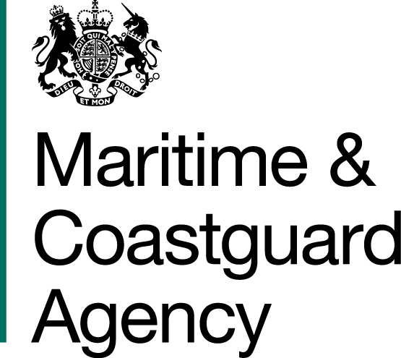 |  |  | Bay 3/21  Spring Place  105 Commercial Road  Southampton  SO15 1EG
 | To whom it may  Concern, |  | Tel:  Fax:  E-mail: | +44 (0)23 8032 9275  +44 (0)23 8032 9388  contracts@mcga.gov.uk
 |  |  | Your ref:  Our ref: |  | TCA 3/7/896 Pt 3
 |  |  | 31st July 2017

INVITATION TO TENDER FOR provision and maintenance of the current Legally Compliant Solution for the Storage, Collection, Transportation and Disposal of Time Expired Pyrotechnics (TEPs) from Selected MCA Sites with a Phased Infrastructure Replacement Programme

You are invited by the Secretary of State for Transport (from now on referred to as "the Authority") to submit a tender for the above contract.

This tender will be a single stage procurement process. One original and one copy (so marked) of your tender and proposals, including any covering letter, will be required. Your Tender Price should be entered onto the Price Schedule included within the documentation.

Tenders must be delivered by 11.00 hours on 4th September 2017

Late tenders will not be accepted and it is your responsibility to ensure that your tender is received on time.

As part of your tender you should supply the following:-
- A detailed written description of service offered
- Form of tender
- Price Schedule

SHOULD YOU BE SUCCESSFUL, THESE DOCUMENTS AND ANY SUBSEQUENT CORRESPONDENCE BETWEEN YOU AND THE DEPARTMENT WILL FORM A BINDING CONTRACT BETWEEN YOU AND THE AUTHORITY.

Please read all the documents listed in the Form of Tender. To ensure that all tenderers have access to the same information you can only obtain further information about contractual issues and Technical Information from me (The Contract Officer). All requests must be submitted in writing to me at the above e-mail address.

Yours sincerely,

Richard Skeats MCIPS
MCA Procurement Team

