**National Army Museum Website Project**

Brief for the redevelopment of the National Army Museum website: structural design, build and launch

May 2016

**Contents Page**

**1. Introduction 3**

**2. The National Army Museum 4**

**3. A new brand 6**

**4. Our audiences 7**

**5. The current website 12**

**6. The new website 19**

**7. Scope of works 24**

**8. Budget 28**

**9. Schedule 28**

**10. Project team 29**

**11. Tender process 29**

**12. Appendices 33**

For action:

Appendix A: Form of Tender

Appendix B: Certificate of Bona-Fide Tender

Appendix C: Supplier Statement

**1. Introduction**

The National Army Museum is working to transform its digital offer. As a first step in this change, the Museum wishes to appoint a suitably qualified and experienced company to create its new website.

The new website is a vital part of the Museum’s vision to create a modern and relevant 21st-century museum. Integral to the project, we will be launching a wholly new brand into the sector, a brand that seeks to stretch the role of the Museum to one of civic engagement.

We very much see our new website as the main communications vehicle through which we will spark conversations with local, national and international audiences and engage them in dialogue about our many stories. Our aim is to encourage engagement and discussion; not simply disseminate information. We want to be able to tell and share stories across multiple formats, enabling circulation rather than just distribution, and be more efficient in a digital environment. Moreover, we want to include strong visual narratives that can be told in/on the website and other media.

We are a Museum whose story is both historic and of the moment. Not a day goes by without our story being in the press or on television; this is a very unique and special position and one that we want to maximise to grow civic engagement with our work.

We are looking for a company with a proven understanding of digital engagement in the cultural, heritage and commercial sectors and who share our bold vision. You will need to demonstrate an awareness of the challenges inherent in balancing the need to deliver value-based content with income generating opportunities and driving support. Ideally, you will also have an affinity for our purpose and our story.

This document explains the project in more detail. The Museum is looking to work closely with a company to develop and deliver the website in a creative and impactful way that is relevant and accessible to all our audiences.

If you are interested in tendering for the project, this document provides the following information:

* Background on the National Army Museum and *Building for the Future*
* NAM’s vision for the new website
* Scope of works
* Schedule
* Budget
* Tender process.

We would welcome your application to work with us.

**2. The National Army Museum**

**2.1 A New Museum**

In spring 2017, a new national Museum will open in London after a three-year closure. The Museum’s vision is bold. To use its rich historical and developing contemporary collections to foster people’s awareness, understanding and knowledge of the British Army, its soldiers and legacy. And through this exploration, encourage debate about an institution that is little understood but is intrinsically part of our democratic society and enables us to live with the freedoms we enjoy everyday.

**2.2 *Building for the Future***

This new Museum is being created through the auspices of the *Building for the Future* (BFTF) project. Set to cost £23.75million, the project has been funded by a Heritage Lottery Fund grant of £11.5m, with the remainder covered by fundraising carried out by the Museum.

The project is realising the wholesale transformation of the Museum’s offer onsite, offsite and online, across seven main work streams.

**1. A new brand and marque**

During 2014-15 the Museum worked to create a new brand model to help direct and inform the development of the new Museum. It has influenced every aspect of the new Museum, from permanent displays, to interior design to signage to the extent that the new building physically embodies the new brand, helping to transform the Museum from a dark and traditional place to a modern, bright, and relevant Museum fit for the 21st century.

**2. A wholly new visitor experience.** A major restructure of the building has created: five new thematic galleries – Soldier, Army, Battle, Society, Discovery; a new 500m2 temporary exhibition gallery; a new three-room learning centre; a new early years learning facility – Play Base; a new research centre and archive; new café; new shop; new boardroom. All are being realised within a building designed to create a more welcoming and engaging physical experience and supported by a fresh approach to public programming (see below).

**3. New programmes for learning and outreach.** The closure of the Museum has provided unprecedented opportunities to pilot new approaches to delivering our learning purpose and to test how the Museum can extend its reach whilst also providing the depth and breadth of offer required of a national museum. On opening the Museum will offer relevant, thought provoking and challenging opportunities to engage with the Collection and our stories through community engagement and curation, new learning services aimed at early years, schools, families, adults and lifelong learners, and new a public programme that seeks to encourage active participation and debate in a wide range of topics from military history to present day conflicts and world geopolitics. It is a place that will spark conversations.

**4. New working models of service delivery and public engagement.** The project has enabled the Museum to review its structure, the ways it fulfils its purpose, the services it offers and its enabling and supporting systems and processes. As the project moves into delivery phase, new teams, processes, services and training are being put in place to deliver an audience-focused, commercially sustainable and more goal driven organisation. This is being facilitated by new working models with a focus on process and cross-departmental and cross-divisional collaboration.

**5. A sharper focus on generating income.** The new visitor experience whilst creating a more welcoming and engaging physical experience has also sought to ensure a focus on facilities and activities to drive earned income. In order to achieve this commercial spaces and the overall offer within the Museum have been designed to be visible, enticing and reflect the growing expectation of Museum audiences.

**6. Better conservation of and access to the Collection.** The project has enabled the conservation of thousands of objects for the new displays. In addition, it has enabled a significant programme of digitisation that will provide easier and greater access to the Museum’s national archives online that through an accompanying cataloguing and external partnerships, will provide a modern, flexible and customer-centred online enquiry services, aimed at meeting the needs of a broad range of researchers from the school pupil to the family historian to the expert academic.

**7.** **Going digital.** Digital transformation underpins much of the new Museum’s work. Whilst attention is necessarily focused on what needs to be done to deliver the modern services expected of a 21st century museum. The creation of the Museum’s new website is seen as the first step in a medium- to long-term digital journey that will see a wholesale review, modernisation and streamlining of the Museum’s systems as digital becomes central not only to realising efficiencies but to delivering a world-class national museum service, locally, nationally and internationally. Digital is central to the Museum achieving a greater sphere of influence and impact and in developing brand awareness.

**3. A New Brand**

As part of *Building for the Future*, the Museum has developed a new brand and approach to visual communications.

The new brand model was developed in 2014-15, and has guided the development of the Museum – from the galleries themselves to the interior design of the Museum and its facilities – the new Museum is literally a physical manifestation of the new brand rather than it being applied after the design of the new Museum.

Whilst detailed information will be provided to the successful consultant, NAM’s new brand model is provided here to convey the nature of our new brand

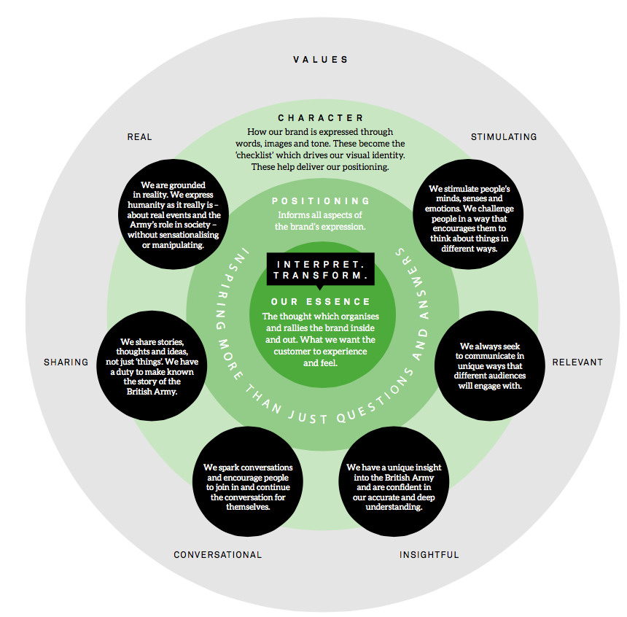

Figure 1: National Army Museum – new brand model

**4. Our Audiences**

**4.1 The Museum’s Audience Segments**

As part of *Building for the Future*, the Museum has undertaken extensive audience research, working with market research company Morris Hargreaves McIntyre. This work identified the following seven market segments for the Museum *before its closure in 2014*. The Museum has used these segments to guide the development of the exhibitions and services within the project and to target and monitor audience development work to date within the delivery of the *Building for the Future* Activity Plan.

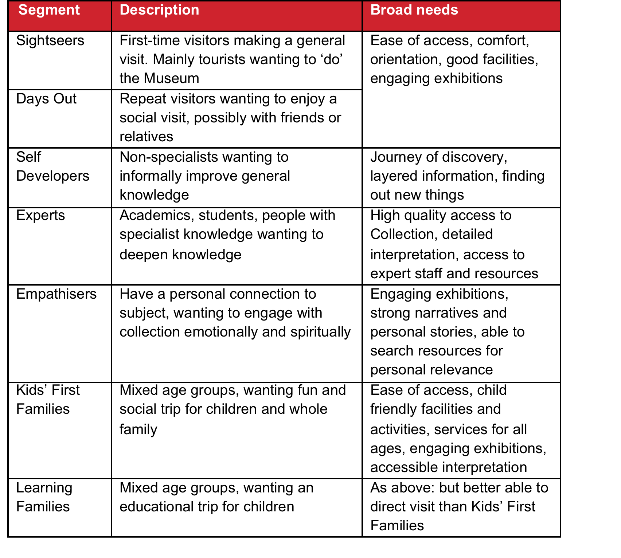

Figure 2: National Army Museum - Visitor segmentation

On opening, the Museum will continue to engage with eachthe above segments but there will be a particular focus on the following audience segments that have been identified as having the strongest potential for growth in visitor numbers:

* Learning Families
* Kids' First Families
* Empathisers
* Self Developers.

Of these, Learning Families and Kids' First Families will be further prioritised. Whilst project also expects to attract a greater number of curiosity-driven first time visits amongst Sightseers – either from the UK or overseas – these are not seen as a high priority in the short-term.

An important strategy in achieving this growth is to grow participation to reflect the population diversity of modern Britain particularly certain demographic groups who are under-represented in the Museum’s pre-closure audiences:

* Women
* Non-specialists
* Local residents from such culturally and socially diverse boroughs as Southwark, Wandsworth, Hammersmith and Fulham and Lambeth.

In addition, the Museum will continue to build relationships and deepening engagement with:

* Schools – particularly from local socially and culturally diverse boroughs in London
* Students and academics – in military history; social history; politics
* Members of the armed services – active and retired.

And as the Museum seeks greater participation and breadth in its audiences, it is looking to improve participation across Black, Asian and Minority Ethnic (BAME) groups, disability groups, young people, older people and N-Sec 5-8, continuing the work achieved through the Activity Plan.

**4.2 Growing Visitor Numbers**

NAM’s projected visitor numbers, post re-opening are as follows:

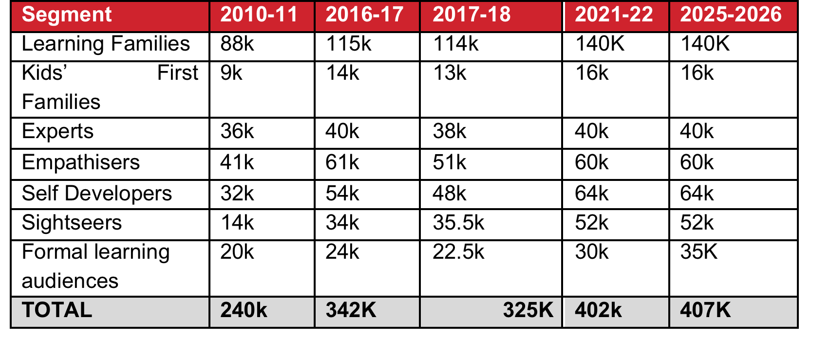

Figure 3: Current and projected attendance figures

NAM will achieve this growth through three areas of audience development:

**Building existing audiences.** Welcoming back existing audiences and increasing the number of participants from those audience groups.

**Developing new audiences.** Reaching audience groups who have not previously engaged with NAM and encouraging them to do so through provision of new offers and better facilities and services, but also through repositioning the organisation in line with those audiences.

**Engaging diversity.** Encouraging a greater breadth of participant in NAM’s audiences, encouraging participants from more diverse ethnic, social and cultural backgrounds

**4.3 Growing Digital Engagement and Audiences**

The Museum took the opportunity of the closure of the physical Museum to refocus its attention on digital engagement, creating a new Digital Engagement Strategy (2014) that helped shape and sharpen the Museum’s web, social media and digital work during 2014-15 and 2015-16 when delivering its Heritage Lottery Fund Activity Plan. During this period the Museum ran a series of digital marketing campaigns, both paid and organic, to maintain brand awareness. Some of this activity was intended to drive traffic to the website; some was intended to help develop our social media communities. Campaign highlights include the following and:

**Waterloo bicentenary (organic):** An organic social media campaign (Feb-Oct 2015) called #WaterlooWednesday resulted in 10,688 comments likes and shares, and 114,601 impressions across social media platforms.

**Waterloo bicentenary (paid):** A paid digital marketing campaign (Apr-Aug 2015), including social media and digital media buying, resulted in 46,524 visits to the NAM website, and 3.4m impressions across social media platforms.

**WW1 Empire & Commonwealth:** NAM created a set of videos to raise awareness of the Empire & Commonwealth contribution to the First World War. A paid digital marketing campaign (Nov 2015) resulted in 291,891 video views and 1.2m impressions across social media platforms.

|  |  |  |  |
| --- | --- | --- | --- |
|  | **PRE-CLOSURE** | **BUILDING FOR THE FUTURE** | |
|  | **2013-14** | **2014-15** | **2015-16** |
| Website (visits) | 778,953 | 880,188 | 930,794 |
| *% increase* |  | *13%* | *6%* |
| Facebook (reach) | 61,707 | 508,084 | 2,941,488 |
| *% increase* |  | *723%* | *479%* |
| Twitter (impressions) | 78,866* | 577,600 | 3,100,400 |
| *% increase* |  | *632%* | *437%* |
| YouTube (views) | 144,026 | 215,234 | 766,839 |
| *% increase* |  | *49%* | *256%* |
| * Reporting on Twitter impressions only began in October 2013. | | |  |
| Figure 4: Web and social media engagement 2014-16 | | |  |

**4.4 Growing Membership**

An integral part of our audience development and growth strategy is to deepen people’s engagement with the Museum. We call this our ‘Ladder of Engagement’. Visualised in Figure 5 this shows how we will plan our communications and engagement activities to enable people to move through increasing levels of engagement with the Museum. Clearly not everyone will want to become part of the NAMily. However, the website as a key information portal, is viewed as being an essential tool in helping deliver this model through providing visitor journeys and click-throughs that link related and engagement content.



Figure 5: Ladder of Engagement – user relationship structure for the National Army Museum

**4.5 Growing Commercial Audiences**

Commercial income is budgeted to be in the region of £2M in the first year of opening. Of this, £1.5M is to be generated as a result of footfall to the Museum. These income targets have been shaped around the visitor targets found at Figure. 3 The remaining £0.5M is to be generated through utilising the web to either book activity, secure venue hire or purchase a product online.

Given this breakdown it is imperative that the website encourages visits to the Museum both through the Museum gallery offer and the signposting and presentation of the commercial areas.

At launch there will be key online facilities required in order to generate the required income all of which are detailed in section 5.

**5. The Current Website**

**5.1 Overview**

NAM launched its current website in 2011. It was developed in-house, using the Drupal content management system, and is maintained in-house through an internal Web Team consisting of a Website Development Officer and an Online Content Officer.

The Website Development Officer is responsible for:

* Implementing and maintaining technology frameworks for website and microsites
* Planning and implementing new functionality
* Planning and implementing new content templates/page layouts
* Preparing/editing images/media for online publication
* Publishing and formatting content with Content Management Systems
* Monitoring, analysing and reporting on digital engagement
* Email marketing
* Moderating user-generated comments and enquiries

The Online Content Officer is responsible for:

* Researching and developing new digital content
* Editing/reviewing digital content developed by others (e.g. blogs)
* Identifying and sourcing assets to illustrate digital content

The Museum is currently recruiting for two additional Web Team roles: a Digital Content Producer (who will supplement the work of the Online Content Officer) and a Website Administration Assistant (who will supplement the work of the Website Development Officer).

The Computer & Technical Services (CATS) Team supports the work of the Web Team by:

* Managing the website hosting environment
* Managing the systems that interface with the website (e.g. CRM)
* Pushing data/assets from the Collection Management System to the website

At the same time, the wider workforce is becoming increasingly involved in developing digital content for the website, especially through blogs (Marketing, Collections) and resources (Learning).

The website serves multiple functions:

* Providing visitor information, including the group offer
* Providing access to the Collection and associated knowledge through the Online Collection and thematic exhibitions
* Promoting the Public Programme – pre-closure mainly comprising the Lunchtime Lecture Programme, Celebrity Speaker events and school holiday events and activities
* Promoting Museum services (Learning, Templer Study Centre (TSC)), expertise and opportunities
* Provide link to ticket booking system/website
* Provide link to online shop
* Provide links to purchase and licence images (through third party operators)
* Promote the venue hire business
* Promote the in venue facilities such as Café, Retail, Kids’ Zone
* Provide sign up to Museum Newsletter
* Providing information about Museum governance

**5.2 Main areas of development**

With an in-house web team comprising technical expertise and military knowledge, web development during 2011-14 focused largely on Collections-based content projects and driving traffic to the online collection with a view to making the Museum’s Collection more visible and accessible.

**5.2.1 Collection content**

Since 2012 an online (MySQL) database, fed by the Museum’s Collection Management System, has supported two distinct ways of accessing Collection content: the Online Collection and the Online Inventory.

Collection content sits outside NAM’s Drupal content management system.

**Online Collection**. This features thousands of the most important objects in the Collection, accompanied by user-friendly captions and associated digital assets. This is the Museum’s primary method for engaging audiences with Collection content.

Functionality includes a responsive light-box for viewing images full-screen and a carousel for scrolling through supplementary images. The Museum has also recently started trialling a hosted tile-based viewer for panning, zooming and paging through a selection of digitised archival material.

**Online Inventory**. This provides accession-level (i.e. not very user-friendly) descriptions for hundreds of thousands of objects in the Collection, the vast majority of which has not been scanned/photographed. This provides specialist users with basic access to lists of what the Museum holds. However, the quality of the data is not of a standard to serve as a method for engaging primary audiences in the short-to-medium term.

**5.2.2 Exhibition content**

A range of online exhibitions has been developed to provide context to NAM’s Collection content. Some of these were migrated from the pre-2011 website. They cover a range of categories – events, campaigns, people, themes, etc.

Exhibition content sits within NAM’s Drupal content management system.

**5.2.3 Famous Units**

There is a section within the Research area of the website that is dedicated to the various British Army regiments and corps that have existed throughout history. This provides an additional layer of content that contextualises the Collection, but also serves to highlight the work of NAM’s affiliated network of regimental and corps museums across the country.

Famous Units content sits within NAM’s Drupal content management system.

**5.2.4 Microsites**

NAM has a range of microsites, which have been developed for externally funded projects or to support temporary exhibitions:

* Black and Asian British Army (2007; HLF-funded community engagement project)
* War Horse (2011; temporary exhibition)
* Building for the Future (2012; current HLF-funded museum redevelopment project)
* Unseen Enemy (2013; temporary exhibition)
* First World War in Focus (2014; part of activity plan for *Building for the Future*).

The majority of these were built in-house using the WordPress content management system. The exception is Black and Asian British Army, which was built on a bespoke CMS by external developers.

**5.3 Systems integration**

A number of systems deliver the content and functionality of our existing website.

**5.4.1 Collection Management System**

As outlined in 5.2.1, the Online Collection and Online Inventory areas of the NAM website are fed by the Museum’s Collection Management System via a MySQL “middleware” database hosted on the website’s production server.

Issues presented by this solution include: the lack of support for faceted search and the limited ability to integrate collections data with wider digital content.

**5.3.2 Online Shop**

NAM has been selling merchandise through a standalone online shop for over ten years. The current shop was developed externally in 2006. This was part of a wider systems migration that brought other business functions, including accounting, onto the Netsuite software platform.

**5.3.3 Online Ticketing**

NAM runs online ticketing for public events through its Netsuite-hosted Online Shop (see 5.3.2). From 2011 until closure in 2014, the Museum used a hosted timed ticketing solution called DigiTickets for its Kids’ Zone play area.

**5.3.4 Online Print Shop**

NAM sells prints of some of its paintings, posters, and photographs through a white-labelled online store. This service is provided by a company called King and McGaw.

Currently the website provides a link through to the print store.

**5.3.5 Customer Relationship Management (CRM)**

Since 2013 NAM has been using the Salesforce CRM system to manage information relating to its customers, audiences and stakeholders. The system is currently used to manage enquiries and for on-and-offline marketing purposes, including email marketing (via an integrated Vertical Response app).

Although we are not seeking CRM development as part of this project, we would welcome a view on the use of this software in relation to its integration with other systems, and therefore its medium- to long-term utility as part of the Museum’s digital transformation.

**5.4 Digital audience data**

The Museum undertakes regular evaluation, monitoring and benchmarking activity of its current website to understand use and audiences. Headline data on their origin, devices used, how they get to the NAM website, why they visit the website and what they use the website for are given below.

*Figure 6: Geographic location of visitors to the Museum’s website (UK v Rest of World); Source: Google Analytics*

The UK drives the most traffic, but there has been year-on-year growth in US and Australian audiences.

*Figure 7: Geographic location of visitors to the NAM website (London v Rest of UK); Source: Google Analytics*

England drives the most traffic, but there has been increasing diversity year-on-year. Equally, London drives the most traffic, but there has been increasing diversity year-on-year.

*Figure 8: Sources of visitors to the NAM website (Organic v Referral v Direct v Other); Source: Google Analytics*

*Figure 9: Devices used to access the NAM website (Desktop v Tablet v Mobile phone); Source: Google Analytics*

Data shows that there is a year-on-year trend away from desktop use towards tablet and mobile phone use. This highlights the importance of factoring in responsive design to the redevelopment of the website.

*Figure 10: Visitor motivations for accessing the NAM website;*

*Source: Qualaroo online survey - Spring 2014, immediately prior to closure (Sample size 3,505)*

*Figure 11: Top five most visited content areas on the NAM website (Online Collection v Research v Exhibitions v Microsites v Online Inventory)*

*Source: Google Analytics*

**6. The New Website**

**6.1 Aim**

To deliver a new website that helps the Museum to fulfil forecast visitor experience and commercial needs and supports access to and understanding of the national Collection.

**6.2 Objectives**

The prioritised objectives for the new website are currently:

1. To drive increased awareness of the Museum’s brand
2. To support attendance growth, particularly in priority segments and demographics
   1. To help signpost and drive uptake of the Museum’s Public Programme of activities and temporary exhibitions
3. To support commercial activity – onsite (Phase 1) and online (Phase 2)
   1. To drive uptake and facilitate pre-booking booking of Play Base Early Years Learning Facility tickets
   2. To drive uptake and facilitate the pre-booking of the Children’s Birthday Party Offer
   3. To showcase the in-venue offer, including retail, catering and venue hire.
   4. To highlight the Museum’s online commercial offers including print on demand (Phase 1) and online shop (Phase2)
4. To deliver enhanced online services
   1. New online event/facility ticket booking and associated commercial opportunities
   2. New enquiry services and pre-visit archive booking facility to the TSC
   3. New dedicated environment for NAM Learning resources to facilitate offsite and onsite learning
5. To provide new opportunities to engage with the work of the Museum and the Collection to enable:
   1. Deeper and more frequent audience engagement with digital content and services
   2. Digital content to be useful and usable for longer
   3. Interfaces for collections projects where people can submit material and record and submit narratives about and for the Collection
   4. Links to partner sites and records
6. To enable more people (staff, stakeholders, audiences) to create, maintain and promote digital content and services
7. To enable digital content to be usable in more contexts (i.e. not confined to the NAM website).

**6.3 Delivering the new brand**

A core function of the new website will be to deliver the Museum’s new brand. Not simply a marque, the new brand is being used to transform the Museum’s focus, the way it works, the way it presents and expresses itself and the ways in which it engages with the public.

It is vital that the new website reflects the new brand and the Museum’s aspiration to transform its role from a museum to a place of civil engagement in the story of the British Army. We want the Museum and the website to be places where people can come to find out more about an institution that is central to our democracy and the freedoms we enjoy everyday, but is little understood or widely spoken about. We need to create environments where conversations about a sometimes-difficult subject can take place.

Our story has incredible stretch that it needs to deliver in respect of content and emotions. Our collection ranges from the 16th to 21st centuries and includes objects that tell stories of utter disaster, tragedy, fear and despair to thrill, adventure, success and fun. It’s a real challenge. But it’s our responsibility to use our new brand and the Collection to engage the British public and wider people in our story.

**6.4 Vision for the Design and User Experience**

Reflecting our new brand and commercial focus, we need the user experience to foreground the visitor experience within the Museum and signpost our increasingly dynamic public programme and opportunities to get involved in our work. We need it to focus on storytelling and provide generous interfaces through which to engage people in our story and rich Collection.

Our storytelling must reflect our new values – real, relevant, stimulating, insightful, sharing and conversational. We need to do this through the content we create and through embedded opportunities to contribute, share and discuss. Within the Museum every gallery contains opportunities for people to give their opinions and leave thoughts. This data will be captured and reflected back within a display in the central space of the Museum called Epilogue. We would love there to be a dynamic relationship between the Museum and the website so that we can take the Museum experience beyond its walls and involve the wider population on the conversations we would like to facilitate. Conversation is at our core.

We need to ensure we provide visitor journeys suitable for all our audiences, from Kids First and Learning Families, to Experts and military historians, to Self Developers and empathisers who are spurred to come to our website though something they have read, seen on the television or that we have circulated. Whilst the collection is central to the Museum, we recognise that it will not be central to all our audiences’ needs and that the website must reflect this.

We also need to ensure that the website conveys that the Museum welcomes people of all ages and interests. Therefore we need a design and user experience that brings together a sense of the modern and historic army as delivered by the galleries, and that also signposts our new Early Years Learning Facility aimed at 0-7 years, Play Base, as well as activities and events for all ages. Rich and diverse, the design and user experience needs to make it easy for our audiences to find what they need, or, be signposted to where to go for more information.

Finally, the new website needs to reflect the values of the organisation whose Collection we care for – pluralistic and meritocratic.

**6.5 Vision for Functionality**

We know that people can find it difficult to engage with the Museum; that before re-development there were real perception and physical barriers to engagement. We need the new website to help us break down these barriers.

Ease of use, transparency, legibility, and accessibility are all crucial. We have already identified a requirement for functionality including but not limited to:

* A searchable calendar, giving information on what’s on at the Museum and the link through to book
* Provide downloadable content – PDF brochures, Birthday Party Invites, Learning Resources etc.
* Show Video footage with or without sound – embedded rather than linking through to Youtube
* Contact forms e.g. able to contact department such as corporate hire, learning etc. using a form rather than sending an email
* Promotional boxes on web pages to surface related content (commercial and non-commercial)

**6.6 Digital Audiences**

The Museum is looking to reach digital audiences in multiple contexts: at home, at work, at school, on the move and within the Museum itself.

The table below demonstrates the three main motivations for audience engagement on the Museum website, as well as the Museum’s priorities for addressing them. It also maps these digital engagement motivations against the segments from the Audience Development Plan.

|  |  |  |  |
| --- | --- | --- | --- |
|  | Priority 1 | | Priority 2 |
|  | Planning a visit | Non-specialist learning/research | Specialist learning/research |
| Experts | X |  | X |
| Self Developers | X | X |  |
| Empathisers | X | X |  |
| Learning Families | X | X |  |
| Kids First Families | X | X |  |
| Days Out | X |  |  |
| Sightseers | X |  |  |
| Formal Learning | X | X | X |

Figure 3: Audience segments mapped against digital motivations

**6.7 Content strategy**

Content development will be managed in-house. This will involve a content audit, copywriting/editing, and digital asset identification and preparation. Ultimately, we would like all content, whether re-purposed from the current website or newly developed, to be managed within a single framework.

We would like to establish a new content framework that supports:

* Distinct content types for different categories of content
* Distinct content filters for each content type
* Faceted search within content types
* Relational links between individual content nodes, grouped by type.

The aims of this framework are:

* To provide a focus and structure for digital content development
* To make it easier for users to find specific content
* To offer useful onward journeys and opportunities for deeper engagement
* To layer content in a way that supports a wide range of learning needs (from beginner to expert)
* To guard against content falling out of use

Based on initial scoping, NAM proposes categorising content as follows.

* Public Events (scheduled; for general public)
* Learning Visits (scheduled; for formal learning audience)
* Learning Resources (for formal learning audiences)
* Blog Posts
* Media (e.g. non-Collection images, video, audio)
* Conversations (for survey-like content)
* Vacancies (employment opportunities)
* Objects (Collection content)
* Campaigns (e.g. Crimean War)
* Units (e.g. Grenadier Guards)
* People (e.g. Duke of Wellington)
* Articles

Further detail on content scoping will be made available on appointment. These categories (along with the filters for each) are open to further exploration and refinement through the discovery phase of the project.

The content framework will also need to support static content – e.g. About Us, Your Visit, etc. This will not need to be exposed via sortable and filterable lists in the same ways as the categories above, but will need to delivered in a hierarchical structure.

**6.8 Technical requirements**

**6.8.1 Hosting environment**

The website will run on the Museum’s dedicated server, currently hosted and managed by Rackspace. Our preference is that the website should be built on a LAMP stack.

**6.8.2 Accessibility**

The website will aim to meet all Priority 1 requirements of the Web Content Accessibility Guidelines (WCAG) 2.0 and as many Priority 2 requirements as possible. Evaluating whether level 1 and 2 checkpoints are met should form part of development and testing and will be supported by the Museum’s Equality Champion and Access Consultant.

**6.8.3 Responsive design**

The website will need to be designed responsively to provide optimal viewing and interaction experience across desktop, tablet and smartphone devices. Content and functionality should be consistent across devices.

**6.8.4 Browser support**

Progressive enhancement will be used to establish a basic level of user experience that all browsers can provide (including IE8 and below, and browsers with styles/scripting disabled), but also to take advantage of the more advanced capabilities of modern browsers. Users should not be forced to upgrade or adjust their browsers in order to access the basic page content.

**6.8.5 Performance**

Performance will be considered at all stages of development and design in order to optimise bandwidth usage and loading times.

**6.8.6 Redirecting URLs**

Redirects will be set up to inform search engines that website content has permanently moved to a new location. In cases where one-to-one matches between old and new pages are not possible (owing to structural changes, content rationalisation, etc.), old pages will point to new pages with similar content.

**7. Scope of Works**

**7.1 Introduction**

The scope of works to be delivered through this project includes the following:

* Hosting environment health check
* Information architecture
* User experience, interaction and interface design
* User interface pattern library
* SEO optimisation/migration research, consultancy and support
* Content Management System (CMS) development
* API development (for surfacing CMS content in multiple contexts)
* CMS systems integrations
* CMS training
* Analytics implementation.

Excluded from this scope of works are:

* Online shop development and system integration
* Online ticket booking system development

**7.2 Hosting environment health check**

NAM would like the successful company to review the Museum’s existing web hosting environment and ensure that is in a suitable condition to deploy the new site (e.g. server is up to date, any security risks are addressed).

Site hosting and maintenance are outside the scope of this project. However, depending on the technologies adopted, NAM may decide to contract out the technical maintenance of the new website in the future.

**7.3 Information architecture**

NAM would like the successful company to define a site structure that supports the content framework outlined in 6.7. This should provide an intuitive navigation scheme, steered by NAM’s priorities for addressing audience motivations. It should also identify the various page templates required.

**7.4 User experience, interaction and interface design**

NAM would like the successful company to develop wireframes/prototypes for each of the required page types demonstrating the layout of page content and how users will interact with the website.

The company will also be required to develop a bespoke visual identity for the website and its various user interface components. The Museum’s new brand implementation guidelines will be made available on appointment.

Both of these elements should address how interaction and design will differ depending on the screen size of the device being used (desktop, tablet, phone).

**7.4.1 Commercial Interaction**

Whilst the delivery of some elements of browsing and transaction are to happen outside of the main museum website, it must still showcase the offer and successfully link through to commercial transaction sites. With expectations of a simple, quick and efficient purchase or booking journey our online audiences will not engage with purchases which are complicated, difficult to navigate or slow.

In addition to linking through to our third party sites the Museum website should offer clear calls to action in order to encourage visits to the museum, booking of ticket or service, or shopping the product offer. These should be delivered as a multi-layered approach, including but not limited to incorporation of a single product/service link, a recommendation based on content browsing and pop up messages and the flexibility to change these.

**7.5 User interface pattern library (design toolkit)**

NAM would like the successful company to deliver a pattern library that provides a framework for all user interface components and utilities designed in response to 7.4. This will make ongoing content development faster, easier and more consistent.

NAM has no objections to this design system being built on top of an existing front-end framework (e.g. Bootstrap, Foundation) if that can be demonstrated to be the most effective solution.

**7.6 SEO optimisation/migration research, consultancy and support**

NAM would like the successful company to ensure that the site structure, architecture and content supports the objective to increase visibility of the site in search engines for relevant search terms and thereby grows traffic from natural SERPs. It is envisaged that this will encompass keyword research and support for the migration of the existing site to the new site including URL rewrites as required.

**7.7 CMS development**

NAM would like the successful company to deliver a content management system (CMS) that supports the content framework outlined in 6.7 and enables the surfacing of content in multiple contexts.

The CMS should offer the following features:

* Support the content framework (see 6.7) through custom content types and filters
* Be easy to use
* Support different roles (e.g. authors, editors, administrators)
* Support content version/revision control
* Support drafts and scheduling
* Support password-protected content (e.g. for private previews)
* Be search engine friendly (e.g. in terms of URLs)
* Support surfacing of content (via API) in multiple contexts

Main aims of the CMS are:

* To enable the management of digital content in one place
* To facilitate a Create Once Publish Everywhere approach to content delivery
* To facilitate the roll-out of digital content management responsibilities to the wider workforce

NAM has no objections to this system being developed using an “off-the-shelf” CMS solution (e.g. Drupal, WordPress) if that can be demonstrated to be the most effective solution.

**7.8 API development**

NAM would like the successful company to deliver an API that allows content stored within the CMS to be surfaced in multiple contexts and integrated with other systems. This may be limited to certain content types (to be agreed during the discovery phase of the project).

**7.9 Systems integrations**

The CMS software will have to “talk to” other systems that are either already in use, currently in development, or yet to be procured. We are seeking for current systems, which will remain in place for launch, to be integrated; there must also be an awareness of other systems yet to be procured as these directly impact on web design and build.

**7.9.1 Collection Management System – already in use**

Some content types (primarily Objects) will need to integrate with NAM’s Collection Management System. This is a bespoke in-house system, built on FileMaker. It

is currently being used to feed a MySQL database that serves as “middleware” for the Online Collection. The data structure of this database will be made available on appointment.

The Museum would welcome proposals for a “middleware” solution that addresses the issues outlined in 5.4.1. This solution should also offer the ability to receive data from other proprietary Collections Management Systems should the Museum migrate to a new system in future.

**7.9.2 Soldiers’ Records Search – currently in development**

The Museum is piloting a scalable approach to searching digitised soldiers’ records online (primarily for genealogical research). This consists of transcribed data and digital scans of archival material. NAM has contracted a company to provide this functionality via a web service, but this will need to be integrated with the website. Full documentation will be made available on appointment.

In the future there may also be a requirement for this to include data sets from the Collection Management System and other databases.

**7.9.3 Online Ticketing System**

The online ticketing system will undergo procurement in 2016 and will launch with the Museum website in Jan 2017.

Online ticketing will facilitate purchases for public events, the Play Base learning facility and associated Children’s Birthday Parties.

There is considerable income processed through this booking system and it is essential that it surfaces as part of the main Museum website with clear calls to action. The ticketing solution will not provide detail about the event/session/party and so the main website will be required to surface this content, engage, stimulate and encourage the user to purchase.

Depending on the procured system, there are a range of potential integration options. Currently, the preferred solution would entail full API integration.

**7.9.4 Online Shop – yet to be procured**

Some content types will need to integrate with a third-party online shop. Currently, the Museum uses its e-commerce system to support online product sales. However, new solutions in this area are being explored.

The online shop system will undergo procurement in 2016 with a view to launch the online shop mid 2017 once the Museum has fully reopened.

The Museum website should offer an intuitive clear and easy click through to online shop and purchase. It should also allow product placement on non-commercial pages through the use of promotional boxes, links and pop ups.

**7.9.5 Customer Relationship Management System – already in use**

Some of the forms on the website will need to integrate with NAM’s Customer Relationship Management System (Salesforce). Integration will need to reflect new approaches to data capture via the website.

**7.10 CMS training**

NAM would like the successful company to provide a small group of NAM staff with CMS training in tasks relating to all available user roles (e.g. administrators, authors, editors). This will equip the in-house team to proceed with content loading.

**7.11 Analytics Implementation**

NAM would like the successful company to support the configuration of analytics software to ensure that all specified goals and metrics can be accurately measured and reported.

**8. Budget**

All costs for individual elements detailed in the response must be fully disclosed along with all calculations.

Quoted fees must include all of the following:

1. Professional fees
2. Development, research and design costs
3. Travel and expenses
4. Accommodation
5. Disbursements
6. Visuals
7. An estimate of any contingency
8. All third party fees
9. Report, printing and presentation costs
10. All other expenses and costs required in the delivery of the project.

The fees should indicate if they include or exclude VAT.

**9. Schedule**

NAM would like to discuss the delivery schedule in detail with the appointed company as part of the discovery phase. However, the following list provides some indicative delivery milestones.

* **Jul 2016** – Project kick-off, discovery phase begins
* **Aug 2016** – Detailed delivery schedule signed off
* **Jan 2017** – Live testing of core offer begins (beta launch)

**10. Project Team**

**Project Sponsor Team**

Genevieve Adkins – Assistant Director (Public Programmes)

Ian Maine – Assistant Director (Collections)

Dawn Watkins – Assistant Director (Commercial & Visitor Experience)

**Project Manager**

Kevin Blaney – Website Development Officer

**11. Tender Process**

**11.1 Tender Requirements**

Proposals should comprise the following.

**11.1.1 Response to Brief**

Response to the brief should demonstrate:

* A clear methodology statement for the development and delivery of the Works detailed in Section 7 including an outline approach to transitioning from the current website to the new one
* An outline work plan identifying key sign-off points informed by this brief
* Confirmation of team members, including sub-contractors if relevant
* Cost plan detailing the tasks and staff responsibilities, daily and hourly rates and expenses.

**11.1.2 Tenderers Project Team, Qualifications and Experience**

Provide details of three relevant projects that demonstrate qualifications and experience. For each project, include a description of the project, you, your company’s and/or sub-contractors’ role, client, budget and project dates.

**11.1.3 Fee**

The Fee is to be a fixed sum for the provision of all Works as outlined in the Scope of Works.

The Fee is to include all expenses. This will include travel costs, accommodation, disbursements, reports and all other expenses and costs required in the provision of the Works. The fee should exclude VAT at the prevailing rate.

**11.1.4 Instalment Payments**

Provide a suggested fee drawdown schedule in your response. NAM reserves the right to amend any suggested drawdown schedule.

**11.1.5 Insurance**

Please provide copies of up-to-date insurance - NAM requires Public

Liability with a minimum of £10 million, Employers Liability with a minimum £10 million and Professional Indemnity Insurance to the value of £2 million.

**11.1.6 References**

Provide reference details of three recent contracts that are relevant to this project. Include the name and contact details of the clients’ representatives who could be approached for references. References will be taken up before confirmation of appointment.

**11.1.7 Financial**

Please provide a copy of the company’s published accounts for the last three years.

**11.1.8 All company documentation as requested below:**

* The completed Form of Tender (Appendix A)
* The completed Certificate of Bona-Fide Tender (Appendix B)
* The completed Supplier Statement (Appendix C)
* All forms (Appendix A, B and C) should be signed by the Tenderer or, in the case of a Company by the Secretary or other authorised person
* Any other information that is required to clarify the tender.

**11.2 Tender Submission**

Tenders should comprise 2x hard copies and 1 x electronic on DVD/memory stick of all tender content as outlined below:

* NAM Website Redevelopment tender proposal
* The completed Form of Tender (Appendix A)
* The completed Certificate of Bona-Fide Tender (Appendix B)
* The completed Supplier Statement (Appendix C)
* Any other information that is required to clarify the tender.

**11.3 Tender Return**

Tenders must be submitted no later than 1200hrs on 27 June 2016 in a plain envelope labelled only with the address below and clearly marked “Tender – Website Redevelopment”. No other marks or wording (including pre-paid franked stamps), which might indicate the identity of the sender, shall appear on the envelope containing the tender.

The tender shall be submitted to:

Mr John Foster

National Army Museum

Royal Hospital Road

Chelsea

London SW3 4HT

Tenders can also be returned via email at the above date and time to: jfoster@nam.ac.uk. The subject of the email should state “Tender - Website Redevelopment”. Any electronic tenders received before this date will be rejected.

Tenders are to remain open for acceptance for a period of 60 days.

**11.4 Tendering Costs**

NAM will not be responsible for or pay for any costs or expenses that are incurred by any tendering consultant in preparing and submitting their tender.

**11.5 Contract Award Criteria**

The tender board may consist of the following NAM representatives:

* Assistant Director (Collections)
* Assistant Director (Public Programmes)
* Assistant Director (Commercial & Visitor Experience)
* Website Development Officer
* ICT Systems & Project Manager

Tenders will be assessed on the following criteria:

* Response to brief **30%**
* Qualifications and Experience **20%**
* Project Team and Resourcing **20%**
* Fee  **30%**

Each proposal will be given a score. A proposal considered to be unsuitable shall be rejected at this stage if it does not respond to important aspects of the brief. NAM shall notify unsuccessful tenderers of the rejection of their proposal after completing the selection process.

Tenders will be awarded on the absolute discretion of the Board of NAM, in accordance with internal policies and statutory regulations. NAM is not required to accept the lowest priced tender.

The decision will be final and binding, no correspondence will be entered into.

**11.6 Tender programme**

The key dates in relation to this tender exercise are detailed below.

|  |  |
| --- | --- |
| **Activity** | **Date** |
| Brief issued | 27 May 2016 |
| Tender submission deadline | 12:00hrs 27 June 2016 |
| Notification shortlisted candidates | 30 June 2016 |
| Interviews | 4 July 2016 |
| Appointment of chosen company | w/c 11 July 2016 |
| Initial project start up meeting – agreement of timings going forward | w/c 11 July 2016 |

The above programme is indicative of NAM’s timescales. However, the project sits within the BftF Master Programme and may be subject to alteration.

The forward programme will be developed in discussion with the appointed company.

**11.7 Enquiries**

Any enquiries arising must be submitted in writing via email to:

Kevin Blaney, Website Development Officer, National Army Museum

Email: kblaney@nam.ac.uk

Enquiries will be answered within three working days.

**APPENDIX A: FORM OF TENDER**

Tender for: National Army Museum Website Project

To: The Council and Director of the National Army Museum

Sirs,

I/We the undersigned, having examined the enclosed tender documents and Appendices, do hereby offer to execute and complete in accordance with the said documents the works described therein:

For the sum as listed in the attached document:

Tenderer Reference:

I/We hereby affirm our agreement to enter into a contract with the Council of the National Army Museum for the due performance of the Works in the form described by the above said documents.

I/We have completed the Certificate of Bona-Fide Tender included in this document.

I/We understand that the Trustees are not bound to accept the lowest or any tender which may be received nor or responsible for any cost incurred in the preparation of any tender.

I/We declare that this offer is to remain open for acceptance for a period of 60 days from the date fixed for the receipt of tenders.

Signed: ____________________________________________________

In the capacity of

Duly authorised to sign the tender on behalf of:

Date:

**APPENDIX B: CERTIFICATE OF BONA-FIDE TENDER**

Tender for: National Army Museum Website Project

I/We certify that this is a bona-fide tender and that I/we have not fixed or adjusted the amount thereof by or under in accordance with any agreement or arrangement with any other person.

I/We also certify that I/We have not done and I/We undertake that I/we will not do at any time any of the following acts:

1. Communicate to a person other than the person calling for these tenders the amount or approximate amount of the proposed tender except where the disclosure, in confidence, of such amount(s) was necessary to obtain insurance premium quotations required for the preparation of the tender.
2. Enter into any agreement or arrangement with any other person that he shall refrain from tendering or as to the amount of any tender to be submitted;
3. Offer or pay or give or agree to pay or give any sum of money or valuable consideration directly or indirectly to any person for doing or having done or causing or have caused to be done in relation to any other tender or proposed tender for the said work any act or thing of the sort described above.

In this certificate the word “person” includes any person and any body, association, corporate or un-incorporated; and “any agreement” includes such transaction, formal or informal, and whether legally binding or not.

Signed: ____________________________________________________

In the capacity of

Duly authorised to sign the tender on behalf of:

Date:

**APPENDIX C: SUPPLIER STATEMENT**

We certify that the information supplied is accurate to the best of our knowledge and that we accept the conditions and undertakings requested in the assessment. We understand that false information could result in our exclusion from the Tender process or the Approved Suppliers List at any time, even after initial inclusion. We also understand that it is a criminal offence to give or offer any gift or consideration whatsoever as an inducement or reward to any servant of a public body and that any such action will empower such body to cancel any contract currently in force and will result in exclusion from the Tender and / or the Approved Suppliers List.

Signed by: _____________________________________________________

Name: (in BLOCK LETTERS) ______________________________________

Title: _________________________________________________________

Date: _________________________________________________________

for and on behalf of: _____________________________________________

This form should be signed by a Director, Partner or other authorised signatory of the organization and returned as part of the Tender Response