Engineering and Construction

Short Contract

A contract between | National Coal Mining Museum for England

and

for | Supply and Installation of Standby Generator

Contract Forms

Contract Data

The Contractor’s Offer and Client’s Acceptance

Price List

Scope

Site Information

Contract Data

The Client’s Contract Data

The Client is

Name | National Coal Minning Museum for England
Address for communications | Caphouse Colliery, New Road, Overton, Wakefield, West Yorkshire WF4 4RH

Address for electronic communications | stephen.oldroyd@ncm.org.uk

The works are | Supply and Electrical Installation, including Commissioning, of a Generator at Caphouse Colliery

The site is | National Coal Minning Museum for England, Caphouse Colliery, New Road, Overton, Wakefield, West Yorkshire WF4 4RH

The starting date is | 22nd August

The completion date is | 19th September 2025

The delay damages are | £172.00 | per day

The period for reply is | 2 | Weeks

The defects date is | 52 | weeks after Completion

The defect correction period is | 2 | Weeks

The assessment day is the | The last day | of each month

The retention is | 0 | %

The United Kingdom Housing Grants, Construction and Regeneration Act (1996) does apply.

The Adjudicator is

Name | To be nominated by the adjudicating body – the Royal Institution of Chartered Surveyors

Address for communications | Church Square House  30-40 High Street  Scunthorpe DN15 6NL

Address for electronic communications | john.tanner@ncm.org.uk

Contract Data

The Client’s Contract Data

The interest rate on late payment is | 0.5 | % per complete week of delay.

For any one event, the liability
of the Contractor to the Client
for loss of or damage to the
Client’s property is limited to | 5,000,000

The Client provides this insurance | N/A

The minimum amount of
cover for the third insurance
stated in the Insurance Table (end of document) is,
for any one event | £5,000,000

The minimum amount of
cover for the fourth insurance
stated in the Insurance Table (end of document)
is, for any one event | £5,000,000

Is the Contractor’s obligation for design to use the skill and care normally used by professionals designing works similar to the works? |  |  |  | Yes
The Contractor provides the following insurance cover
INSURANCE AGAINST |  | MINIMUM AMOUNT OF COVER | PERIOD FOLLOWING COMPLETION OR EARLIER TERMINATION
Liability of the Contractor for claims made against it arising out of its failure to use the skill and care normally used by professional designing works similar to the works |  | £1,000,000 | 12 years
 |  | In respect of each claim, without limit to the number of claims
The Adjudicator nominating
body is | The Royal Institution of Chartered Surveyors

The tribunal is | Litigation

If the tribunal is arbitration, the
arbitration procedure is

The conditions of contract are the NEC4 Engineering and Construction Short Contract June 2017 and the following additional conditions – As listed below

Z1.1 | The Public Contracts Regulations 2015 | - The Client may terminate the Contractor's obligation to provide the Service/ Works if any of the provisions of paragraph 73(1) of The Public Contracts Regulations 2015 apply.  If the Client terminates under the provisions of paragraph 73(1) (b) of the Public Contracts Regulations 2015 as a result of information not disclosed by the Contractor at the Contract Date, the procedures and amounts due on termination are the same as if the Contractor has substantially failed to Provide the Service/ Works.  If the Client otherwise terminates under the provisions of paragraph 73(1) of the Public Contracts Regulations 2015, the procedures and amounts due on termination are the same as if the Parties had been released under the law from further performance of the whole of this contract.  - The Contractor does not appoint a Subcontractor or supplier if there are compulsory grounds for excluding the Subcontractor or supplier under regulation 57 of the Public Contracts Regulations 2015.  - The Contractor includes in any subcontract awarded by him provisions requiring that payment due to the Subcontractor or supplier under the subcontract is made no later than 30 days after receipt of a valid and undisputed invoice, unless this contract requires the Contractor to make earlier payment to the Subcontractor, invoices for payment submitted by the Subcontractor are considered and verified by the Contractor in a timely fashion, undue delay in considering and verifying invoices is not sufficient justification for failing to regard an invoice as valid and undisputed and any contract awarded by the Subcontractor for work included in this contract includes provisions to the same effect as these provisions.
Z1.2 | Local Government Ombudsman | - In the event of any complaint to the Local Government Ombudsman (“The Ombudsman”) by any person, touching upon the matter, whether directly or indirectly, relating to this contract and its operation, the Contractor shall co-operate fully with the Ombudsman in any investigation he chooses to undertake;  - co-operation includes making available to the Ombudsman all the information held by the Contractor relating to this contract and the matter under investigation.
Z1.3 | Freedom of Information Act (1) | - “Environmental Information Regulations” means the Environmental Information Regulations 2004 or any statutory re-enactment thereof and includes any guidance and/or codes of practice issued by the Information Commissioner or relevant government department in relation to such legislation.  - “Freedom of Information Act” means the Freedom of Information Act 2000 or any statutory re-enactment thereof and includes any subordinate legislation made under the Act together with any guidance and/or codes of practice issued by the Information Commissioner or relevant government department in relation to such legislation.  - The Contractor acknowledges the obligation of the Client to comply with the Freedom of Information Act and the Environmental Information Regulations and shall assist and co-operate with the Client to comply with such obligations.  - Where the Contractor provides information under this contract in confidence to the Client the Client may consult with the Contractor with regard to the discharge of the Client’s obligations under the Freedom of Information Act or Environmental Information Regulations, including with regard to any exemption that may apply to the release of said information.  - Notwithstanding the fact that information is supplied to the Client by the Contractor on a “commercial confidence” basis the Contractor hereby agrees to the release of any information by the Client which the Client in its discretion determines that it may have to release to any third party under the Freedom of Information Act or Environmental Information Regulations.  - If requests to the Client for information under the Freedom of Information Act or Environmental Information Regulations relate to information held by the Contractor on behalf of the Client, then the Contractor must provide any relevant information to the Client within 10 days of notification by the Client.
Z1.4 | Freedom of Information Act (2) | - The Parties acknowledge that, except for any information which is exempt from disclosure in accordance with the provisions of the Freedom of Information Act 2000 (FOIA), the content of this contract may be disclosed by the Client. The Client shall be responsible for determining in its absolute discretion whether any of the content of the contract is exempt from disclosure in accordance with the provisions of the FOIA.  - Notwithstanding any other term of this contract, the Contractor hereby gives his consent for the Client to publish the contract in its entirety, (but with any information which is exempt from disclosure in accordance with the provisions of the FOIA redacted) including from time-to-time agreed changes to the contract, to the general public.  - The Client may consult with the Contractor to inform its decision regarding any exemptions, but the Client shall have the final decision in its absolute discretion.
Z1.5 | Data protection | - “Data Protection Act” means the Data Protection Act 2018 or any statutory re-enactment thereof and includes any subordinate legislation made under the Act together with any guidance and/or codes of practice issued by the Information Commissioner or relevant government department in relation to such legislation.  - For the purposes of this condition the terms “data controller” “data processing” “data processor” “data subject” and “personal data” shall have the meaning set out in the Data Protection Act.  - The Contractor shall comply and shall procure that his employees, servants, agents and sub-Contractors comply with any notification requirements under the Data Protection Act and both Parties will duly observe all obligations under the Data Protection Act arising in connection with this contract.  - Without prejudice to the general obligation in condition 3 above, where the Contractor is processing personal data as a data processor for the Client in the course of the Providing the Service the Contractor shall:  - process the personal data only in accordance with the Client’s instructions;  - comply with all relevant laws;  - process the personal data only to the extent and in such manner as is necessary for Providing the Service;  - implement appropriate technical and organisational measures to protect the personal data against unauthorised or unlawful processing and against accidental loss destruction damage alteration or disclosure, such measures to be appropriate to the harm which might result from any unauthorised or unlawful processing accidental loss destruction or damage and having regard to the nature of the personal data to be protected;  - take reasonable steps to ensure the reliability of any persons who may have access to the personal data;  - obtain prior written consent from the Client before transferring any personal data to any sub-Contractor for Providing the Service;  - ensure that personal data is not transferred outside the European Economic Area;  - ensure that all employees, servants, agents and sub-Contractors required to access personal data are informed of the confidential nature of the personal data and comply with the obligations set out in this condition;  - ensure that no personal data is published, disclosed or divulged to any third party by the Contractor his employees, servants, agents or sub- Contractors unless directed in writing to do so by the Client.  - The Contractor shall notify the Client within five Working Days if it receives a request from a data subject for access to personal data or a complaint or request relating to the Client’s obligations under the Data Protection Act.  - The provisions of this condition shall apply during the continuance of this contract and after its termination howsoever arising.
Z1.6 | Using the Contractor’s Design | - The Client shall have an irrevocable license to use and copy the Contractor’s design free of any charge for any purpose connected with construction, use, alteration or demolition of the property to which the design relates unless otherwise stated in the Scope and for other purposes as stated in the Scope. The above license shall include the right to grant sub licenses to other parties.”
Z1.7 | General Data Protection Regulation (GDPR) | - The following terms used in this section of the Scope have the definitions given to them in the General Data Protection Regulation (EU) 2016/679 (GDPR).  - The Data is personal data.  - The Client is the controller.  - The Contractor is the processor.  - The Contractor processes the Data only in accordance with the Scope and in compliance with the requirements of the GDPR.  - The Contractor obtains written commitments to confidentiality from persons authorised to process the Data and requires them not to process the Data except in accordance with the Scope.  - The Contractor implements technical and organisational measures to maintain a level of security of the Data appropriate to the risk presented by processing.  - The Contractor includes in any subcontract which involves the processing of Data the same requirements for Data processing to those in this contract. Further sub- subcontracting which involves the processing of Data is not made without the agreement of the Client.  - The Contractor assists the Client by appropriate technical and organisational measures for the fulfilment of the Client’s obligation under the GDPR.  - In accordance with the instruction of the Client, the Contractor deletes or returns the Data to the Client before the defects date.  - The Contractor makes available to the Client information necessary to demonstrate compliance with the requirements for processing the Data.  - The Contractor assists in audits, including inspections, conducted by or on behalf of the Client.  - The Contractor immediately informs the Client if it believes that an instruction infringes the GDPR or data protection provisions of a Member of the European Union.  - If instructed by the Client, the Contractor assists the Client to ensure compliance with its obligations under the GDPR.
Z1.8 | Conditional Termination for Failure to Secure Funding | 1.8.1 The Client may exercise the right to terminate the contract under Clause 90.6 if the Coal Authority fails to obtain the necessary funding for the project to which this contract relates.  1.8.2 The Contractor is entitled to be paid in accordance with Clause 92.1.
Z1.9 | Incorporation of Quality Submission | 1.9.1 The Contractors responses to the quality questions contained in the scope document dated 25th June are incorporated into this Contract and form part of the Scope.  1.9.2 The Contractor shall perform the contract in accordance with the commitments and methodology set out in their quality submission.

Contract Data

The Contractor’s Contract Data

The Contractor is

Name
Address for communications

Address for electronic communications

The fee percentage is |  | %

The people rates are

category of person | unit | rate

The published list of Equipment is

The percentage for adjustment for Equipment is |  | % (state plus
 |  | or minus)

The Contractor’s Offer and Client’s Acceptance

The Contractor offers to Provide the Works in accordance with these conditions of contract for an amount to be determined in accordance with these conditions of contract.

The offered total of the Prices is

Enter the total of the Prices from the Price List.

Signed on behalf of the Contractor

Name

Position

Signature

Date

The Client accepts the Contractor’s Offer to Provide the Works

Signed on behalf of the Client

Name

Position

Signature

Date

Price List

ITEM NUMBER | DESCRIPTION |  |  |  | PRICE
Contractor to complete full Price List in Section 3.1 of the Tender Documents.
1.0 | PRELIMINARIES
2.0 | SCOPE OF WORK
 | Total of the Prices

The method and rules used to compile the Price List are -
- Sheets are to be fully completed including the entry of a rate for every item with a quantity and a value for every price item, such items are not to be left blank and terms such as “not applicable” “n/a” or “included” are not to be used; nil values should be completed as “0” or “0.00”.

- This Price List is to be read in conjunction with all other tender documentation and Scope; the Works shall be as indicated on the drawings, specification and this Price List and the Contractor is required to ascertain the exact nature, quantity and scope of all Works by physical inspection of the site in conjunction with the information contained in this section of the Works and the information shown on the tender drawings/specifications accordingly. No claim by the Contractor for any additional payment shall be entertained on the grounds of misunderstanding or lack of knowledge in connection with existing conditions, nor shall the Contractor be relieved from any risk or obligations under the contract because he did not foresee any matter which may affect the execution of the works.

- Contractor shall add additional items as required to ensure that all work activities are priced in order to complete the Works.

- So far as applicable to the works, the Contractor shall comply with statutory obligations under the Building Safety Act 2022 and any and all related secondary legislation or regulations enacted or published by the UK Government (and any associated guidance documents) from time to time, including but not limited to the Building Regulations, etc. (Amendment) (England) Regulations 2023 and the Building (Higher-Risk Buildings procedures) (England) Regulations 2023 (the “BSA”).

Scope

1 Description of the works

Delivery and electrical installation, including commissioning, of a generator to meet the following specification and scope:
Installation of a brand-new generator, to meet the following specifications:
200KW output.

415V output.

50Hz.

Diesel powered.

Maximum width due to building constraints: 3000mm
Maximum height due to building constraints: 2500mm

Maximum length due to building constraints: 4500mm

Must be brand new equipment, not reconditioned or second-hand.

12 months full warranty

On-going supplier service contract – Years 1-5 of which to be included as part of the quoted price.

EXCLUSIONS:

The Contractor must include delivery of the generator to site and it being craned to adjacent to the installation point. The Client will then move the generator into the required position inside the building – estimated time 3 hours. The Contractor will then be responsible for the electrical installation using existing cabling and the commissioning of the generator.
The Client will be responsible for the removal of the existing generator, the clearance of the space, and the physical installation of the new generator into the space, before the Contractor then undertakes electrical installation and commission.

2 Drawings

DRAWING NUMBER | REVISION | TITLE
N/A

3 Specifications

TITLE | DATE OR REVISION | TICK IF PUBLICLY AVAILABLE
Pre-Construction Information
AS SET OUT ABOVE |  | Yes

Scope (continued)

4 Constraints on how the Contractor Provides the Works

The Contractor shall refer to the constraints identified in the following documents;

NA

No claim by the Contractor for any additional payment shall be entertained on the grounds of misunderstanding or lack of knowledge in connection with these constraints, nor shall the Contractor be relieved from any risk or obligations under the contract because it did not foresee any matter which may affect the execution of the works.

Use of the Site:
General:
Do not use the site for any purpose other than carrying out the Works.

Limitations:
Do not display or permit advertisements to be displayed without the consent of the Client.

Working hours:
The working hours on site are limited to between 08:00 and 17:00hrs Monday to Friday.
The working hours on site are limited to between 08:00 and 17:00hrs Saturday and Sunday.
It is preferable that the works take place on a Monday or Tuesday.
Please note: It is highly preferable that the works take place on a Monday and Tuesday, but it is recognized that this might not be feasible.

The Contractor must ensure that all emergency routes are kept clear at all times.

Scope (continued)

Deliveries to Site shall only be permitted during the working hours. The Contractor shall liaise with the Client team around acceptable routes and timings of vehicle movements.

The Contractor shall inform the person in charge of any occupied premises on the site of the Works before moving any vehicle or plant along or across any car park, paved area, soft landscaped areas, access road or drive, etc., if outside of the agreed approach to be agreed before work starts, in order that staff can assist in ensuring a clear passage for the vehicles or plant. The Contractor shall provide assistance to the drivers of vehicles and plant when reversing and when maneuvering in restricted areas.

General Requirements:

The Contractor shall include for all requirements in connection with the following:

- Providing all mechanical plant and vehicles, non-mechanical plant, scaffolding, tools, etc., necessary for the proper execution of the Works.

- Paying employer’s contributions for National Health Insurance, Pensions, Industrial Injuries and Unemployment Insurances and Redundancy Payments.

- Paying employer’s holidays with pay contributions.

- Transporting workpeople to and from site, including any payment of travelling time or lodging allowance.

- Safeguarding the Works, materials and plant against damage and theft and providing all necessary fences, hoardings, fans, watching and lighting necessary to protect the public.

- Complying with police regulations and restrictions on parking vehicles, waiting and delivery of materials.

- Protecting the Works from adverse weather.

- Drying out the Works including the use of approved appliances, provision of fuel, power and attendance.

- On completion of the Works the Contractor shall thoroughly tidy and leave the site fit for occupation.

- The adjacent building(s), fittings and site are to be protected from damage during the progress of the Works. Any damage resulting from the Works is to be made good at the Contractor’s expense to the satisfaction of the Project Manager.

- Contractors are advised to visit the site and satisfy themselves as to the means of access, extent and nature of the Works, the conditions under which the Works shall be carried out and conditions affecting the supply of labour and materials and any other matters which may, due to local circumstances, affect their tender.

Scope (continued)

The Client reserves the rights of advertising on any fence, hoarding, scaffolding, etc., used in the Works.

The Contractor shall, as required by the Client, attend progress meetings on site and shall arrange for sub-contractors and suppliers to be present as required by the Client.

Condition / Dilaps Survey:

Not applicable

Protection of the Works:
The Contractor shall be responsible for reinstatement of those areas of the Site that do not form part of the works to their original condition as recorded in the Client’s and Contractor’s joint pre-entry survey.

The Contractor shall design and/or undertake the works so that all existing assets, which do not form part of the works, belonging to the Client or any other third party are protected against settlement or damage.

Any damage to existing assets shall be assessed and repaired by the Contractor at their cost to the acceptance of the Client.

Room for Meetings:
Facilities: The Contractor will have access to toilet and welfare facilities on site. Any meeting rooms required for the delivery of the project will be provided by the Client.

Safety:
Submit details in advance of safety provisions and procedures (including those relating to materials, which may be deleterious), which shall require their compliance when visiting the site. Protective clothing and/ or equipment: Provide and maintain on site for visitors to the site.

Sanitary Accommodation:
As above, to be provided by the Client within the main Museum complex.

Scope (continued)

5 Requirements for the programme

The Contractor shall submit to the Client for acceptance a programme at the Pre-Commencement meeting, showing, where relevant, the following information;

- The starting date, access dates and Completion Date.

- Planned Completion.

- The order and timing of the work activities which the Contractor plans to do in order to provide the Works which shall also include but not be limited to:

- Project meetings
- Sign-off of final production drawing/works plan
- Start of works on site
- Handover of the Site to the Client.

- All constraints stated or implied in the Contract, including, but not limited to:

- Site safety and management,
- Compliance with design approval procedures, including submission, awaiting approval and resubmission and modification; and
- Restrictions on access due to phasing and building users.

Programme arrangement

Given the simple nature of the programme, this can be provided as a simple text list to the Client

The Contractor shall include with his programme the profile of working days per week anticipated over the whole of the Contract period.

The Contractor shall liaise with the Project Manager to agree programme dates for correcting Defects and make arrangements for access.

6 Services and other things provided by the Client

ITEM | DATE BY WHICH IT WILL BE PROVIDED
None.

Site Information

SITE MAP AND INSTALLATION POINT:

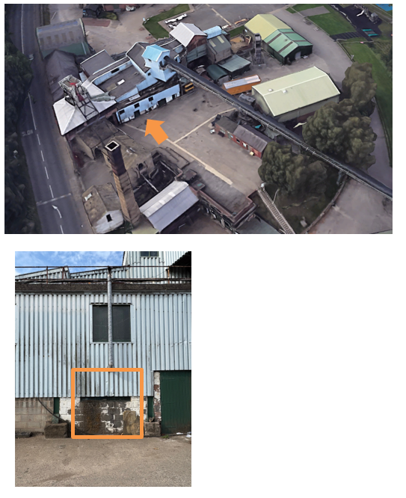

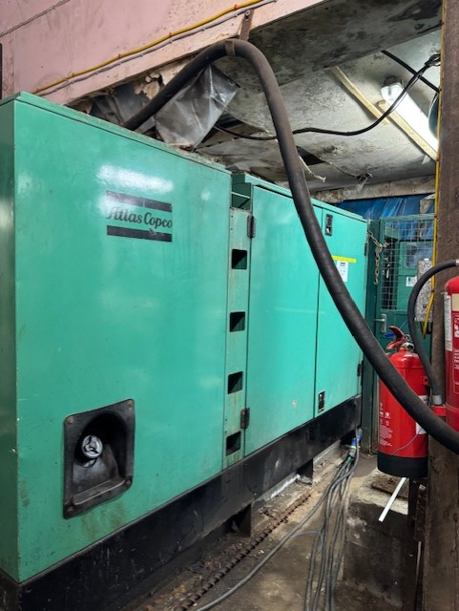



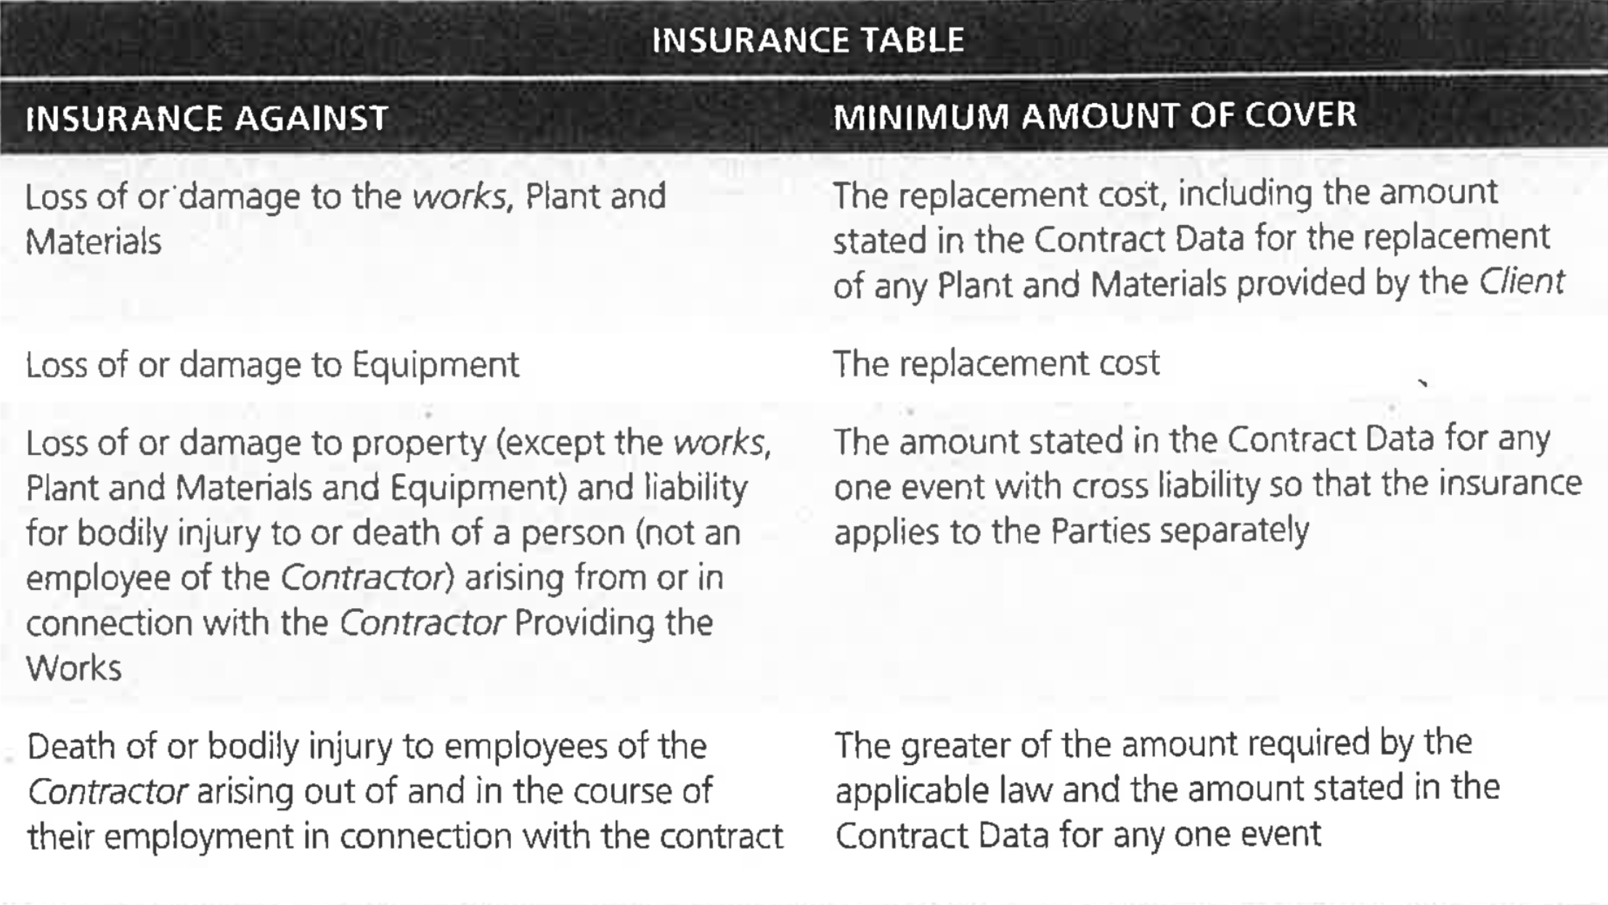

INSURANCE TABLE

