**REQUEST FOR INFORMATION**

**SUBMARINE DELIVERY AGENCY**

**Supply of Spares, Repairs and Technical Support Relating to Submarine Mechanical and Secondary Steam Propulsion**

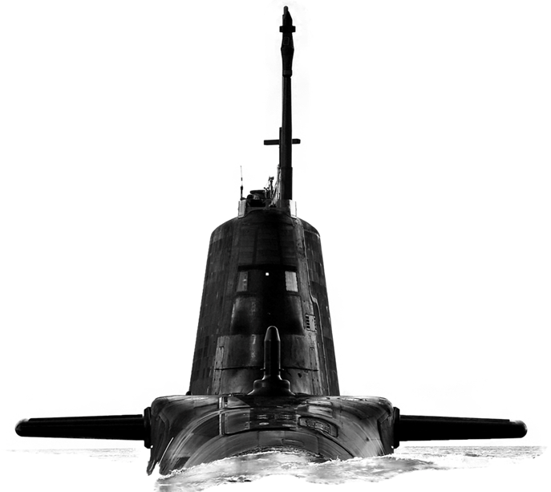

Version 1.0

22 March 2023

**CONTENTS**

Confidentiality..............................................................................................................3

Introduction..................................................................................................................3

Background…………...................................................................................................3

Purpose of the Request for Information (RFI).............................................................3

RFI Procedure............................................................................................................ 4

How to Delivery Responses to this RFI………............................................................4

Contacts......................................................................................................................4

Timeframe...................................................................................................................5

Annex A - Request for Information Questionnaire……….........................................A-1

**Confidentiality**

1. All information included in this Request for Information (RFI) is confidential and only for the named addressee. No information included in your response, or in discussions connected to it, will be disclosed to any other party.

**Introduction**

1. The Submarine Delivery Agency (SDA) has been sourcing submarine spares and repairs described in this RFI the same way for a number of years. This RFI covers a broad range of equipment and seeks to understand the scope for exploiting synergies in approach.
2. The effective supply of submarine spares and repairs is crucial to achieving platform availability. The SDA is seeking opportunities to reduce lead times and friction in the delivery of spares and repairs, and we would like to invite your company to answer a few questions to explore ways in which this can be achieved.
3. This RFI is not a bidding opportunity but a means by which industry can provide information. Any resulting procurement activity will be conducted competitively.

**Background**

1. Secondary Steam Propulsion Systems encompass 6 Master Equipments comprising a wide range of Secondary Steam System equipment. These are:
   1. Main Steam System Valves
   2. Auxiliary Steam System Valves
   3. Steam Drains & Gland Steam System Valves
   4. Main Steam Turbines
   5. Turbo Generators (Mechanical)
   6. Steam and Feed Ancillary
2. Mechanical Equipment is a range of equipment used by submarine platforms and is comprised of both first and non-first level items including but not limited to:
   1. NAB Castings
   2. Tail Cones
   3. Mast Fittings
   4. Submarine Acoustic Tiles
3. Each Master Equipment is used throughout the Royal Navy’s submarine Fleet.

1. The Submarine Delivery Agency has a requirement to source supply of consumables and permanent stock items to support the equipment described above, including survey and repair of supporting equipment, plus technical support relating to all in scope equipment. The planned contract start date is early 2024.
2. The Authority anticipates a planned demand against 518 consumable, 40 capital spare items and 49 repairable stock items. This is estimated to represent in the region of 60% of this requirement with the balance being made up of ad hoc requirements to be priced at the time of order.

**Purpose of the RFI**

1. This RFI aims to achieve 4 outcomes:
2. To gather information about the current market offering for the provision of submarine spares and repairs;
3. To explore the ways in which a future contract or contracts could be structured and priced to enable a high performing supply and repair service which offers reliability and responsiveness in order to improve frontline platform availability;
4. To explore the option of bringing together similar requirements for the provision of spares, repairs and technical support into one contract;
5. Develop a procurement strategy that will deliver best value for money for Defence and enable a contract to be in placed in early 2024.

**RFI Procedure**

1. This Request for Information will be advertised on the Defence Sourcing Portal (DSP) and Contracts Finder and issued to all who request an RFI together with other companies whom the MOD believes may be able to provide useful intelligence on this requirement.
2. Responses to this RFI will be reviewed by subject matter experts from different functional areas within the Submarine Delivery Agency. Following receipt of responses to this RFI the Authority may initiate follow on engagement with either individual potential suppliers, groups of potential suppliers or all potential suppliers. This may be undertaken in writing or through virtual meetings.
3. Any details provided in response to this RFI or during subsequent engagement will be used for information purposes only and will not be used to determine the potential suppliers who will be invited to bid, should the Authority proceed to tender.
4. The results and analysis of this RFI shall not constitute any form of pre-qualification exercise. Any formal procurement process will be undertaken in accordance with EU Procurement Law.
5. Nothing in this RFI, or any other engagements with Industry prior to a formal procurement process, shall be construed as a representation as to the Authority’s ultimate decision in relation to the future requirement.

**How to deliver responses to this RFI**

1. To respond to this RFI please complete the form at Annex A and return electronically to [Sarah.Bulmer490@mod.gov.uk](mailto:sarah.bulmer490@mod.gov.uk) no later than 13:00 18 April 2023. Responses will be acknowledged by email although please be aware that due to annual leave over the Easter period confirmation responses may be delayed.

**Contacts**

1. Please raise questions relating to this RFI by email to [Sarah.Bulmer490@mod.gov.uk](mailto:Sarah.Bulmer490@mod.gov.uk)

**Timeframe**

1. This is the timeframe for the RFI and follow-on activity:

23 March 2023 - RFI Published on Defence Sourcing Portal.

13.00 – 18 April 2023 – Last date for submission of answers to RFI.

Supply of Spares, Repairs and Technical Support Relating to Submarine Mechanical and Secondary Steam Propulsion

**Request For Information – Supplier Response**

|  |  |
| --- | --- |
| **Question** | **Answer** |
| Company Name |  |
| Company Address |  |
|  |  |
| Name of Company representative completing the RFI |  |
| Contact details (e-mail and telephone number) |  |
| Company web site address |  |
|  |  |
| Main products/services/line of business |  |
| Main market sector/customers |  |
| Number of years in this market sector |  |
|  |  |
| Pricing |  |
| The MOD seeks FIRM prices for a duration of one year, with subsequent years priced using a pre agreed Variation of Price (VOP) formula based upon Office for National Statistics (ONS) indices. | |
| 1. Taking into account the current supply market, please outline any risks, assumptions and dependencies which impact your ability to provide FIRM prices for a year. |  |
| 1. Please state the maximum duration for which FIRM pricing could be held and outline the reasons for this. |  |
| 1. Please state the preferred duration for which FIRM pricing could be held and outline the reasons for this. |  |
| 1. Where anticipated demand can be provided for the majority of items, does this support longer duration firm pricing. |  |
| 1. Where items do not have a planned demand but may be required on an ad hoc basis, what would be the anticipated lead time for the provision of a price and what factors would influence this? |  |
| 1. Where a demand plan has been provided, how feasible would it be to provide an all-inclusive price per item to include all sourcing and management fees? Please outline any relevant assumptions or dependencies which would apply to this all-inclusive pricing approach. |  |
| 1. Where guaranteed orders are placed at the outset of the contract, please advise whether discounts could be offered. |  |
| 1. Where discounts are offered for guaranteed orders could this discount be applied to subsequent orders of the same items during the contract term. |  |
| 1. The Authority has set out its intention to award a contract which is firm priced for the first year and VOP for subsequent years. Please provide your comments upon the acceptability of this approach to your organisation. |  |
| 1. Whilst the Authority intends to award a contract which is firm priced for the first year and VOP for subsequent years, we are interested to hear your views on any alternative pricing mechanism which you would consider more suitable to this market to achieve best value and explain how this would be mutually beneficial. |  |
| 1. The Authority is required to consider the use of Reverse Auctions in procurement Activity. What, if any impact would a Reverse Auction have on your ability or decision to bid? |  |
| Contract composition |  |
| This RFI explores the option of bringing together the supply of spares, repairs and technical support in respect of both Secondary Steam Propulsion AND Submarine Mechanical. | |
| 1. Does your organisation envisage being able to cover all of the requirement described above, or part of it? Please explain which part of the requirement could be covered by your organisation |  |
| 1. Please describe the ideal model for your company to deliver this service; would your organisation prefer to bid to deliver this service as a whole, or to deliver part of the service (eg either propulsion or mechanical). |  |
| 1. What are the main benefits of your preferred delivery model for both your organisation and for the SDA? |  |
| 1. Are there any risks or concerns specific to this market that the SDA should be aware of? |  |
| 1. Are there any opportunities to streamline the delivery of spares and repairs that we have not considered above? If so, please describe these. |  |
| Social Value | |
| 1. Central Government seeks to identify opportunities to increase social value across its contracts. What opportunities for added social value are relevant to the supply of submarine spares and repairs and how could your company work with the SDA in pursuit of these. Further information on the Government’s approach to Social Value can be found on gov.uk |  |