**Short description**

The current police Records Management System (RMS) (Athena) serves a collaboration of 9 police forces under a single shared IT solution to allow data sharing across the four key functional pillars of Case, Custody, Intelligence and Investigation, on a centrally hosted/managed environment.

The purpose of this Prior Information Notice is to gain an understanding of the latest developments/ innovations and capabilities for a police/law enforcement records management solution. This includes exploring the potential use of technologies such as artificial intelligence, robotic process automation, facial recognition, transcription and must have data quality automation and the ability to work with mobile devices built in.

The collaboration of 9 Forces wish to establish the level of market interest in participating in the procurement process. At this stage, information gathered through market consultation may be used to inform internal business planning, requirements capture and any subsequent procurement process; and will NOT be appraised in any future tender evaluation exercise.

Participation or non-participation in this preliminary market consultation exercise shall not prevent any supplier participating in any potential procurement process, nor is it intended that any information supplied shall place any supplier at an advantage or disadvantage in any forthcoming procurement process. For the avoidance of doubt, this is the scoping phase of the project and is not part of a formal procurement process.

The Procurement will be for a managed services agreement (up to a term of 10 years (tbc)) for the delivery of software and related services through a single supplier or suppliers.

**Description of the procurement**

We wish to explore suppliers’ ability to innovate, develop and deploy a secure, agile, always on, resilient, cloud-based Records Management System (RMS). The overall solution (which could comprise single or multiple providers) MUST provide the four key pillars of Intelligence, Investigation, Case Management & Custody but could also include other elements such as property management.  The solution must incorporate the ability to input and output information to and from mobile and fixed devices in a manner appropriate for the device being used and with full interoperability between the various platforms. The user experience will be of paramount importance including ease of use, simplicity in training and automated tips/guidance as and when inconsistencies in input data are detected. Mandated metadata and automated cross checking will also need to be incorporated to ensure input information is as accurate and specific as it can be and to avoid duplicates/incorrect information storage. Open interfaces and interoperability will also be an important consideration for current and future flexibility and ensure ease of access to core police data for a multiplicity of needs.

The current RMS system is a fully integrated, web-based information and communications technology solution managing business critical core policing processes and workflow, including:

* Intelligence Management
* Investigation Management
* Protection of Vulnerable People
* Anti-Social Behaviour
* Defendant Management (Custody and Case preparation)
* Warrants Management
* Digital Public Contact
* Problem Solving Platform
* Data Analytics

There are 34,000 registered users.

Average daily peak is ~ 6000 users.

Average system usage over previous 12 months: (Also see data in Section VI -Complimentary Information)

* Arrests: 2.9m
* Cases: 2.4m
* Custody: 1.9m
* Investigations: 14m
* Documents: 50m
* Intelligence reports: 5.7m
* Object Link count within Athena RMS: 593m

Current Interfaces are to multiple third-party policing technology systems, including:

* Police National Database (PND)
* Police National Computer (PNC)
* Crown Prosecution Service
* Police force mobile phone devices

The contracting authorities referred to in Section I.1, as contracting authorities for their respective police forces, will shortly undertake a competitive flexible procurement to appoint a supplier to provide and fully manage a highly resilient, police records management system.  The successful supplier(s) will be required to work alongside representatives from the contracting authorities and relevant third parties, to implement, and configure the system to the requirements of the contracting authorities including the provision of appropriate resources to support this.  The successful supplier(s) may be required to enter into either a single contract with all contracting parties, or individual contracts with each contracting party.  Alternatively, the contracting authorities may appoint the successful supplier(s) to a framework agreement allowing individual call off contracts to be issued by individual contracting authorities and other blue light organisations listed in I.1.

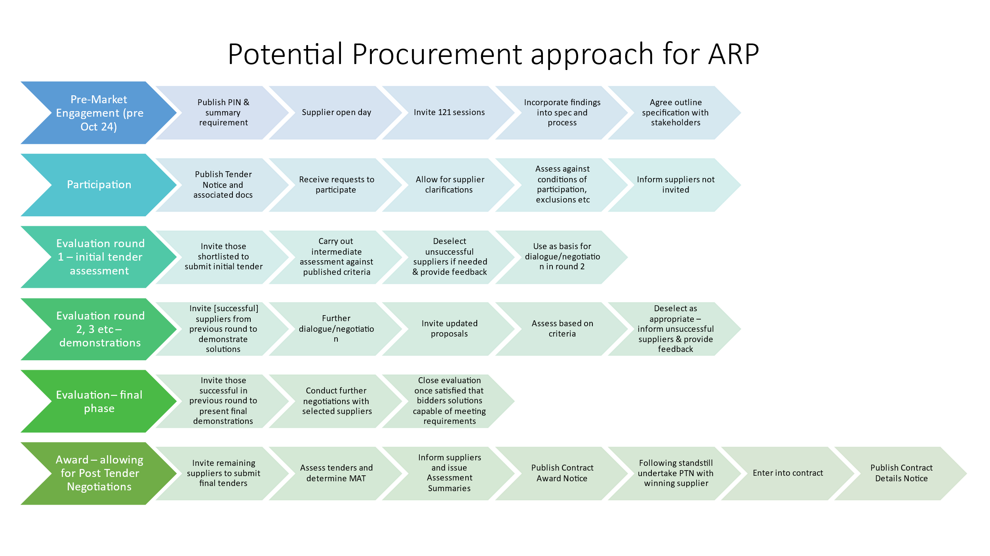

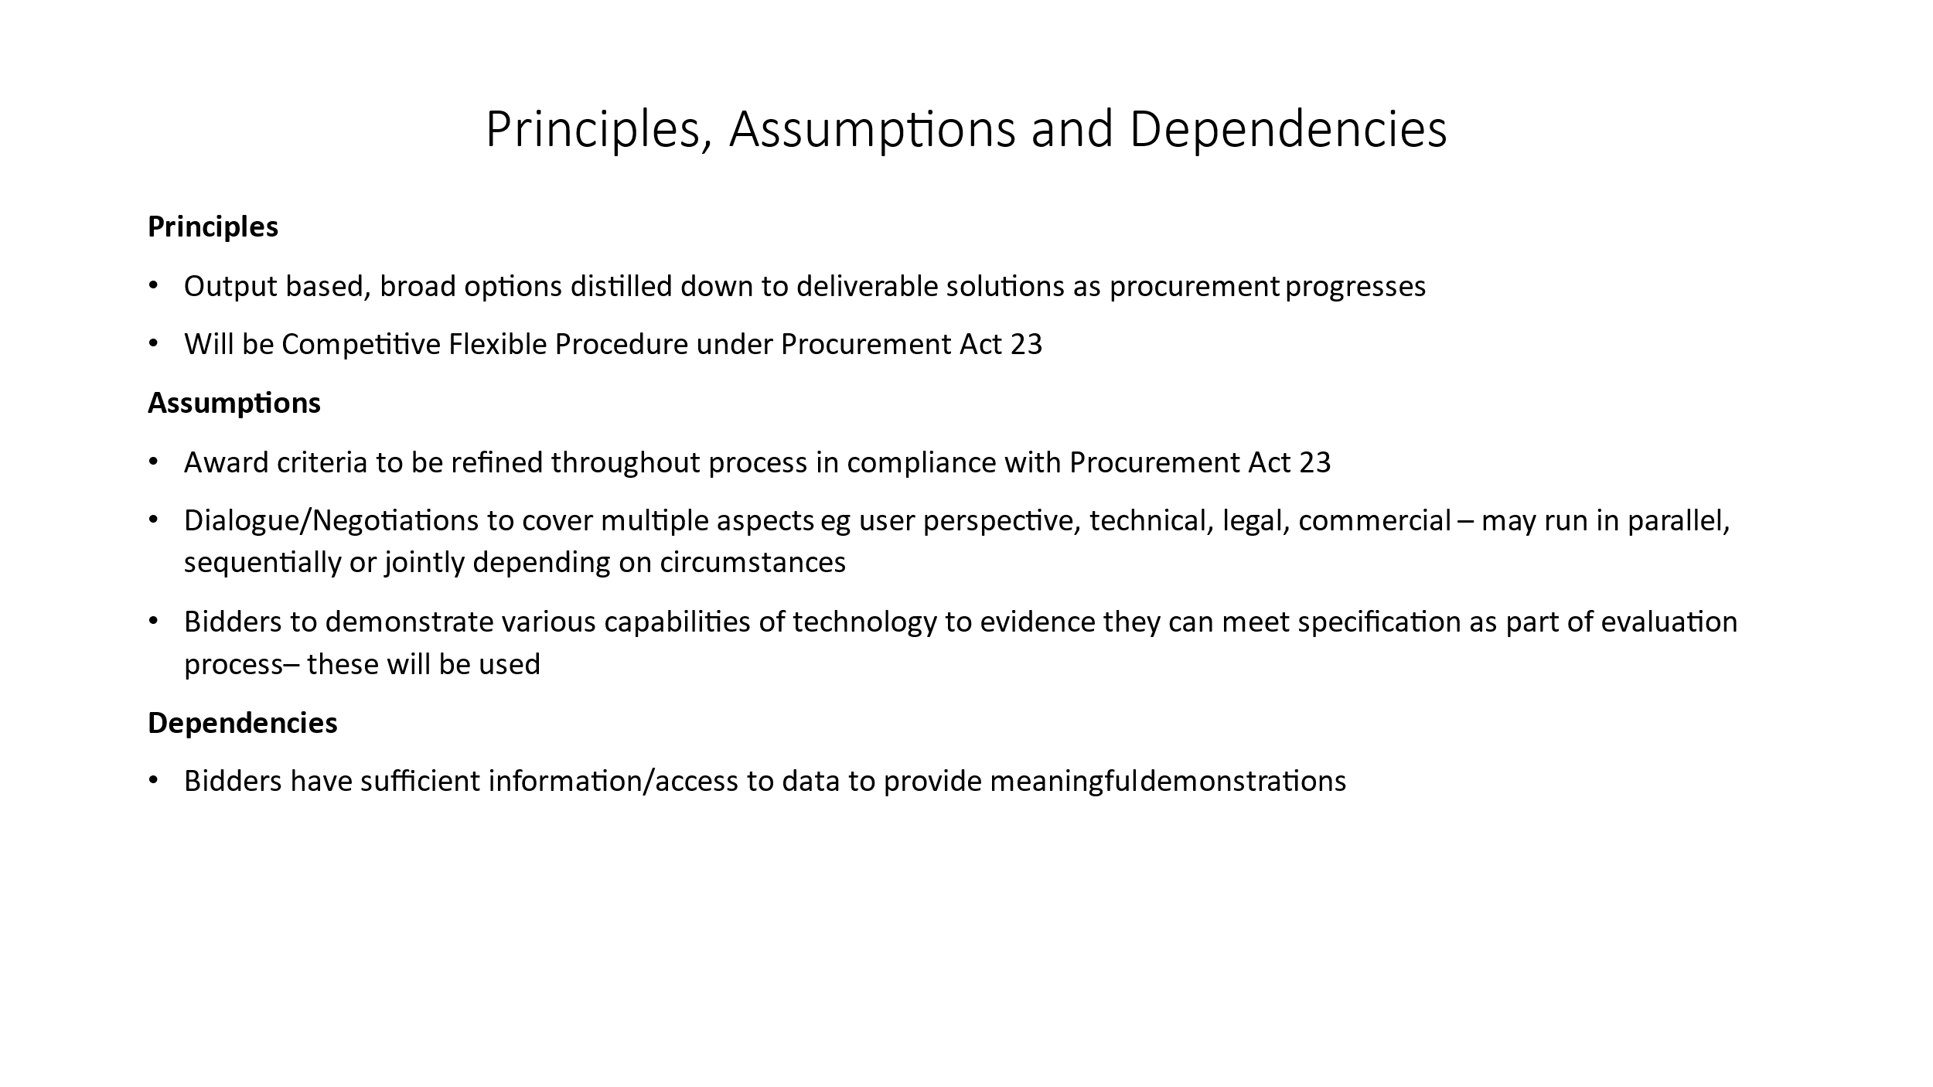

**Section VI: Complementary Information**.

**Registered users**

**Average Daily Peak**

System usage over previous 12 months (June 23-May 24):

Arrests:



Cases:



Custody:



Investigations:



Documents:



Intelligence reports:



Links:



**II.2.14) Additional information**

This PIN is to signal an intention to commence market engagement with interested suppliers. To participate, please follow the guidance set out in Section VI.3 (Additional Information) below. The estimated date of tender notice publication is subject to change because of market engagement and further research. The estimated total value of the contract is also subject to change depending on market fluctuations and final requirements.

Please note that the authorities intention is to work directly with supplier of the records management system rather than via third parties representing one or more suppliers.

**Section VI: Complementary information**

VI.3) **Additional information**

**Pre-Market Engagement Questionnaire**

Suppliers who wish to participate in this market engagement exercise should complete the pre-market engagement questionnaire attached.

The aim of this Pre-Market Engagement is to:

• Give suppliers further background to the Athena Replacement Programme Procurement (ARP)

• Use the pre-market engagement to support the development of a User Requirements Specification so that the tender documents are appropriate and address key issues raised by suppliers.

• Give suppliers an understanding of our requirements and what we want to achieve from the contract.

• Evaluate the range of capabilities, services, costs and various pricing modules available from the various suppliers that will or may be interested in this procurement opportunity.

• Develop an understanding on how long the project will take to implement.

• Understand the risks and issues associated with the provision of a resilient, cloud-based Records Management System (RMS)

• Provide interested parties with an opportunity to inform the future tender structure (e.g., division into project phases etc.) and the duration of any awarded Contract.

Once we have received and analysed responses to this questionnaire, we plan to hold one to one discussions with suppliers to explore suppliers’ views in more detail. Details of these discussions will be shared with suppliers in due course and will be communicated directly with suppliers.

Following completion of the premarket engagement, the Athena Replacement Programme intends to conduct a procurement exercise to identify a suitable supplier to supply and deliver a cloud-based Records Management System.

Full details are contained in the documentation attached to this notice.

**Clarification Question Deadline: 12.00 noon on 30/09/2024**

**Response Deadline to Expression of interest: 12.00 noon on 04/10/2024**

**Completed questionnaires must be submitted by 12.00 noon - 18/10/2024 -**

**All communication must be via the tender portal.**

There are no formal tender documents to be completed other than the questionnaire.

NB: NO OTHER FORM OF COMMUNICATION WILL BE ACCEPTED FOR THIS STAGE OF THE OPPORTUNITY.