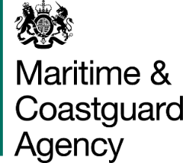

The Maritime and Coastguard Agency (MCA) is an Executive Agency of the Department for Transport. The MCA is responsible throughout the UK for implementing and developing the UK Government’s maritime safety and environmental protection policy. That includes co-ordinating Search and /Rescue at sea through Her Majesty’s Coastguard 24 hours a day, and checking that ships meet UK and international safety rules. The MCA work to prevent the loss of lives at the coast and at sea, to ensure that ships are safe, and to prevent coastal pollution: Safer Lives, Safer Ships, Cleaner Seas.

The MCA provides a full range of search and rescue, counter pollution, survey, inspection and enforcement activities and has 12 major business activities:

Survey | Seafarers’ Services
Inspection | Search and Rescue
Enforcement | Pollution Response and Salvage
Ship Registration | Stakeholder Communication
Navigation Services | Ministerial Services
Strategic Prevention Design/Development | Regulatory Process

These activities are maintained by support services responsible for providing a range of administrative functions including: infrastructure, MCA people, financial management and administration and corporate management.

In accordance with the 2010 Equality Act, our capacity as a public body means we have a statutory duty to eliminate unlawful discrimination, promote equality of opportunity and promote good relations between people of different backgrounds. Contractors will be expected to ensure that the service they provide promotes good relations between the MCA and its customers and does not directly or indirectly discriminate on the grounds of any of the protected characteristics specified in the Act.

You are invited to submit a tender for the following project:

MCA REFERENCE:
A STUDY TO REVIEW THE RISKS PRESENTED BY, AND TO, SHIPPING WITHIN THE UNITED KINGDOM EXCLUSIVE ECONOMIC ZONE (UK EEZ) AND TO ASSESS THE AVAILABILITY AND ADEQUACY OF EMERGENCY TOWAGE ARRANGEMENTS.
Background

- In 2011, in the wider context of the Comprehensive Spending Review, a
ministerial decision was taken to withdraw the UK’s publicly funded emergency towing service in its entirety. The view was taken that emergency towing was a matter for commercial ship owners and their insurers, using the services of commercial towing vessels.

- Emergency Towing Vessels (ETV’s) first entered into service on behalf of the MCA in 1994 on the recommendation of Lord Donaldson, following the Braer tanker disaster on Shetland. There were initially two ETV’s stationed off Dover and Stornoway (Winter only) and subsequently, following a review in 2000, this was increased to four with additional tugs stationed at Shetland and the South West Approaches.

- The primary role of the ETV’s was to intercept ships which had become disabled before they grounded or collided with other ship traffic, securing a tow and towing the casualty to a place of safety. A number of ancillary and secondary functions existed but claimed only a small fraction of the vessels’ tasking.

- However, on withdrawal of the service the Government recognised the paucity of commercial towage availability in and around northern Scotland and the Northern and Western Isles. Funding for a single Emergency Towing Vessel (ETV) to cover these areas was reinstated and a single ETV continues to patrol this region. The current vessel is contracted until 31 December 2021.

- The last full review of emergency towing requirements in the UK took place 10 years ago. It is likely that the situation has changed in the intervening years in terms of vessel size, shipping density, ship reliability, the increasing complexity of potentially polluting cargoes in a single vessel and the commercial availability of ocean going emergency towage.

General Requirement

- The MCA wishes to commission a study into the risks presented by, and to, shipping within the UK EEZ and to assess the availability and adequacy of any emergency towage arrangements in the UK. Based on the level of risk and the local commercial availability of emergency towage, the study will be designed to research the current and future risks to, and from, shipping, and make recommendations as to whether the UK requires emergency towing services at strategic locations around the UK coastline. The specific areas of investigation will be:

- the risks currently presented by and to shipping within the UK EEZ in terms of the risks to life, to the environment (the potential impact of pollution from ships on the marine environment and coastline), to navigation and to related interests (economic activity i.e. port activity, fishing, tourism etc.);
- the potential future risks (out to 2025) presented by and to shipping within the UK EEZ (changes in traffic density, size/type of ships, cargoes carried, fuel used etc.);
- the current options for emergency towage within the UK EEZ, their efficacy based on the risk and their availability;
- whether there is a need for the provision of a dedicated Emergency Towing Service within the UK EEZ to meet the UK government's commitment to maritime safety and environmental protection;
- what the scope of this service should be in relation to the threat posed;
- a cost benefit analysis of the options proposed; and
- the feasibility and impact of any additional secondary duties that might be undertaken by an emergency towing service e.g. SAR, Counter Pollution, Customs, Border, Fisheries Patrol duties, Fire Fighting, Civil Hydrography and academic research activities.

- The consultant is to produce a report with conclusions, options and recommendations for consideration by the MCA regarding any future prevention and mitigation activities that may be appropriate within the UK EEZ. The report should also identify any additional secondary government supportand/or commercial activities which may be compatible. Value for money and potential income generation should be considered, however, the impact of any secondary activities on emergency towage response times should also be outlined.

- Any recommendations for an emergency towing capability in any of the specified areas should be accompanied by a technical recommendation for the type of emergency towage that would be appropriate for that area.
Scope of Work

- In order to determine the current and future level of risk posed to the UK coastline, the consultant will need to examine data on a number of factors, including:

- the density of ship traffic at specific points/areas around the UK coast for 2013 - 2017. Those points/areas are to include the Dover Straits and it’s approaches, the Southwest Approaches and St Georges Channel, the Irish Sea and approaches to the North Channel, the Minches, the Fair Isle Channel and the Pentland Firth (see Appendix A for chartlets of specified areas);
- the composition of this ship traffic in terms of ship and broad cargo type
- specific off-shore industry hazards, e.g. windfarms etc;
- statistics on shipping incidents for 2013 - 2017. Incidents would include mechanical failure leading to a vessel being not under command, collisions between ships or offshore objects, loss of cargo, sinkings, listings, groundings and fires/explosions;
- the future risk should be a broad assessment based on predicted trends in the shipping industry. This would include changes to the volume and type of shipping transiting the UK EEZ, the density of shipping in the UK EEZ (likely to correspond to planned offshore developments), financial pressures and changes in the fuels used and cargoes carried; and
- for the UK coastline generally, but with particular focus on the points/areas specified, the potential impacts that might be anticipated should an incident occur in terms of shipping traffic, environmental sensitivities and related interests. This will be based on the probable incident scenarios developed following the assessment of the current and future risks for each area.

- Anticipated output from the above will also include recommendations to bridge any identified gaps in responsibilities, and any improvements which could be made on a cost/benefit basis. All recommendations must abide by the SMARTA principles e.g. they must be:

- Specific
- Measurable
- Achievable
- Realistic
- Time-limited (for implementation)
- Agreed (with MCA)

- In order to determine the current availability and geographic spread of commercial towage, the consultant will need to investigate the availability of towing vessels capable of routinely providing a service in open ocean conditions (to include AHT’s, AHTS’s, OSRV’s and ERRV’s).

- The availability and geographic spread of harbour towage should also be
examined, focusing on those vessels with a capability of greater than 30bpt. The viability of using these vessels for open ocean towage should also be examined.

- Based on the risk assessment and investigation into the availability of
commercial towage, the consultant should assess whether there is any need for a dedicated emergency towing service for each of the locations examined in the study. The form and scope of the service proposed should be commensurate with the threat posed.

- Possible secondary functions for any emergency towing vessel taken on should
be examined. In order to achieve this, speculative conversations should take place between the consultant and any possible beneficiaries to establish both the need and feasibility of a shared service. The likely impact of these secondary functions on the ETV’s response times should be assessed.

- If a recommendation is made for the use of ETVs, tenderers should identify and recommend types of emergency towing for each area specified. This to be based on:

- Vessels likely to be encountered in the specified area;
- Conditions which could be encountered in the specified area and the impact of the wind speed, wave height and current on bollard pull;
- The area of coverage and the risk in that given area; and
- The activities which an ETV could be engaged in during an incident (recovery of casualty vessel crew, firefighting, container/wreck recovery (when it poses an immediate and serious navigational hazard)).

- The technical recommendation should produce recommended/ideal vessel specifications detailing:

  - Bollard pull;
  - Speed;
  - Size of vessel;
  - Design of vessel (hull shape, keel depth, deck layout);
  - Equipment on-board, including:

- Towing equipment,
- Deck machinery (winches, cranes etc.)
- Bridge and passage planning equipment,
- Personal protective equipment,
- Rescue and sea survival equipment,
- Salvage and damage control equipment,
- Firefighting equipment, and
- Pollution prevention/control equipment;

  - Crew knowledge, experience.

Timescale

- The work would be completed over a six-month period with interim deadlines for
submissions within that period for:

- The completion of the risk assessment by the end of month two;
- The completion of the assessment of commercial towing capability in the UK by the end of month four;
- The completion of the final report with recommendations by the end of month six.

Payment

- Payment shall be made incrementally upon receipt of each stage of the report,
with:

- 30% of the payment made upon receipt of the risk assessment;
- 30% of the payment made upon receipt of the assessment of mitigation measures considered (ie. availability and adequacy of emergency towing availability) and draft final analysis;
- 40% upon completion of the final report with its recommendations.

The MCA pays undisputed invoices 30 days in arrears.

Deliverables

- The final report is to comprise of the following main sections:

- Executive Summary
- Objective and Scope
- Structure and Methodologies - theoretical and practical
- Risks and Assumptions
- Mitigation measures
- Findings
- Analysis
- Conclusions
- Recommendations

- The MCA requires two hard copies of the report and one pdf software version.
The successful organisation should understand that the MCA would wish to publish the final report on the DfT/MCA website.

Contract Management

- A number of contract management meetings are to be programmed with the MCA, dates to be arranged:

- 1 x project kick-off meeting
- 2 x monthly progress meetings
- 1 x meeting to review draft report
- 1 x meeting to accept Final Report

All meetings will be conducted at MCA HQ in Southampton.

- In addition, a number of regional stakeholder meetings are anticipated (4), to be arranged by the contractor in liaison with MCA. The MCA will cover the cost of the venue and catering. The contractor is to factor their administrative and personnel’s travel and subsistence cost for these into their tender.

Sustainability and Ethical Procurement
- The MCA is committed to sustainable procurement. This means making the necessary decisions to protect our environment and to operate its procurement activity in an economically, socially and environmentally responsible way. Tenderers should indicate ways in which their organisation promotes and practices sustainable development and how this can impact on this contract.

- Tenderers should detail options to identify and promote measures to reduce emissions during transport of goods. Including rail freight or low emission/fuel efficient heavy goods vehicles.
25. In addition, the MCA expects that all of its contractors will abide by the principles of the government’s Supplier Code of Conduct, to be found at https://www.gov.uk/government/publications/supplier-code-of-conduct. Please indicate where requested on the Form of Tender whether you agree to this.
26. More information on sustainability considerations can be found at:
- https://www.gov.uk/government/policies/making-sustainable-development-a-part-of-all-government-policy-and-operations;
- https://www.gov.uk/government/collections/sustainable-procurement-the-government-buying-standards-gbs.

Reference documents
- Report of Lord Donaldson’s Inquiry into the prevention of Pollution from Merchant Shipping – Safer Ships, Cleaner Seas 1994
- Lord Donaldson’s Review of Salvage and Intervention and their Command and Control 1999
- Protection of the UK Marine Environment – A Review of Emergency Towing Vessel Provision Around the Coast of the UK 2000
- Emergency Towing Study by Captain C Belton, RN (retired), 1995
- Marico Marine Group’s ETV Assessment of Requirements Report 2008
- Be Aware 1 & 2, published by the Bonn Agreement in 2012 - 2014

Appendix A

Dover Straits & Sunk
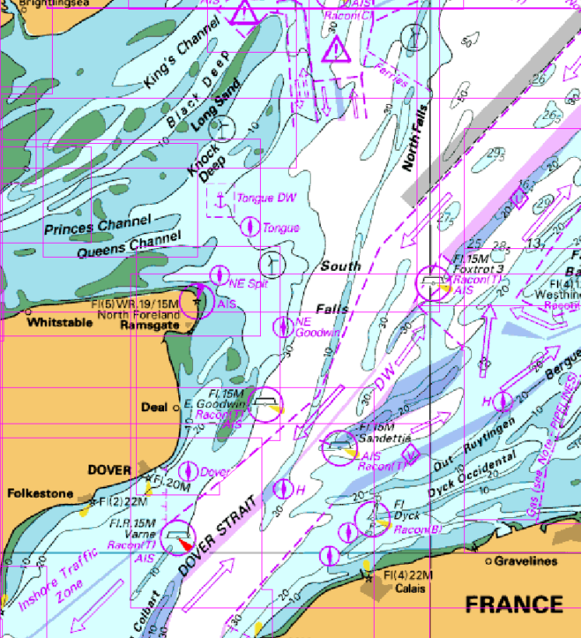
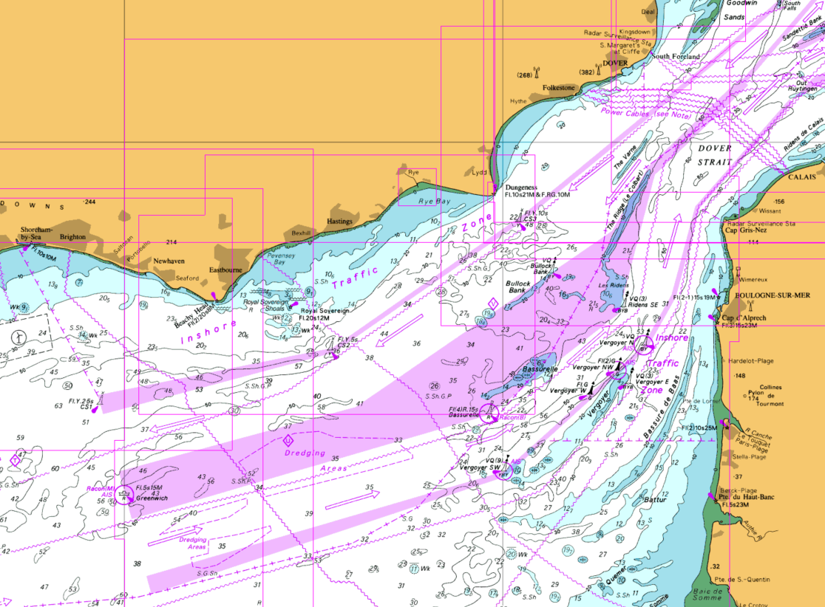

South West Approaches

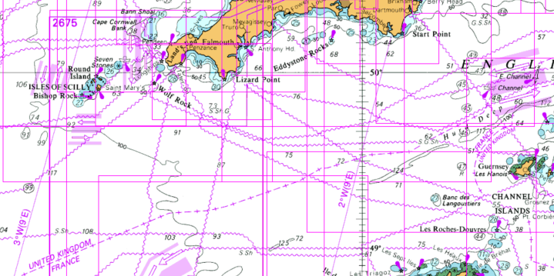

St Georges Channel

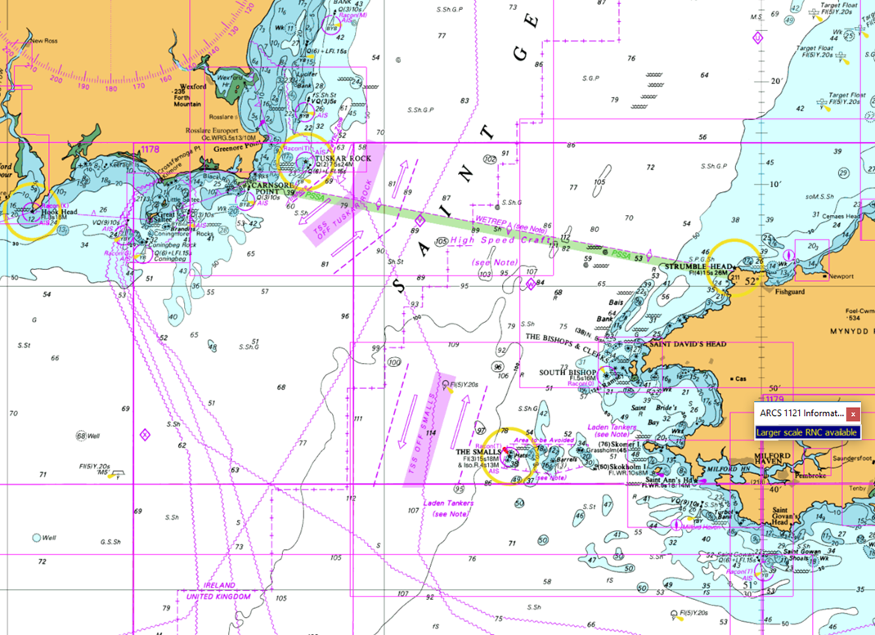

North Channel

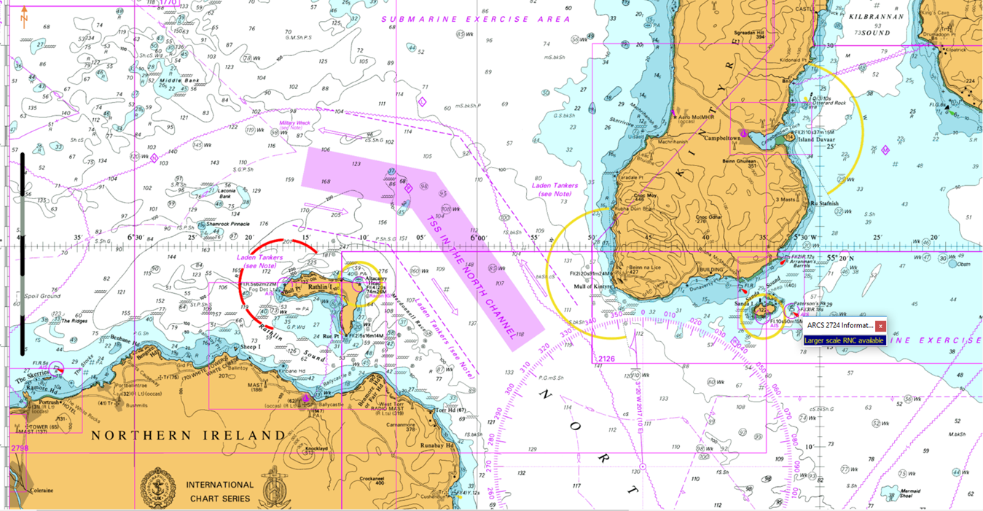

The Minches and Deep Water Route

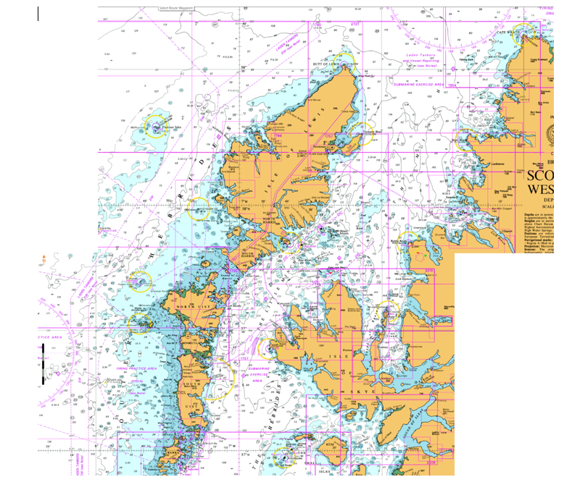

Pentland Firth

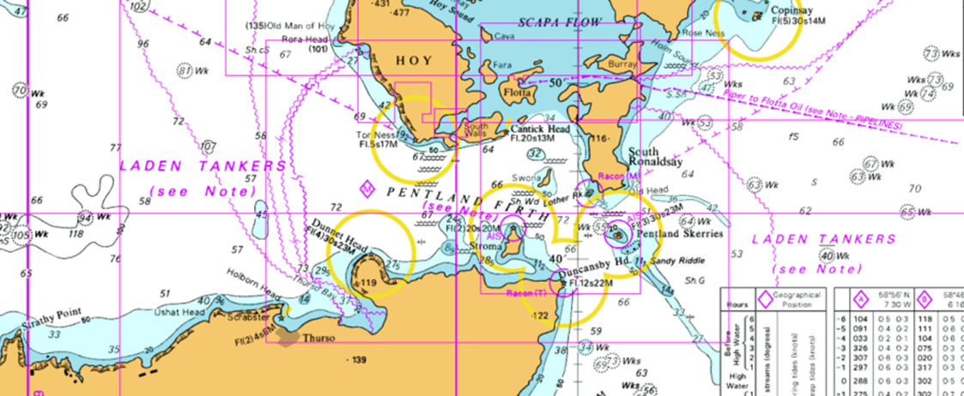

Fair Isle Channel

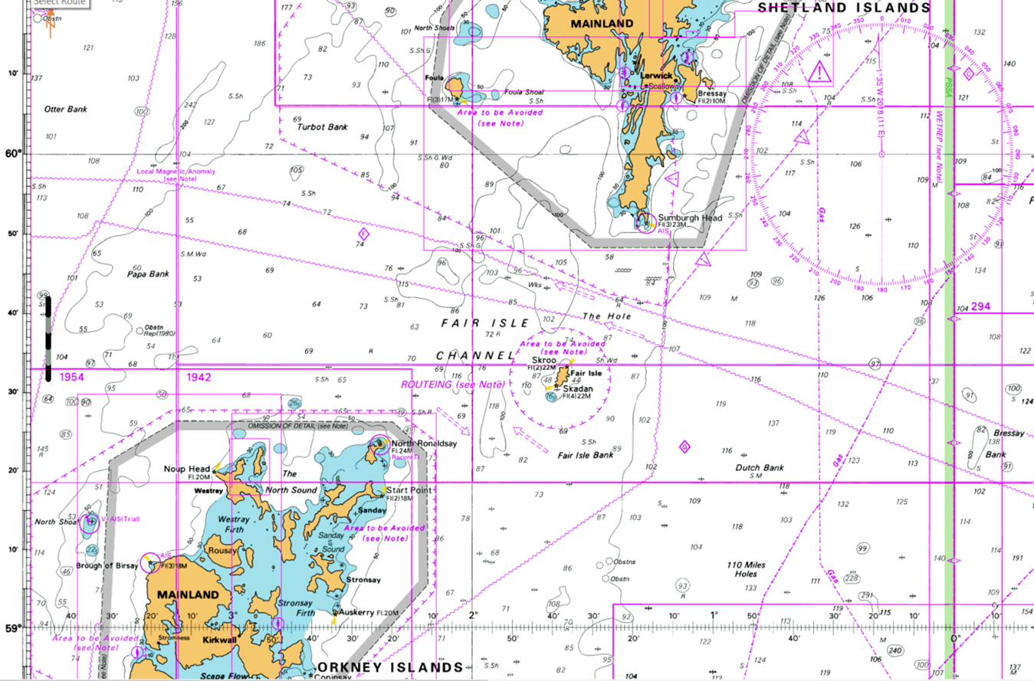

More recently, a focused review of the risks to and from shipping, and the characteristics of an appropriate emergency towing vessel to meet the risks identified, was undertaken by London Offshore Consultants Ltd for the sea areas to the north and north west of Scotland, published in June 2016. This study supported the 5 year funding of the current ETV in this region.
E.g. Border Force, HMRC, Fisheries, the GLA’s, Civil Hydrography.
E.g Marine research
Government funded emergency towing vessels are expected to be at 30 minutes notice to deploy to a casualty vessel , 24/7.
Ibid Footnotes 2, 3 and 4.
(a).Tender documents must outline all risks and issues identified for the project and suggest mitigation measures.. (b) Tender documents should make explicit any assumptions that have been used in the formulation of the bid, preferably in a separate sub-section. c) Tender documents should make explicit any data licenses required in order to complete the project work, or access / use the project deliverables and include the cost of these in their tender bid and tabulated cost breakdown. (d) Contractor(s) are required to comply with the data storage and handling requirements, and confidentiality guidelines set out in the terms and conditions and the requirements of the UK Governments Security policy framework. Further information on the Security policy framework can be found at: https://www.gov.uk/government/publications/security-policy-framework

