**08 Nov 21**

**Data Centre Rationalisation (DCR) - Early Market Engagement**

This Request for Information (RFI) notice invites interested vendors to read and provide feedback on the details shared below concerning the Data Centre Rationalisation (DCR) requirement.

Responding to this announcement is voluntary and does not start the official procurement process for the DCR requirement. The DCR team intends to provide further details of any future procurement in January/ February 2022. The department will not be funding any work undertaken by vendors in responding to this RFI. This RFI is being used to engage potential vendors with the concept of DCR and to aid the team in shaping the requirement for any future competitive procurement that may follow.

**Problem statement**

Much of the Ministry of Defence ‘s (MOD) Information and Communications Technology (ICT) infrastructure is housed in disparate data centres and server rooms throughout the Defence Estate. Some ICT facilities are well-managed and in good condition, but many require remediation or modernisation (obsolescence management), and some exist on sites that MOD will close over the next few years under the ‘Better Defence Estates’ optimisation plan. The Digital Strategy for Defence requires the MOD to have a concise and consolidated view of performance, value, resilience, efficiency, and the associated security risks of its ICT infrastructure. The current disaggregated landscape of data centres across the MOD does not enable the delivery of this strategy. Analysis of OFFICIAL and SECRET ICT infrastructure, and the applications and data hosted therein, has identified opportunities to migrate application and data services from existing legacy hosting environments across the MOD estate to an optimal mix of MODCloud (public and private cloud), Crown Hosting, and retained MOD data centres.

**Desired outcome**

A significant reduction on the reliance of Top-Level Budgets (TLBs) owned and managed ICT infrastructure across the MOD estate. Data and application services utilising an optimal mix of modern and efficient cloud services, and managed data centre hosting solutions. DCR does not introduce new services, rather, it migrates existing services from their current modes of operation to future modes of operation where business (and operational) need is continually satisfied. Demonstrable improvements in security, resilience, sustainability, and transparency of MOD IT services. Moreover, Defence expects there will be realisable cost savings through reduced operational expenditure and efficiencies borne from managing the growth of digital services in cloud environments. The realisation of the cost efficiencies identified through modelled data, would need to be confirmed and agreed as actuals for each component migration under DCR prior to the saving being applied to the owning TLB.

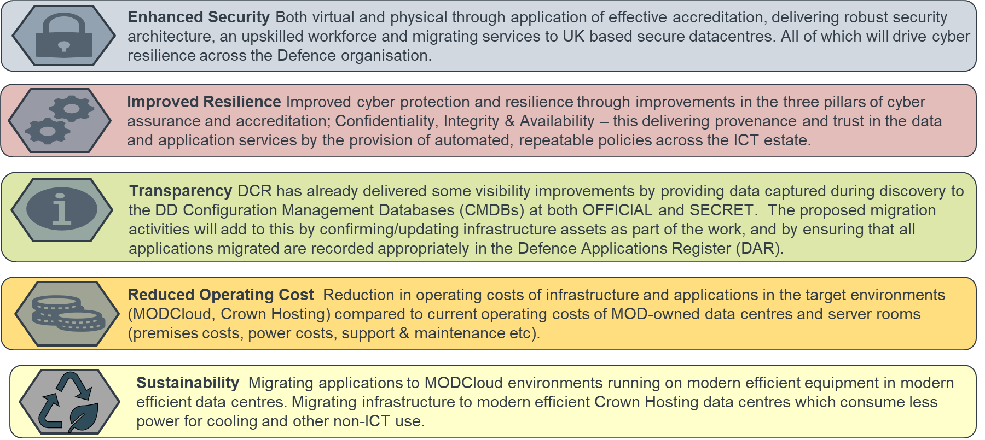

**Purpose**

The purpose of this document is to outline the key aspects of the DCR project and seek advice from industry experts on how best to shape the delivery aspects of the project and the most appropriate commercial mechanisms, excluding the Crown Commercial Services G-Cloud Framework, to drive successful outcomes.

**Background**

The blurring of the boundaries between the business and operational environments, and the necessity to achieve ‘information advantage’ over the UK’s adversaries, are key drivers behind the MOD’s Digital Transformation Strategy. The genesis of the DCR project was the recognition that much of the current ICT infrastructure across the MOD is obsolete and is becoming increasingly expensive to maintain. In its current state, effective data exploitation is impossible and is preventing Defence from realising its digital ambition.

A discovery exercise commenced in 2019 to map the current ICT landscape both in terms of physical infrastructure, but also the application and data services being consumed by TLBs to meet the business need. Whilst data centre/server room inventories were relatively straightforward to obtain, the application and data service information remains incomplete. This is largely due to the lack of deployed system monitoring tooling and the limitations of the Defence Application Register. There will be a requirement for physical site visits and confirmation of the discovery information with the on-site system owners as part of the migrations.

The key stakeholders are the Front-Line Commands (Navy, Army Royal Air Force), but other TLBs have migration requirements under DCR or are pursuing independent migration programmes. Most of the application and data services are business-related services, but some applications and data relate to operational capability development and 3rd party suppliers. Each migration has been costed on its own merits and business need, however, at an enterprise level there may be the opportunity of utilising shared business services. The project is owned and managed by Defence Digital but TLBs will be required to agree individual migration plans and accept the liability for the ongoing service costs (which are likely to be drawn from different budget types, e.g. power consumption costs are met through site infra budgets for on-prem data centres rather than the IT budget). Overseas, deployed, and above secret data centres remain out of scope for DCR as are data centres that are exclusively hosting local network distribution infrastructure. Navy, Army, Air, and UKSC TLBs are the primary stakeholders.

**Delivery approach**

A client-side project support team will be required to manage the engagement with the multitude of stakeholders associated with DCR and manage the interaction of the project within the wider MOD Digital Transformation Programme and other related programmes. The project support team will also maintain the overarching responsibility for project management, reporting and governance (including benefits realisation). Additionally, it is anticipated that a delivery partner will be selected to deliver circa 30 migrations over a 3-year period commencing in April 2022.

**Client-side project support services**

There is a requirement for a client-side team of experienced resources to liaise with TLBs and system owners/managers to enable and support delivery of migrations by suppliers, and to manage and assure all aspects of those deliveries. The client-side team supplier will need specialist project and change management expertise and a proven ability to ‘get things done’ in Defence. Responsibilities of the core client-side team will include:

* TLB engagement & communications
* Maintenance of project documentation and record management
* Maintaining the balance of migration effort across the difference migration deliveries to ensure that no one enabling function is overwhelmed
* Delivery assurance and supplier management
* Technical assurance
* Compliance with MOD processes (Accreditation, JSP604, etc.)
* Project controls and reporting
* Management of risks, issues, assumptions, and dependencies
* Embedding resources into the FLCs to enable and support site and FLC teams in the activities they will need to undertake as part of the migrations

All personnel employed within the client-side project support team will be required to hold SC clearance and maintain training currency for the use of MODNet and MODNet/S (where appropriate).

**Migrations to cloud environments**

There is a requirement for one or more suppliers to migrate application and data services from running on ICT infrastructure in MOD-owned datacentres and server rooms to running in production environments onto Cloud platforms (MODCloud in the first instance), including making any software changes required to enable applications to run this way. In some cases, migrations will also include the setting up of development and test environments on behalf of the system owner. The work will consist of the migration of a number of ‘Migration Units’ comprising one or more applications, from existing infrastructure to one of the MODCloud platforms. Broadly speaking, each Migration Unit is an independent piece of work, and it would be possible to place the work with multiple suppliers, each responsible for a given number of Migration Units. However, it is likely to be more efficient for a single supplier to set up a ‘migration factory’ to deliver all Migration Units, and from which MOD would benefit from both economies of scale and learning curve effects (productivity/efficiency will increase over the course of the project).

Illustrative scope of the migrations to cloud shown below:

|  |  |  |  |  |
| --- | --- | --- | --- | --- |
| Application migrations | OFFICIAL | | SECRET | |
| Locations | Apps | Locations | Apps |
| MODCloud ICE | 7 | 18* |  |  |
| MODCloud ACE | 8 | 15 |  |  |
| Cloud (other) | 2 | 4 |  |  |
| MODCloud SECRET |  |  | 3 | 30 |

* data incomplete

**Migrations to physical environments**

There is a requirement for one or more suppliers to relocate (‘lift & shift’) applications and the underlying ICT infrastructure (servers, storage etc) from MOD datacentres and server rooms to Crown Hosting datacentres. Included in the migrations to physical environments are the migration units where application and data services are migrated to VMs managed centrally by the MOD or an individual TLB. Again, the work will consist of largely independent ‘Migration Units’, each consisting of a quantity of equipment and one or more applications. Again, it would be possible to place the work with multiple suppliers, each responsible for a given number of Migration Units, although it may be more efficient to use a single supplier.

Illustrative scope of the migrations to physical environments is shown below:

|  |  |  |  |  |
| --- | --- | --- | --- | --- |
| Physical migrations | OFFICIAL | | SECRET | |
| Locations | Racks | Locations | Racks |
| Crown Hosting | 7 | 48 | 8 | 47 |

**Response Submission Deadline** 

Responses to this RFI must be submitted no later than 23:59 GMT on Monday 29th November 2021.

**Questions**

See page 5 below

**Questions to Industry**

1. Having reviewed the overview for DCR, please outline any requirements or alternative approaches the MOD should consider?
2. The services that are expected to be procured will include migration services (cloud and physical) and, project management services. What delivery model would you recommend that promotes an effective business outcome?
3. What pricing & payment mechanism would you propose the MOD use for this requirement? Does this mechanism drive value for money? How does the mechanism work?
4. What pricing & payment mechanisms would you propose as an alternative to Time & Materials and how would it work?
5. What delivery approach/s would you propose and why? (E.g. central migration factory; a programme of individual migration projects; other).
6. What would you expect/need MOD to do or have in place in order to enable you to be successful in this work (this can include equipment the MOD may need to supply)?
7. MOD is large and organisationally complex organisation, and DCR will be migrating infrastructure/services for many internal stakeholders. What organisational challenges would you expect, and how would you approach them?
8. Do you have any case studies that are relevant to this project? If no, proceed to question 9, if yes please answer the below:

* What was your approach?
* Was this within Government or in industry?
* What worked well?
* Would you do anything differently/ is there any shared learning from this experience?

1. What routes to market (excluding the CCS G-Cloud Framework) would enable your organisation to meet this requirement?
2. Is there anything further the MOD should consider regarding this requirement?