|  |  |  |  |  |  |  |
| --- | --- | --- | --- | --- | --- | --- |
|  |  |  | | | | |
|  | |
|  | |
|  | |  | | | | |
| Digitising the National Farm Survey - Transcription | | | | | | |
|  | Invitation to Tender | | | | |  |
|  |
|  |
|  |  |  |  |  |  |  |
|  |  |  |  |  |  | |
|  |  |  |  |  |  |  |
|  |  |  |
|  |  | | |  | |
| Research, Grants and Academic Engagement | | | | 07.10.2024 | |

Section 1: Purpose 3

Section 2: Background 3

About The National Archives 3

About the Project 3

Size of the Collection 3

Section 3: Requirements 4

3.1 Transcription of Original Material 4

3.2 Transcription Accuracy 4

3.3 Transcription Output 4

3.4 Transcription QA by The Authority 4

3.5 Data Protection 4

3.6 Transcription Location 5

3.7 Security 5

3.8 Segregated data, back-ups, anti-virus checks 6

Section 4: Project Deadlines, Batching and Transfer 6

4.1 Project Deadlines 6

4.2 Data Transfer 6

4.3 Batching 6

4.4 Reporting 7

Section 5: Price 7

Section 6: Evaluation of ITT Responses 7

Evaluation Criterion 1: Methodology 7

Evaluation Criterion 2: Experience 8

Evaluation Criterion 3: Price 8

Evaluation Criterion 4: Proof of Concept 8

Evaluation Criterion 5: Social Value 9

Section 7: Evaluation Methodology 9

Section 8: How to Respond 11

Submission of Tenders 11

Competition Timetable 12

Queries 12

Section 9: Contract Terms 12

Appendix A – Information to be Captured During Transcription 13

Image Arrangement 13

Document Types 13

Required Metadata 14

Appendix B – Sample Template for Capturing Transcribed Data 25

Section 1: Purpose

This Procurement Process is for The National Archives to identify and select a supplier to transcribe information from the National Farm Survey collection. Transcription of the handwritten information in key data fields will be completed from the digitised images provided. Outputs of the created metadata will be delivered by the supplier in CSV (comma separated values) files that conform to a specified data schema.

Section 2: Background

About The National Archives

The National Archives (“The Authority”) is a non-ministerial department, and the official archive and publisher for the UK Government, and for England and Wales. We are the guardians of over 1,000 years of iconic national documents. We are expert advisers in information and records management and are a cultural, academic and heritage institution. We fulfil a leadership role for the archive sector and work to secure the future of physical and digital records.

About the Project

The 1941-1943 National Farm Survey of England and Wales is one of the most comprehensive records of land that we possess within our national collection. It contains comprehensive data on c. 320,000 English and Welsh farms and was intended to form the basis for post-war agricultural planning in Britain. The records include information on land use, condition, water supply and electrification, livestock and crops, rent, mechanisation and motive power.

The National Archives has been awarded a grant from the Lund Trust to digitise the National Farm Survey in full and create a new digital cataloguing arrangement that would make each farm searchable online through The National Archives’ catalogue.

Size of the Collection

The Survey contains data on approx. 320,000 English and Welsh farms with information captured primarily in English and with some Welsh names. Digitisation is ongoing but it is estimated that the collection will be around 2.5 million images. The information relating to each farm is captured across 4 different forms and more details of the arrangement of information and fields to be transcribed can be found in Appendix A. It is estimated that 16 million fields will need to be transcribed with an average character count per field of 12, totalling 192,000,000 data points/keystrokes.

Section 3: Requirements

3.1 Transcription of Original Material

The Authority requires the transcription of specific metadata from digital images, which will be provided to the supplier by the Authority. Images will be provided in batches at a timescale agreed with the successful supplier with the intent that all work is completed, received and signed off by The Authority by the stated deadline.

The complete record for each farm consists of up to 4 different printed forms, filled in with predominantly handwritten and some typed text. There is a different set of metadata requirements for each form, although several fields are common to all forms. The data to be transcribed is detailed in Appendix A.

The forms will be in English, but some records may include Welsh place, farm and personal names.

3.2 Transcription Accuracy

The Authority expects the Supplier to be able to achieve an overall minimum standard of 98.5% character accuracy per entry on all transcription work. Errors identified by The Authority will be pushed back to the supplier to be corrected and re-submitted.

3.3 Transcription Output

Each form has different transcription fields to be completed. Details can be found for each form and the individual requirements in Appendix A.

Outputs for each form are expected to be delivered to The Authority as a CSV, one file corresponding to a specific batch of completed images. In many cases the form covers multiple pages (and therefore images), in these cases each image will need to be referenced in the CSV file to confirm no data has been missed. An example CSV file will be available through iWeb, a cloud-based sharing platform. Please contact [procurement@nationalarchives.gov.uk](mailto:procurement@nationalarchives.gov.uk) for access to the platform. All submissions to The Authority must conform exactly to the appropriate metadata requirements for each form. Errors will be pushed back to the supplier to be corrected and re-submitted.

The supplier will be required to validate the csv file for correctness before sending to The Authority. A CSV Validator tool will be provided to enable this.

3.4 Transcription QA by The Authority

The Authority will check submissions by the supplier for completeness, transcription accuracy and conformity to the CSV data schema. Identified errors will be rejected to be corrected and re-submitted by the supplier.

3.5 Data Protection

All of the records within scope of this exercise are open to the public. Although they do contain personal information about individuals (farm owners), there is no sensitive personal data present on the forms. Given the date of collection of the original information, it is anticipated that the vast majority of individuals named in the records will be deceased, although it is possible that a very small number of these records contain information relating to living individuals. Dates of birth were not collected as part of the survey, so it is impossible for either The Authority or the supplier to identify any of these records, should they exist. The Authority therefore expects the supplier to use their normal security protocols for this project.

3.6 Transcription Location

The Authority has no specific requirement for the location of the transcription work to be completed. If the work is to be completed outside of the EEU, the supplier must provide evidence of the appropriate Data Sharing Agreement that is in place for that region and the UK. The supplier will also need to complete the International Data Transfer Agreement form issued by the Information Commissioner’s Office to comply with the Data Protection Act 2018. The form can be found here: . [Standard Data Protection Clauses to be issued by the Commissioner under S119A(1) Data Protection Act 2018 (ico.org.uk)](https://ico.org.uk/media/for-organisations/documents/4019538/international-data-transfer-agreement.pdf)

3.7 Security

The supplier must:

3.7.1: Demonstrate good information security governance, such as via externally validated accreditation of your security policies and security position against a recognised standard, such as ISO 27001 or Cyber Essentials Plus.

3.7.2: Demonstrate good information security risk management, e.g. through the creation and adoption of a risk management plan, including roles and responsibilities, risk management activities, and security controls.

3.7.3: Describe the policies and practices you have in place to that describe your approach to information security.

3.7.4: Inform us where data be held e.g. within the UK or EEA.

3.7.5: Describe what data encryption do you use for data encrypted in-transit (such as via HTTPS, TLS 1.2+) and at-rest (such as with AES-256).

3.7.6: Describe what security controls are in place, such as firewalls, secure configuration of services, access control, antivirus / malware protection, and regular patching and updates.

3.7.7: Demonstrate your incident response process, and how TNA would be notified promptly of any security incidents.

3.7.8: Describe your regular security testing regime, such as penetration testing, including frequency of tests.

3.7.9: Describe how you will allow for data to be imported and exported in batches, with provisions to retrieve data at the end of the contract.

3.8 Segregated data, back-ups, anti-virus checks

The Authority expects that digital images and transcribed metadata will be held in discrete and segregated locations to avoid any mixing of data with other projects that the supplier may be working on. This segregated area must have appropriate security constraints to prevent unauthorised internal and external access to the data.

The Authority reserves the right to inspect the data security provision of the Supplier at any time during the execution of the project and during the lifetime of the contract.

The Authority expects the Supplier to make back-up copies of all data to mitigate against data loss. Back-ups of data must be held under the same security considerations as all data related to that project. Details of where the back-ups are processed and held must be provided to the Authority.

All data and backup data should be held for a minimum of 3 months beyond the completion of the project before being deleted.

Any data delivered to The Authority must be virus-free.

Section 4: Project Deadlines, Batching and Transfer

4.1 Project Deadlines

The supplier must complete the transcription of initial test batch which can be approved by The Authority prior to full production commencing. This must be completed within six weeks of the start of the contract. The complete project must be completed and fully accepted by The Authority within 15 months of the start of the contract.

4.2 Data Transfer

Images for transcription will be provided by The Authority using encrypted Hard Disk Drives.

There is no specific requirement for how the completed transcription data should transferred to The Authority. However, all data transfer methodologies must be secure and virus free. If transfer is to be via hard drives, these must be encrypted. If transferred digitally the supplier must demonstrate that the pipeline is secure.

4.3 Batching

Given the estimated size of the collection (approx. 2.5million images), batches will be created for transcription. The batches will be of an agreed size and created by The Authority to be presented to the supplier for transcription. Deliveries of completed work must conform to the appropriate batch of images and be submitted only once each batch has been finished. The Authority will assess each batch for completeness (all images must be recorded within the CSV file according to the requirements set out by The Authority), transcription accuracy at character level and conformity to the CSV schema. The CSV Validator tool will be provided to the supplier to enable them to self-validate the CSV file before delivery.

Rejected work will be corrected and re-submitted by the supplier and each batch will only be approved and accepted by The Authority once all corrections have been made.

Additional intermediate milestones will be agreed with the successful supplier, in line with the proposed approach.

4.4 Reporting

The supplier will be expected to produce monthly progress reports on the transcription work to The Authority. These reports should provide detail on progress within a batch, delivery dates of completed batches and estimated delivery dates of future batches.  They should also contain information about error rates and fixes.

It is expected that all work is completed and approved by The Authority by the overall project deadline.

Section 5: Price

The maximum contract value must not exceed £120,000 exclusive of VAT.

Section 6: Evaluation of ITT Responses

It is for potential suppliers to determine what format their Response should take. However, please ensure that within your Response you address as a minimum the following categories.

You should also note that your Response will be used to populate the Contract Schedules, so you must ensure that you make clear contractual commitments throughout and provide high-quality, compelling and convincing evidence to support all elements of your response.

Evaluation Criterion 1: Methodology

Please describe fully the activities that you will deliver under the contract. This should include:

* Your proposed methodology to undertake the transcription and quality assurance of data, the remedy of inaccurate data, and the transfer of data.
* Your proposed methodology for handling queries with The Authority.
* If you intend to use any AI or machine learning tools or techniques, please explain how you intend do so.
* The timescales for the transcription, quality assurance of data, and the remedy of inaccurate data, including how you will complete the work before or to the deadlines provided.
* The risks you have identified that could impact on your ability to deliver the activities you have described above, and how you intend to address these.
* How you will meet the Security requirements specified in para 3.7 of this document.
* Please indicate your preferred subcontractor(s), should you intend to use one. All sub-contractors should be secured at the point of application and cannot be changed once your application has been submitted. You must clearly indicate which of the above activities will be delivered by you, and which will be delivered by the proposed subcontractor. Applicants are encouraged to provide evidence of the preferred subcontractor’s availability to deliver, such as through a letter of support.

Evaluation Criterion 2: Experience

Please describe fully any previous experience you, and/or your preferred sub-contractor, have in the transcription, quality assurance, transfer & remedy of hand-written and typed text.

Please provide any relevant evidence to support your response.

Evaluation Criterion 3: Price

Please outline the proposed price for the work outlined within this tender document.

Evaluation Criterion 4: Proof of Concept

In addition to submitting a response to evaluation criteria 1 – 3 outlined above, all respondents are required to participate in an activity to test the quality of their transcription outputs.

Alongside this tender document, the Authority will provide:

* a sample selection of images to transcribe;
* a transcription metadata csv file template;
* a copy of the CSV schema.

The images, CSV file and schema will be available through iWeb, a cloud-based sharing platform. Please contact [procurement@nationalarchives.gov.uk](mailto:procurement@nationalarchives.gov.uk) for access to the platform.

For all of the images provided, please return the required metadata outlined within Appendix A of this document, and in line with the requirements set out within the detailed guidance available via the iWeb platform. Please provide the metadata within the blank csv file template provided alongside the images. An example set of metadata is provided in Appendix B.

When undertaking the proof-of-concept activity you must follow the methodology proposed within your bid. If you are proposing to use a sub-contractor to complete the transcription, the sub-contractor must undertake the proof-of-concept activity.

Alongside a complete CSV file conforming to the requirements in Appendix A, you must also submit a text file containing the checksum of the CSV file.

Evaluation Criterion 5: Social Value

Please describe what measures will you put in place to identify, assess, mitigate and monitor modern slavery risks within your proposed supply chain for the delivery of this contract, and how you will demonstrate that these measures are being carried out throughout the contract period.

Section 7: Evaluation Methodology

Responses will be evaluated, and a Contract Award decision made, using the following criteria:

|  |  |  |  |  |
| --- | --- | --- | --- | --- |
| **CRITERIA** | **MAXIMUM AVAILABLE UNWEIGHTED SCORE** | **MINIMUM UNWEIGHTED SCORE REQUIRED** | **WEIGHTING** | **MAXIMUM AVAILABLE WEIGHTED SCORE** |
| Criterion 1: Methodology | 10 | 7 | 2.5 | 25 |
| Criterion 2: Experience | 10 | 7 | 1 | 10 |
| Criterion 3: Price | 10 | N/A | 1 | 10 |
| Criterion 4: Proof of Concept Activity | 10 | N/A | 4.5 | 45 |
| Criterion 5: Social Value | 10 | N/A | 1 | 10 |
| **TOTAL** | | | | 100 |

For Criteria 3 (Price), the bidder submitting the lowest price will be awarded the maximum of 10 (unweighted) points. All other bidders will be awarded a (unweighted) points score by applying the following formula: **((lowest submitted price/bidder’s submitted price)*10)**

Responses to Criteria 4 (Proof of Concept Activity) will be scored based on a comparison between each Potential Supplier’s character accuracy rate in the proof-of-concept activity. (unweighted) Points scores will be awarded by applying the following formula: **((accuracy percentage/highest submitted accuracy percentage)*10)**

A point score between 0 and 10 is available for Criteria 1 (Methodology), Criteria 2 (Experience) and Criteria 5 (Social Value). These points will be allocated applying the criteria as listed in the table below. Criteria 1 and Criteria 2 are subject to a minimum score requirement. You must achieve each of those minimum scores in order to be considered for Contract award. If your Response to either of these criteria mainly has the criteria of one score, but also has one or more criteria of a lower score, then that Criteria will be awarded the lower score.

|  |  |
| --- | --- |
| **10 Points** | * Potential Supplier’s Response exceeds TNA’s expectations. * Potential Supplier’s Response makes clear contractual commitments throughout. * Potential Supplier has provided high-quality, compelling and convincing evidence to support all elements of their Response. * Potential Supplier has submitted a Response which is highly relevant to the Requirement. * Potential Supplier’s Response is clear, comprehensive and easy to understand. * Where relevant, Potential Supplier has demonstrated a high level of capability to deliver new and innovative service approaches. |
| **7 Points** | * Potential Supplier’s Response meets TNA’s expectations. * Potential Supplier’s Response makes clear contractual commitments throughout. * Potential Supplier has provided evidence to support most elements of their Response. The evidence supplied is good and relevant to the Requirement. * Potential Supplier has submitted a Response which is highly relevant to the Requirement. * Potential Supplier’s Response is clear, comprehensive and easy to understand. * Where relevant, Potential Supplier has demonstrated some level of capability to deliver new and innovative service approaches. |
| **4 Points** | * Potential Supplier’s Response only partly meets TNA’s expectations. * Potential Supplier’s Response makes clear contractual commitments only in part. * Potential Supplier has provided evidence to support only some elements of their Response. The evidence supplied has only some relevance to the Requirement. * Potential Supplier’s Response is not always clear, comprehensive and easy to understand. * Where relevant, Potential Supplier has demonstrated limited capability to deliver new and innovative service approaches. |
| **1 Point** | * Potential Supplier’s Response fails to meet TNA’s expectations. * Potential Supplier’s Response makes only limited contractual commitments * Potential Supplier has provided little or no evidence to support most elements of their Response. * The evidence supplied is weak and has limited relevance to the Requirement. * Potential Supplier’s Response is not clear, comprehensive or easy to understand. * Where relevant, Potential Supplier has demonstrated little or no capability to deliver new and innovative service approaches. |
| **0 Points** | * No Response submitted. |

Section 8: How to Respond

Submission of Tenders

Please submit your Response by 5pm UK time on 15th November 2024 to  [procurement@nationalarchives.gov.uk](mailto:procurement@nationalarchives.gov.uk). Please include National Farm Survey in the title of your email.

As part of the submission bidders must provide **all three of the following**:

* An explanation of how you plan to deliver against the evaluation criteria. It is for Potential Suppliers to determine what format their Responses should take.
* The completed CSV file for the proof-of-concept activity.
* A text file containing the checksum of the CSV file.

Responses must specify the contractual commitments you are making to the delivery of the Contract.

Submissions received after the deadline will not be considered.

Competition Timetable

|  |  |
| --- | --- |
| Competition opens | October 7th 2024 |
| Deadline for clarification questions | November 1st 2024 |
| Deadline for submission of tenders | November 15th 2024 |
| Identification of preferred supplier | December 6th 2024 |
| Contract signed | December 23rd 2024 * |
| Project Commencement | January 2nd 2025 * |

* The “Contract signed” and “Project commencement” dates are subject to change in agreement with the supplier.

Queries

Please submit any clarification questions by November 1st2024 to [procurement@nationalarchives.gov.uk](mailto:procurement@nationalarchives.gov.uk). Please include National Farm Survey in the title of your email. Any clarification questions received that The Authority deems to be relevant to more than one potential supplier may be shared with all potential suppliers.

Section 9: Contract Terms

The contract will be awarded subject to our standard terms and conditions, which can be found [here](https://www.nationalarchives.gov.uk/about/commercial-opportunities/information-for-our-suppliers/).

The volume data expressed in this Invitation to Tender are estimates only. The amount of work required to complete the project may be more or less and if this variance is significant, adjustments will be made to the contract terms (including charges from the supplier) will be considered by The Authority.

TNA reserves the right not to award and to complete its objectives through other means.

Appendix A – Information to be Captured During Transcription

This appendix provides a general overview of the arrangement of images, document types, required metadata and the information to be captured for each type of form. Please note that it does not represent the full schema and instructions. More detailed guidance for the transcription proof of concept activity will be available via the iWeb platform. For access, please contact [procurement@nationalarchives.gov.uk](mailto:procurement@nationalarchives.gov.uk).

Image Arrangement

The physical documents are arranged in bundles. One bundle typically corresponds to one parish, which contains forms for the many farms within that parish.

Each bundle consists of a cover, four different types of form and occasionally other types of document, such as correspondence.

Within each physical bundle, the documents are grouped by the type of form, so different forms for the same farm are not adjacent.

The records have been imaged a bundle at a time. The images will be provided in a file structure that replicates the physical arrangement of the documents. For example:

* MAF32-19
  + MAF32-19-158 (contains all the images from a bundle)
    1. Cover
    2. Form No. C51-SSY
    3. Form No. B496-EI
    4. Form No. C47-SSY
    5. AGRICULTURAL RETURN (SF form)

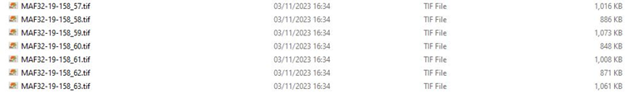

Document Types

The document types will be one of the following:

* C 51/SSY form – single-sided form
* C 47/SSY form or C 49/SSY form (for Welsh Counties) – double-sided form
* B496/EI form – double-sided form
* SF form –double sided form
* SF C 69/SSY form– double-sided form
* Other - Cover, letter or note (anything else)

Most farms will have one of each of the four forms corresponding to it. Some farms may not have all forms.

Required Metadata

One row of the CSV template must contain the metadata for one document. Most documents will consist of two images; however, some may vary. The filename of every image must be recorded for every document. Where a document has two sides, there will be two images which will each have a different filename to be captured within a single row of the csv template.

In the case of the form material, additional information will need to be captured as detailed below. In most cases this information will be present on one side of the form only.

For letters or notes, only the image filenames and document types need to be noted. More detailed guidance for the transcription proof of concept activity will be available via the iWeb platform. For access, please contact procurement@nationalarchives.gov.uk.

**C 51/SSY** (single sided form)

Example image:

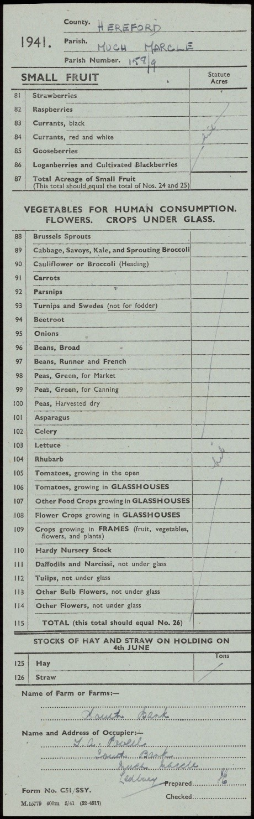

|  |  |
| --- | --- |
| **C 51/SSY form: metadata to be captured** | |
| Filenames | The filenames of the images, i.e. “MAF32-19-158_16.tif”. – |
| Document type | *“C51/SSY form”.* |
| County | This should be the same for all the forms in the bundle and a list of authorised values will be provided, e.g. in this case the value could be pre-populated as *“HF Herefordshire”.* If pre-populated, a check should be made that the assumed value matches the information on the form and corrected if wrong. |
| Parish | This should be the same for all the forms in the bundle and a list of authorised values will be provided, e.g. in this this case the value could be pre-populated as *“158 Much Marcle”.* If pre-populated, a check should be made that the assumed value matches the information on the form and corrected if wrong. |
| Farm number | To be transcribed as seen from the last part of the Parish Number, e.g. *“9”.* |
| Farm name | To be transcribed as seen from the Name of Farm or Farms, e.g. *“South Bank”* |
| Addressee name | To be transcribed from the Name and Address of Occupier, e.g. *"J A Powell"*. Please see detailed guidance available via the iWeb platform for detailed rules on how The National Archives expects names and titles to be captured. |
| Address | To be transcribed from the Name and Address of Occupier, e.g. *“South Bank, Much Marcle, Ledbury”.* Please see detailed guidance available via the iWeb platform for detailed rules on how The National Archives expects common abbreviations to be expanded. |

**C 47/SSY**

The information to be captured is found on the reverse of the form.

Example image (front of form):

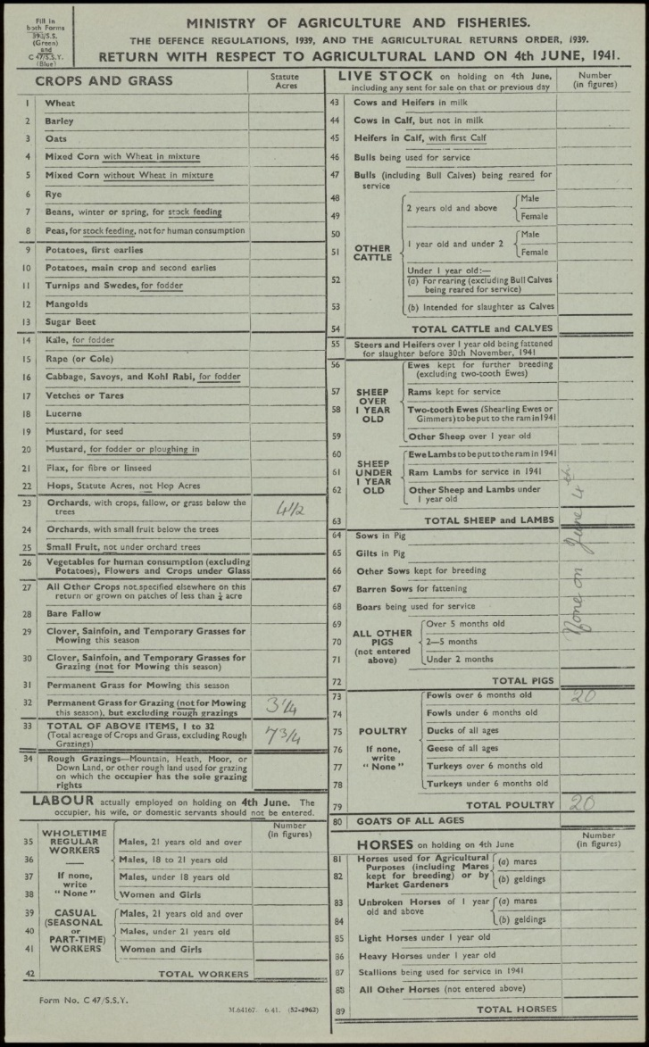

Example image (reverse of form):

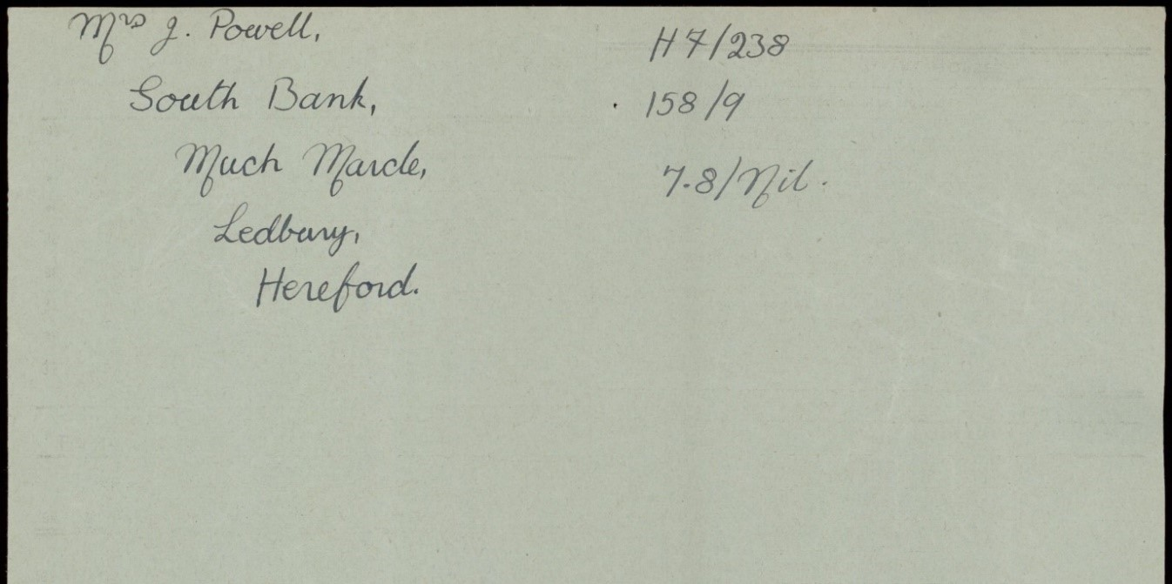

|  |  |
| --- | --- |
| **C47/SSY form: metadata to be captured** | |
| Filenames | The filenames of the images. |
| Document type | *“C47/SSY form”.* |
| Addressee name | Name of the person(s) the form is addressed to, including their title,e.g. *“Mrs J Powell"*. In this instance, the title *“Mrs”* would be recorded in one field/column and *“J Powell”* in another. Please see detailed guidance available via the iWeb platform for detailed rules on how The National Archives expects names and titles to be captured. |
| County | This should be the same for all the forms in the bundle and a list of authorised values will be provided, e.g. in this case the value could be pre-populated as *“HF Herefordshire”.* If pre-populated, a check should be made that the assumed value matches the information on the form and corrected if wrong. |
| Parish | This should be the same for all the forms in the bundle and a list of authorised values will be provided, e.g. in this this case the value could be pre-populated as *“158 Much Marcle”.* If pre-populated, a check should be made that the assumed value matches the information on the form and corrected if wrong. |
| Farm number | To be transcribed as seen as the number after the parish number, e.g. *“9”.* |
| Address | The address the form is sent to e.g. *“South Bank, Much Marcle, Ledbury, Herefordshire”.*Please see detailed guidance available via the iWeb platform for detailed rules on how The National Archives expects common abbreviations to be expanded. |

**B496/EI**

The information to be captured is to be found on the front of the form.

Example image (front of form):

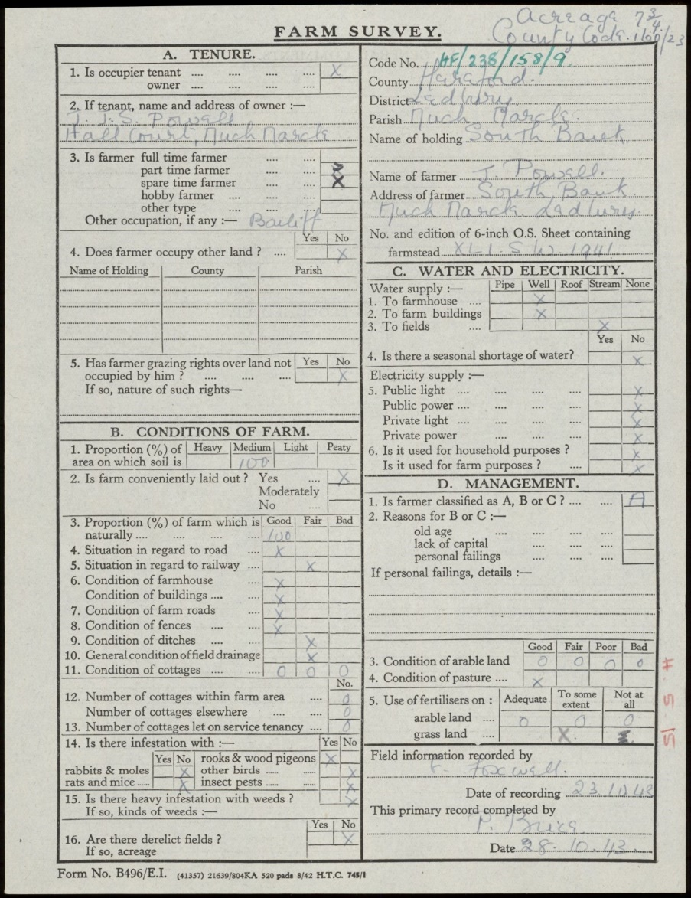

Example image (reverse of form):

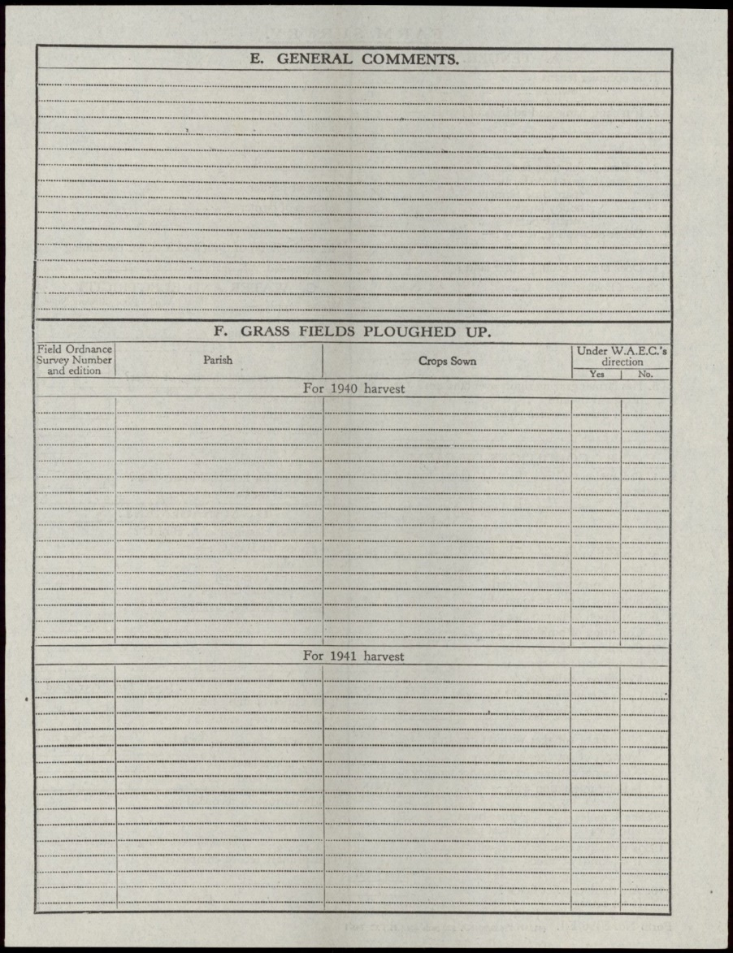

|  |  |
| --- | --- |
| **B496/EI form: metadata to be captured** | |
| Filenames | The filenames of the images. |
| Document type | *“B496/EI form”* |
| Owner name | To be transcribed as seen from section A2, e.g. “*J J S Powell’,* following a specified set of rules. Please see detailed guidance available via the iWeb platform for detailed rules on how The National Archives expects names and titles to be captured. |
| County | This should be the same for all the forms in the bundle and a list of authorised values will be provided, e.g. in this case the value could be pre-populated as *“HF Herefordshire”.* If pre-populated, a check should be made that the assumed value matches the information on the form and corrected if wrong. |
| Parish | This should be the same for all the forms in the bundle and a list of authorised values will be provided, e.g. in this this case the value could be pre-populated as *“158 Much Marcle”.* If pre-populated, a check should be made that the assumed value matches the information on the form and corrected if wrong. |
| Farm name | To be transcribed as seen from Name of Holding, e.g. *“South Bank”.* |
| Farm number | To be transcribed as seen as the number after the parish number (see Code No on image), e.g. *“9”.* |
| Farmer name | To be transcribed as seen from Name of Farmer, e.g. *“J Powell"*. Please see detailed guidance available via the iWeb platform for detailed rules on how The National Archives expects names and titles to be captured. |
| Farmer address | To be transcribed from the Address of Farmer, e.g. *“South Bank, Much Marcle, Ledbury”.* Please see detailed guidance available via the iWeb platform for detailed rules on how The National Archives expects common abbreviations to be expanded. |
| Acreage | To be transcribed from handwritten annotation at top right, with fractions converted to decimals, e.g. *“7.75”.* |
| OS map sheet | To be transcribed as seen from No and edition of 6 inch OS sheet containing farmstead, e.g. “*XLI SW 1941”.* |
| Field info date | To be transcribed from Date of recording and standardised as day month (in full) year, e.g. “*23 October 1943”.* |
| Primary record date | To be transcribed from Date and standardised as day month (in full) year, e.g. *“28 October 1943”.* |

**SF**

The information to be captured is to be found on the reverse of the form.

Example image (front of the form):

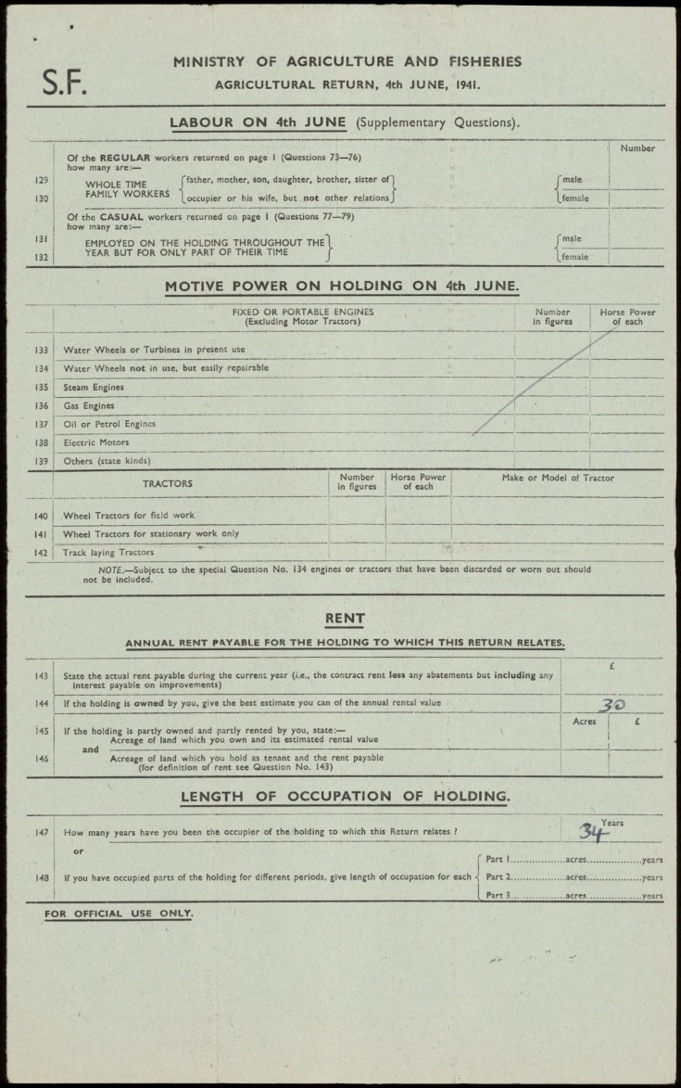

 Example image (reverse of the form):

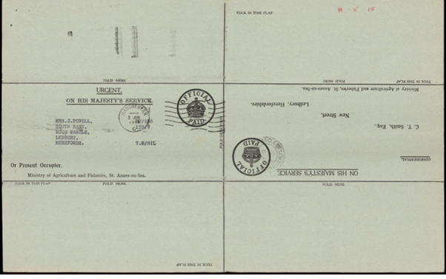

|  |  |
| --- | --- |
| **SF form: metadata to be captured** | |
| Filenames | The filenames of the images. |
| Document type | *“SF form”* |
| County | This should be the same for all the forms in the bundle and a list of authorised values will be provided, e.g. in this case the value could be pre-populated as *“HF Herefordshire”.* If pre-populated, a check should be made that the assumed value matches the information on the form and corrected if wrong. |
| Parish | This should be the same for all the forms in the bundle and a list of authorised values will be provided, e.g. in this this case the value could be pre-populated as *“158 Much Marcle”.* If pre-populated, a check should be made that the assumed value matches the information on the form and corrected if wrong. |
| Farm number | To be transcribed as seen as the number after the parish number (see number circled on image), e.g. *“9”.* |
| Addressee name | Name of the person(s) the form is addressed to, including their title, e.g. *“Mrs J Powell"*. In this instance, the title *“Mrs”* would be recorded in one field/column and *“J Powell”* in another. Please see detailed guidance available via the iWeb platform for detailed rules on how The National Archives expects names and titles to be captured. |
| Address | To be transcribed, e.g. *“South Bank, Much Marcle, Ledbury, Herefordshire”.* Please see detailed guidance available via the iWeb platform for detailed rules on how The National Archives expects common abbreviations to be expanded. |

**Any other type of document**

There could be other types of documents included in the folders such as cover/note/letter/other document. The document type to be recorded is “Other”. Where and if the parish and the farm number are clearly indicated those are the only fields that must be captured.

Appendix B – Sample Template for Capturing Transcribed Data

|  |  |  |  |  |  |  |  |  |  |  |  |  |
| --- | --- | --- | --- | --- | --- | --- | --- | --- | --- | --- | --- | --- |
| filename_1 | filename_2 | document_type | county | parish | primary_farm_number | additional_farms | farm_name | addressee_title | addressee_individual_name | addressee_group_names | address | [columns continue on next page] |
| MAF32-19-158_16.tif |  | C 51/SSY form | HF Herefordshire | 158 Much Marcle | 9 |  | South Bank | * | J A Powell | * | South Bank, Much Marcle, Ledbury |  |
| MAF32-19-158_55.tif | MAF32-19-158_56.tif | B 496/EI form | HF Herefordshire | 158 Much Marcle | 9 |  | South Bank |  |  |  |  |  |
| MAF32-19-158_145.tif | MAF32-19-158_146.tif | C 47/SSY form or C 49/SSY form | HF Herefordshire | 158 Much Marcle | 9 |  |  | Mrs | J Powell | * | South Bank, Much Marcle, Ledbury, Herefordshire |  |
| MAF32-19-158_334.tif | MAF32-19-158_335.tif | SF form | HF Herefordshire | 158 Much Marcle | 9 |  |  | Mrs | J Powell | * | South Bank, Much Marcle, Ledbury, Herefordshire |  |

|  |  |  |  |  |  |  |  |  |  |  |  |
| --- | --- | --- | --- | --- | --- | --- | --- | --- | --- | --- | --- |
| owner_title | owner_individual_name | owner_group_names | owner_address | farmer_title | farmer_individual_name | farmer_group_names | farmer_address | acreage | OS_map_sheet | field_info_date | primary_record_date |
|  |  |  |  |  |  |  |  |  |  |  |  |
| * | J J S Powell | * | Hall Court, Much Marcle | * | J Powell | * | South Bank, Much Marcle, Ledbury | 7.75 | XLI SW 1941 | 23 October 1943 | 28 October 1943 |
|  |  |  |  |  |  |  |  |  |  |  |  |
|  |  |  |  |  |  |  |  |  |  |  |  |

In this example, a blank cell means that this field is not relevant for that form. A single asterisk indicates that the field is relevant to the form but there is no data to enter in this instance.