**Framework Schedule 6 (Order Form Template and Call-Off Schedules)**

**Order Form**

**Microsoft Surface Hubs for DIO**

CALL-OFF REFERENCE: **712265452**

THE BUYER: REDACTED

BUYER ADDRESS DIO Commercial, Army Headquarters, Marlborough Lines, Monxton Road, Andover, Hants SP11 8HJ

THE SUPPLIER: XMA Limited

SUPPLIER ADDRESS:44 Wilford Industrial Estate, Nottingham, NG11 7EP

REGISTRATION NUMBER: 02051703

DUNS NUMBER: 298484148

SID4GOV ID: Not applicable

APPLICABLE FRAMEWORK CONTRACT

This Order Form is for the provision of the Call-Off Deliverables and dated 28th October 2024.

It’s issued under the Framework Contract with the reference number RM6098 for the provision of Technology Products & Associated Service 2.

CALL-OFF LOT(S):

Lot 2 Hardware

CALL-OFF INCORPORATED TERMS

The following documents are incorporated into this Call-Off Contract. Where numbers are missing we are not using those schedules. If the documents conflict, the following order of precedence applies:

1. This Order Form including the Call-Off Special Terms and Call-Off Special Schedules.
2. Joint Schedule 1 (Definitions and Interpretation) RM6098
3. Framework Special Terms
4. The following Schedules in equal order of precedence:

* Joint Schedules for RM6098
  + Joint Schedule 2 (Variation Form)
  + Joint Schedule 3 (Insurance Requirements)
  + Joint Schedule 6 (Key Subcontractors)
  + Joint Schedule 9 (Minimum Standards of Reliability)
  + Joint Schedule 10 (Rectification Plan)
  + Joint Schedule 12 (Supply Chain Visibility)
* Call-Off Schedules for RM6098
  + Call-Off Schedule 2 (Staff Transfer) Part E
  + Call-Off Schedule 5 (Pricing Details) See Appendix D the pricing schedule spreadsheet
  + Call-Off Schedule 9 (Security) Part A
  + Call-Off Schedule 14 (Service Levels)
  + Call-Off Schedule 16 (Benchmarking)
  + Call-Off Schedule 17 (MOD Terms)

1. CCS Core Terms (version 3.0.11) as amended by the Framework Award Form
2. Joint Schedule 5 (Corporate Social Responsibility) RM6098
3. [Call-Off Schedule 4 (Call-Off Tender) as long as any parts of the Call-Off Tender that offer a better commercial position for the Buyer (as decided by the Buyer) take precedence over the documents above.]

No other Supplier terms are part of the Call-Off Contract. That includes any terms written on the back of, added to this Order Form, or presented at the time of delivery.

CALL-OFF SPECIAL TERMS

The DEFCONS as per Call-Off Schedule 17 apply.

CALL-OFF START DATE: 28th October 2024

CALL-OFF EXPIRY DATE: 31st March 2025

CALL-OFF INITIAL PERIOD: 5 Months

CALL-OFF DELIVERABLES:

The requirement is made up of the following:

**Batch 1**

|  |  |  |  |
| --- | --- | --- | --- |
| Item | Quantity | Unit Price Ex VAT | Total Price Ex VAT |
| Microsoft Surface Hub 3 - 50 inch | 24 | REDACTED | REDACTED |
| Cart - 50 inch | 24 | REDACTED | REDACTED |
| 50 inch Warranty - 3 years | 24 | REDACTED | REDACTED |
| Microsoft Surface Hub 3 - 85 inch | 5 | REDACTED | REDACTED |
| Cart - 85 inch | 5 | REDACTED | REDACTED |
| 85 inch Warranty - 3 years | 5 | REDACTED | REDACTED |

|  |
| --- |
| Delivery – individual to site – 18 locations with delivery charge REDACTED per site. Total delivery charges for all 18 sites REDACTED |
| Transportation of devices from delivery vehicle into the internal office location if required. |
| Removal of package where applicable – price for 1 x 85-inch device |
| Removal of package where applicable – price for 1 x 50-inch device |

**Batch 2 – Optional** – Note: **Price for information purposes only and not to be evaluated as part of the tender award criteria** – optional requirements not to exceed the value of £65,000.00. Although not all sites can be identified at the time of this tender release the total combined amount of batch 2 will not exceed the above total. Some sites have been identified within this bracket and include: Portsmouth – PO1 3NH, Whittington Barracks WS14 9PY and Main Building SW1A 2HB. This Batch 2 is optional and will be called off by DIO when required and authorised by DIO Senior Commercial Manager.

|  |  |
| --- | --- |
| **Item** | **ROM Quantity** |
| Microsoft Surface Hub 3 - 50 inch | 5 |
| Cart - 50 inch | 5 |
| 50 inch Warranty - 3 years | 5 |
| Microsoft Surface Hub 3 - 85 inch | 1 |
| Cart - 85 inch | 1 |
| 85 inch Warranty - 3 years | 1 |

LOCATION FOR DELIVERY (Batch 1)

|  |  |  |  |
| --- | --- | --- | --- |
| **Site** | No/ of deliveries to site | Device requirements | |
| Glasgow - Kentigern House G2 8EX | 1 | 1 X 50 | 1 X 85 |
| Beith - KA15 1JT | 1 | 1 X 50 |  |
| Swynnerton – ST15 0QN | 1 | 1 X 50 |  |
| Catterick - DL9 3LR | 1 | 2 X 50 | 1 X 85 |
| Tidworth – SP9 7QD | 1 | 1 X 50 |  |
| Donnington V19 | 1 | 3 X 50 | 1 X 85 |
| Brecon – LD3 7EA | 1 | 1 X 50 |  |
| Wittering – PE8 6HB | 1 | 1 X 50 |  |
| Andover - SP11 8HJ | 1 | 3 X 50 | 1 X 85 |
| Dale – CH2 4BD | 1 | 1 X 50 |  |
| Waddington – LN5 9NB | 1 | 1 X 50 |  |
| Cranwell – NG34 8HB | 1 | 1 X 50 |  |
| Puckridge – GU11 2HL | 1 | 1 X 50 |  |
| Lakenheath IP27 9PP | 1 | 2 X 50 |  |
| Fairford – GL7 4DL | 1 | 2 X 50 |  |
| Whittington – WS14 9PY | 1 | 1 X 50 |  |
| Shrivenham – SN6 8LA | 1 |  | 1 x 85 |
| Wattisham – IP7 7RA | 1 | 1 X 50 |  |

DATES FOR DELIVERY Of THE DELIVERABLES

Delivery date details – Not all specific date details are yet to be finalised but high-level delivery dates for Batch 1 sites will be between November 2024 and March 2025. The programme plan is in draft form (see plan on a page below) and subject to change.

Plan on a Page – draft form – subject to change

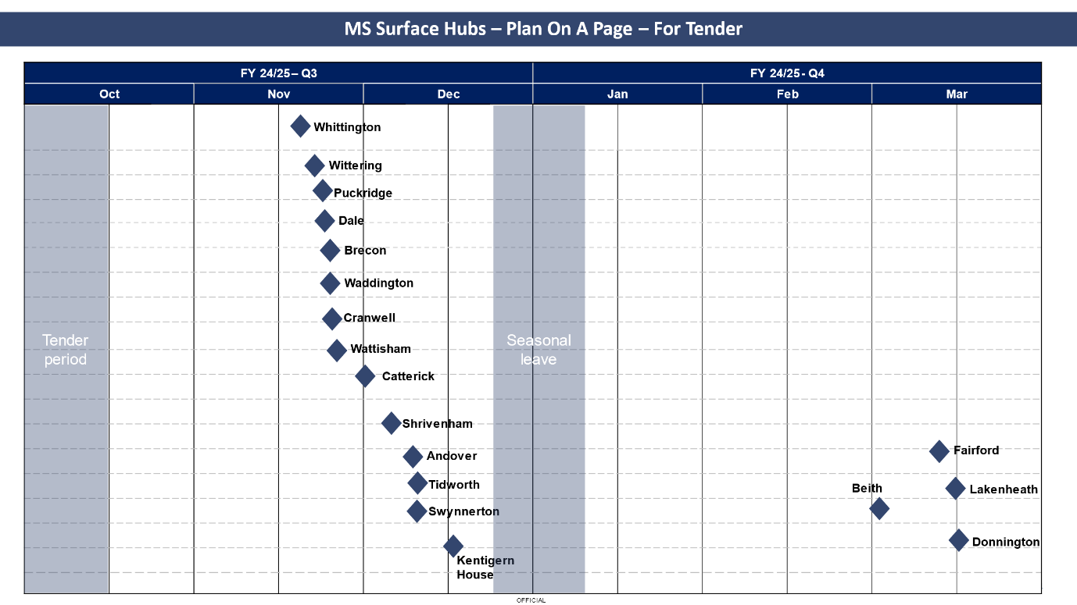Orders placed will require delivery no later than 10 working days. Delivery dates and times for November and December:

|  |  |  |
| --- | --- | --- |
| **Site** | **Delivery Date** | **Delivery Time** |
| Whittington | 07/11/2024 | 09:00 |
| Wattisham | 08/11/2024 | 10:00 |
| Catterick | 11/11/2024 | 13:00 |
| Waddington | 11/11/2024 | 09:00 |
| Wittering | 11/11/2024 | 13:00 |
| Dale | 13/11/2024 | 09:00 |
| Cranwell | 13/11/2024 | 13:00 |
| Aldershot (Puckridge) | 13/11/2024 | 09:00 |
| Brecon | 15/11/2024 | 09:00 |

|  |  |  |
| --- | --- | --- |
| **Site** | **Delivery Date** | **Delivery Time** |
| Kentigern House | 03/12/2024 | 13:00 |
| Tidworth | 9/12/2024 | 09:00 |
| Swynnerton | 12/12/2024 | 08:00 |
| Andover | JAN 2025 – TBC | TBC |
| Shrivenham | JAN 2025 - TBC | TBC |
| Donnington | FEB 2025 - TBC | TBC |
| Fairford | MAR 2025 – TBC | TBC |
| Lakenheath | MAR 2025 – TBC | TBC |
| Beith | MAR 2025 – TBC | TBC |

The supplier must comply with DEFCON 129. Upon order, the supplier shall provide a Safety Data Sheet in respect of each Dangerous Good in accordance with the UK REACH Regulations and the Health and Safety at Work Act 1974 (as amended).

Upon order and in advance of delivery the supplier shall provide itemised receipts with serial number(s) to enable the appropriate MS Pro Licence to be assigned.

Within 48 hours of delivery the supplier shall register the device(s) with Microsoft for Warranty purposes.

TESTING OF DELIVERABLES

None

WARRANTY PERIOD

The warranty period for the purposes of Clause 3.1.2 of the Core Terms shall be 3 years.

MAXIMUM LIABILITY

The limitation of liability for this Call-Off Contract is stated in Clause 11.2 of the Core Terms. Each Party's total aggregate liability in each Contract Year under each Call-Off Contract (whether in tort, contract or otherwise) is no more than the greater of £5 million or 150% of the Estimated Yearly Charges unless specified in the Call-Off Order Form.

CALL-OFF CHARGES

**£285,350.09 (exc VAT)** the Charges for the Deliverables

The Charges will not be impacted by any change to the Framework Prices. The Charges can only be changed by agreement in writing between the Buyer and the Supplier because of:

* Specific Change in Law
* Benchmarking using Call-Off Schedule 16 (Benchmarking)

REIMBURSABLE EXPENSES

Expenses are not reimbursable and will be owned by the supplier.

PAYMENT METHOD

Payment will be made through CP&F. (Purchase Order number TBC).

BUYER’S INVOICE ADDRESS:

REDACTED

DIO CIO-CSS SW Proj Mgr

REDACTED

CIO Customer Service Support, DIO

St George’s House, DIO Head Office

DMS Whittington

Lichfield

Staffordshire WS14 9PY

Electronic submission via Exostar to CP&F Purchase Order

BUYER’S AUTHORISED REPRESENTATIVE

REDACTED

DIO Commercial

REDACTED

DIO Commercial Business Improvement - Policy

Army Headquarters, Marlborough Lines, Monxton Road, Andover, Hants SP11 8HJ

BUYER’S ENVIRONMENTAL POLICY

[JSP 418 Part 1 - Directive (publishing.service.gov.uk)](https://assets.publishing.service.gov.uk/media/5a7e1601e5274a2e87daf749/20141209-JSP_418_Part1_Final-U.pdf)

BUYER’S SECURITY POLICY

[Security policy framework - GOV.UK (www.gov.uk)](https://www.gov.uk/government/publications/security-policy-framework/hmg-security-policy-framework)

SUPPLIER’S AUTHORISED REPRESENTATIVE

REDACTED

SUPPLIER’S CONTRACT MANAGER

REDACTED

PROGRESS REPORT FREQUENCY

Required for the mid-contract review. Timeliness of delivery to be included within the reports.

PROGRESS MEETING FREQUENCY

The supplier will be required to attend a mid-contract review at DIO Whittington to assess performance to date and programme the remainder of the requirements.

Additional meetings only required if the authority deem necessary.

KEY STAFF

REDACTED

KEY SUBCONTRACTOR(S)

Not applicable.

COMMERCIALLY SENSITIVE INFORMATION

Unit Price.

SERVICE CREDITS

Service Credits will accrue in accordance with Call-Off Schedule 14 (Service Levels).

The Service Credit Cap is: £5000.

The Service Period is: 10 weeks

A Service Level Failure is: failure to receipt delivery within business hours on agreed delivery date.

ADDITIONAL INSURANCES

Not applicable

Insurances in accordance with Joint Schedule 3 (Insurance Requirements).

GUARANTEE

Not applicable

SOCIAL VALUE COMMITMENT

The Supplier agrees, in providing the Deliverables and performing its obligations under the Call-Off Contract, that it will comply with the social value commitments in Call-Off Schedule 4 (Call-Off Tender)]

|  |  |  |  |
| --- | --- | --- | --- |
| **For and on behalf of the Supplier:** | | **For and on behalf of the Buyer:** | |
| Signature: | REDACTED | Signature: | REDACTED |
| Name: | REDACTED | Name: | REDACTED |
| Role: | REDACTED | Role: | REDACTED |
| Date: | 30/10/2024 | Date: | 1/11/2024 |