SC1A PO (Edn 02/18)

PURCHASE ORDER
Contract No: FLEET/00733
Contract Name: The Provision of Random Drug and Alcohol Testing for the Royal Fleet Auxiliary (RFA)
Dated: 13/09/2018
Supply the Deliverables described in the Schedule to this Purchase Order, subject to the attached MOD Terms and Conditions for Less Complex Requirements (up to £118,133) (Edn 08/18)
Contractor | Quality Assurance Requirement (Clause 8)
Name:
Registered Address:

Consignor (if different from Contractor’s registered address) | Transport Instructions (Clause 10)
 | Select method of transport of Deliverables
Name:
 | To be Delivered by the Contactor X
 | [Special Instructions]
Address:
 | To be Collected by the Authority
 | [Special Instructions]
 | Each consignment of the Deliverables shall be accompanied by a delivery note.

1

SC1A PO (Edn 02/18)
Progress Meetings (Clause 13) | Progress Reports (Clause 13)
The Contractor shall be required to attend the following meetings:  Subject:  Frequency:  Location: | The Contractor is required to submit the following Reports:  Subject:  Frequency:  Method of Delivery:  Delivery Address:

Payment (Clause 14)
Payment is to be enabled by CP&F.
Forms and Documentation | Supply of Hazardous Deliverables (Clause 9)
Forms can be obtained from the following websites: https://www.aof.mod.uk/aofcontent/tactical/toolkit | A completed DEFFORM 68 and, if applicable, Safety Data Sheet(s) are to be provided by email with attachment(s) in Adobe PDF or MS WORD format to:  - The Commercial Officer detailed in the Purchase Order, and  - DSA-DLSR-MovTpt-DGHSIS@mod.uk
(Registration is required).
https://www.gov.uk/government/organisations/ministr
y-of-defence/about/procurement#invoice-processing
https://www.dstan.mod.uk/
https://www.dstan.mod.uk/ | by the following date:  or if only hardcopy is available to the addresses below:  Hazardous Stores Information System (HSIS)  Defence Safety Authority (DSA)  Movement Transport Safety Regulator (MTSR)  Hazel Building Level 1, #H019  MOD Abbey Wood (North)  Bristol BS34 8QW
(Registration is required).
The MOD Forms and Documentation referred to in the Conditions are available free of charge from:
Ministry of Defence, Forms and Pubs Commodity
Management
PO Box 2, Building C16, C Site
Lower Arncott
Bicester, OX25 1LP
(Tel. 01869 256197 Fax: 01869 256824)
Applications via email:
DESLCSLS-OpsFormsandPubs@mod.uk
If you require this document in a different format (i.e. in a larger font) please contact the Authority’s Representative (Commercial Officer), detailed below.

2

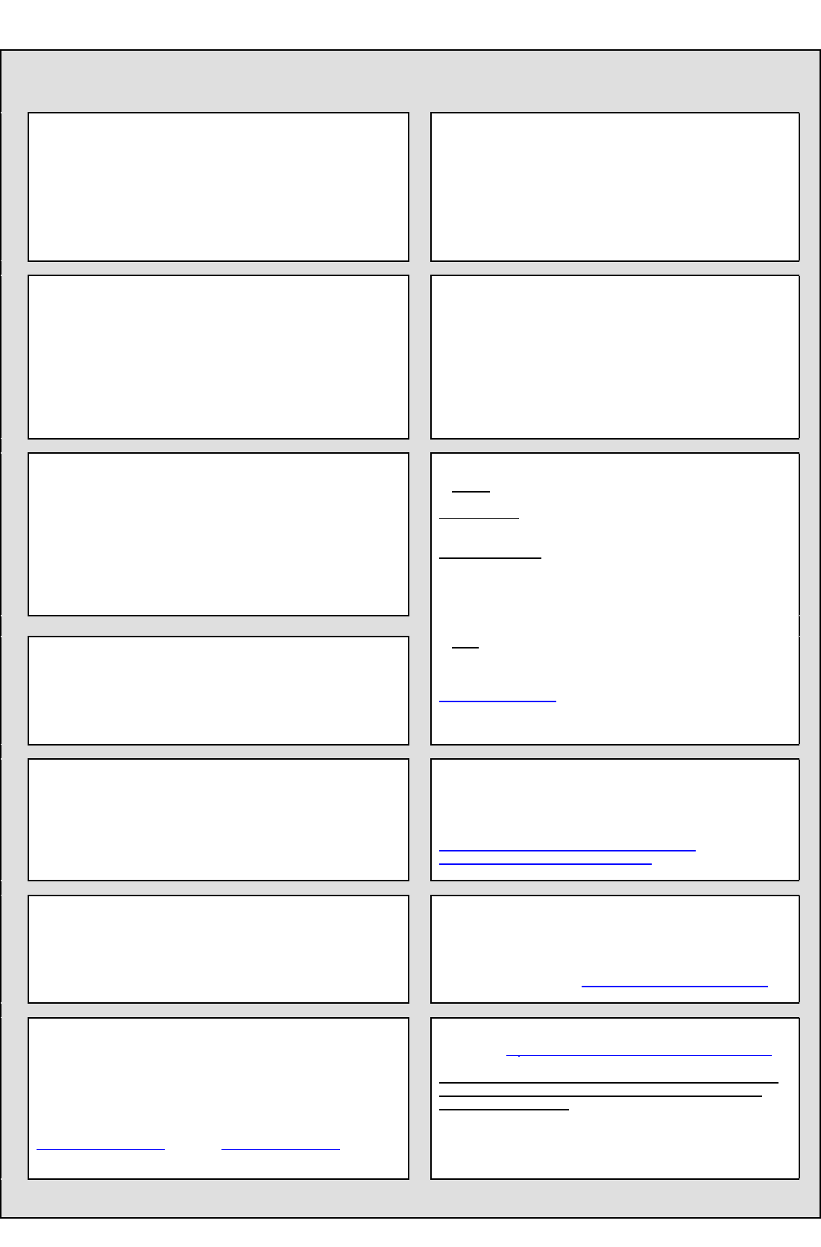
SC1A PO (Edn 02/18)
3
DEFFORM 111 (Edn 12/17)
Appendix - Addresses and Other Information
5. Drawings/Specifications are available from
6. Intentionally Blank
4. (a) Supply / Support Management Branch or Order Manager: Branch/Name:

(b) U.I.N.
3. Packaging Design Authority Organisation & point of contact:
(Where no address is shown please contact the Project Team in Box 2)

- Commercial Officer
Name: Lauren Terry
Address: Room 303, Building 1/080, Jago Road, HM Naval Base, Portsmouth, Hampshire, PO1 3LU
Email: lauren.terry103@mod.gov.uk

- Project Manager, Equipment Support Manager or PT Leader (from whom technical information is available)
Name: Alison Woodgate
Address:
Email:

7. Quality Assurance Representative:
Name:
Commercial staff are reminded that all Quality Assurance requirements should be listed under the General Contract Conditions.
AQAPS and DEF STANs are available from UK Defence Standardization, for access to the documents and details of the helpdesk visit http://dstan.uwh.diif.r.mil.uk/ [intranet] or https://www.dstan.mod.uk/ [extranet, registration needed].
* NOTE
- Many DEFCONs and DEFFORMs can be obtained from the MOD Internet Site: https://www.aof.mod.uk/aofcontent/tactical/toolkit/index.htm
- If the required forms or documentation are not available on the MOD Internet site requests should be submitted through the Commercial Officer named in Section 1.
12. Forms and Documentation are available through *:
Ministry of Defence, Forms and Pubs Commodity Management
PO Box 2, Building C16, C Site
Lower Arncott
Bicester, OX25 1LP (Tel. 01869 256197 Fax: 01869 256824)
Applications via fax or email: DESLCSLS-OpsFormsandPubs@mod.uk
11. The Invoice Paying Authority
Ministry of Defence  0151-242-2000 DBS Finance
Walker House, Exchange Flags Fax: 0151-242-2809
Liverpool, L2 3YL Website is: https://www.gov.uk/government/organisations/ministry-of-defence/about/procurement#invoice-processing
10. Transport. The appropriate Ministry of Defence Transport Offices are:
- DSCOM, DE&S, DSCOM, MoD Abbey Wood, Cedar 3c, Mail Point 3351,
BRISTOL BS34 8JH
Air Freight Centre
IMPORTS  030 679 81113 / 81114 Fax 0117 913 8943
EXPORTS  030 679 81113 / 81114 Fax 0117 913 8943
Surface Freight Centre
IMPORTS  030 679 81129 / 81133 / 81138 Fax 0117 913 8946
EXPORTS  030 679 81129 / 81133 / 81138 Fax 0117 913 8946
- JSCS
JSCS Helpdesk No. 01869 256052 (select option 2, then option 3)
JSCS Fax No. 01869 256837
www.freightcollection.com
8. Public Accounting Authority
- Returns under DEFCON 694 (or SC equivalent) should be sent to DBS Finance ADMT – Assets In Industry 1, Level 4 Piccadilly Gate, Store Street, Manchester, M1 2WD
 44 (0) 161 233 5397
- For all other enquiries contact DES Fin FA-AMET Policy, Level 4 Piccadilly
Gate, Store Street, Manchester, M1 2WD
 44 (0) 161 233 5394
9. Consignment Instructions
The items are to be consigned as follows:

SC1A PO (Edn 02/18)
Contractor Commercially Sensitive Information (Clause 5). Not to be published.
Description of Contractor’s Commercially Sensitive Information:
Cross reference to location of sensitive information:
Explanation of Sensitivity:
Details of potential harm resulting from disclosure:
Period of Confidence (if Applicable):
Contact Details for Transparency / Freedom of Information matters:
Name:
Position:
Address:
Telephone Number:
E-mail Address:

Offer and Acceptance
A) The Purchase Order constitutes an offer by the
Contractor to supply the Deliverables. This is open  for acceptance by the Authority for days from the date of signature. By signing the Purchase Order the Contractor agrees to be bound by the attached | B) Acceptance
Terms and Conditions for Less Complex
Requirements (Up to £118,133) (Edn 02/18).
Name (Block Capitals): | Name (Block Capitals):
Position: | Position:
For and on behalf of the Contractor | For and on behalf of the Authority
Authorised Signatory | Authorised Signatory
Date: | Date:
C) Effective Date of Contract:

4

SC1A PO (Edn 02/18)
SCHEDULE OF REQUIREMENTS FOR THE SUPPLY OF THE PROVISION OF RANDOM DRUG AND ALCOHOL TESTING FOR THE ROYAL FLEET
AUXILIARY (RFA)
Deliverables
Item Number | MOD Stock  Reference No. | Part No.  (where  applicable) | Specification | Consignee  Address Code  (full address is  detailed in  DEFFORM 96) | Packaging  Requirements  inc. PPQ and  DofQ (as  detailed in  DEFFORM 96) | Delivery Date | Total Qty | Firm Price (£) Ex VAT
 |  |  |  |  |  |  |  | Per Item | Total inc.  packaging (and delivery if specified in the Purchase Order)
1 | N/A | N/A | The Provision of Random Drug and  Alcohol Testing for the Royal Fleet  Auxiliary (RFA) - YEAR ONE | N/A | N/A | N/A | N/A
2 | N/A | N/A | The Provision of Random Drug and  Alcohol Testing for the Royal Fleet  Auxiliary (RFA) - YEAR TWO | N/A | N/A | N/A | N/A
3 | N/A | N/A | The Provision of Random Drug and  Alcohol Testing for the Royal Fleet  Auxiliary (RFA) - YEAR THREE | N/A | N/A | N/A | N/A
4 | N/A | N/A | The Provision of Random Drug and  Alcohol Testing for the Royal Fleet  Auxiliary (RFA) - YEAR FOUR  (OPTION YEAR) | N/A | N/A | N/A | N/A
Total
Firm
Price

Item Number | Consignee Address (XY code only)
N/A

5

