Invitation to Tender

Title: Project Management Brooksby Building BACS additional works - Project Management.

Date: 8th November 2024

Procurement: John Nixon

Owner: Ben Williams

Client: The Pirbright Institute

Table of Contents
1 Introduction 3
1.1 Document Purpose 3
1.2 Contract Notice 3
1.3 Contract Type 3
1.4 Contract Duration 3
2 Contract Scope 3
3 Instructions to Tenderers 6
3.1 Location of Works 6
3.2 Procurement Timetable 6
3.3 Tender Submission Requirements 6
3.4 Tender Submission and Clarifications 7
3.5 Tender Evaluation 7
3.6 THE PIRBRIGHT INSTITUTE Terms and Conditions 9
3.7 Confidentiality 9
3.8 Conditions of Tender 10
4 APPENDICES 11

Introduction
The Pirbright Institute is inviting tenders for the Project Management Brooksby Building BACS additional works - Project Management at The Pirbright Institute.

Document Purpose
The primary purpose of this document is to provide potential suppliers with the information to allow them to submit adequate information to tender for the services.

Contract Notice
A notice for this contract was placed on Contracts Finder on 8th November 2024 by The Pirbright Institute.

Contract Type
NEC4 Professional Services Contract

Contract Duration
The award contract duration will be 8th January 2024 - 31st December 2025.

Contract Scope
The contract is for a single supplier to provide Project Management in relation to the Project Management of Brooksby Building BACS additional works project at The Pirbright Institute, Ash Road, Pirbright, Surrey, GU24 0NF.

See Appendix E - Contract Scope.

PROJECT SCOPE AND OBJECTIVES
The primary purpose of this version of the document is intended to:
• Give details of works required to potential suppliers so they can submit quotation and program of works.
• Fulfil the client brief and pre-construction information aspects of construction design management (CDM) regulations 2015.

The Scope of Services for this contract is as follows:

Full Project Management to include:
Management of program for all three packages of work listed above
Management of sub-contractors, these will be appointed directly by The Pirbright Institute
Management of interdependencies
Principal point of contact for the project, liaising with internal and external stakeholders as required
Reporting: Production of Project Highlight Report on a monthly basis, on Pirbright template document
Responsible for ensuring project benefits are realised
Management of project budget
Responsible for monthly cashflow forecast reporting
Proactive management of project risks and issues, owner of Project Risk Register and Issues Register
Regular site attendance to ensure project is progressing as per program.
Quality Assurance
Site attendance at monthly Project Board meetings
Handover of all documentation in line with Pirbright Project Information File (PIF) structure. A Sample PIF is attached in Appendix E1B.

PROJECT GOVERNANCE AND PROJECT DELIVERY
The envisaged project delivery team is outline below:

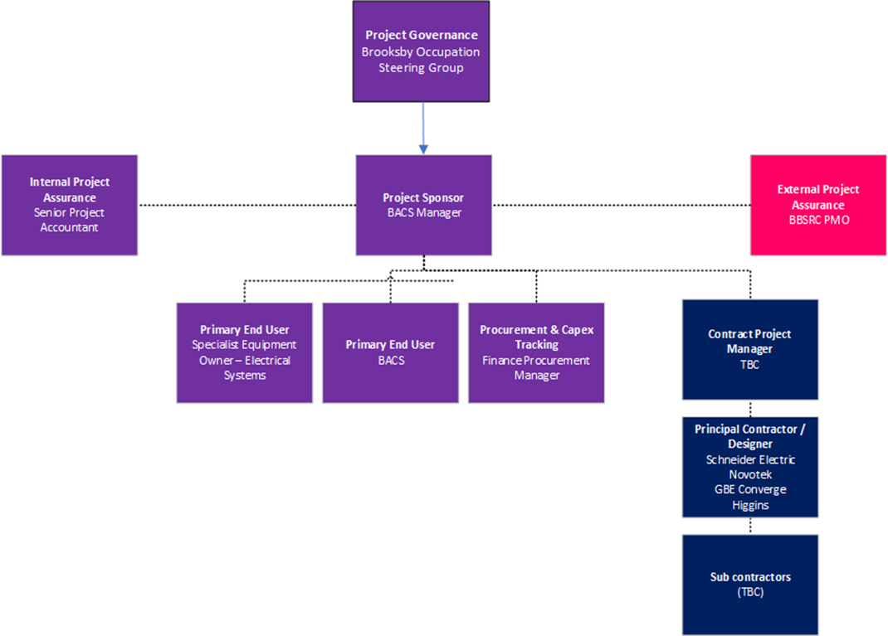

Responsibilities
The responsibilities of each party for these works are as follows:

Pirbright Project Sponsor:

Business Case Author
Budget Control
Benefit realisation.
Escalation of issue to senior management when required.
Halting project if required.
Approving changes to project scope.
Reviewing and agreeing detailed design before work commences.
Responding to contractor queries.
Review and amending of Project Highlight reports.
Advising the Project Manager on the application of site processes and what personnel should be consulted for project queries.

Pirbright Project Manager:

Drive day to day activities to delivery of the scope of works.
Preparation of monthly Project Highlight Reports on Pirbright template
Act as site host for principal contractors / designers.
Create and agree with principal contractors the content of the construction site induction.
Create and maintain scope of works document.
Create and maintain a project risk register.
Create and maintain project program.
Managing project documentation
Raise purchase orders if required.
Co-ordinate the contractor, designers, and institute personnel to facilitate works.
Facilitate site access.
Reviewing and agreeing detailed design before work commences.
Arrange and chair project meetings and issuing notes of meetings.
Responding to contractor queries
Arrangement of permits and isolations
Ensuring works are performed in a safe manner.
Co-ordinating snagging surveys as required.
Handover to Pirbright Engineering Management
Arranging training where appropriate

Instructions to Tenderers

Location of Works
The works will take place at the following address:

The Pirbright Institute Ash Road
Pirbright, Surrey GU24 0NF

Procurement Timetable

The timetable for this tender is anticipated as below:

Key Task/Milestone | Date
Tender Stage
Notice published on Contracts Finder | 8th November 2024
Invitation to Tender issued through Contracts Finder or on Request
Site Visits to be arranged through ben.williams@pirbright.ac.uk | 13th - 14th November 2024
Deadline for receipt of questions relating to the tender | 14:00 18th November 2024
Answers to questions circulated | 12:00 (Noon) 22nd November 2024
Date for receipt of Tender Submissions to PirbrightTenders@pirbright.ac.uk only | 12:00 (Noon) 3rd December 2024
Evaluation of Tender Submissions | 4th December 2024 - 13th December 2024
Contract Award | 16th December 2024
Contract Commencement Date | 8th January 2025

Tender Submission Requirements

Tenderers should ensure that their Tender is submitted on company headed paper and confirm the following:

    - Cover Letter on company headed paper.
    - Tenders for works broken down where appropriate into project stages.
    - Acceptance statement of THE PIRBRIGHT INSTITUTE chosen T&Cs detailing any modifications required.
    - Acceptance statement of confidentiality statement included in this ITT document.

    - Details of how the specification will be met.
    - Details of relevant experience
    - Details of relevant qualification
- Details of 3 relevant case studies. Case studies are to provide the following details:
  - What were the aims and objectives of the project
  - What was your approach to achieving the aims and objectives?
  - What work was completed?
  - How did you manage Health and Safety?
  - What issues arose during the works and how did you overcome this?
  - What benefits did you deliver to the client?
    - Example Risk Assessment / Method statement at High Hazard site.
    - Details of quality management system processes/accreditations utilized.
    - Details of Safety management system processes utilized.
    - Location of proposed subcontractors to be provided.
    - Details of any proposed Sub-Contractors
    - Project Manager(s) will need to undergo site security clearance so they can work unescorted.

Tenderers should be fully complete and include above and the following as part of their Tender submission:
    - Appendix A - Supplier Pre-Qualification Questionnaire
    - Appendix C - Pricing Schedule (Please complete in line with the Instructions for Completion Tab)
    - Appendix F - Form of Offer

Tender Submission and Clarifications
The PIRBRIGHT INSTITUTE contact for queries and clarifications is

Name | Position | Email & Telephone
John Nixon | Procurement Buyer | Procurement.department@pirbright.ac.uk

All queries will be collated, and clarifications issued to all tenderers during the process. Deadline for receipt of questions relating to the tender by no later than 14:00 18th November 2024.

Tender submissions to PirbrightTenders@pirbright.ac.uk only and by no later than 12:00 (Noon) 3rd December 2024.

Tender Evaluation

Once received, tenders will be evaluated by members of the PIRBRIGHT INSTITUTE Estates Management team.

Tenders will be evaluated based on cost, commercial and quality aspects, and references will be sought where appropriate.

Evaluation will take the form of scoring via a scoring matrix see Appendix B.

Where required, clarifications will be sought by THE PIRBRIGHT INSTITUTE from tenderers to ensure scoring is fair.

Where tender contract price is deemed by THE PIRBRIGHT INSTITUTE to be abnormally high or low, they may be discounted from the competition and not taken through to the scoring stage of the tender. It will be at the discretion of THE PIRBRIGHT INSTITUTE

whether clarification is sought for the abnormally high/low proposal. In the event that a tender submission contains other abnormal factors, clarification will be sought by THE PIRBRIGHT INSTITUTE. Should THE PIRBRIGHT INSTITUTE not be satisfied with the clarification response, they may disqualify the tender from the competition and no further evaluation/scoring will be conducted for the tender submission.

On completion of evaluation and scoring of tender submissions, where the highest scoring submissions are within 5% of each other, it will be at the discretion of THE PIRBRIGHT INSTITUTE to award the contract to the supplier they deem most appropriate for the contract provision.

THE PIRBRIGHT INSTITUTE Terms and Conditions
The contract will be based on the following model:
NEC4 Professional Services Contract (PSC).

Confidentiality

By submitting a tender proposal in response to this ITT the tenderer is agreeing to the following:

All information supplied to you by The Pirbright Institute, including this ITT and all other documents relating to this Procurement Process, either in writing or orally, must be treated in confidence and not disclosed to any third party (save to your professional advisers, consortium members and/or sub-contractors strictly for the purposes only of helping you to participate in this Procurement Process and/or prepare your tender response) unless the information is already in the public domain or is required to be disclosed under any applicable laws.

You shall not disclose, copy or reproduce any of the information supplied to you as part of this Procurement Process other than for the purposes of preparing and submitting a tender response. There must be no publicity by you regarding the Procurement Process or the future award of any contract unless the Customer Organisation has given express written consent to the relevant communication.

This ITT and its accompanying documents shall remain the property of The Pirbright Institute.
The Pirbright Institute reserves the right to disclose all documents relating to this Procurement Process, including without limitation your tender response, to any employee, third party agent, adviser or other third party involved in the procurement in support of, and/or in collaboration with, the Customer Organisation. The Pirbright Institute further reserves the right to publish the Contract once awarded and/or disclose information in connection with supplier performance under the Contract in accordance with any public sector transparency policies (as referred to below).

By participating in this Procurement Process, you agree to such disclosure and/or publication by the Customer Organisation in accordance with such rights reserved by it under this paragraph.
The Freedom of Information Act 2000 (“FOIA”), the Environmental Information Regulations 2004 (“EIR”), and public sector transparency policies, including the placing of contract award

notices on the Contracts Finder database, apply to The Pirbright Institute (together the “Disclosure Obligations”).

You should be aware of The Pirbright Institute’s obligations and responsibilities under the Disclosure Obligations to disclose information held by The Pirbright Institute. Information provided by you in connection with this Procurement Process, or with any contract that may be awarded as a result of this exercise, may therefore have to be disclosed by The Pirbright Institute under the Disclosure Obligations, unless The Pirbright Institute decides that one of the statutory exemptions under the FOIA or the EIR applies.

If you wish to designate information supplied as part of your tender response or otherwise in connection with this tender exercise as confidential, you must provide clear and specific detail as to:

- The precise elements which are considered confidential and/or commercially sensitive.
- Why you consider an exemption under the FOIA or EIR would apply.
- The estimated length of time during which the exemption will apply.

The use of blanket protective markings of whole documents such as “commercial in confidence” will not be sufficient. By participating in this Procurement Process you agree that The Pirbright Institute should not and will not be bound by any such markings.
In addition, marking any material as “confidential” or “commercially sensitive” or equivalent should not be taken to mean that The Pirbright Institute accepts any duty of confidentiality by virtue of such marking. You accept that the decision as to which information will be disclosed is reserved to The Pirbright Institute, notwithstanding any consultation with you or any designation of information as confidential or commercially sensitive or equivalent you may have made.

You agree, by participating further in this Procurement Process and/or submitting your tender response, that all information is provided to The Pirbright Institute on the basis that it may be disclosed under the Disclosure Obligations if The Pirbright Institute considers that it is required to do so and/or may be used by the Customer Organisation in accordance with the provisions provision of this ITT.
Tender responses are also submitted on the condition that the appointed supplier will only process personal data (as may be defined under any relevant data protection laws) that it gains access to in performance of this Contract in accordance with The Pirbright Institute’s instructions and will not use such personal data for any other purpose. The contracted supplier will undertake to process any personal data on The Pirbright Institute’s behalf in accordance with the relevant provisions of any relevant data protection laws and to ensure all consents required under such laws are obtained.

Conditions of Tender
    - In submitting a proposal in response to this invitation to tender tenderers do so on the conditions specified or referred to herein and on the following express conditions.
    - Tenderers should consider only the information contained within this invitation to tender, or otherwise communicated in writing to tenderers, when making their offer.
    - Information supplied by THE PIRBRIGHT INSTITUTE is supplied for general guidance in the preparation of tenders. Tenderers must satisfy themselves by their own

investigations with regard to the accuracy of such information. THE PIRBRIGHT INSTITUTE cannot accept responsibility for any inaccurate information obtained by Tenderers.
    - Tenderers shall not, before the date and time specified for return of the tender, communicate to any person the amount or approximate amount of the tender or proposed tender
    - The tender shall be a bona-fide tender and shall not be fixed or adjusted by or under or in accordance with any agreement or arrangement with any other person.
    - Tenderers shall not enter into any agreement or arrangement with any other person with the intent that the other person shall refrain from tendering or between you agree as to the amount of any other tender to be submitted.
    - THE PIRBRIGHT INSTITUTE shall not be liable for or pay any direct or indirect costs howsoever incurred by any Tenderer in the preparation of their tender, or for the costs of any post-tender clarification meetings, presentations, demonstrations or by any Tenderer who fails to respond by the deadline set.

APPENDICES

Appendix A - Supplier Pre-Qualification Questionnaire Appendix B - PM Brooksby Building - Scoring Matrix Appendix C - Pricing Schedule
Appendix D - NEC4 PSC Contract Data
Appendix D - NEC4 PSC Contract Data Schedule 1 - Z Clauses

Appendix E - SCOPE OF SERVICES Project Management Brooksby Building BACS additional works.
Appendix E1 A - Technical information + feasibility
Appendix E1 B - Project Information File Checklist Appendix E1 C - Site Rules
Appendix E1 D - Project Risk Register Appendix E1 E - Document Storage

Appendix F - Form of Offer

Appendix G - The Pirbright Institute's use of animals in research

