

Council Offices, South Street, Farnham, Surrey GU9 7RN

Briefing document for invitation to tender

in respect of the

Renovation of the Entrance Gates to

West Street Cemetery, Farnham,

Surrey GU9 7AP.
 |  |  | Page
1. | Background |  | 2
2. | Glossary |  | 3
3. | Requirements |  | 4-18
4. | Outcomes |  | 19
5. | Timescale |  | 19
6. | Resources |  | 19
7. | Contract management and performance |  | 18-19
8. | Insurance |  | 20
9. | Form of Contract & CDM Responsibilities |  | 20-21
10. | Tender |  | 19-20
 | Annex A – Form of Tender |  | 23-25
 | Annex B – Schedule of Costs |  | 27
 | Annex C – Payment Schedule |  | 28
 | Annex D – Methodology |  | 29-30
 | Annex E - References |  | 31

Background
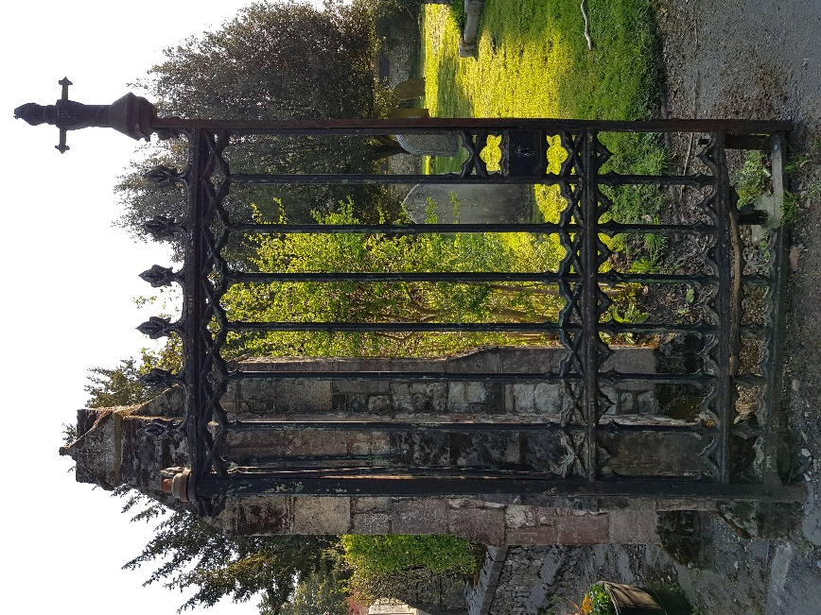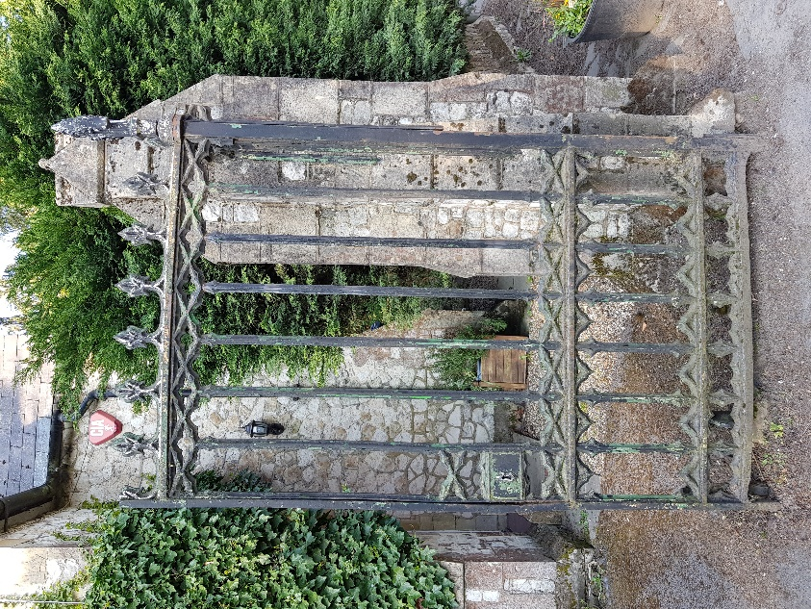
The gates at the entrance to the West Street Cemetery in Farnham are thought to be contemporary to the creation of the cemetery in the Victorian period. The entrance to the cemetery including the gates and pillars is grade 2 listed and of local interest.
The gates are owned by Farnham Town Council who are seeking the renovation of the gates to good working order.
Weighing approximately 800Kg, the gates have been dismounted from their pillars and sympathetically blast cleaned. An assessment has been carried out of the physical status of the structure and decoration of the gates. They consist of traditionally forged, fixed and joined wrought iron frames with cast iron infill decoration with leading between the cast and wrought and are showing significant corrosion and impact damage.
The gates are currently in storage and can be inspected by tenderers by arrangement with:
Alan Corcoran
Projects Officer
Farnham Town Council
Mob. 07444 901074
e-mail: alan.corcoran@farnham.gov.uk

Glossary of Terms

Restoration: The act of restoring something to its original state.
Renovation: The process of improving a broken or damaged object.
Repair: The process of bringing an object back to its original function
Refitting: The replacement of the gates into the gateway and any operations required to re-hang the gates to provide full function.
Project. Any work to renovate the Entrance gates to the West Street Cemetery, Farnham as the result of this specification.
Wrought iron: Wrought iron being the iron alloy of a semi-fused mass of iron with fibrous slag inclusions rather than the colloquial reference for decorative mild steel work. Known as ‘Charcoal’ iron pre 19th century and subsequently ‘Puddled iron’ before the advent of steel.
Cast Iron: Moulded high carbon iron alloy often used for decorative goods.
Mild Steel: Being a modern material often used in replacement of Wrought Iron. Conforming to: BS EN10025:2019 / S275JR
Tenon: A round or rectangular ‘tongue’ projecting from a shoulder, usually on the end of a bar to fit a corresponding mortise, to achieve a joint
Pivot: A bearing carrying a load parallel to the axis of the shaft, but commonly used for any shaft or pin on which something turns. A traditionally constructed gate often uses an integral pivot pin at the bottom of the back stile, rotating in a socket set into the ground to take the weight of the gate
Journal: A bearing where the load is at right angles to the axis of the shaft. Often used as the top hinge of a traditionally constructed and usually heavy gate, the journal is part of the back stile of the gate, machined or forged to a circular section.

Statement of Requirements

3.1 Overview
Physical restoration and refitting of the gates, operationally and aesthetically, including, but not necessarily limited to the following basic requirements:
- All work should be sympathetic to and considerate of the age and original materials of the gates. Wherever possible the work undertaken should adopt the same methods as used in the original construction.
- Repair of or replacing cast iron decoration.
- Finishing and/or painting of the gate and all ancillary gate furniture to a high standard that is appropriate to its heritage status.
- Documentation of the repair or restoration process, including, but not limited to:
  - Method statement for work route including specific method statements for the refitting works.
  - Photographic record of the work undertaken in the work route.
- Documentation of the maintenance schedule and requirements following the work.
- Refitting the gates at the cemetery entrance in good working order, including any necessary sub-contracted masonry work.
3.2 Heritage Requirements
Waverley Borough Council Historic Buildings Officer has indicated that:
- the gates are grade 2 listed and have been listed as part of the aesthetic appearance of the West Street cemetery entrance.

- as this is considered a repair, and that listed consent is not required provided that the finished appearance will be unchanged and any joints/welds etc between existing and new material will be neatly finished:

  - the use of like for like materials in the renovation of the gates is not necessary,
  - recreation of original tooling marks is not required,

With this in mind, the repair is expected to balance a sympathetic approach between traditional and modern techniques and materials to provide the desired outcomes.
The original gate materials appear to be wrought iron of the later puddled iron type and have cast iron infill decoration.
The original construction techniques include hot forged sections with tenoned joints in the main frame with the cast infill being screwed or pegged in place with lead as a matrix to take up the gaps.
Each gate leaf is mounted on a bottom pivot with pivot pin sockets located in the ground for spacing and operation with a journal at the top of the back stile on a mounting strap fixed into the gate pillar during construction.
The Gates are designed to be lockable when closed and have hold-backs to secure them open.
3.3. General Work Practice Requirements
The heritage status of the gate suggests that as much of the original material be retained as possible. New elements should be created using the original techniques and similar tooling where possible. Traditional techniques and materials should be used wherever possible including the hot forging of replacement sections, particularly joining tenons, for strength and durability.
Given the size, construction, material and condition of this gate, it is expected that attempting to simply repair the gates using modern electrical welding repairs to the structure will not provide a sufficiently strong and long-lasting outcome.
All replacement work and disassembled and re-assembled elements will be closely fitted to existing and replacement elements. All tenon joints shall be neatly and strongly tenoned and riveted together, with heads of tenons to be finished appropriately as per the original work.
It is expected that the missing and damaged cast elements will be replaced with new appropriate castings in malleable or spheroidal graphite iron. Due to the fitting and accurate dimensional requirements, it is expected that a series of casting specific patterns will need to be created for the elements.
Prior to assembling/reassembling ironwork, joints and meeting surfaces will be coated with a suitable protective coating such as red lead or zinc phosphate amongst others as appropriate.

3.4 Work specification following post media blast assessment
It is expected that each gate will be dismantled carefully to minimise damage to retained frame sections and further damage to decorative cast sections which should be removed in their entirety or as necessary in preparation for the repair and replacement works as detailed below:
3.4.1) Right Hand Gate – works required
- Back stile: Corrosion and wear at bottom of back stile around and below tenon and at bottom pivot pin.

Expected work route: Retain, rebuild, and reface existing back stile and bottom pivot pin to original sections.

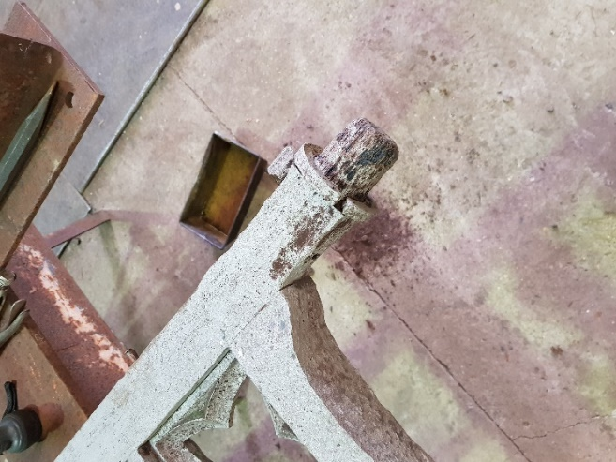
- Bottom Stile: Significant corrosion. Section showing structural deformation.

Expected work route: Replace with forged mild steel bottom stile including remaking hot forged tenon joints.
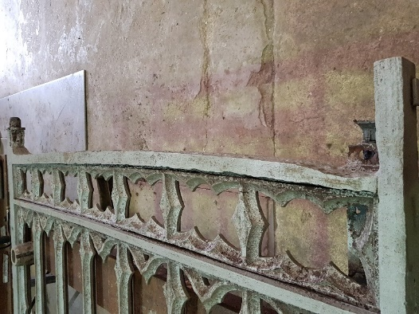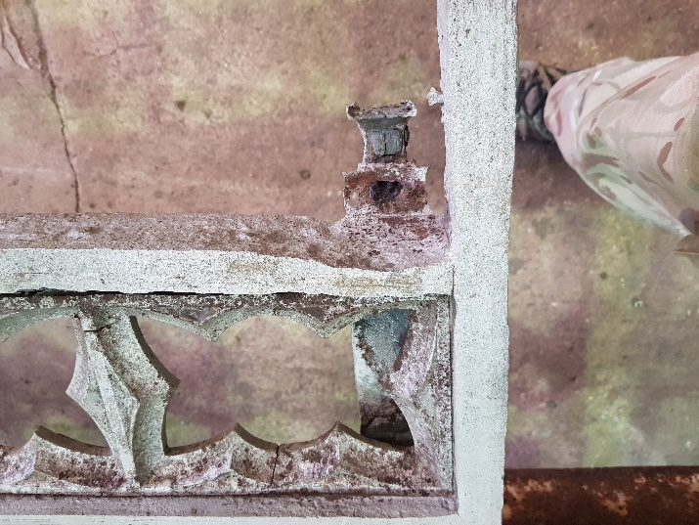

- Front Stile: Section showing structural deformation.

Expected work route: Retain and straighten original section.
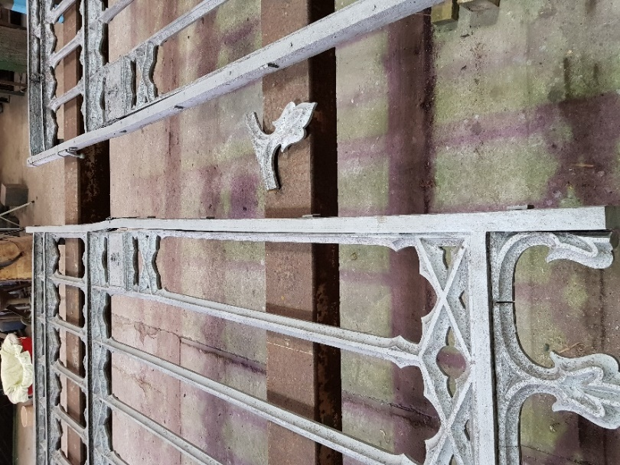
- Top Rail: Section showing structural deformation.

Expected work route: Retain and straighten original section.
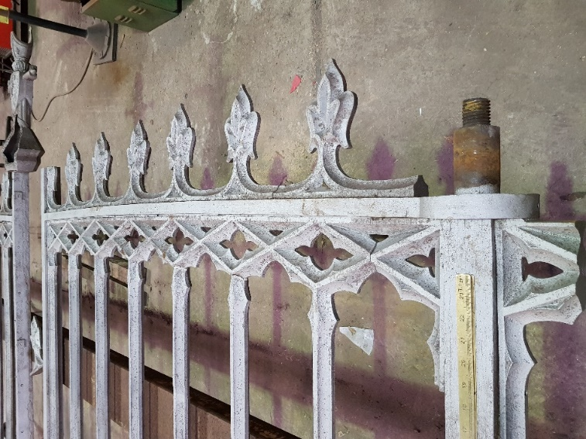

- Centre Rails: Considerable corrosion on and around leading

Expected work route: Retain and rebuild original section if possible
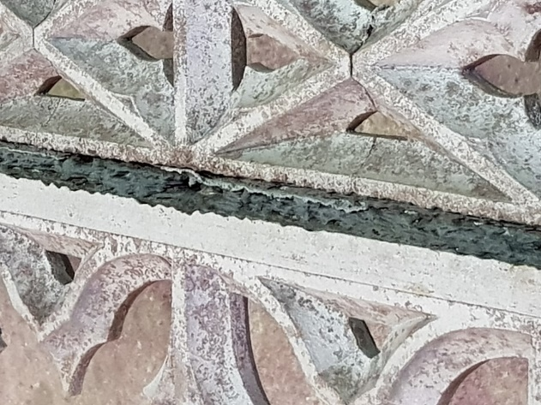
- Lock: Mechanism is missing or corroded completely.

Expected work route: Rebuild Lock Box and source/ make new lock to fit with suitable period inspired decorative key and duplicate.

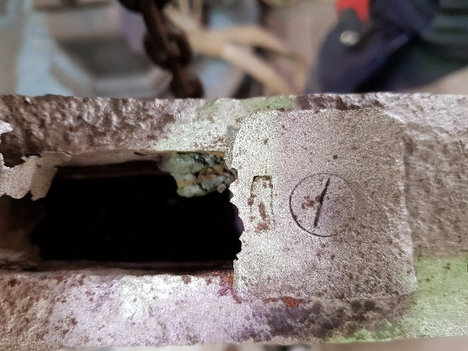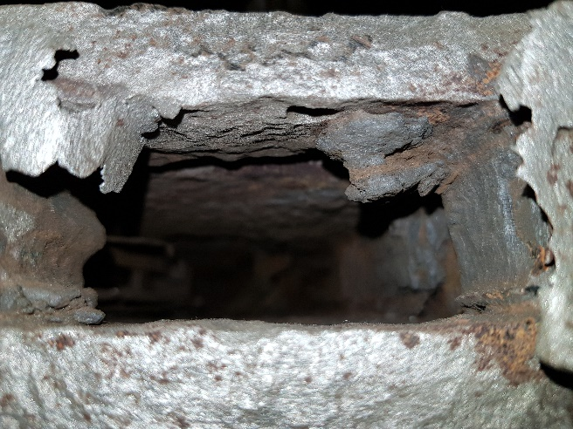

- Cast decorative infill: Some missing cast decoration sections. Some cast sections have deformed due to movement of the frames.

Expected work route: Cast replacement sections and fit using lead as filling media for gaps
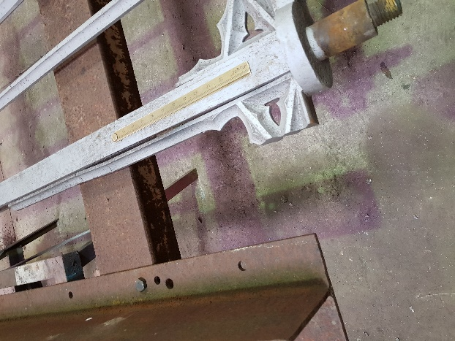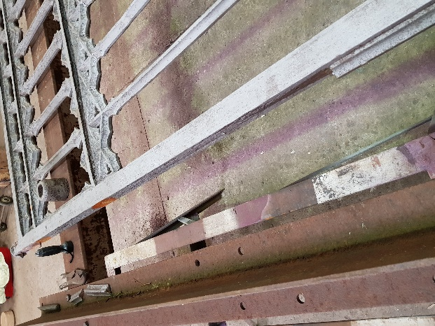

- Closure Strip: Missing section.

Expected work route: Replace section appropriately using traditional fixing methods.
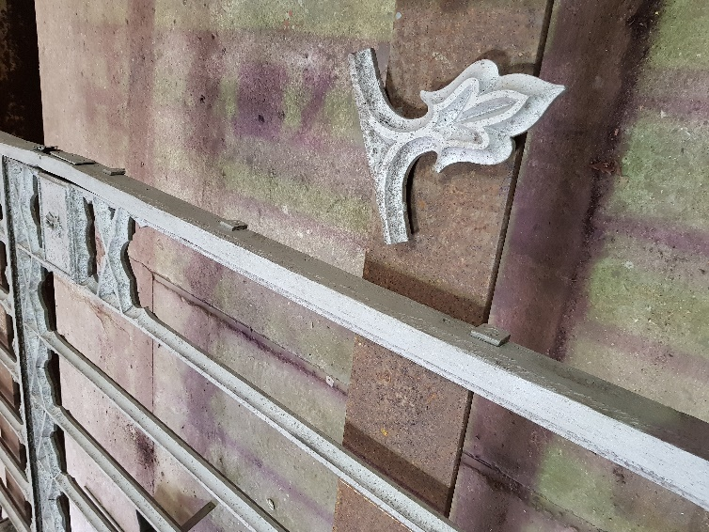
3.4.2) Left Hand Gate – works required
(i) Back Stile: Section showing structural deformation. Bottom pivot pin showing considerable corrosion.
Expected work route: Retain and straighten original section. Build and reface sections as required particularly Bottom pivot.

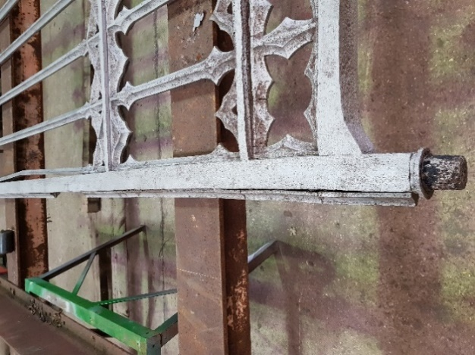

(ii) Bottom Stile: Tenon to front stile has snapped, and section shows structural deformation
Expected work route: Replace with hot forged section in mild steel including remaking tenon joints.
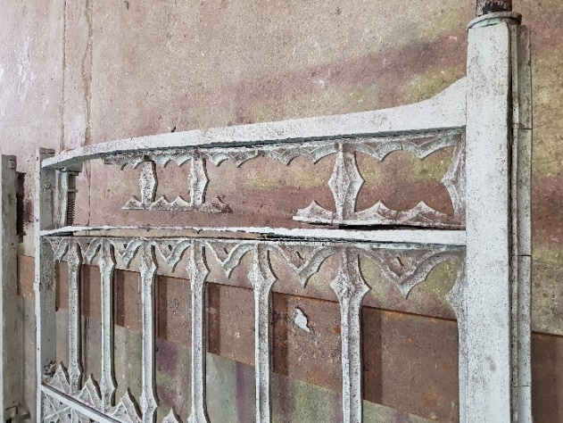

(iii) Front Stile: Section shows structural deformation. Support wheel became detached during dismount. Drop bolt inoperable.
Expected work route: Preferably retain and straighten original section. Otherwise replace section in mild steel including traditional fixing methods. Repair or replace drop bolt. Please note that It is expected that the support wheel will not be necessary if the gates are repaired adequately (although contractors’ views on this would be welcome).
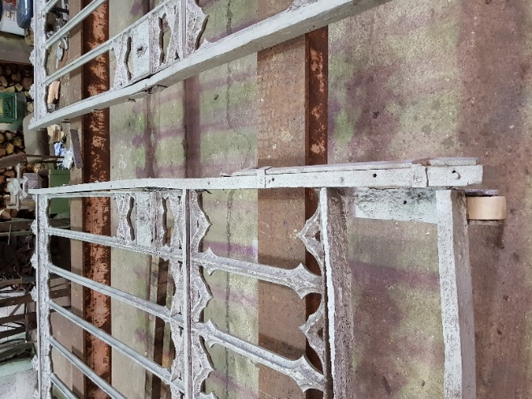
(iv) Top Rail: Section showing structural deformation.
Expected work route: Preferably retain and straighten original section.

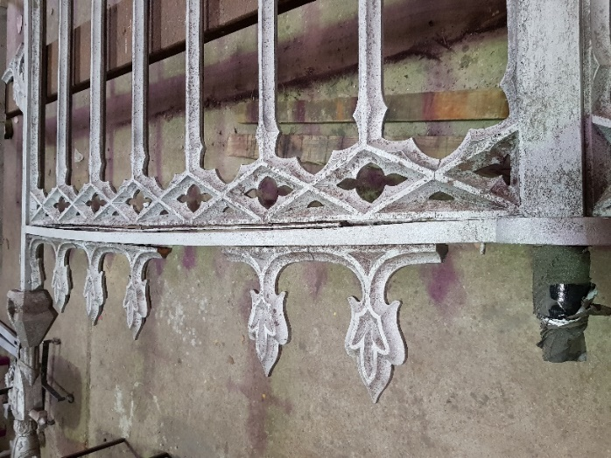

(v) Centre Rails: Section showing considerable corrosion.
Expected work route: Retain where possible or replace sections in mild steel including remaking tenon joints.
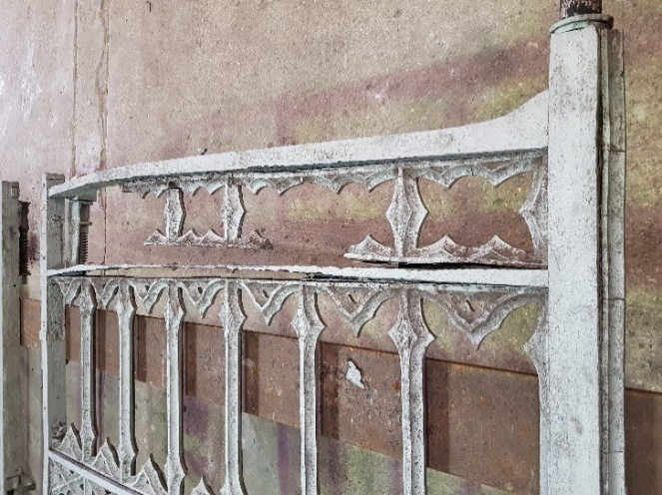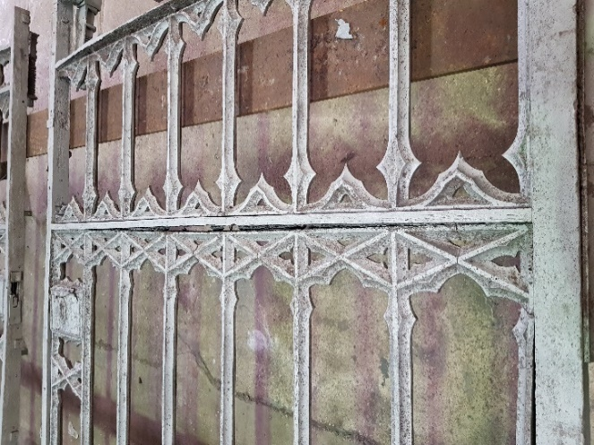
(vi) Lock: Cast Lock box as part of infill is cracked.
Expected work route: Retain and repair cast section in conjunction with provision of Lock mechanism on other gate (see R(vi)).
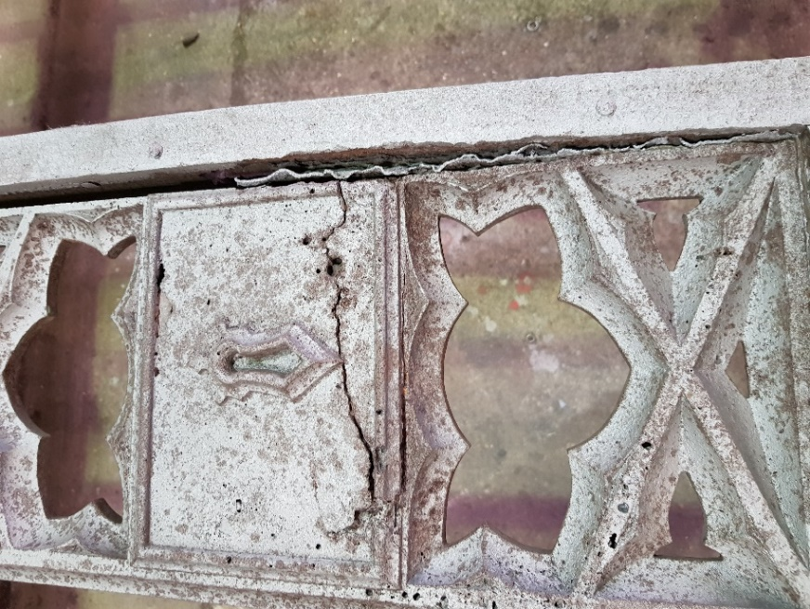

(vii) Cast decorative infill: Significant amount of cast decoration missing. Structural stability of the decoration fixings is compromised.
Expected work route: Cast replacement sections and fit using lead as filling media.

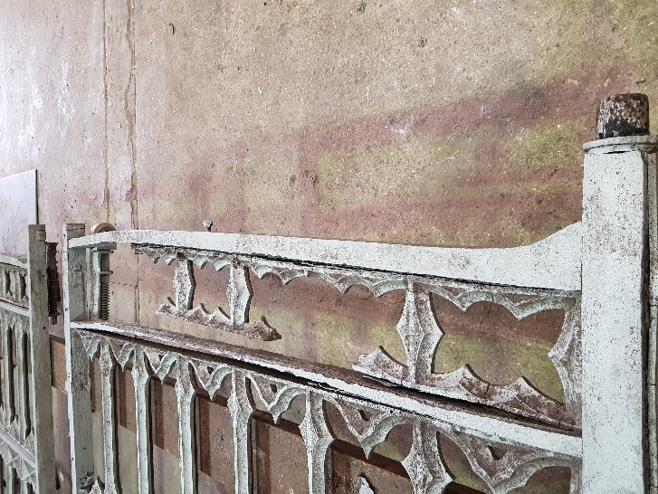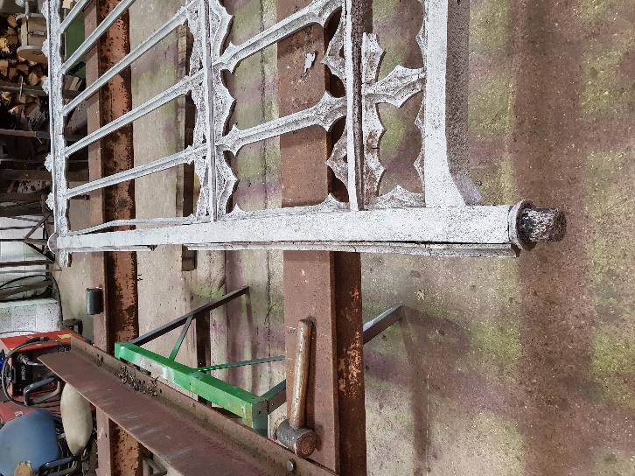

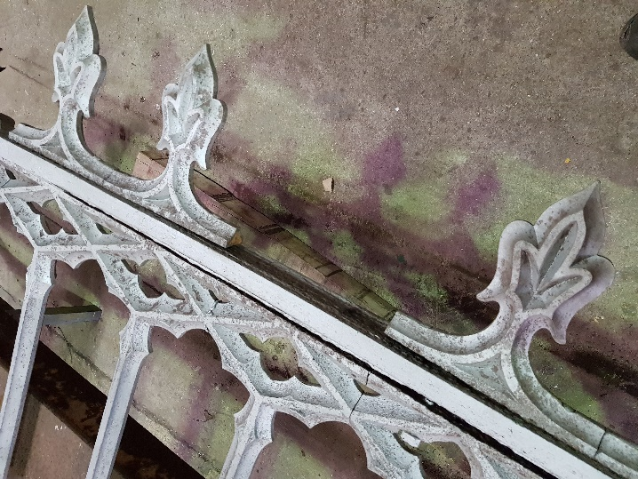

(viii) Closure strip: Section missing.
Expected work route: Recreate and replace section appropriately using traditional fixing methods.
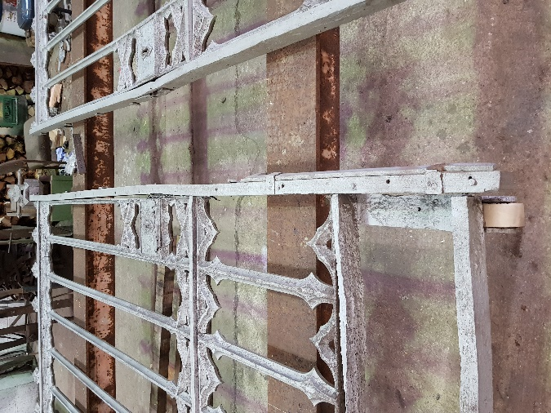
- Central decorative motif on front stile: Casting is damaged with a section missing.
Expected work route: Repair and replace cast sections as required.
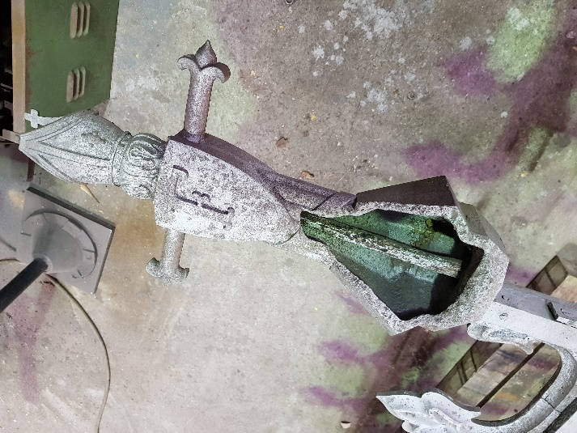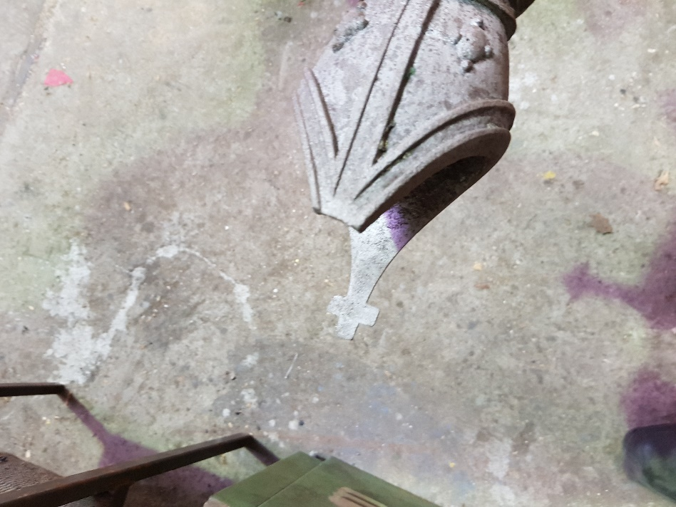

    - Ancillaries – works required

Holdbacks: Inoperable.
Expected work route: Repair holdbacks to bring them into operable condition.

Top journal support straps: Corroded.
Expected work route: Repair top journal support straps as required.

Bottom journal pivot sockets: Corroded.

Expected work route: Repair or remake pivot pin sockets cups to original section for correct operation.

Finials: appear to be in good condition.
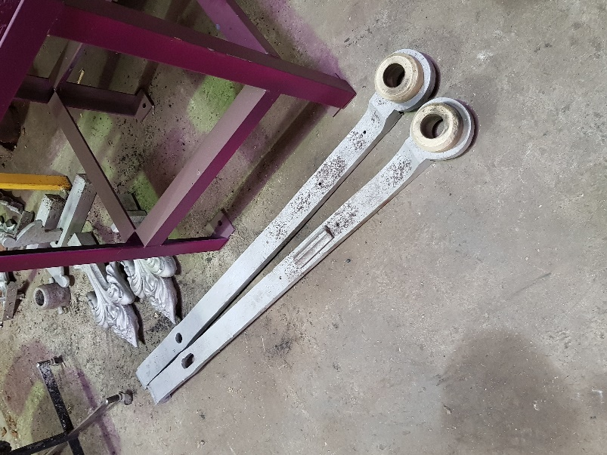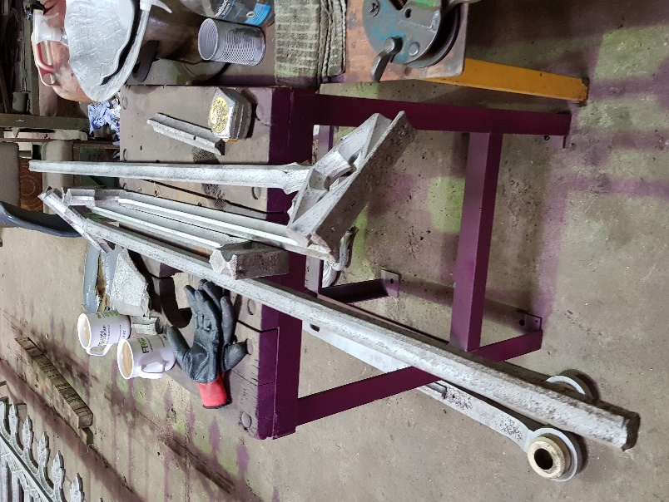
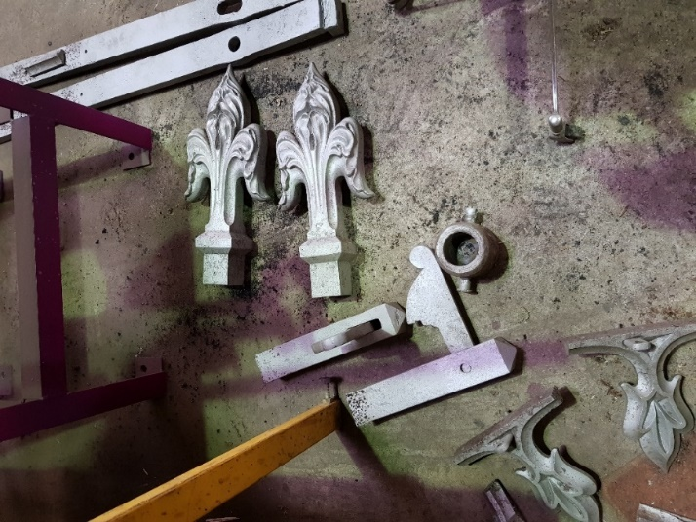

3.4.4) Finishing
Prior to assembling/reassembling ironwork, joints and meeting surfaces will be coated with a suitable protective coating such as red lead or zinc phosphate.
After repair and re-assembly, the gates will require surface treatment. It is suggested that a further shot blast is followed by primer and top coats wet spray paint treatment.
Finishing and/or painting of the gate and all ancillary gate furniture to be to a high standard that is appropriate to its heritage status.
3.4.5) Refitting
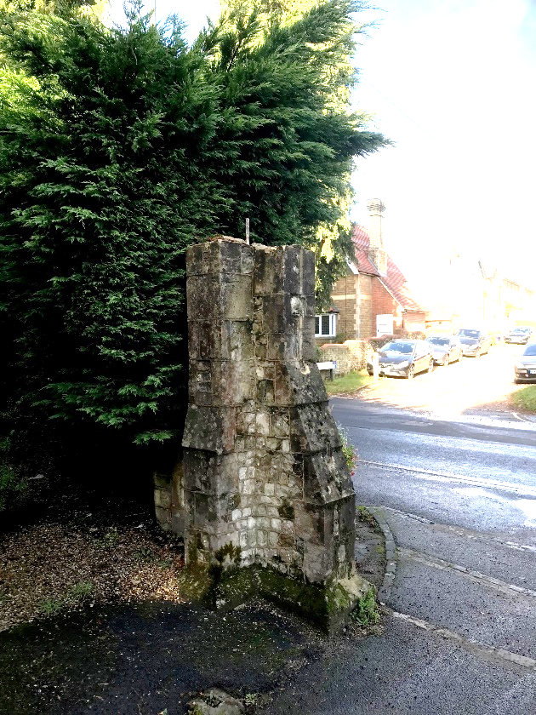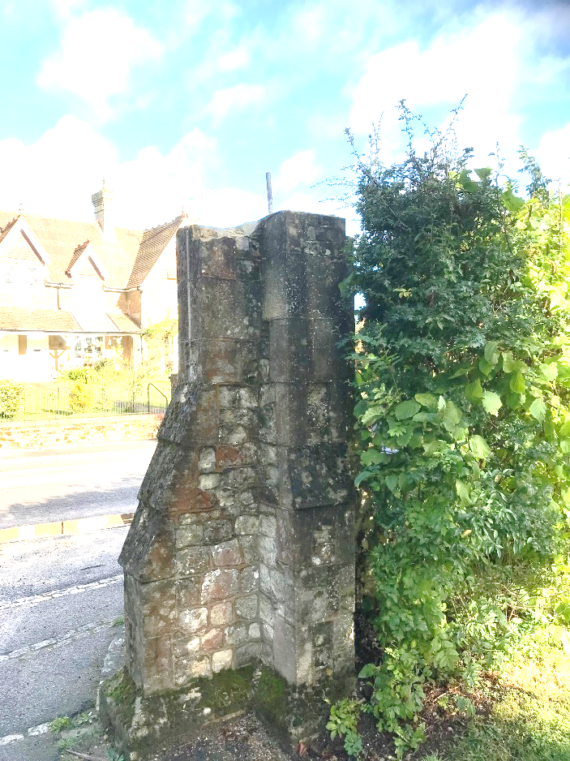
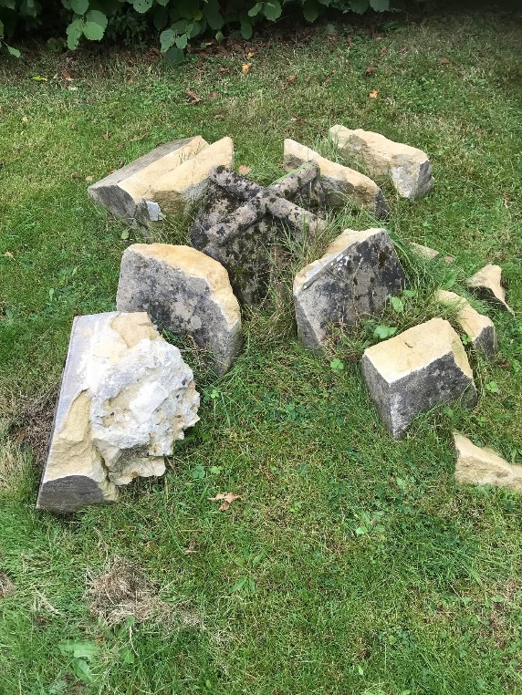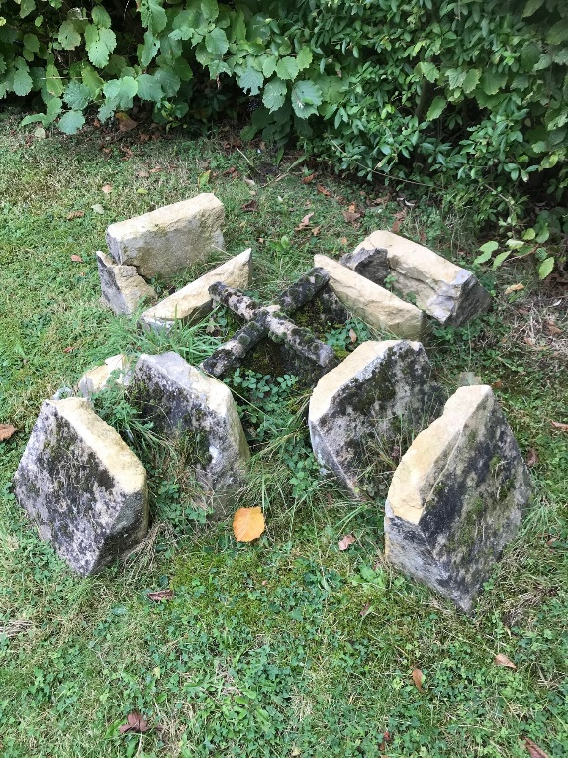
Gates to be refitted to the cemetery entrance in good working order, including any sub-contracted masonry work. It is anticipated that a support frame will be necessary as the piers are constructed around the top journal support straps. The bottom journal bearing pots will be secured into the gates are hung to adjust the hang and closure of the gates.
It is advised that tenderers visit the site to assess the masonry work required and the possible need to appoint a specialist sub-contractor. The stonework removed in the dismounting process (illustrated above) is to the left of the main gates. Please note that although the dismounting work was undertaken by Haven Stone Memorials, Grove Farm, The Street, Crookham Villages, Fleet GU51 5RX (contact Clifford Holmes, Tel.07755 505240) who have indicated that they will be willing to talk to prospective contractors about the project but are unlikely to be in a position to do the work. The main contractor is, therefore, free to appoint their own sub-contractor or use in-house expertise if available. The methodology employed, however, must comply with both heritage and health and safety standards.
The existing holdbacks should be able to be used and can be secured into the ground to enable the gates to be held open.
Being in a public area, an appropriate Construction Phase Plan for the refitting is to be provided by the main contractor, to be approved by Farnham Town Council. The issues to be addressed include:

1. The safety of general users of pedestrian and vehicular access.
2. The safety and access for residents of The Lodge which is adjacent to the entrance where the gates are to be refitted.
3. The safety and access for the user of the Chapel building (a sculpture studio).
4. The effect of dust, vibration and noise from stonework and mechanical devices on workers and users of the area.
5. The potential dangers caused by possible overhead lifting gear and parking of necessary vehicles.
6. The risk of working with lime.
7. Toilet and welfare facilities.

4. Outcomes
Farnham Town Council requires the correct operation and appearance of the gates.
- The gates shall be fully operational allowing the gates to be easily closed, opened, able to be restrained when open or shut and locked when closed to deny access through the gates when required.
- The gates should be restored to a level allowing operation with a simple maintenance schedule that is manageable by basically trained personnel.
- The project should be carried out in a timely manner.
- Health and safety risks shall be minimised to all involved in the work at all stages of the work and in particular the public during refitting activities.
- Work and progress inspection by Farnham Town Council will be required during the work route.
- Transparency in 3rd party contracts placed in support of the work route is required.
- The project should be well documented for council records, including materials used methods employed and photographic records.

Timescale
Tenders should include in the Form of Tender document the proposed timescale for the project, including a proposed start date.

Resources
All resources (costs and staffing) required for the work route to be undertaken and the outcomes to be met are to be provided by the approved contractor. Only inspection and review resource will be provided by Farnham Town Council.

Contract Management and Performance

Review Process
- Materials review
Review of significant external contracts and deliverables
- Assembly Review
To allow the assembled articles to proceed to Finishing
- Delivery Review
Completion of works including refitting and delivery acceptance review

Payment Plan
Tenders should set out proposed payment schedule against progress (Annex C).

Subcontract reporting
The successful contractor is required to notify Farnham Town Council of any significant external contracts (e.g., for masonry work)

Access to work for inspection
Tenders should state specifically where all stages of the work are to take place

Insurance
The successful tenderer will be asked to provide evidence of public liability insurance of at least £10m.

9. Form of Contract and CDM Responsibilities
The form of contract for this project will be a JCT Minor Works Building Contract, with the successful tenderer being appointed as the Main Contractor and Principal Designer under the CDM Regulations and as such will be responsible, inter alia, for the production of the Construction Phase Plan and the Health & Safety File.

10. Tender
10.1. Tenders should include the completion and return of the following Annexes:
- Annex A – Main Tender document
- Annex B – Schedule of Charges
- Annex C – Proposed Payment schedule
- Annex D – Proposed Methodology
- Annex E - References

10.2. You are required to submit a fixed priced tender, and this is to remain open for acceptance for 12 weeks from the date of Tender return. Contingency sums should be included separately and explained. If necessary, drawing upon contingency sums will be subject to agreement with Farnham Town Council.

10.3. The proposed start date is to be agreed with Farnham Town Council

10.4 Farnham Town Council does not undertake to accept either the lowest or any Tender bid. The tender bid will be assessed by cost, programming and start date and quality of submission to include health and safety.

10.5 Neither the Farnham Town Council or Servant of the Employer shall have any authority to make any representation or explanation to persons tendering as to the meaning of the Contract Document or as to anything to be done or supplied by the Tenderer or as to any other matter or things so to bind the Employer or fetter the judgement or discretion of Farnham Town Council in the exercising of its powers and duties under the terms of the Contract.

10.6 Should the Tenderer be uncertain as to the meaning or intention of or wish to qualify anything contained within the Contract Documents he must set forth the particulars of each uncertainty or qualification in writing. The Form of Tender shall be endorsed accordingly and such written particulars shall be submitted with the Tender.

10.7 The Tenderer is hereby notified of the complexity of the works and site conditions. The tenderer is clearly advised to visit the site before completing this tender, and take this factor into account at tender stage, as now claims will be entertained in the future owing to circumstances relating to these factors.

10.8 No Tender will receive consideration unless submitted by the due date and time, and comply with all instructions.

10.9 Tenders should arrive by no later than 1.00pm on 25 November 2021 addressed as follows:
Tender Document
Not to be opened until
1.00pm on 25 November 2021

The Town Clerk
Farnham Town Council
Council Offices
Farnham
Surrey GU9 7RN

Annexe A
FORM OF TENDER
(Please detach and return together with Annexes B, C, D & E duly completed)
Renovation of the Entrance Gates to West Street Cemetery, Farnham, Surrey, GU9 7AP
To: Farnham Town Council, Council Offices, South Street, Farnham, Surrey GU9 7RN
I/We the undersigned, having examined the Briefing Document for this work, do hereby offer and agree to enter into a Contract to provide, execute, comply, complete and maintain the whole of the said works in accordance with the said Briefing Document for the sum:

.......................................................................................................................

.........................pounds.............................................. pence excluding VAT

£......................................p excluding VAT

Of which £……………………………….. (excluding VAT) is a contingency sum.

This offer is valid for a period of 12 weeks from the Tender return deadline.

My/Our provisional indication of the amount of tax that the Employer will be called upon to pay under the VAT agreement amounts to the sum of:

£......................................p

I/We hereby under to complete the whole of the works for handover within
……….. weeks from commencement on site, with a commencement date of
…………… and completion by ……………..
These dates may be deferred due to COVID 19 implications

Note: Commencement date subject to change at the discretion of Farnham Town Council.

Works will commence within 2 (Two) weeks of receipt of order / Letter of Intent or by agreement – subject to compliance by us with CDM Regulations.

I/We further agree that, until the formal contract is prepared and executed, this Tender, with the written acceptance thereof under the hand of the Chief Executive (or other duly authorised Officer) shall constitute a binding Contract between us.

I/We understand that you are not bound to accept the lowest or any tender you may receive and that you will not pay ANY expenses incurred directly or indirectly by me/us associated with the preparation of this Tender.

I/We undertake that in the event of my/our tender being accepted by you, I/we will, within 14 days of being called upon so to do, execute a formal contract under seal, forming a binding agreement in the form and containing the terms and conditions and other matters referred to in the Tender Documents and in accordance with the Tender programme.

I/We warrant compliance with all Acts of Parliament, directives, regulations, rules, orders and other legislative requirements of the EU and United Kingdom (England and Wales specifically).

I/We acknowledge that any correspondence with you or records of statements made to you by me/us be incorporated into and form part of the Contract if you so require.

I/We acknowledge that this invitation to Tender must be treated as private and confidential by me/us and that the Tender Documents and the copyright therein are and remain your property.

I/We undertake not to release details of this tender or the fact that I/we have been invited to tender except in confidence to professional advisors or others who have a legitimate need to know. I/We warrant that I/we have not entered into any arrangement or agreement with any person regarding the amount of my/our tender.

I/We understand that the successful Tenderer(s) will be deemed to be the Principal Contractor and responsible, inter alia, for CDM compliance.

As witness my/our hand(s) this ........................ day of................................... 2021
Signature Signature of Witness

....................................................................... ..................................................................

Name Name of Witness

........................................................................ ...................................................................

In the capacity of Address

........................................................................ .....................................................................

Duly authorised to sign Tenders for and on Occupation
behalf of:

Company.......................................................... ....................................................................

Address of Registered Office

................................................................................................................................................

................................................................................................................................................

Telephone number ...................................................................

Tender Schedule of Costs – West Street Cemetery Gates Annex B
Please note that all costs should be included in this schedule. Where no cost is shown against an item,
it will be assumed that the cost is covered elsewhere. Please attach schedule to FORM OF TENDER.

Item No. in Tender Briefing | Description | Tender price (excluding VAT)  £
3.4.1. | Right Hand Gate
(i) | Back stile
(ii) | Bottom stile
(iii) | Front stile
(iv) | Top rail
(v) | Centre rails
(vi) | Lock
(vii) | Cast decorative infill
(viii) | Closure strip
3.4.2 | Left Hand Gate
(i) | Back stile
(ii) | Bottom stile
(iii) | Front stile
(iv) | Top rail
(v) | Centre rails
(vi) | Lock
(vii) | Cast decorative infill
(viii) | Closure strip
(ix) | Central decorative motif on front stile
3.4.3 | Ancillaries
 | Holdbacks
 | Top journal support straps
 | Bottom journal pivot sockets
3.4.4 | Finishing
 | Protective coating
 | Surface treating
3.4.5 | Refitting
 | Other Charges (not included elsewhere)
 | Preliminaries
 | H&S
 | Design
 | Transportation (Gates are currently in foundry in Normandy, Surrey)
 | Other (please identify)
 | Contingency sum
 | TOTAL

Annex C

Proposed Payment Schedule

Payment | % of Tender Cost | Trigger for payment
Completion, including refitting and masonry work |  | Inspection of completed work
Retention
Total | 100%

Methodology – West Street Cemetery Gates Annex D

Item No. in Tender Briefing | Description | Proposed Methodology  Please tick if the same as the “Expected work route” in Section 3.4.  Otherwise provide brief descriptions.
3.4.1. | Right Hand Gate
(i) | Back stile
(ii) | Bottom stile
(iii) | Front stile
(iv) | Top rail
(v) | Centre rails
(vi) | Lock
(vii) | Cast decorative infill
(viii) | Closure strip
3.4.2 | Left Hand Gate
(i) | Back stile
(ii) | Bottom stile
(iii) | Front stile
(iv) | Top rail
(v) | Centre rails
(vi) | Lock
(vii) | Cast decorative infill
(viii) | Closure strip
(ix) | Central decorative motif on front stile
3.4.3 | Ancillaries
 | Holdbacks
 | Top journal support straps
 | Bottom journal pivot sockets
3.4.4 | Finishing
 | Protective coating
 | Surface treating
3.4.5 | Refitting
 | Other Work
 | Preliminaries
 | H&S
 | Design
 | Transportation
 | Other (please identify)

Annex E
Referees- West Street Cemetery Gates
Please supply details of 2 referees that can be approached by Farnham Town Council in respect of this project.
Name of Organisation…………………………………………………….
Contact…………………………………………………………………………..
Address…………………………………………………………………………..
……………………………………………………………………………………….
……………………………………………………………………………………….
Post Code ………………………………………………………………….
Tel.
e-mail
Relevant project (s)

Name of Organisation…………………………………………………….
Contact…………………………………………………………………………..
Address…………………………………………………………………………..
……………………………………………………………………………………….
……………………………………………………………………………………….
Post Code ………………………………………………………………….
Tel.
e-mail
Relevant project (s)

