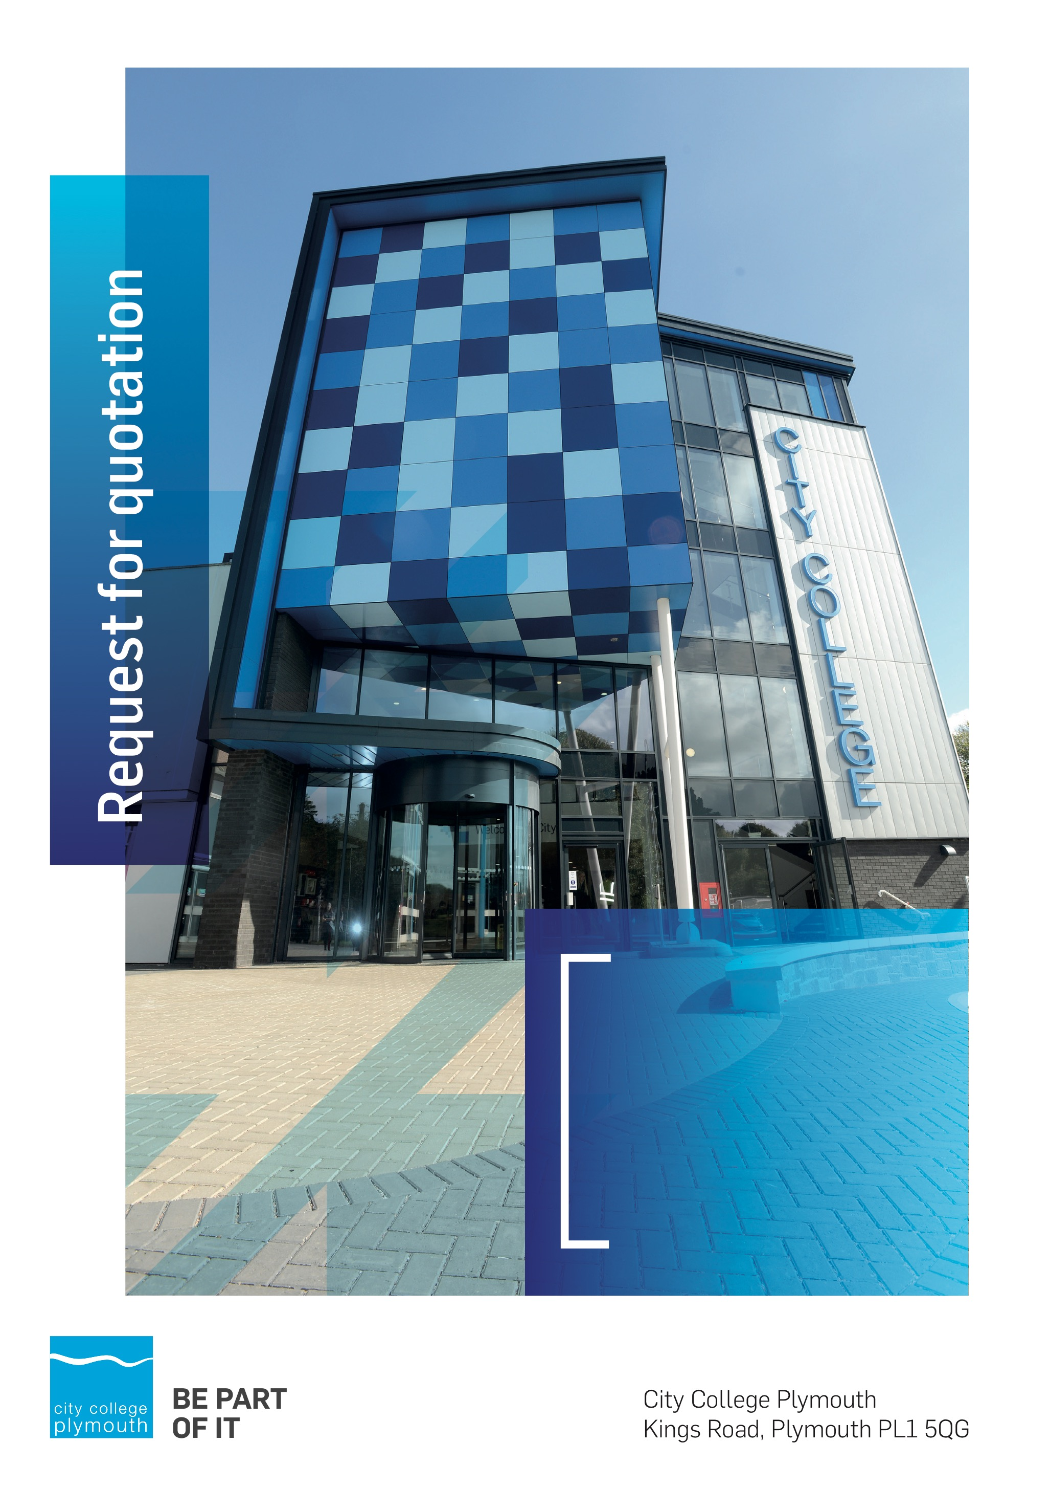

Request for Quotation
RFQ179
FE Capital Transformation Fund – Professional Services
Issued 17th May 2021

Table of Contents
Table of Contents 2
Confidentiality Statement 3
Open Procedure 3
Submission Details 4
Submission Deadlines 4
Submission Questions and Clarifications 4
Electronic Submissions 4
Introduction and Executive Summary 6
Business Overview & Background 6
Our VisioN 6
Our CORE VALUES 6
Our CULTURE 6
Background 6
Detailed Requirement 7
Timescales 8
Written Submission 8
Pricing 8
Terms and Conditions 9
Validity 9
Selection Criteria 9
Award Price 9
Written submission 10
Assessment of Quotations 10
Freedom of Information Act 2000 10
General Data Protection Regulation (GDPR) 2018 11
Agreement Conditions Acceptance and Declaration 11
Supporting Documentation 11

Confidentiality Statement
This document, and any attachments thereto, regardless of form or medium, is intended only for use by the addressee(s) and may contain legally privileged and/or confidential, copyrighted, trademarked, patented or otherwise restricted information viewable by the intended recipient only. If you are not the intended recipient of this document (or the person responsible for delivering this document to the intended recipient), you are hereby notified that any dissemination, distribution, printing or copying of this document, and any attachment thereto, is strictly prohibited and violation of this condition may infringe upon copyright, trademark, patent, or other laws protecting proprietary and, or, intellectual property. In no event shall this document be delivered to anyone other than the intended recipient or original sender and violation may be considered a breach of law fully punishable by various domestic and international courts. If you have received this document in error, please respond to the originator of this message or email him/her at the address below and permanently delete and/or shred the original and any copies and any electronic form this document, and any attachments thereto and do not disseminate further.
Thank you for your consideration, City College Plymouth.
Where no notice is given, all information contained herein is Copyright 2021 City College Plymouth.

Open Procedure
The College fully adheres to the requirements of the Public Contracts Regulations 2015, including for opportunities which are under threshold amounts.
Any Contractor who directly or indirectly canvasses any Member or Officer of the Institution, or advisor concerning the award of the contract for the provision of the services, or who directly or indirectly obtains or attempts to obtain information from any such member or Officer concerning any Tender or proposed Tender for the service will be disqualified from having his/her Tender considered.

Submission Details

Submission Deadlines
All submissions for responding to this Request for Quote must be submitted via email as stated below, no later than:
Wednesday 26 May 2021
12:00 Noon
Any submissions received after this date will not be considered.

Submission Questions and Clarifications
You may contact the following person if you have any questions or require clarification on any topics covered in this Request for Quotation by 21 May 2021.
Adam Baker
Procurement Assistant
Phone: 01752 30513
Email: tenders@cityplym.ac.uk
All correspondence during the Tender should be channeled via the Procurement Officer using the above details only. Bidders found to have gained an unfair advantage shall be disqualified from the current opportunity and future opportunities with the College for a minimum of four (4) years.

Electronic Submissions
Electronic submissions in response to this Request for Quotation are required and must meet the following criteria:
Sent via email to: tenders@cityplym.ac.uk
Document standards:
- Text must be in Microsoft Word format;
- Price tables must be in Microsoft Excel format (using pricing schedule in Appendix A);
- Supportive evidence may additionally be submitted in PDF format;
- Images, Designs, and other supporting evidence may be in either JPEG or PDF format
- Signed Agreement Acceptance and Declaration.

Please note that the College is able to accept submissions sent in a compressed or “.zip” file format, so long as the files contained meet the standards described above.

WARRANTY:
By submitting your tender bid, you are warrantying to the College that you have not breached our canvassing or soliciting clause.

If any successful tenderer awarded a contract is found to have provided an inaccurate warranty, then the College reserves the right to terminate the awarded contract with immediate effect and re-tender the contract from which the successful tenderer will be excluded from re-bidding and shall be disqualified from any future opportunities for a period of four years.

Introduction and Executive Summary
City College Plymouth is seeking funding approval from the DfE to refurbish the Hospitality building. Approval in principle is expected in May, at which stage a detailed business case will be prepared for submission by the end of July. This case is to be supported by a scheme developed to RIBA Stage 2 and it is to develop this scheme that the college is seeking to appoint a multi-disciplinary professional team. It is anticipated that the refurbishment will have a construction cost of £3.5 million and will be delivered during 2022/23. The initial appointment will be to RIBA Stage 2 only but this request covers all of the RIBA stages to deliver the project. The completed works are to be ready for teaching to commence in September 2023.
The anticipated value of the supply contract will exceed £25,000. Therefore, as per the Public Contracts Regulations 2015 the opportunity will be advertised on the government portal ‘Contracts Finder’.

Business Overview & Background
City College Plymouth has a learning environment and organisational culture that impacts positively on the health, wellbeing and sustainability of our community and enables all of our students and staff to achieve their full potential.
City College Plymouth is one of the largest providers of innovative, technical and professional, education in the South West with a national reputation for promoting enterprise, employability and science, technology, engineering and mathematics (STEM). The College plays a central role in the educational, cultural and economic life of the region and works with strategic partners to facilitate growth, raise aspirations and foster wealth creation.
The College was awarded the Teaching Excellence Framework (TEF) Gold award for its university-level provision and its most recent Ofsted inspection confirmed that the College continues to be ‘Good’ with many outstanding features. The College was rated first in the South West and second nationally for student satisfaction in the latest FE Choices student satisfaction survey.
City College Plymouth is also one of the first Institutes of technology in the UK Working in collaboration with education providers and employers across the South West to improve the training in science, technology, engineering and maths in order to address skills gaps within these industries and support regional growth.
City College supports the region’s employers with their award-winning Apprenticeship provision, as well as providing a range of courses and bespoke training programmes which enable employees to upskill or retrain to better support their business’ requirements.
The College operates on two main sites within the city, serving 12,500 students and employing over 650 staff. The College operates year round, with opening times from 0800-2100 on some days.

Our Guiding principle
City College Plymouth has a learning environment and organisational culture that impacts positively on the health, wellbeing and sustainability of our community and enables all of our students and staff to achieve their full potential.

Our Vision
To be the learning destination of choice

Our CORE VALUES
Respect, ownership, integrity for all

Our CULTURE
Nurturing a passion for teaching and learning
Enriching our community through knowledge, experience and skills
Enabling every student to be the best that they can be

The Way Forward - our Priorities
• Staff - our most important investment
• Students - our purpose
• Community - making a difference
• Achievement - reputation for success
• Wellbeing - infusing health into every day

Detailed Requirement
You are invited to submit a fee proposal for the following project team roles:
- Architect
- Mechanical, Electrical & Public Health Engineer
- Structural Engineer
- Principal Designer
- Quantity Surveyor
- Planning consultant
The services provided shall be as described in the RIBA Plan of Work 2020, unless specifically excluded within this tender submission. The Architect will fulfil the role of lead designer, responsible for co-ordinating the activities of the other consultants throughout the design stages. If successful with the funding application, the college will directly appoint a Project Manager and Contract Administrator.
The Hospitality building is a 1980s three storey building of just under 3,000m2. It currently provides specialist facilities for hospitality and catering on the ground and first floors, including a training restaurant and café. On the second floor is an art room, simulated aircraft interior and general classrooms.
The ground floor has benefitted from limited internal refurbishment but the external fabric of the building is not in good condition and the roof is overdue for replacement. Investment is needed in the heating and ventilation systems and replacement of the electrical switchgear is considered a maintenance priority. The scope of work is envisaged to include:
- External wall cladding and insulation including replacement windows & doors
- Roof coverings including upgraded insulation
- Alterations to internal layouts and repurposing of existing spaces
- Full internal refurbishment of walls, floors and ceilings
- Upgrade electrical switchgear, power, data and lighting
- Improvements to heating and ventilation
The existing accommodation is not suitable for current group sizes and teaching methods, nor does it incorporate the spaces and technology required for modern digital learning. The college has engaged a space planner and will provide the successful team with a client brief which includes spatial requirements.
On completion the accommodation may include:
- Training restaurant, café and supporting training kitchens
- Teaching facilities for sport, public services, travel & tourism
- Open / social learning area(s)
- Staff work rooms
- Changing and locker rooms

The milestones to achieve the funding application deadline are:
Milestone | Date
Appoint professional team | Tuesday 01 June
Sign off Strategic Brief (Stage 0) | Friday 11 June
sign off Initial Project Brief (Stage 1) | Wednesday 23 June
Sign off Final Project Brief, Cost Plan and Concept Design (Stage 2) | Wednesday 14 July
Submit funding application to DfE | Friday 30 July
Decision from DfE | Friday 17 September

PROCUREMENT Timescales

Action | Date
Tender Issued | 17/05/2021
Deadline for Queries | 21/05/2021
Tender Response Date | 26/05/2021
Award Date | 01/06/2021
Implementation Date | 14/07/2021

Written Submission
You should submit a written document, which details your company offer with particular interest to the areas outlined below. This submitted document will be scored as per the table on page 9.
- Fees broken down into RIBA plan of work stages as per appendix A
- Previous experience of similar projects undertaken and details of past management of works in the educational sector including references.
- How you will provide the required services, in particular outlining your current commitments and how you will ensure the timelines are met.
- Your technical ability and qualifications - to supply all relevant qualifications, memberships and affiliations that you hold.

Please can you also answer the following questions within the above document as part of the quality of service score;
1. Describe the composition of your team and give examples of similar projects on which you have worked together.
2. Provide a programme detailing the resources you will allocate to ensure the RIBA Stage 2 deadline is met. Indicate what information you will require from the college.
3. If funding is successful, describe the subsequent stages of the project and the anticipated timescales for achieving each stage sign off

Pricing
Bidders should complete the pricing matrix in Appendix A with lump sum fees based upon a construction cost of £3.5 million
The initial appointment will be up to and including Riba stage 2 the remainder will be subject of approval to be confirmed by the DFE in September 2021.
Prices should be fixed and valid for the contract period and not subject to increase or escalation of any kind throughout the contract.

Terms and Conditions
The College’s normal business terms are 1-2 months from the date of invoice. Payment will become due subject to the above upon the College’s full acceptance of the goods/services. This Request for Quotation and any resulting purchase order will be subject to the College’s General Terms and Conditions of Purchase of Goods/Services – see Appendix B.

Validity
Bidder’s offers should be open and valid for acceptance for a period of no less than four months [120] days from the date of submission.

Selection Criteria
The successful supplier will have provided the Most Economically Advantageous Tender (MEAT) to the college. It should be noted that the bidder with the lowest submitted prices will not necessarily be down-selected. All bidders will be notified via email of the results of the outcome no later than 90 days from the date of submission. The date of contract award will be provided within that email.
The marking criteria is as follows:
Category | Weight
Price | 60%
Previous experience of similar education sector projects | 10%
Quality of Service, ability to provide within timeline | 25%
Technical ability and qualifications | 5%
Please see table below for more details on the scoring method.

Award Price
Lowest quote price divided by quote price multiplied by 100

Written submission
Assessment | Score | Interpretation
Excellent | 4 | Comprehensive response supported by examples  Description fully supported by details that demonstrate the applicant’s ability to provide the required services.
Good | 3 | Broad response supported by relevant examples.  Description well supported by details that demonstrate the applicant’s ability to provide the required services.
Satisfactory | 2 | Reasonable response supported by some evidence.  Description adequately supported by details that demonstrate the applicant’s ability to provide the required services.
Poor | 1 | Limited response not well supported by evidence.  Description inadequately supported by details that demonstrate the applicant’s ability to provide the required services.
Unacceptable | 0 | No response or insufficient information provided.

Assessment of Quotations
Bidders must ensure that their quotation fully addresses all information requested within this RFQ document. Bidders must ensure that any quotation fully meets the specification required. The College reserves the right to discount any quotation which does not fully meet the specification.
The College reserves the right to seek clarification with bidders upon receipt of quotations and may request one or more bidders to attend an interview.

Freedom of Information Act 2000
Under the Freedom of Information Act 2000 the College cannot guarantee that information provided by bidders during the course of this RFQ procedure or any resulting contract will be held a confidential. The College will not routinely release information to interested parties unless required to do so in order to meet our statutory obligations.

General Data Protection Regulation (GDPR) 2018
All bidders must comply with the General Data Protection Regulation (GDPR) 2018 in respect of using and processing personal information. Bidders must have in place technical and organisational safeguards to protect personal data from unauthorised use, disclosure or loss.
The College reserves the right to request a copy of your privacy statement if you are the successful bidder.

Agreement Conditions Acceptance and Declaration
Bidders are required to sign and return the attached Agreement Conditions Acceptance and Declaration, Appendix D.

Supporting Documentation
Appendix A: Pricing Schedule
Appendix B: City College Plymouth Standard Terms & Conditions
Appendix C: Suitability Questionnaire
Appendix D: Agreement Conditions Acceptance and Declaration

