
Commercial Medicines Unit
NHS England
2nd Floor
Rutland House
Runcorn
Cheshire
WA7 2ES

All messages regarding the
Offer documentation should
be sent via the Atamis Website:
health.atamis.co.uk

Tuesday 24th October 2023

Invitation to offer for: NHS Branded Medicines Framework for North of England and Midlands and East - 1 March 2024

Offer reference number: CM/PHR/22/5678

CM/PHR/22/5678/01 - NHS Framework for NORTH OF ENGLAND Branded Medicines - Tranche B. Period of framework: 1 March 2024 to 31 August 2025 with an option or options to extend (at the Authority’s discretion) for a period or periods up to a total of 24 months.

CM/PHR/22/5678/02 - NHS Framework for NORTH OF ENGLAND Branded Medicines (to transition to Tranche B) Period of framework: 1 March 2024 to 31 August 2025 with an option or options to extend (at the Authority’s discretion) for a period or periods up to a total of 24 months.

CM/PHR/22/5678/03 - NHS Framework for MIDLANDS AND EAST Branded Medicines - Tranche A. Period of framework: 1 March 2024 to 31 August 2026 with an option or options to extend (at the Authority’s discretion) for a period or periods up to a total of 12 months.

CM/PHR/22/5678/04 - NHS Framework for MIDLANDS AND EAST Branded Medicines (to transition to Tranche B). Period of framework: 1 March 2024 to 31 August 2025 with an option or options to extend (at the Authority’s discretion) for a period or periods up to a total of 12 months.

NHS England (‘Authority’) invites offers for the above-mentioned goods and/or services as defined in Document No. 03 Framework Agreement and Terms and Conditions. Offers shall be made subject to the terms of:

Document No.01 This covering letter
Document No.02 Terms of offer
Document No.03 Framework Agreement and Terms and Conditions
Document No.04a Quality Assurance Process
Document No.04b Assessment Criteria, Stability Protocol and Additional Specification Requirements
Document No.05 Selectt offer schedule instructions
Document No.05a Selectt Offer schedule – CM_PHR_22_5678_01,02, 03 & 04
Document No.05b Tender Product listing and usage – CM_PHR_22_5678_01,02, 03 & 04
Document No.05c Volume discounts or additional products offer schedule
Document No.06 Form of offer
Document No.07a Quality control technical sheet
Document No.07b Quality Assurance Policy to support the National Contract Procurement of Licensed Medicines v6 (Issued October 2023)
Document No. 08 Confidential information schedule
Document No. 09 Tender Design and Instructions on completing the offer schedule
Document No. 10 Participating Authorities

all of which constitute this Invitation to offer.

If any of the documents constituting the Invitation to offer is missing, please contact the undersigned immediately via the Atamis messaging portal.

The Authority does not bind itself to accept the lowest offer or any offer at all and reserves the right to accept an offer either in whole or in part, each item being for this purpose treated as offered separately. The Authority reserves the right to conclude a framework agreement for the supply of the goods and/or services with more than one Offeror.

I would like to draw your attention to the following important points when completing and submitting your offer:

1. All offers must be written in English.

2. All offers must be submitted subject to and in accordance with the documentation comprising the Invitation to offer. Save where the Offerors are instructed to provide information, the documentation comprising the Invitation to offer must not be amended in any way.

3. All offers must be loaded onto the Commercial Medicines Unit’s eTendering portal health.atamis.co.uk

4. Offers must be open for 90 days.

5. Offers must be fully completed and available on the designated website no later than 13:00 on Thursday 23rd November 2023.

I must also draw your attention to the enclosed Form of offer where all the requirements for completing and submitting an offer can be found. Failure to comply with these instructions may result in your offer being rejected.

I hope that the above instructions are clear but please contact the undersigned via the Atamis messaging portal if there is anything you wish to clarify.

Yours faithfully

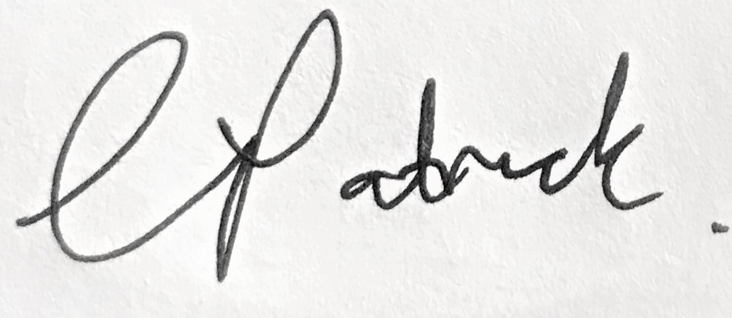

Collette Patrick
Sourcing Specialist
Branded and Biosimilars, IV Fluids and Dose Banded Chemotherapy

