**Appendix One:**

**Map One: Location Map**

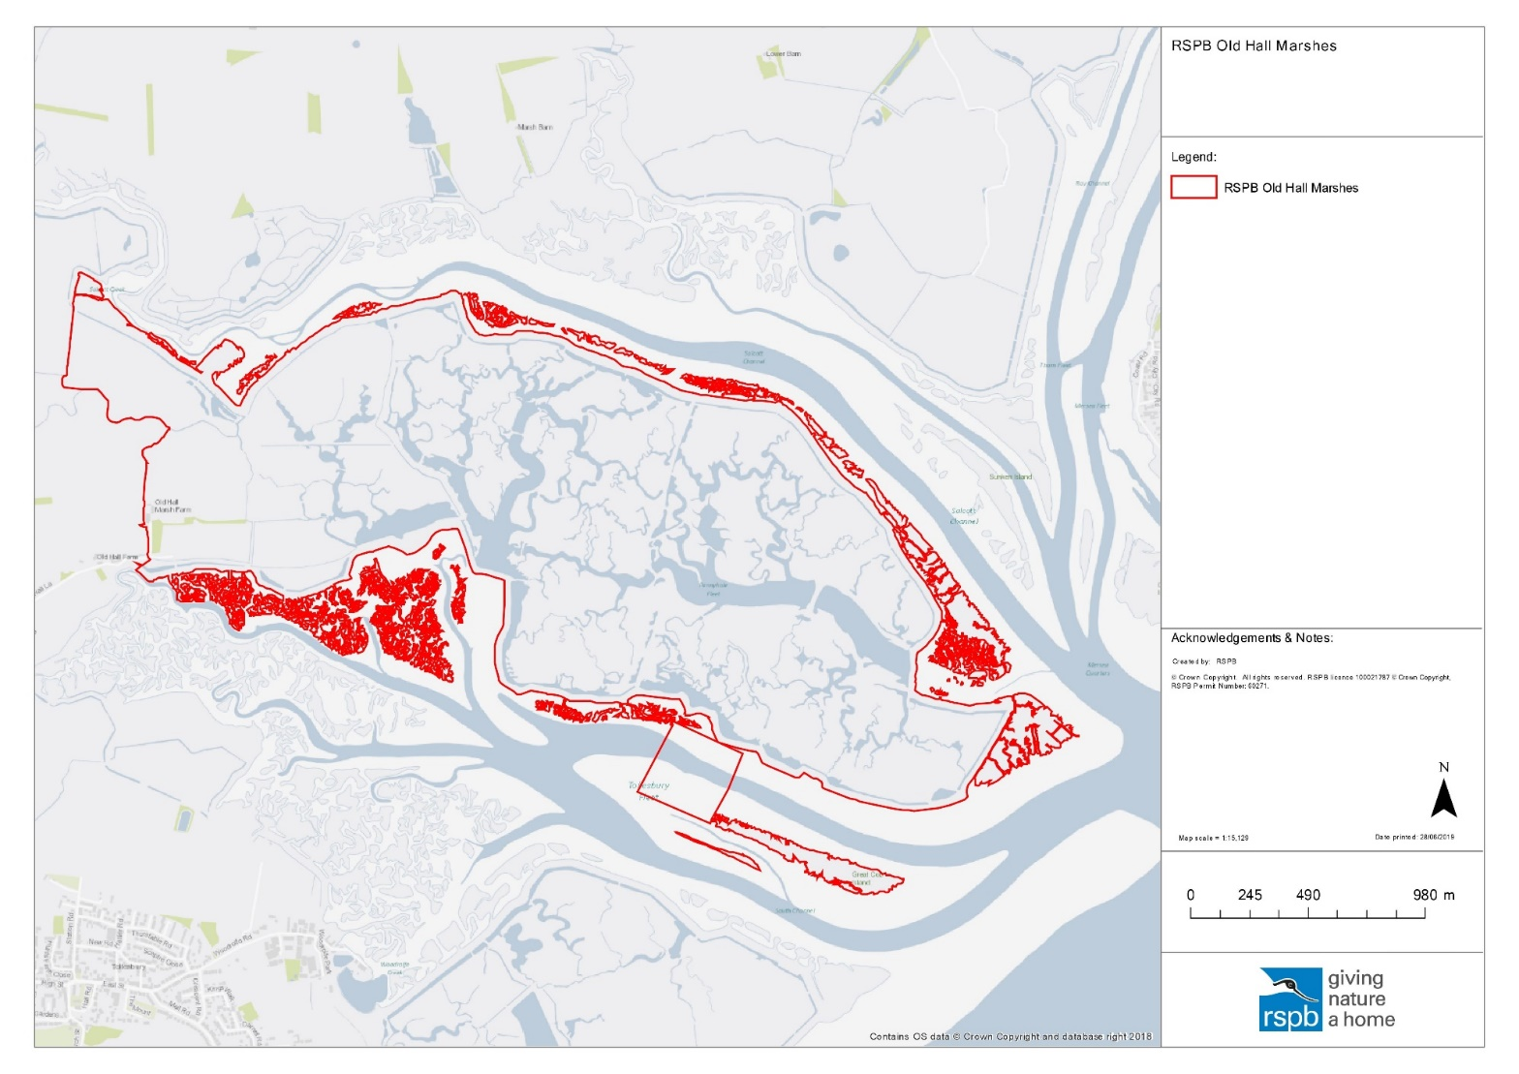

**Map Two: Project plan Map**

**Map Three: Bale work**

**Map Four: Field 1/8 work**

**Map Five Field 6 and 7 work**

