**The Supply Chain Network - Overview**

*The Supply Chain Network (TSCN) is a partnership bringing together a programme of support for businesses within the Yorkshire and Humber regions, led by East Riding of Yorkshire Council. TSCN’s priority is to continually support SME’s to make supply chain opportunities visible, accessible and winnable and assist regional businesses to be supply chain ready to access opportunities. This continuous support is provided to businesses who are seeking guidance and help in maximising their supply chains, in order to help them become more efficient and potentially successful in winning more work whilst helping to secure their longevity for the future. In addition, TSCN provides businesses with regular information and updates on what is happening within regional key sectors and helps to identify where potential new supply chain opportunities may be available.

**Procurement Opportunity**

TSCN is currently looking to procure an individual / organisation to further develop and maintain our resources website held on wordpress.com. The focus is to create an improved customer journey for accessing resources uploaded by The Supply Chain Network and partners.

Work to include the development of:

* Top categories section listing out topics by function (operations, logistics, warehousing, sales, Marketing & communications, procurement, supply chain, finance, management and leaders and Legal) as a minimum with the ability to add more.
* Personalisation
* Creating a further call to action to drive traffic to other resources
* Cross market other products and services for IEY
* Ability to collect data and report on access/views/time spent/journey and general analytics
* Member suggestion form to obtain feedback on resources and any new resources to be developed
* Sign up option for marketing with auto email push notifications when new resources are posted

**Proposal Requirements**

As a minimum responses should include:

1. Details of up to date experience of individual/agency, that substantiate you meet the requirements of the opportunity
2. Evidence to demonstrate a comprehensive knowledge of WordPress development including themes and plugins through the submission of previous work as appropriate
3. Explanation of how the site will be maintained, updated and secured over an initial period of 1 year.
4. Proposal for UX design and customer journey to be presented as part of the proposal.
5. Proposal for access provision for internal team to add articles/members/videos etc
6. Provide a clear project plan which will include delivering training for the site management, refreshing of all resource tagging etc
7. Additional log in security
8. Severity Level Guidelines (as part of the Service level agreement) for issues to be addressed

**Cost Information Requirements**

Please include in the proposal a breakdown of the following costs:

1. Number of days/hours proposed for the duration of the project
2. Demonstration of how the days/hours are calculated for successful delivery
3. Hourly/daily rate/s to be applied

**Milestones**

|  |  |
| --- | --- |
| 1. Tender advertised | Monday 19th December |
| 1. Expression of interest | Monday 9th January |
| 1. Final submission of queries and questions regarding tender | Monday 16th January |
| 1. Closing date for submissions | Monday 23rd January |
| 1. Scoring of submissions | W/C Monday 23rd January |
| 1. Notification to successful applicants | Thursday 26th January |
| 1. Inception meetings and agreement of approach | W/C Monday 30th January |
| 1. Delivery of contract | Completion by Friday 31st March, 2023 |

**Expressions of interest to be sent to both Josh Elliott-Shircore and Cheryl McDougall via email** [**Josh.shircore@eastriding.gov.uk**](mailto:Josh.shircore@eastriding.gov.uk) **/** [**Cheryl.mcdougall@eastriding.gov.uk**](mailto:Cheryl.mcdougall@eastriding.gov.uk) **by Thursday 9th January and access to the current resource portal will be provided.**

**Questions about the specification should be directed to Josh Elliott-Shircore and Cheryl McDougall via email** [**Josh.shircore@eastriding.gov.uk**](mailto:Josh.shircore@eastriding.gov.uk) **/** [**Cheryl.mcdougall@eastriding.gov.uk**](mailto:Cheryl.mcdougall@eastriding.gov.uk) **by Monday 16th January.**

**If you are interested in this opportunity responses should be sent to Josh Elliot-Shircore and Cheryl McDougall via email** [**Josh.shircore@eastriding.gov.uk**](mailto:Josh.shircore@eastriding.gov.uk) **/** [**Cheryl.mcdougall@eastriding.gov.uk**](mailto:Cheryl.mcdougall@eastriding.gov.uk) **by Monday 23rd January 2023.**

* Marketed as The Supply Chain Network, The Sustainable Supply Chain project is part funded by the European Regional Development Fund. The project assists SMEs to enhance their competitiveness through developing their supply chain opportunities.

**Attachments**

ERYC terms and conditions

Appendix 1: Award criteria

Appendix 2: Scoring criteria

Appendix 3: Map of area

* Marketed as The Supply Chain Network, The Sustainable Supply Chain project is part funded by the European Regional Development Fund. The project assists SMEs to enhance their competitiveness through developing their supply chain opportunities

**Appendix 1: Award Criteria**

|  |  |
| --- | --- |
| **Experience and Knowledge** |  |
| Details of up to date experience of individual/agency, that substantiate you meet the requirements of the opportunity Evidence to demonstrate a comprehensive knowledge of WordPress development including themes and plugins through the submission of previous work as appropriate | **30%** |
| Project Management |  |
| Project management of the project, how you will manage security, on going maintenance, updates and any issues requiring a swift response. | **25%** |
| Development of the portal |  |
| Proposal for UX design and customer journey to be presented as part of the proposal. Proposal for access provision for internal team to add articles/members/videos etc | **25%** |
| **Costs** |  |
| The lowest overall bid will receive full marks. All other offers will be scored a comparative mark, by calculating the percentage difference between them and the offer which achieved the highest mark, and deducting this from the highest available mark.  e.g. Company A price = £1000 (10 points)  Company B price = £1250  Score for company B will be calculated as:  10 – (((1250 – 1000) / 1000)*10) = 7.5 points | **20%** |
| **OVERALL SCORING** | 100% |



|  |  |
| --- | --- |
| **Score** | **Criteria for awarding the score** |
| 0 | Complete failure to grasp/reflect the issue or does not provide a proposal. |
| 1 -2 | Serious weaknesses, or does not address the question in a meaningful way. |
| 3 - 4 | The proposal falls short of the expected standard and reflects limited understanding missing some aspects. Significant weakness or risks associated with the answer. |
| 5 -6 | The proposal meets the required standard in most material respects but is lacking or inconsistent in others. |
| 7 – 8 | Good understanding and interpretation of requirements. |
| 9 – 10 | Excellent understanding and interpretation. Innovative and proactive with a sound strategy. |

Appendix 3: Map of area

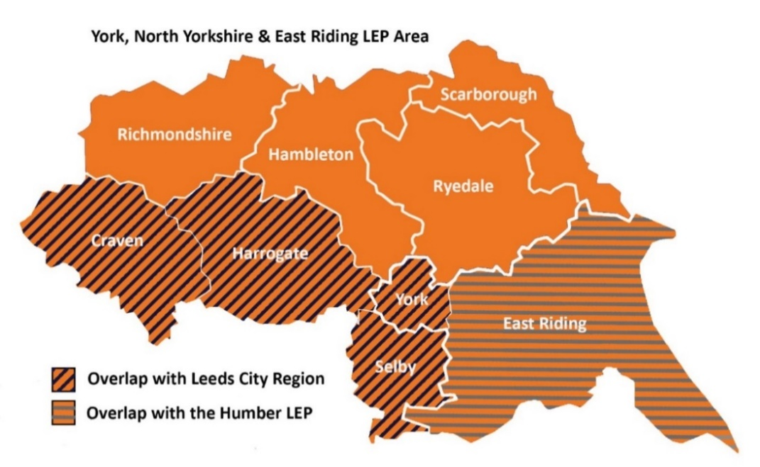

**York area**