

LIVERPOOL VISION
INVITATION TO TENDER
For
The International Business Festival Marketplace Stands.

Contents
Structure of the Invitation to Tender 3
1. Introduction 4
2. Requirement Overview 10
3. Indicative Timetable 10
4. Specification of services or goods required 11
5. Responses required: 14
6. Evaluation 22
Appendix 1 - ITT Instructions and Conditions 23
Appendix 2- Terms & Conditions of Contract 26
Appendix 3 – Legal Comments Table 27

Structure of the Invitation to Tender

This Invitation to Tender (‘ITT’) is divided into a number of specific sections:

1. Introduction

2. Requirement Overview
High level background to the requirement, specified in more detail in section 4.

3. Indicative Timetable
This sets out the dates and times for responding, evaluating, award and service commencement.

4. Specification of Services or Goods required.
This section provides the details of LV’s specific requirements and your Response should ensure these are referred to.

5. Tender Response
This section sets out the information that you are requested to provide, so that Liverpool Vision can assess, evaluate and select the tenderer that best meets its requirements.

6. Evaluation
This section sets out the criteria, weighting and scoring methodology that Liverpool Vision will use to evaluate Responses.

Appendix 1 ITT Instructions and Conditions
Appendix 2 Terms and Conditions of Contract
Appendix 3 Legal Comments Table

Introduction

Liverpool Vision now invites quotations for the supply of a series of proprietary solutions to provide the 2018 International Business Festival Marketplace Stands.
Your quotation must be inclusive of the supply, build and maintenance of all stands. Full management of requirements and upgrade requests that exhibitors may have before, during and after the festival, on-site project management of stands including daily turnarounds if required for the duration of the festival.
For more information on the above modules, please see section: 2. Specification of Goods or Services.
Tenderers will need to respond to the requirements listed, considering the evaluation criteria specified and submitting via the process and timelines as indicated in addition to the general requirements specified in section 3 and 4.
NB: Please note that Liverpool Vision retains the right to select one supplier, multiple suppliers (dependent on proven integration capability) or none (if any one or all of the bids be adjudged by the selection panel as being of an inadequate standard).

About Liverpool Vision

Liverpool Vision is a company limited by guarantee, wholly owned by Liverpool City Council. Its business plan, activities and finances are overseen by a Board of Directors, chaired by the Mayor of Liverpool. Vision’s purpose is to generate jobs and investment in the city. It does this by marketing it as a business, investment and leisure location, through the Marketing Liverpool team and by working with the private sector in the city and internationally to generate investment projects.
Liverpool is a global city, one that’s proud of its heritage and culture but also passionate about looking to the future. That makes it an inspiring and exhilarating place to do business.
With a global perspective and exceptional economic strengths, Liverpool is recognised as one of the UK’s leading business destinations. Blue-chips, start-ups, entrepreneurs and emerging talent are attracted to Liverpool by investment opportunities, business benefits and an outstanding quality of life. That’s where we fit in at Liverpool Vision.
Liverpool Vision is the city’s economic development company that integrates economic development and business and enterprise support designed to accelerate the city’s growth and build a sustainable economy.
We are the company creating an environment for growth, generating a long term impact in both the supply and demand sides of the economy. Liverpool Vision also plays a huge role in transforming perceptions of Liverpool, by communicating positive messages about the city to local, national and international audiences, reaching many hundreds of businesses and opinion formers.
Liverpool Vision has three (directorates) related functions:
- Marketing Liverpool.
- Invest Liverpool.
- International Festival for Business.

Each directorate is overseen by an experienced director, leading a dedicated team of staff. They are supported by a small support function providing business planning and development services, financial management and human resources skills.
Marketing Liverpool includes the Liverpool Convention Bureau.

You can find out more at www.liverpoolvision.co.uk and www.itsliverpool.com

  - About the International Business Festival:

















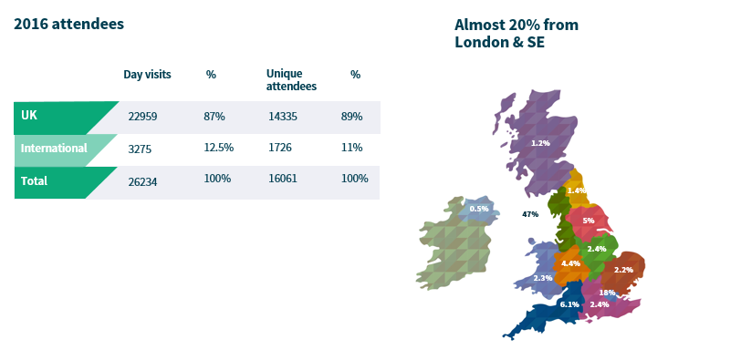

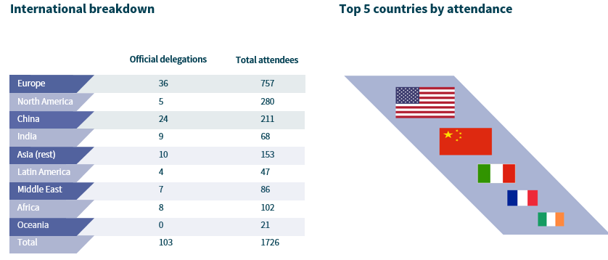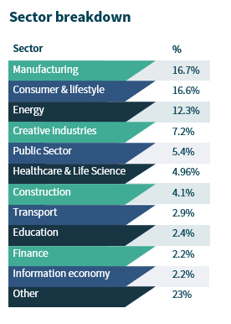







Requirement Overview

The International Business Festival Marketplace will consist of approximately 100 stands of varying scale and package. The stands are to be positioned in various locations around the main festival floor. The exact locations of these will be confirmed on consultation with the design agency and festival team however please refer to the draft floorplan in Section 4.

A breakdown of the sizes, quantities and the minimum requirement of each of the packages to be supplied by the successful supplier are included in Section 4.

We envisage the majority of stands will be purchased for multiple days/weeks however consideration should be given for the possibility of a turnaround of every stand on each of the nine core festival days. In exceptional circumstances we may need to remove or offer flexibility for exhibitors to add additional items to their stands but will have to be provided and communicated through the successful supplier.

Indicative Timetable

This timetable is indicative only and LV reserves the right to change it at its absolute discretion.
Publication of ITT | Thursday 3rd August 2017
Opportunity to raise items for clarification ends | Wednesday 9th August 2017 by 1:00pm
LV response to clarification requests, posted on LV website, tenders section. | Thursday 10th August 2017
Return of completed ITT Response to LV | Wednesday 16th August 2017 by 2:00pm
Presentation / Interview with shortlisted tenderers (if applicable). To be confirmed following evaluation. | Monday 21st August 2017
Indicative award (subject to final due diligence and contract) | Thursday 24st August 2017
Service Commencement | Upon Contract Signature

Specification of services or goods required

THE SOLUTION
For the International Marketplace stands we want a sleek and modern solution. The solution should have no more than one solid wall, no higher than 2m. The solution must be able to offer flexibility and provide a uniformity that will add to the festival aesthetic.
Our preference is for a solution that can provide an open and porous feel on the festival floor that MUST have the capability to turnaround all 100 exhibitors on a daily basis if required and in a limited number of exceptional circumstances possibly be removed and re-installed.
DESIGN & OPERATIONS INTEGRATION
The successful supplier will be required to work alongside our appointed design agency to ensure the solution offered fits with the overall festival look and feel desired. Please see below the initial draft floorplan for the festival floor (subject to change). We will also request a period of consultation with the design agency to establish the best possible layout and formation of marketplace stands to maximise potential revenue.
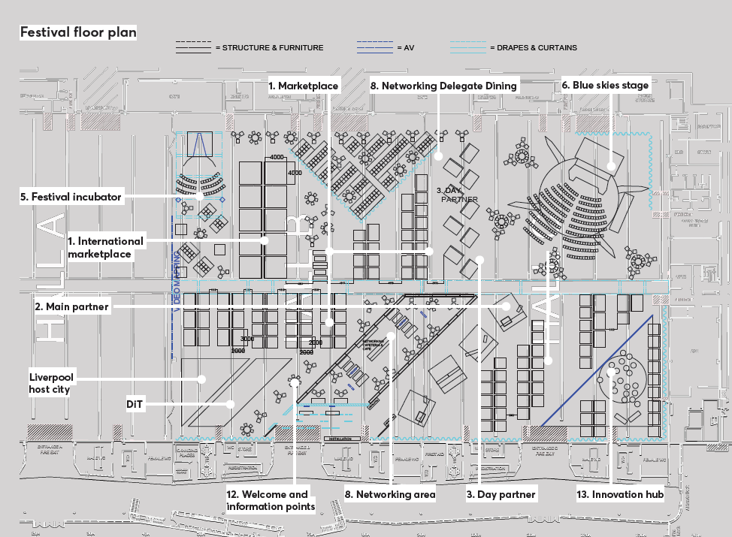
The successful supplier must be willing to integrate with the festival’s Operations Team and the appointed Build/Operate & De-Rig management agency throughout the contract. They must demonstrate the resource and capability in-house to provide full project management of the chosen solution and all aspects contained within the packages; inclusive of on-site management for the duration of the festival and liaising with potentially up to 900 individual exhibitors, ensuring their needs are met both before and during their hire period, including management of deliveries for stands.

The successful supplier should also be able to provide a web based exhibitor portal which can be integrated within the festival website and be able to rely any information back to our system that we may require.
Sale of marketplace stands will go live through the festival website at the end of September 2017.
The successful supplier must be able to provide all aspects of the specification and meet the upgrade options maximum price points. A commission arrangement will be discussed with the successful supplier for any additional upgrades.
FURTHER VENUE INFORMATION

Further useful information on the Exhibition Centre Liverpool (ECL) can be found here:
http://www.exhibitioncentreliverpool.com/

The strict and tight build and de-rig timescales below must be adhered to and offer no room for flexibility, consideration given to the other structures and suppliers that will also require access to the venue during these times.
BUILD & SET UP: 8th June 2018 @ 06:00 – 12th June 2018 @ 07:59
OPEN PERIOD: 12th June 2018 @ 08:00 – 28th June 2018 @ 18:00
DE-RIG: 28th June 2018 @ 18:01 – 1st July 2018 @ 02:00

2018 INTERNATIONAL BUSINESS FESTIVAL FULL OPERATING HOURS
DAY & DATE | ACCESS TIMES
Friday 8th June | 06:00 - 24 Hour access commences for BUILD only
Saturday 9th June | 24 Hour access continues for BUILD only
Sunday 10th June | 24 Hour access continues for BUILD only
Monday 11th June | 24 Hour access continues for BUILD only
Tuesday 12th June | 06:00 – Access for BUILD ends  06:00 – 08:00 – Access for exhibitor and organiser set up  08:00 – ALL Venue open to delegates  18:00 – Halls close to delegates, atrium remain open. Exhibitor and organiser turnaround commences in Halls.  19:00 – Atrium access close to delegates. Exhibitor and organiser turnaround continues.  20:00 – ALL venue shut down
Wednesday 13th June | 06:00 – 08:00 – Access for exhibitor and organiser set up  08:00 – ALL Venue open to delegates  18:00 – Halls close to delegates, atrium remain open. Exhibitor and organiser turnaround commences in Halls.  19:00 – Atrium access close to delegates. Exhibitor and organiser turnaround continues.  20:00 – ALL venue shut down
Thursday 14th June | 06:00 – 08:00 – Access for exhibitor and organiser set up  08:00 – ALL Venue open to delegates  18:00 – Halls close to delegates, atrium remain open. Exhibitor and organiser turnaround commences in Halls.  19:00 – Atrium access close to delegates. Exhibitor and organiser turnaround continues.  20:00 – ALL venue shut down
Friday 15th June | 10:00 – 16:00 – Access for operational maintenance and turnaround
Saturday 16th June | 10:00 – 16:00 – Access for operational maintenance and turnaround
Sunday 17th June | 10:00 – 16:00 – Access for operational maintenance and turnaround
Monday 18th June | 10:00 – 16:00 – Access for operational maintenance and turnaround
Tuesday 19th June | 06:00 – 08:00 – Access for exhibitor and organiser set up  08:00 – ALL Venue open to delegates  18:00 – Halls close to delegates, atrium remain open. Exhibitor and organiser turnaround commences in Halls.  19:00 – Atrium access close to delegates. Exhibitor and organiser turnaround continues.  20:00 – ALL venue shut down
Wednesday 20th June | 06:00 – 08:00 – Access for exhibitor and organiser set up  08:00 – ALL Venue open to delegates  18:00 – Halls close to delegates, atrium remain open. Exhibitor and organiser turnaround commences in Halls.  19:00 – Atrium access close to delegates. Exhibitor and organiser turnaround continues.  20:00 – ALL venue shut down
Thursday 21st June | 06:00 – 08:00 – Access for exhibitor and organiser set up  08:00 – ALL Venue open to delegates  18:00 – Halls close to delegates, atrium remain open. Exhibitor and organiser turnaround commences in Halls.  19:00 – Atrium access close to delegates. Exhibitor and organiser turnaround continues.  20:00 – ALL venue shut down
Friday 22nd June | 10:00 – 16:00 – Access for operational maintenance and turnaround
Saturday 23rd June | 10:00 – 16:00 – Access for operational maintenance and turnaround
Sunday 24th June | 10:00 – 16:00 – Access for operational maintenance and turnaround
Monday 25th June | 10:00 – 16:00 – Access for operational maintenance and turnaround
Tuesday 26th June | 06:00 – 08:00 – Access for exhibitor and organiser set up  08:00 – ALL Venue open to delegates  18:00 – Halls close to delegates, atrium remain open. Exhibitor and organiser turnaround commences in Halls.  19:00 – Atrium access close to delegates. Exhibitor and organiser turnaround continues.  20:00 – ALL venue shut down
Wednesday 27th June | 06:00 – 08:00 – Access for exhibitor and organiser set up  08:00 – ALL Venue open to delegates  18:00 – Halls close to delegates, atrium remain open. Exhibitor and organiser turnaround commences in Halls.  19:00 – Atrium access close to delegates. Exhibitor and organiser turnaround continues.  20:00 – ALL venue shut down
Thursday 28th June | 06:00 – 08:00 – Access for exhibitor and organiser set up  08:00 – ALL Venue open to delegates  16:30 – All auditoria close to delegates. DE-RIG to commence.  18:00 – ALL venue close to delegates. 24 Hour access for DE-RIG to commence.
Friday 29th June | 24 Hour access continues for DE-RIG only
Saturday 30th June | 24 Hour access continues for DE-RIG only  ALL VENUE MUST BE VACATED BY MIDNIGHT FOR VENUE HANDOVER @ 02:00

SPECIFICATIONS OF REQUIRED SOLUTION
For this tender we require 100 stands in the below formation, size and packages.
Quantity | Size | Package option | Inclusions
20 | 2m x 2m | A | - 1 x standard festival background graphic (personalisation option available)  - Small counter/podium with lockable storage included  - Stool  - Lighting for stand  - Stand number  - Power supply integrated from venue  - Floor demarcation of space provided
44 | 2m x 2m | B | All of package A inclusions plus;  - TV Screen  - Shelf or table for laptop/computer  - Literature holder
8 | 3m x 2m | A | - 1 x standard festival background graphic (personalisation option available)  - Small counter/podium with lockable storage included  - Lighting for stand  - Stand number  - Power supply integrated from venue  - Floor demarcation of space provided
18 | 3m x 2m | B | All of package A inclusions (excl small storage) plus;  - TV Screen  - Large counter/podium with lockable storage  - Shelf or table for laptop/computer  - Literature holder
10 | 4m x 4m | C | - 1 x standard festival background graphic (personalisation option available)  - Extra-large counter/podium with lockable storage included  - Lighting for stand  - 4 poseur tables with 10 stools  - 42” TV screen with keyboard etc.  - Stand number  - Literature holder  - Power supply integrated from venue  - Floor demarcation of space provided

Responses required:
Tenderers are invited to respond to the questions set out in this section, having regard for the evaluation criteria weightings set below:
Value For Money | 30%
Capability and Resource | 30%
Approach and Understanding of the Requirement | 15%
Flexibility / Innovativeness | 15%
Accreditations / Qualifications | 10%
Total | 100%

For more information on evaluation of responses, please see Section 6 – Evaluation.

Please use the section reference numbering, as this will assist in the evaluation process.

All responses should be submitted in an unmarked sealed envelope, stating “Response for International Business Festival Marketplace Tender” and marked for the attention of: Zac Roberts, Procurement intern, Liverpool Vision, 10th Floor, The Capital, 39 Old Hall Street, Liverpool, L3 9PP.
Please provide 2 printed responses, together with an electronic copy contained on a USB / Memory Device. This will ensure integrity of the process and allow fair, equal and transparent treatment of responses.
LV appreciate the environmental impact and request therefore that where practical duplex printing on environmentally friendly paper is utilised and that additional materials not directly related are not included.
Certain documentary requirements that are indicated by asymbol need only be submitted in electronic format.
If delivering by hand, please be advised that because of a barrier system in a shared building, you will need to ask reception in the Capital Building to phone Liverpool Vision (0151) 600 2900 that your submission has arrived for collection.
Envelopes must not indicate the identity of your organisation.

There is an opportunity to ask LV for further information to assist you in the preparation of your responses during the Items for Clarification period. If you have an Item for Clarification, please e-mail Zac Roberts (zroberts@liverpoolvision.co.uk) during the opportunity period. Please note that responses to these Items for Clarification from LV may be posted on the LV website rather than a response via e-mail. It is your responsibility to make regular checks of the LV website for updates on these.
Please do not contact any other members of Liverpool vision during the tender process.

5.1.1 Lots
Not applicable.

5.1.2 Executive Summary
Please provide an Executive Summary of your response.

5.1.3 Evaluation Questions:
As referred to earlier in this document, the evaluation framework that we will utilize to arrive at a successful tenderer award for this tender is clear and each element with its associated % evaluation mark allocation is shown below.
Additionally, a list of evaluation questions is included within each evaluation criteria and we request that your submission specifically responds to these questions in order to give your organization the optimum chance to secure the highest score.
Value for Money (30%)
- Please provide a full breakdown of proposed costs to deliver the specifications described; Including details of materials, delivery, team, inclusive of all expenses but exclusive of VAT.
- Please provide a full breakdown of proposed costs of optional extras that can be provided and purchased at the festival for exhibitors and include a potential commission option which can be acceptable to both parties with the successful selling of optional extras.
Capability and Resources (30%)
- Please provide specific case studies that your organization has successfully delivered that are similar to the task outlined within the outlined within this tender document.
- Please provided a clear and detailed plan of activity that your organization can achieve the timescale required by this tender, with a prospective team plan to deliver with evidence. Specifically:
  - On how long will it take to produce the stands.
  - The delivery of the stands to the site.
  - The construction time of the stands.
  - The deconstruction time of the stands.
  - If needed, how long it would take to install stands during the festival.
  - If needed, how long it would take to remove stands during the festival.
- Please provide a detailed plan of how you will be able to provide and deliver additional stock as requested by any of the exhibitors while on the festival floor.
- Please provide a detailed plan on how you provide a solution to the turning around of stands on a day to day bias.
- Please provide a clear and detailed plan with evidence of previous examples and a timescale of how you will be able to provide a web based exhibitor portal, that is able to integrate within our website for the festival, for delegates to purchase stands and upgrades and have that information relayed back to our system.

Approach and Understanding of the Requirement (15%)
- Please provide a detailed presentation that explains your understanding of the overall requirements along with visuals of the viable, deliverable and affordable solution you are proposing.
- Please provide a clear and detailed demonstration, with evidence of previous work, of how you are able to provide a web based exhibitor portal that can integrate with our website and that is able to rely booking information back to our system.
Flexibility/ Innovativeness (15%)
- Please describe how your organization embeds flexibility into the development of designing and positioning of the stands.
- Please describe how flexible your organization would be to any changes that exhibitors may make to the stands that they have bought, whether that be prior to or on the day of the festival.
Accreditations/ Qualifications (10%)
- Please provide details of any accreditations, qualifications or awards you have received.

5.2 General company information required
The following information / requirements will not be scored, but are mandatory; ensuring that we know enough about the companies that we work with and that they are fit for purpose. If not satisfied, then LV reserves the right at its absolute discretion not to award a contract irrespective of how the tenderer has scored using the evaluation criteria.

Please provide a suitable response to the following:
5.2.1 | Full name of organisation (this should be the name of the organisation acting as prime contractor, where applicable).
5.2.2 | Trading name of organisation (if different from above).
5.2.3 | Date of formation
5.2.4 | Registered number if a limited company (please supply a copy of the certificate of incorporation and any certificate of change of name)
5.2.5 | Registered address of organisation and address of principal trading office
5.2.6 | Main Phone number
5.2.7 | Name and contact details in relation to tender preparation
5.2.8 | Address and phone number of office from where business would be conducted in support of this contract, if different from the above
5.2.9 | Full names of all directors / company secretary/ partners/associates or proprietor
5.2.10 | Have any of the persons named in 5.2.9 above, been subject to bankruptcy proceedings or been involved in an organisation which has been subject to liquidation proceedings or had receivers appointed? If yes, please give details.
5.2.11 | Have any of the persons named in 5.2.9 above, been convicted of any criminal offence, apart from minor traffic offence? If yes, please give details.
5.2.12 | Do any of the persons named in 5.2.9 above, have relative(s) who are senior employees of the LV? If yes, please provide details.
5.2.13 | Have any of the persons named in 5.2.9 above, ever been employed by the LV? If yes, please give details.
5.2.14 | If your organisation is a member of a group of companies, give the name and address of the holding company
5.2.15 | Please state the approximate number of employees in your organisation and companies acting in partnership (where relevant), who are specifically engaged in delivering similar services to those proposed by LV.

5.3 Financial Information
5.3.1 | Please enclose  your organisation’s most recent audited accounts and annual reports. This should include: Balance Sheet, Profit and Loss Account, Full notes to the accounts, Director’s Report/Auditor’s Report.
5.3.2 | If you have submitted accounts for a year ending more than 10 months ago, please confirm that the organisation described in the enclosed accounts is still trading. Also supply a statement of turnover since the last set of published accounts.
5.3.3 | If your organisation’s accounts and annual reports are consolidated into those of your parent company or group, then for each of the last two years please provide for your organisation, your organisation’s turnover, profit before tax and net assets.
5.3.4 | Are there any outstanding claims or litigation against your organisation with regard to systems and / or service delivery? If yes, please give details.

5.4 Professional Conduct
5.4.1 | Has your Organisation or proposed partners or any employee within these organisations who would be working on this contract, committed a criminal offence relating to the conduct of your business or profession? If so, please provide details.
5.4.2 | Is your Organisation or are your proposed partners currently involved with any legal proceedings (including Arbitration or any other form of alternative dispute resolution) with any other organisations including local authorities? If so, please provide details.
5.4.3 | Are there any issues, current or likely, in relation to your Organisation or proposed partners that may give rise to any conflict of interest? If so, please provide details.
5.4.4 | Please identify any potential conflicts of interest relating to this contract.

5.5 Insurance requirements
The appointed supplier will be required to maintain appropriate levels of insurance in a number of areas and supply copies of relevant policies as appropriate. Please complete the enclosed table

Area | Level of cover expected | Level of cover currently held | Level of cover to be provided | Further details
Public liability | £10m
Employer’s liability | £5m
Professional Indemnity | £1m

Please note that the insurance cover detailed above needs to be in place before activities commence in pursuance of the services required and will not be considered as part of the costs under the contract between LV and the selected supplier.

5.6 Health and Safety
The appointed Tenderer will be required to ensure that all elements of your services are planned and implemented in accordance with best practice set out in the Health and Safety Executive (HSE) Event Safety Guide (the ’Purple Guide’) and other such guidance appropriate to your business, and to provide a specific detailed risk assessment of all Health and Safety issues associated with the service.
Please confirm your acceptance of this.

5.7 Business Continuity
The appointed supplier will be required to have in place suitable plan. Please provide a copy of your organisation’s business continuity plan (“BCP”) and specifically state how this would be applicable to the service requirements of LV.

5.8 Equal Opportunities
LV expects all suppliers and contractors to operate within its Equal Opportunity Policy.
Please confirm your acceptance of this.
The appointed supplier will be required to have in place suitable plan and to provide  a copy of its organisation’s policy and specifically state how this would be applicable to the service requirements of LV.

Evaluation

Tender Responses will be evaluated using the following criteria and weightings:
Value For Money | 30%
Capability and Resource | 30%
Approach and Understanding of the Requirement | 15%
Flexibility / Innovativeness | 15%
Accreditations / Qualifications | 10%
Total | 100%

Responses, other than Price, will be scored as follows. Intermediate scoring, for example 3.7, is permissible: -
0 | Poor | No response or partial response and poor evidence provided in support of it. Does not give confidence in the ability of the Tenderer to deliver the services.
1 | Weak | Response is supported by a weak standard of evidence in several areas giving rise to concern about the ability of the Tenderer to deliver the services.
2 | Satisfactory | Response is supported by a satisfactory standard of evidence in most areas but a few areas lacking detail/evidence giving rise to some concerns about the ability of the Tenderer to deliver the services.
3 | Good | Response is comprehensive and supported by good standard of evidence. Gives confidence in the ability of the Tenderer to deliver the services. Meets the requirements.
4 | Very good | Response is comprehensive and supported by a high standard of evidence. Gives a high level of confidence in the ability of the Tenderer to deliver the services. May exceed the requirements in some respects.
5 | Excellent | Response is very comprehensive and supported by a very high standard of evidence. Gives a very high level of confidence the ability of the Tenderer to deliver the services. May exceed the requirements in most respects.

Responses should reflect the services specified and will be evaluated against the response requirements set out in Section 5, on the basis of the above award criteria.
Liverpool Vision reserves the right to contact certain tenderers if clarification of their tender is required.

Price will be evaluated using the following method:
30% will be awarded to the lowest cost bid and the remaining Tenderers will be allocated scores based on their deviation from this figure.

For example, if the lowest cost is £40 and another cost is £48 then the lowest cost Tenderer gets 30% (full marks) for cost and the second placed Tenderer gets 25% and so on. (£40/£48 x 30% = 25%).

Successful tenderers will be expected to have suitable financial stability to undertake these pieces of work and to have insurances and policies in place that are adequate to undertaking payment from public funds. If LV regards responses in section 5 to be unsatisfactory, then LV reserves the right at its absolute discretion not to award a contract irrespective of how the tenderer has scored using the evaluation criteria.

Appendix 1 - ITT Instructions and Conditions

Please note that by submitting a response to this ITT that you agree and comply with all parts of the ITT Instructions and Conditions section.

1.1 General Instructions

1.1.1 This document is made available on the condition that the information contained within it is used solely in connection with the competitive process for this ITT and for no other purposes.

1.1.2 Whilst reasonable care has been taken in preparing this document, the information within it does not purport to be comprehensive or to have been independently verified. LV accepts no liability or responsibility for the adequacy, accuracy or completeness of any information stated. No representation or warranty, express or implied, is given by LV or any of its representatives with respect to the information contained herein or upon which this ITT is based. Any liability for such matters is expressly disclaimed.

1.1.3 LV reserves the right, without prior notice, to change, modify, or withdraw the basis of its request and/or to reject all proposals and terminate negotiations at any time. In no circumstance will LV incur any liability in respect of time, effort or costs incurred in regard to either discussions, meetings or time spent in respect of reviewing and/or responding to this document or any subsequent material.

1.1.4 This document is not intended to provide the basis for any investment decision. The recipients of this document must make their own independent assessment of the requirements after making such investigations and taking such professional advice as it deems necessary.

1.1.5 The information in this document shall be kept confidential by the Tenderer and may not be copied, reproduced, distributed or passed to any other persons, at any time, without the prior written authorisation of LV. Ownership in any response to this ITT shall be vested in LV upon delivery of the same and such response shall only be returned at the sole discretion of LV and at the recipient’s cost.

1.1.6 This ITT is not a purchase order and does not constitute an offer capable of acceptance. This ITT does not commit LV or any official of it to any specific course of action. The issue of this ITT does not bind LV or any official of it to accept any proposal, in whole, or in part, whether it includes the lowest priced proposal, nor does it bind any officials of LV to provide any explanation or reason for its’ decision to accept or reject any proposal. Moreover, while it is the intention of LV to enter contract negotiations with the selected Tenderer, the fact that LV has given acceptance to a specific Tenderer does not bind it or any official of it in any manner to the Tenderer.

1.1.7 Without prejudice to any prior obligations of confidentiality you may have, no publicity relating to this ITT or to the acceptance by LV of any ITT response or to the letting of any future contract shall be released by you without the prior written approval of LV.

1.1.8 You shall be deemed to have examined before the submission of your tender response, all the provisions in this ITT as well as regulations and other information relevant to your tender response, and to have fully considered the risks, contingencies, and other circumstances, which could affect the tender response. You shall be responsible for obtaining all information by the making of reasonable and prudent inquiries and, by prior arrangement.

1.1.9 By submitting a Tender Response the Tenderer represents that it has read and understood the ITT. The Tenderer will consider the contents of any submitted tender response as an offer to contract.

1.1.10 Any attempt by Tenderers or their advisors to influence the contract award process in any way may result in the Tenderer being disqualified. Specifically, Tenderers shall not directly or indirectly, at any time:
(a) Revise or amend the content of their Tender in accordance with any agreement or arrangement with any other person, other than in good faith with a person who is a proposed partner or supplier;
(b) Enter into any agreement or arrangement with any other person as to the form or content of any other Tender, or offer to pay any sum of money or valuable consideration to any person to effect changes to the form or content of any other Tender;
(c) Enter into any agreement or arrangement with any other person that has the effect of prohibiting or excluding that person from submitting a Tender;
(d) Canvass LV or any employees or agents of LV in relation to this procurement; or
(e) Attempt to obtain information from any of the employees or agents of LV or its advisors concerning another Tenderer or Tender; or
(f) Offer, pay, promise to pay, or authorize the giving of any financial or other benefit to any person for the purpose of obtaining an improper advantage, or otherwise conduct themselves in a manner contrary to any anti-bribery or anti-money laundering legislation and/or regulations in the broadest sense (whether issued by the EU, the US, the UN or any other body) or any other such rule or legislation that may apply from time to time.

1.1.11 Tenderers are responsible for ensuring that no conflicts of interest exist between the Tenderer and its advisors, and LV and its advisors and Partners. LV reserves the right to disqualify any Tenderer that is guilty of any misrepresentation in relation to its Tender or the tender process. Any Tenderer who fails to comply with the requirements of this clause may be disqualified from the procurement process at the discretion of LV.

1.1.12 Only information provided as a direct response to this ITT will be evaluated. Information and detail which forms part of general company literature or promotional brochures etc. will not form part of the evaluation process. Marketing material should not be included with your tender response. Supplementary documentation may be attached where you have been directed to do so. Such material must be clearly marked with the name of the organisation and the section to which it relates. All sections must be answered unless advised otherwise.

1.1.13 Please note that LV may require clarification of the answers provided or ask for additional information.

1.1.14 The response should be submitted by an individual of the organisation, company or partnership who has authority to answer on behalf of that organisation, company or partnership.

1.1.15 Should there be any obvious typographical errors or misunderstandings in the ITT documentation then clarification should be sought. However, if the response is found to misrepresent facts, the documents will be deemed void. In the case where the error or misrepresentation is not discovered until after the contract is awarded, we reserve the right to determine the contract and costs incurred by us as a result of the determination shall be recoverable from the Tenderer under the contract.

1.1.16 If applying on behalf of a consortium, please list the names and addresses of all other members of the consortium. Any contract will be entered into with the nominated lead organisation and all members of the consortium, who will in these circumstances each be required to execute said contract together with all ancillary documentation, evidencing their joint and several liability in respect of the obligations and liabilities of the contract. It will be for members of the consortium to resolve their respective duties and liabilities amongst each other. For administrative purposes, any associated documentation will be sent to the nominated lead organisation.

1.1.17 If sub-contractors are proposed to assist in the delivery of the service, please list the business names, registered offices, addresses and specific areas of service which they will deliver.

1.1.18 It is the responsibility of tenderers to ensure that their tender is delivered not later than the appointed time. LV does not undertake to consider tenders received after that time unless clear evidence of posting is available (i.e. a clear post mark and/or certificate of posting). It should be noted that mail is not delivered directly to the recipient but through a central post room. This may delay receipt of post, and allowances should be made.

1.1.19 Whilst LV is committed to selecting a supplier or suppliers, it reserves the right not to accept any proposals or award the contract.

1.1.20 LV does not bind itself to accept the lowest or any tender, and reserves the right to accept a portion of any tender, unless the tenderer expressly stipulates otherwise on his tender. The right is also reserved to award more than one contract.

1.2 In responding to this ITT you specifically agree the following:
1.2.1 Having examined all parts of the ITT that the supply of the Goods and/or Services to LV will be at the rates/prices as provided. All prices must be quoted on the basis indicated in the accompanying documents, except where the tenderer proposes alternative priced procedures, and should exclude VAT. Discounts for prompt payment should be stated. The basis of the price shall be inclusive of all costs and delivery to LV.

1.2.2 That any other terms or conditions or any general reservations which may be printed on any correspondence emanating from the tenderer in connection with this tender or with any contract resulting from this tender, shall not be applicable to the on-going relationship between LV and the selected supplier(s).

1.2.3 That any contract whatsoever that may result from this tender shall be subject to the laws of England and Wales as interpreted in an English Court.

1.2.4 The prices quoted and all other information supplied in this tender are valid and open to acceptance by LV for a period three calendar months from the tender return date specified in the ITT

1.2.5 The essence of competitive tendering is that LV shall receive bona fide competitive tenders from all companies tendering. In recognition of this principle, any response is declared to be a bona fide tender, intended to be competitive and that you have not fixed or adjusted the amount of the tender by or under or in accordance with any agreement or arrangement with any other person.

1.2.6 You declare that you have not done and undertake that you will not do any of the following acts:-
(a) communicate with a person, other than the person calling for this tender, the amount or approximate amount of the proposed tender.
(b) enter into any agreement or arrangement with any other person that he shall refrain from tendering or as to the amount of any tender to be submitted.
(c) offer to pay or give, or agree to pay or give, any sum of money or valuable consideration directly or indirectly to any person for doing or having done or causing or having caused to be done in relation to any other tender or proposed tender for the requirement any act or thing of the sort described above.

LV may, if requested to do so, disclose the name of any successful tenderer.

In this declaration the word "persons" includes any person and anybody or association, corporate or incorporate. The words "agreement or arrangement" include any such transaction, formal or informal, whether legally binding or not.

1.3 Freedom of Information

1.3.1 LV is subject to The Freedom of Information Act 2000 (“Act”) and The Environmental Information Regulations 2004 (“EIR”).

1.3.2 As part its duties under the Act or EIR, it may be required to disclose information concerning the procurement process or the contract to anyone who makes a request.

1.3.3 If the prospective Tenderer considers that any of the information provided in their response is commercially sensitive (meaning it could reasonably cause prejudice to the prospective Tenderer if disclosed to a third party) then it should be clearly marked as "Not for disclosure to third parties” together with valid reasons in support of the information as being exempt from disclosure under the Act and the EIR.

1.3.4 LV will endeavour to consult with the prospective Tenderer and have regard to comments and any objections before it releases any information to a third party under the Act or the EIR. However, LV shall be entitled to determine in its absolute discretion whether any information is exempt from the Act and/or the EIR, or is to be disclosed in response to a request of information. LV will make its decision on disclosure in accordance with the provisions of the Act or the EIR and will only withhold information if it is covered by an exemption from disclosure under the Act or the EIR.

Appendix 2- Terms & Conditions of Contract

This appendix contains the terms of LV’s standard Terms & Conditions for services.

By submitting a Response, the Tenderer is agreeing to be bound by the terms of this ITT and the agreements save as in relation to those areas of the agreements specifically highlighted in the response to Appendix 3. As such, if the terms of the agreements render proposals in the Tenderer’s Response unworkable, the Tenderer must submit full details of the unworkable/unacceptable provisions within the Agreement by completing the Legal Comments Table attached at Appendix 3.

Following receipt of this Response, LV will consider whether any amendment to the Agreement is required. Any amendments will be published through a Clarifications Log and will apply to all Tenderers. Where both the amendment and the original drafting are acceptable and workable to LV, LV will publish the amendment as an alternative to the original drafting. In this case, Tenderer’s should indicate if they prefer the amendment; otherwise the original drafting will apply. Any amendments which are proposed, but not approved by LV through this process, will not be acceptable and may be construed as a rejection of the terms of the Agreement leading to the disqualification of the tender.

Appendix 3 – Legal Comments Table
Clause/Paragraph /Schedule | Summary of Issue | Suggested Revisions

