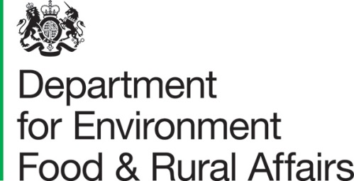 |  | T: 03459 335577  helpline@defra.gov.uk  www.gov.uk/defra
Kings Meadow House
Reading
RG1 8DQ

Specification Template
Project / contract Information
Project name | Internal Wall Damp
Project SOP reference | BLDFMP23-050
Contract reference | Kings Meadow House, Internal Wall Damp
Date | 28/09/23
Version number | V01
Author | Anne Webb
Revision history

Revision date | Summary of changes | Version number
 | First Issue | V01
Details of the Works
Details of works are: -
Investigate sourced of damp ingress and repair to both the west wing and north wing fire stairs.
Investigate and advise if and where we may need an Asbestos Survey.
1 Objective
- to prevent water ingress to Kings Meadow House West Wing Fire stairs
- to investigate Kings Meadow House North Wing sire stairs for similar issues
- to make good any down services.
- To make good brickwork in West Wing fire stairs including decorating
- To replace corroded radiator on grd floor West Wing

1.2 Specification
Expect works to be design and build.
Initial survey carried out by Avison Young. Details required below and full report available on request.
**West Wing Stairwell Damp There are initial investigations that can be undertaken into the suspected downpipe leak before you commit to the expensive and disruptive removal of the radiators blocking the access hatches. We first recommend removing the section of inverted roofing around the rooftop drainage outlet to check the integrity of the waterproofing in this area and ensure that the outlet is still firmly fixed in position. A specialist drainage CCTV survey company may be able to check the integrity of the downpipe by using a push CCTV camera, sent down into the pipe from the rooftop outlet. If the defect is in a difficult to access location it may be possible to affect a repair using a downpipe relining system inserted from above. Rooftop Plantroom’s South Grille Leak The mastic seals to the cladding and grille should be renewed, and it may also be necessary to dismantle the cladding around the grille to confirm the issue and fully remedy it. ***

1.3 The works specifically exclude –

2. Drawings, site information or reports already available:
a) Kings Meadow House – original building plans to be provided on request. Many of the documents are hard copies.
b) copy of previous asbestos surveys can be provided on request. Old type 2 and 3 surveys
c) Relevant copy of Aviston Young initial survey to be provided

3. Constraints on how the Contractor delivers the Works:
a) Working hours to be agreed with the client – normal working hours 9 am until 4 pm. Out of hours be request only.
b) Making good as required
c) removal of waste within the waste management policy
d) working at height
e) weight restrictions in car park.
4. Requirements of the programme:
a) The work needs to be completed by :- Feb 2024
b) Site visit will be essential date to be confirmed
c) Updated drawings and technical information to be supplied on completion
d) Relevant O & M’s will be required on completion
5. Services and other things provided by the Purchaser:
a) Welfare facilities during works.
Toilets, Changing rooms, Showers, car parking.

