APPENDIX B
SERVICE DESCRIPTION

CONTENTS

1. INTRODUCTION 2
2. background to the authority 3
3. Background to requirement/OVERVIEW of requirement 4
4 Purpose…………………………………………………………………………………….5
5. Scope of Requirements 6
6. service levels and performance 7
7. Additional Requirements 9
8. Location 9
9. Security requirements 9
10. PROJECT TIMETABLE 10
11. BUDGET 10

INTRODUCTION

1.1 The Department for Work and Pensions (DWP) is responsible for welfare, pensions and child maintenance policy. As the UK’s biggest public service department it administers the State Pension and a range of working age, disability and ill health benefits to over 22 million claimants and customers.
The Finance Group employs over 5,000 people and we are based in over 200 locations with concentrations around the Corporate Centre Hubs.
DWP Finance Group includes the following teams and Directorates:
- Commercial Directorate
- Contracted Employment Provision
- Corporate and Change Finance
- Debt Management
- Financial Control
- Financial Strategy & Planning Directorate
- Health Services
- Housing Delivery and Operations Finance
- Internal Audit and Investigations
- Performance Management & Assurance Directorate which includes the Portfolio Management
1.2 The Finance Group has an important part of play in delivery of all of the DWP priorities; we do this by controlling costs, driving value and helping to keep the Department safe. To be truly effective we must fully embrace the concept of One DWP by working closely together with each other, our partners and stakeholders and respect and value each other.
We also aim to create a more confident and financially and commercially aware DWP by building capability and competency.
Our functions are broad and range from traditional financial and commercial management and control, information provision and assurance to delivery of more operational activities such as Debt Management.
1.3 Our people are professional, highly skilled, determined and dedicated to working with all of our partners and stakeholders to make ‘One DWP’ a continuing reality.
That is why we all constantly strive to live by our 6 FG values
  - To solve problems – not create them;
  - To act collaboratively – not in a silo;
  - To deliver continuous improvement – not rest on past achievements;
  - To be honest – and where necessary that means telling people things that they might not want to hear;
  - To be supportive and respectful of others; and
  - To embrace learning – both as a team and as individuals.
1.4 Within the Finance Group, the Commercial Directorate (CD) has undergone significant changes and having focused on designing a new operating model the Commercial Directorate now wish to develop a compelling vision for CD supported by a cohesive mission statement with supporting values and culture.

background to the authority
2.1 The Commercial Directorate is responsible for managing £3 billion annually on third party spend that supports the delivery of key services across the department (2014/15 £3,006.4m and 2015/16 forecast of £3,089.9m). The DWP pipeline is made up of some 647 contracts across 5 main category teams, comprising 85 contracts at the pre procurement stage; 36 contracts at the procurement stage and 526 contracts at the contract management stage. In the next 12 months, 61% of these contracts (321) will reach their current contract end date. There are 225 suppliers represented in the pipeline.

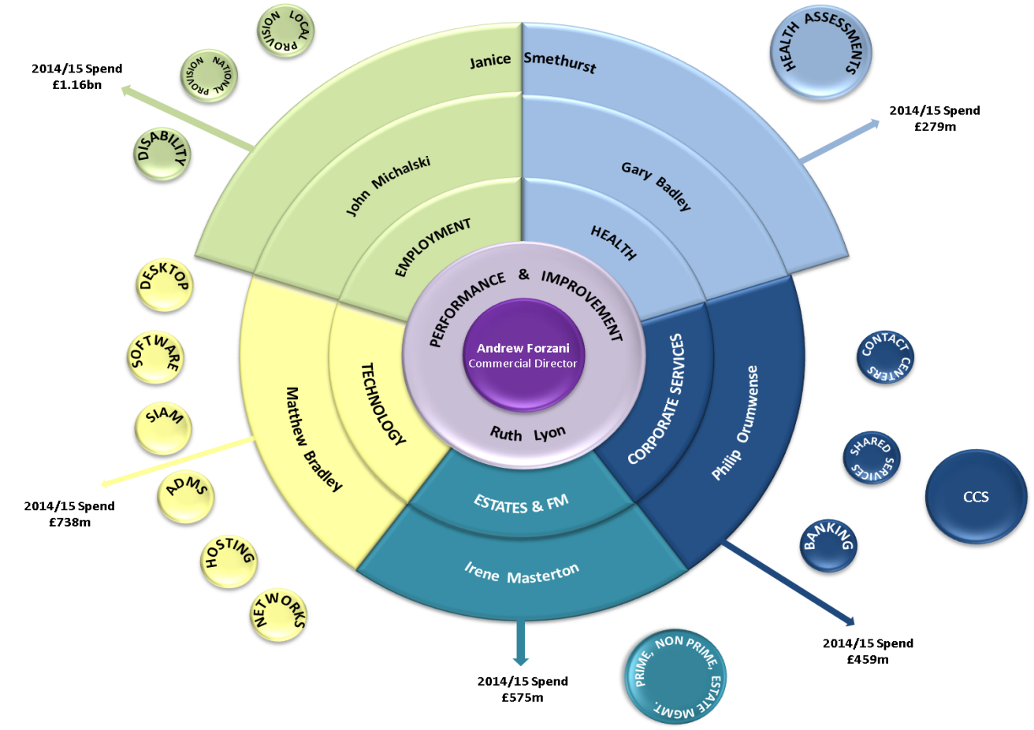

Background to requirement/OVERVIEW of requirement

Commercial Directorate (CD) has adopted a category management approach to commercial activity, to drive greater industry expertise in the key DWP commercial spend areas and to deliver a more end to end service to customers. The focus is on developing deeper industry knowledge to drive greater savings through new procurement activity or through re-negotiating and better management of existing contracts. This change in focus requires increased commercial skills and knowledge in specific key categories with an emphasis on understanding markets and suppliers to drive better deals through robust supplier management and negotiations. Category plans are in place covering all our sub categories and these are regularly reviewed as well as discussed with stakeholders.

The objective is that CD will be fully transformed by March 2017 into a smaller more strategic and experienced team with a different grade mix. The final stage of organisation design which includes a voluntary exit scheme and staff surpluses will lead us to our final headcount target.

CD will operate out of 5 key Hub Sites. These are:

London

Sheffield

Leeds

Warrington/Birchwood

Blackpool
3.4 The requirement is for the Contractor to understand CD and the journey we have gone through and where we are going. To engage with CD, to develop and embed a new culture and set of CD values and behaviours i.e.(what does CD mean to us?)
The desired outcome is that CD build a positive sense of team and belonging and ensure we support and challenge each other.

PURPOSE

CD has a mixture of existing civil servants, new appointments and interims. A recent people survey highlighted a need to improve people engagement and given the scale of improvement needed – specialist support is required to change the culture. CD need to develop a culture and set of values and behaviours that will bind us together as we move forward and complement wider DWP and Finance Group values (1.3 above).
4.2 CD is currently focussing resources to deliver commercial transformation and therefore needs to bring in external expertise to consult with CD staff, design, launch, implement and embed a new culture and vision and provide new capabilities and tools to embed long-term change.

4.3 The timing is critical as CD will launch its new operating model on 4 April and CD staff and new recruits and consultants will start to migrate into their new roles from this date. Therefore the programme will need to run in parallel, culminating with a ‘Launch’ at the beginning of July 2016 and post launch reinforcement.

Scope of Requirements

The Department is seeking to procure professional advice and expertise to support the CD Senior Management Team (CDSMT) to plan for and implement a new culture within CD. The new culture will be underpinned by a new set of values and behaviours, that all of CD will be required to sign up to.

The Contractor shall be required to undertake session planning & stimulus development with a core group of people who will contribute towards and help to drive this programme forward. The Contractors expertise will be required to develop, support and deliver suitable products, activities and plans to ensure successful delivery of the overarching objective at 5.1 above.

The Contractor shall be required to develop robust implementation plans with task durations and state the products and activities that will be required.

5.4 The Contractor will develop a survey or utilise other industry best practice techniques in order to delve deeper into the thoughts, experiences and ideas of the wider CD workforce, building on the results of the recent employee survey. The Contractor will involve and consult with a CD wide focus group.

5.5 The Contractor shall develop staff engagement methods & facilitate events to draw out our culture, values and the behavioural change required.

5.6 This activity will culminate in the production of a CD lture, values and behaviours proposal. The proposal shall clearly define the culture DWP needs to establish and the behaviours and values that will support DWP’s new culture.

5.7 The Contractor shall run sessions with Senior Team to sign off the new culture, values, behaviours and mission & vision proposals.

5.8 The Contractor shall design and develop appropriate tools to drive long-term culture change and proposals for embedding the change.

5.9 The Contractor shall design and support the activities required for the CD launch event in July 2016, writing and designing the materials which all 300 employees will work through/experience.

5.10 The Contractor shall facilitate a series of workshops that support CDSMT to embed the new culture, behaviours and values that will lead to an exit point empowering the staff to make the change themselves and take personal responsibility for the change.

5.11 The Contractor will produce a set of embedding tools for CD to own, roll-out and enable re-use post launch.

service levels and performance

The Authority will measure the quality of the Supplier’s delivery by:

The Plan as at the Effective Date is set out below:
Milestone | Deliverables | Duration (Working Days) | Milestone Date
Programme set up | planning & stimulus  development with a core group of people who will contribute towards and help to drive this programme forward. |  | April 2016
Staff engagement | Engage with all CD staff to draw out our Culture, values and the behavioural change required |  | April 2016 Onwards
Mission and Vision | Draft a staff led mission and vision for CD |  | May Onwards
CD Values and Behaviours draft | Production of a CD Culture, values and behaviours proposal |  | June 2016
Sign off | Presentation of draft proposals to Senior Team |  | June 2016
Launch Event | The Contractor will design and support the activities for the CD launch event., writing and designing the materials which all 300 employees will work through/experience |  | early July 2016
Toolkit | Develop and present a culture, values and behaviours toolkit/plan to senior team for sign off |  | July 2016
Skills transfer | The successful supplier will transfer the necessary skills and toolkits as a handover plan, to the Head of Performance & Improvement and nominated individuals within the Capability Team, clearly outlining how DWP ensure the new culture, values and behaviour can be sustained |  | July 2016

If so required by the Customer, the Supplier shall produce a further version of the Plan (based on the above plan) in such further detail as the Customer may reasonably require. The Supplier shall ensure that each version of the Implementation Plan is subject to approval. The Supplier shall ensure that the Implementation Plan is maintained and updated on a regular basis as may be necessary to reflect the then current state of the implementation of the Services.

The Customer shall have the right to require the Supplier to include any reasonable changes or provisions in each version of the Implementation Plan.

The Supplier shall perform its obligations so as to achieve each Milestone by the Milestone Date.
- Payment can only be made following satisfactory delivery of pre-agreed certified products and deliverables.

- Before payment can be considered, each invoice must include a detailed elemental breakdown of work completed and the associated costs.

Location

The Project is to be based in London and the Consultants will be expected to travel to Hub locations, identified at 3.3 in order to undertake staff engagement.

Security requirements

9.1 Not Applicable as we expect it to be covered as part of the Terms and Conditions.

PROJECT TIMETABLE

10.1 See 6.1.1

BUDGET

Prices should be submitted in pounds sterling and be inclusive of expenses and exclusive of VAT.

The budget allocation is £97,160.00.

