Market Hall – kitchen refurbishment

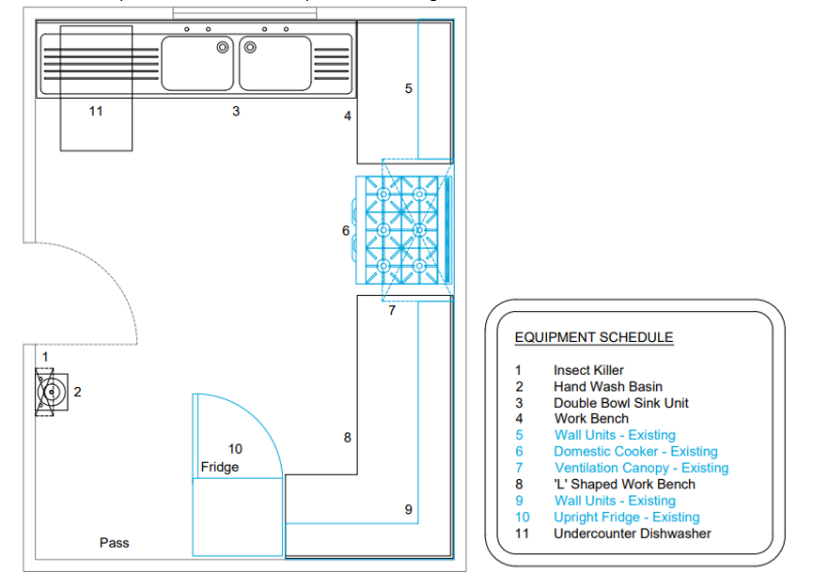

Cost Plan

|  |  |  |
| --- | --- | --- |
| Item | Description | Budget Cost £ |
| 1 | • Remove all items attached to walls and store for reuse – fire extinguisher, insect-o-cutor, paper towel dispensor, fire blanket, first aid kit, clock |  |
| 2 | • Remove all kitchen base units and the wall cupboard adjacent the window only and dispose of with associated plumbing isolations. |  |
| 3 | line walls upto tile line with 6mm plywood / repair plaster |  |
| 4 | remove/release radiator and extractor fan to facilitate |  |
| 5 | * supply and fit with full height whiteroc * supply and fit new coved skirt & vinyl flooring |  |
| 6 | * supply and fit stainless steel shroud to wall behind cooker |  |
| 7 | • supply and fit 1/2 hr fire rated loft hatch |  |
| 8 | • supply and fit 1/2 hr fire rated shutter to serving hatch |  |
| 9 | • oven to be isolated and temporarily moved take up existing flooring to allow new coved vinyl flooring to be fitted / reinstate cooker |  |
| 10 | • supply and fit new handwash sink |  |
| 11 | • allow plumbing for new dishwasher under sink |  |
| 12 | • supply and fit new stainless steel kitchen units to reflect units already in place. (We currently have 2 supply only quotations for kitchen units. We are happy to proceed with this and free issue as fit only element) |  |
| 13 | • provide quotation to remove carpet to corridor and replace with vinyl and stick on skirt |  |
| 14 | • decorate ceiling and woodwork |  |
| 15 | • supply and fit new safety signage |  |
|  |  |  |
|  | Totals |  |
|  |  |  |