HIGHWAYS AGENCY
Asset Management Office

ASSET DATA MANAGEMENT MANUAL

PROVIDER REQUIREMENTS

Edition 1 – August 2012
Version: 1.4

Revision Sheet
Revision | Edition, Part, Section | Summary of Change | Date Issued
1.0 | All | ASC Area 2 Issue | April 2011
1.1 | Glossary | Wording of descriptions altered for TSD, FWD, GPR and TRACS  Addition of Confirm  Additional wording to the SCRIM definition | April 2011
1.3 | Glossary | Wording of description altered for AMOR | May 2011
1.3 | 0.1 The Employers Role Overview | Footer: Appendix reference amended | May 2011
1.1 | Figure 1 | Altered wording | April 2011
1.1 | Function 1 Provider Role – Pavement Data Custodian and Structures Data Custodian | Amendments to text | April 2011
1.1 | ADM Sub Process 3.2 - Scope | Two bullet points removed | April 2011
1.1 | ADM Sub Process 3.3 - Associated Documents | Additional reference  Change in reference  Additional reference | April 2011
1.2 | ADM Sub Process 3.3 - Associated Documents | Text Removed | April 2011
1.3 | ADM Sub Process 3.3 - Associated Documents | Updated Appendix Ref
1.2 | ADM Sub Process 3.4 - Associated Documents | Text Removed | April 2011
1.3 | ADM Sub Process 3.4 - Associated Documents | Updated Appendix Ref | May 2011
1.1 | ADM Sub Process 3.5 - Associated Documents | Change in reference  Additional reference | April 2011
1.2 | ADM Sub Process 3.5 - Associated Documents | Text Removed | April 2011
1.3 | ADM Sub Process 3.5 - Associated Documents | Updated Appendix Ref | May 2011
1.2 | ADM Sub Process 3.6 - Associated Documents | Change in reference  Additional reference  Text Removed | April 2011
1.3 | ADM Sub Process 3.6 - Associated Documents | Updated Appendix Ref | May 2011
1.1 | ADM Sub Process 3.7 - Associated Documents | Change in Competency Level | April 2011
1.2 | ADM Sub Process 3.9 - Associated Documents | Change in reference  Additional reference  Text Removed | April 2011
1.3 | ADM Sub Process 3.9 - Associated Documents | Updated Appendix Ref | May 2011
1.3 | ADM Sub Process 3.10 – Updating and submitting lighting data for billing processes | Addition of Sub Process. | May 2011
1.2 | ADM Sub Process 4.2 - Associated Documents | Change in reference  Additional reference  Text Removed | April 2011
1.3 | ADM Sub Process 4.2 - Associated Documents | Updated Appendix Ref | May 2011
1.1 | ADM Sub Process 5.1 - Associated Documents | Change in Competency Level | April 2011
1.1 | Appendix A  Scope of Data  Carriageway construction  Carriageway inventory  Forward Facing Video  Schedule of Roadworks  Advice on Data  Accessing Accident Data using HAPMS | Bullet 5 – Amendments to text  Amendments to text  Amendments to text  Amendments to text  Amendments to test  Section removed  Amendments to text | April 2011
1.3 | Appendix A  A.1.1 Schedule of Road works | Amendment to Appendix reference | May 2011
1.1 | Agent Authority Codes | Table removed | April 2011
1.1 | Appendix B  B.1.2  B.1.4  B.1.5  B.1.6  B.1.8  B.2.2  B.2.3  B.2.4  B.2.10  B.3 | Amendments to text  Amendments to text  Amendments to text  Amendments to text  Amendments to text  Amendments to text  Amendments to text  Section Deleted  Annex reference changed  Amendments to text  Table reference changed | April 2011
1.3 | Appendix B  B.1 | Bullet point 6 reference amended | May 2011
1.1 | Appendix C  C.2 Network Level Surveys  C.3 Scheme Level Surveys  Deflectograph  Table 15 Pavement  Condition Survey Strategy  C.3 Visual Condition  Figure 15  C.4.1 Pavement Visual Surveys  C.4.6 Corrections and Analysis | Amendments and additions to text  Amendment to text  Amendment to diagram  Amendment to text  Updated diagram and text  Amendments to text  Amendment to text | April 2011
1.3 | Appendix C  C.1 | Figure number amended | May 2011
1.1 | Appendix E | Table removed  Amendments to text  Text removed  Addition of two tables | April 2011
1.3 | Appendix E  E.1 | Addition to Text | May 2011
1.3 | Appendix E  E.2 | Text added | May 2011
1.3 | Appendix E  E.3 | Addition of text  Addition of Table | May 2011
1.3 | Appendix E  E.4 | Addition of text | May 2011
1.1 | All HAPMS Documentation Link through out document | Address changed. | April 2011
1.3 | Appendix F | Addition of text | May 2011
1.4 | Glossary | Addition of text (IAM IS) | August 2012
1.4 | 0.1 The Employers Role Overview | IAM IS added to asset data systems | August 2012
1.4 | ADM Sub Process 3.1 – Asset Data Requests from the Employer | Text removed | August 2012
1.4 | Appendix A | A.1.1 moved to A.1.2  A.1.2 moved to A.1.3  A.1.3 moved to A.1.4  A.1.4 moved to A.1.5 | August 2012
1.4 | Appendix A  A.1.1 | Addition of text (IAM IS Routine and Planned Maintenance) | August 2012
1.4 | Appendix F | Appendix removed (Condition Data (Defects)) | August 2012
1.4 | Appendix E | E.1 Text Deleted (Carriageway Inventory Data) | August 2012
1.4 | Appendix E | E.1 Text inserted (Carriageway Inventory Assets) | August 2012
1.4 | Appendix E | E.2 Text Deleted (Operational Lighting Inventory Data) | August 2012
1.4 | Appendix E | E.3 moved to E.2  E.4 moved to E.3 | August 2012
1.4 | Appendix F | Appendix added (Drainage Assets) | August 2012
Contents
i. Glossary 10
ii. Introduction to Asset Data Management 16
iii. What are Asset Data? 17
iv. The Asset Data Management Process 20
0. The Employer’s and Provider’s General Roles 22
0.1. The Employer’s Role Overview 22
0.2. Provider’s Role Overview 22
Function 1. Asset Data Governance 23
Function 2. Asset Data Management Policy and Standards 27
ADM Sub Process 2.1 Quality Plan Manage Asset Data Process(s) 27
ADM Sub Process 2.2 Development of Improved Asset Data Management Methodologies 27
Function 3. Asset Data Capture, Population, Analysis and Use 28
ADM Sub Process 3.1 Asset Data Requests from the Employer 28
ADM Sub Process 3.2 Changes to the Approved Network Model 30
ADM Sub Process 3.3 Asset Data Update Post Works 32
ADM Sub Process 3.4 Asset Data Update Post Assessment/Survey 35
ADM Sub Process 3.5 Asset Data Post Works Population/Update (Other Schemes) 37
ADM Sub Process 3.6 System Update after Inspection 40
ADM Sub Process 3.7 Recording of Flood Events on the Employer’s Drainage Data Management System 45
ADM Sub Process 3.8 Asset Data Requests 47
ADM Sub Process 3.9 Capture and Storage of Data outside Employer Asset Data Systems 48
ADM Sub Process 3.10 Updating and submitting lighting data for billing purposes 50
Function 4. Asset Data Audit, Assurance and Compliance 52
ADM Sub Process 4.1 Audit 52
ADM Sub Process 4.2 Annual Asset Data Review 52
Function 5. Asset Data Management Improvement and Optimisation 54
ADM Sub Process 5.1 Correction of Asset Data Deficiencies 54
ADM Sub Process 5.2 Continuous Improvement 55
Appendix A: Asset Data Management Systems 56
A.1 Current Employer Asset Data Management Systems 56
A.2 Provider Asset Data Information Systems 60
Appendix B: The Employer’s Current Approved Network Model Procedures 61
B.1 Section Referencing Principles 61
B.2 Section Referencing Procedures 64
B.3 Cross Section Positions 68
Appendix C: Pavement Condition Surveys 76
C.1 Pavement Condition Survey Strategy 76
C.2 Network Level Surveys 76
C.3 Scheme Level Surveys 77
C.4 Visual Surveys 78
C.5 Fitting data to the Network 80
Appendix D: Data, Records and Inspections of Highway Structures 83
D.1 General 83
D.2 Scope of Highway Structures 83
D.3 Type of Records required in Employer’s Structures Data Management System 83
D.4 Data input to Employer’s Structures Data Management System for new build, modifications and renewals 84
D.5 Supply of Structure Records in Connection with Changeover of Responsibility 84
D.6 Supply of Records for Structures on the HA Network Owned by Others 84
D.7 Supply and Upkeep of Operational Records for Existing Structures 85
D.8 Maintenance Inspections 86
D.9 The Management of Sub-Standard Highway Structures, Concrete Half Deck and Hinge Deck Structures 87
Appendix E: Carriageway Inventory Assets 89
E.1 General 89
E.2 Standard Lighting Electricity Billing Inventory 91
E.3 Variable Lighting Billing Inventory 95
Appendix F: Drainage Assets 96
F.1 Drainage Asset managemet 96

Table of Figures
Figure 1 Asset Data Hierarchy Diagram 18
Figure 2 ADM Process 20
Figure 3 ADM Ingredients 20
Figure 4 Sub Process Structure 21
Figure 5 XSP Convention 69
Figure 6 Position of Markers of Two Lane Dual Carriageway 70
Figure 7 of Markers on Two Way Single Carriageway 71
Figure 8 Start of Dual Carriageway 71
Figure 9 Slip Road entering Main Carriageway 71
Figure 10 Main Line Addition at a Ghost Island Merge 72
Figure 11 Lane Gain and Drop 73
Figure 12 Trunk Roads meeting at a ‘T’ Junction 74
Figure 13 Trunk Roads meeting at a Cross Roads 74
Figure 14 Trunk Roads meeting at a Roundabout 75
Figure 15 Pavement Condition Survey Strategy 78
Figure 16 Principles of Rubber-Banding 81
- Glossary
ID | Term | Acronym | Description
1 | Asset Data Management Manual | ADMM | The aim of the ADMM is to define and communicate the Agency’s asset data management requirements and the governance protocols to assure high quality asset data. The ADMM is owned by the AMG Data Team in NDD C
2 | Asset Data Management process | ADM | The ADM process is what the Agency uses to manage its Asset Data. It is based around the Demming Cycle (Plan, Do, Check Act) and is designed to optimise over time. The process is governed by a multi directorate governance board and is managed by the AMG Data Team in NDD C.
3 | Asset Management Group | AMG | The group’s purpose is to support delivery within NDD by improving efficiency and value through optimal and prioritised allocation of resources using accurate and robust performance information.
4 | Asset Management Group Data Governance Board | AMG DGB | The AMG Data Governance Board is the senior governance group responsible for asset data. The board is chaired by a member of the Agency appointed by the HA Executive Role with the appropriate seniority to take overall responsibility and accountability for asset data management in the organisation.
5 | Asset Management Group Data Team (HA) | AMG Data Team | Providing the governance for managing Asset Data.
6 | Asset Management Office (HA) | AMO | The central team that will deliver a new set of asset management tools and processes to the wider business
7 | Asset Management Plan | AMP | The AMPs will assist the Agency in collating asset performance data and understanding current practice in planning and managing assets at an Area level.
8 | Asset Maintenance Operational Requirements | AMOR | Provides the Highways Agency's mandatory requirements for the delivery of routine maintenance and operational service within the Asset Support Contract.
9 | Asset Support Contract | ASC | New model contract to replace the existing MAC contracts.
10 | Confirm |  | Licensed software package forming the core of the Employer’s Pavement Management System (HAPMS). The Employer holds a number of user licences for this software for use by the Provider.
11 | Data Management Strategy | DMS | The DMS sets out the strategy for the management of highway asset data within the Agency, to promote effective Data Management, resulting in a well structured, stable and integrated data set that is available across the whole organisation.
12 | Decisions Support Tools/Modelling | DST/Modelling | The system and process that uses asset inspection data and pre-defined algorithms to model asset deterioration, manage risk and optimise programmes through informed decisions. Requires data attributes, data hierarchy, data quality/confidence targets.
13 | Design Manual for Roads and Bridges | DMRB | Current Standards, Advice Notes and other published documents relating to Trunk Road Works.
14 | Design, Build, Finance, Operate | DBFO | A contract where roads are built and maintained with private capital
15 | Environmental Information System | EnvIS | EnvIS is a system for defining and categorising the man-made or natural assets within and surrounding the Strategic Road Network.
16 | Falling Weight Deflectometer | FWD | A testing device used to evaluate the physical properties of pavement construction by measuring the surface deflection response to a dropped weight, measured using geophones at the centre and offsets form the pulse load.
17 | Ground Penetrating Radar | GPR | Depth sounding techniques that utilise radio waves to obtain information regarding the subsurface structure of the material under investigation. The technique can be used to assess construction thickness, the location of reinforcement or other features.
18 | Highway Agency Geotechnical Information System | HAGIS | Stores information using the latest digital mapping, which allows users to view geographical data for a specific area of the UK by zooming in and out and using the built in GIS tools.
19 | Highways Agency Drainage Data Management System | HADDMS | The management system for the drainage of the motorway and all purpose trunk road networks.
20 | Highways Agency Geotechnical Data Management System | HAGDMS | Holds details of the Highways Agency geotechnical asset, together with geological maps, borehole details, and specialist reports.
21 | Highways Agency Lands | HAL | HAL handles casework relating to the Agencys external customers whose land or property is directly or indirectly affected by The Agencys road building programme.
22 | Highways Agency Management Information System | HAMIS | HAMIS collects and relates operational and financial information to facilitate effective decision-making. It is a single platform for information for all Directorates, from simple code look up utilities to more sophisticated forecasting and reporting tools.
23 | Highways Agency Pavements Management System | HAPMS | The management system for carriageway pavements of the motorway and all purpose trunk road networks.
24 | Highways Agency Valuation System | HAVS | Road Asset Valuation System
25 | Information Asset Owners | IAO | The role of IAO is a position required by the Cabinet Office for all significant datasets held and controlled by the Agency.
26 | Infrastructure for Spatial Information in the European Community | INSPIRE | A European Parliament directive that aims to establish an infrastructure for spatial information in the EC for the purpose of making available “relevant, harmonised and quality geographic information”.
27 | Integrated Asset Mangement Information System | IAM IS | A ‘commercial off the shelf’ system (Exor) to replace 17 of the Agency and supplier asset management systems.
28 | Levels of Service | LoS | Level of Service (LOS) set to be outward facing measures that relate to the service the road user experiences.
29 | Managing Agent Contract | MAC | The contract by which the Strategic Network is managed and maintained within each area.
30 | Manual of Contract Documents for Highways Works | MCDHW | This manual principally looks at the primary documents required for the preparation of contracts for Trunk Road Works.
31 | Metadata |  | Metadata describes other data. It provides information about a certain item's content.
32 | Maintenance Requirements Plan | MRP | The Provider’s plan to deliver the maintenance requirements as defined in the AMOR.
33 | National Asset Data Assessment | NADA | To review the Agency’s approach to acquiring, collating, using and managing the data needed to support existing Agency systems and processes
34 | Network Development and Delivery Directorate Central (HA) | NDD C | NDD C enables the delivery of consistent asset management of the Strategic Road Network by identifying a strategic direction, allocating resources, measuring performance and delivering specific programmes and projects that enhance capability and support the NDD Regions.
35 | Network Management Manual | NMM | Former standard that described the requirements and advice for the management of maintenance on the trunk road network.
36 | Network Operations Data | NO | The data used to support Agency operations, including:  · Fault Reporting – technology asset faults.  · Customer Relations – recording and responding to asset defects.  · Legislative Requirements – data management compliance.  · Contract Management – data to support the contract process.  · Asset Valuation – the actual or predicted value (cost/condition) of all assets.
37 | Network Services Directorate (HA) | NetServ | NetServ support operational delivery and technical advice; provide support services and strategic procurement; to lead and enable the development of the future directions of the Strategic Road Network; and agree business planning and performance.'
38 | Performance Audit Function | PAF | A joined-up approach to performance auditing across the whole of NDD and its supply chain.
39 | Performance Monitoring |  | A set of internal system data metrics and external asset performance metrics, including: indicator specification, indicator hierarchy, data requirements, indicator reporting.
40 | Ordinance Survey Grid Reference | OSGR | Ordinance Survey Grid Reference
41 | Plan, Do, Check, Act | PDCA | The ADM Process is based around the Demming cycle of Plan, Do, Check, Act.
42 | Programme Development |  | The system and processes to justify and prioritise maintenance as set out in the programme development manual?
43 | Routine Maintenance Management System | RMMS | The RMMS implements historic management procedures for routine maintenance of trunk roads.
44 | Routine and Winter Service Code | RWSC | Former manual that provided the requirements and advice for the management of maintenance on the trunk road network.
45 | Sideways-force Coefficient Routine Investigation Machine | SCRIM | This machine is used to measure the skid resistance of the trunk road network by measuring the sideways force generated by a standard measuring tyre on a wetted road surface.
46 | Traffic Speed Condition Surveys | TRACS | Laser measurement apparatus to enable surveys of the road surface condition to be carried out whilst travelling at variable speeds to match prevailing traffic.
47 | Traffic Speed Deflectometer | TSD | The TSD is an advanced system for the measurement and collection of structural pavement condition data, mounted on an articulated vehicle chassis. The technique uses Doppler lasers, mounted in the vehicle to measure the velocity of flexible pavements as they deflect under the weight of the loaded vehicle whilst travelling at traffic speeds up to 80kph.

- Introduction to Asset Data Management
- General
This document, the Asset Data Management Manual Provider Requirements (to be referred to as the ADMM from now on in this document), sets out the Provider’s mandatory deliverables to achieve the Employer’s asset data management outcomes.
The ADMM replaces the data requirements previously set out in the Network Management Manual (NMM) Part 2 and the Routine and Winter Service Code (RWSC). The ADMM is referenced in the Asset Maintenance Operational Requirements (AMOR) document. The ADMM defines the Provider’s asset data management obligations following completion of schemes, AMOR and Maintenance Requirements Plan (MRP) activities.
- Asset Groups and Data Groups
The current asset data types in the scope of this edition of the ADMM are;
- Structures
- Pavements
- Carriageway Inventory
- Drainage
- Geotechnical
The asset data sub groups include;
- Inventory data
- Construction data
- Condition data
- Location Data
- What are Asset Data?
Asset data include the following data and information sets:
- Asset Inventory Data and Information
- Information including asset hierarchy, quantity, age and serviceable life. The associated data processes and systems include inventory capture, validation, storage, management, improvement, updating and reporting
- These data are only captured once for each asset build and renewal
- Asset Condition Data and Information
- Data and information captured through inspections and surveys
- The processes, systems and outputs of visual assessment and survey of the highway network that are used to ensure that the condition of assets is known and monitored, and that asset defects are identified and appropriately classified
- These data are captured on a cyclic frequency dependent upon the deterioration rate of the asset
- Asset Construction Data and Information
- Data and information relating to the materials and dimensions
- These data are captured once for each asset build and renewal
- Asset Location Data and Information
- Data and information relating to the location of the asset to the Approved Network, to local and national grids
- These data are captured once for each asset build
The scope includes all data in these categories stored in Agency asset data systems (e.g. SMIS) or Provider’s systems (e.g. Pavement category defect data held on Provider’s Routine and Planned Maintenance system). The Employer owns all asset data about physical assets it owns, plus additional data it may have instructed the capture or maintenance of at any time.
Asset Data Hierarchy
Asset Group – e.g. Pavements
Asset Sub-Group – e.g. Carriageway
Asset Type – e.g. Surface Layer
Data Group – e.g. Construction
Data Item (Attribute) – e.g. Pavement Type (material)
Table 1 Asset Data Hierarchy

Concept  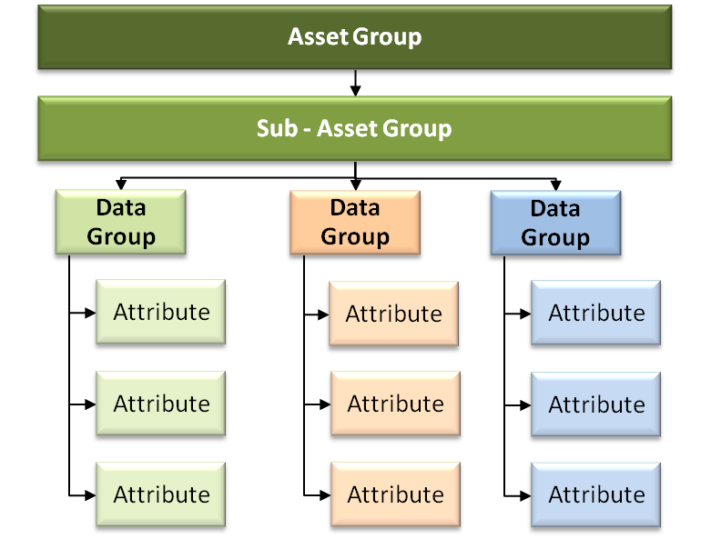 | Example  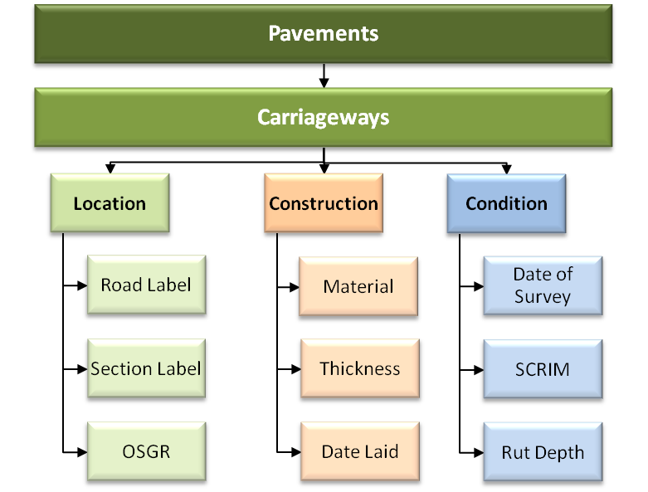
Figure 1 Asset Data Hierarchy Diagram
- Asset Data Uses
Asset Data are used in the following processes:
- Maintenance Operations
- Defect Reporting – recording and responding to asset defects
- Legislative Requirements – data management compliance
- Contract Management – data to support and evidence contractual obligations
- Maintenance Management
  - The processes, systems and information on the occurrence, effectiveness and costs of the various regimes of maintenance applied to the infrastructure assets
- Performance Monitoring
  - Internal process data metrics and external asset performance metrics, including: indicator specification, indicator hierarchy, data requirements, indicator reporting
- Modelling Inputs and Outputs
  - Asset inventory and condition data are used with pre-defined algorithms to model asset performance (deterioration). These models generate information (predictions) that are used to manage risk and optimise programmes through informed decisions
- Programme Development Inputs and Outputs
  - Asset condition and modelling data are used to justify and prioritise options and develop a forward programme of work
- Asset Valuation
  - Asset inventory and condition data are used to derive the value of the Agency’s assets
- Reporting
  - Asset data are used to inform reports produced by the Agency on a wide variety of subjects. Asset Data are also requested by members of the public and also elected members of political bodies from Parish Councils to Parliament
- Sharing
  - Asset data are shared with other government and non government organisations to aid them in their operations. The Agency and the Environment Agency have a memorandum of understanding that includes provision for the sharing of asset data
- The Asset Data Management Process
This manual details the sub processes, their outcomes, deliverables, roles and responsibilities in the ADM and how they relate to each of the functions in Section 3.
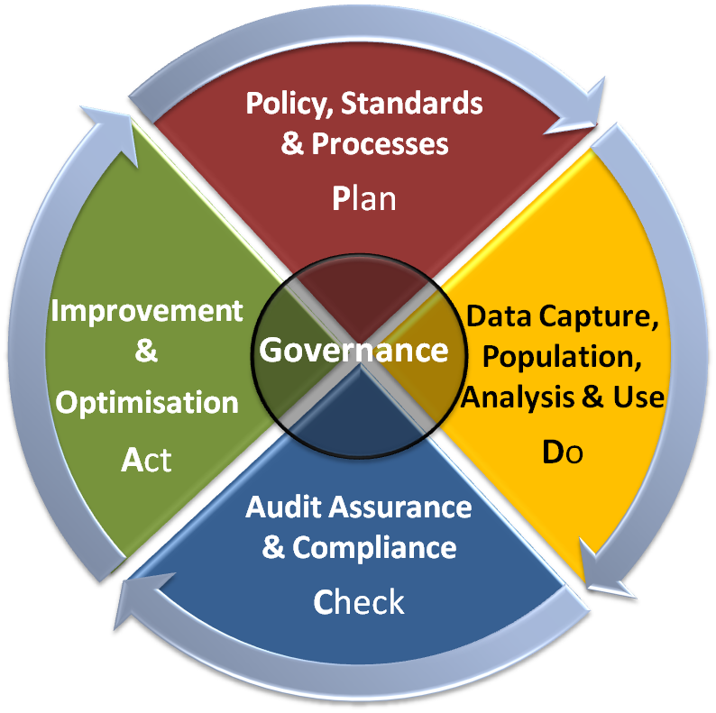  Figure 2 ADM Process | The ADM process is designed to provide the Employer and its supply chain, with a consistent set of asset data management outcomes that will deliver the Employer’s vision of asset data.  The ADM process is structured around five functions, Plan, Do, Check, Act and Governance. Each function feeds into the following function. Within each function there are a set of sub processes that define the outcomes and deliverables each function delivers to the overall ADM process.  The sub processes have been developed from the Employer’s previous standards and guidance with good data management practice. They represent the Employer’s definitive asset data management process.
As the process evolves quantitative goals for asset data quality and asset data management maturity will be established and the performance against them measured to ensure continuous improvement and optimisation of the process over time. These goals will be linked to the Employer’s organisational objectives to enable the process to optimise and adapt as these objectives evolve.
Within each sub process the roles and responsibilities required to deliver the outcomes and deliverables are defined. Where appropriate the sub process is mapped to illustrate how the roles interact. These processes do not replace the processes defined in the current Provider’s Quality Plan/contracts or the need for future contracts to develop processes as part of their Quality Plans.  Where the Provider is responsible for the delivery of a sub process outcome, it is expected that they will develop a more detailed process. This is to represent their organisational processes, in the delivery of the outcome, and the deliverables within the sub process. | 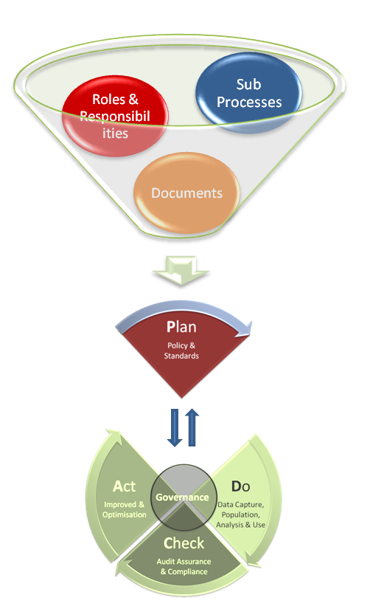  Figure 3 ADM Ingredients

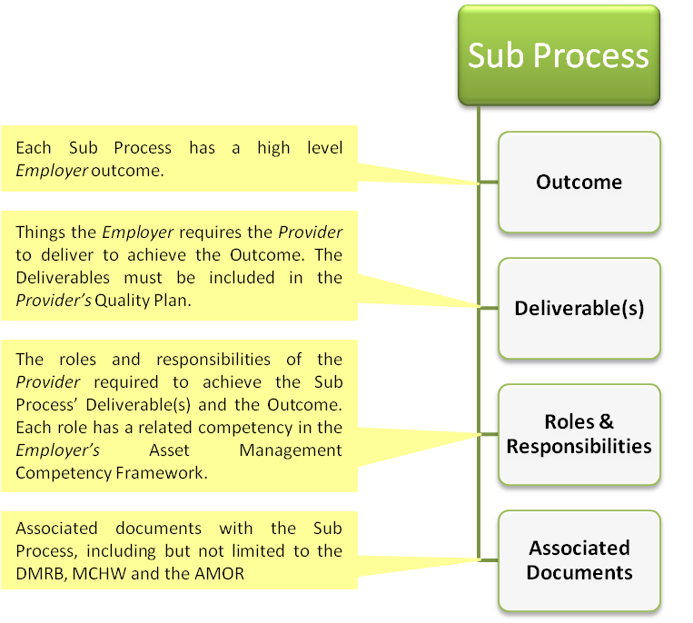
Figure 4 Sub Process Structure

- The Employer’s and Provider’s General Roles
  - The Employer’s Role Overview
The Employer’s responsibilities in the ADM process are to;
- Provide the following asset data systems, or other future systems that may provide broadly equivalent functionality, for the retention of and access to asset data to enable the Provider to fulfil their contractual duties to maintain the asset data in a complete, current and accurate state;
- Integrated Asset Management Information System (Routine and Planned
Maintenance)
  - Pavement Data Management System
  - Carriageway Inventory Data Management System
  - Structures Data Management System
  - Geotechnical Data Management System
  - Drainage Data Management System
- Provide the initial population of asset data available at the beginning of the contract through the above systems for the Provider to maintain, update and report on as per their contractual obligations
Appendix A Current Employer Asset Data Management Systems of the ADMM Provider Requirements (this document) sets out the Employer’s current asset data management systems.
  - Provider’s Role Overview
The full value of asset data to the Provider and the data owner (the Employer) can only be realised when data are substantially correct, current and complete.
The Provider is responsible for ensuring that the Employer’s asset data are up to date and accurate during the Contract Period (to the required quality as defined by their respective contract).
The Provider has a responsibility to report asset data in an accurate manner ensuring that there can be no misinterpretation caused by their analysis or reporting methods.
The Provider is responsible for maintaining data required for the operational management of the asset. Where the current systems defined in the contract (both Employer’s and Provider’s) do not provide a means through which to capture, retain or analyse an asset data type, the Provider must provide a medium through which to achieve this on behalf of the Employer. This means must be agreed by the Service Manager.
The Provider must comply with this document or obtain agreement to depart from it in accordance with the contract requirements set out in Service Information Annex 25.

Asset Data Governance
The Provider is responsible for ensuring that the Employer’s asset data are up to date and accurate. To assure that they are meeting this requirement the Provider will implement the following asset data governance roles. These roles are not mutually exclusive and one individual in the Provider’s organisation may carry out more than one role.
Provider Role – Quality Plan Core Process Executive Owner - Establish Network Needs
Required Competency Level – Strategic
In addition to the responsibilities set out in the contract, the Executive Owner of the Quality Plan Core Process “Establish Network Needs”, incorporating the Sub Process “Manage Asset Data”, will deliver the following responsibilities;
The Quality Plan Core Process Executive Owner will;
- Provide sponsorship of the ADM processes in the supply chain organisation
- Take strategic responsibility for the asset data quality in the supply chain organisation
- Appoint and assign the appropriate roles within their organisation to discharge their asset data responsibilities assuring high quality data (e.g. Asset Data Custodian)
- Ensure that the appropriate processes are in place in their organisation to deliver high quality data
- Communicate the processes and raise awareness of them throughout their organisation
- Act as the senior point of contact with the Service Manager in relation to asset data management
Provider Roles – Asset Data Custodians
The asset data custodians control quality and ensure custodial care of asset data in the Provider’s organisation.
Provider Role – Network Referencing Manager (NRM) and Deputy
Required Competency Level – Tactical
The Provider must designate a member of their staff, the NRM and a deputy. The Employer maintains a schedule of nominated NRMs and their deputies.
Any changes to the Provider’s NRM or deputy must be notified to the Service Manager within 10 working days. The new NRM and/or deputy must be fully apprised of the Approved Network maintenance procedures. The NRM and deputy must have attended the NRM course run by the Employer or other persons authorised by the Employer.
The NRM;
- Is responsible for the accuracy, completeness and timeliness of the updates to the Approved Network Model in their Contract.
- Is responsible for liaison with the Employer’s Network Auditor regarding section referencing when necessary.
- Will respond to requests for information from the Employer’s Network Auditor to ensure that the Approved Network Model is up to date and for data relating to the Network within 20 working days
Provider Role – Pavement Data Custodian
Required Competency Level – Tactical
This role is responsible for controlling the quality of pavement asset data in the Employer’s Pavement Data Management System.
The Pavement Data Custodian will;
- Ensure compliance with all data management specifications relevant to managing the pavement asset
- Act as focal point to receive any communications regarding development changes to Employer’s Pavement Data Management System and redistribute to all relevant personnel within the Provider’s organisation
- Act as focal point to receive any communications regarding changes to the specifications for data management related to pavement asset management data and redistribute to all relevant personnel within the Provider’s organisation
- Be first point of contact for providing access to the Employer’s Pavement Data Management System for the Provider’s Team
- Manage access rights to the Employer’s Pavement Data Management System for the Provider’s Team
Provider Role – Structures Data Custodian
Required Competency Level – Tactical
This role is responsible for controlling the quality of structures asset data in the Employer’s Structures Data Management System.
The Structures Data Custodian will;
- Ensure compliance with all data management specifications relevant to managing the structures asset
- Act as focal point to receive any communications regarding development changes to Employer’s Structures Data Management System and redistribute to all relevant personnel within the Provider’s organisation
- Act as focal point to receive any communications regarding changes to the specifications for data management related to structures asset management data and redistribute to all relevant personnel within the Provider’s organisation
- Be first point of contact for providing access to the Employer’s Structures Data Management System for the Provider’s Team
- Manage access rights to the Employer’s Structures Data Management System for the Provider’s Team
Provider Role – Provider Geotechnical Maintenance Liaison Engineer (GMLE)
Required Competency Level – Tactical
The Provider’s GMLE is appointed to be responsible for all geotechnical matters carried out by the Provider, including geotechnical asset data. The appointment of the Provider’s GMLE is defined in HD 41.
The GMLE will;
- Liaise with the Employer’s Geotechnical Advisor as required.
- Ensure compliance with all data management specifications relevant to managing the geotechnical asset
- Act as focal point to receive any communications regarding development changes to the Employer’s Geotechnical Data Management System and redistribute to all relevant personnel within the Provider’s organisation
- Act as focal point to receive any communications regarding changes to the specifications for data management related to geotechnical asset management data and redistribute to all relevant personnel within the Provider’s organisation
- Be first point of contact for providing access to the Employer’s Geotechnical Data Management System for the Provider’s Team
- Manage access rights to the Employer’s Geotechnical Data Management System for the Provider’s Team
Provider Role – Drainage Liaison Engineer (DLE)
Required Competency Level – Tactical
The Provider’s DLE is appointed to be responsible for all drainage surveys, maintenance and renewals. The appointment of the DLE is defined in the AMOR document.
The DLE will;
- Ensure compliance with all data management specifications relevant to managing the drainage asset
- Act as focal point to receive any communications regarding development changes to the Employer’s Drainage Data Management System and redistribute to all relevant personnel within the Provider’s organisation
- Act as focal point to receive any communications regarding changes to the specifications for data management related to drainage asset management data and redistribute to all relevant personnel within the Provider’s organisation
- Be first point of contact for providing access to the Employer’s Drainage Data Management System for the Provider’s Team
- Manage access rights to the Employer’s Drainage Data Management System for the Provider’s Team.
Provider Role – Flooding Champion
Required Competency Level – Tactical
This role is responsible for the integration and coordination of flood risk management within their contract. This role may be carried out by the DLE as defined in AMOR document.
The Flooding Champion will;
- Ensure compliance with all data management specifications relevant to managing the flood hotspots
- Act as focal point to receive any communications regarding development changes to the Employer’s Drainage Data Management System in relation to flooding data and redistribute to all relevant personnel within the Provider’s organisation
- Act as focal point to receive any communications regarding changes to the specifications for data management related to flooding data and redistribute to all relevant personnel within the Provider’s organisation
Provider Role – ICT Account Liaison Officer (ALO)
Required Competency Level – Tactical
The Provider’s ALO is responsible for protecting the integrity of the asset data held in the Employer’s Information Systems by ensuring that only authorised users have access to the systems. This role is fully documented within the contract but must be understood as a data governance role as well.
The ALO will;
- Ensure that all users of the Employer’s system(s) comply with the requirements set out in the documents comprising the Application for External Access (available from the Service Manager)
- Liaise directly with ICT with responsibility for managing Provider user accounts and any issues arising as a result thereof
- Arrange access via ICT to Provider staff required to use Employer information systems
- Liaise with the GMLE and DLE to ensure that there is an accurate single record of which Provider Staff have access to which Employer information systems
Provider Role – Carriageway Inventory Data Custodian
Required Competency Level – Tactical
This role is responsible for controlling the quality of carriageway inventory asset data in the Employer’s Carriageway Inventory Data System and the Provider’s system(s) for capturing and storing Carriageway Inventory data not held by the Employer.
The Carriageway Inventory Data Custodian will;
- Ensure compliance with all data management specifications relevant to managing the Carriageway Inventory
- Act as focal point to receive any communications regarding development changes to Employer’s Carriageway Inventory Data System and the Provider’s system(s) for capturing and storing data not held by the Employer, and redistribute to all relevant personnel within the Provider’s organisation
- Act as focal point to receive any communications regarding changes to the specifications for data management related to the Carriageway Inventory asset management data and redistribute to all relevant personnel within the Provider’s organisation
- Be first point of contact for providing access to the Employer’s Carriageway Inventory Data System and the Provider’s system(s) for capturing and storing Carriageway Inventory data not held by the Employer for the Provider’s Team
- Manage access rights to the Employer’s Carriageway Inventory Data System and the Provider’s system(s) for capturing and storing Carriageway Inventory data not held by the Employer for the Provider’s Team

Asset Data Management Policy and Standards
The Asset Data Management Policy and Standards Function sets out the obligations of the Provider concerning the continual improvement and development of the processes in place for managing asset data within the ASC.
        - Quality Plan Manage Asset Data Process(s)
The Provider will set out how they will manage asset data as part of their Quality Plan (in accordance with the requirements of the contract).
        - Development of Improved Asset Data Management Methodologies
The Provider continually seeks to improve the delivery of asset data management (including but not limited to data capture and analysis) in line with the overarching requirements. Any changes to delivery of asset data management as required by these standards will require an agreement to depart from them in accordance with Annex 25 of the contract.

Asset Data Capture, Population, Analysis and Use
The Asset Data Capture, Population, Analysis and Use Function details the ADM Sub Processes the Provider must deliver to ensure complete, current and accurate asset data.
This function sets out the obligations of the Provider with reference to the following tasks;
- supplying the Employer or third parties with relevant asset data when required
- maintaining an approved Network Model
- capturing and storing asset data, not already held within the Employer’s or Provider’s current data management systems, in an appropriate manner and
- updating the relevant primary asset data systems following any works/schemes, inspections or surveys
        - Asset Data Requests from the Employer

Scope
All asset data held by the Provider for and on behalf of the Employer.

Outcome
The Employer has access to asset data held by the Provider in a timely and consistent manner.

Deliverable
The Provider will respond to all requests for asset data held by them within 10 working days.

Deliverable
The Provider will provide the asset data in the format agreed by the Service Manager.

Roles and Responsibilities
Provider Role
Required Competency Level – Operational
The Provider will;
- Ensure the requested data are complete
- Ensure the requested data are current
- Ensure the requested data are accurate
- Provide any required context to ensure the data are understood by the Employer

Associated Documents
ADMM Provider Requirements
Relevant Standards (including but not limited to the AMOR and DMRB)

Changes to the Approved Network Model
The Employer requires an accurate Approved Network Model to fit asset data to. The Approved Network Model is maintained in the Employer’s current Pavement Management System as defined in the contract and Appendix B: The Employer’s Current Approved Network Model Procedures.
The Approved Network Model is a master data set that is used by other systems as well as Employer’s current Pavement Management System where the data are mastered, it is therefore critical to the Employer that it is accurate and up to date.

Scope
Changes to the Approved Network Model as a result of;
- All schemes (including major improvement schemes)
- Trunking of existing Local Authority Roads
- Detrunking of Employer Roads
- At the request of the Employer or other persons authorised by the Employer
- Incorrect data (deficiency)

Outcome
This Employer has a complete, current and correct Approved Network Model that can be used as a master data set.

Deliverable
Timeliness – Changes associated with schemes
This includes all schemes without exception.
The Provider must make any changes to the Approved Network Model by the date that the relevant section is adopted/trunked by the Employer.

Deliverable
Timeliness – Changes not associated with schemes
This includes but is not limited to any defects in the Approved Network and Section Referencing data identified at any time during the Contract Period and any requests for changes to the Approved Network Model from the Employer or an organisation authorised by the Employer.
The Provider must amend the Approved Network Model within 20 working days of identifying and validating the required change.

Deliverable
The Provider will ensure all changes to the Approved Network Model are complete and accurate.
Instruction on how to complete this deliverable can be found in Appendix B: The Employer’s Current Approved Network Procedures.

Roles and Responsibilities
Provider Role – Network Referencing Manager (NRM) and Deputy
The Provider’s NRM may delegate this duty but the responsibility for accurate and timely data as defined in the Governance Section of this document remains with the NRM.
Required Competency Level - Tactical
The Provider is responsible for;
- The accuracy, completeness and timeliness of the Approved Network Model in their contract
- Ensuring changes to the Approved Network are carried out in accordance with the procedures set out in Appendix B: Approved Network Procedures
- Liaising with the Employer’s Network Auditor regarding changes to the Approved Network Model

Associated Documents

- The ADMM Appendix B: The Employer’s Current Approved Network Procedures (this document)
- HAPMS Documentation Index - http://10.222.254.2/hapms (available through Highways Agency Extranet)

Asset Data Update Post Works
After completing any works or survey activity the Provider is required to update the relevant primary asset data systems with changes to inventory, construction and condition data in a complete, accurate and timely manner.

Scope
All schemes and surveys carried out as part of the ASC contract.
Inventory, excluding location/network referencing (please see Appendix B: The Employer’s Current Approved Network Model Procedures), construction and condition data.
Where alternative options for the capturing and storing asset data and information records are required see ADM Sub Process 3.9 Capture and Storage of Data outside Employer Asset Data Systems

Outcome
The Employer has complete, current and accurate asset data in the relevant primary asset data systems on completion of The Provider’s schemes or surveys in timely manner.

Deliverable
Schemes/Surveys (excluding Structures Major Modification Schemes)
The Provider will update the relevant primary asset data system, as detailed by this document in Appendix A with the new As-Built/survey asset data within two months of completion of the scheme/survey on site as defined in Service Information of the contract.

Deliverable
Timeliness – Major Modification Structures Schemes
The Provider will update the Employer’s Structures Data Management System with the new inventory data at least one month prior to the Pre Opening Inspection (POI) as defined in the Design Manual for Roads and Bridges Volume 3 BD 62.

Deliverable
Timeliness – Carriageway Inventory All Schemes (including works to correct defects)
On receipt of the asset data records from the Scheme Contractor the Provider will update the relevant primary asset data systems as defined in this document in Appendix A with the new As-Built/Installed Carriageway Inventory asset data within two months of completion of the scheme/survey on site as defined in the contract.

Deliverable
Completeness
The Provider will ensure all data changed by the scheme or survey are updated in the relevant primary asset data system in their entirety.

Deliverable
Accuracy
The Provider will ensure the data changed by the scheme or survey are updated accurately into the relevant primary asset data system.

Roles and Responsibilities
Provider Role – Data Capture and Upload
Required Competency Level – Tactical
The Provider is responsible for ensuring that the data input are;
- integral from point of capture to point of load into the relevant primary asset data system
- compliant with the relevant standards
- available in the relevant asset data system in a timely manner

Associated Documents
Below are the documents that provide the specific guidance on the update of the relevant asset data system.
- ADMM Provider Requirements (this document)
- Appendix A sets out the Employer’s current asset data systems
- Appendix E defines the Provider requirement to maintain asset data in the Primary Asset Data systems and also the Carriageway Inventory data in the Central Inventory Module of the Employer’s Pavement Data Management System
- BD 62 and 63 – Structures
- HD 41 – Geotechnical
- DMRB Vol 7 - Pavements
- HD 43, SD 15 and the Draft IAN HADDMS Data Population - Drainage
- TD 23 – Lighting
- ADMM Provider Requirements (this document)
- Appendix E Table 02 – Required (Mandatory) Inventory Records
- Appendix E Table 03 – Recommended (Desirable) Inventory Records
- TD 25 – Traffic Sign
- TD 26 – Road Markings and Road Studs
- TD 24 – Traffic Signals
- BD 53 - Tunnels
- HAPMS Documentation Index - http://10.222.254.2/hapms (available through Highways Agency Extranet)
- Relevant Asset System User Guides – All

Asset Data Update Post Assessment/Survey
The Provider is required to undertake surveys on the Network during the Contract Period to ascertain the condition of the asset for schemes or general condition monitoring.

Scope
All surveys instructed by the Provider or Service Manager during the Contract Period including but not limited to;

- All surveys identified under the Provider’s Maintenance Requirements Plan (MRP)
- Drainage condition surveys
  - CCTV
  - Connectivity Surveys
  - Priority Drainage Asset Validation Surveys
- Pavement Visual Surveys
- Pavement Condition Surveys
  - Ground Penetrating Radar (GPR)
  - Deflectograph
  - Falling Weight Deflectometer (FWD)
  - Retro-reflectivity
- Pavement Asset Data Collection Surveys
  - Geophysical and Ground Investigation Surveys, Boring Tests, Trial Pits, Test Piles
- Bridge Assessment Surveys
- Topographical Surveys (including aerial surveys)
- Land Ownership Surveys
- Lighting and Electricity Surveys

All Provider Assessments/Surveys must comply with the data requirements defined in the relevant survey standards.

Outcome
All Provider and Service Managerinstructed survey data are available, in the relevant Employer’s or Provider’s asset data system as defined in the contract, in a complete, accurate and timely manner.

Deliverable
The Provider will ensure survey data are provided in the correct format as defined by the relevant standards.

Deliverable
Timeliness
All Provider commissioned survey data will be loaded by the Provider into the relevant asset data system within two months of completion on site of the survey.

Roles and Responsibilities
Provider Role – Data Capture and Upload
Required Competency Level – Tactical
The Provider is responsible for ensuring that the data input are;
- integral from point of capture to point of load into the relevant primary asset data system
- compliant with the relevant standards
- available in the relevant asset data system in a timely manner

Associated Documents
Below are the documents that provide the specific guidance on the update of the relevant asset data system.
- ADMM Provider Requirements (this document)
- Appendix A sets out the Employer’s current asset data systems
- Appendix E defines the Provider requirement to maintain asset data in the Primary Asset Data systems and also the Carriageway Inventory data in the Central Inventory Module of the Employer’s Pavement Data Management System
- Appendix F sets out the Defect Codes
- Appendix C ADMM Provider Requirements (this document) - Pavement Surveys
- HD 28 - Pavement Maintenance Assessment (Skidding Resistance)
- HD 29 - Data for Pavement Assessment.
- HD 30 - Maintenance Assessment Procedure
- HAPMS Documentation Index - http://10.222.254.2/hapms (available through Highways Agency Extranet)
- HD 43, SD 15, the Draft IAN HADDMS Data Population - Drainage Surveys
- DMRB Volume 3 Section 3 - Structures Assessments/Surveys
- HD 41 - Geotechnical Assessments/Surveys

Asset Data Post Works Population/Update (Other Schemes)
The Employer may instruct or allow others to carry out schemes on the Network managed by the Provider. In these circumstances the Provider is required to ensure that the asset data are available in the relevant asset data system in a complete, current, accurate and timely manner.

Scope
This includes but is not limited to;
- Major Project Schemes
- Managed Motorway Schemes
- Technology Schemes

Outcome
The Employer has complete, current and accurate asset data in the relevant primary asset data systems on completion of schemes in timely manner.

Deliverable
Timeliness – Schemes (excluding Structures Major Modification Schemes)
On receipt of the asset data records from the Scheme Contractor the Provider will update the relevant primary asset data system, as defined by this document in Appendix A with the new As-Built asset data within one month of receipt.

Deliverable
Major Modification Structures Schemes
On receipt of the Inventory Data the Provider will upload the structures inventory data as defined in the Design Manual for Roads and Bridges Volume 3 BD 62 and BD 63 into the Employer’s Structures Data Management System at least one month prior to the Pre Opening Inspection (POI).

Deliverable
Timeliness – Carriageway Inventory All Schemes (including works to correct defects)
On receipt of the asset data records from the Scheme Contractor the Provider will update the relevant primary asset data systems as defined in this document in Appendix A with the new As-Built/Installed Carriageway Inventory asset data within one month of receipt.

Deliverable
Completeness
The Provider will ensure all asset data changed by the scheme or survey are updated in the relevant primary asset data system in their entirety.

Deliverable
Accuracy
The Provider will ensure the asset data changed by the scheme or survey are updated accurately into the relevant primary asset data system.

Roles and Responsibilities
Provider Role - Asset Data Input
Required Competency Level - Tactical
The Provider is responsible for being aware of any changes to the network and facilitating the update of asset data into the relevant asset data system.
Agree with the Service Manager the format for the Scheme Contractor to provide the data in.
Ensure the data provided and input are;
- complete and correct
- compliant with the relevant standards
- available in the relevant asset data system in a timely manner
To note:
Where the Scheme Contractor has access to the relevant asset data system(s) and the availability of authorised staff to make the updates it is possible to utilise them to load the preliminary data.
On completion of the data load the Provider will carry out a check of the data loaded and once satisfied with the quality sign off the data as complete and correct.
This must be carried out in order to deliver the outcome and deliverables defined in this sub process.

Associated Documents
Below are the documents that provide the specific guidance on the update of the relevant asset data system.
- ADMM Provider Requirements (this document)
- Appendix A sets out the Employer’s current asset data systems
- Appendix E defines the Provider requirement to maintain asset data in the Primary Asset Data systems and also the Carriageway Inventory data in the Central Inventory Module of the Employer’s Pavement Data Management System
- BD 62 and 63 – Structures
- HD 41 - Geotechnical
- HD 43 and 45 - Drainage
- TD 23 – Lighting
- TD 25 – Traffic Sign
- TD 26 – Road Markings and Road Studs
- TD 24 – Traffic Signals
- BD 53 - Tunnels
- HAPMS Documentation Index - http://10.222.254.2/hapms (available through Highways Agency Extranet)
- Relevant Asset System User Guides – All

System Update after Inspection
The Provider is required to undertake inspections as defined in the AMOR document and record the data captured as part of the inspection.

Scope
All Provider Asset Inspections defined in the AMOR and MRP.
The Provider will record inspection and defect data in the Provider’s Routine and Planned Maintenance System as defined in Annex 6 of the contract and Appendix A.2.1 of this document.

Outcome
The Employer is able to access or be supplied in timely manner by the Provider, complete, current and accurate asset inspection data from the relevant primary asset data systems (see Appendix A: Current Asset Data Management Systems on completion of the Provider’s inspections.

Deliverable
Timeliness
Paved Areas and Carriageway Inventory Inspections
The Provider must complete all Paved Areas and Carriageway Inventory Inspections in the Provider’s Routine and Planned Maintenance System within one month of the inspection taking place.
Structures
The Provider must complete and “authorise” Inspections in the Employer’s Structures Data Management System within three months of the inspection taking place.
Drainage
The Provider must complete Inspections in the Employer’s Drainage Data Management System within one month of the inspection taking place.
Geotechnical
The Provider must approve all inspection data in the Employer’s Geotechnical Data Management System, within 3 months of the completion of the inspections programmed for any given inspection season.

Deliverable
Paved Areas and Carriageway Inventory Inspections
The Provider will capture and hold as a minimum the following records after a Paved Areas and Carriageway Inventory Inspections;
- Details of relevant inspections (including but not limited to defects)
- Details of actions taken in respect of the performance including response to incidents, winter service provided and temporary protective measures and repairs

Deliverable
Paved Areas and Carriageway Inventory Inspections Data
The Provider must load all Paved Areas and Carriageway Inventory Inspections in the Provider’s Routine and Planned Maintenance System and ensure that the Carriageway Inventory data held by the Employer’s Pavement Management System’s Central Inventory Module are up to date and accurate.
Some Carriageway Inventory items cannot be held in the current Employer asset data systems and therefore the Provider is required to provide alternative data storage options for as long as needed through the Contract Period.
Where alternative options for the storage of asset data and information records are required see ADM Sub Process 3.9 Capture and Storage of Data outside Employer Asset Data Systems.

Deliverable
Completeness
The Provider will ensure all data captured through their inspection regimes as defined in the AMOR and MRP documents are updated in the relevant asset system in their entirety.

Deliverable
Accuracy
The Provider will ensure the data captured through their inspection regimes as defined in the AMOR and MRP documents are updated accurately into the relevant asset data system.

Roles and Responsibilities
Provider Role – Paved Areas and Carriageway Inventory Inspection Data Input
Required Competency Level - Operational
The Provider will ensure that the inspection data input are;
- integral from point of capture to point of load into the relevant primary asset data system
- complete
- correct
- accurate
- compliant with the relevant standards
- available in the relevant asset data system in a timely manner
- referenced using the Carriageway Inventory and Defect Codes in Appendices E and F
Provider Role – Structures Inspection Data Input
Required Competency Level - Operational
The Provider will ensure that the inspection data input are;
- integral from point of capture to point of load into the relevant primary asset data system
- compliant with the relevant standards
- available in the relevant asset data system in a timely manner
Provider Role – Structures Inspection Data Authorisation
Required Competency Level - Tactical
The Provider will ensure that the inspection data input are;
- complete
- correct
- accurate
- compliant with the relevant standards
- available in the relevant asset data system in a timely manner
Provider Role – Geotechnical Inspection Data Input
Required Competency Level - Operational
The Provider will ensure that the inspection data input are;
- integral from point of capture to point of load into the relevant primary asset data system
- compliant with the relevant standards
- available in the relevant asset data system in a timely manner
Provider Role – Geotechnical Inspection Data Authorisation
Required Competency Level - Tactical
The Provider will ensure that the inspection data input are;
- complete
- correct
- accurate
- compliant with the relevant standards
- available in the relevant asset data system in a timely manner
Provider Role – Drainage Inspection Data Input
Required Competency Level - Tactical
The Provider will ensure that the inspection data input are;
- integral from point of capture to point of load into the relevant primary asset data system
- complete
- correct
- accurate
- compliant with the relevant standards
- available in the relevant asset data system in a timely manner

Associated Documents
Below are the documents that provide the specific guidance on the update of the relevant asset data system.
- ADMM Provider Requirements (this document)
- Appendix A sets out the Employer’s current asset data systems
- Appendix E defines the Provider requirement to maintain asset data in the Primary Asset Data systems and also the Carriageway Inventory data in the Central Inventory Module of the Employer’s Pavement Data Management System
- Appendix F sets out the Defect Codes
- BD 62 and 63 – Structures
- HD 41 - Geotechnical
- HD 43, 45 and the Draft IAN HADDMS Data Population - Drainage
- TD 23 – Lighting
- TD 25 – Traffic Sign
- TD 26 – Road Markings and Road Studs
- TD 24 – Traffic Signals
- BD 53 - Tunnels
- Relevant Asset System User Guides – All
- HAPMS Documentation Index - http://10.222.254.2/hapms (available through Highways Agency Extranet)

Recording of Flood Events on the Employer’s Drainage Data Management System
The Provider has a requirement to record all reported flood events on their network.

Scope
All reported flood events as defined in the AMOR document.

Outcome
All reported flood events are recorded in the Flood Register on the Employer’s Drainage Data Management System in a timely, complete and accurate manner.

Deliverable
The Provider must record as minimum the following details of all “Ongoing” flood events in the Flood Register within 24 hours of notification;
- Ordnance Survey Grid Reference Coordinates (OSGR)
- Date
- Time

Deliverable
The Provider must enter full details of a flood event and set the status to “Closed” within 28 days.

Roles and Responsibilities
Provider Role – Flood Champion
Required Competency Level – Tactical
The Provider will ensure that flood event data input are;
- complete
- correct
- accurate
- compliant with the relevant standards
- available in the relevant asset data system in a timely manner

Associated Documents
Below are the documents that provide the specific guidance on the update of the relevant asset data system.
- ADMM Provider Requirements (this document)
- AMOR Document

Asset Data Requests
Asset data are used by a number of different individuals and organisation internal and external to the Employer. Data are owned by the Employer and only the Employer can authorise their distribution externally.
Care should be given to distributing asset data as without proper context it can be easily misinterpreted causing reputational damage to the Employer and the Provider.

Outcome
Access to the Employer’s asset data is only provided to authorised persons for approved purposes and with appropriate context to prevent unintentional misinterpretation.

Deliverable
The Provider will record and pass all third party requests received directly onto the Employer’s Service Manager within one working day. The Provider will not release asset data without the prior approval of the Service Manager.

Roles and Responsibilities
Provider Role
Required Competency Level – Operational
The Provider will ensure that all third party asset data requests are;
- accurately recorded
- passed to the Service Manager within one working day

Associated Documents
Not used.

Capture and Storage of Data outside Employer Asset Data Systems
Where asset data are captured by the Provider for and on behalf of the Employer, and are maintained outside the Employer’s asset data systems or the Provider’s asset data systems as defined in the contract, permanently or for a period of time prior to upload, appropriate steps must be taken by the Provider to ensure data usability, reliability, authenticity and preservation.
Details of the proposed solution should be submitted for approval to the Employer’s Service Manager, as defined in Annex 25 of the contract.

Scope
This sub process covers all asset data not held in systems defined in Annex 6 of the Provider’s contract.

Outcome
All Employer’s’ asset data are held in a consistent format and are integral, usable, reliable and accurate.

Deliverable
The Provider will submit a proposal to the Service Manager to agree the appropriate format(s) that the asset data will be captured and stored in as defined in Annex 25 of the contract.

Deliverable
The Provider will document the format and any changes or fixes made to how the asset data are stored and make this available to the Employer on request.

Deliverable
The Provider will ensure that they are able to produce updates and reports to the Employer in an agreed format on request.

Roles and Responsibilities
Provider Role
Required Competency Level – Tactical/Strategic
- To ensure all data are stored on media that maintain their usability, reliability, authenticity and preservation for the Contract Period
- To design and implement storage conditions and handling processes that protect data from unauthorised access, loss or destruction, and from theft and disaster
- To ensure data systems are designed so that data remain accessible, authentic, reliable and useable through any kind of system change, for the entire period of their retention. This may include migration to different software, re-presentation in emulation formats or any other future ways of re-presenting data. Where such changes occur, evidence should be kept, along with details of any variation in design and format
- To provide the agreed data files or update to the relevant asset system when requested by the Service Manager

Associated Documents
Below are the documents that provide the specific guidance on the update of the relevant asset data system.
- ADMM Provider Requirements (this document)
- Appendix A sets out the Employer’s current asset data systems
- Appendix E defines the Provider requirement to maintain asset data in the Primary Asset Data systems and also the Carriageway Inventory data in the Central Inventory Module of the Employer’s Pavement Data Management System
- Appendix F sets out the Defect Codes
- BD 62 and 63 – Structures
- HD 41 - Geotechnical
- HD 43, 45 and the Draft IAN HADDMS Data Population - Drainage
- TD 23 – Lighting
- TD 25 – Traffic Sign
- TD 26 – Road Markings and Road Studs
- TD 24 – Traffic Signals
- BD 53 - Tunnels
- Relevant Asset System User Guides – All
- HAPMS Documentation Index - http://10.222.254.2/hapms (available through Highways Agency Extranet)

Updating and submitting lighting data for billing purposes
The Employer requires accurate and timely lighting inventory data to ensure they have the correct energy consumption data for billing purposes.

Scope
Asset data and energy consumption data as required by BSCP520 and defined in Table 4 of Appendix E.3.

Outcome
The Employer has complete, current and correct lighting inventory and energy consumption data for billing purposes.

Deliverable
Timeliness
The Provider must submit an updated lighting inventory file as defined in Appendix E.3 and complying with the BSCP520 monthly.

Deliverable
The Provider will ensure all lighting asset data and energy consumption data as required by BSCP520 and defined in Table 4 of Appendix E.3 and submitted to the Employer are complete and accurate.

Roles and Responsibilities
Provider Role
Required Competency Level - Tactical
The Provider is responsible for;
- Submitting to the Employer the lighting inventory and energy consumption data as required in BSCP520 and defined in Appendix E.3 in a complete, accurate and timely of manner
- To ensure all data are stored on media that maintain their usability, reliability, authenticity and preservation for the Contract Period
- To design and implement storage conditions and handling processes that protect data from unauthorised access, loss or destruction, and from theft and disaster
- To ensure data systems are designed so that data remain accessible, authentic, reliable and useable through any kind of system change, for the entire period of their retention. This may include migration to different software, re-presentation in emulation formats or any other future ways of re-presenting data. Where such changes occur, evidence should be kept, along with details of any variation in design and format.

Associated Documents
- AMOR Document
- BSCP520
- ADMM Provider Requirements (this document)
  - Appendix E.3 sets out the fields to be provided to the Employer

Asset Data Audit, Assurance and Compliance
The Asset Data Audit, Assurance and Compliance function provides check points for the Employer and Provider to review and ensure the accuracy of Asset Data and efficiency of the Asset Data Management process.
        - Audit
The Provider is required under the contract to submit to regular audit of their Quality Management Plan, this will include the audit of the Sub Process Manage Asset Data as defined in Annex 24.
        - Annual Asset Data Review
The Provider is responsible for maintaining the asset data in a complete, current and accurate manner. To demonstrate that they are complying with this requirement the Provider will regularly review the asset data for completeness, currency and accuracy and identify any deficiencies for correction in ADM Sub Process 5.1.

Scope
All asset data the Provider is responsible for managing as defined in the contract that are held in the Employer’s and Provider’s asset data systems as defined in the contract and developed as part of ADM Sub Process 3.9.
This does not include any asset data deficiencies identified in the Asset Data Gap Analysis report at the start of the contract as defined in Annex 25.

Deliverable
The Provider will undertake a review of the asset data held in the Employer’s and Provider’s asset data systems for completeness, currency and correctness 12 months after the access date and every 12 months after that until the end of the Contract Period.

Deliverable
The Provider will record all deficiencies found through the review.
Deficiencies identified that occurred prior to the contract but were not identified by the Provider at the beginning of the contract will notify the Employer’s Service Manager within 5 working days of identification.

Roles and Responsibilities
Provider Role
Required Competency Level - Tactical
The Provider’s responsibilities are;
- To review all asset data every 12 months starting from access date.
- To raise deficiencies to the Service Manager within the defined timescales

Associated Documents
Below are the documents that provide the specific guidance on the data to be reviewed.
- ADMM Provider Requirements (this document)
- Appendix A sets out the Employer’s current asset data systems
- Appendix E defines the Provider requirement to maintain asset data in the Primary Asset Data systems and also the Carriageway Inventory data in the Central Inventory Module of the Employer’s Pavement Data Management System
- Appendix F sets out the Defect Codes
- BD 62 and 63 – Structures
- HD 41 - Geotechnical
- HD 43, 45 and the Draft IAN HADDMS Data Population - Drainage
- TD 23 – Lighting
- TD 25 – Traffic Sign
- TD 26 – Road Markings and Road Studs
- TD 24 – Traffic Signals
- BD 53 - Tunnels
- Relevant Asset System User Guides – All
- HAPMS Documentation Index - http://10.222.254.2/hapms (available through Highways Agency Extranet)

Asset Data Management Improvement and Optimisation
The Asset Data Management Improvement and Optimisation Function is structured to ensure that asset data held by the Employer and the Provider is correct and that processes are in place to regularly monitor and improve asset data and asset data management.
        - Correction of Asset Data Deficiencies
The Provider has a requirement to maintain the Employer’s asset data in a complete, current and correct manner throughout the Contract Period. To ensure they are able to comply with this they must undertake a yearly review. Any deficiencies identified through the annual review, excluding those identified at the beginning of the Contract Period as defined in Annex 25, must then be corrected by the Provider.

Scope
All asset data that the Provider is responsible for maintaining throughout their Contract Period in the Employer’s or Provider’s asset data systems or in a format as agreed through ADM Sub Process 3.9. This excludes deficiencies identified at the beginning of the Contract Period as defined in Annex 25 of the contract.

Deliverable
The Provider will correct all contractual non conformity deficiencies in asset data completeness, currency and/or accuracy identified in Sub Process 3.1 and as specified in the contract within 20 working days of identification, or the issuing of a corrective action plan if needed by the contract, which ever is the later.

Deliverable
ADM Sub Process 4.2 requires the Provider to identify all deficiencies in asset data completeness, currency and accuracy. Where the deficiency occurred prior to the current contract access date and was not identified at the beginning of the contract as required in Annex 25 of the contract, the Provider will notify the Service Manager within three working days.
When directed by the Service Manager the Provider corrects the deficiencies in asset data within 20 working days.

Roles and Responsibilities
Provider Role
Required Competency Level – Operational/Tactical
The Provider is responsible for;
- Ensuring all corrections of asset data deficiencies are updated in a timely manner
- All corrections are complete, current and accurate

Continuous Improvement
The Provider continually seeks to improve the delivery of asset data management (including but not limited to data capture and analysis) in line with the overarching requirements.
Improvements may be identified by sub processes in the Asset Data Audit and Performance Measurement.
Any changes to delivery of asset data management as required by these standards will require an agreement to depart from them in accordance with Annex 25 of the contract.
- Asset Data Management Systems
  - Current Employer Asset Data Management Systems
    - IAM IS Routine and Planned Maintenance
Senior Responsible Owner (SRO): NDD Central
Asset Sponsor: Asset Management Office, NDD Central
Support: IAM IS Support Team
Contact ICTService+ on 0845 3710 717 or ictservice+@highways.gsi.gov.uk
Associated Documents:
ADMM Provider Requirements (this document)
AMOR
IAM IS Technical Operations Guide
Annex 6, Annex 24 and Annex 25 of the Asset Support Contract
Scope of Data: Under the Employer’s Integrated Asset Management Initiative a Routine and Planned Maintenance System will be provided by the Employer as part of the IAM IS. The Provider will use this IAM IS Routine and Planned Maintenance System as the system to directly undertake the following:
- Schedule and record routine and planned maintenance on the network.
- Record the outcomes of inspections, including but not limited to defects.
- Record the completion of routine works, including but not limited to dates and Defined Cost and direct fee and subcontract fee of the routine works completed.
- Record and track all network customer enquiries.
- To maintain a record of all asset data in an accurate and timely manner as per requirements set out in Annex 6, Annex 24 and Annex 25 of the Asset Support Contract and the ADMM Provider requirements.

Provider Obligations and Responsibilities
The IAM IS Routine and Planned Maintenance System will provide sufficient functionality to meet the above Provider’s obligations under the ADMM Provider requirements Annex 6, Annex 24 and Annex 25 of the Asset Support Contract.
The Provider particularly needs to note tables 6.3 and 6.4 of Annex 6 explaining which systems will be used during the life of the contract to manage asset data, and section 25.4.3 of Annex 25 explaining obligations relating to the maintenance of asset data. 25.4.3(7) sets out the obligation to use IAM IS directly to undertake routine and planned maintenance activities.

    - Pavement Data Management System (HAPMS)
Senior Responsible Owner (SRO): NDD Central
Asset Sponsor: NetServ
Support: HAPMS Support Team (HAST)
Contact ICTService+ on 0845 3710 717 or ictservice+@highways.gsi.gov.uk
Associated Documents:
HAPMS Documentation Index - http://10.222.254.2/hapms (available through Highways Agency Extranet)
DRMB Vol 7, Section 3, HD 28, Pavement Maintenance Assessment.
DRMB Vol 7, Section 3, HD 29, Data for Pavement Assessment.
DRMB Vol 7, Section 3, HD 30, Maintenance Assessment Procedure.
Various Standards for Carriageway Inventory Data as referenced in the ADM Sub Processes in this document.
Scope of Data: To provide core data on the pavement asset in support of corporate governance and to provide a pavement management tool for agents. To provide information for forwarding to the public on planned road works and incidents.
Facilities within the HAPMS software are provided to update and maintain the following information:
- Construction: HAPMS contains the definitive record of the physical construction of the carriageway asset. It is the responsibility of the Provider to ensure that layer and material information, including date of construction, are complete and are updated following completion of maintenance or improvement schemes.
- SCRIM IL: HAPMS contains the definitive record of SCRIM Investigatory Levels for the trunk road network. It is the responsibility of the Provider to ensure that all IL’s reflect the correct application of the Employer’s current policy.
- Speed Limits: HAPMS contains the definitive record of speed limits on the trunk road network. It is the responsibility of the Provider to ensure that the speed limit data is updated following the completion of maintenance or improvement schemes.
- Carriageway Inventory: HAPMS contains the definitive record of carriageway related inventory (as defined in Appendix E: Carriageway Inventory Data) for the trunk road network. It is the responsibility of the Provider to ensure that the records contained within this central repository are updated following the completion of maintenance or improvement schemes.
- Lane Geometry: HAPMS contains records of lane geometry, including widths, within the XSP Detail section attribute. Providers are required to maintain the information within this attribute including ensuring that lane geometry information is updated following the completion of maintenance and improvement schemes.

Carriageway Construction
HAPMS contains the record of pavement construction for the Approved Network. The pavement record is stored against each half lane width (wheeltrack) and is to be updated from as-built records following all new construction / maintenance actions.

SCRIM Investigation Levels (IL)
The SCRIM investigation levels are set in accordance with HA policy as defined in HD 28.

Speed Limits
The legal speed limit is stored against each section or parts therein, where speed limits differ over the length of the section.

Carriageway Inventory
The carriageway inventory provides the definitive record of non-pavement carriageway assets.

Forward Facing Video
A forward facing video had been produced from the TRACS surveys. Images of the road network at 5m intervals are accessed through viewing software that links the images to their position on a map. The latest images are available as a hosted service from the present TRACS contractor. Requests for access to this system should be made to the HAPMS Support Team through ICT Service+.

Machine Survey Pre-processor (MSP)
MSP is a stand-alone software application for the validation, route-fitting and pre-processing of data collected during machine pavement condition surveys. It is described in more detail in Appendix C.4.6.
Unlike Confirm, MSP is owned by the Employer and the Provider does not need a license to use it on the trunk road network only.

Scheduled Road works
Scheduled Road works (SRW) is a HAPMS (Confirm) module for the recording of lane closures on the Network. As a module of Confirm, SRW is subject to the same license obligations and is only available for use on the trunk road network.

Accident Data
The Employer is committed to improving safety on its network and to contribute to achieving the Department for Transport’s casualty reduction targets. Under the Employer’s Safety Strategy, the ‘Operational Folder -Operational Guide to the Safety Strategic Plan’ sets out guidance for managing safety, provides injury accident data at both national and local levels, and offers information and advice on data analysis. This advice includes suggestions for extending traditional problem identification, analysis and prioritisation techniques and reflecting changes in accident patterns across the Network.
With the inclusion of accident data within the HAPMS database, those individuals working in the fields of road safety and maintenance on the trunk road network will have desktop access to data on injury and fatal accidents
Accident Data available within HAPMS
The accident data in HAPMS relates only to reported injury accidents (no damage-only data are included). The current policy is to accept only validated data into the HAPMS system. This validation exercise is undertaken annually and the data made available between June and August of the following calendar year. The earliest year that data is available for is 1994.
Accessing Accident Data using HAPMS
To obtain access to this newly available data, users are directed in the first instance to the Contact ICTService+ on 0845 3710 717 or ictservice+@highways.gsi.gov.uk with details of your requirements. (Note the data is automatically available to existing HAPMS users).
Source of the accident data
The data is from the national STATS19 injury accident database. This is a database held by the Department for Transport and contains all the objective information recorded by the police when a road traffic accident is reported. The STATS19 form consists of attendant circumstances, a vehicle record for each accident-involved vehicle and a casualty record for each casualty, and can be found on the DfT website.
Advice on data usage
This is contained in the operational folder which can be found on the DfT website.
Other Sources of Trunk Road Accident Information
For additional accident information please continue to use:
- Summaries of the injury accident data relating to the motorway and trunk road network available in the operational folder (which can be found on the Employer web site).
    - Structures Management Information System (SMIS)
Senior Responsible Owner (SRO): NDD Central
Asset Sponsor: NetServ
Engineering Issues and Access Support: SMIS Administrator – smis@highways.gsi.gov.uk
Software or other usage issues Support: Contact ICTService+ on 0845 3710 717 or ictserviceplus@highways.gsi.gov.uk
Associated Documents:
DMRB – Vol 3, Section 2, BD 62/07, As Built, Operational and Maintenance Records for Highways Structures.
DMRB – Vol 3, Section 1, BD 63/07, Inspection of Highways Structures
Scope of Data: To provide core data on the structures asset in support of corporate governance, and to provide a structures management tool for Agents.
    - Geotechnical Data Management System (HAGDMS)
Senior Responsible Owner (SRO): NDD Central
Asset Sponsor: NetServ
Support: HADDMS and HAGDMS Support Team
Contact support@hagdms.com
Associated Documents:
DMRB Vol 4 Section 1 HD 41/03, Maintenance of Highways Geotechnical Assets.
DMRB Vol 4 Section 1 HD 22/08, Managing Geotechnical Risks.
Scope of Data: The primary purpose of the system is as an electronic-data and risk-management-system to support the overall management of the geotechnical asset over the full life-cycle of the highway network.
    - Drainage Data Management System (HADDMS)
Senior Responsible Owner (SRO): NDD Central
Asset Sponsor: NetServ
Support: HADDMS and HAGDMS Support Team
Contact support@hagdms.com
Associated Documents:
DMRB Vol 4 Section 2 HD 43/04, Drainage Data Management System for Highways.
DMRB Vol 11 Section 3, Part 10, HD 45/09, Road Drainage & Environment.
Draft IAN HADDMS Data Population Guidance
Scope of Data: HADDMS is a national repository of the HA drainage asset inventory and its current condition, which supports 'joined-up' processes for the management of the HA network.
  - Provider Asset Data Information Systems
    - Other Provider Asset Data Systems
This includes those data systems/file formats developed to capture and hold data that the current Employer and Provider systems do not currently have functionality for.
- The Employer’s Current Approved Network Model Procedures
  - Section Referencing Principles
Section referencing divides the Network into sections, each having fixed start and end positions and road alignment. Each section also has certain constant characteristics along its length, for example, the number of permanent lanes and environment (rural/urban).
Sections must be terminated at the following locations:
- Major road junction
- End of slip road taper (sections on both the slip road and main carriageway must terminate)
- Change from one-way to two-way traffic or vice versa
- Change in the number of permanent lanes (short lengths of additional or reduced lanes at or around junctions may be ignored)
- Rural/urban boundary
- Provider boundary (including the boundaries of secondary Provider’s – see Appendix B.2.6)
- Change of road number (including, for example, a change from A1 to A1M)
- End of trunk road, e.g. the road becomes a local road
In addition, care should be taken to select practical section lengths because accuracy is essential to all aspects of section referencing. When selecting sections, account should also be taken of the recommendations on network referencing contained in this document.
Note that:
- Each side of a dual carriageway must be referenced separately
- Lay-bys separated from the main carriageway (known as ox-bow lay-bys) are sections in their own right. It is not necessary to split sections on the main carriageway to form a junction between the main carriageway and the lay-by.
- Roundabouts are referenced as separate sections.
    - Agent Authority Area Codes
Agent Authority (AA) Area Codes are used for the referencing of sections. In most cases AA area codes correspond to Local Authority areas (Counties and Metropolitan Authorities) and must be used for the referencing of sections wholly or primarily within those areas. However each Provider is also assigned its own AA area code which may be used, but only with the approval of the Network Auditor.
For the complete list of Agency Authority Area Codes refer to the DfT website.

    - Section labels
Each section is assigned a section label formulated as follows:
- A four-digit AA area code (see B.1.1), followed by
- An “A” or “M” character depending on the section’s road class, followed by
- The road number of up to four digits, followed by
- An optional “M” character (depending on the road class), followed by
- A forward slash (“/”), followed by
- A section number of up to three digits
The following are all examples of syntactically valid section labels:
- 1900M1/3
- 1900M62/105
- 1900A1M/25
- 1900A1001M/123
- 1900A10/15
- 4720A6120/103
Each section label is individual to that section, irrespective of surrounding sections. There is no requirement to maintain sequential labelling of sections along a road.
    - Section start and end dates
Each section has a start date, i.e. the date on which it is considered to have become part of the Approved Network.
Initially each section will not have an end date – it will be known as a “Live” section. An end-date will be defined when the section is no longer considered to be part of the Approved Network. This will be either because the length of road no longer exists, has been de-trunked or has been re-referenced.
    - Location Reference Points (LRPs)
Within the Employer’s Pavement Data Management System Location Reference Points (LRPs) can be recorded against sections.

A Location Reference Point (LRP) is a known point somewhere on a section. LRPs may be classified as either:
- An embedded LRP where there is something physically marking the point, typically a pair of studs, or Section Reference Marker (see also section B.1.7), in the centre of a lane.
- A geographic LRP where there is nothing physically marking the point.
Each LRP is given a label, a chainage, a cross-section position (XSP), a position within the XSP, between 0.0 (left hand side) and 1.0 (right hand side), and a pair of coordinates.
As a minimum, a LRP must be defined by the Provider for the start and for the end of each section, each with a pair of coordinates to a resolution of 1m. The recorded coordinate for the LRP at the start or end of the section may be taken at any point on the cross-sectional line passing through the LRP within the extent of the carriageway.
    - Use of LRPs within the Employer’s Pavement Data Management System
Currently the only direct use of LRPs within the Employer’s Pavement Data Management System are as reference points for the start and end of survey lanes within planned survey routes. When a planned survey route is created, for each survey lane the Employer’s Pavement Data Management System will search for a LRP in the following sequence:
- A LRP at the start of the survey lane in the survey lane XSP,
- A LRP at the start of the survey lane in another XSP,
- A LRP at the end of the preceding survey lane in its XSP,
- A LRP at the end of the preceding survey lane in another XSP,
    - Geographic Representation
Two geographic representations of each section are held within the Employer’s Pavement Data Management System. These are known as the 1:50,000 and 1:2,500 idealisations.
The Provider must maintain the 1:50,000 Idealisation as a good representation of the Network.
The 1:2500 idealisation is the responsibility of the Employer’s current System Support Team. It is sourced from the GPS stream of a TRACS survey. Any inaccuracies must be reported through the Employer’s current System Support Team.
    - Section Reference Markers
Section start and end points are referenced on the ground by one or more pairs of cored thermoplastic markers positioned in the left-hand lane of dual carriageways or one-way single carriageways and on both sides of two-way single carriageways (see Appendix B.3). The markers are 100mm in diameter and placed 175mm apart. They have a depth of between 10mm and 20mm and the top surface is level with the road surface. The material is a plastic resin with white filler that contains reflective glass particles. It conforms to British Standard (BS) 3262 (1989).
The section reference markers referred to in this section are patented. The Employer has authority to install them as section reference markers on its carriageways. They cannot be used for any other purpose (e.g. delineating zebra or pelican crossings) or on any other roads without the patent being infringed. The patent number is GB2179385B and is administered by:
East Midlands Diamond Drilling Ltd., a member of the Vickers Highbank Group Ltd.,
Churchfield House,
1Lockwood Close,
Top Valley,
Nottingham
(0115 967 9000).
The section reference markers form the first order of surveying reference for all maintenance assessment surveys (excluding TRACS, TSD, Retroreflectivity or SCRIM surveys). They must be positioned with a longitudinal tolerance of ±0.25m. The centres of the 100mm diameter holes used to form the section reference markers must be 175mm ±5mm apart.
  - Section Referencing Procedures
    - Introduction
Section referencing is primarily a desk exercise, but should be supported by site visits if necessary.
Changes to section referencing by the Provider is undertaken using the Employer’s Pavement Data Management System.
    - Section Length Changes – Re-referencing / Re calibrating a Section
Before changing a section’s length, the Provider must measure the distance between the start and end section reference markers using a calibrated measuring device, capable of measuring to an accuracy of ±1m. If the section reference markers are not in place, these must be re-instated before the length is measured.
If a section length is found to be wrong, adjacent sections must be investigated to ensure the overall Network length is consistent with identifiable physical features, for example, roundabouts.
Re-calibrating a section cause’s associated condition data to be stretched (or shrunk) in length.
Sections should only be re-calibrated when correcting a section length that was found to be wrong.
If a section’s measured length is more than 10% (for sections shorter than or equal to 500m in length) or 50m (for sections over 500m) of the current the Employer’s Pavement Data Management System length, and other data is located on that section (for example, condition data) the section must be re-referenced not re-calibrated.
Re-referencing means end-dating an old section and creating a new one – it should happen only when sections change or are outside the recalibration tolerance. The new section created should be populated with any condition and wheel track information from the original section - copied and assigned to the relevant lanes - ensuring that survey data remains assigned to the correct real world location.
A section must be re-referenced under the following circumstances:
- The start and/or end point of the section has moved (for example, the taper of a slip road has been extended). This may also result in a length change;
- A change in section function or direction, or;
- A change in the number of permanent lanes, environment or one-way or two-way status.
- An error in the length has been identified and re-calibration is not possible because the recalibration tolerances are exceeded.
    - Changes associated with Schemes
The Provider must carry out the section referencing resulting from improvement schemes.
It is the responsibility of the consultant/designer to provide a set of drawings to the relevant Provider that show the Network for the area affected by the scheme when opened. To carry out this operation, the designer will need to liaise, through the Employer’s Scheme Project
Sponsor (PS), with the Network Referencing Manager (NRM), who is responsible for the section referencing, including creating any new sections within the Employer’s Pavement Data Management System.
Once a line of communication has been established between the consultant/designer and the Provider, any revisions to the scheme layout should be communicated directly to the Provider. Liaison with the PS and the Service Manager will then be the responsibility of the Provider.
The Provider must consider the effect of the scheme on existing sections, i.e. consider which sections need to be modified, retired or replaced. Existing sections must be retained where the road alignment and other characteristics (as described in B.1) remain intact, e.g. where the section is only reconstructed and its alignment remains unchanged. Otherwise sections must be retired or created as appropriate.
The installation/reinstallation of section reference markers and the removal of any redundant markers must be undertaken as part of the improvement scheme contract to ensure the correct section reference markers are in place before the new or improved road opens.
    - Trunking of existing Local Authority roads
Where they do not already exist, section reference markers must be installed to match the section referencing. The Provider must ensure that the data described in Appendix A1.1 are complete and accurate within the Employer’s Pavement Data Management System database by the date the relevant section of carriageway is adopted/trunked by the Employer.
    - Changes instigated by the Employer
Exceptionally, the Employer may deem it necessary to modify the section referencing. The Employer will contact the relevant NRM to discuss the changes required.
The Employer reserves the right to make changes to section referencing.
    - Sections Shared by Providers
Where shared maintenance sections exist, the Provider responsible for the maintenance of the pavement (the “primary” Provider) is responsible for specifying and maintaining the section referencing and any information relating to it.
Sections must terminate at the ends of the length of road for which a secondary Provider is responsible (see also Appendix B.1). Thus a section must be wholly allocated to a single primary Provider or shared by a primary Provider and a secondary Provider in the same manner over its complete extent.
    - Changes to the Approved Network within the Employer’s Pavement Data Management System
If any of the characteristics of a section are altered, the section must be retired and one or more sections created. This is done by giving the original section an appropriate end date and creating the new section(s), with the updated characteristics, giving it/them a start date that is one day after the end date of the now retired section. (See also Appendix B.1.3).
Where a section becomes no longer a part of the Approved Network, such as when it is detrunked or demolished, it must be retired by giving it an appropriate end date.
    - Re-use of Section labels
Section labels of retired sections may be re-used. However, on any given day, the section label must be unique within the Approved Network.
    - Section Creation and Retirement Data
When any section is created or retired, the reason (and certain other data) must be entered into the Employer’s Pavement Data Management System.

Introduction
This section describes the data requirements within the Employer’s Pavement Data Management System in order to support the Employer’s System for Management (SfM) Phase 2 Network Assets Solution.

Data Requirement
Within the Employer’s Pavement Data Management System the section data fields required for SfM are:
- Road, section label
- Start date
- End date
- Length
- Section Function
- Operational Area
- Permanent Lanes
- Single or Dual
- Environment
- Local Authority

Sections Creation
For all sections created the following data are also required:
1. Creation Type
Creation Type is to be selected from the following:
New Build. For all section creations resulting from a construction or improvement scheme. This includes modified sections – e.g. where they are widened or lengthened.
Trunking. When the section addition results from a local authority road being brought into the Employer’s ownership.
Re-referencing. The new section has been created solely due to re-referencing – this is most common following a road number change.
Data Cleansing. When a section is ‘found’ i.e. the section has been in existence and under the control of Employer but has not previously been recorded.
2. PIN (Project Number)
All “New Build” sections require the PIN field to be populated with the PIN of the project that created that section.
3. Traffic Accumulation Date
The Traffic Accumulation Date should be set to the date of last major strengthening or the date of original construction if no major strengthening has since been carried out.

Retired Sections
For all sections retired the following data are also required:
1 Retirement Type
Retirement Type is to be selected from the following:
Demolition. For all section retirements resulting from a construction scheme, e.g. an existing pavement section is demolished as part of a bypass scheme.
Detrunking. When the section retirement results from the section being transferred to local authority management.
Re-referencing. The section has been retired solely due to re-referencing – this is most common following a road number change.
Data Cleansing. This type should be selected when a section is retired due to the fact that it should not be recorded as a section e.g. a single physical section has been recorded twice.
2 PIN (Project Number)
All “Demolition” sections require the PIN field to be populated.
N.B. Within the Employer’s Pavement Data Management System, the above Creation and Retirement data can vary by chainage within a section.
    - Section LRPs at Provider Boundaries
As stated in Appendix B.1, sections must terminate at a Provider boundary. A common section LRP will therefore be located at the boundary between Provider’s. Both Provider’s must use a common LRP number at this point. This number must therefore be unique within both Provider’s’ Areas.
When changes are made to LRP located at boundaries, the Provider’s must retain evidence of agreement between both parties as to the new position and number.
One Provider is responsible for the placement of the section Reference Marker(s) for this LRP, and this responsibility must be recorded by that Provider (see Appendix B.2.11).
    - Recording of Section Reference Markers
In order to enable the accurate replacement of lost or damaged section reference markers, the Provider must keep records of their locations. Provider’s must record this information within the Employer’s Pavement Data Management System as LRP’s. The Provider is then responsible for the completeness, accuracy and timeliness of that LRP data.
  - Cross Section Positions
Each reference section represents a strip of road including both the carriageway and off-carriageway features (e.g. footways and verges) up to the highway boundary. The section therefore may be considered to consist of a number of longitudinal strips that correspond to features such as lanes, and lines that indicate the edge of the carriageway etc. These longitudinal strips and lines are referred to as Cross Section Positions (XSPs). It should be noted that each strip does not have to have a constant width.
The XSPs that may be used within the Employer’s Pavement Data Management System are shown in Table 2 with the numbering and position of the XSPs across the highway:

Name of XSP | Abbreviation | Strip or Line | Numbering Convention
Left Boundary | LB | Line
Left Boundary Area | LA | Strip
Left Off Carriageway | L | Strip | 1 to 9, right to left
Left Edge | LE | Line
Left Hard Shoulder | LH | Strip
Left Additional Nearside Lane | -L | Strip | 1 to 9, right to left
Left Permanent Lane | CL | Strip | 1 to 9, left to right
Left Additional Offside Lane | +L | Strip | 1 to 9, left to right
Centre Line | CC | Line
Right Additional Offside Lane | +R | Strip | 1 to 9, right to left
Right Permanent Lane | CR | Strip | 1 to 9, right to left
Right Additional Nearside Lane | -R | Strip | 1 to 9, left to right
Right Hard Shoulder | RH | Strip
Right Edge | RE | Line
Right Off Carriageway | R | Strip | 1 to 9, left to right
Right Boundary Area | RA | Strip
Right Boundary | RB | Line
Table 2 XSPs to be used in the Employer’s Pavement Data Management System and the Provider’s Routine and Planned Maintenance System
The implied direction of the section in Figure 5 is ‘left to right across the page’. The shaded XSPs correspond to longitudinal lines, the un-shaded XSPs to longitudinal strips.
Figure 5 XSP Convention
It should be noted that the XSP conventions assume that the two sides of a dual carriageway are modelled independently. Thus, any details relating to the central reservation must be modelled by Right Off Carriageway XSPs. Also, as shown in the Table, some XSPs may have an ‘index’ in the range 1 to 9.
Examples of typical use of on-carriageway XSPs are shown in the diagrams below.
These notes apply to all Figures in this Appendix
- On dual carriageways, section reference markers must be positioned in the centre of the wheeltracks of the left hand lane.
- On single carriageways section reference markers must be positioned in the centre of the wheeltracks in the left hand lane in both directions.
- Section reference markers must be installed at staggered crossroads as if it is two separate ‘T’ junctions.
- The cored thermoplastic markers must be installed on a line perpendicular to the nearside kerb, edge line or projected kerb line passing through the notional position of the end of the sections(s). Markers must be installed clear of all carriageway markings.
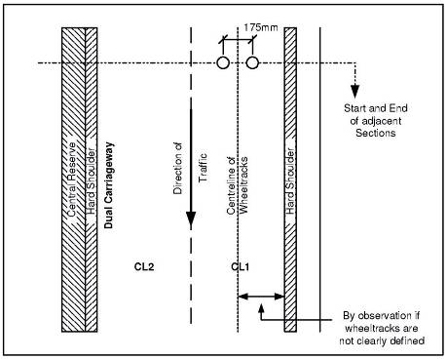
Figure 6 Position of Markers of Two Lane Dual Carriageway
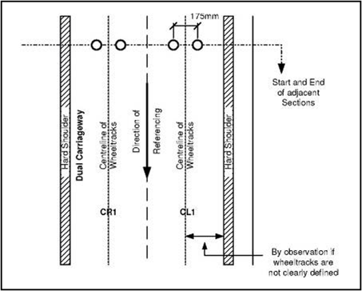
Figure 7 of Markers on Two Way Single Carriageway
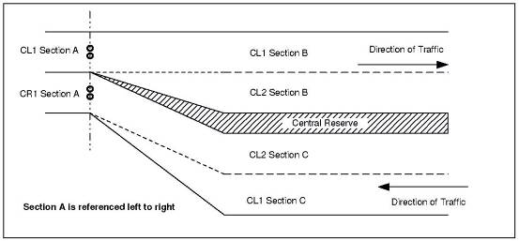
Figure 8 Start of Dual Carriageway
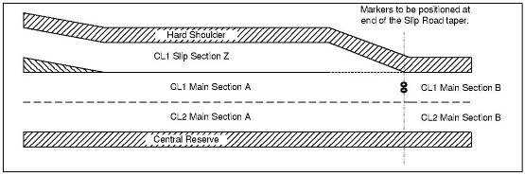
Figure 9 Slip Road entering Main Carriageway
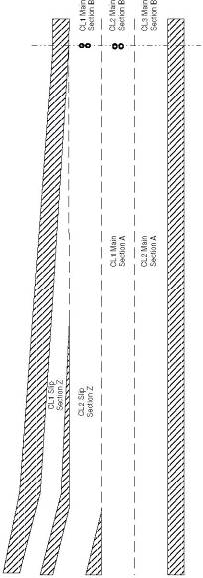
Figure 10 Main Line Addition at a Ghost Island Merge
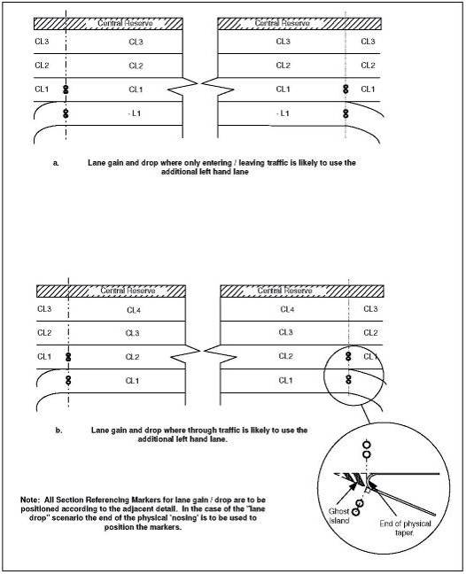
Figure 11 Lane Gain and Drop
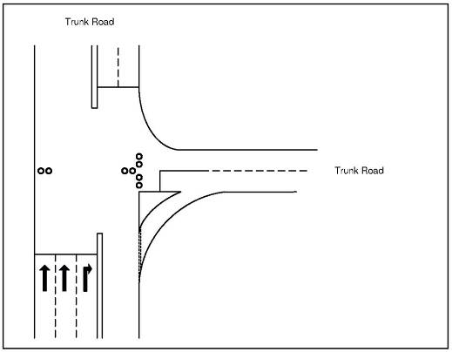
Figure 12 Trunk Roads meeting at a ‘T’ Junction
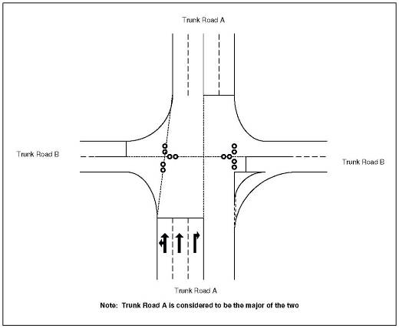
Figure 13 Trunk Roads meeting at a Cross Roads
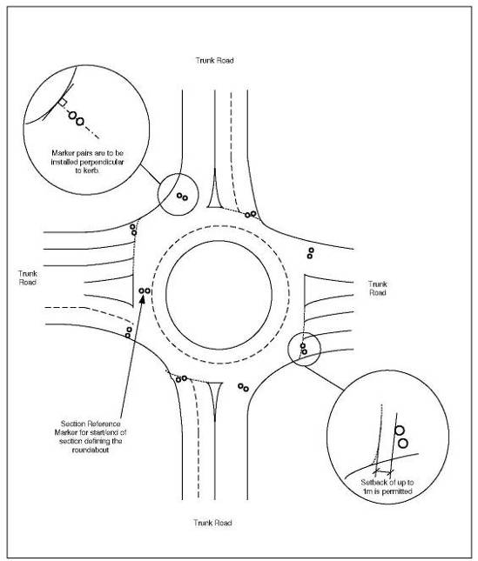
Figure 14 Trunk Roads meeting at a Roundabout
- Pavement Condition Surveys
This section describes the strategy for Pavement Condition Surveys, which is supported by the facilities provided in the Employer’s Pavement Data Management System.
For the purpose of clarity, a differentiation is made between surveys and inspections:

Surveys
Defined as the collection of data either by machine or visually. Machine surveys are the collection by machine of measurements. Visual surveys are a mixture of assessments and measurements, with data capture possibly by hand-held computer

Inspections
Defined as viewing of the relevant length of road, either on foot or from a slow moving vehicle, to apply and to record judgements but not to collect data
  - Pavement Condition Survey Strategy
There are two levels of pavement condition survey:
- Network level
- Scheme level
All network level pavement issues (for example, network level reporting, budget planning, targeting of priority lengths for treatment) will be based on the data collected by the Network level surveys See Figure 15.
Any additional data required to define/design individual maintenance scheme will be collected by the scheme level surveys. The actual scheme level condition surveys required to be undertaken for each individual scheme will vary from scheme to scheme.
Lengths of road that will be candidates for treatment will be defined by the relevant maintenance engineer, and will include those lengths identified by the Network surveys and any other lengths that the maintenance engineer wishes to consider for other reasons.
After the Network level surveys, and prior to the confirmation that any length of road is considered a candidate for treatment and subject to scheme level surveys, an inspection must be carried out by an engineer (or experienced Inspector). This inspection must formally confirm that the length identified from the Network surveys, or by other means, is a proper candidate for treatment and give the engineer or Inspector’s considered views of other elements of the proposed work, which are currently considered as part of the Value Management exercise.
  - Network Level Surveys
The network level machine surveys are:
TRACS - undertaken on the entire network each year and for multiple lanes.
SCRIM - undertaken on the entire network each year in the most heavily trafficked lane, usually lane 1.
TSD - the entire mainline lane-one surveyed with in a two year cycle. Approximately 75% of the mainline lane 1 of the network being surveyed each year to provide entire network mainline lane 1 coverage but with some repeat surveyed lengths.
The Employer currently centrally procures and manages the annual TRACS, SCRIM and TSD surveys.
  - Scheme Level Surveys
The range of scheme level surveys includes:

Deflectograph
For schemes other than existing rigid construction or where there is available TSD data, providing data that is needed to assess the structural condition of the pavement and to determine whether the pavement is, or remains, long life.
Mandatory Surveys
These surveys are mandatory under HD30;
- Dynamic Cone Penetrometer (DCP)
- Coring or trial pits (including any subsequent laboratory testing of samples)

Visual Condition
For flexible pavements requiring surface treatment, providing data to establish the preferred option for surface treatment for the scheme.
The survey will vary in content depending on the existing pavement construction.
If possible, the visual condition survey should be undertaken at the same time as other Scheme level surveys to limit the number of lane closures.
In addition, special surveys that are relevant to a particular scheme, or options for a scheme, may be undertaken including:
- Falling Weight Deflectometer (FWD)
- Ground Penetrating Radar (GPR)/Seismic
- CCTV surveys of drainage pipe runs
- Topographical surveys
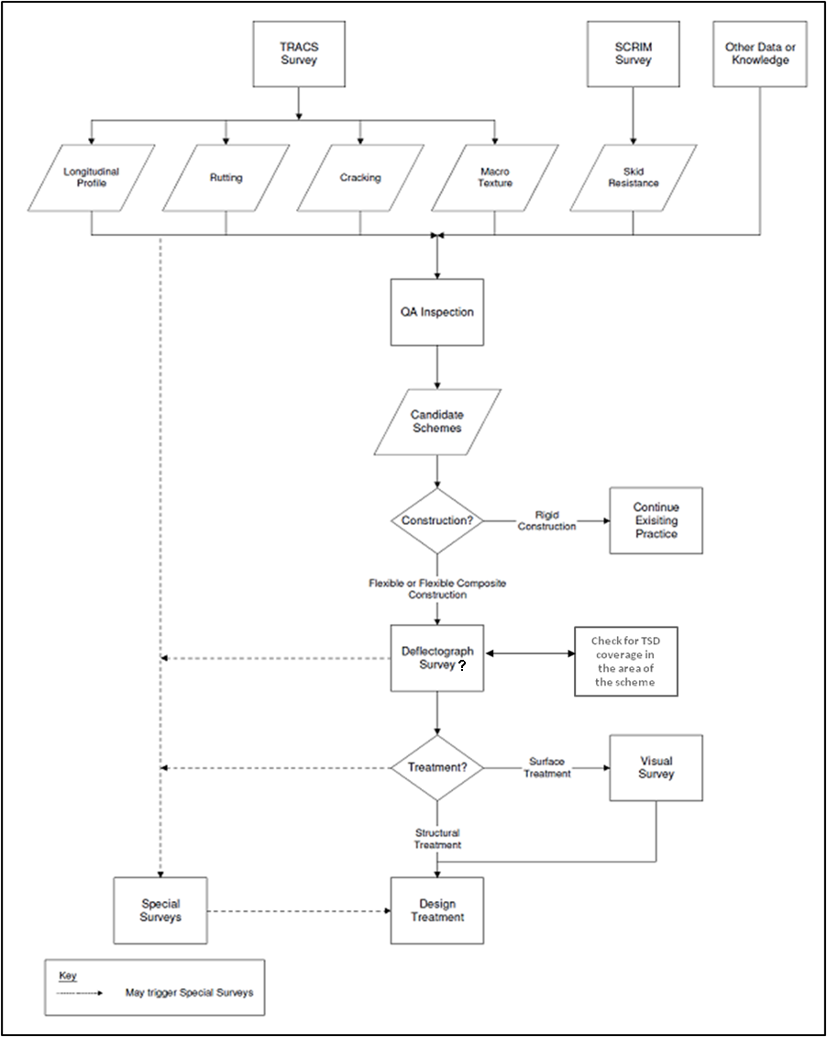
Figure 15 Pavement Condition Survey Strategy
It is intended that data from scheme level surveys (including Special surveys) will supplement the data available from the Network level surveys, which will be available (other than crack intensity) at a disaggregated level for scheme consideration.
  - Visual Surveys
    - Pavement Visual Surveys
Pavement Visual Surveys provide information, supplementary to that provided by network machine surveys, to support the design, evaluation and audit of potential maintenance schemes on flexible carriageway pavements (PVS-f).
    - Network Visual Surveys (NVS)
Network Visual Surveys (NVS) of those parts of the Network that are not covered by machine surveys (kerbs, footways, cycle tracks and hard-paved verges) for the Employer’s reporting on performance of that network.
    - Visual Survey Software
The Employer provides the following software for the purposes of undertaking the Employer’s Pavement Data Management System Visual Surveys.
DCD Software, Version 2.01a.HA
Functionality has been provided within the Employer’s Pavement Data Management System that must be used for the definition and outputting of survey routes to the handheld computer, and for loading of completed surveys, from the handheld computer.
    - Survey Procedure
The Provider will carry out the NVS and Pavement Visual Surveys in accordance with the provisions of the HAPMS Visual Survey Manual available through Highways Agency Extranet http://10.222.254.2/hapms
    - Visual Condition Surveys (VCS) on Concrete Surfaced Pavements
VCSs must form part of the inspection procedure to be adopted before the opening to traffic of newly laid concrete surfaced pavements and must also be carried out at the end of the Contract maintenance period. The surveys must be carried out by the Provider and the consultant/designer (if one is appointed) following agreement with the Service Manager, and inspection records must be kept by the Provider.
Procedures and methods for carrying out VCSs for concrete surfaced pavements (including CRCP) are fully described in the DMRB: Volume 7, section 3, and Part 2 HD29.
The Provider must retain a fair copy of the 1:100 scale field inspection sheet. Note: this data can be held electronically. Two copies of the pavement construction data and defect summaries must be submitted to the Service Manager within three months of the completion of the survey.
    - Machine Survey Pre-Processor (MSP)
The Employer’s MSP is a stand-alone software application that is to be used by the Provider or by the Provider’s survey contractors, to process data from machine surveys, including SCRIM and Deflectograph, prior to loading into Confirm.
The MSP:
- Reads in and validates the format and consistency of Raw Condition Data (RCD) collected by the relevant survey machines;
- Validates the measured values;
- Carries out corrections to, and/or some analysis of, the measured values ;
- Maps the survey to a Survey Route, defined within a file; and
- Outputs the corrected/analysed data and mapping information as Base Condition Data (BCD), for subsequent loading into Confirm.

Accessing MSP
MSP is a stand-alone application that can be installed on any PC whether connected to the Employer Extranet or not.
Any requests for help in using MSP, including requests for copies of the software, should be directed to the Employer Contact ICTService+ on 0845 3710 717 or ictserviceplus@highways.gsi.gov.uk.

Corrections and Analysis
The corrections and/or analysis carried out by MSP are:
SCRIM data
- Correction for static calibration
- Correction for Distance Calibration Factor
Deflectograph data
- Correction for static calibration
- Correction for wheel load
- Linear interpolation of temperature
- Correction for Distance Calibration Factor
Traffic Speed Deflectometer data
- Corrections
  - Fitting data to the Network
This section deals with the business and technical processes for fitting a survey to the defined Network. Tools are provided within the Employer’s Pavement Data Management System for the definition of survey routes, which are then used by MSP to fit the measured condition to the Network. Appendix C.4.6 of this document provides a description of the MSP software.
The MSP user manual describes the technical process of fitting a survey to the Network. This document describes the business processes for dealing with surveys which do not ‘fit’ and sets out the actions the Provider is required to undertake to resolve these issues.
It is important to note that the Network Referencing Data held within the Employer’s Pavement Data Management System database is regarded by the Employer as the definitive description of the trunk road network and this definition includes the recorded section lengths.
For each type of condition survey, fitting tolerances are defined for the purposes of loading condition information against sections stored within the Employer’s Pavement Data Management System. For example the current tolerances for the fitting of Deflectograph survey information is 20% for sections that are less than 250m in length or 50m for sections longer than 250m.
Surveys which fall within tolerances are then “rubber-banded” (see figure 16) to fit within the chainage limits of the section. Surveys (or data) with chainage measurements outside these tolerances are initially rejected and require further checking as described in the next two sections.
Figure 16 demonstrates the principles of rubber banding data to the Network.
Figure 16 Principles of Rubber-Banding
    - Employer Commissioned Surveys
Where the Employer’s survey contractor identifies a section perceived to be incorrect within the Employer’s Pavement Data Management System, the Employer’s System Support Team will ask the Provider’s NRM to help resolve the issue by providing the following, but not limited to, data;
- Section length
- Ordnance Survey Grid Reference (OSGR) locating the Location Reference Point at the section’s start
- OSGR locating the Location Reference Point at the section’s end
OSGRs must be measured with differential Geographic Positioning System (GPS).
    - Provider Commissioned Surveys
In the case of scheme specific surveys such as Deflectograph, and where the Provider user is attempting to bulk update the construction records as a result of a Ground Penetrating Radar (GPR) survey, it is the responsibility of the Provider’s NRM to ensure that any new data is fitted to the Network.
It is not acceptable for a section to be temporarily recalibrated for the purposes of fitting data.
Users concerned about fitting either survey data or bulk updates to section attributes such as construction or inventory, should in the first instance contact ICTService+ on 0845 3710 717 or ictserviceplus@highways.gsi.gov.uk
- Data, Records and Inspections of Highway Structures
  - General
The overarching principles and requirements for the provision and maintenance of records and inspections for trunk road structures throughout the UK are set out in BD 62 ‘As Built, Operational and Maintenance Records for Highway Structures’, BD 63 ‘Inspection of Highway Structures’, and BD 53 ‘Inspection and records for Road Tunnels’. This Appendix is supplementary to those requirements.
Records for new build, modifications and renewals works to trunk road highway structures in England are required by BD 62 Annex A to be supplied and input into Employer’s Structures Data Management System by the organisation responsible for the design of the works (the Designer), taking account of Employer’s Structures Data Management System online User Guidance. For network improvement and maintenance works carried out under Provider contracts, the Provider will be responsible for ensuring that his Designer fulfils this duty.
The acceptance into Employer’s Structures Data Management System of records for new build, modifications and renewal works, together with the upkeep of operational records in Employer’s Structures Data Management System, is the responsibility of the Provider, who must take reasonable steps to satisfy themselves that Employer’s Structures Data Management System is populated correctly at all times.
  - Scope of Highway Structures
The scope of highway structures for which records must be held and maintained in Employer’s Structures Data Management System, and inspections undertaken is given in BD 62 Annex A Table 4.
The normal Maintenance Inspection regime of General, Principal and Special Inspections in accordance with BD 63 must apply to each Structure Type shown in the Table, except as indicated below:
Small Span Structures (formerly ‘Small Culverts’). For Bridges and Buried structures between 0.9m and 1.8m span, Principal Inspections are not required, except for corrugated steel culverts, in which case the normal Maintenance Inspection regime must apply.
Masts. Posts for Highway Signs are not recorded on Employer’s Structures Data Management System and are not covered by the Employer’s Structures Data Management System inspection process.
Tunnels. General, Principal, Special, and M&E Inspections must be in accordance with BD 53 ‘Inspection and Records for Road Tunnels’
Service Crossings and Other Structures. For other structures not defined in the Table but needing technical approval the Provider must contact the Employer’s Structures Data Management System Administrator.
  - Type of Records required in Employer’s Structures Data Management System
The type of as built, operational and maintenance structure records to be held are described in Section 4 of BD 62 and must be maintained by the Provider within the relevant branch of the Employer’s Structures Data Management System hierarchy, as explained in Employer’s Structures Data Management System User Guidance Volume 1 and in the Employer’s Structures Data Management System Designer Guide. The Provider must ensure that document records that they upload into the Structure File Branch are located in the correct subfolder.
Where bridge and culvert structures are modified to cater for road widening, the new construction must be input as part of the existing structure.
  - Data input to Employer’s Structures Data Management System for new build, modifications and renewals
For structures new build, modifications and renewals, Designers are required to submit the necessary inventory details and Structure File records as set out in BD 62 Annex A.
With respect to inventory data the Provider must confirm within Employer’s Structures Data Management System, as part of Pre Opening Inspection (POI) duties, the acceptance of the completed data input.
For new structures, the Provider must liaise with the Designer so that the Designer can establish an acceptable referencing system for the structure for Employer’s Structures Data Management System inventory and inspection recording purposes.
For modifications and renewals to existing structures (including widening) that have not yet been migrated to the condition indicator style inventory, it is essential that the Provider “migrates” the component hierarchy of the structure before the Designer inputs the modification data. The Designer and Provider must therefore liaise at a sufficiently early date to enable this to be done. This requirement is also stated in the Employer’s Structures Data Management System Designer Guide.
  - Supply of Structure Records in Connection with Changeover of Responsibility
    - Records at Transfer of HA Structures to the Ownership of Others
Where a new structure has been constructed under an Employer contract, but ownership is to be transferred to a third party, full data and documentation is to be supplied by the Designer in accordance with BD 62.
Where an existing structure is to be transferred to a third party, the Provider must update the data and documentation in Employer’s Structures Data Management System, prior to transfer (see H.7).
    - Records at the Transfer of Existing Third Party Structures to the Ownership of the Highways Agency
When transfer of ownership from a third party to the Employer is to take place, the Provider must apply to the Employer’s Structures Data Management System Administrator for a new Structure Key and, at least one month prior to the planned handover inspection, create a suitable inventory in Employer’s Structures Data Management System. Following the handover inspection (refer to Acceptance Inspections in BD 63), the Provider must input the inspection records into Employer’s Structures Data Management System in accordance with H.8.
  - Supply of Records for Structures on the HA Network Owned by Others
For newly built structures over, under or adjacent to the highway but owned by others, on instruction from the Area Manager or other authorised person the Owner should supply to the Provider, and the Provider obtain from the Owner, within three months of substantial completion of the structure, summary information about the structure for inputting into Employer’s Structures Data Management System, comprising:
- A completed Early Notification of Structure spreadsheet, which should be obtained from the Employer’s Structures Data Management System Administrator.
- Minimum headroom information for each span over the road, rail or navigable waterway
- Three electronic report images are required for the 277(Employer’s Structures Data Management System) report. These are a 1:2500 scale map of the vicinity, a general elevation photograph and a general arrangement drawing. Advice on image formatting can be found in Employer’s Structures Data Management System User Guidance Volume 1.
- Where the Provider is able to acquire this information it must be entered onto Employer’s Structures Data Management System correctly and without delay. Where the Provider is unable to obtain this information from the Owner, the Provider should on instruction from the Area Manager or other authorised person, create and input this information to Employer’s Structures Data Management System

  - Supply and Upkeep of Operational Records for Existing Structures
As part of the ongoing management cycle of a structure, Employer’s Structures Data Management System contains various functions for use by the Provider. Requirements for these are summarised below.
    - Maintenance Inspections
The Provider must carry out Maintenance Inspections in accordance with BD 63 and must input information from General, Principal and Special Inspections directly into Employer’s Structures Data Management System in accordance with H.8 below.
The Provider must complete and “authorise” inspections in Employer’s Structures Data Management System within three months of the inspection taking place.
The Provider must use the inspection scheduling facility in Employer’s Structures Data Management System for inspections and monitoring.
Where a Provider is responsible for maintenance of a new structure, the initial Acceptance Inspection should be the Pre Opening Inspection (POI) (see BD 63 Section 5). This inspection must constitute the commencement of the programmed General and Principal Inspection intervals. The POI may be either a General Inspection or a Principal Inspection although should normally be a Principal Inspection, but it must in all cases be sufficiently detailed to enable the Provider to fulfil its responsibilities of future maintenance and management of the structure.
Monitoring Inspections are separately identified in Employer’s Structures Data Management System and are recurring Special Inspections for the management of substandard structures.
    - Maintenance Actions
Maintenance Actions are created in Employer’s Structures Data Management System as recommended actions to deal with particular maintenance needs, for entry onto the Highways Agency’s Structure Renewals Programme. The Provider must create these within Employer’s Structures Data Management System, either:
- during the inspection inputting process;
- during the development of the planned forward programme;
- outside of the normal inspection process (e.g. following an assessment or incident).
The Provider must review and accept Maintenance Actions within three months of the action being identified. Where Maintenance Actions are identified at the time of a Maintenance Inspection, the Provider must undertake this review before the inspection input is “authorised”. The Provider will need to allocate suitably qualified staff (with the “Engineer” user role) to undertake these duties on their behalf.
    - Developing Maintenance Projects
The Provider must use the Project Forming, Estimating, Scheduling and Bidding, and Continuous Value Management functions in Employer’s Structures Data Management System as required by the Employer as part of the effective management of the structures asset.
    - Ongoing Review of Employer’s Structures Data Management System Inventory
The Provider must take the opportunity to check and update relevant parts of the Employer’s Structures Data Management System inventory whenever current information can be checked or ascertained during normal operational activities. This should be at least on the following occasions:
- Before “authorising” a Principal Inspection input into Employer’s Structures Data Management System (e.g. physical details and images).
- Within two months of completion of maintenance schemes (e.g. additional or amended physical details and images).
- Within two months of input of inventory information into Employer’s Structures Data Management System by Designers (i.e. acceptance of Designer’s data and record input).
- Where existing structures have yet to be converted to a component level inspection, at initiation of the component level inspection regime (i.e. instigate component hierarchy and ensure physical data is attributed correctly within the hierarchy).
- Before data for a modified structure (e.g. widening) is input by the Designer. (i.e. “migrate” (for condition reporting purposes) the component hierarchy if not already done).
- Where an existing structure is to be transferred to a third party, the Provider must update the data and documentation in Employer’s Structures Data Management System prior to transfer.
- Upon receipt or known creation of any more recent information or on recognition of any incorrect information.
- Within one week of the physical addition or removal of any Interim Measure.
The Provider should note that Employer’s Structures Data Management System now contains a module for recording inventory data on coating systems for steel and concrete. This module must be populated as part of the ongoing review of Employer’s Structures Data Management System Inventory.
    - Structural Assessments and Load Management
The Provider must input Assessment records resulting from assessment work into Employer’s Structures Data Management System through the Load Management section and the Structure File section as appropriate.
Advice in Employer’s Structures Data Management System User Guidance Volume 4 - Operational must be followed regarding the completion of the Load Management section.
  - Maintenance Inspections
The Provider must use the inspection and monitoring scheduling facility in Employer’s Structures Data Management System for planning and programming Maintenance Inspections.
The Provider must undertake all inspections as “component level” inspections and defect information (ratings, images etc.) recorded against the component referencing system for the structure within Employer’s Structures Data Management System, as set out in the Employer’s Structures Data Management System User Manual and on screen guidance. The Provider must “authorise” Inspection data within three months of the inspection taking place.
General, Principal and Special Inspection reports, can be generated from Employer’s Structures Data Management System. Where some inspections require additional information beyond that for which there is functionality in Employer’s Structures Data Management System for keyed input, (e.g. Acceptance Inspections, enhanced Maintenance Inspections etc), a report prepared externally to Employer’s Structures Data Management System may be created and submitted to the HA for acceptance and then uploaded into the relevant section of the Structure File in Employer’s Structures Data Management System.
At handover of new structures to the Provider, the Provider must confirm in Employer’s Structures Data Management System, as part of their POI Acceptance Inspection duties, their acceptance of the Designer’s completed data input for the structure.

  - The Management of Sub-Standard Highway Structures, Concrete Half Deck and Hinge Deck Structures
    - Background

The Employer is concerned that contemporary records of Interim Measures for the management of sub-standard structures are not always being expeditiously fed in to Employer’s Structures Data Management System. Similarly, there is concern that management programmes for concrete half joint and hinge deck structures are not being taken forward expeditiously and, again, that contemporary records within Employer’s Structures Data Management System are neither complete nor up to date. Such concerns have arisen following the failure of major highway structures in Canada, the USA and elsewhere in the world and the lessons learnt.
    - Sub-Standard Highway Structures
The requirements for the identification, assessment and management of sub-standard structures are defined in DMRB standard BD 79 (The Management of Sub-standard Highway Structures) and BD 21 (The Assessment of Highway Bridges and Structures). BD 79 covers the safe management of sub-standard highway structures including requirements and guidance on the use of Interim Measures during or following the assessment process. Interim Measures, crucial for the management of such structures, may include load reduction, monitoring, risk analysis or further assessment or a combination of these, together with appropriate Technical Approval procedures and requirements for auditable documentation and record keeping.
Further guidance on Interim Measures can be found in Employer’s Structures Data Management System User Guidance Volume 4 - Operational.
    - Concrete Half Joint and Hinge Deck Structures
The vulnerability of concrete half joint and hinge joint structures has long been recognised and their management is covered by CHE Memoranda 132 and177 and CHE Memorandum 126/03 respectively together with the associated IAN 53/04 for Highways Agency structures. The assessment of concrete half joints is covered by BA 39. The assessment of hinge deck structures is covered by BA 93.
These documents set out clear requirements for the identification, inspection and testing, assessment, risk analysis and management of concrete half joint and hinge joint structures together with the entry of record information into Employer’s Structures Data Management System.
    - Instruction
To address the above issues, the Provider is reminded they must:
- review and update Interim Measures for the management of substandard structures for their Network and keep this data regularly maintained in Employer’s Structures Data Management System to provide an auditable record;
- ensure that Interim Measures are added/updated in Employer’s Structures Data Management System within one week of any change on the Network and that the expected end date is revised should the Interim Measure be expected to remain in place for longer;
- ensure that Interim Measures are deleted from Employer’s Structures Data Management System within a week of being removed from the structure;
- comply with all the requirements of the several documents relating to concrete half joint and hinge deck structures;
- ensure that all relevant bridge record information for sub-standard highway structures, concrete half joint and hinge deck structures is gathered, held and maintained within Employer’s Structures Data Management System.
- Carriageway Inventory Assets
  - General
Carriageway Inventory Assets refer to those assets that appear on or alongside the carriageway excluding structures, drainage and geotechnical assets. The IAM IS is the master data set for Carriageway Inventory Assets inventory, construction and condition data. The Provider is responsible for ensuring these data are up to date, accurate and complete as per the sub process deliverables in this document.
Carriageway Inventory Assets include but are not limited to the assets listed below:
Asset Type Code | Asset Type Description
ARBE | Arrester Bed
BIKE | Cycle Track
BRDW | Bridleway
CATL | Cattle Grid
CEIS | Central Island
CERE | Central Reserve
COCB | Communication Cabinet
CCTV | CCTV Mast
HWAY | Highway
CWGA | Carriageway Gates
DELO | Detector Loop
DEPO | Depot
DIPO | Distribution Point
EDTM | End Terminals
EMTB | Emergency Telephone Box
FEBW | Fences, Environmental Barriers and Walls
FEGA | Fence Gates
FEPI | Feeder Pillar
FOOT | Footway
HARM | Hatched Road Markings
HDST | Hard Standing
Asset Type Code | Asset Type Description
HEDG | Hedge
HNDR | Handrail
KERB | Kerb
LABY | Layby
LORM | Longitudinal Road Markings
MCPR | VRS Add On Motorcycle Protection
NEWA | New Asset Type
NMUX | NMU Crossing
PEDX | Pedestrian Crossing
PEGR | Pedestrian Guard Rail
PORA | Police Ramp
REFU | Refuge Area (Managed Motorways)
REWA | Retaining Wall
RFMP | Reference Marker Point
ROST | Road Studs
RSTA | Rest Area
SABO | Safety Bollard
SOFT | Soft Estate
SGFA | Sign Face
SGFC | Sign Face Condition
SGPO | Post (Signs)
SNGA | Snow Gates
SPKT | Spill Kit
STIL | Stile
STPS | Steps
SWRM | Switchroom
TREE | Tree
TRRM | Transverse and Special Road Markings
Asset Type Code | Asset Type Description
TRSI | Traffic Signals
VERG | Verge
VRS | Vehicle Restraint System
XOVE | Crossover
CRCU | Crash Cushion
LIPO | Lighting Point
CHAN | Channel

  - Standard Lighting Electricity Billing Inventory
The data in Table 4 below are to be submitted to the Employer, or persons/organisations designated by the Service Manager, monthly on a day as instructed by the Service Manager and in a format as instructed by the Service Manager.

Column | Label | What it means | Field Type | Length | Examples | Detailed explanation
A | Agent Record No. | Agents Record Number | Numeric
B | Lamp Equiv. No. | Lamp Equivalent Number | Alphanumeric | 6 | SL 'Street lighting'
C | Item Class Code | Item Class Code | Alphanumeric | 2
D | No Of Lamps | No of Lamps | Numeric
E | No Of Pecus | No of PECUs | Numeric
F | Pecu Type | PECU Type | Alphanumeric | 5 | eg HPC 'Hybrid Photo Cell'
G | Pecu Lux On | PECU Lux On | Numeric |  | eg 55, 70, 100 | Light level at which lights go on.
H | Pecu Lux Off | PECU Lux Off | Numeric |  | eg 28, 70, 140 | Light level at which lights go off.
I | Switch Type | Switch Type | Alphanumeric | 5 | eg 24 hrs, Man, Time, | How the lights are switched
J | Time On | Time On | Alphanumeric | 5 | eg SUNS, DUSK, 2200 | Dusk is 30 mins after sunset
K | Time Off | Time Off | Alphanumeric | 5 | eg SUNR, DAWN, 0700 | Dawn is 30 mins before sunrise
L | Lamp Type | Lamp Type | Alphanumeric | 5 | eg SON, SON/T, etc | Full list on Elexon Website
M | Lamp Max Watt. | Lamp Max Wattage | Numeric
N | Gear Type | Gear Type | Alphanumeric | 4 | eg None, SG 'Standard gear' etc | Type of control / starter equipment fitted
O | Feature Location | Location | Alphanumeric | 30 |  | Marker post or general description
P | Road Name | Road Name | Alphanumeric | 24
Q | Parish | Parish | Alphanumeric | 24
R | Town County | Postal Town/County | Alphanumeric | 24
S | Grid Ref Letter | Grid Ref. Letters | Alphanumeric | 2 |  | If applicable
T | Grid Ref East | Grid Ref. Eastings | Numeric |  |  | If applicable
U | Grid Ref North | Grid Ref. Northings | Numeric |  |  | If applicable
V | Grid Supply Point | Grid Supply Point | Alphanumeric | 6 |  | Reference, supplied by supply company
W | Feeder Pillar Id | Feeder Pillar ID | Alphanumeric | 6 |  | Feeder pillar reference number
X | Ind Or Grp | Individual or Group Control | Alphanumeric | 3 | IND or GRP | Must be completed
Y | Percent Util | Operating Percent Per Day | Numeric |  |  | Percentage of utilisation per day for signals
Z | Exit Point | Is Item An Exit Point | Alphanumeric | 1 | Y or N
AA | Exit Grid Ref | Grid Ref. of Exit Point | Alphanumeric | 8 |  | If applicable
AB | Exit Capacity | Exit Point Capacity if >3KVA | Numeric |  |  | If available
AC | Metered | Metered or Unmetered | Alphanumeric | 1 | M or U
AD | Rec Name | REC Name | Alphanumeric | 30 | Host DNO name | In Area 13 only DNO's are Norweb, Yorkshire Electricity or Scottish Power
AE | Commission Date | Equipment Commission Date | Date |  | Null entry | In year 2000 format
AF | Inst Cap Cost | Installation Capital Cost | Numeric |  | Null entry | In year 2000 format
AG | Column Manu | Column Manufacturer | Alphanumeric | 12 | eg Abacus, Mallatite, etc | Who made the column?
AH | Mounting Height | Mounting Height | Numeric |  | eg 6,8,10,12, etc (metres) | How high is it?
AI | Column Material | Column Material | Alphanumeric | 5 | eg Steel, Alum, etc
AJ | Prot Coating | Protective Coating | Alphanumeric | 5 | eg HDG | HDG = Hot dipped galvanised
AK | Paint Colour | Paint Colour | Alphanumeric | 6 | eg grey, black, etc
AJ | Column Fixing | Column Fixing | Alphanumeric | 6 | eg flange , wall, etc
AM | Column Xsect | Column Cross Section | Alphanumeric | 3 | eg tub, hex, oct | Tubular, hexagonal or octagonal
AN | No Brackets | Number Of Brackets | Numeric
AO | Bracket Project | Bracket Projection | Numeric |  | eg 1000, 1250, etc in mm | distance in mm
AP | Lantern Manu | Lantern Manufacturer | Alphanumeric | 12 | eg Thorn | Urbis, Thorn, etc etc
AQ | Lant Mod Ref | Lantern Model Reference | Alphanumeric | 8 | eg ZX3
AR | Lantern Distrib | Lantern Distribution | Alphanumeric | 3 | eg LTI | Low thread increment, Medium Thread increment, etc
AS | Lantern Setting | Lantern Setting | Alphanumeric | 8 | eg POS11X
AT | Lantern Protect | Lantern Protection | Alphanumeric | 4 | eg IP65 | How weather resistant it is
AU | Last Lamp Chng | Last Lamp Change Date | Date |  | In year 2000 format
AV | Last Elec Test | Last Electrical Test | Date |  | In year 2000 format
AW | Last Det Insp | Last Detailed Inspection | Date |  | In year 2000 format
AX | Sign Size | Sign Size | Numeric |  | eg 600, 1000, etc (mm)
AY | Sign Diag No | Sign Diagram No. (if fitted) | Alphanumeric | 6 | eg ADS, etc
AZ | Col Root Prot | Column Root Protection | Alphanumeric | 3 | eg NP, CF, etc | NP 'No Protection', CF = Full depth concrete
BA | Flange Base | Flange Base | Alphanumeric | 3 | eg ENP, B, etc | ENP = Flange plate exposed, not protected, B = Flange plate buried, etc
BB | Col Location | Column Location | Alphanumeric | 16 | eg Central Reserve | Where it is, so it can be found!!
BC | Road Env | Road Environment | Alphanumeric | 12 | eg Motorways | Could be Urban, residential , etc
BD | Ground Cond | Ground Conditions | Alphanumeric | 14 | eg Well drained | Poorly drained, etc
BE | Wind Expo | Wind Exposure | Alphanumeric | 10 | eg Exposed | Exposed, normal, or sheltered
BF | Env Situ | Environment Situation | Alphanumeric | 4 | eg INIA ' Inland non industrial area' | Could be near sea front, etc
BG | Des 4 Fatigue | Designed for Fatigue | Alphanumeric | 8 | eg Yes | Yes, no, or Unknown
BH | Attachments | Attachments | Alphanumeric | 4 | eg FNDA | Fitted column not designed for attachments, could be 'None' , etc
BI | Ext Influ | External Influences | Alphanumeric | 5 | eg Rural | Urban or rural
Table 4 Lighting Electricity Billing Inventory

  - Variable Lighting Billing Inventory
Data for lighting assets affected by variable lighting for carbon reduction purposes are to be submitted to the Employer, or persons/organisations designated by the Service Manager, monthly on a day as instructed by the Service Manager and in a format as instructed by the Service Manager.

Appendix F: Drainage Assets

F.1 Drainage Asset Management
The Highways Agency Drainage Data Management System (HADDMS) maintains the master data set for drainage asset inventory, construction and condition (excluding routine defects managed in the IAM IS) data.
The IAM IS maintains an abridged copy of the HADDMS drainage asset inventory, construction and condition data to enable the Provider to schedule routine inspections, maintenance activities and to apply defects to the assets. The Agency will ensure that the data in IAM IS matches the data in HADDMS.

The current systems are detailed in the Provider’s contract Annex 6 and Appendix E of the ADMM (this document). Please note the Employer also provides other asset data systems that are not currently in the scope of the ADMM
The Competency Levels are defined in the Asset Data Management Section of the Employer’s Asset Management Competency Framework.
Defined in the first bullet of the scope of this ADM Sub Process

