Framework Schedule 6 (Order Form Template and Call-Off Schedules)

Order Form

CALL-OFF REFERENCE: 709474450.2

THE BUYER: Defence Infrastructure Organisation

BUYER ADDRESS Kentigern House
65 Brown Street
Glasgow
G2 8EX

THE SUPPLIER: Arcadis LLP
SUPPLIER ADDRESS: Arcadis London
80 Fenchurch Street,
EC3M 4BY
London
United Kingdom

REGISTRATION NUMBER: OC368843
DUNS NUMBER: 217498241
SID4GOV ID: N/A

APPLICABLE FRAMEWORK CONTRACT

This Order Form is for the provision of the Call-Off Deliverables and dated 19/12/23
It’s issued under the Framework Contract with the reference number RM6168 for the provision of Establishment Management Plans.

CALL-OFF LOT(S): Lot 4 Surveying and Strategic Advice

CALL-OFF INCORPORATED TERMS
The following documents are incorporated into this Call-Off Contract. Where numbers are missing we are not using those schedules. If the documents conflict, the following order of precedence applies:
- This Order Form including the Call-Off Special Terms and Call-Off Special Schedules.
- Joint Schedule 1(Definitions and Interpretation) RM6168
- The following Schedules in equal order of precedence:

- Joint Schedules for RM6168
- Joint Schedule 2 (Variation Form)
- Joint Schedule 3 (Insurance Requirements)
- Joint Schedule 4 (Commercially Sensitive Information)
- Joint Schedule 6 (Key Subcontractors)
- Joint Schedule 7 (Financial Difficulties)
- Joint Schedule 9 (Minimum Standards of Reliability)
- Joint Schedule 10 (Rectification Plan)
- Joint Schedule 11 (Processing Data)
- Joint Schedule 12 (Supply Chain Visibility)

- Call-Off Schedules for RM6168
- Order Form- Template-Short-Form
- Call-Off Schedule 1 (Transparency Reports)
- Call-Off Schedule 2 (Staff Transfer)
- Call-Off Schedule 3 (Continuous Improvement)
- Call-Off Schedule 4 (Call Off tender (V3.1)
- Call-Off Schedule 5 (Pricing Details)
- Call-Off Schedule 6 (ICT Services)
- Call-Off Schedule 7 (Key Supplier Staff)
- Call-Off Schedule 8 (Business Continuity and Disaster Recovery)]
- Call-Off Schedule 9 (Security)
- Call-Off Schedule 10 (Exit Management)
- Call-Off Schedule 12 (Clustering)
- Call-Off Schedule 13 (Implementation Plan and Testing)
- Call-Off Schedule 14 (Service Levels)
- Call-Off Schedule 15 (Call-Off Contract Management)
- Call-Off Schedule 16 (Benchmarking
- Call-Off Schedule 17 (MOD Terms)
- Call-Off Schedule 20 (Call-Off Specification)

- CCS Core Terms (version 3.0.10)
- Joint Schedule 5 (Corporate Social Responsibility) RM6168
- Call-Off Schedule 4 (Call-Off Tender) as long as any parts of the Call-Off Tender that offer a better commercial position for the Buyer (as decided by the Buyer) take precedence over the documents above.

No other Supplier terms are part of the Call-Off Contract. That includes any terms written on the back of, added to this Order Form, or presented at the time of delivery.

CALL-OFF SPECIAL TERMS
The following Special Terms are incorporated into this Call-Off Contract:
None
CALL-OFF START DATE: 17/01/24
CALL-OFF EXPIRY DATE: 31/12/25
CALL-OFF INITIAL PERIOD: 2 Years

CALL-OFF DELIVERABLES

Option A:
The milestones are detailed in ‘QA1_EMP_Lot2_Arcadis Response Dated November 2023 & ‘20230822_Attachment_3_EMP_SOR_V1.0_O (002)’ Dated 6th September 2023
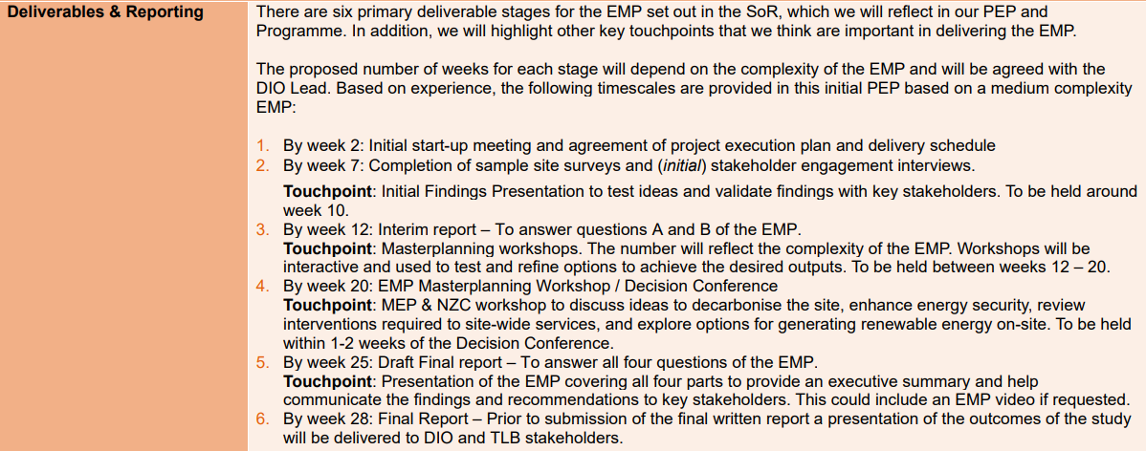

MAXIMUM LIABILITY
The limitation of liability for this Call-Off Contract is stated in Clause 11.2 of the Core Terms.

The Estimated Year 1 Charges used to calculate liability in the first Contract Year is
£1,200,000.00 Ex VAT

CALL-OFF CHARGES

Option A:

The call off charges for the contract are contained within ‘20230822_Attachment_4_Pricing_Schedule_Lot 2_O V2 Final Arcadis’

Redacted

TOTAL CALL OFF CONTRACT VALUE - £2,400,000.00 Ex VAT (Limit of Liability)

The Charges will not be impacted by any change to the Framework Prices. The Charges can only be changed by agreement in writing between the Buyer and the Supplier because of:
- Indexation
- Specific Change in Law
- Benchmarking using Call-Off Schedule 16 (Benchmarking)

REIMBURSABLE EXPENSES
None (To be Agreed Outside of the Framework)

PAYMENT METHOD

CP&F via Exostar

BUYER’S INVOICE ADDRESS:

Redacted
Redacted
Redacted

BUYER’S AUTHORISED REPRESENTATIVE
Redacted
Redacted
Redacted
Kentigern House, 65 Brown Street, Glasgow, G2 8EX

BUYER’S ENVIRONMENTAL POLICY

Management of environmental protection in defence (JSP 418) - GOV.UK (www.gov.uk)

BUYER’S SECURITY POLICY

Security policy framework: protecting government assets - GOV.UK (www.gov.uk)

SUPPLIER’S AUTHORISED REPRESENTATIVE
Redacted
Redacted
Redacted
Arcadis London
80 Fenchurch Street,
EC3M 4BY
London
United Kingdom

SUPPLIER’S CONTRACT MANAGER
Redacted
Redacted
Redacted
Arcadis London
80 Fenchurch Street,

EC3M 4BY
London
United Kingdom

PROGRESS REPORT FREQUENCY
Insert report frequency: On the first Working Day of each calendar month

PROGRESS MEETING FREQUENCY
Insert meeting frequency: Quarterly on the first Working Day of each quarter

KEY STAFF
Redacted
Redacted
Redacted
Arcadis London
80 Fenchurch Street,
EC3M 4BY
London
United Kingdom

Redacted
Redacted
Redacted
Arcadis London
80 Fenchurch Street,
EC3M 4BY
London
United Kingdom

KEY SUBCONTRACTOR(S)
Trading Name(s): Cundall Johnston & Partners LLP
Registered Address(ees) and contact details: Partnership House Regent Farm Road,
Gosforth, Newcastle Upon Tyne, NE3 3AF
Redacted
Redacted

Trading Name(s): HLMAD Ltd
Registered Address(ees) and contact details: Wool + Tailor Building Fifth Floor, 10-
12 Alie Street, London, England, E1 8DE
Redacted
Redacted

Trading Name(s): Thinkidea Ltd
Registered Address(ees) and contact details: Windsor House, 103 Whitehall Road,
Colchester, Essex CO2 8HA
Redacted
Redacted

Trading Name(s): Gardiner & Theobald LLP
Registered Address(ees) and contact details: 10 South Crescent, London WC1E
7BD
Redacted
Redacted

Trading Name(s): Avison Young (UK) Limited
Registered Address(ees): and contact details: 3 Brindleyplace, Birmingham, B1 2JB.
Redacted
Redacted

Trading Name(s): WSP UK Ltd
Registered Address(ees) and contact details: WSP House, 70 Chancery Lane, Lon-
don WC2A 1AF
Redacted
Redacted

COMMERCIALLY SENSITIVE INFORMATION
Not applicable

SERVICE CREDITS
Not applicable

ADDITIONAL INSURANCES
Not applicable

GUARANTEE
Not applicable

SOCIAL VALUE COMMITMENT
The Supplier agrees, in providing the Deliverables and performing its obligations under the Call-Off Contract, that it will comply with the social value commitments in Call-Off Schedule 4 (Call-Off Tender)

For and on behalf of the Supplier: |  | For and on behalf of the Buyer:
Signature: | Redacted | Signature: | Redacted
Name: | Redacted | Name: | Redacted
Role: | Redacted | Role: | Redacted
Date: | 17 January 2024 | 3:58 PM GMT | Date: | 1/17/2024

