New Forest National Park Authority

Invitation to Quote: NFNPA – 0038

Whole Plan, Affordable Housing and CIL Viability Assessment

- Introduction

  - The New Forest National Park was designated in 2005 and covers 220 square miles in southern England within the counties of Hampshire and Wiltshire. The National Park is home to 35,000 people and has one of the highest population densities of any National Park in England. The largest villages in the National Park have around 3,000 residents. For planning purposes, the New Forest National Park has the highest status of protection in relation to landscape and scenic beauty and is recognised as an area where development is restricted. The Authority deals with around 1,000 planning applications per annum.

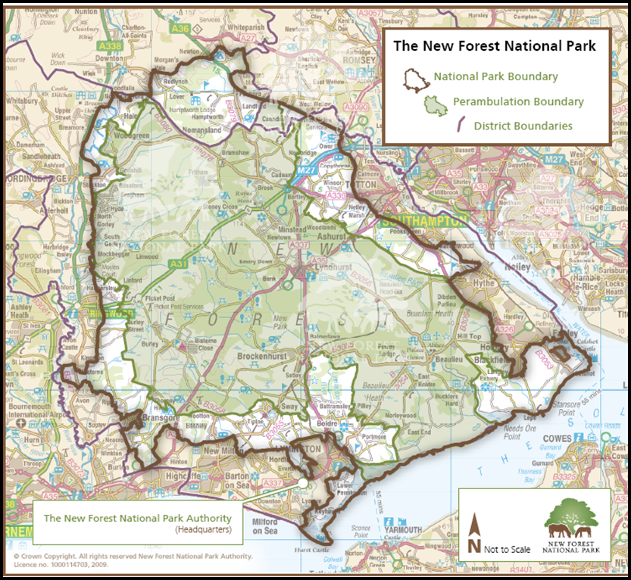

1.2 The National Park Authority is the organisation responsible for promoting the purposes of the National Park and the interests of those who live and work within it. The Authority is also the sole statutory planning authority for the Park, covering the development management, planning policy, enforcement and minerals & waste planning functions. As guardians of a national park, the New Forest National Park Authority has statutory purposes and socio-economic responsibilities as specified in the Environment Act of 1995:

- To conserve and enhance the natural beauty, wildlife and cultural heritage of the area; and
- To promote opportunities for the understanding and enjoyment of the special qualities of the Park by the public.

1.3 Working in partnership with other organisations it is also the Authority's duty to seek to foster the economic and social well-being of the local communities within the National Park. We like to sum this up as Protect - Enjoy - Prosper.

1.4 Please visit www.newforestnpa.gov.uk for more information on the New Forest National Park Authority.

- The Brief

New Forest National Park Local Plan Review – timetable

2.1 As part of its statutory planning role, the Authority is responsible for producing and updating the planning policy framework for the National Park. The Authority is in the process of reviewing its Local Plan for the National Park to cover the period 2016 – 2036 which will, once adopted, replace the Core Strategy & Development Management Policies DPD (2010).

2.2 This process commenced in 2015 and in October 2016 the Authority published a (non-statutory) consultation draft Local Plan for an 8-week period of public consultation. This draft Local Plan recognises the significant landscape and nature conservation designations that cover the New Forest National Park and new development is therefore restricted. The draft Local Plan proposes an additional 700 dwellings in the National Park over the Plan-period (an average of 35 dwellings per annum); as well as a limit on the size of new dwellings to 100 square metres. The draft Local Plan proposes a limited number of housing allocations within the National Park, with the largest being a proposed 90 dwelling greenfield site.

2.3 Following consideration of the consultation responses received late last year, the Submission draft Local Plan is due to be published in October 2017 for a statutory 6-week consultation. The new Local Plan will set out strategic and development management policies; allocate land for development; and set out the approach to affordable housing delivery.

2.4 The Submission draft Local Plan is due to be considered by the full National Park Authority meeting in mid-October 2017 prior to public consultation. The Local Plan viability report is therefore required by the end of July 2017 so as to meet reporting deadlines. The viability work will need to be prepared in close consultation with Authority officers and is likely to be an iterative process.

2.5 Secondly, in 2016 the Authority took the decision to implement the Community Infrastructure Levy following the introduction of further restrictions on the use of Section 106 agreements to fund infrastructure (including pooling restrictions and the introduction of a site size threshold through the NPPG). National policy recommends that the preparation of a CIL Charging Schedule is worked up and tested alongside the production of the Local Plan (NPPF, para. 175). Therefore the Authority is looking to develop these in tandem, informed by a consistent evidence base on development viability. Given the recommendations in the recently published ‘A new approach to developer contributions: A report by the CIL Review Team’ (October 2016), at this stage the Authority requests that quotes for the CIL viability modelling are provided separately to the whole Local Plan and affordable housing work.

Project Brief

2.6 As part of the required evidence base for the review of the Local Plan and the production of a CIL Charging Schedule for the National Park, the Authority invites submissions and quotes from suitably qualified consultants with an established track record and relevant experience in the production of the following outputs:

A whole-Plan viability assessment of the Authority’s emerging Submission draft Local Plan 2016 – 2036 | Required by the NPPF.  The assessment should focus on the cumulative viability implications of the proposed planning policies on the cost of development.  This is likely to involve a proportionate appraisal of the draft planning policies against a range of development scenarios/typologies (e.g. greenfield and brownfield allocations, windfall development, conversions) and taking into account normal development costs in the National Park.
Advice on the viability of various forms and combinations of affordable housing provision that can be supported within the National Park | This should be undertaken within the context of the Government’s clear emphasis on meeting local affordable housing needs through the development that does take place within National Parks and the significant local need for affordable housing as identified in the New Forest Strategic Housing Market Area Assessment (2014).
Undertake a viability assessment to inform the preparation of a New Forest National Park CIL Charging Schedule | This assessment should consider different types and locations of development to provide the viability evidence for the setting of CIL rates.  As set out above, a separate quote should be provided for this work. The Government’s response to the CIL Review Team’s report may be clearer by the time of an inception meeting.

2.7 The Authority expects the whole-Plan viability assessment to focus on the overall viability of the Local Plan and to ensure that it will not prevent the delivery of development within the National Park. In terms of affordable housing, the Authority is seeking advice through viability modelling on the overall percentage of affordable housing that is deliverable; the threshold at which on-site affordable housing is viable; and the appropriate level of financial contributions towards affordable housing where on-site provision cannot be sought. The whole Plan and affordable housing viability assessments must meet the requirements of the National Planning Policy Framework and National Planning Practice Guidance, which state that,

“…the sites and the scale of development identified in the plan should not be subject to such a scale of obligations and policy burdens that their ability to be developed viably is threatened…to ensure viability, the costs of any requirements likely to be applied to development, such as requirements for affordable housing, standards, infrastructure contributions or other requirements should, when taking account of the normal costs of development and mitigation, provide competitive returns to a willing land owner and willing developer to enable the development to be deliverable.” – NPPF, para. 173

The NPPF goes onto state in paragraph 174 that local planning authorities, “…need to assess the likely cumulative impacts on development of all existing and proposed local standards, SPDs and policies that support the local plan, when added to national standards…”

2.8 As emphasised in the NPPF and the Government’s recent Housing White Paper (February 2017), the assessments should be proportionate and based on meeting the expectations of the Local Plan and CIL Examinations. The successful consultant is also requested to state if they will be able to represent the Authority at the Local Plan and CIL Examinations on any matters relating to the viability assessment evidence and provide an estimate of cost based on standard hourly/daily rates.

Background information on viability

2.9 Some viability work has been undertaken previously in the National Park which may provide useful background information. This information will be shared with the successful consultant at the inception meeting. Relevant studies include:

- New Forest National Park Affordable Housing Viability Assessment, Three Dragons, 2009: This fed into the adopted Core Strategy (2010) planning policies on affordable housing and concluded that development within the National Park could support the significant provision of affordable housing.

- New Forest District and New Forest National Park CIL Viability Assessment, DTZ, 2011: The Authority jointly commissioned initial CIL viability modelling with New Forest District Council in 2011. The report focused predominantly on the New Forest District Council area (outside the National Park) but did draw some conclusions for the Park. At the time the decision was taken not to implement CIL within the Park and so the work was not progressed.

- Affordable housing contributions work – DVS, 2012: To inform the production of the Development Standards SPD in 2012, DVS were commissioned to undertake work on land values within the main villages of the National Park to inform the financial contributions sought towards affordable housing from new residential development in these villages.

2.10 By way of further context, Annex 1 sets out the background to development within the New Forest National Park. This highlights the particular planning framework for new development in the New Forest National Park, based around the high level of protection for the landscape and habitats; the strong emphasis in national policy on the delivery of affordable housing to meet local needs; and high house prices.

Methodology

2.11 The consultant should set out in their response to the invitation to quote their proposed methodology for the production of a viability assessment for the Local Plan (including the affordable housing policies); and the development of a CIL Charging Schedule (covered by a separate quote). Assessment methodologies should follow established industry best practice and meet the requirements of the NPPF and NPPG to demonstrate the deliverability of sites to ensure the Local Plan and CIL Charging Schedule are based on sound evidence.

2.12 Prospective suppliers should:
- Provide no more than 2 sides of A4 explaining their suitability, experience and approach to the brief.
- Include their proposed price for this work

- Evaluation

3.1 The evaluation will be undertaken on the basis of the most economically advantageous supplier to the Authority, taking into account both the indicative prices provided as well as the quality aspects of each respective bid. The Authority has not placed an indicative budget on this work, but would emphasise the need for a proportionate assessment that reflects the limited scale of future development planned within the New Forest National Park.

- Timeline

Stage | Date
ITQ released | 21 March 2017
ITQ submission deadline | 13 April 2017
Evaluation of tenders & possible interviews | w/c 17 April 2017
Contract award | w/c 24 April 2017
Inception meeting | Within 2 weeks of the contract award
Draft reports | 30 June 2017
Officer comments on draft reports | 14 July 2017
Completion of Contract | 31 July 2017
4.1 The successful consultants will be expected to attend an initial inception meeting within 2 weeks on the contract being awarded with Authority officers to agree the main inputs into the assessments. Sample site typologies and case studies to be assessed will also be discussed and agreed. Further details of the work can be agreed in writing with the Authority during the course of the contract as required. A copy of our Standard Conditions of Contract for Services can be found below:

4.2 All submissions can be made via our e-Procurement portal In-tend and must be submitted by 12 noon on Thursday 13 April 2017.

4.3 Any queries must be made via the In-tend portal and any subsequent clarifications will be notified likewise (you will receive email notification from the In-tend system should this be the case).

4.4 The Authority reserves the right to withdraw this contract opportunity without notice and will not be liable for any costs incurred by suppliers during any stage of the process.

In case of content query, please contact:

David Illsley
Policy Manager
New Forest National Park Authority
david.illsley@newforestnpa.gov.uk
Direct Line: 01590 646672

For queries relating to the procurement process or any issues with our e-Procurement portal, In-tend, please contact:

Chris Pathmadeva
Finance and Procurement Officer
New Forest National Park Authority
chris.pathmadeva@newforestnpa.gov.uk
Direct Line: 01590 646678

Annex 1 – Background to development within the New Forest National Park

- Affordable Housing

1.1 The existing Core Strategy & Development Management Policies DPD (2010) requires all developments to contribute towards affordable housing (i.e. a zero site size threshold). The Core Strategy sets a target for 50% of all developments within the main villages (Ashurst, Brockenhurst, Lyndhurst and Sway) to be affordable housing, with the rest being open market housing. Outside the four main villages, the current Core Strategy supports the delivery of 100% affordable housing on rural exceptions sites.

1.2 Following the High Court decision on the West Berkshire & Reading Borough Council vs Secretary of State case, the Authority has since May 2016 implemented its affordable housing policies in line with the updated requirements of the NPPG, namely:

Development Size | Affordable Housing Requirements
Developments between 1 – 5 (inclusive) dwellings (net) | No affordable requirement
Developments of between 6 – 10 (inclusive) dwellings (net) | Financial contribution towards off-site affordable housing provision only
Developments of 11 dwellings or more (net) | On-site affordable housing sought

1.3 This lower threshold of 5 dwellings is enabled by the NPPG in light of the New Forest’s National Park status. For developments of between 6 and 10 dwellings (net), the Authority seeks a financial contribution towards affordable housing and the scale of contribution currently sought is based on the figures set out in the adopted Development Standards SPD (2012).

1.4 The Authority’s draft Local Plan 2016 – 2036 (October 2016) includes a draft affordable housing policy that reflects the requirements of national planning policy (i.e. the thresholds set out above). As affordable housing falls outside the remit of the Community Infrastructure Levy (CIL), affordable housing contributions will continue to be sought from certain developments within the National Park in the future through Section 106 agreements. .

- Public Open Space Provision

2.1 The adopted Core Strategy seeks open space provision from all developments – i.e. no site size threshold. In recognition of the typically small-scale of development within the Park, this is typically in the form of a financial contribution towards off-site open space, sport and recreation provision/ enhancements. The Authority’s adopted Development Standards SPD (2012) sets out more detail on the financial contributions required.

2.2 As above, in light of the May 2016 High Court decision on contributions from small developments and subsequent amendments to the NPPG, the Authority now only seeks financial contributions towards open space provision from developments of 6 dwellings or more. Looking ahead, the Authority’s decision to implement the Community Infrastructure Levy (CIL) in the National Park will mean open space enhancements will be funded through CIL rather than Section 106 agreements.

- Transport Contributions

3.1 The Authority works in partnership with the statutory highways authorities within the National Park (Hampshire County Council for the majority of the Park, and Wiltshire Council) on transport matters. The Authority’s adopted Core Strategy seeks financial contributions to support transport projects from all developments – i.e. no site size threshold. The Authority’s adopted Development Standards SPD (2012) sets out more detail on the financial contributions required towards transport measures and includes a list of projects in the National Park that would be delivered by the highways authority.

2.2 As above, in light of the May 2016 High Court decision on contributions from small developments and subsequent amendments to the NPPG, as a ‘tariff based contribution’, the Authority now only seeks financial contributions towards transport measures from developments of 6 dwellings or more. Looking ahead, the Authority’s decision to implement the Community Infrastructure Levy in the National Park will be funded through CIL.

- Habitat Mitigation measures

4.1 More than half of the New Forest National Park is designated as being of international importance for nature conservation. This includes the heathland habitats at the core of the Forest as well as significant parts of the National Parks Southampton Water and Solent coastline.

4.2 In line with the relevant legal requirements, all development is required to ensure that it will not affect the integrity of the Forest’s Natura 2000. In terms of the scale of development that takes place within the National Park, this is typically achieved through financial contributions towards the agreed mitigation schemes development for the New Forest and Solent habitats. The current contribution levels are £1,250 per dwellings toward mitigating impacts on the New Forest SPA, and £181 per dwellings towards implementing the interim Solent Disturbance Mitigation project measures.

4.3 As these mitigation measures are a legal requirement, they remain unaffected by the Government’s amendments to the NPPG and the introduction in May 2016 of a national threshold below which financial contributions are not sought. Consequently these contributions continue to be sought from single dwelling developments within Park. In addition, as the majority of the habitat mitigation measures do not involve hard ‘infrastructure’, they remain outside the scope of CIL.

Paragraphs 14, 115 and 116 of the National Planning Policy Framework, 2012

