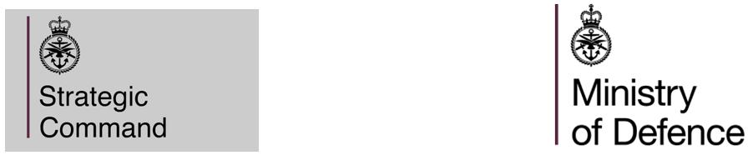

**DEFENCE MEDICAL SERVICES**

**Virtual Market Engagement Event**

**THE PROVISION OF TRI-SERVICE MEDICAL PERSONNEL TRAINING TO HEALTH AND CARE PROFESSIONS COUNCIL PARAMEDIC STANDARD**

**REFERENCE NO: 712907450**

**START DATE:**  5th October 2024

**DATE RESPONSE REQUIRED:** 29th October 2024

Dear Potential Provider,

Defence Medical Services are requesting information on the below mentioned requirement. The Authority intends to engage with industry and is looking for expressions of interest from parties who could potentially provide and wish to understand more about the requirement.

**The Requirement:** A cohort of up to 20 students per year to receive Level 6 (BSc) training that enables them to register with the Health and Care Professions Council (HCPC) as a paramedic. Trainees are to begin training no later than September 2025 and thereafter annually.

This market engagement is seeking to engage with potential Providers to establish whether there is scope to enable students to undertake a 2-year academic programme which recognises students ‘Accreditation for Prior Experiential Learning (APEL). This programme must recognise previous Knowledge, Skills and Experience (KSE) of students in their Defence roles that enables them to join the BSc pathway at the start of Year 2.

The Contractor shall deliver the requirement by providing residential academic and practical placement-based learning through a named University or Higher Education Institution (HEI) and Ambulance Service(s) or Ambulance Trusts within mainland UK.

The Contractor shall provide a nationally recognised BTEC Level 3 Certificate in Emergency Response Driving (CERAD).

The Contractor shall also provide uniforms and Personal Protective Equipment (PPE).

It is the Authority’s intention to hold a virtual market engagement event. At the event the Authority will discuss the requirement. Post the virtual event the Authority will issue a Microsoft form to gain an understanding on those keen to tender for this requirement and provide the opportunity for feedback on the requirement.

The event will take place 10:00 5th November 2024 online through MS Teams. Deadline for registration 29th October 2024, Maximum of 3 attendees per organisation.

**OUR TIMETABLE**

|  |  |
| --- | --- |
| **DATE** | **ACTIVITY** |
| 5th October 2024 | Publication of the Market Engagement Event Invitation |
| 29th October 2024 | Request for invitation response period closure (Please submit request responses to [rhean.phoenix101@mod.gov.uk](mailto:rhean.phoenix101@mod.gov.uk)) |
| 31st October 2024 | Invitation to virtual Market Engagement Event Issue |
| 10:00 5th November 2024 | Virtual Market Engagement Event |

Please note the following general conditions:

This request will help us to refine the requirements.

• We reserve the right not to proceed with this procurement. Nothing shall constitute a commitment to instigating a formal procurement process.

• Any and all costs associated with the attendance to the market engagement event shall be borne by the Potential Provider. The Authority shall not contribute in any way to meeting costs to any response.

• Information contained within this document is confidential and must not be revealed to any third party without prior written consent from us.

• No down-selection of Potential Providers will take place as a consequence of any responses or interactions relating to this request.

• No information provided by a Potential Provider in response to this request will be carried forward, used or acknowledged in any way for the purpose of evaluating the Potential Provider, in any subsequent formal procurement process that may take place.

• Should a Potential Provider fail to respond to this request, it will not affect any further participation in any possible future procurement for this capability.

• Once in the meeting, your name, email or telephone number (depending on how you access the meeting) will be visible to other attendees. By requesting an invitation you are adhering to this particular data being accessible.

Rhean Phoenix

Defence Medical Services