**Reference:** Project_2823.

**Title:**TRA – Future Trade Remedies Service – Case Management System Built on Microsoft Technologies - Early Engagement Questionnaire.

**Background:**

The Trade Remedies Authority (TRA) exists to defend the UK against unfair international trade practices. We investigate whether trade remedies are needed to prevent injury to UK industries caused by unfair trading practices or unforeseen import surges, and we make recommendations on appropriate measures to defend UK economic interests.

The Trade Remedies Authority is an executive non-departmental public body, sponsored by the Department for Business and Trade.

**Trade Remedies Service:**

The [Trade Remedies Service](https://www.trade-remedies.service.gov.uk/) (TRS) allows users (industries/businesses) to request a trade remedies investigation or review of an existing decision, take part in an active trade remedies case, invite an organisation or individual to represent a party in an active case or add a colleague to their account for an active case.

The original TRS was developed by an external third-party supplier, and later moved in-house to the Department for Business and Trade (DBT) Digital Data and Technology (DDaT) team. The original code has been refactored and, in places, rebuilt from the ground up by the in-house team to form the existing solution.

Now, the Future TRS project has been initiated to replace the existing TRS solution, including a new technical solution and operational changes to improve efficiency and productivity. The Discovery stage of the project is in progress; an options analysis activity is ongoing to assess whether the new TRS can be provided through:

1. Implementing a pre-built supplier’s COTS case management solution built using Microsoft Technologies,
2. Or by developing and building a bespoke case management solution with Microsoft Technologies unique to TRA.

This Early Engagement Questionnaire is to understand the view of the market in terms of its approach to this requirement, key considerations, indicative timescales, and costings. Information that it gathers will be used to refine requirements and inform an internal business case. TRA are open to responses to the questionnaire regarding solutions which involve implementing a pre-built supplier’s COTS solutions built using Microsoft Technologies, and/or developing and building a bespoke solution using Microsoft Technologies.

It should be noted that DBT and TRA makes no commitment to procure these services and may decide to not progress this any further following this engagement with the market. TRA and DBT are not liable for any costs incurred by respondents to this Early Engagement Questionnaire.

DBT and TRA reserves the right to change any information contained within the Early Engagement documentation at any time, and Potential Suppliers rely upon any information provided entirely at their own risk.

**Early Engagement Process & Market Questionnaire:**

As detailed in the notice, DBT and TRA are looking to engage with relevant suppliers in the market – such as Microsoft Gold Partners.

Suppliers that are interested in engaging are asked to complete the questionnaire in **Annex B** of this document and submit by the deadline stated below.

Once the deadline has passed, DBT and TRA will review the submissions, and this will aid internal decision making ahead of any potential future procurement work. This is not a formal invitation to tender.

**Submission of Response:**

Please submit your completed questionnaires in **Annex B** by no later than **17.00 on Tuesday 22nd August 2023.**

Please submit your completed questionnaire to: [CommercialDDaT@BusinessAndTrade.gov.uk](mailto:CommercialDDaT@BusinessAndTrade.gov.uk).

**ANNEX A – High Level Requirements**

**TRA Technical Estate:**

* The TRA are a Microsoft E5 licence holder and utilise the following products to service ~150 users. IT Infrastructure services are cloud-based (Azure).
  + MS Teams
  + SharePoint
  + PowerBI
  + Project for the Web (with a Power Platform wrapper to extend functionality, utilised by the Investigations/Case teams)
  + Power Platform/Power Automate for a small number of low-complexity use cases.
* Any Future TRS system will need to be integrated with the TRA Technical Estate, which is represented in the high-level diagram below.

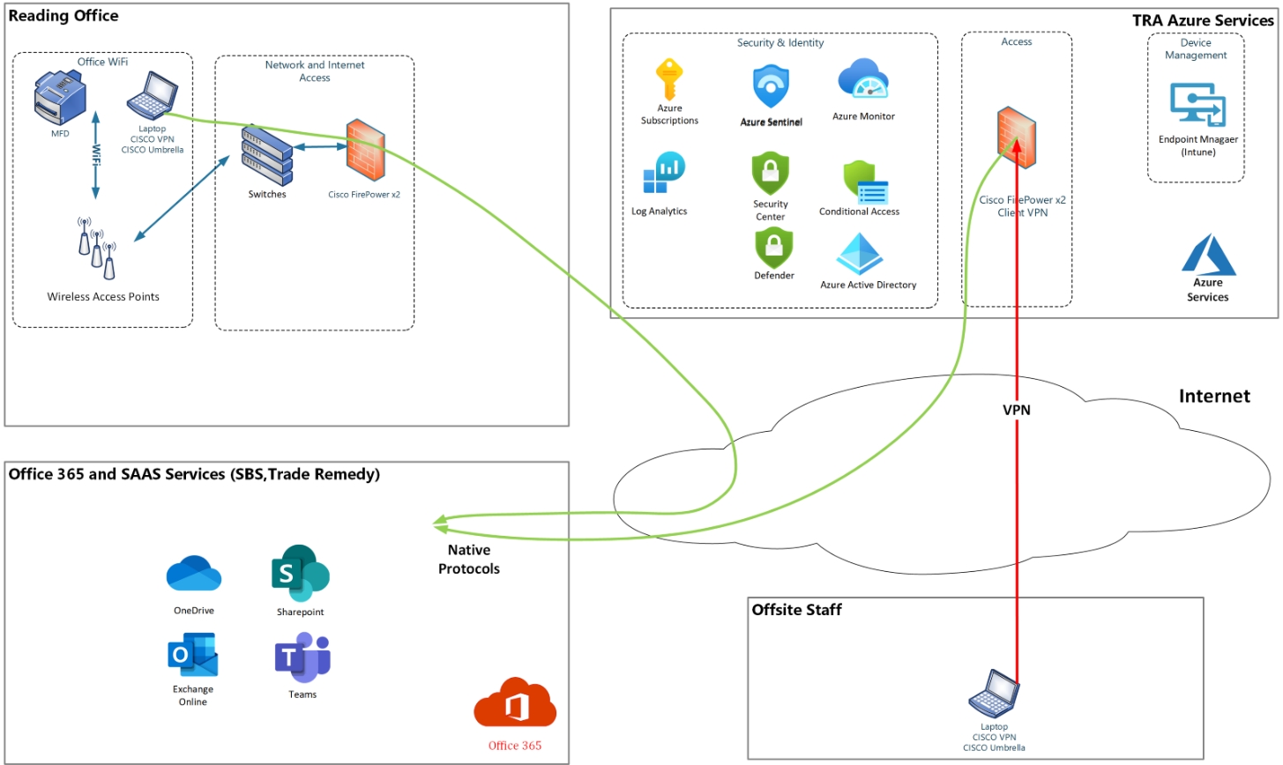

**High Level Functional Requirements:**

The following are high level functional requirements that address key areas of functionality within the TRS. These will be refined during the Discovery phase that is currently in place to define the product backlog of user stories for the Future TRS system.

**Public User Management:**

* As an Admin User of an interested party, I want to manage users from own organisation.
* As an Admin User of an interested party, I want to manage users from own organisation.
* As an Admin User I want to update my organisation’s details.
* As a representative of a foreign government, I want the foreign government form changed to reflect the fact they are governments, not companies.
* As an Admin User of a 3rd party, manage user from own organisation.

**Apply for New Case:**

* As an interested party or 3rd party representative I want to apply for a new investigation/new case.
* As a registered public user of the TRS, I want to apply for a review of an existing measure (including transition measures).
* As a Caseworker I want to review/accept requests for new investigations.

**Audit and Analytics:**

* As a TRA Administrator I want to view and download an audit log of case events.
* As a TRA Administrator I want Google Analytics tagging on the public site enhanced so I can understand time and number of steps taken by users to go through processes.
* As a TRA Administrator I want Google Analytics tagging on the caseworker site improved so I can understand how caseworkers are using the site.

**Caseworker User Management:**

* As a Caseworker I want to manage customers (filter active / inactive users).
* As a Caseworker I want to manage public organisations – either interested parties or 3rd party.
* As a Caseworker I want to manage public users on a case – either interested parties or 3rd party.
* As a Caseworker I want to view the Parties on a case and add new parties to a case – View parties (filter sampled / not filtered) applicant, party type, awaiting approval, rejected. Indicate parties verified/unverified.
* As a Caseworker I want to manage parties already associated with a case.
* As a Caseworker I want to manage incomplete customer accounts.
* As a TRA Administrator I want to manage TRA users.
* As a Caseworker I want to manage TRA team members on a case.
* As a Caseworker I want to login and reset my password.
* As a Caseworker I want to update my own details.

**Manage Documents and Submissions:**

* As a user registered on a case, I want to make submissions to a case.
* As an EIT contributor, I want to upload responses without registering for a case.
* As a Caseworker I want to review draft submissions.
* As a Caseworker I want to review document sufficiency / deficiency.
* As a Caseworker I want to publish documents on behalf of an interested party.
* As a Caseworker I want to request information from an interested party.
* As a Caseworker I want to publish a TRA document.
* As a Caseworker I want to manage submissions.
* As a Public User registered on a case, I want an email reminder when submission is due soon.
* As a Public User registered on a case, I want to receive email reminder when submission is late.
* As a Public User registered on a case, I want to be able to request an extension on making a submission.
* As a Caseworker I want to view submissions made to a case.
* As a Caseworker I want to see files related to a case – filter by respondent / investigator.
* As a Caseworker I want to manage case documents (review bundles of case documents) Filter live / draft.
* As a TRA Head of Investigation I want to manage application bundles.
* As an Administrator, I want to manage notices so that they can be seen by public users.

**Case Management:**

* As a Lead Investigator I want to manage workflow on a case and Case Configuration.
* As an Administrator I want to manage case settings.
* As a Head of Investigation, I want to create and initiate an Ex-Officio Case.
* As a Caseworker I want to add / edit linked case.

**Reporting and Feedback:**

* As a TRA Administrator, I want to see a dashboard / exportable report of overall TRS activity (e.g., number of active cases, by type, by status, number of parties involved).
* As a TRA Administrator I want to view customer feedback.

**User Dashboards:**

* As a Public User I want to see a user dashboard so I can see an overview of my situation and navigate to other parts of the TRS.
* As a Caseworker I want to view a list of cases – (Case Type, Number, Name, Created date, applicant, status, next action, due date).
* As a Caseworker I want to view a Case Overview.
* As a member of the Public, I want a dashboard where I can see public documents.

**System Management and Operation:**

* As an Administrator I want to be able to view and set system parameters.
* As a Caseworker I want to impersonate users so I can help diagnose problems and view public users’ journey.

The figure below shows the high-level end-to-end Level 0 process for case submissions to provide further context.

**High Level Non-Functional Requirements:**

**Scalability:**

* The service will provide the ability to add new features and functionalities.
* The service must ensure the capabilities can cope and perform well under an increased or expanding workload and demand.
* The solution must be scalable across different levels of expertise.

**Volumetric:**

* The system shall be capable of storing data and up to +400 document files for a single application.

**Security:**

* The solution shall support security requirements for uploading, handling, and storing Confidential Data.
* The solution must have the capability to enforce separation or user types, roles, and duties. Robust processes must be in place to ensure that only relevant and authorised access is provided.
* Users shall be uniquely identified to the service.
* User access to certain areas shall be limited to authorised users.
* The service will automatically time-out and close inactive sessions after a configurable period of inactivity with a warning.
* Secure two-factor authentication.
* High security to protect highly confidential and commercially sensitive case data.
* Access must be provided to non-confidential files.
* The solution shall incorporate a dedicated secure storage database.

**Availability:**

* The service will normally be available 24 hours a day, 7 days a week.
* Tools must be available to measure availability in line with agreed SLAs.
* The service must be resilient against single point failures.
* Notifications and alerts must be provided during system downtime.

**Backup and Recovery:**

* The service must be able to be backed up and recovered within 24 hours.

**Compatibility:**

* The service must be compatible with the latest version -2 of all major browsers.

**Data Management:**

* Data values must be validated for the expected data type e.g., numeric, alphanumeric, alphabetic, date.

**Monitoring:**

* All expected and unexpected errors must be logged.
* Error logs / reports must contain the following as a minimum:
  + Date / Time
  + Username
  + Category (e.g., Error, Warning, Info)

**Performance:**

* The system shall be capable of allowing up to 100 users to access the application concurrently.
* The service will respond to requests in under 500 milliseconds.
* Real-time for rendering speed on file upload and download.

**Quality:`**

* When a service error occurs the user should receive an explanatory message indicating that there is something wrong with the system which has not been caused by them.
* The service must be transaction-safe such that when confirmation of submission is given to a user, ALL data is stored.

**Reporting:**

* The service must be able to provide reports on service usage and other required metrics within a defined time period.

**Usability:**

* In the event that the system is unavailable, a status page informing the user of the outage must be available.
* A user shall be able to complete a form within a determined amount of time.
* A user shall be able to save and return to the point at which the uncompleted form was saved within a configurable time period.
* The system shall be capable of uploading and storing document files.
* It must be easy and quick to learn and operate the system.
* The system shall be 100% flexible for the process and template settings.

**User Interface:**

* All aspects of the user interface shall be intuitive and user friendly.

**Accessibility:**

* The service must meet WCAG 2.1 accessibility standards.
* The system must follow GDS design standards (Styles/Components/Patterns).

**Archiving:**

* The system must be able to archive completed cases.

**Analytics:**

* The system shall report user engagement and analytic data.

**ANNEX B – QUESTIONNAIRE**

|  |  |  |
| --- | --- | --- |
| No. | Question | Response |
| 1 | **Pricing:**   1. Based on the information provided, can you please detail a breakdown/itemised list of potential indicative costs to deliver this project through Microsoft Technologies? 2. Would this require additional Microsoft Provision/Power Platform Licenses? 3. Is your offering based on a pre-built COTS solution by or a bespoke solution? 4. How many hours/weeks of work would you anticipate would be needed, to deploy a project of this size to TRA? 5. Would this require a support contract approach? To change and manage the system throughout the year? 6. Post project completion, could the solution then be evolved by TRA staff using a low code platform? E.g., for ongoing enhancements. |  |
| 2 | **Timelines:**  The Discovery phase is currently underway and will output standard artefacts to describe the goal of the Future TRS system: Personas, As-Is Business Process + Pain Points, To-Be Business Process, Product Backlog (MVP/DAY ONE, ENHANCEMENT RELEASE).  At this point we can provide a Level 0 as-is business process to enable suppliers to understand the scope of the Trade Remedies Service.  The TRA will manage the overall Future TRS project, in partnership with relevant and appropriate 3rd parties.  The itemised table below depicts at a high level the mandatory phases the project will pass through.  Due to the criticality of the TRS system, the total project duration is anticipated to be in the region of 6-12 months.  It is expected that the project will follow an iterative approach with project activities taking place in two-week sprints.   1. Based on the information provided, can you please provide an indicative timeline in line with the template below, to demonstrate how you would propose to deliver this project? |  |
| |  |  |  |  |  |  | | --- | --- | --- | --- | --- | --- | | **#** | **Phase** | **Status** | **Outputs** | **Comments from TRA** | **Indicative Timeline** | | 1 | INITIATION | COMPLETE |  | Completed by TRA. |  | | 2 | DISCOVERY | IN PROGRESS | PERSONAS | In progress in TRA. |  | |  |  |  | AS IS BUSINESS PROCESS + PAIN POINTS | In progress in TRA. |  | |  |  |  | TO BE BUSINESS PROCESS | In progress in TRA. |  | |  |  |  | PRODUCT BACKLOG (MVP/ DAY ONE, Enhancement Release) | In progress in TRA. |  | | 3 | DESIGN (Software) | NOT STARTED | Design documentation |  |  | | 3 | DESIGN (Target Operating Model for BAU) | NOT STARTED | Updated business processes |  |  | | 4 | RELEASE 1 BUILD (MVP) | NOT STARTED | MVP code and configuration |  |  | | 5 | RELEASE 1 UAT (MVP) | NOT STARTED | Signed-off MVP |  |  | | 6 | RELEASE 1 PILOT LIVE (Private Beta) | NOT STARTED | MVP release live | This may include a parallel run with the existing TRS for a specified period of time. |  | | 7 | RELEASE 1 DEFECT FIXES | NOT STARTED | Fixes for post go-live bugs |  |  | | 8 | RELEASE 1 UAT FOR FIXES | NOT STARTED | Signed-off fixes for post go-live bugs |  |  | | 9 | RELEASE 1 GO LIVE (Public Beta) | NOT STARTED | Cutover to the final version of MVP with bug fixes. | Cutover to the new system from the old TRS once the parallel run has been signed-off by the Project Board. |  | | 10 | RELEASE 1 STATBILITY PERIOD FIXES & UAT | NOT STARTED | Post go-live bug fixes |  |  | | 11 | RELEASE2 BUILD (DAY TWO ENHANCMENTS) | NOT STARTED | Release 2 including prioritised non-MVP functionality | This may include enhancements identified through user research after MVP go-live. |  | | 12 | RELEASE 2 UAT (DAY TWO ENHANCEMENTS) | NOT STARTED | Signed-off Release 2 functionality |  |  | | 13 | RELEASE 2 LIVE (Private Beta) | NOT STARTED | Release 2 live in production environment |  |  | | 14 | RELEASE 2 DEFECT FIXES | NOT STARTED | Release 2 bug fixes |  |  | | 15 | RELEASE 2 UAT FOR FIXES | NOT STARTED | Signed-off fixes for Release 2 bugs |  |  | | 16 | RELEASE 2 FINAL VERSION (Public Beta) | NOT STARTED | Final version of Release 2 implemented in production |  |  | | 17 | STABILITY PERIOD FIXES & UAT | NOT STARTED | Bug fixes during warranty period before support and maintenance passes to BAU team |  |  | | | |
| 3 | **Wider Marketplace Innovation:**   1. Based on the information you have been presented, are there any innovative ideas or suggestions on how to deliver this requirement you would like to share with DBT and TRA? 2. Are there any market considerations which you would like to highlight to DBT and TRA which should be factored into the procurement? |  |
| 4 | **Case Studies:**   1. Do you have any prior experience, lessons learned or case studies delivering similar projects? |  |
| 5 | **Future Discussions:**   1. Would you be open to a 121 non-committal discussion with TRA about this early engagement questionnaire? |  |