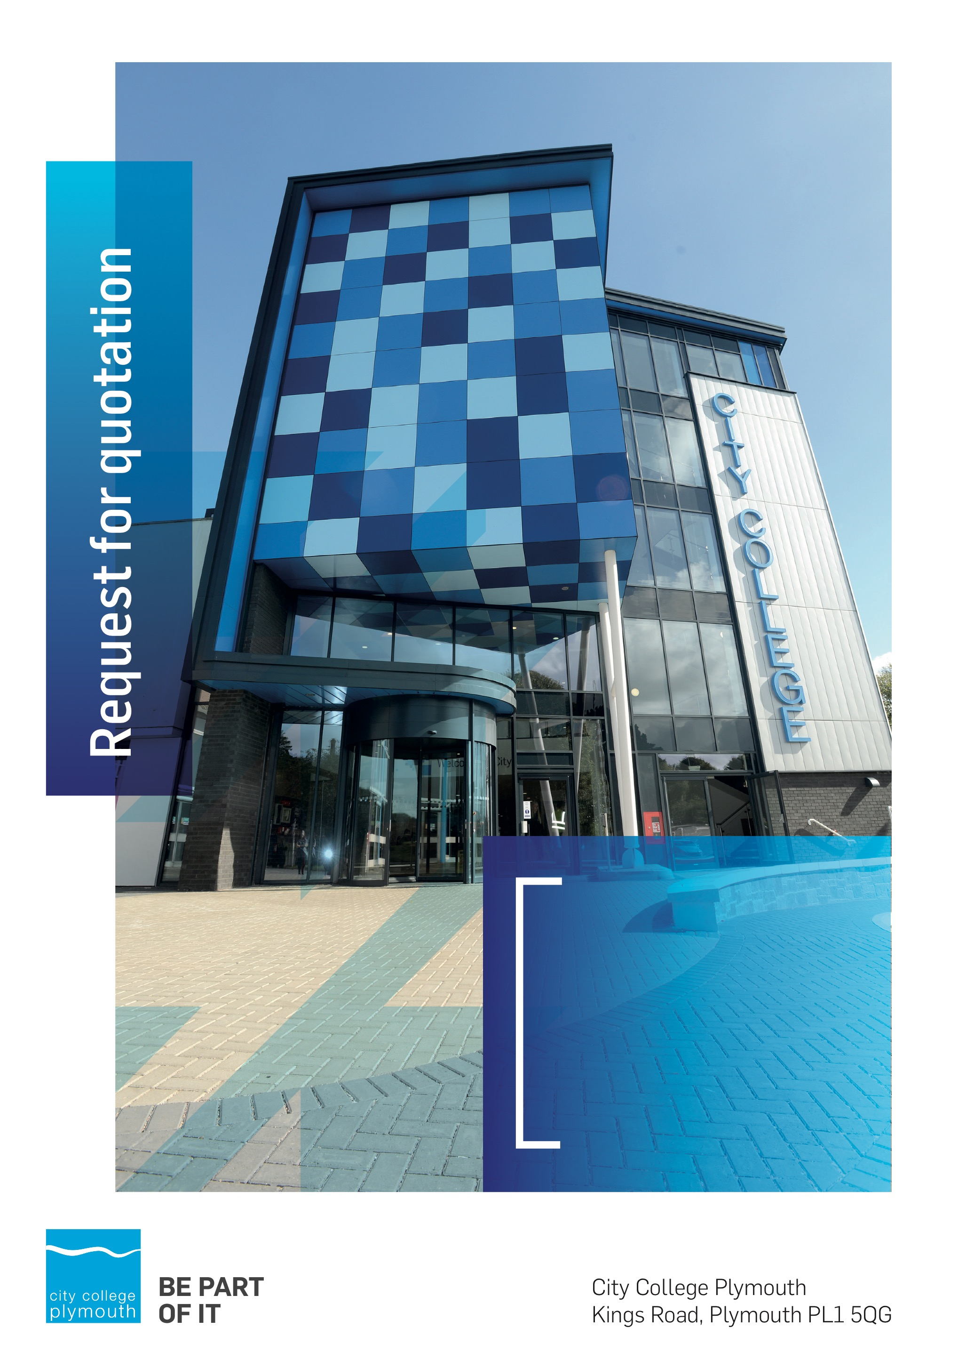

Mini Quote MQ118
Sports Hall Dividing Curtain
Issued 24/08/2020

Business Overview & Background
The College operates on two sites within the city, serving 12,533 students and employing over 500 staff. The College operates year round, with opening times from 0800-2100 on some days.

Our Vision … is where our future lies
We are a College with a national reputation for promoting enterprise, employability and science, technology, engineering and mathematics (STEM).

Our Mission … is what we focus on each and every day
To be the South West’s leading provider of innovative, technical, professional education and training by supporting partnerships for growth, raising aspirations and fostering wealth creation

Background
City College Plymouth is one of the largest providers of innovative, technical and professional, education in the South West with a national reputation for promoting enterprise, employability and science, technology, engineering and mathematics (STEM). The College plays a central role in the educational, cultural and economic life of the region and works with strategic partners to facilitate growth, raise aspirations and foster wealth creation.
The College was awarded the Teaching Excellence Framework Gold award for its university-level provision and its most recent Ofsted inspection confirmed that the College continues to be ‘Good’ with outstanding features. The College was rated first in the South West and second nationally for student satisfaction in the latest FE Choices student satisfaction survey.
City College supports the region’s employers with their award-winning Apprenticeship provision, as well as providing a range of courses and bespoke training programmes which enable employees to upskill or retrain to better support their business’ requirements. Their successful partnership working with the local business community resulted in a 99.5% satisfaction rate in the Government’s national ‘FE Choices employer satisfaction survey 2016 to 2017’ - placing them first in the country for general further education colleges.
City College Plymouth offers a wide range of academic and vocational courses in a variety of subjects. The total number of students supported by the College in 2016/17 was 12,533 - which comprised: 3,569 full-time students, including 765 higher education students and 179 non EU students; 8,964 part-time students; and 1,599 apprentices. The College also employs over 500 staff.

Requirement
City College Plymouth is looking to make more efficient use of its sports hall by the installation of a dividing curtain, which would allow multiple groups to use the space at once.
The following are the basic requirements;
- Heavy duty aluminium trackway to ensure maximum security
- 2m High with 22mm/50mm Mesh
- Manually Operated
- Blue Curtain/netting
A site visit is required prior to submitting a price to ensure the installation can be accurately spec and price. Please contact Emma Ford on 01752 305740 to arrange a visit.

Submission Deadlines
All submissions for responding to this Mini Quote must be submitted via email as stated below, no later than 4th September 2020
Any submissions received after this date will not be considered.

Submission Questions and Clarifications
You may contact the following person if you have any questions or require clarification on any topics covered in this Mini Quotation:
Adam Baker
Procurement Assistant
Phone: 01752 305313
Tenders@cityplym.ac.uk

pricing
Your pricing should be submitted using Appendix A.
Prices should be firm and valid for the contract period and not be subject to increase or escalation of any kind.
The data provided in Appendix A should not be considered a commitment to purchase, services will only be ordered on award of contract.

Terms and Conditions
The College’s normal business terms are 1-2 months from the date of invoice. Payment will become due subject to the above upon the College’s full acceptance of the goods/services. This Request for Quotation and any resulting purchase order will be subject to the College’s General Terms and Conditions of Purchase of Goods/Services – see Appendix B.

Validity
Bidder’s offers should be open and valid for acceptance for a period of no less than thirty [30] days from the date of submission.

