Direct No: 02380 055978
E-mail: TenderEnquiries@os.uk
Date: 16th May 2018
RFQ Ref: BS0717.2018

Dear Sir/Madam
REQUEST FOR QUOTATION (RFQ) – TESTING TRAINING AND QUALIFICATIONS
Ordnance Survey Ltd is a company registered in England and Wales (company registration number 09121572) whose registered address is at Explorer House, Adanac Drive, SOUTHAMPTON, SO16 0AS, UK (OS). OS is a limited company in which the entire share capital is owned by the Department for Business, Energy & Industrial Strategy (BEIS).
OS is the national mapping agency of Britain and is responsible for the surveying, production, maintenance, and marketing of a wide range of geographic information, relied on by government, business, and individuals. Further information can be found on our website: http://www.os.uk

This RFQ sets out OS’s requirements for the provision for; ongoing training and qualifications for our test practice including agile testing, test automation, software testing, advanced test and management, fundamentals of testing.
To support this, OS are requesting services, as specified in Appendix A (Statement of Requirements). If you require any additional information in order to provide the required submission, please submit any questions to the procurement contact above, via the following email address: TenderEnquiries@os.uk (marked for the attention of the procurement contact), no later than noon on Friday – 25th May 2018 for final receipt of clarification questions. OS reserves the right to issue the response to any clarification request made by you to all participants.
Email Subject should contain the RFQ Ref: BS0717.2018.
All submissions must be returned no later than noon on Tuesday –29th May 2018. Please note that OS may reject any submission not received by this date.
Email Subject should contain the RFQ Ref: BS0717.2018.
OS reserves the right to cease this procurement process at any time without any liability (whether in contract, tort or negligence) to the participant. All OS’s technical and commercial information contained within this RFQ must be considered confidential and must not be disclosed to a third party.
OS has no liability for any costs incurred by the participant in preparing or evaluating this quotation. The request and submittal of the quote does not constitute a purchase agreement between OS and the participant. OS reserves the right to amend, add or delete its requirements from this RFQ. This RFQ does not constitute an order or contract offer and there is no obligation for OS to accept your submitted proposal.
All documents and information contained in this RFQ shall remain the property of OS. Participants shall not disclose either: a) the fact that they have been invited to participate in this RFQ or release details of the proposed contract; or b) details of their quotation in whole or in part, other than on an ‘in confidence’ basis to those who have a legitimate need to know or with whom they need to consult for the purposes of preparing the quotation.
Amendments to RFQ
At any time prior to the date for submission of RFQ responses, OS may amend the procurement process or the RFQ. Any such amendment shall be issued to all participants at the same time, and if appropriate to ensure participants have reasonable time in which to take such amendment into account, the date for submission of RFQ’s shall, at the discretion of OS, be extended
Freedom of Information Act 2000 (‘FOIA’) and Environmental Information Regulations 2004 (‘EIR’)
OS is committed to meeting their legal responsibilities under FOIA and EIR. Accordingly, all information submitted to OS (including without limitation, the information contained in the RFQ and the proposals received from Participants in response) may need to be disclosed by OS in response to a request for information.
OS may also decide to include certain information in the relevant publication scheme maintained under FOIA or EIR. In making a submission, each participant therefore acknowledges and accepts that the information contained therein may be disclosed under the FOIA or EIR.
In respect of any information submitted by a participant that it considers being commercially sensitive the participant should: 1) clearly define such information as commercially sensitive; 2) explain the potential implications of disclosure of such information; and 3) provide an estimate of the period of time during which the Participant believes that such information will remain commercially sensitive.
However, participants should be aware that even where a participant has indicated that information is confidential or commercially sensitive, OS is responsible for determining, at its absolute discretion, whether such information is exempt from disclosure under FOIA or EIR, or must be disclosed in response to a request for information. Blanket labelling of all the content of submissions as ‘confidential’ is not acceptable.
Participants should also note that the receipt by OS of any material marked ‘confidential’ or equivalent does not mean that that OS accepts any duty of confidence by virtue of that marking, and OS has the final decision regarding the disclosure of any such information in response to a request for information under the FOIA or EIR.
Conflict of Interest
Participants are responsible for ensuring that there are no conflicts of interest either between their own advisers and those of OS, or between the members of its consortium and their sub-contractors. Participants must notify OS of any actual or potential conflict of interest as soon as reasonably practicable as soon as it becomes aware of such a conflict and the measures it has taken and/or proposes to take to deal with such a conflict. OS reserves the right to disqualify the Participant where the measures taken or proposed do not address the conflict to OS’s satisfaction.
Non-canvassing, non-collusion, compliance with Bribery Act 2010 and The Modern Slavery Act 2015
OS takes a zero-tolerance approach to bribery. Participants must have demonstrated that they take a robust approach to bribery prevention through either written policies or oral communication and training of its staff and agents.
OS also takes a zero-tolerance approach to slavery and is committed to preventing acts of slavery and human trafficking (as set out in the Modern Slavery Act 2015 (MSAct)) from occurring within both its business and supply chain. Ordnance Survey will expect any successful Contractor to be able to ensure it, and its supply chains, are compliant with the MSAct.
Participants must not canvass or solicit or offer any gift or consideration whatsoever as an inducement or reward to any officer or employee of, or person acting as an adviser to, OS in connection with the submission of a Tender, evaluation of responses, short-listing of Participants and in connection with the overall procurement exercise.
Participants must submit a bona fide response and confirm, by a signed return of the certificate at Appendix E, that it has not prepared its response in collusion with any third party and will not engage in collusive behaviour during the tender process.

Please do not hesitate to contact me if you have any questions concerning this project; thank you in advance for your support with this project.
Yours sincerely

Jacques Fourie
Supplier Relationship Management – Business Services
For and on behalf of Ordnance Survey Limited

APPENDIX A – STATEMENT OF REQUIREMENTS

Background to the project:
Testing is a fundamental part of our software development lifecycle, and we have identified an ongoing programme of continuous improvement. Within the engineering dept we conduct continuous training to ensure that our engineers and testers skills are up to date. We have identified a requirement over the next year that will likely include all of the following courses and we’re looking for a highly specialised provider to provide these courses.
Requirement 1
Courses as follows:
- BCS Intermediate Software Testing
- Certified Agile Tester
- ISTQB Advanced Test Automation Engineer
- ISTQB Advanced Technical Test Analyst
- ISTQB Foundation
- ISTQB Agile Foundation Extension

In the pricing sheet we have outlined a requirement for cost per person as per below:
- Onsite (in OS Offices) for 6-10 delegates.
- Offsite (external to OS) for 1-5 delegates 6-10 delegates.

Onsite course to be held at Ordnance Survey, Explorer House, Adanac Drive, Southampton, SO16 0AS
Offsite courses to be held in the Southampton area.
Requirement 2
Onsite training course for ISTQB Advanced Technical Test Analyst – for up to 16 delegates held at OSHQ
To provide a total inclusive cost for running the ATTA course and associated examination for between 12-16 delegates

Onsite course to be held at Ordnance Survey, Explorer House, Adanac Drive, Southampton, SO16 0AS

Timescale

The following dates are for guidance only.
The dates below represent an outline of the planned progress for the procurement, although these dates are for guidance only and are intended to provide Participants with the timeframe which we presently foresee for this procurement. We may change this timetable at any time at our sole discretion.

16th May 2018 | Monday | Contract Finder Notice, Issue RFQ
25th May 2018 at 12 noon | Friday | Deadline for receipt of clarification questions
29th May 2018 at 12 noon | Tuesday | Deadline for submission of proposals
4th June 2018 | Monday | Contract award decision letter and unsuccessful letter
June 2018 |  | Commencement Date of Contract

APPENDIX B - AWARD & SCORING CRITERIA

OS’s award criteria for this RFQ is based on making an evaluation of the most economically advantageous tenders (MEAT), based on an assessment of quality, timing, and price. OS will not be bound to accept the lower price quote. Post-negotiation may be entered into, if necessary to qualify or clarify tenders, or to discuss potential improvement or adjustments to the Participant’s offer. OS’s evaluation team will consist of competent and experienced personnel able to assess and score each aspect of the submissions. A moderation exercise by the team will ensure that scoring is applied on a fair, reasonable and consistent basis.
OS requirements are set out in Appendix A, and has allocated the following marks:
Quality: 150 marks in total are available
Timings: 20 marks in total are available
Price: 140 marks in total are available

Quality & Timings
Submissions against the quality, and timings and will be marked in accordance with the Evaluation Matrix, and against the below questions. The ‘final evaluated’ values will be added together to give the overall score for the evaluation. The bids will be ranked according to the overall scores achieved.

Evaluation Matrix:

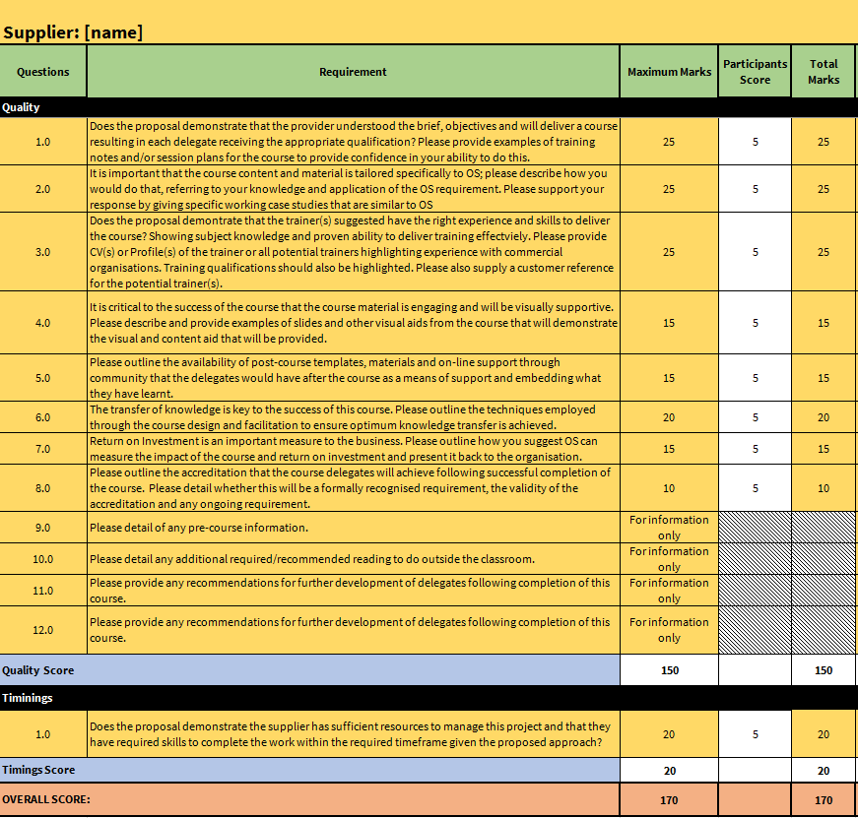
Submissions against the Statement of Requirements (in Appendix A) for quality & timings will be marked in accordance with the Evaluation Matrix, using the scoring criteria below.
Judgement | Score | Performance
Capable | 5 | Provides a full and comprehensive response to the requirement/s, supported by evidence (where applicable), to indicate the Participant can fully meet the requirement/s and does not raise any concerns about the Participants ability to meet all of the relevant requirement/s and/or to deliver the services to the required standard.
Potential | 3 | Provides a full response to the requirement/s, however the supporting evidence only partially addresses the requirement; and/or  Provides a response to the requirement/s, which raises concerns about the Participant’s ability to meet the requirement/s.
Concerns | 1 | Responds to the requirement/s, however, has only partially addressed the specific issues (if any) identified by OS; and/or  Provides insufficient evidence (where applicable) to support its response; and/or  Responds to all the requirement/s with insufficient detail raising significant concerns about the Participants ability to meet all the requirement/s; and/or  Provides a response which raises significant concerns about the Participants ability to meet the requirement/s.
Inadequate | 0 | Does not provide a response to the requirement/s; or  Responds to the requirement/s, however fails to address the specific issues (if any) identified by OS; or  Fails to provide any evidence (where applicable) to support its response.

Price
The Price evaluation will be based on the total cost. In order to compare the prices, the lowest overall price will be given 100 marks. The other scores are calculated as a mark of the lowest price to give a normalised score, i.e. Individual tenderer’s score = Lowest Price /Individual Tendered Price x 100. This ensures that all results are comparable on the same basis.
All bidders to complete the pricing document included with this RFQ - BS0717.2018 Pricing Document - Testing Training.
PRICING DOCUMENT

Overall Score
The proposal with the highest score, when quality, timings and price are added together will be awarded the contract.

APPENDIX C – TERMS & CONDITIONS

Please note that any order placed, will be under OS’s terms and conditions. All Participants must accept our terms and conditions for this RFQ.

APPENDIX D – COMPANY INFORMATION
Please complete and return the attached Company Information form, this will not be scored as part of the evaluation process but will held on our records for information purposes. However, if the information contained in this form, highlights any areas of concern about the viability of your organisation, we reserve the right to eliminate any proposals put forward by you.

APPENDIX E – Certificate of Non-canvassing and Non-collusion

In recognition of the principle that the essence of selective tendering is that OS shall receive bona fide competitive Tenders from all those tendering.
WE CERTIFY THAT:
1 the Tender submitted is a bona fide tender intended to be competitive;
2 that we have not nor any person employed by us or acting on our behalf has:
2.1 canvassed or solicited any member, officer or employee of OS in connection with the Tender submitted or the award of the contract; and
2.2 fixed or adjusted the amount of the Tender with any third party (or solicit any third party to fix or adjust their tender); and
2.3 communicated details of our Tender to any third party, other than OS or, where the Tender is submitted on behalf of a consortium, to other consortium members; and
2.4 prevented or dissuaded any third party from tendering; and
2.5 promised, offered, given, requested or accepted any advantage or inducement or consideration directly or indirectly to any third party in connection with the Tender.
3 we will not nor any person employed by us or acting on our behalf will at any time undertake any of the acts in paragraph 2 above.
- This bone fide form of offer must be signed by an authorised signatory: in the case of a partnership, by a partner for and on behalf of the firm; in the case of a limited company, by an officer duly authorised, the designation of the officer being stated. By signing this document, you are agreeing that you have the authority to submit a tender and enter into a Contract on behalf of the company that you represent.

Signature
On Behalf of
Name
Title
Date

APPENDIX F – UK LIVING EXPENSES POLICY

For Suppliers and Contractors to Ordnance Survey

Overnight accommodation
Any Training Provider/Contractor making booking arrangements for accommodation associated with delivering goods or services to OS must always be within the set limits below.
London (inside the M25) | up to £125 per night
Elsewhere | up to £100 per night

Meals
Suppliers/Contractors can claim for the actual cost of meals eaten when working for OS within these set limits:
Evening meal (if you are staying overnight) | up to £25 per night with your receipt.
Lunch, if you’re:  - away for more than 5 hours, and  - more than 5 miles away from your usual place of work, and not at Explorer House | up to £5.75 per day with your receipt. This limit covers both the food and drink you buy.
Lunch or other refreshments, if you’re:  - away for more than 10 hours, and  - more than 5 miles away from your usual place of work, and not at Explorer House | up to £22 per day with your receipt. This limit covers both the food and drink you buy.

Road Mileage Allowance Rates
Rates per business mile (2017 to 2018)
Transport | Rate p/mile
Cars & Vans | 45p
Motorcycles | 24p

Example
Your employee drives 1000 miles in their car/van, and you make a payment of RME to cover this. The qualifying amount for the earnings period would be £450 (1,000 x 45p).

